##### CSC380: Intro to Software Engineering

This document is a summary of the project description, system requirements, user stories, along with use cases, sequence diagrams, traceability matrix, and UML class and sequence diagrams, for “Questioneers”.

Team Members: Douglas Myrdek, Cedric Hansen, Brian Emigholz, Dylan Richmond

##### Table Of Contents

1. Project Description
2. System Requirements
3. User Stories
4. Use Cases
   1. High level use cases
   2. Detailed use cases
   3. Use case diagram
5. Traceability Matrix
6. UML Diagrams
   1. Sequence diagrams
   2. Class diagrams

##### Project Description

This project will be a desktop game, whose gameplay will consist of answering questions, and voting on other players answers. This game will pit 2-16 players against each other to find who has the funniest responses to the questions given. The gameplay will be as follows. Consider a game with 4 players. In any given round, players 1&2 will get a certain random question, players 2&3 will get another random question, 3&4 another, and finally players 1&4 will get the same question. This means that for any given round, players will answer 2 distinct question, each of which will also be answered by another player. Once each player submitted both of their answers, every player will get to vote on each question that was given in the round. This means that each player will vote for each of the 4 questions that was given in the round. At the end of each voting round, all players will see a current leaderboard., The game will continue for however many rounds was decided by the host upon the games creation.

Upon opening the application, the user will have 2 options: create game, and join game.

1. Upon pressing the create game button, the user will be brought to a screen which gives them a few options, including setting the number of rounds, max number of players, etc.., along with a field to enter their own name, and a button to actually launch the game (make the lobby available for others to join). The host will then be brought to a waiting screen which will display which users are currently in the lobby, along with a button to start the game, bringing all users to the gameplay previously described.
2. Upon pressing the join game button, the user will be brought to a screen which has text fields for their name, and port number, along with a button for them to "join" whatever game was created by the host in bullet point 1. Once the user joins the game, they will be brought to the waiting screen along with the host, but will not be given the button to start the game. These users will also be brought to the gameplay as previously described

At the completion of the game, a leaderboard will be shown, and a winner will be declared.

##### SYSTEM REQUIREMENTS

|  |  |  |
| --- | --- | --- |
| **Identifier** | **Priority** | **Requirements** |
| REQ1 | 1 | The system shall connect all users to the appropriate ngrok server port(which will be specified by the host after port forwarding localhost:4122) |
| REQ2 | 1 | The system shall create a new instance of a game |
| REQ3 | 1 | The system shall create new users when a new thread connects to the server |
| REQ4 | 4 | The system shall run on any computer with java installed |
| REQ5 | 1 | The system shall create a “client socket” for each user |
| REQ6 | 1 | The system shall create a “serverSocket” for whoever is hosting the game, and will connect the host using a “client socket” |
| REQ7 | 5 | The system shall allow users to add their own questions/question packs to the game |
| REQ8 | 5 | The system shall allow users to save their username and past scores |
| REQ9 | 5 | The system shall allow users to add a profile pictures |
| REQ10 | 2 | The system shall allow the game to complete rounds of gameplay |
| REQ11 | 3 | The system shall allow the host to select game settings |
| REQ12 | 3 | The system shall display the username of all players connected to the lobby while in the “Pre game lobby” page |
| REQ13 | 4 | The system will only allow the host to begin the game while in the “Pre game lobby” page |
| REQ14 | 3 | The system will display the current question, and question number for each round of play |
| REQ15 | 3 | The system will not allow users to submit blank responses to questions |
| REQ16 | 2 | The system will allow users to vote on which question they found more entertaining |
| REQ17 | 2 | The system will keep track of how many votes a certain answer received |
| REQ18 | 3 | The system will display a leaderboard between rounds |
| REQ19 | 2 | Once the host has created a lobby, there will be a text label which will contain the “room code” which will be entered by players joining the game while on the join game page. |
| REQ20 | 2 | The system will give users the appropriate question depending on which round of gameplay |
| REQ21 | 3 | The system shall give random questions to each pair of users, which will be taken from a large set of questions |
| REQ22 | 2 | The system will have GUI’s to display all of the games content |
| REQ23 | 2 | The system will allow users to answer questions |
| REQ24 | 4 | The system shall allocate the appropriate number of points based on how many votes an answer received |

*Note: Priority 1 indicates most important, while 5 is least important

##### USER STORIES

|  |  |  |
| --- | --- | --- |
| Identifier | User Story | Size |
| ST-1 | As a host, I can create a game lobby | 10 pts |
| ST-2 | As a user who wants to join existing lobby, I can join an existing lobby by typing in the room code | 15 pts |
| ST-3 | As a host, I can start the game from the pregame lobby screen | 10 pts |
| ST-4 | As any user, I can enter in my username | 1 pt |
| ST-5 | As a host, I can see who has joined my lobby | 5 pts |
| ST-6 | As a host, I can select the settings for the game | 3 pts |
| ST-7 | As a player, I can see which question I need to answer | 3 pts |
| ST-8 | As a player, I can vote on other peoples answers | 5 pts |
| ST-9 | As a player, I can see the leaderboard at the end of every round | 3 pts |
| ST-10 | As a player, I can type my response to my question | 1 pt |
| ST-11 | As a player, I can resize my window | 3 pts |

###### USE CASES

###### 4a- high level use cases

|  |  |  |
| --- | --- | --- |
| **Actor** | **Actors Goal** | **Use case ID** |
| Host | Create a lobby | CreateLobby (UC-1) |
| Non-Host Player | Join an existing game by using a room code | JoinGame (UC-2) |
| Host | Launch Game from pregame lobby | StartGame (UC-3) |
| Host | See the current players in the lobby | ViewUsers (UC-4) |
| Host | Edit the settings for the current game | EditSettings (UC-5) |
| General Player | Can view the question I am supposed to answer | ReceiveQuestion (UC-6) |
| General Player | Vote on other players answers | Vote (UC-7) |
| General Player | I can see the Scoreboard at the end of each round | ShowScoreboard (UC-8) |
| General Player | I can respond to the question I am supposed to answer | Submit (UC-9) |

###### 4B - Detailed use cases:

|  |  |
| --- | --- |
| **Use Case ID: 1** | **CreateLobby** |
| Related Requirements | REQ2 |
| Initiating actor | Host |
| Actors Goal | To start a new server for a game so that others can join. |
| Participating Actors | N/A |
| Preconditions | System must be started  Host player must be running ngrok tcp port 4122 |
| PostConditions | There is a server session that is accepting client connections.  The host is connected to the server. |
| Flow of events for Main Success Scenario | 1. Host starts application and clicks “Create Lobby” button 2. System creates a new server and connects host as a client |

|  |  |
| --- | --- |
| **Use Case ID: 2** | **JoinGame** |
| Related Requirements | REQ1 |
| Initiating actor | Non-Host Player, and Host Player |
| Actors Goal | Join an existing game by using a room code. |
| Participating Actors | N/A |
| Preconditions | There must be a server that the user can connect to.  The player must know the port to use to connect. |
| PostConditions | They are in a lobby with the host and anyone else that joined. |
| Flow of events for Main Success Scenario | 1. Non-Host Player clicks “Join Game” button 2. System asks for lobby/port number 3. Non-Host Player enters the lobby/port number |

|  |  |
| --- | --- |
| **Use Case ID: 3** | **StartGame** |
| Related Requirements | REQ13 |
| Initiating actor | Host |
| Actors Goal | Launch Game from pregame lobby. |
| Participating Actors | Non Host Player |
| Preconditions | The host must have created a new server.  There must be the people in the lobby. |
| PostConditions | All players connected to the server will be in a game. |
| Flow of events for Main Success Scenario | 1. Host clicks “Launch Game” 2. System creates a game object with all users in the lobby as players 3. System gives all players their questions 4. The system sends all players to the next screen so they can answer their questions |

|  |  |
| --- | --- |
| **Use Case ID: 4** | **ViewUsers** |
| Related Requirements | REQ12 |
| Initiating actor | Host |
| Actors Goal | See the current players in the lobby. |
| Participating Actors | N/A |
| Preconditions | The host must have created a new server.  There must be user(s) connected to the server. |
| PostConditions | The players that are connected to the server are listed for the host. |
| Flow of events for Main Success Scenario | 1. Host creates new server 2. System displays the users connected to the server |

|  |  |
| --- | --- |
| **Use Case ID: 5** | **EditSettings** |
| Related Requirements | REQ11 |
| Initiating actor | Host |
| Actors Goal | Edit the settings for the current game. |
| Participating Actors |  |
| Preconditions | The host must have created a new server. |
| PostConditions | The settings for the server session are saved. |
| Flow of events for Main Success Scenario | 1. Host creates new server 2. System to enter settings for game 3. Host can select settings for game 4. System saves settings for when game is created |

|  |  |
| --- | --- |
| **Use Case ID: 6** | **ReceiveQuestion** |
| Related Requirements | REQ20, REQ21 |
| Initiating actor | System |
| Actors Goal | Can view the question I am supposed to answer. |
| Participating Actors | General Player |
| Preconditions | The host has created a server and launched the game with certain settings.  The game has figured out which users are receiving which questions |
| PostConditions | Questions will be displayed to each user with a spot to type an answer. |
| Flow of events for Main Success Scenario | 1. System calculates how questions are distributed 2. System sends questions to each player 3. System displays one question at a time to each player |

|  |  |
| --- | --- |
| **Use Case ID: 7** | **Vote** |
| Related Requirements | REQ16, REQ17 |
| Initiating actor | General Player |
| Actors Goal | Vote on other players answers. |
| Participating Actors | General Player |
| Preconditions | All answers to questions have been received. |
| PostConditions | The votes for each answer have been tallied by the game. |
| Flow of events for Main Success Scenario | 1. General Player selects which answer they find funniest 2. System tallies that vote and gives a point to the player who submitted the answer |

|  |  |
| --- | --- |
| **Use Case ID: 8** | **ShowScoreboard** |
| Related Requirements | REQ18, REQ22, REQ24 |
| Initiating actor | System |
| Actors Goal | I can see the Scoreboard at the end of each round. |
| Participating Actors | General Player |
| Preconditions | Votes have been tallied and players’ scores are tallied. |
| PostConditions | The score for each player has been displayed. |
| Flow of events for Main Success Scenario | 1. System determines order of highests scores by player 2. System displays the list of players based on scores |

|  |  |
| --- | --- |
| **Use Case ID: 9** | **Submit** |
| Related Requirements | REQ20, REQ21, REQ23 |
| Initiating actor | General Player |
| Actors Goal | I can respond to the question I am supposed to answer. |
| Participating Actors | N/A |
| Preconditions | Users must have received the questions they are supposed to answer.  They must be able to type in a response. |
| PostConditions | The game will have collected all of the answers to each question. |
| Flow of events for Main Success Scenario | 1. General Player types in answer to their question 2. System takes the answer and associates it with that player |

###### 4c Use case diagram

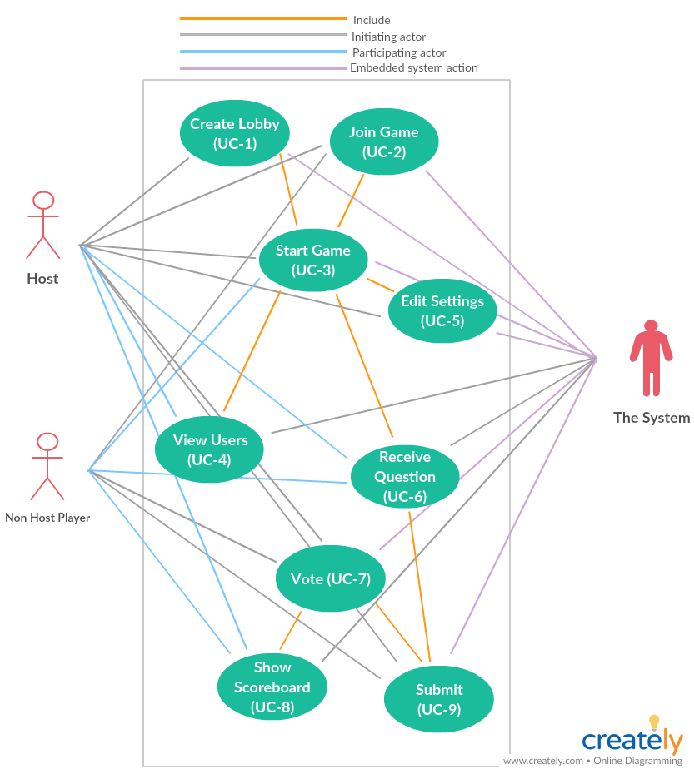

##### Traceability matrix

Traceability matrix can be found in the attached spreadsheet (For now)

##### UML Diagrams

###### 6a- Sequence diagram

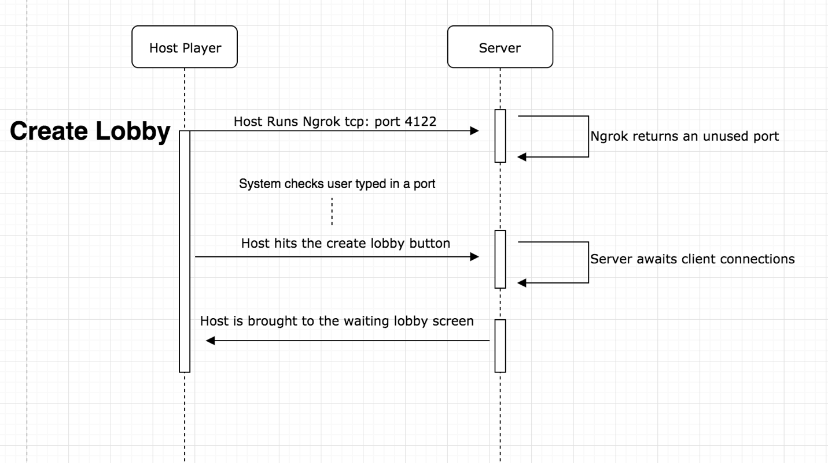

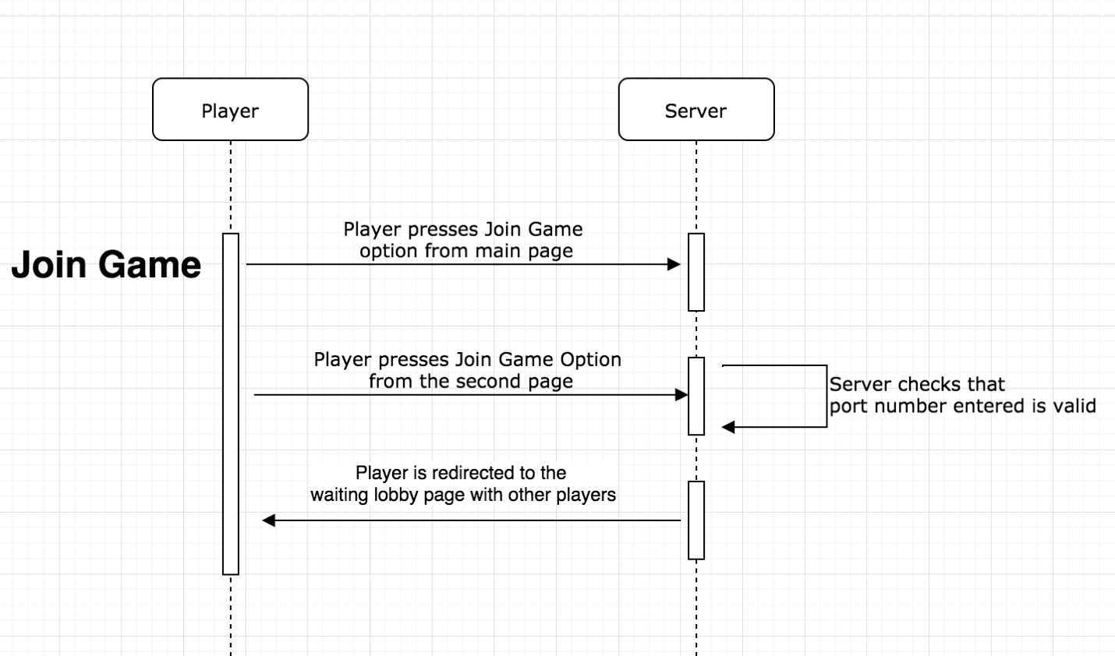

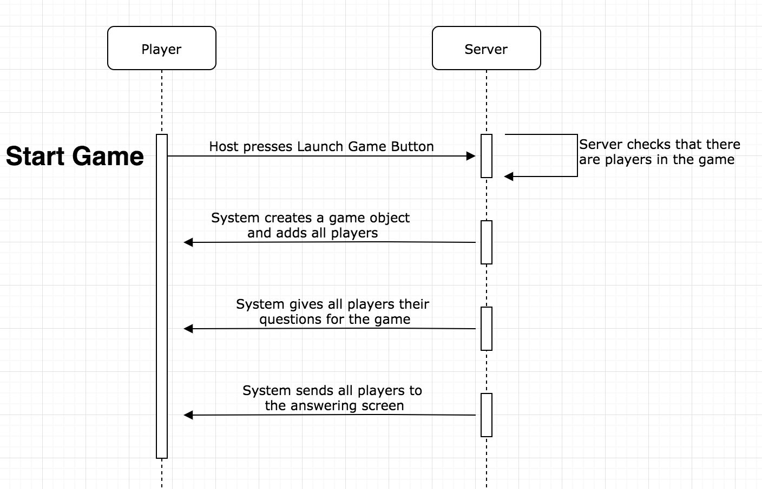

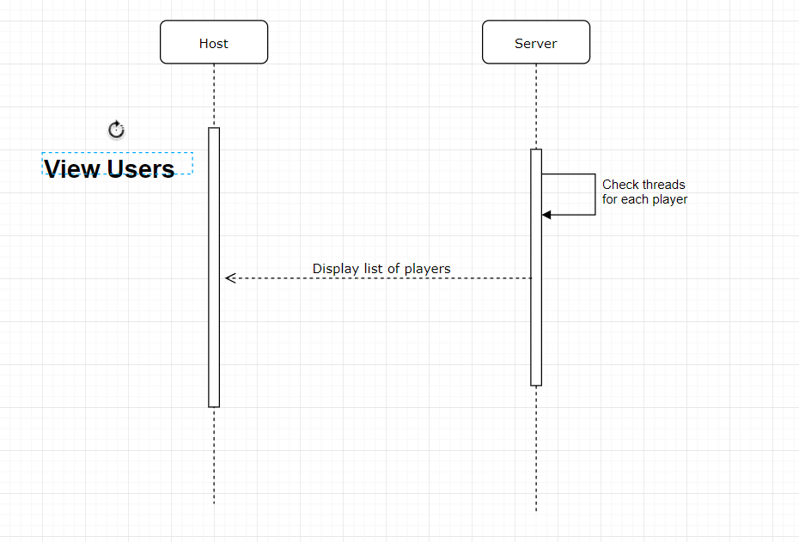

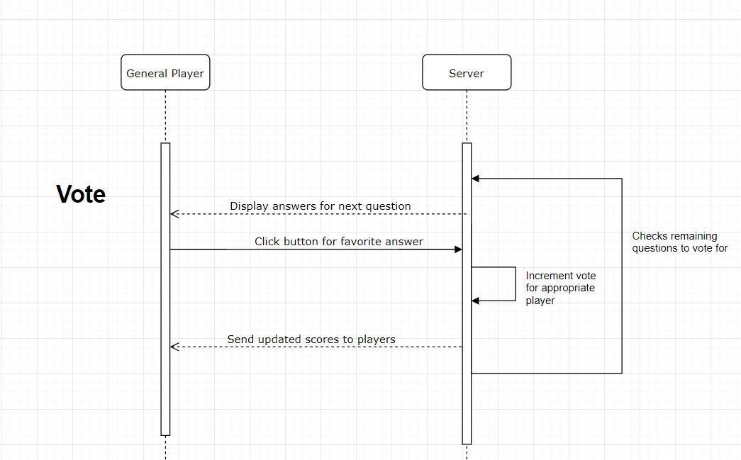

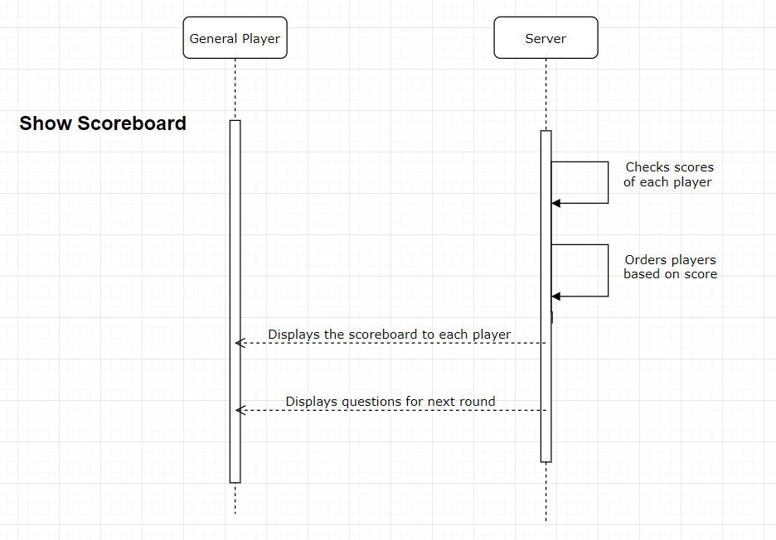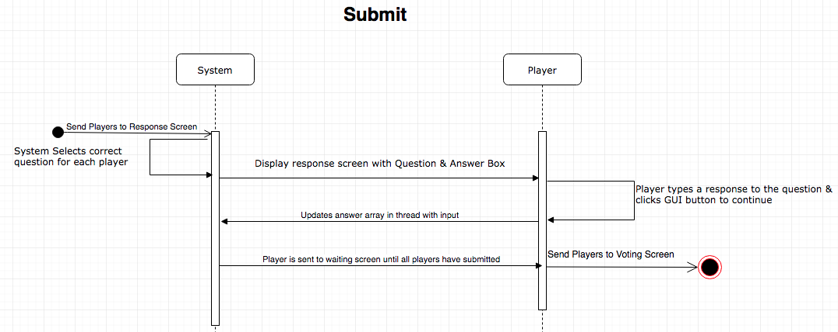

##### 6b- Class Diagrams

###### 