PAROLE AND PROBATION
INFORMATION SYSTEM
(PPIS)
End-User and System Administrator Manual
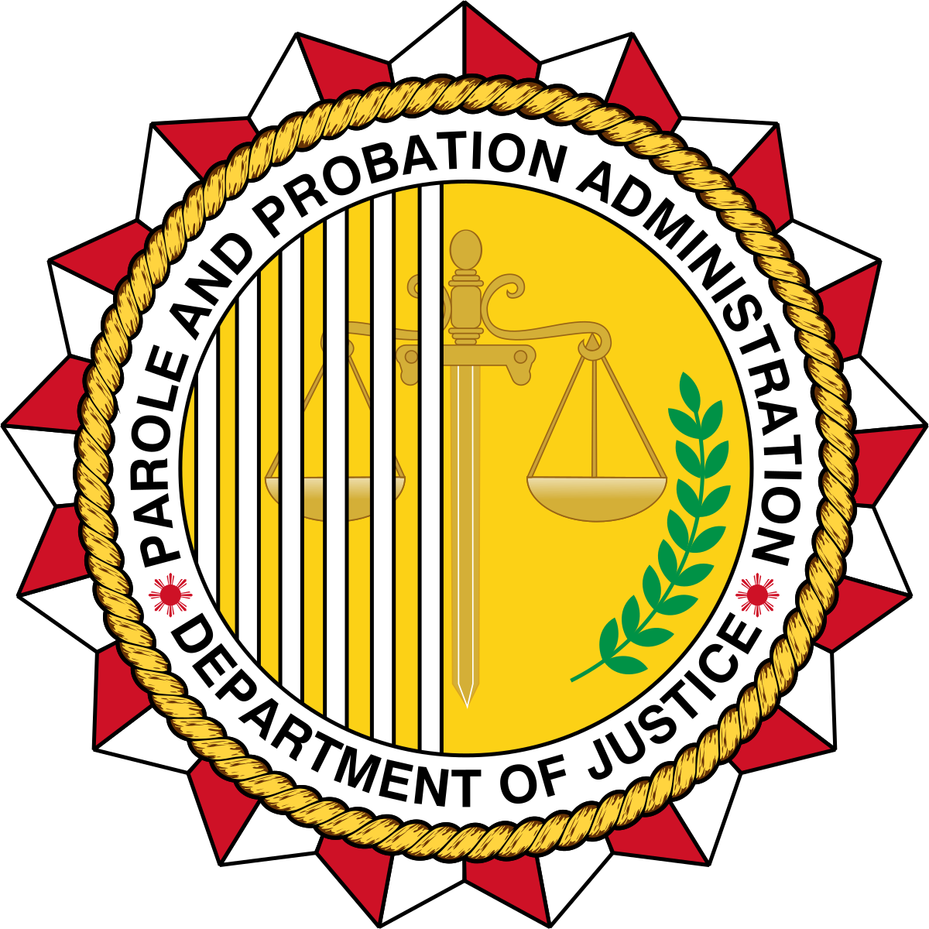

Table of Contents
Table of Contents
Table of Contents 2
1. Understanding the PPIS: Overview 5
2. System Modules 5
3. Logging in through UAMS portal. 5
4. Navigation 6
5. Docket Access 8
Probation Investigation 8
Probation Investigation (View) 9
Probation Investigation (Update) 10
Probation Investigation (Attachments) 12
Probation Investigation (Delete) 12
Probation Courtesy Investigation 13
Probation Courtesy Investigation (View) 15
Probation Courtesy Investigation (Update) 15
Probation Courtesy Investigation (Attachments) 16
Probation Courtesy Investigation (Delete) 17
Probation Supervision 18
Probation Supervision (View) 19
Probation Supervision (Update) 20
Probation Supervision (Attachments) 21
Probation Supervision (Delete) 22
Probation Courtesy Supervision 23
Probation Courtesy Supervision (View) 24
Probation Courtesy Supervision (Update) 25
Probation Courtesy Supervision (Attachments) 26
Probation Courtesy Supervision (Delete) 27
Parole and Pardon Investigation 28
Parole and Pardon Investigation (View) 29
Parole and Pardon Investigation (Update) 30
Parole and Pardon Investigation (Attachments) 31
Parole and Pardon Investigation (Delete) 32
Parole and Pardon Courtesy Investigation 33
Parole and Pardon Courtesy Investigation (View) 34
Parole and Pardon Courtesy Investigation (Update) 35
Parole and Pardon Courtesy Investigation (Attachments) 36
Parole and Pardon Courtesy Investigation (Delete) 37
Parole and Pardon Supervision 38
Parole and Pardon Supervision (View) 39
Parole and Pardon Supervision (Update) 40
Parole and Pardon Supervision (Attachments) 42
Parole and Pardon Supervision (Delete) 42
Parole and Pardon Courtesy Supervision 43
Parole and Pardon Courtesy Supervision (View) 44
Parole and Pardon Courtesy Supervision (Update) 45
Parole and Pardon Courtesy Supervision (Attachments) 46
Parole and Pardon Courtesy Supervision (Delete) 47
6. Fact Sheet 48
Fact Sheet Probation 48
Fact Sheet Probation (Open Client Profile) 49
Fact Sheet Probation (Client Profile Tabs) 52
Fact Sheet Probation (Upload or Take Photo) 53
Fact Sheet Probation (Upload Fingerprint) 54
Fact Sheet Probation (Worksheet and PSIR Overview) 55
Fact Sheet Probation (Navigate to Worksheet) 56
Fact Sheet Probation (Fill Out Worksheet) 57
Fact Sheet Probation (Print Worksheet) 58
Fact Sheet Probation (Navigate to PSIR) 59
Fact Sheet Probation (Fill Out PSIR) 60
Fact Sheet Probation (Print PSIR) 61
Fact Sheet Role Workflows (CPPO, Field Officer, Clerk/Other) 62
CPPO and other full-access accounts 62
Field Officer accounts 63
Clerk and other accounts 65
What each role can do 66
Fact Sheet Parole and Pardon 66
Fact Sheet Parole and Pardon (Update) 67
Fact Sheet Parole and Pardon (Attachments) 68
7. Forms 69
Forms 69
Forms (Add Document) 70
8. My Organization 71
User Accounts (For Administrator of the System) 71
User Accounts (Update) (For Administrator of the System) 72
User Accounts (Delete) (For Administrator of the System) 74
User Accounts (Add Record) (For Administrator of the System) 75
User Roles (For Administrator of the System) 77
User Roles (Update) (For Administrator of the System) 77
User Roles (Add Record) (For Administrator of the System) 78
Field Office (For Administrator of the System) 79
Field Office (View) (For Administrator of the System) 80
Field Office (Update) (For Administrator of the System) 81
Field Office (Delete) (For Administrator of the System) 82
Field Office (Add Record) (For Administrator of the System) 83
Region (For Administrator of the System) 84
Region (Update) (For Administrator of the System) 85
Region (Delete) (For Administrator of the System) 86
Region (Add Record) (For Administrator of the System) 87
Permission (For Administrator of the System) 88
Permission (Update) (For Administrator of the System) 89
Permission (Add Record) (For Administrator of the System) 90

1. Understanding the PPIS: Overview
Probation and Parole Information System (PPIS) is a platform used to manage records related to probation, parole, and pardon cases. It is designed to support case handling and record management functions and is interoperable with the Expanded Parole and Probation Case Management Information System (EPPCMIS), allowing seamless data sharing between the two systems.
Within the system, users can create, update, and delete records depending on the selected module and performed action. It also provides data export options, enabling users to download displayed table records in CSV, PDF, or Excel formats, as well as print records directly using available print functions in data tables.
For data retrieval and review, users can quickly filter records using inline column search fields or dropdown filter options located above table columns. Results are updated dynamically as filter criteria are entered or selected, allowing for efficient and real-time data querying.

Manual purpose: This manual provides end-users with step-by-step guidance on navigating the PPIS website, using the actual on-screen interfaces and system labels as they appear in the application.

Role access: Menu options may differ depending on the user’s role.

Screenshot indicators: Red boxes and arrows labelled “Click” indicate the specific controls to be selected in each screenshot.

2. System Modules
- Docket Access – Shows the docket records of probation, parole, and pardon
- Fact Sheet - Maintains client investigation and supervision case records. This serves as the eCase Folder of the client
- Forms – Views and adds documents or forms when permitted.
- My Organization - Maintains users, roles, field offices, regions, and permissions.

3. Logging in through UAMS portal.
- Open OpenVPN.
- Login through VPN using your Login Credentials.
- Open UAMS Portal (http://uams.probation.gov.ph/ppa-uams).
- Login using the end-user credentials.
- Click the PPIS tile in UAMS to access the system, provided you have the required access permissions.
- Wait for PPIS to finish loading and enter your OTP.
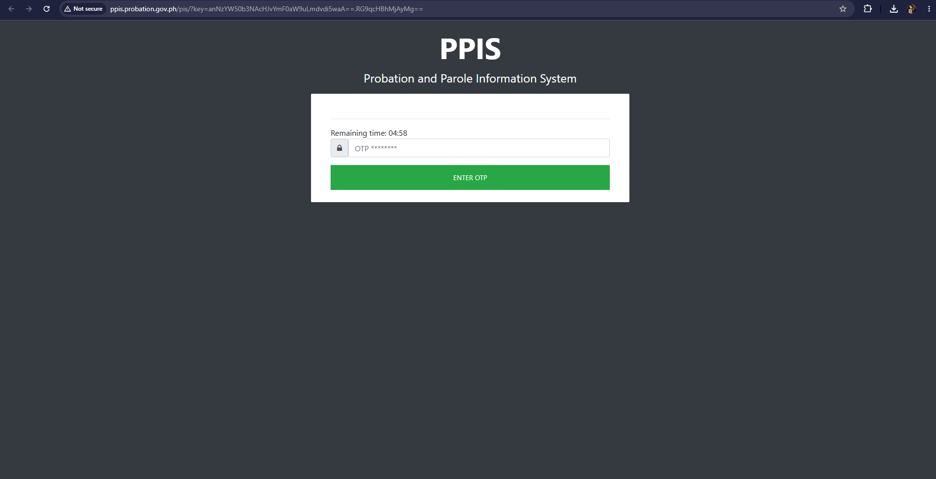
Otp page

4. Navigation
1. Use the left menu to move between Docket Access, Fact Sheet, Forms, and My Organization.
2. Click a menu group such as Docket Access, Fact Sheet, Forms and My Organization to show its submenu.
3. Click the exact module name that the end-user needs to open.
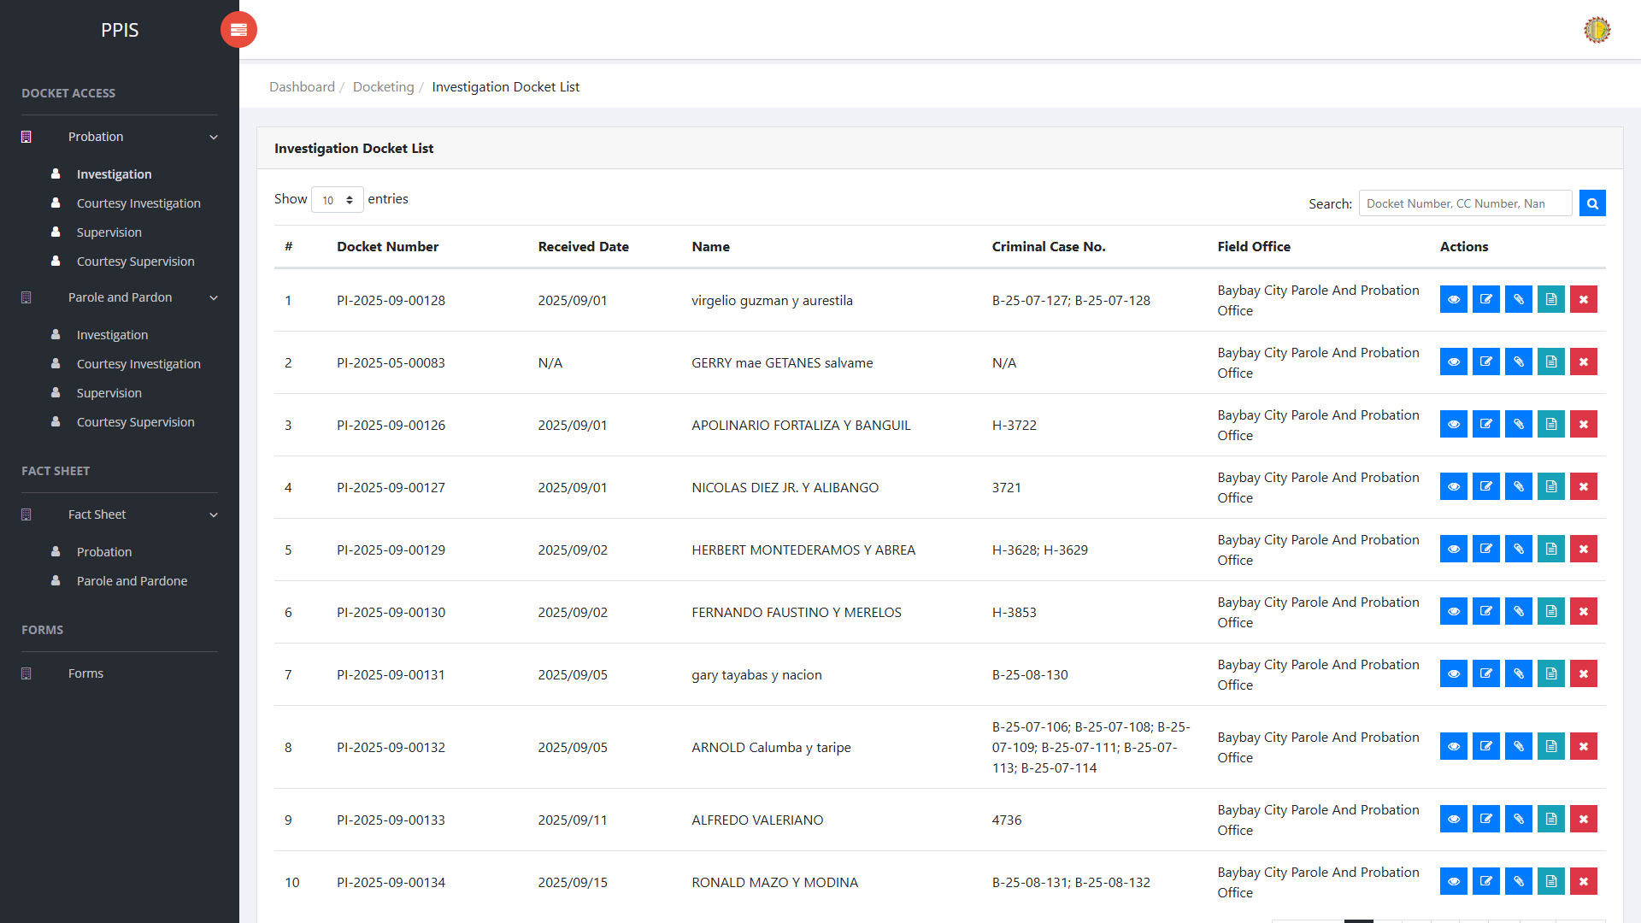
Main navigation

5. Docket Access

Opening the Fact Sheet from a docket
From any docket list, the end-user can open the client fact sheet without leaving Docket Access. Use Fact Sheet in the Actions column of the selected row.
1. Open a docket list under Docket Access, for example Probation Investigation.
2. Locate the record the end-user needs.
3. In the Actions column, click Fact Sheet.
4. Wait for the client view profile to open. The page shows the client photo area, profile tabs, and tab content below.
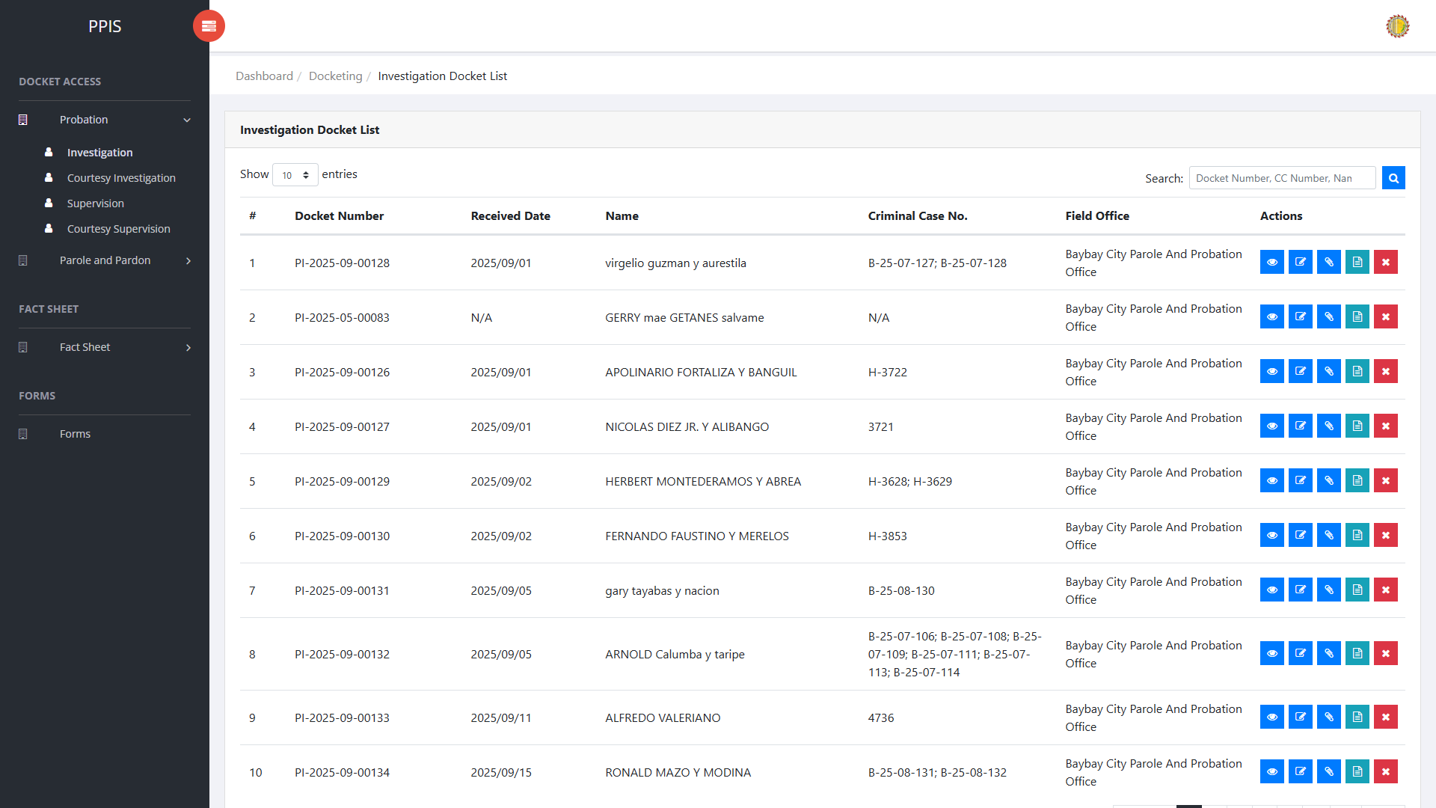
Docket list — Fact Sheet in the Actions column
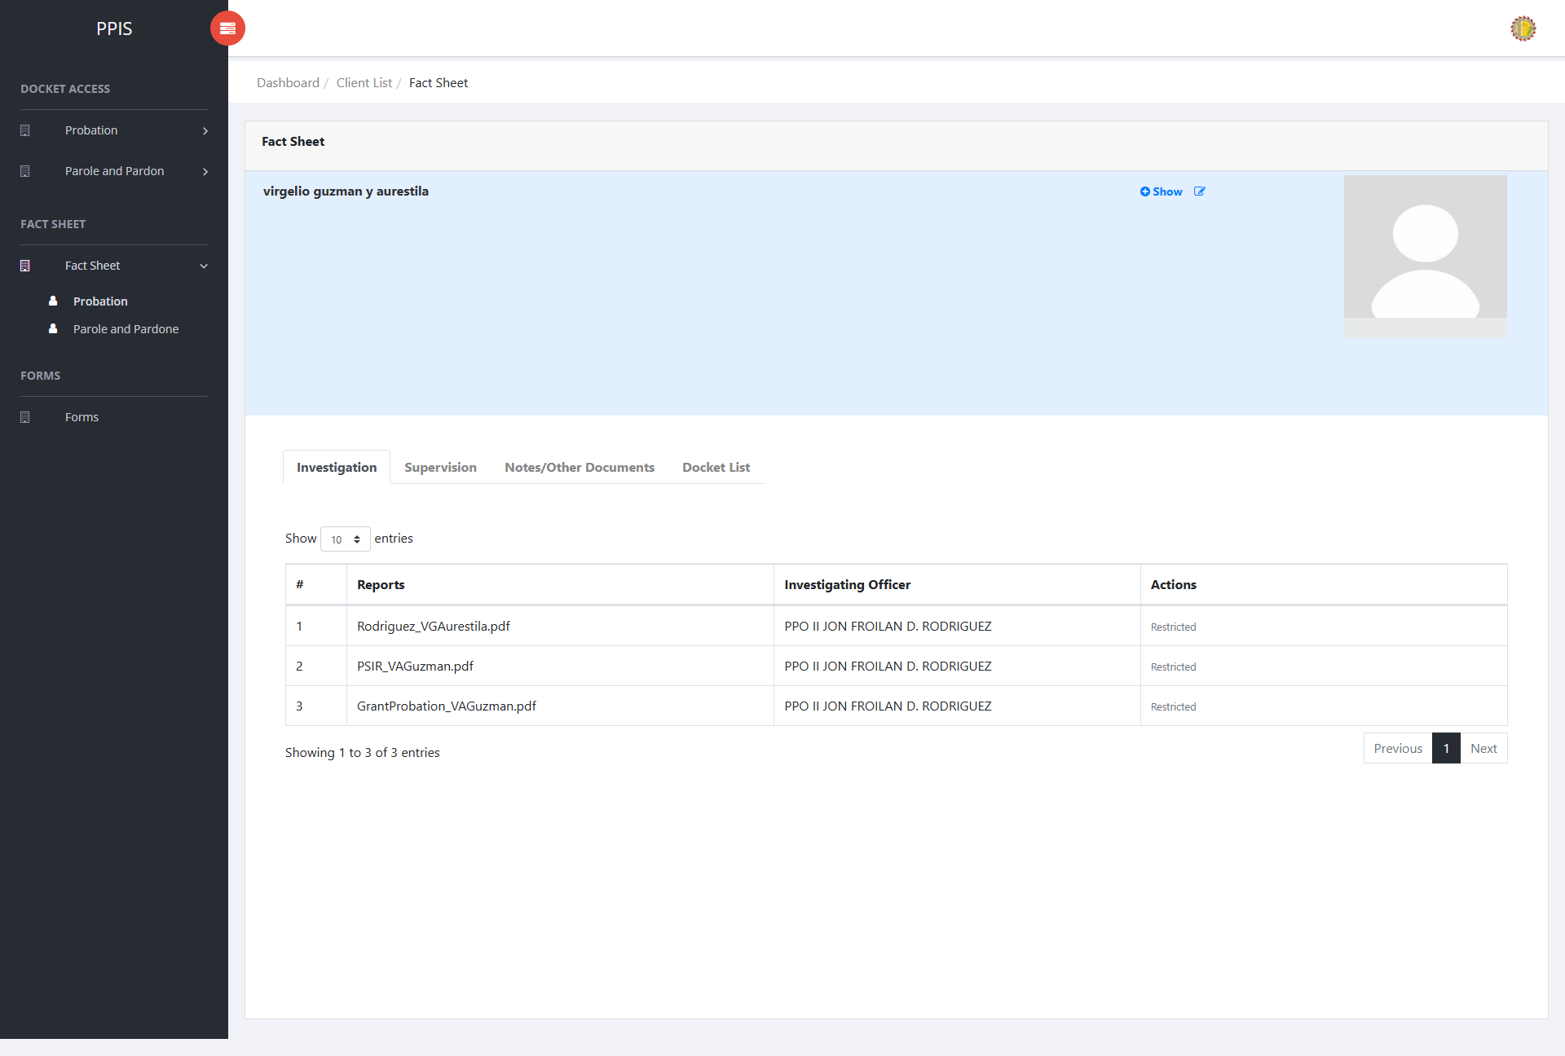
Client view profile opened from Fact Sheet on a docket

Probation Investigation
Use this page to search, review, update, attach documents to, or remove probation investigation dockets.
1. From the left menu, open Probation Investigation.
2. To search for a record, input the available details in the Docket Number, CC Number, or Name fields.
3. Click Run search to apply the search.
4. In the Actions column, use View, Update, Attachments, Fact Sheet, or Remove for the selected row.
Probation Investigation list page

Probation Investigation (View)
1. On the Probation Investigation list page, locate the record the end-user needs to review.
2. Click View in the Actions column.
3. Read the details on the view page. Use this screen for checking information before making any changes.
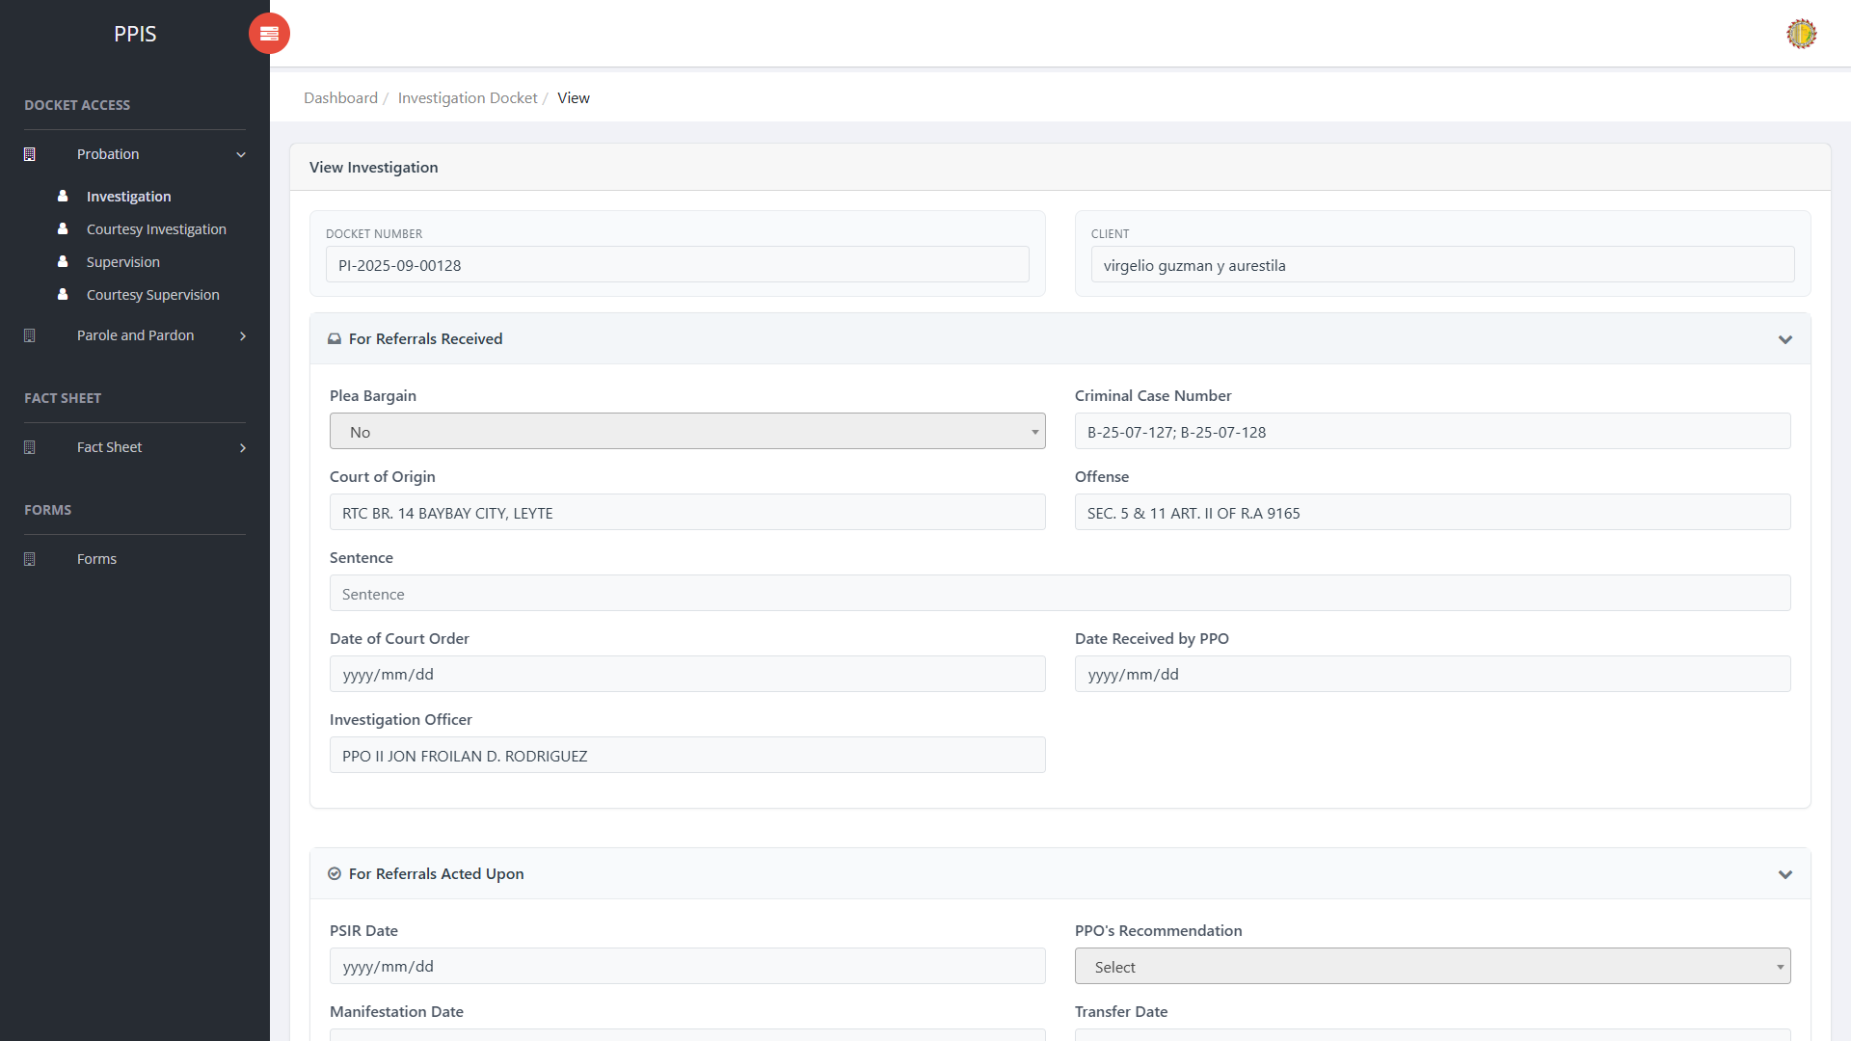
Probation Investigation (View)

Probation Investigation (Update)
1. On the Probation Investigation list page, locate the record that needs correction.
2. Click Update in the Actions column.
3. Wait for the update screen to open.
4. Review the current details and update Docket Number, Client Name, Plea Bargain, Criminal Case Number, Court of Origin, Offense, Sentence, Date of Court Order.
5. Click Confirm to save after checking the information.
6. Wait for the system to return to the list page or refresh the record display.
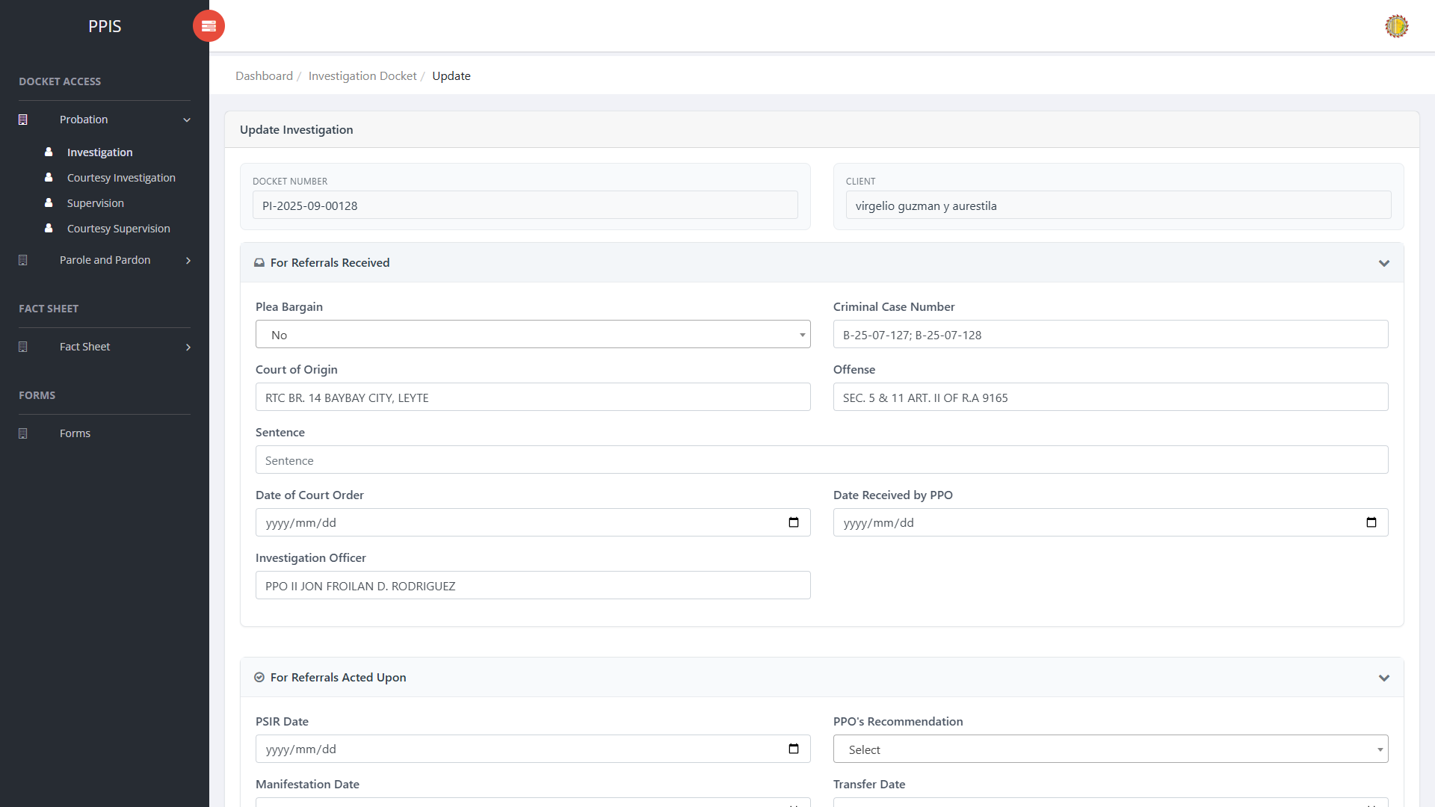
Probation Investigation (Update)

Probation Investigation (Attachments)
1. On the Probation Investigation list page, click Attachments for the correct record.
2. Wait for the attachments screen to open.
3. Complete the attachment details, such as Kind, Type, and Upload File when shown.
4. Click Confirm to upload the file.
5. Use View, Download, or Delete only for the attachment listed in the table.
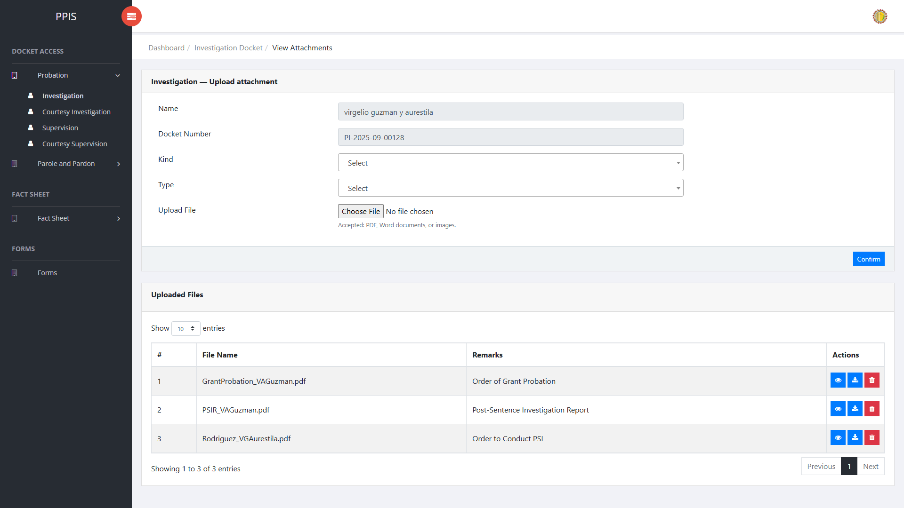
Probation Investigation (Attachments)

Probation Investigation (Delete)
Deletion warning: Use Remove only for records approved for deletion. For documentation, stop at the confirmation dialog unless removal is required.

1. On the Probation Investigation list page, locate the record to be deleted.
2. Click Remove in the Actions column.
3. Wait for the confirmation modal dialog box to appear.
4. Read the confirmation message carefully. The system warns that removal cannot be undone.
5. Click Cancel inside the modal dialog to stop, or click Remove permanently inside the modal dialog only when deletion is authorized.
6. Wait for the modal dialog to close. The table refreshes to reflect the remaining records.
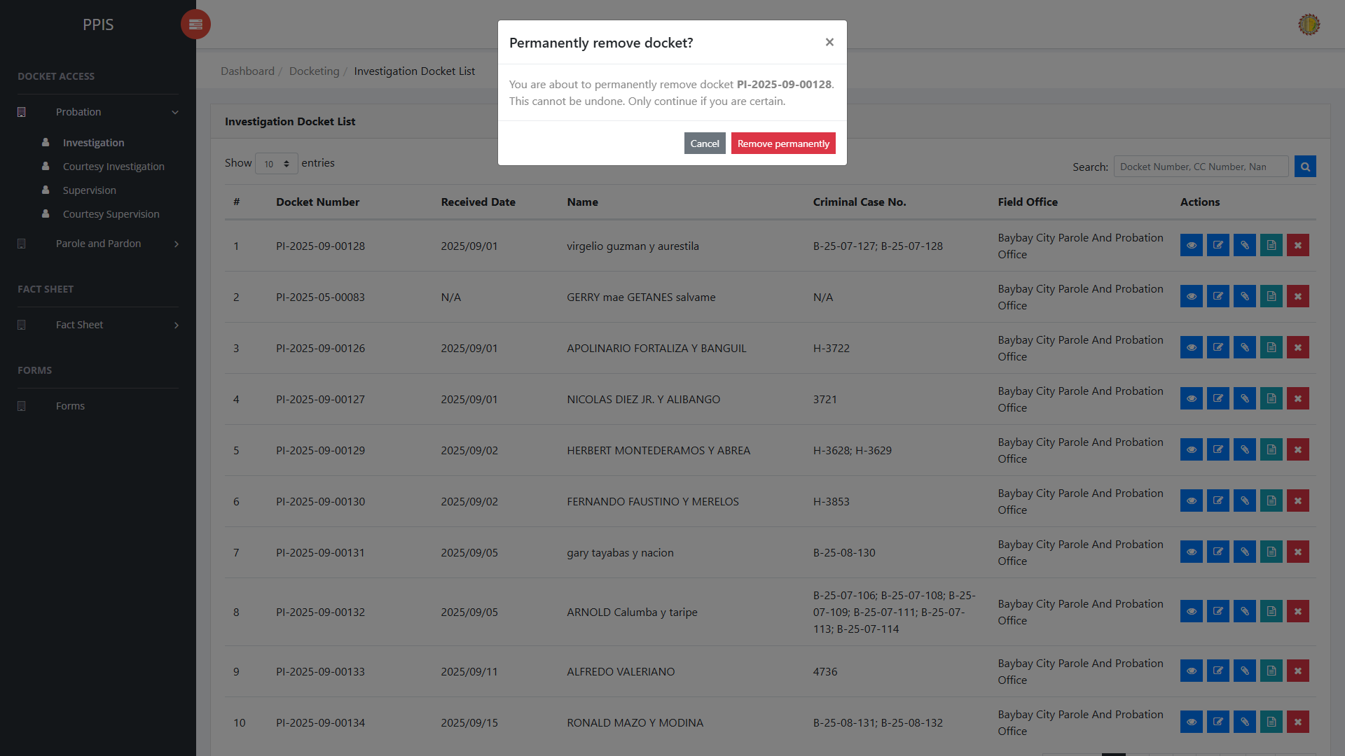
Probation Investigation (Delete)

Probation Courtesy Investigation
Use this page to manage courtesy investigation dockets under the probation workflow.
1. From the left menu, open Probation Courtesy Investigation.
2. To find a record, enter the known information in Search docket / name.
3. Click Run search to apply the search.
4. In the Actions column, use View, Update, Attachments, Fact Sheet, or Remove for the selected row.
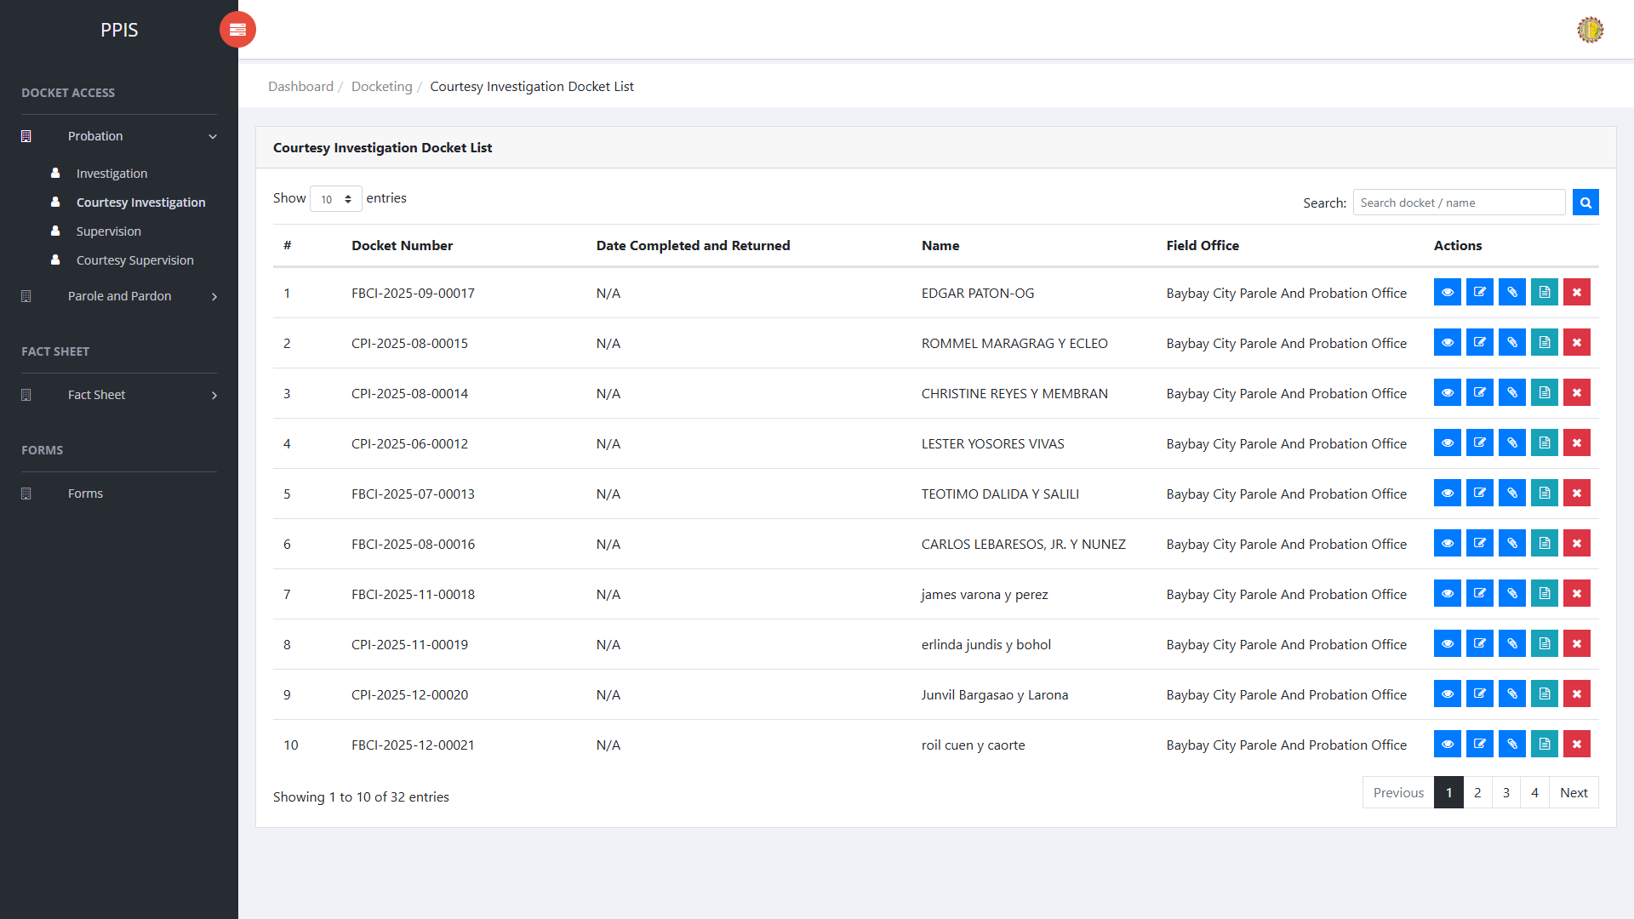
Probation Courtesy Investigation list page

Probation Courtesy Investigation (View)
1. On the Probation Courtesy Investigation list page, locate the record the end-user needs to review.
2. Click View in the Actions column.
3. Read the details on the view page. Use this screen for checking information before making any changes.
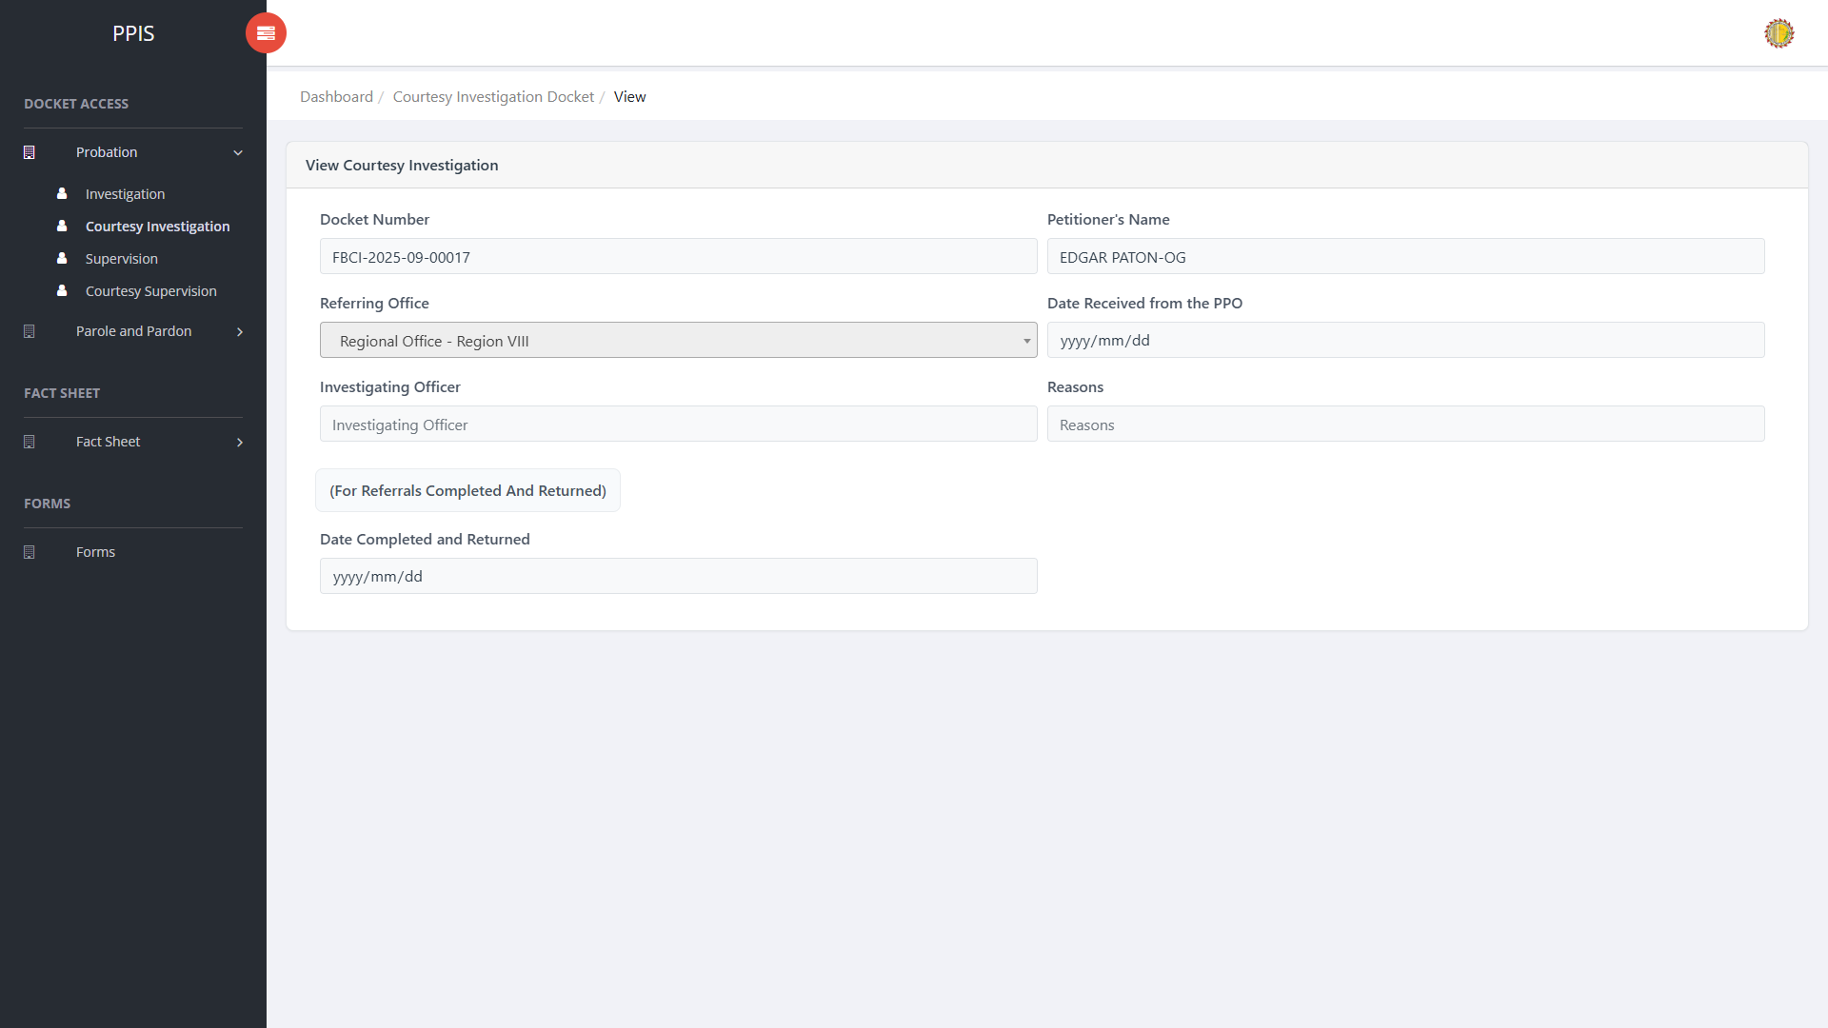
Probation Courtesy Investigation (View)

Probation Courtesy Investigation (Update)
1. On the Probation Courtesy Investigation list page, locate the record that needs correction.
2. Click Update in the Actions column.
3. Wait for the update screen to open.
4. Review the current details and update Docket Number, Petitioner's Name, Referring Office, Date Received from the PPO, Investigating Officer, Reasons, Date Completed and Returned.
5. Click Confirm to save after checking the information.
6. Wait for the system to return to the list page or refresh the record display.
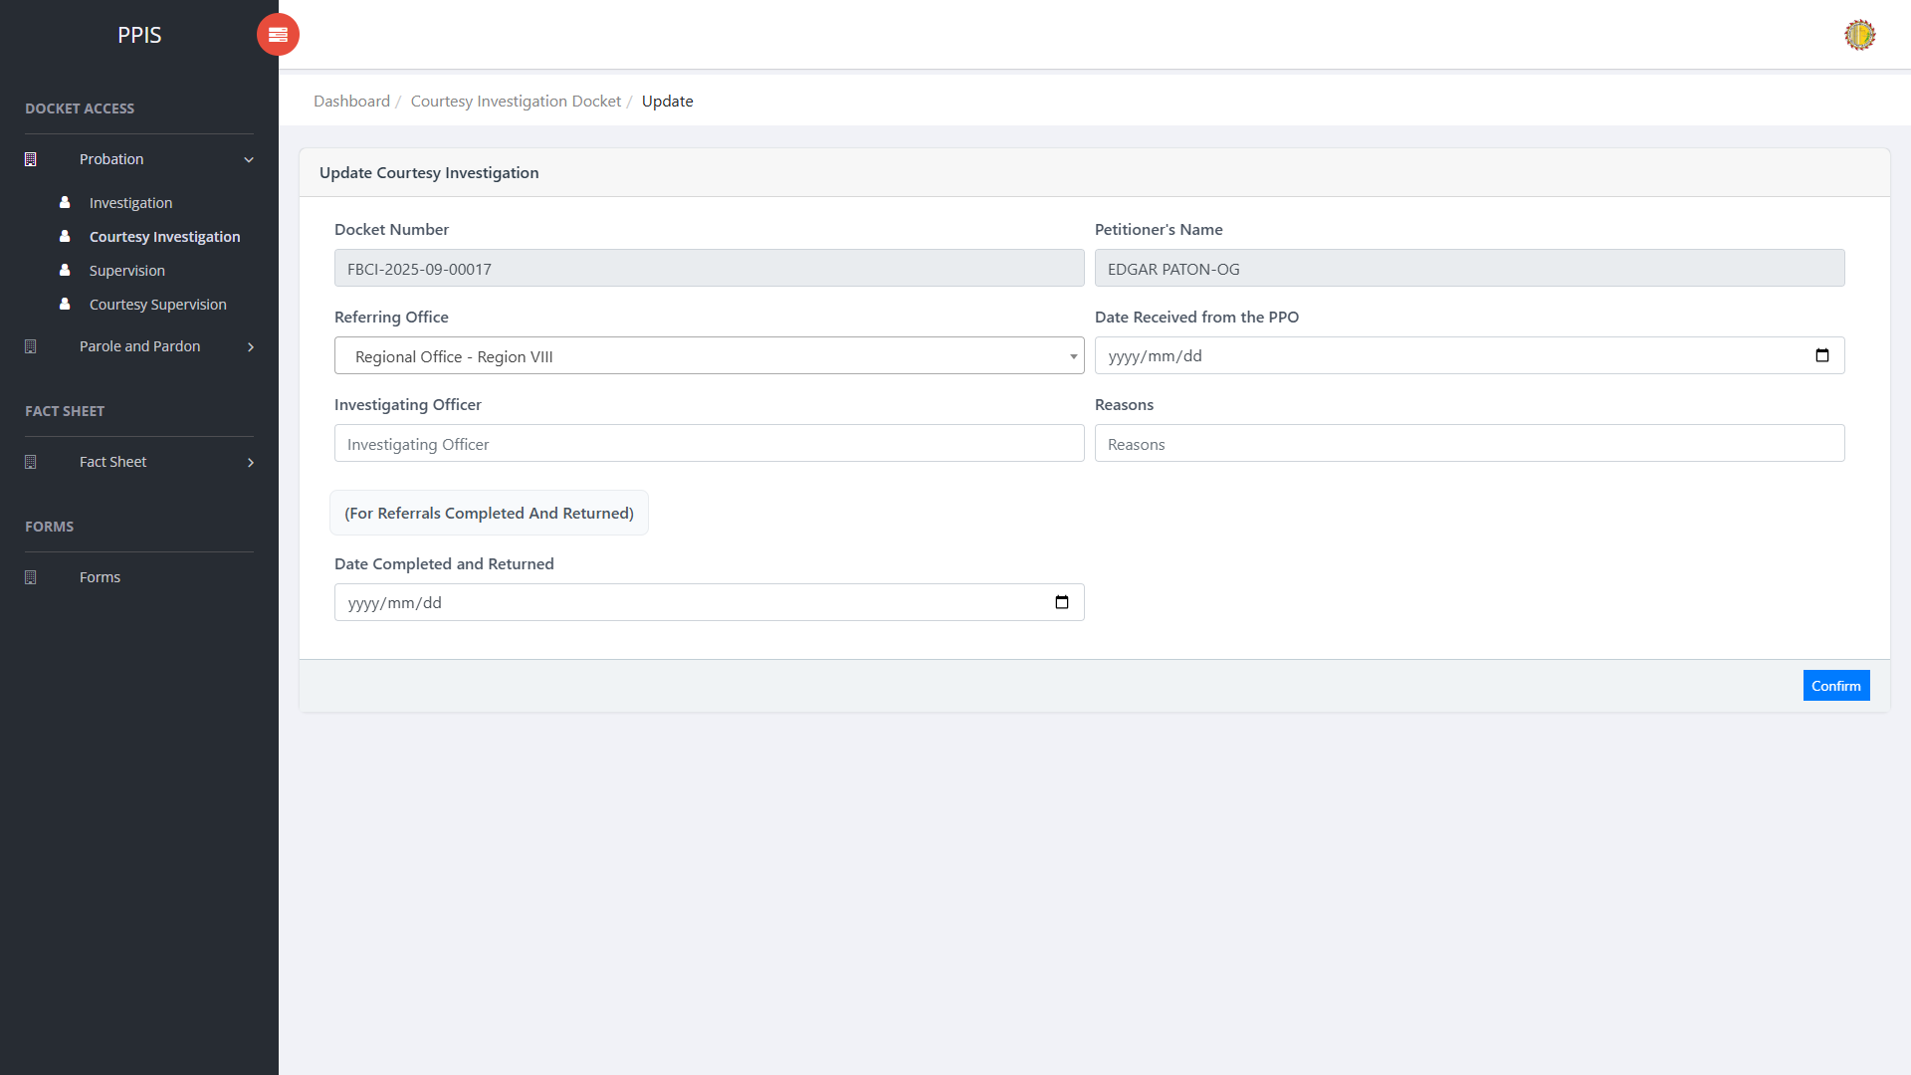
Probation Courtesy Investigation (Update)

Probation Courtesy Investigation (Attachments)
1. On the Probation Courtesy Investigation list page, click Attachments for the correct record.
2. Wait for the attachments screen to open.
3. Complete the attachment details, such as Kind, Type, and Upload File when shown.
4. Click Confirm to upload the file.
5. Use View, Download, or Delete only for the attachment listed in the table.
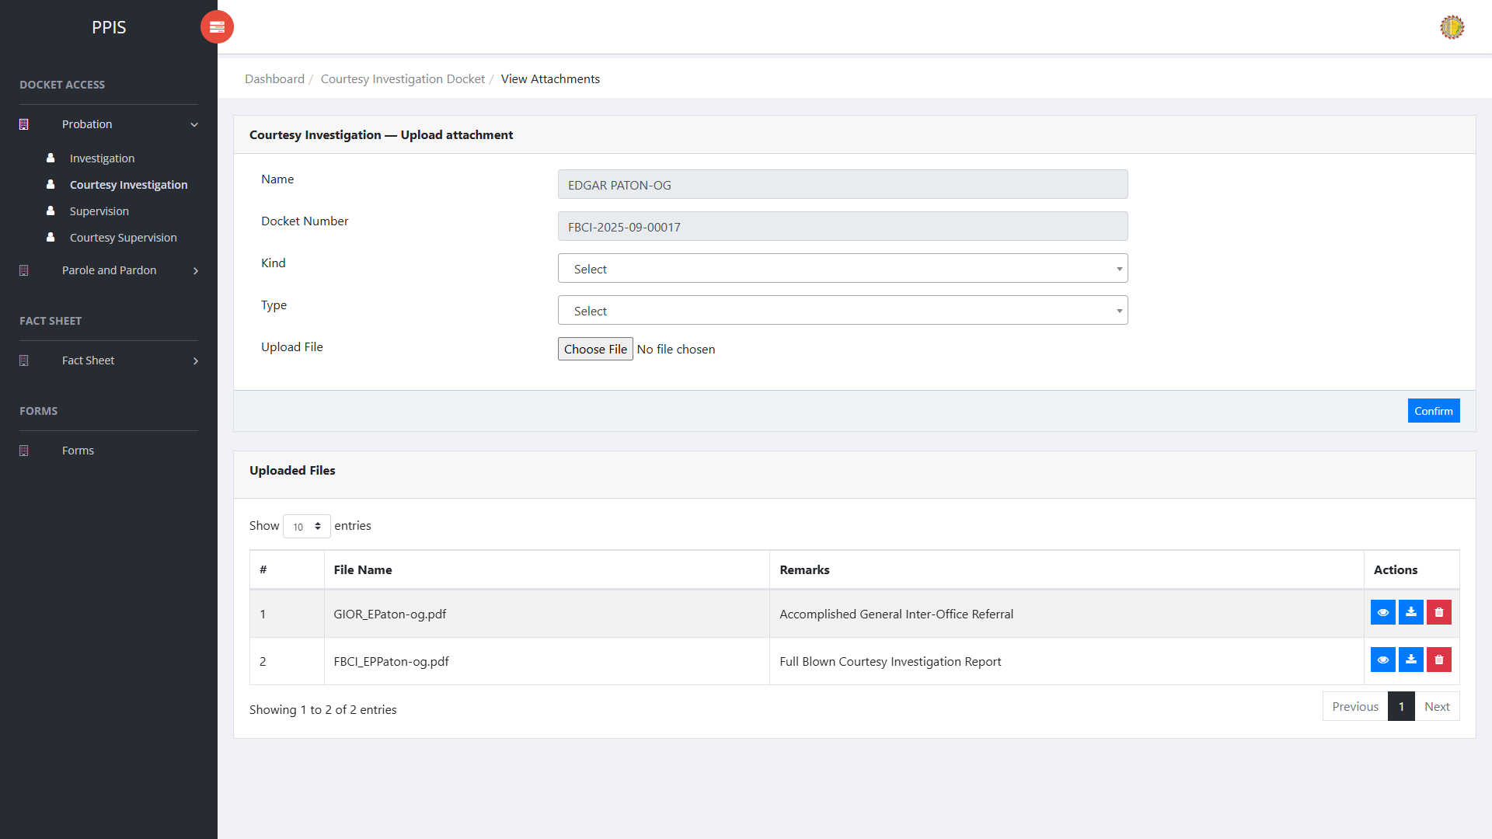
Probation Courtesy Investigation (Attachments)

Probation Courtesy Investigation (Delete)
Deletion warning: Use Remove only for records approved for deletion. For documentation, stop at the confirmation dialog unless removal is required.

1. On the Probation Courtesy Investigation list page, locate the record to be deleted.
2. Click Remove in the Actions column.
3. Wait for the confirmation modal dialog box to appear.
4. Read the confirmation message carefully. The system warns that removal cannot be undone.
5. Click Cancel inside the modal dialog to stop, or click Remove permanently inside the modal dialog only when deletion is authorized.
6. Wait for the modal dialog to close. The table refreshes to reflect the remaining records.
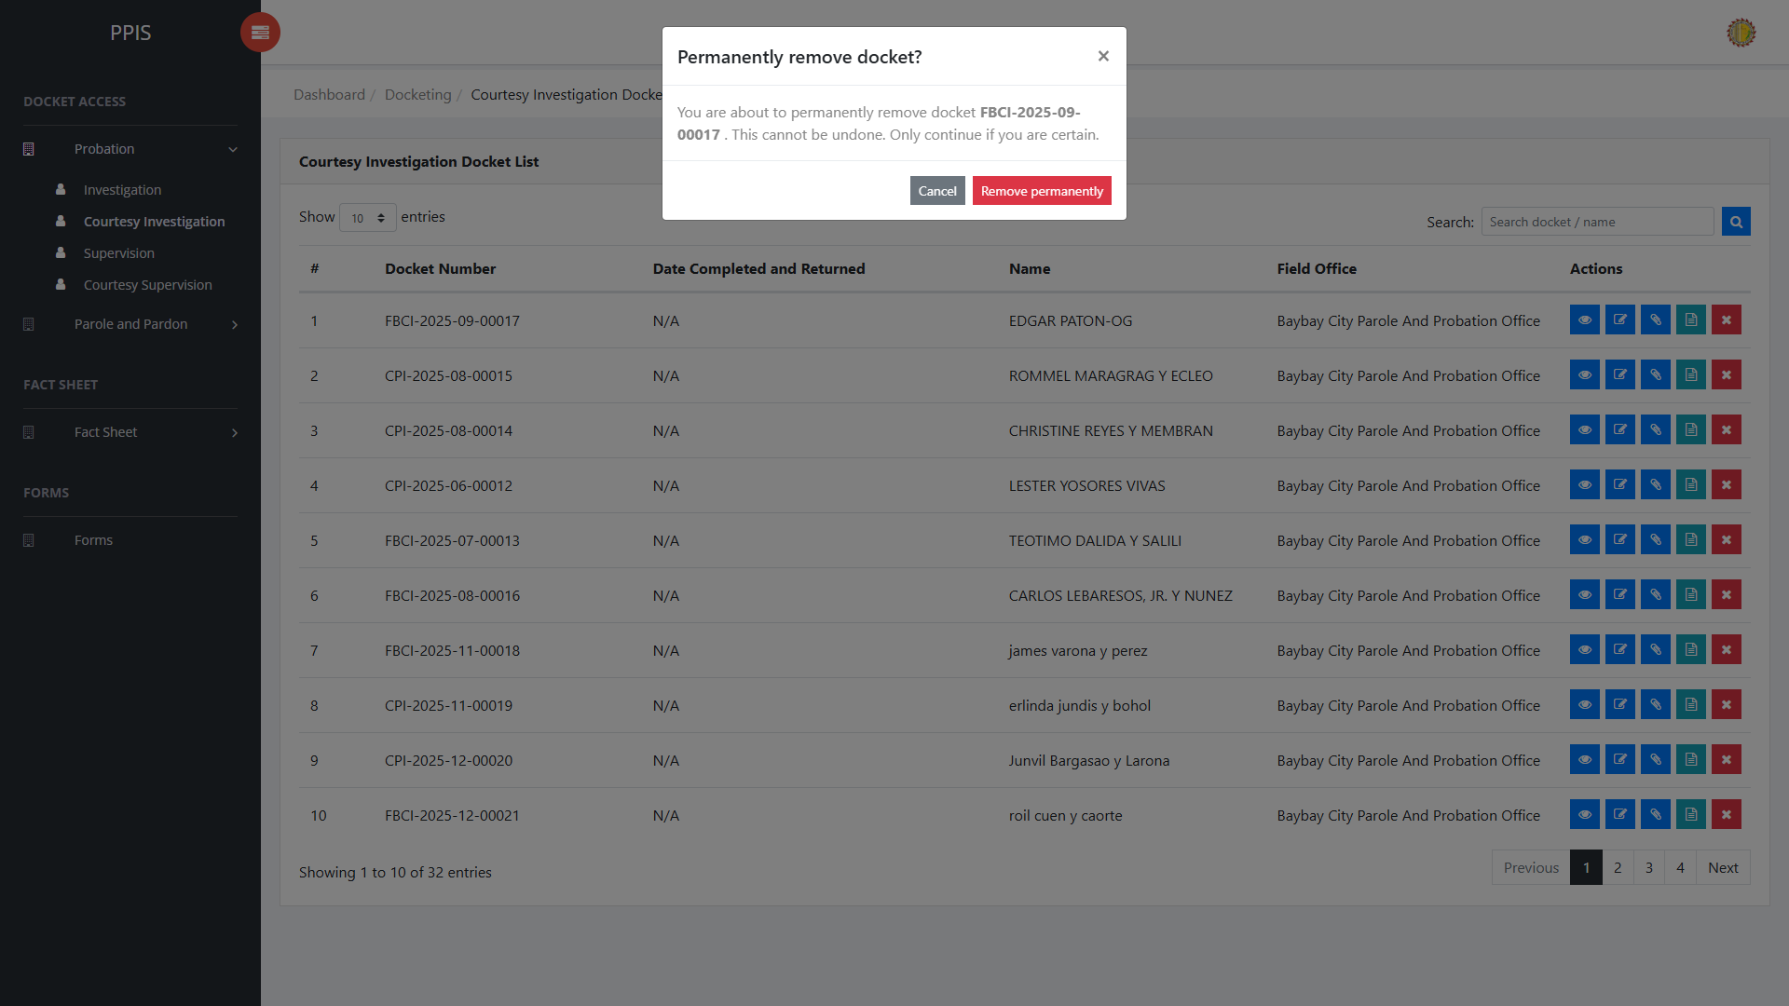
Probation Courtesy Investigation (Delete)

Probation Supervision
Use this page to manage probation supervision dockets and related record actions.
1. From the left menu, open Probation Supervision.
2. To find a record, enter the known information in Search docket / name.
3. Click Run search to apply the search.
4. In the Actions column, use View, Update, Attachments, Fact Sheet, or Remove for the selected row.
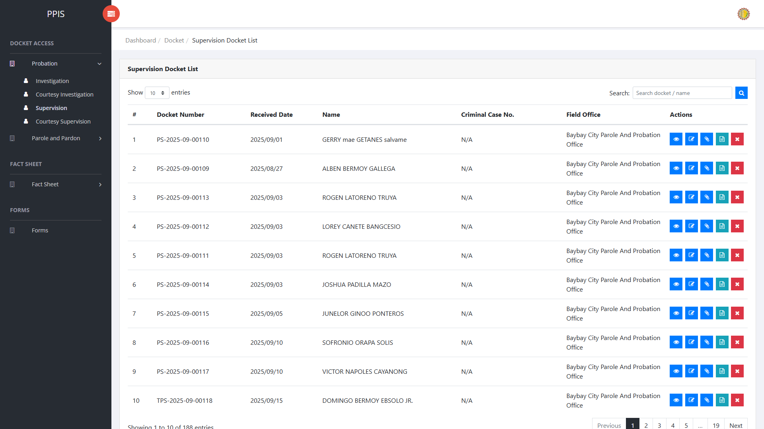
Probation Supervision list page

Probation Supervision (View)
1. On the Probation Supervision list page, locate the record the end-user needs to review.
2. Click View in the Actions column.
3. Read the details on the view page. Use this screen for checking information before making any changes.
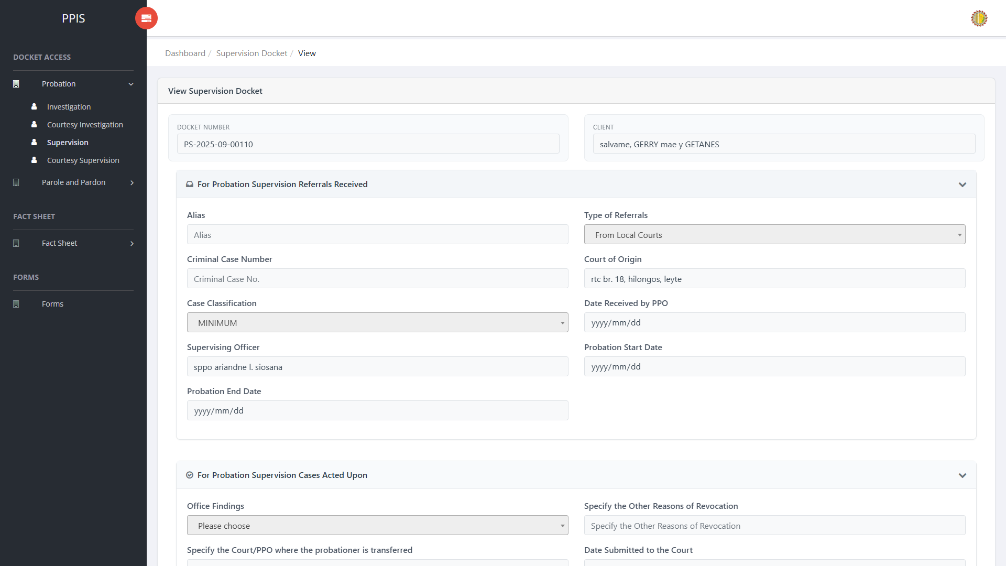
Probation Supervision (View)

Probation Supervision (Update)
1. On the Probation Supervision list page, locate the record that needs correction.
2. Click Update in the Actions column.
3. Wait for the update screen to open.
4. Review the current details and update Docket Number, Client Name, Alias, Type of Referrals, Criminal Case Number, Court of Origin, Case Classification, Date Received by PPO.
5. Click Confirm to save after checking the information.
6. Wait for the system to return to the list page or refresh the record display.
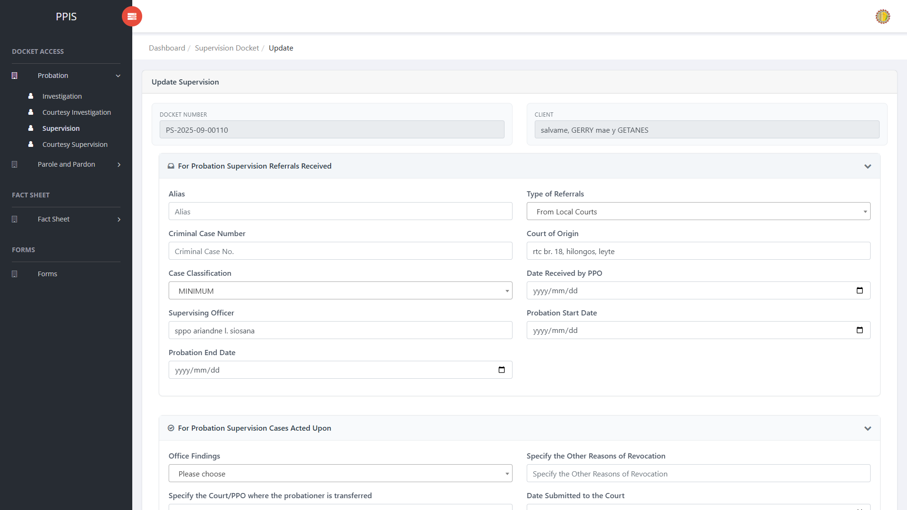
Probation Supervision (Update)

Probation Supervision (Attachments)
1. On the Probation Supervision list page, click Attachments for the correct record.
2. Wait for the attachments screen to open.
3. Complete the attachment details, such as Kind, Type, and Upload File when shown.
4. Click Confirm to upload the file.
5. Use View, Download, or Delete only for the attachment listed in the table.
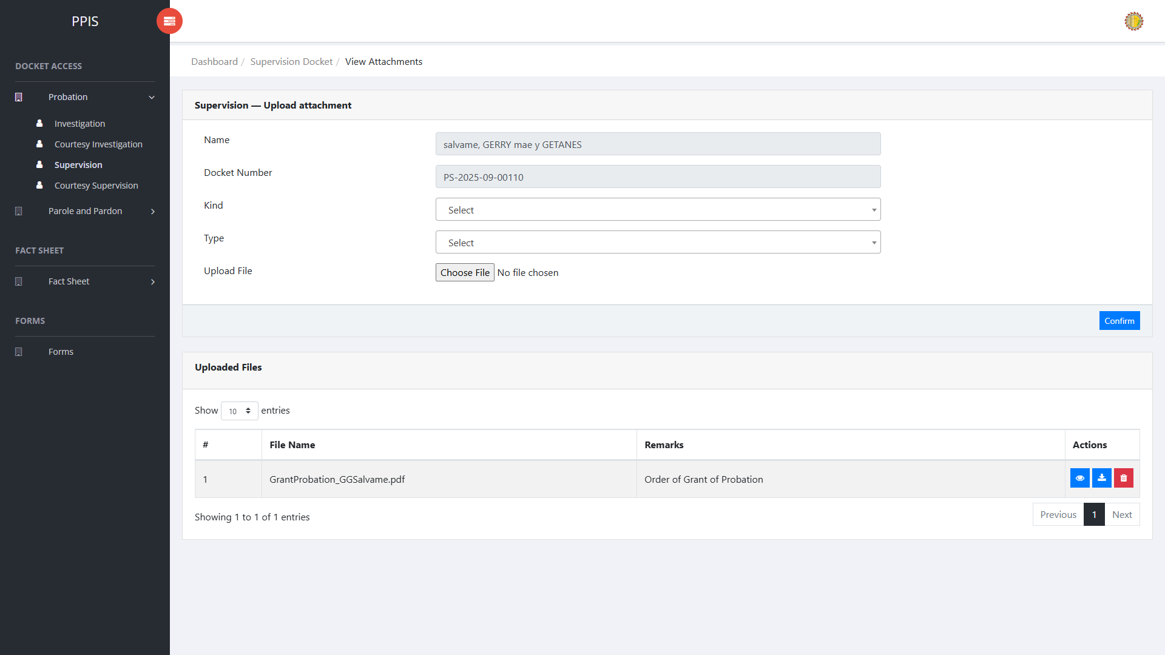
Probation Supervision (Attachments)

Probation Supervision (Delete)
Deletion warning: Use Remove only for records approved for deletion. For documentation, stop at the confirmation dialog unless removal is required.

1. On the Probation Supervision list page, locate the record to be deleted.
2. Click Remove in the Actions column.
3. Wait for the confirmation modal dialog box to appear.
4. Read the confirmation message carefully. The system warns that removal cannot be undone.
5. Click Cancel inside the modal dialog to stop, or click Remove permanently inside the modal dialog only when deletion is authorized.
6. Wait for the modal dialog to close. The table refreshes to reflect the remaining records.
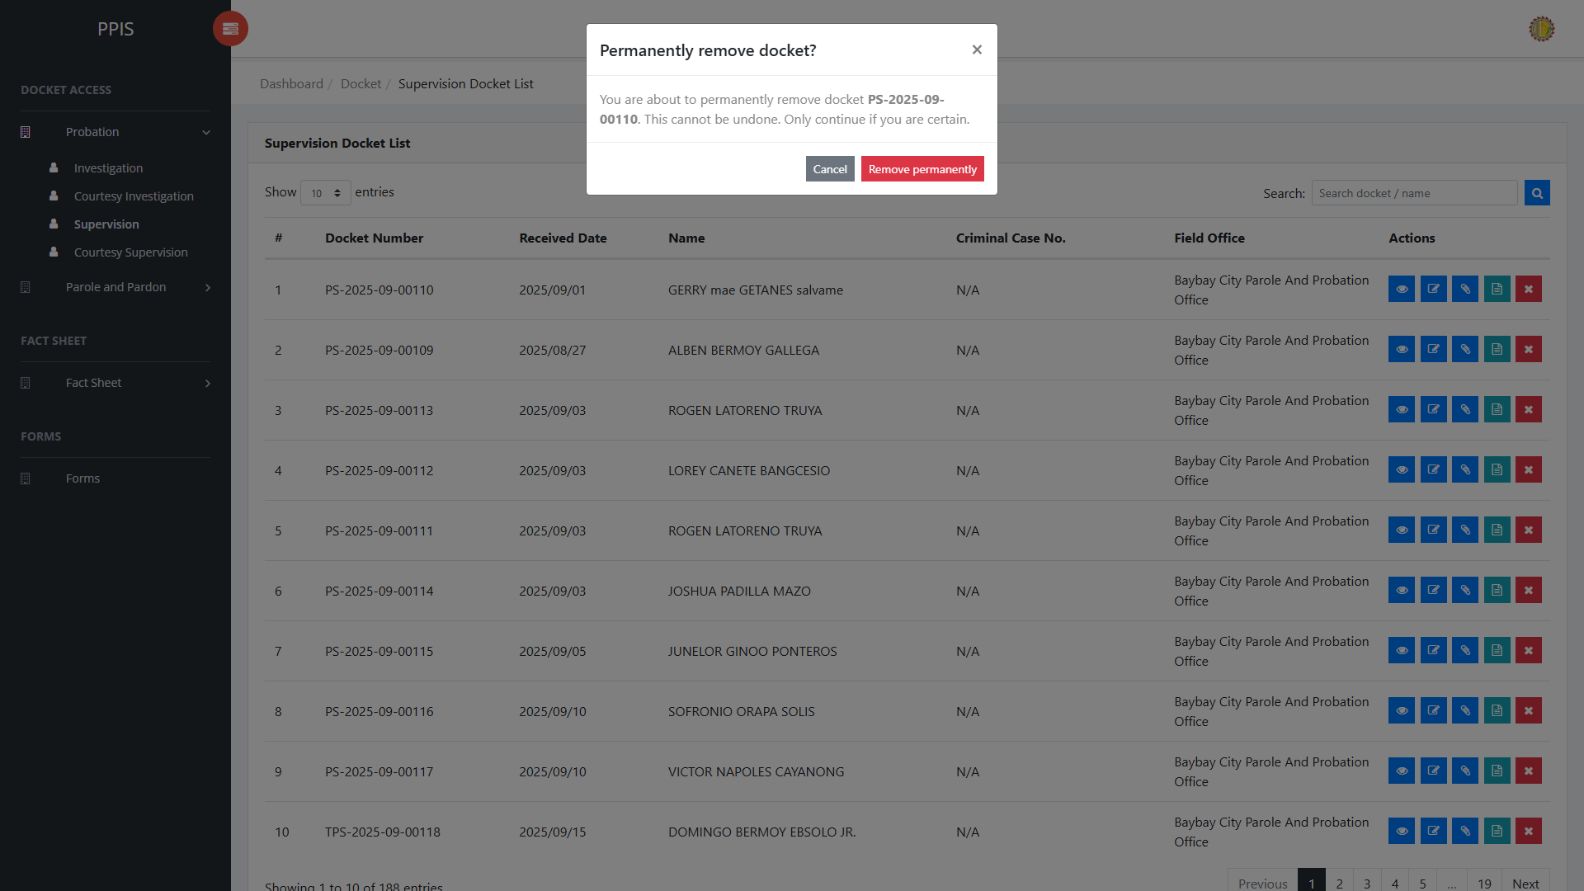
Probation Supervision (Delete)

Probation Courtesy Supervision
Use this page to manage courtesy supervision dockets under the probation workflow.
1. From the left menu, open Probation Courtesy Supervision.
2. To find a record, enter the known information in Search docket / name.
3. Click Run search to apply the search.
4. In the Actions column, use View, Update, Attachments, Fact Sheet, or Remove for the selected row.
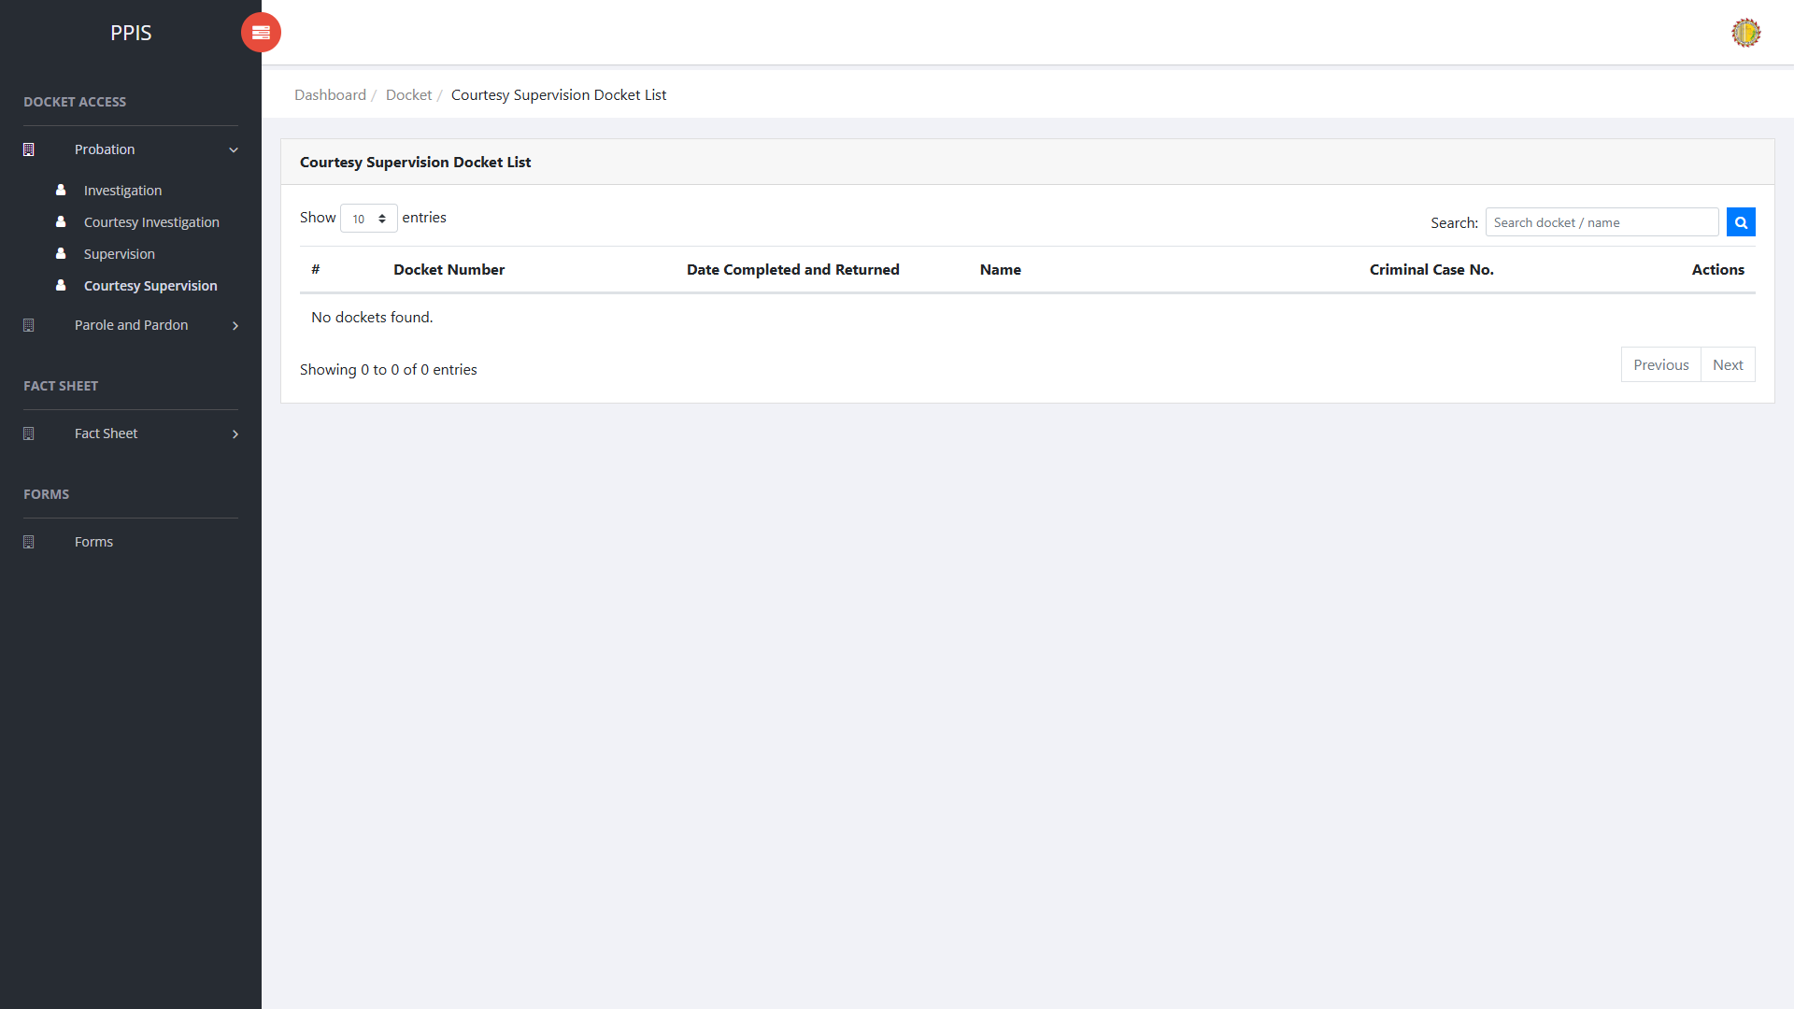
Probation Courtesy Supervision list page

Probation Courtesy Supervision (View)
1. On the Probation Courtesy Supervision list page, locate the record the end-user needs to review.
2. Click View in the Actions column.
3. Read the details on the view page. Use this screen for checking information before making any changes.
Probation Courtesy Supervision (View)

Probation Courtesy Supervision (Update)
1. On the Probation Courtesy Supervision list page, locate the record that needs correction.
2. Click Update in the Actions column.
3. Wait for the update screen to open.
4. Review the current details and update Docket Number, Client Name, Criminal Case No., Court of Origin, Referring Office, Date Received from the PPO, Supervising Officer, Period of Supervision.
5. Click Confirm to save after checking the information.
6. Wait for the system to return to the list page or refresh the record display.
Probation Courtesy Supervision (Update)

Probation Courtesy Supervision (Attachments)
1. On the Probation Courtesy Supervision list page, click Attachments for the correct record.
2. Wait for the attachments screen to open.
3. Complete the attachment details, such as Kind, Type, and Upload File when shown.
4. Click Confirm to upload the file.
5. Use View, Download, or Delete only for the attachment listed in the table.
Probation Courtesy Supervision (Attachments)

Probation Courtesy Supervision (Delete)
Deletion warning: Use Remove only for records approved for deletion. For documentation, stop at the confirmation dialog unless removal is required.

1. On the Probation Courtesy Supervision list page, locate the record to be deleted.
2. Click Remove in the Actions column.
3. Wait for the confirmation modal dialog box to appear.
4. Read the confirmation message carefully. The system warns that removal cannot be undone.
5. Click Cancel inside the modal dialog to stop, or click Remove permanently inside the modal dialog only when deletion is authorized.
6. Wait for the modal dialog to close. The table refreshes to reflect the remaining records.
Probation Courtesy Supervision (Delete)

Parole and Pardon Investigation
Use this page to find, review, update, attach files to, or remove parole and pardon investigation dockets.
1. From the left menu, open Parole and Pardon Investigation.
2. To find a record, enter the known information in Docket Number, CC Number, Name.
3. Click Run search to apply the search.
4. In the Actions column, use View, Update, Attachments, Fact Sheet, or Remove for the selected row.
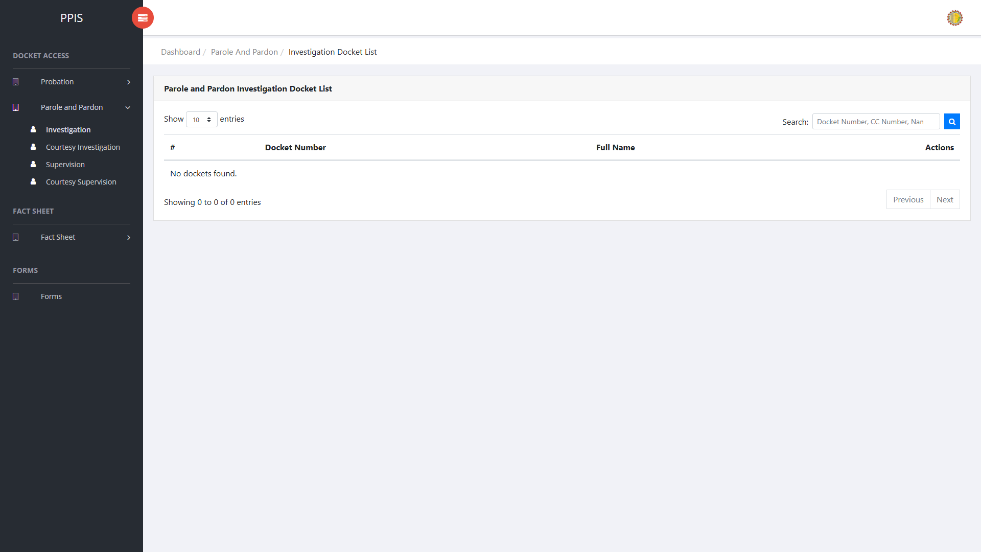
Parole and Pardon Investigation list page

Parole and Pardon Investigation (View)
1. On the Parole and Pardon Investigation list page, locate the record the end-user needs to review.
2. Click View in the Actions column.
3. Read the details on the view page. Use this screen for checking information before making any changes.
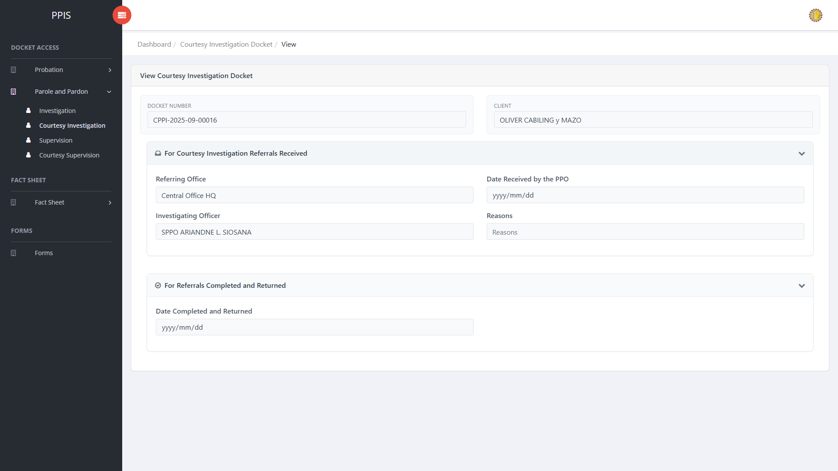
Parole and Pardon Investigation view page

Parole and Pardon Investigation (Update)
1. On the Parole and Pardon Investigation list page, locate the record that needs correction.
2. Click Update in the Actions column.
3. Wait for the update screen to open.
4. Review the current details and update Docket Number, Full Name, Referring Office, Date Received by the PPO, Investigating Officer.
5. Click Confirm to save after checking the information.
6. Wait for the system to return to the list page or refresh the record display.
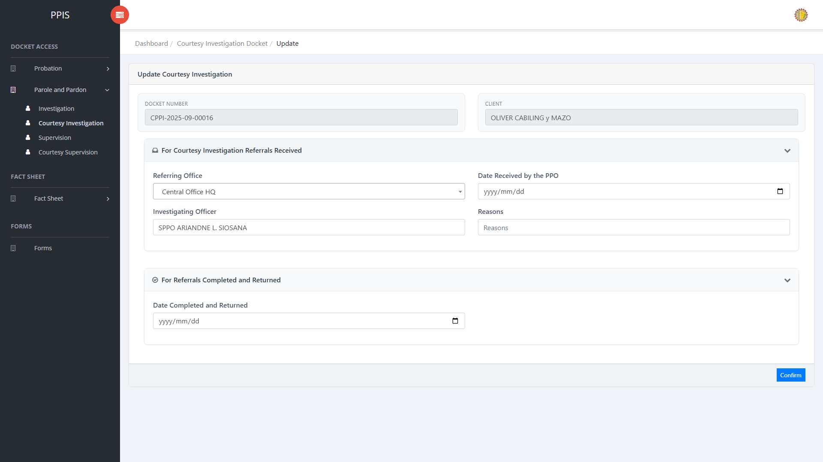
Parole and Pardon Investigation update page

Parole and Pardon Investigation (Attachments)
1. On the Parole and Pardon Investigation list page, click Attachments for the correct record.
2. Wait for the attachments screen to open.
3. Complete the attachment details, such as Kind, Type, and Upload File when shown.
4. Click Confirm to upload the file.
5. Use View, Download, or Delete only for the attachment listed in the table.
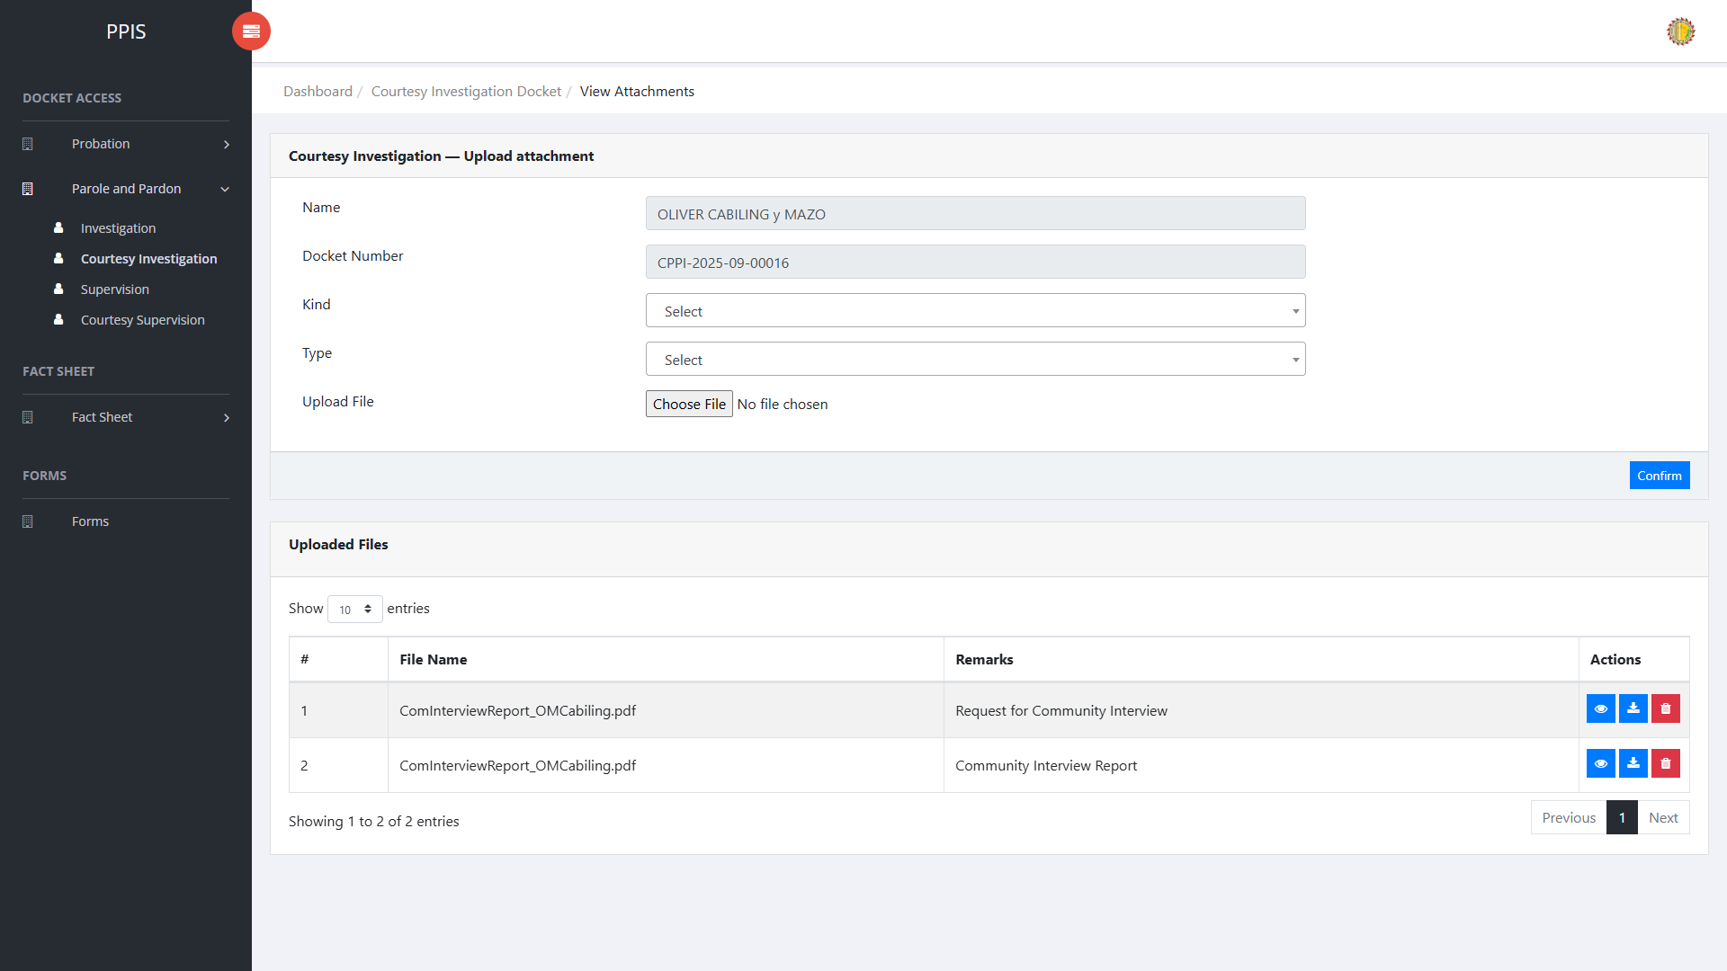
Parole and Pardon Investigation attachment page

Parole and Pardon Investigation (Delete)
Deletion warning: Use Remove only records approved for deletion. For documentation, stop at the confirmation dialog unless removal is required.

1. On the Parole and Pardon Investigation list page, locate the record.
2. Click Remove in the Actions column.
3. Wait for the confirmation modal dialog box to appear.
4. Read the confirmation message carefully. The system warns that removal cannot be undone.
5. Click Cancel inside the modal dialog to stop, or click Remove permanently inside the modal dialog only when deletion is authorized.
6. Wait for the modal dialog to close. The table refreshes to reflect the remaining records.
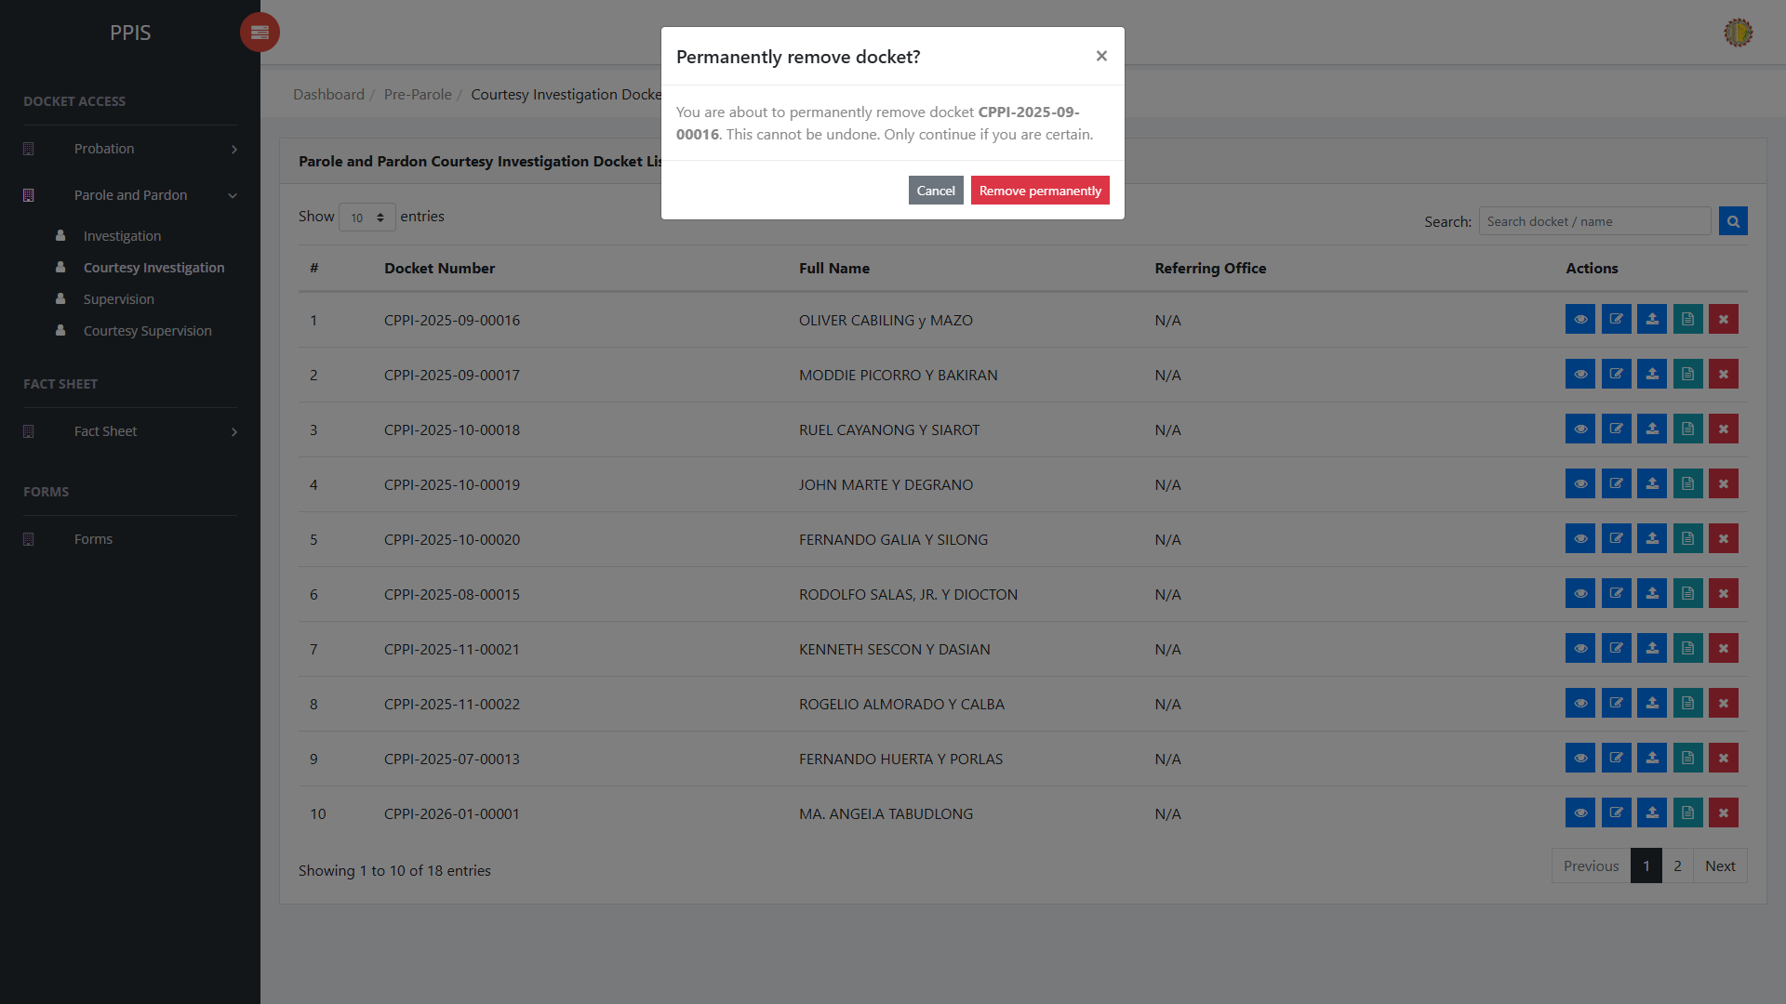
Parole and Pardon Investigation delete page

Parole and Pardon Courtesy Investigation
Use this page to manage courtesy investigation records for parole and pardon cases.
1. From the left menu, open Parole and Pardon Courtesy Investigation.
2. To find a record, enter the known information in Search docket / name.
3. Click Run search to apply the search.
4. In the Actions column, use View, Update, Attachments, Fact Sheet, or Remove for the selected row.
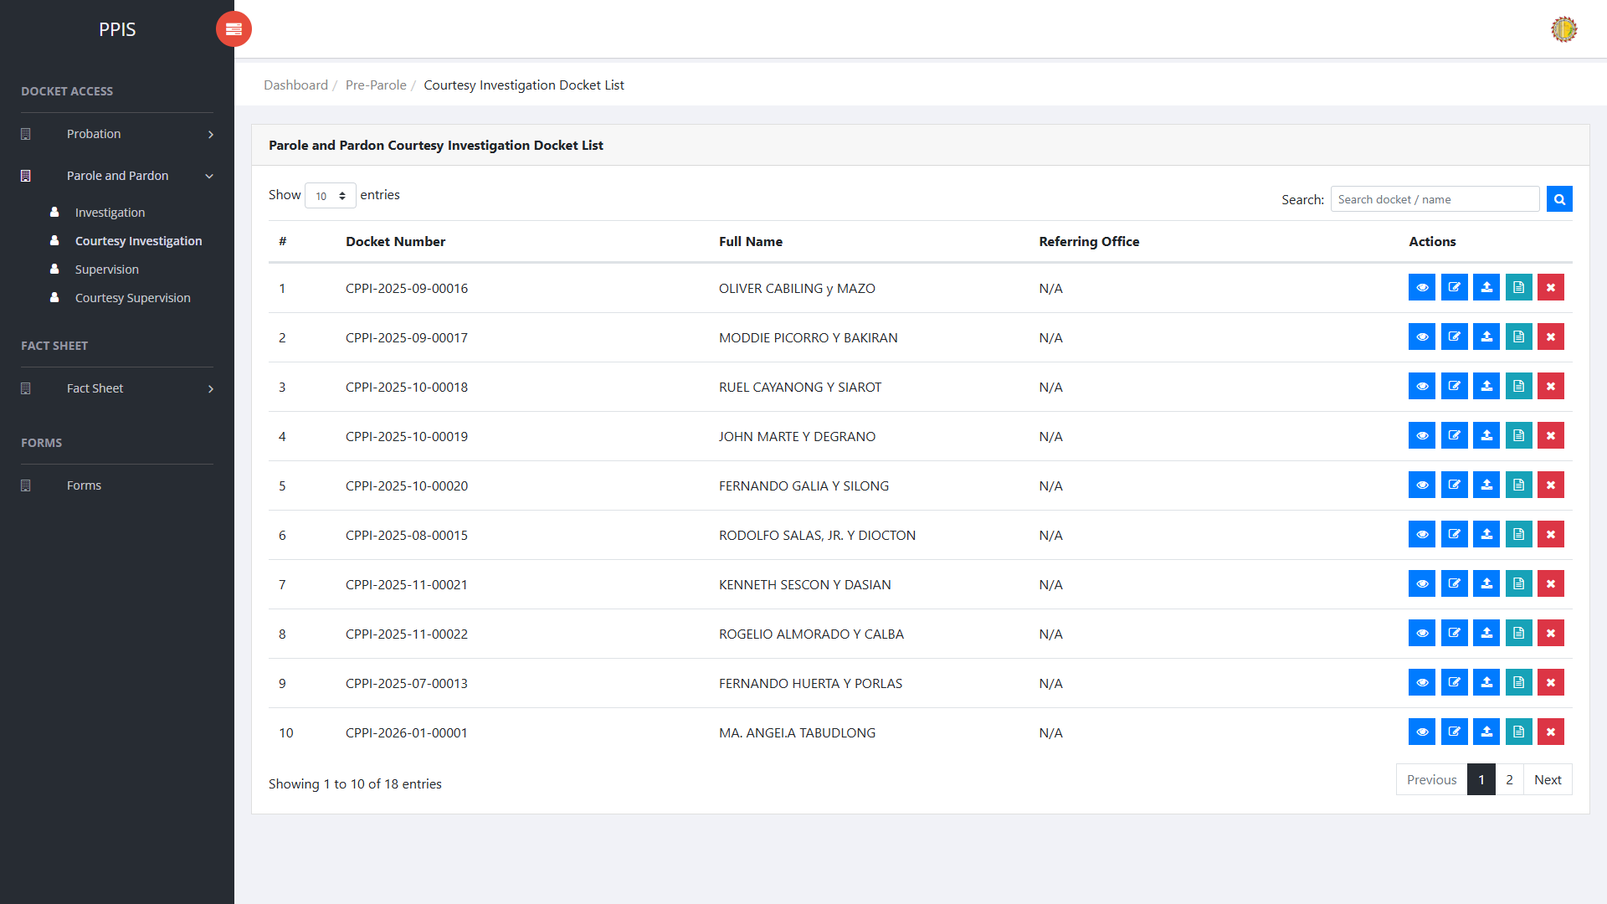
Parole and Pardon Courtesy Investigation list page

Parole and Pardon Courtesy Investigation (View)
1. On the Parole and Pardon Courtesy Investigation list page, locate the record the end- user needs to review.
2. Click View in the Actions column.
3. Read the details on the view page. Use this screen for checking information before making any changes.
Parole and Pardon Courtesy Investigation (View)

Parole and Pardon Courtesy Investigation (Update)
1. On the Parole and Pardon Courtesy Investigation list page, locate the record that needs correction.
2. Click Update in the Actions column.
3. Wait for the update screen to open.
4. Review the current details and update Docket Number, Client Name, Referring Office, Date Received by the PPO, Investigating Officer, Reasons, Date Completed and Returned.
5. Click Confirm to save after checking the information.
6. Wait for the system to return to the list page or refresh the record display.
Parole and Pardon Courtesy Investigation (Update)

Parole and Pardon Courtesy Investigation (Attachments)
1. On the Parole and Pardon Courtesy Investigation list page, click Attachments for the correct record.
2. Wait for the attachments screen to open.
3. Complete the attachment details, such as Kind, Type, and Upload File when shown.
4. Click Confirm to upload the file.
5. Use View, Download, or Delete only for the attachment listed in the table.
Parole and Pardon Courtesy Investigation (Attachments)

Parole and Pardon Courtesy Investigation (Delete)
Deletion warning: Use Remove only records approved for deletion. For documentation, stop at the confirmation dialog unless removal is required.

1. On the Parole and Pardon Courtesy Investigation list page, locate the record.
2. Click Remove in the Actions column.
3. Wait for the confirmation modal dialog box to appear.
4. Read the confirmation message carefully. The system warns that removal cannot be undone.
5. Click Cancel inside the modal dialog to stop, or click Remove permanently inside the modal dialog only when deletion is authorized.
6. Wait for the modal dialog to close. The table refreshes to reflect the remaining records.
Parole and Pardon Courtesy Investigation (Delete)

Parole and Pardon Supervision
Use this page to manage parole and pardon supervision records.
1. From the left menu, open Parole and Pardon Supervision.
2. To find a record, enter the known information in Search docket / name.
3. Click Run search to apply the search.
4. In the Actions column, use View, Update, Attachments, Fact Sheet, or Remove for the selected row.
5. To filter the displayed records, enter search criteria in the inline search fields within the column headers or choose a value from the available drop-down filters. The table automatically refreshes to display the matching records.
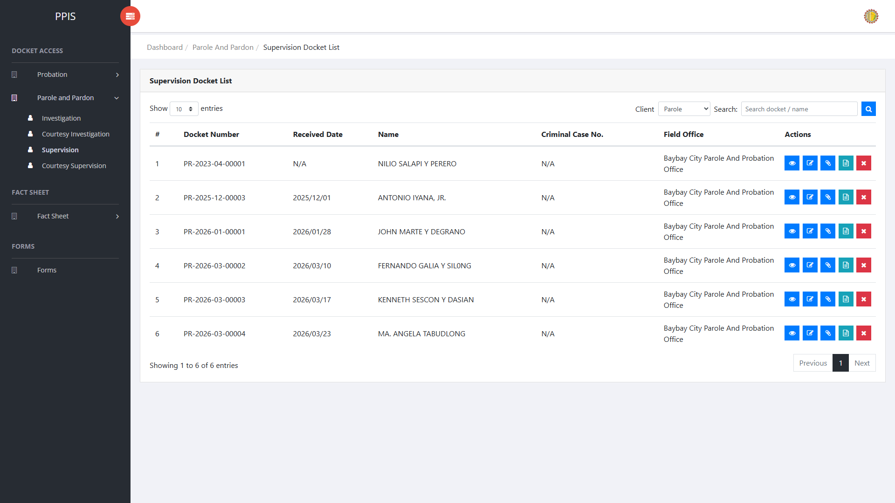
Parole and Pardon Supervision list page

Parole and Pardon Supervision (View)
1. On the Parole and Pardon Supervision list page, locate the record the end-user needs to review.
2. Click View in the Actions column.
3. Read the details on the view page. Use this screen for checking information before making any changes.
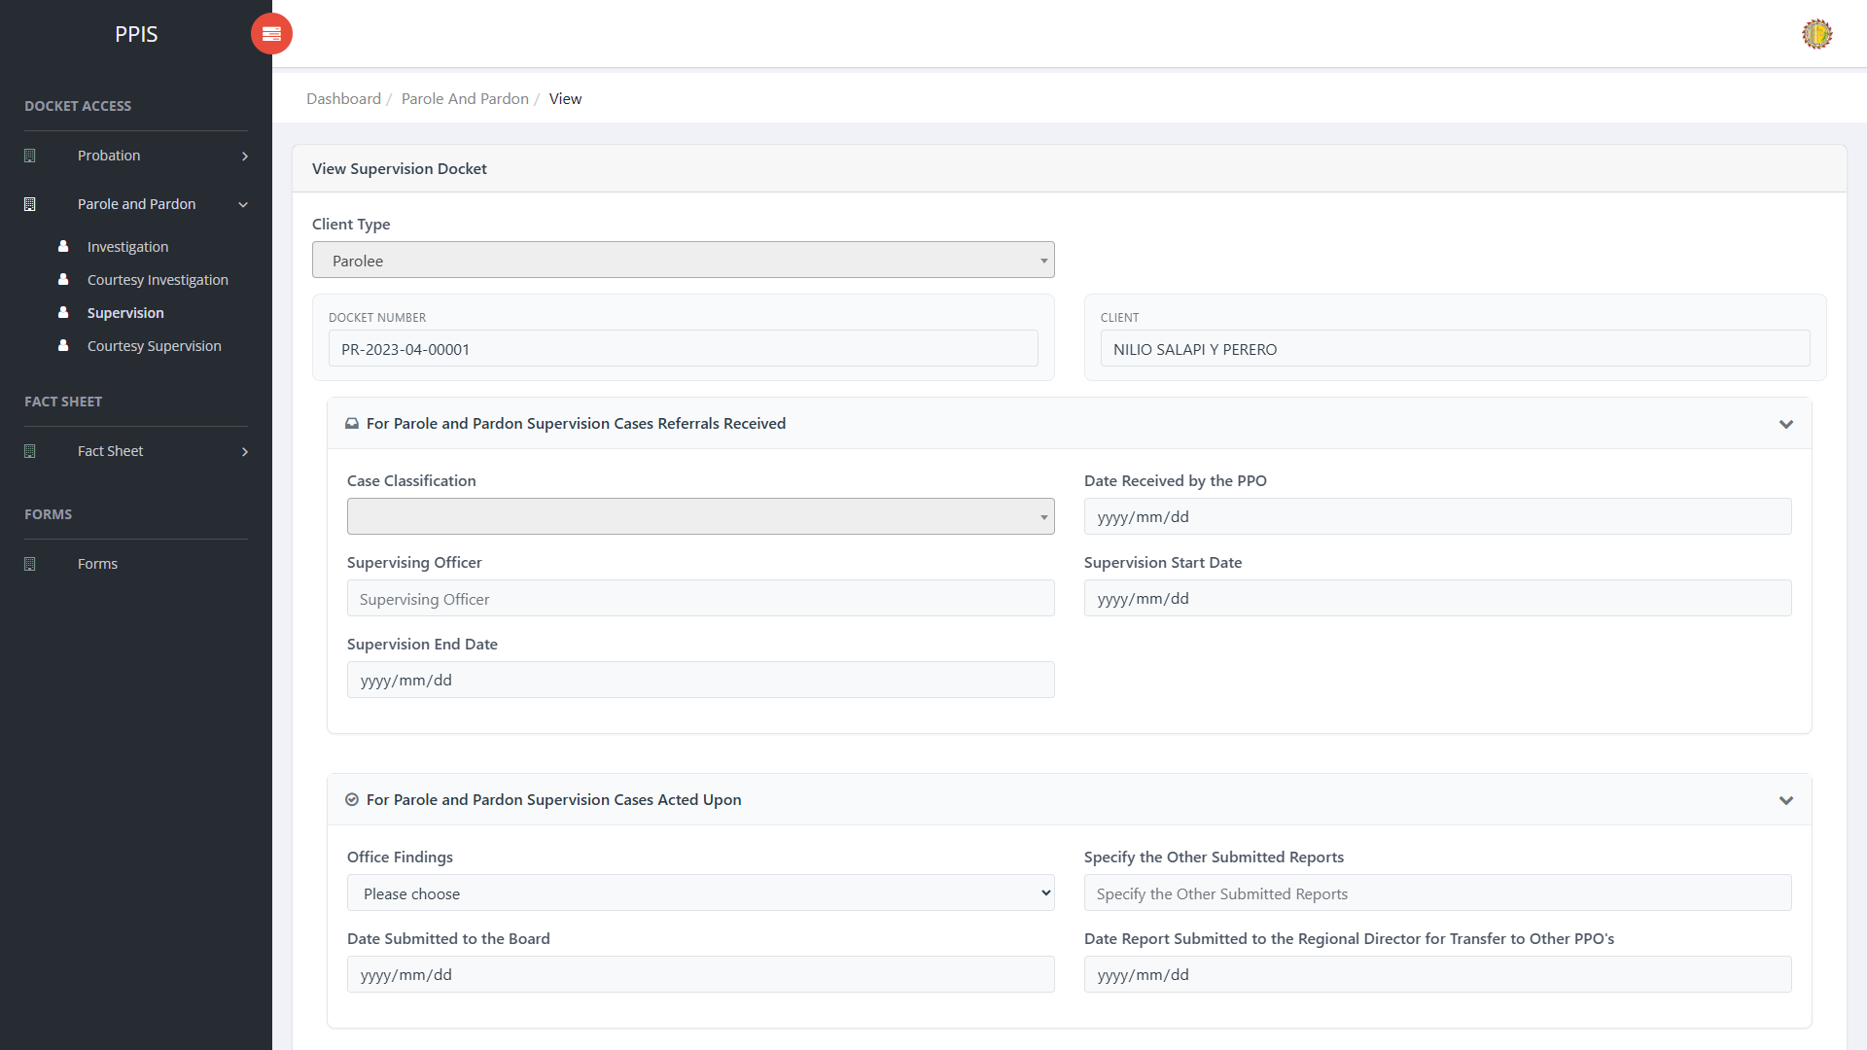
Parole and Pardon Supervision (View)

Parole and Pardon Supervision (Update)
1. On the Parole and Pardon Supervision list page, locate the record that needs correction.
2. Click Update in the Actions column.
3. Wait for the update screen to open.
4. Review the current details and update Client Type, Docket No., Client, Case Classification, Date Received by the PPO, Supervising Officer, Supervision Start Date, Supervision End Date.
5. Click Confirm to save after checking the information.
6. Wait for the system to return to the list page or refresh the record display.
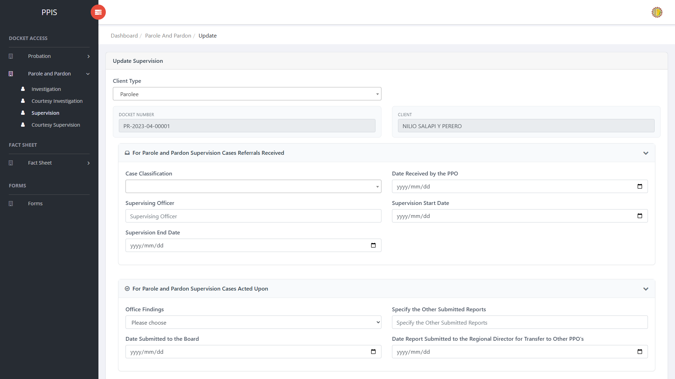
Parole and Pardon Supervision (Update)

Parole and Pardon Supervision (Attachments)
1. On the Parole and Pardon Supervision list page, click Attachments for the correct record.
2. Wait for the attachments screen to open.
3. Complete the attachment details, such as Kind, Type, and Upload File when shown.
4. Click Confirm to upload the file.
5. Use View, Download, or Delete only for the attachment listed in the table.
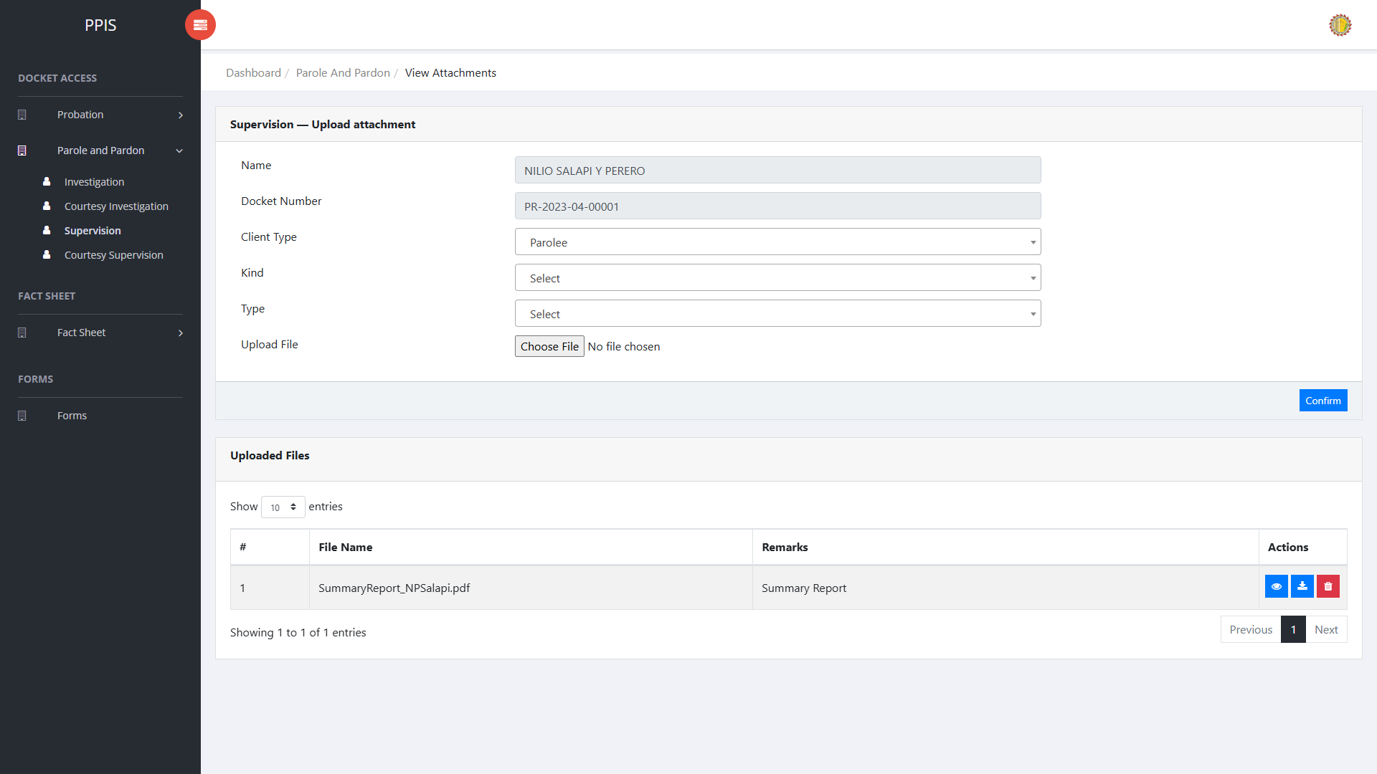
Parole and Pardon Supervision (Attachments)

Parole and Pardon Supervision (Delete)
Deletion warning: Use Remove only for records approved for deletion. For documentation, stop at the confirmation dialog unless removal is required.

1. On the Parole and Pardon Supervision list page, locate the record to be deleted
2. Click Remove in the Actions column.
3. Wait for the confirmation modal dialog box to appear.
4. Read the confirmation message carefully. The system warns that removal cannot be undone.
5. Click Cancel inside the modal dialog to stop, or click Remove permanently inside the modal dialog only when deletion is authorized.
6. Wait for the modal dialog to close. The table refreshes to reflect the remaining records.
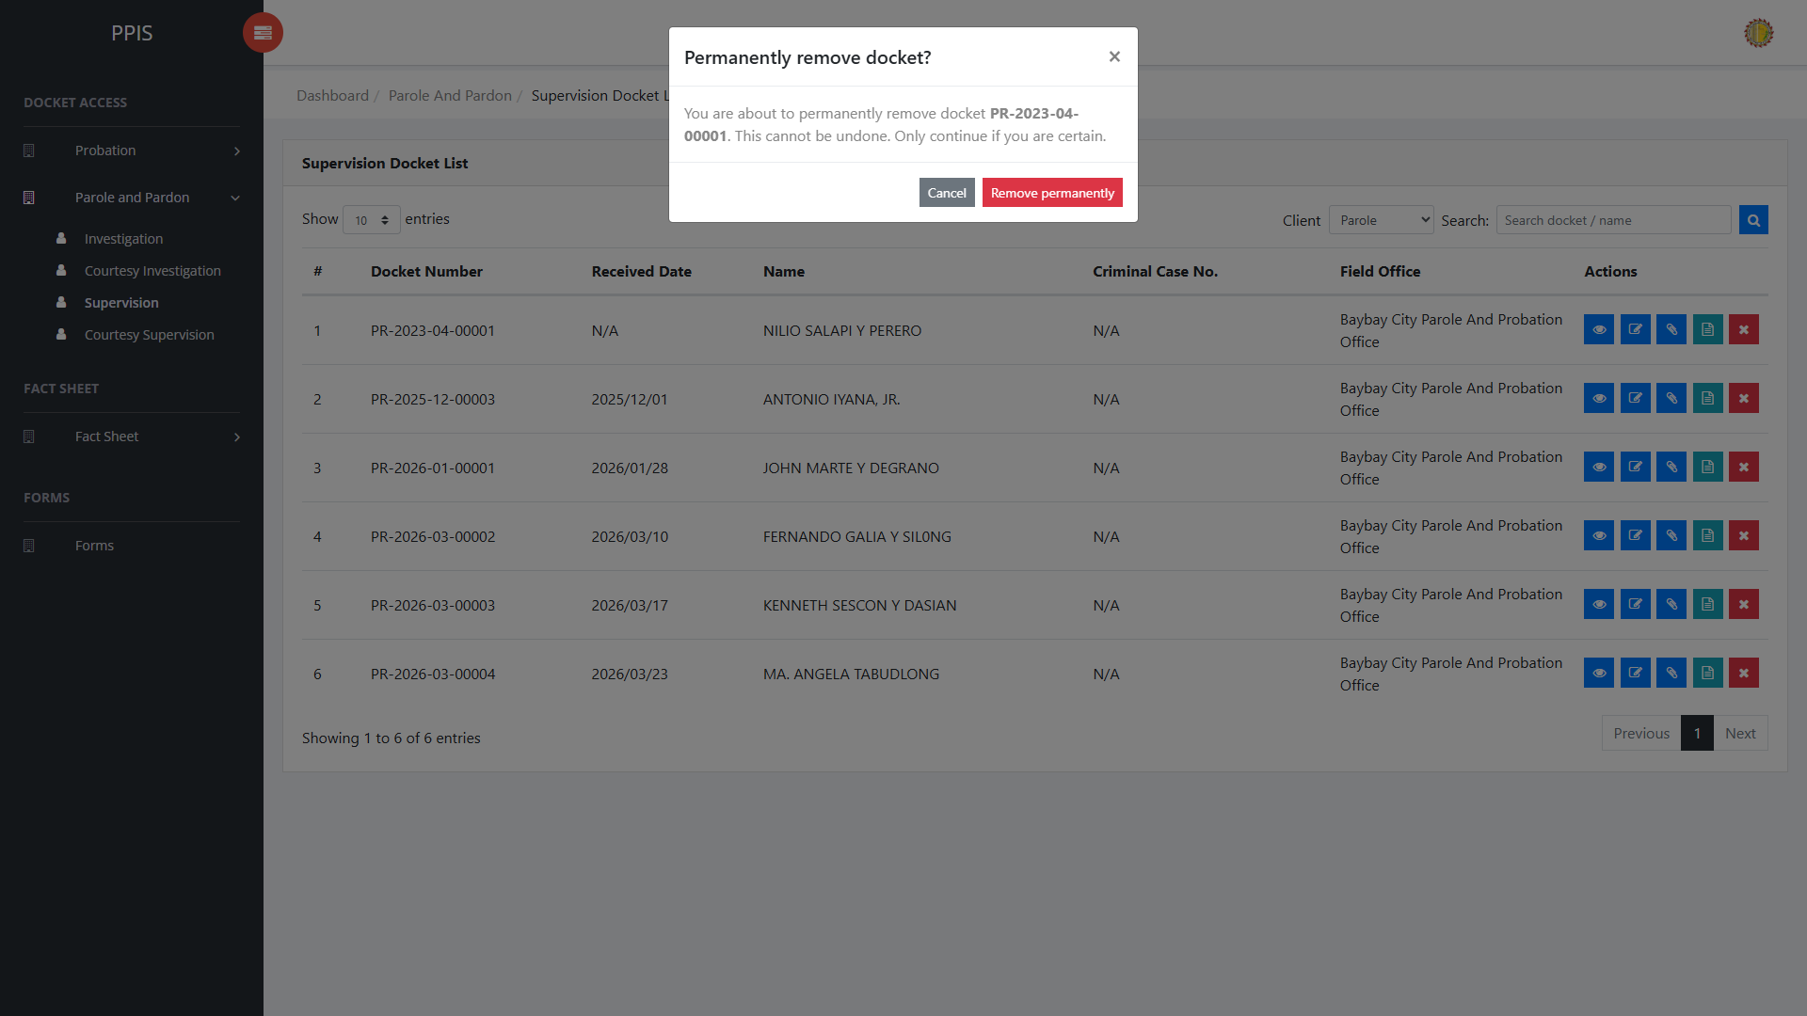
Parole and Pardon Supervision (Delete)

Parole and Pardon Courtesy Supervision
Use this page to manage courtesy supervision records for parole and pardon cases.
1. From the left menu, open Parole and Pardon Courtesy Supervision.
2. To find a record, enter the known information in Search docket / name.
3. Click Run search to apply the search.
4. In the Actions column, use View, Update, Attachments, Fact Sheet, or Remove for the selected row.
5. To filter the displayed records, enter search criteria in the inline search fields within the column headers or choose a value from the available drop-down filters. The table automatically refreshes to display the matching records.
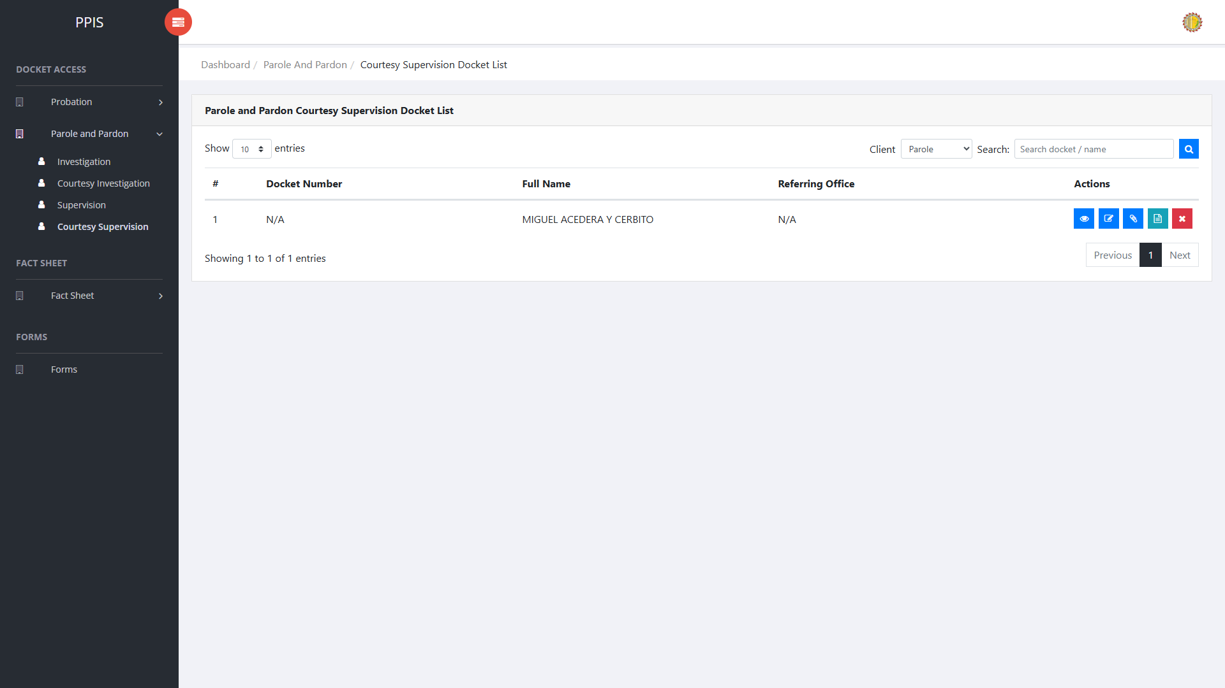
Parole and Pardon Courtesy Supervision list page

Parole and Pardon Courtesy Supervision (View)
1. On the Parole and Pardon Courtesy Supervision list page, locate the record the end-user needs to review.
2. Click View in the Actions column.
3. Read the details on the view page. Use this screen for checking information before making any changes.
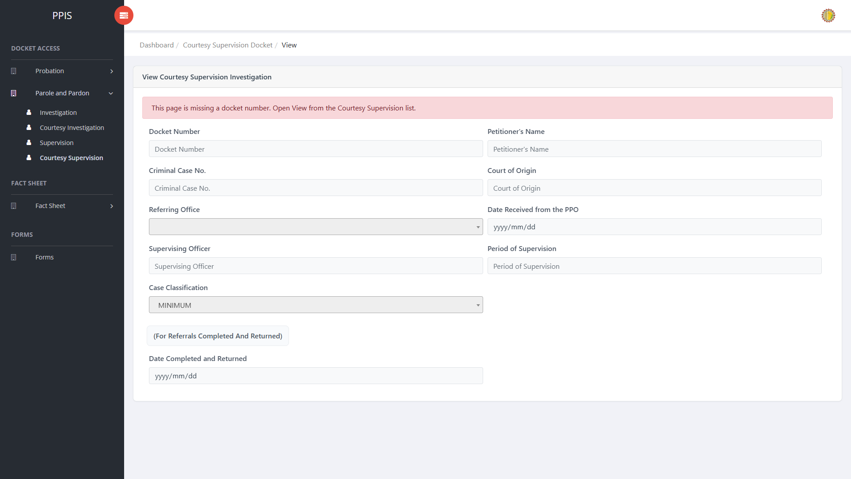
Parole and Pardon Courtesy Supervision (View)

Parole and Pardon Courtesy Supervision (Update)
1. On the Parole and Pardon Courtesy Supervision list page, locate the record that needs updated.
2. Click Update in the Actions column.
3. Wait for the update screen to open.
4. Review the current details and update Client Type, Docket Number, Petitioner's Name, Criminal Case No., Court of Origin, Referring Office, Date Received from the PPO, Supervising Officer.
5. Click Update to save after checking the information.
6. Wait for the system to return to the list page or refresh the record display.
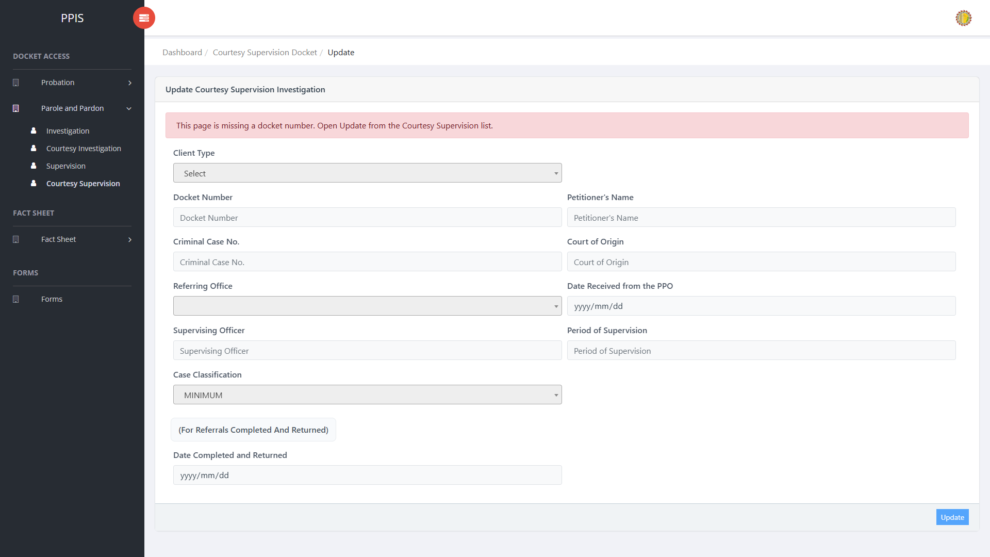
Parole and Pardon Courtesy Supervision (Update)

Parole and Pardon Courtesy Supervision (Attachments)
1. On the Parole and Pardon Courtesy Supervision list page, click Attachments for the correct record.
2. Wait for the attachments screen to open.
3. Complete the attachment details, such as Kind, Type, and Upload File when shown.
4. Click Confirm to upload the file.
5. Use View, Download, or Delete only for the attachment listed in the table.
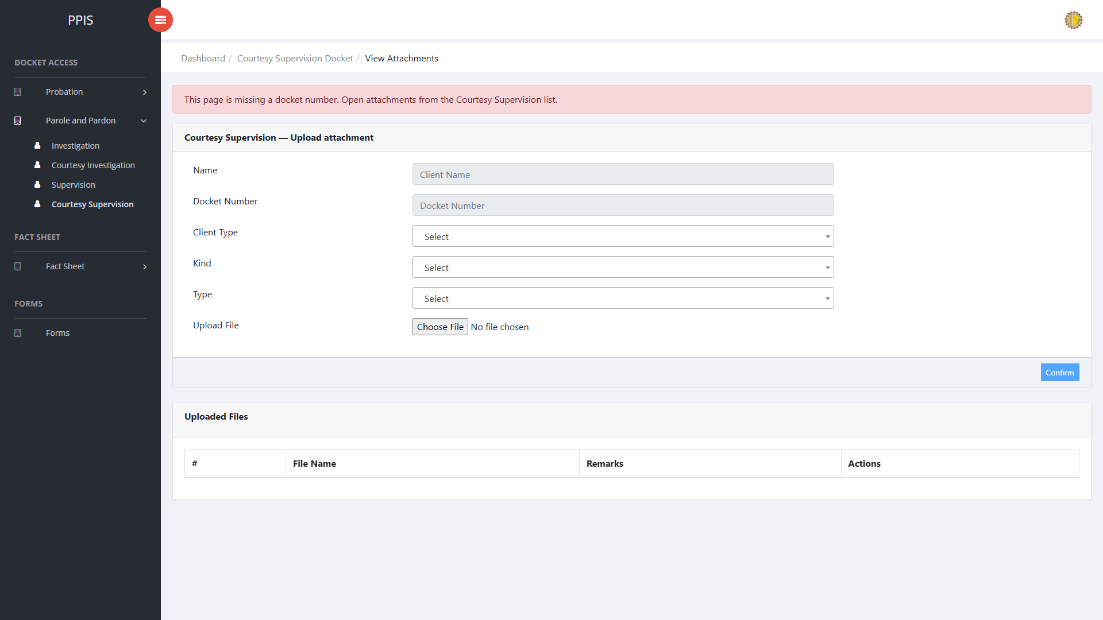
Parole and Pardon Courtesy Supervision (Attachments)

Parole and Pardon Courtesy Supervision (Delete)
Deletion warning: Use Remove only for records approved for deletion. For documentation, stop at the confirmation dialog unless removal is required.

1. On the Parole and Pardon Courtesy Supervision list page, locate the record to be deleted.
2. Click Remove in the Actions column.
3. Wait for the confirmation modal dialog box to appear.
4. Read the confirmation message carefully. The system warns that removal cannot be undone.
5. Click Cancel inside the modal dialog to stop, or click Remove permanently inside the modal dialog only when deletion is authorized.
6. Wait for the modal dialog to close. The table refreshes to reflect the remaining records.
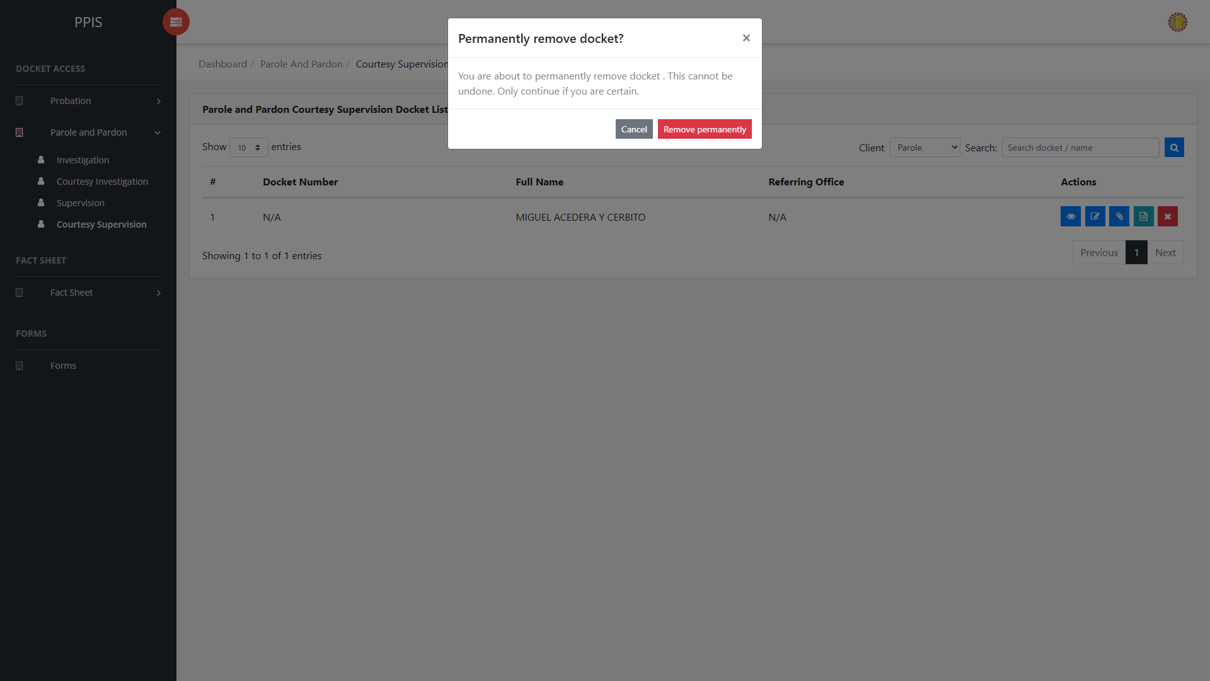
Parole and Pardon Courtesy Supervision (Delete)

6. Fact Sheet

Fact Sheet Probation
Use this page to find and open probation client fact sheets.
1. From the left menu, open Fact Sheet Probation.
2. To find a record, enter the known information in Name or case number data field.
3. Click Run search to apply the search.
4. Review the records shown on the page and the end-user undertakes the necessary actions to be taken.
5. To filter the displayed records, enter search criteria in the inline search fields within the column headers or choose a value from the available drop-down filters. The table automatically refreshes to display the matching records.
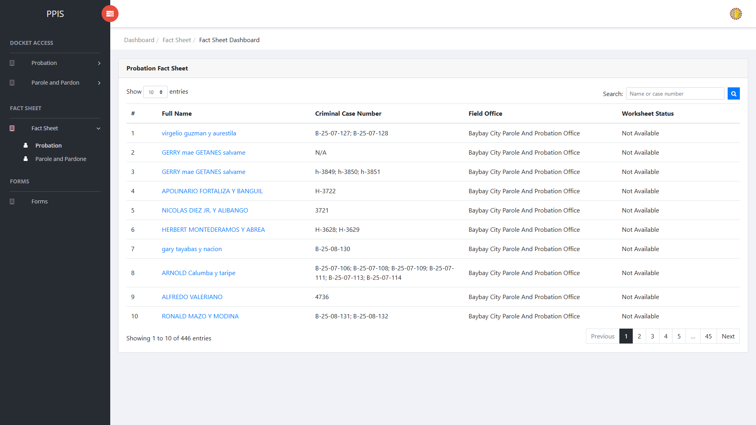
Fact Sheet Probation list page

Fact Sheet Probation (Open Client Profile)
1. On the Fact Sheet Probation list page, locate the client the end-user needs to open.
2. Click the client name in the Full Name column.
3. Wait for the client view profile to open. The page shows the client photo area, profile tabs, and tab content below.
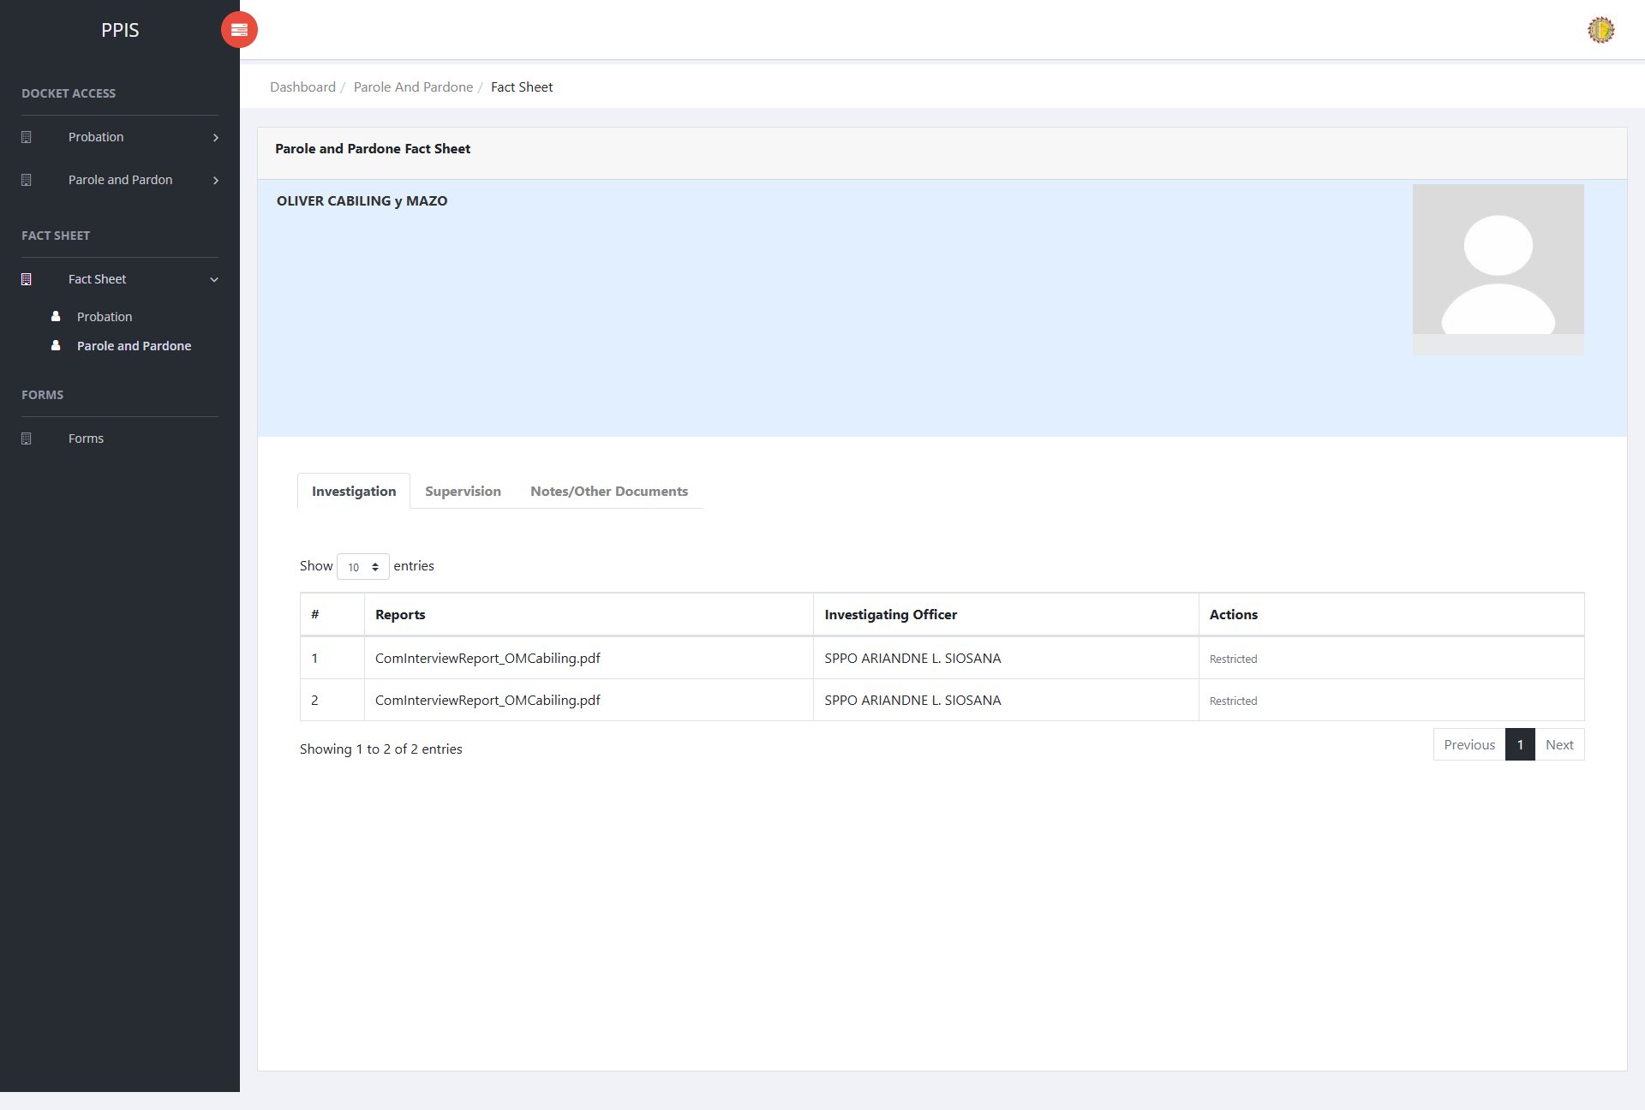
Fact Sheet Probation — click client name
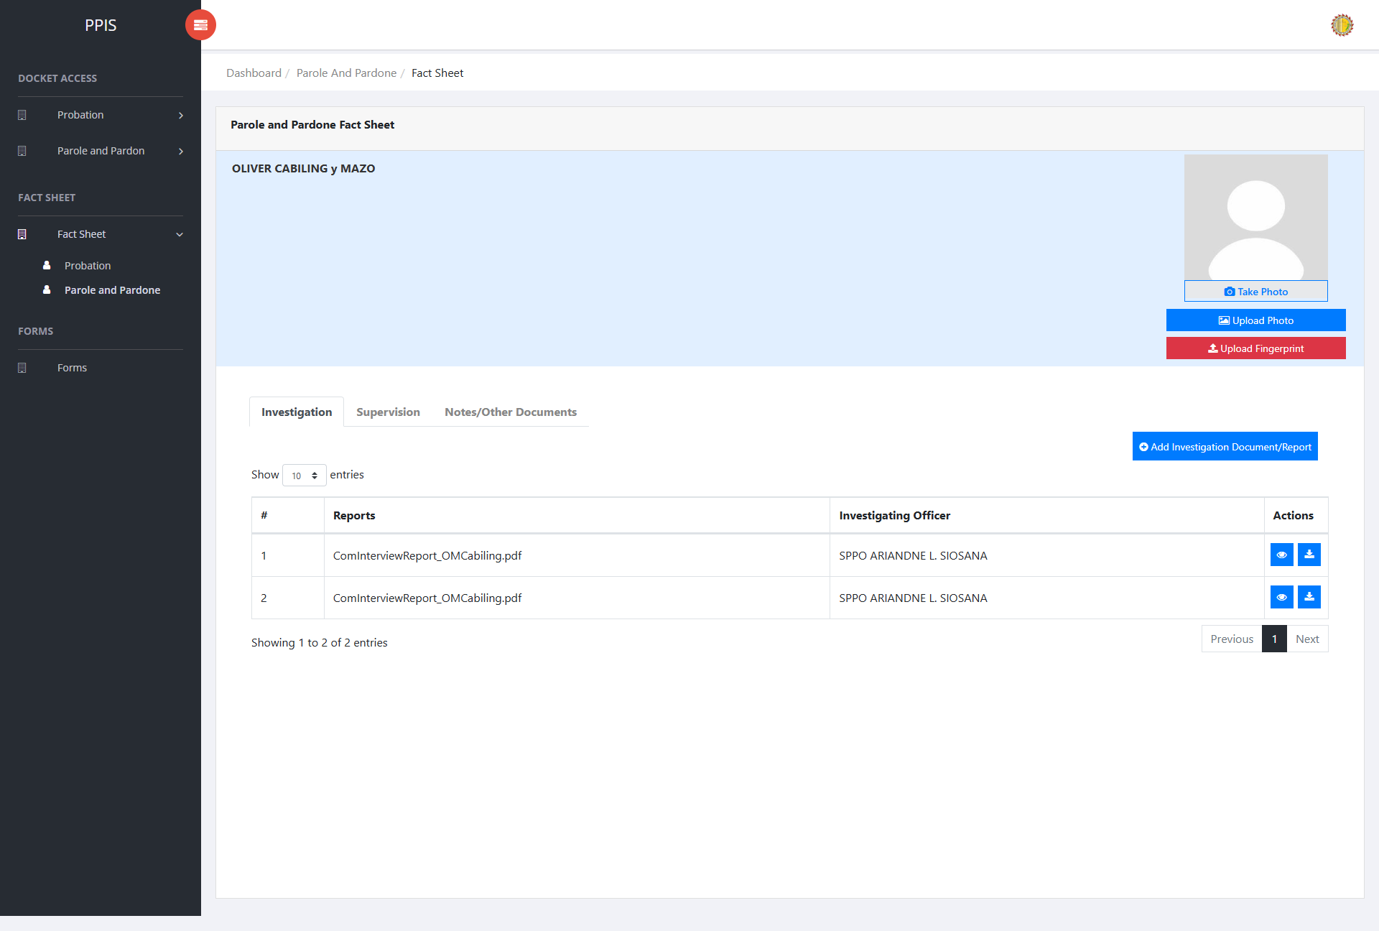

Fact Sheet Probation — client view profile

Fact Sheet Probation (Client Profile Tabs)
Fact Sheet Tabs
Use the tabs in the Client View Profile to navigate through the different sections of the client's record.
Investigation — Review and upload investigation documents and reports related to the client. Use Add Investigation Document/Report when a new file must be attached.
Supervision — Review and upload supervision documents and reports for the client. Use Add Supervision Document/Report when a new file must be attached.
Notes/Other Documents — Keep supplementary notes and other supporting documents for the client. Use Add Note/Other Document to upload a file.
Docket List — Review dockets linked to the client. Use this tab to create or update the Worksheet and PSIR for a selected docket.
1. On the client view profile, read the tab labels across the top of the page.
2. Click the tab that matches the information the end-user needs to review or update.
3. Wait for the tab content to load before using any buttons or tables shown in that section.

Fact Sheet Probation (Upload or Take Photo)
1. On the client view profile, locate the client photo area on the left side of the page.
2. To upload an existing image file, click Upload Photo.
3. In the Upload Profile dialog, choose an image file, then click Confirm.
4. To capture a new photo with the device camera, click Take Photo.
5. In the Capture Camera dialog, click Open cam, allow camera access if the browser asks for permission, then click Capture.
6. Review the captured image. Click Retake if the end-user needs another shot, or click Confirm to save the photo to the client profile.
7. Wait for the success message. The client photo area refreshes with the uploaded or captured image.
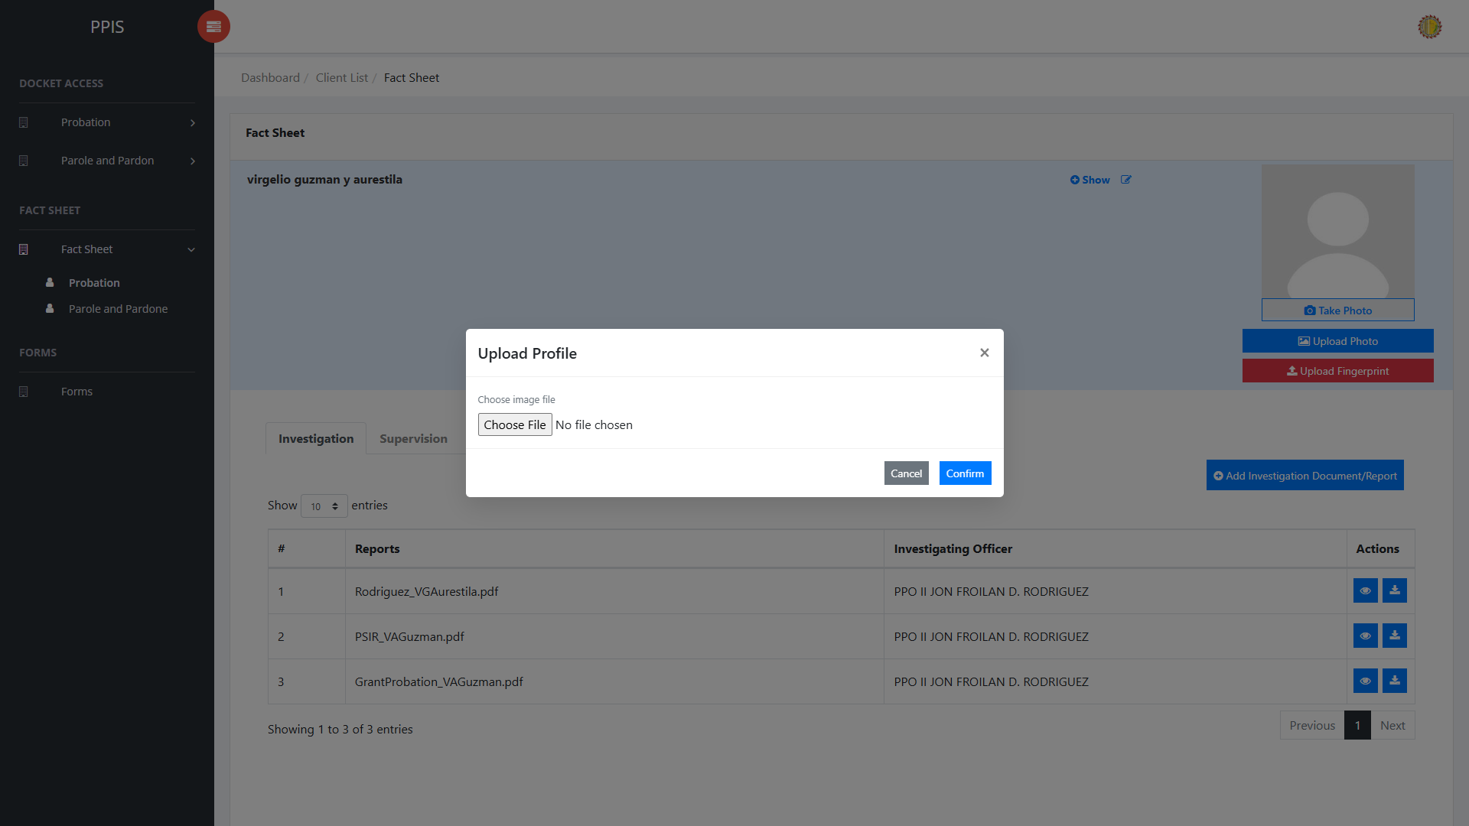
Fact Sheet Probation — upload photo
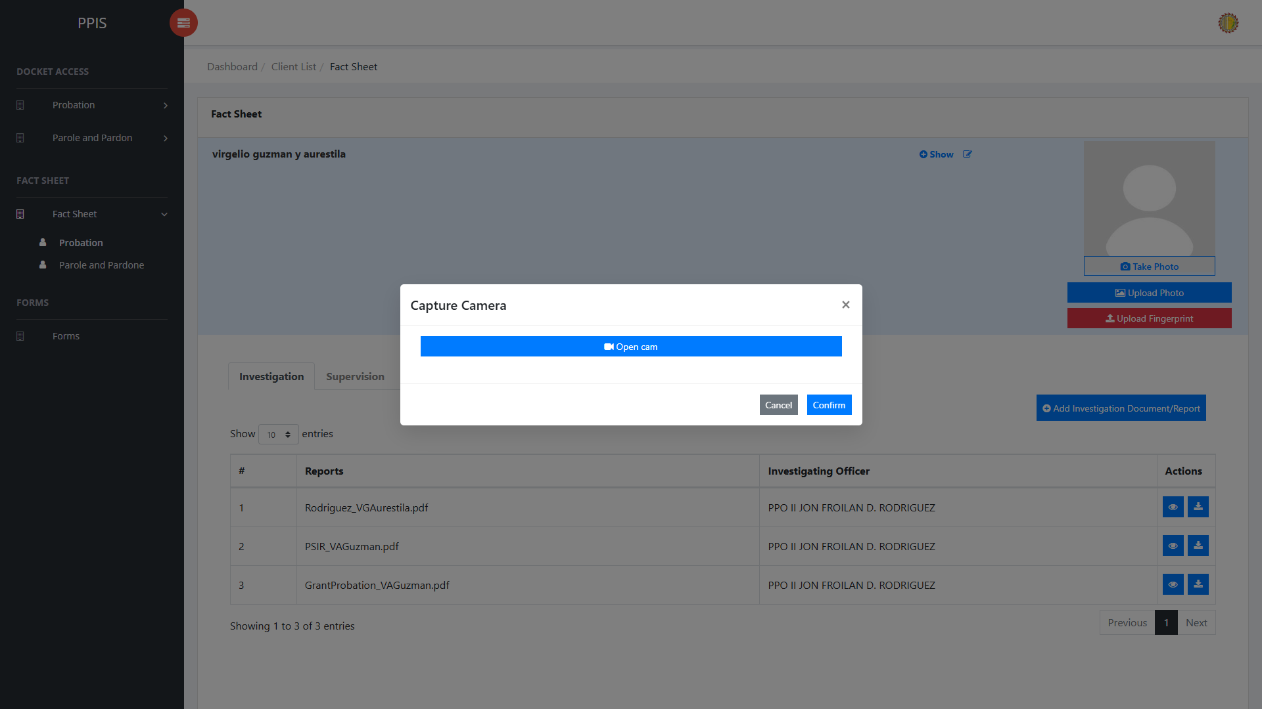
Fact Sheet Probation — take photo

Fact Sheet Probation (Upload Fingerprint)
1. On the client view profile, click Upload Fingerprint below the photo buttons.
2. Wait for the Upload Fingerprint dialog to open.
3. Click the fingerprint image for the finger the end-user needs to upload: Right Thumb, Right Index, Right Middle, Right Ring, or Right Little.
4. Select the fingerprint image file from the end-user’s computer.
5. Repeat the finger selection for any additional fingerprints that must be uploaded.
6. Click Confirm to save the fingerprint files to the client profile.
7. Wait for the success message, then close the dialog when finished.
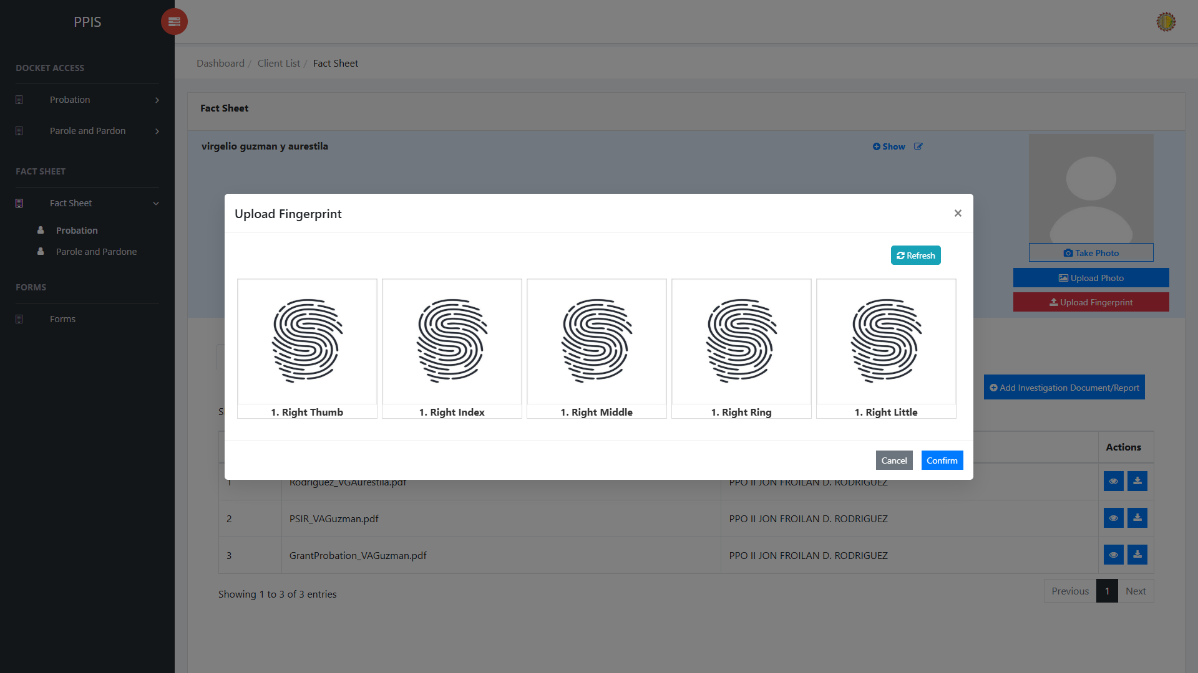
Fact Sheet Probation — upload fingerprint

Fact Sheet Probation (Worksheet and PSIR Overview)
The Worksheet and Post-Sentence Investigation Report (PSIR) are prepared from the Docket List tab on the client view profile. Each Worksheet and each PSIR belongs to one docket number. When the status is Not Available, click Edit to start a new Worksheet or PSIR for that docket. When a Worksheet or PSIR already exists, click Edit to continue or update it.
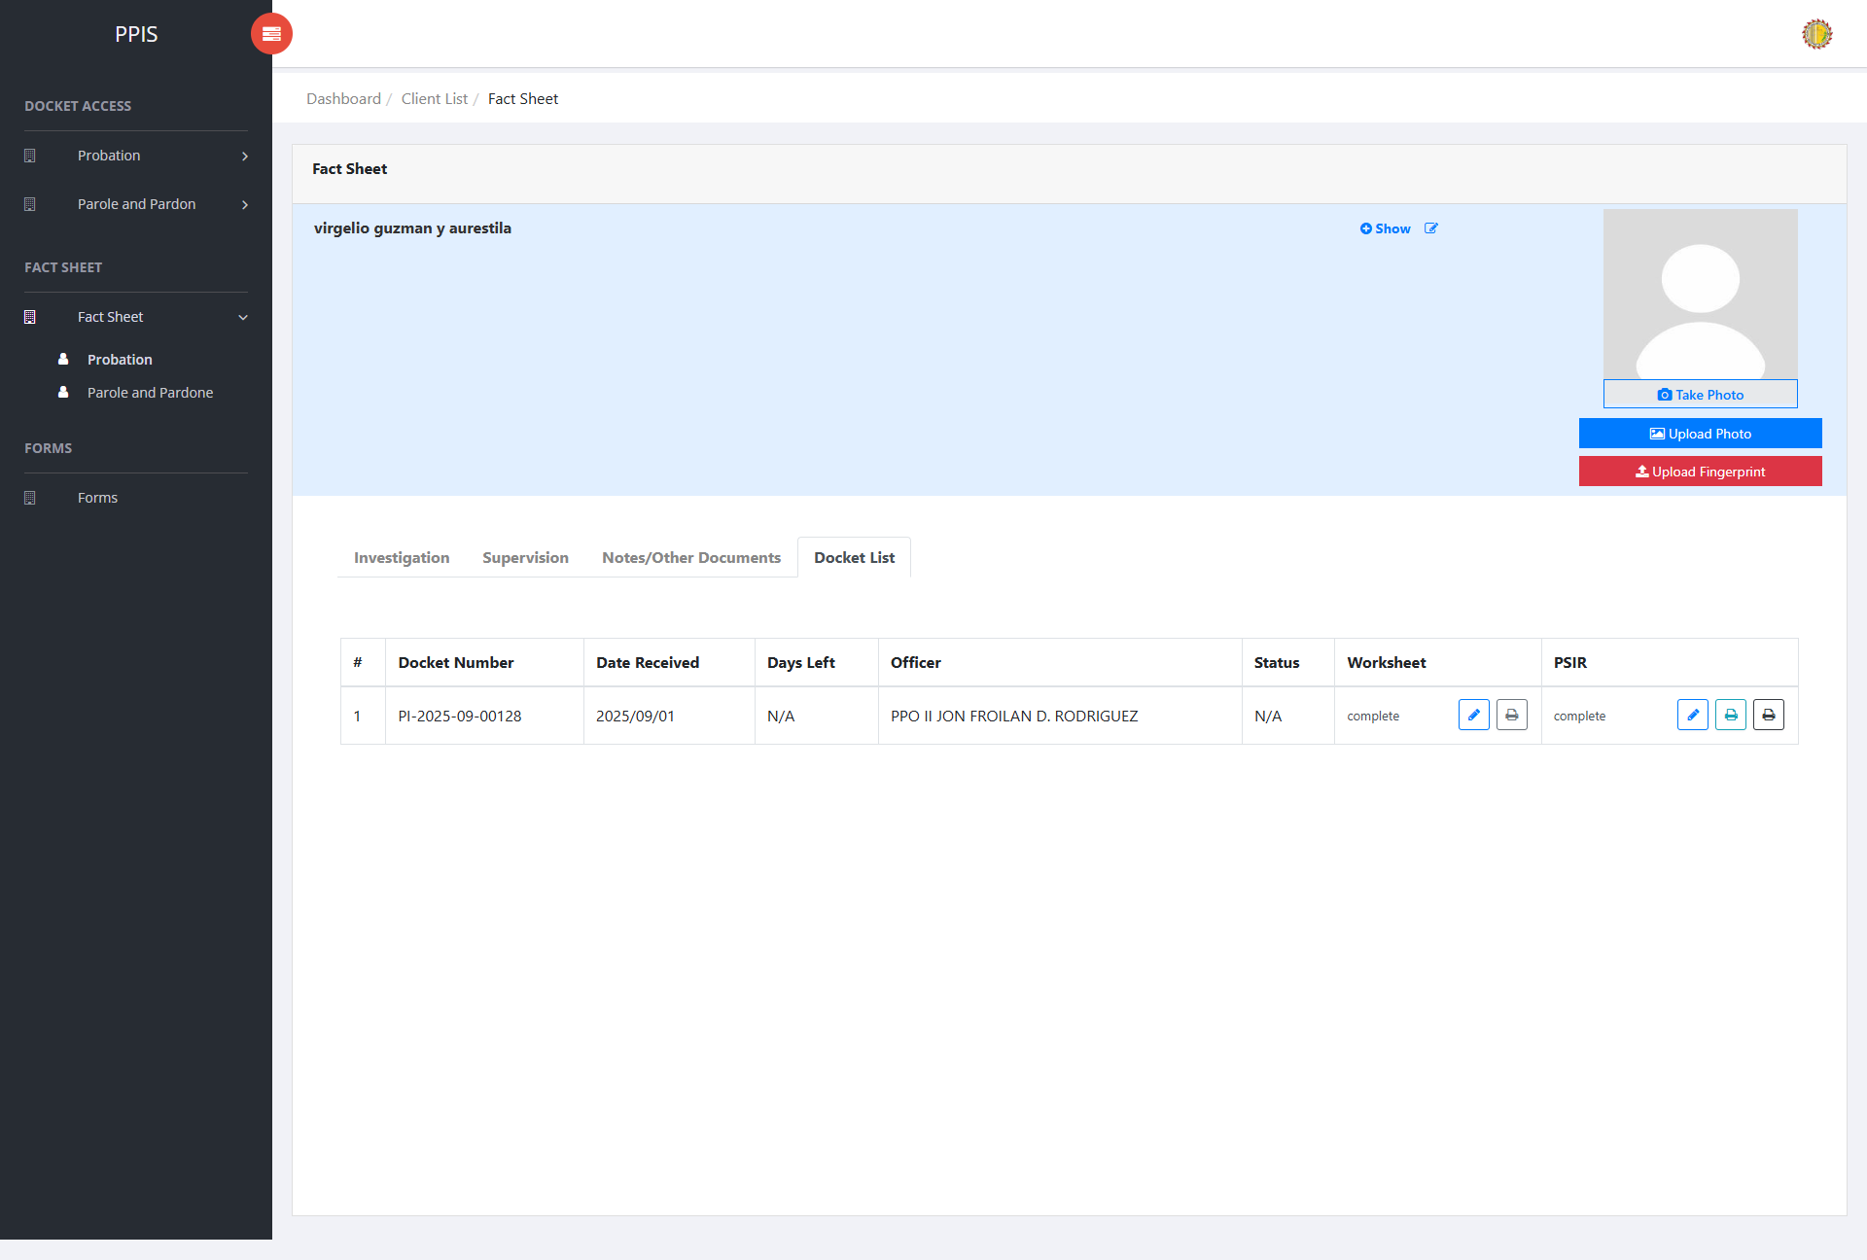
Fact Sheet Probation — Worksheet and PSIR Overview

Fact Sheet Probation (Navigate to Worksheet)
1. From the left menu, open Fact Sheet Probation.
2. Locate the client, then click the client name to open the client view profile.
3. On the client view profile, click the Docket List tab.
4. Review the docket table. Each row shows Docket Number, Date Received, Investigating Officer, Status, and the Worksheet and PSIR columns.
5. In the Worksheet column, note the current status (for example, complete, incomplete, or Not Available).
6. Click Edit in the Worksheet column for the docket that needs the worksheet. If the status is Not Available, Edit starts a new worksheet for that docket. If a worksheet already exists, Edit opens the saved record so it can be updated.
7. Wait for the worksheet editor to open on the Identifying Data section.
Fact Sheet Probation — Navigate to Worksheet

Fact Sheet Probation (Fill Out Worksheet)
1. On the Worksheet screen, navigate through the tabs located at the top of the page to access each section. Complete the information sequentially in the following order: Identifying Data, Present Offense, Prior Records, Identification Data, Family Background, Present Situation, Educational History, Employment History, and Community Background/Environmental Factors.
2. On the active tab, enter the required information in the fields as shown (for example, Petitioner's Name, Alias/es, Date of Initial Interview, Interviewed By, Present Address, and Permanent Address on Identifying Data).
3. When the current section is complete, click Save at the top right of the form.
4. In the confirmation dialog, click Save Changes when creating a new worksheet, or Update Changes when updating an existing worksheet. Use the back arrow at the top of the worksheet page to return to the client fact sheet.
5. Wait for the success message. The system saves the section and may open the next worksheet section automatically.
6. To open another worksheet tab without using Save, click the tab name. When the warning dialog appears, click Proceed to open the selected tab.
7. Continue entering and saving data for each worksheet tab until all sections are complete. Once all required sections have been populated, the Worksheet Status on the Docket List tab will automatically display Complete.
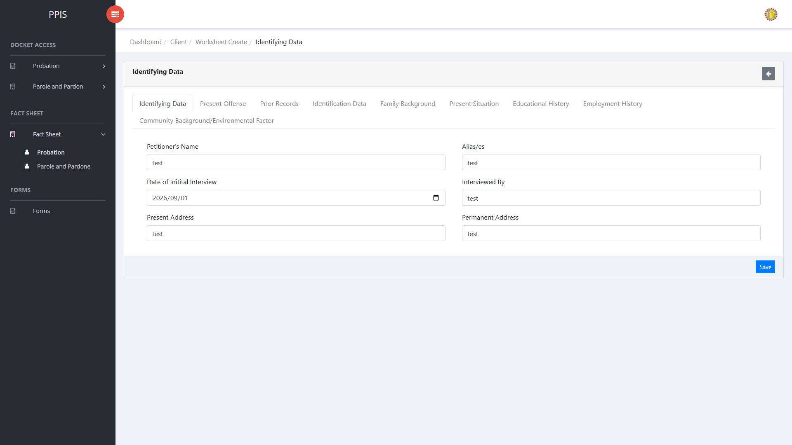
Fact Sheet Probation — Fill Out Worksheet
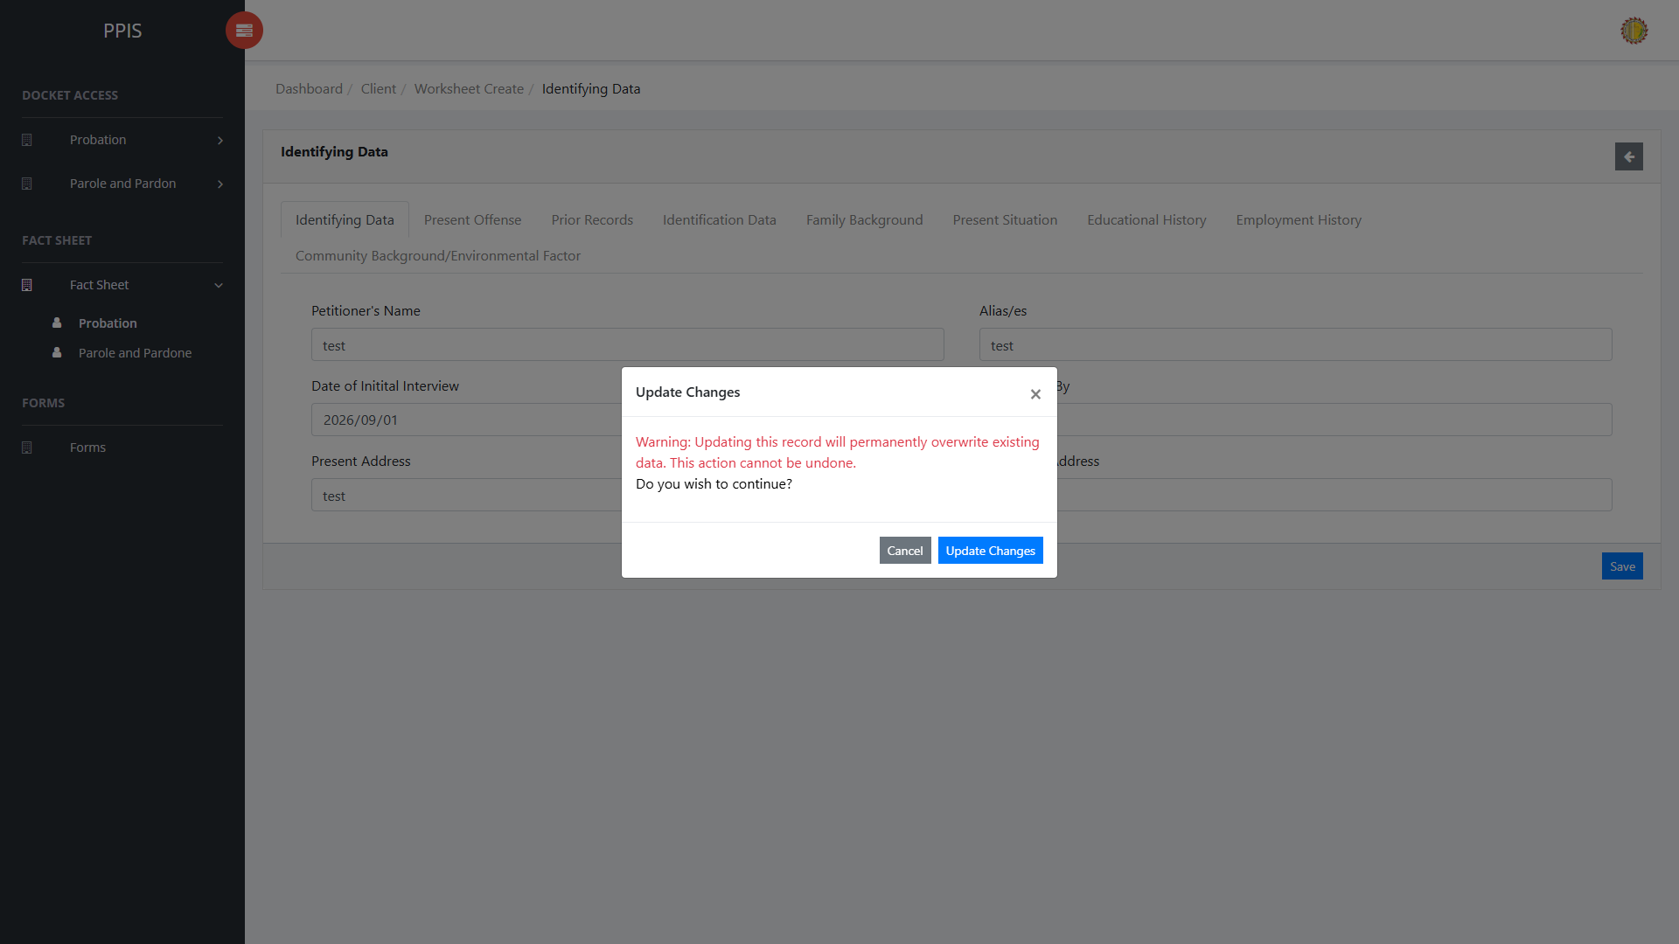
Confirmation dialog — Save Changes or Update Changes

Fact Sheet Probation (Print Worksheet)
1. Open the client view profile and click the Docket List tab, or return to it after saving worksheet data.
2. Locate the docket row for the worksheet to print.
3. In the Worksheet column, click Print.
4. Wait for the print preview window to open and display the formatted worksheet.
5. Click Print in the preview header. The browser print window opens.
6. Review the print layout, choose the printer or Save as PDF, then click Print in the browser window to finish.
7. Click the close (×) button on the preview window when printing is finished.
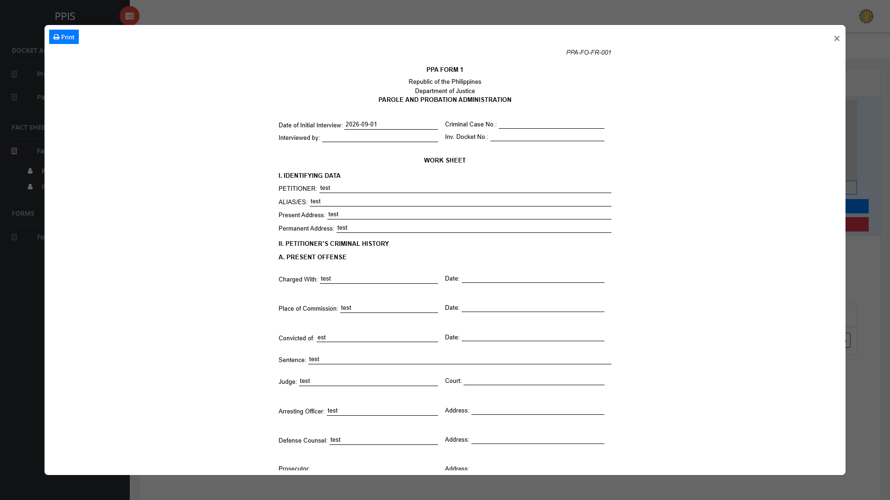
Fact Sheet Probation — Worksheet Print Out Sample

Fact Sheet Probation (Navigate to PSIR)
1. From the left menu, open Fact Sheet Probation.
2. Click the client name to open the client view profile.
3. Click the Docket List tab.
4. In the PSIR column, note the current status (for example, complete, incomplete, or Not Available).
5. Click Edit in the PSIR column for the docket that needs the PSIR. If the status is Not Available, Edit starts a new PSIR for that docket. If a PSIR already exists, Edit opens the saved record so it can be updated.
6. Wait for the PSIR editor to open on the Identifying Data section.
Fact Sheet Probation — Navigate to PSIR

Fact Sheet Probation (Fill Out PSIR)
1. Use the tabs at the top of the PSIR screen to move between sections. Complete each section in sequence: Identifying Data, Present Offense, Prior Records, Birth Data and Family Background, Present Situation, Education and Job History, Medical History, Traits/Characteristics and Background in the Community, Analysis/Evaluation and Projected Thrust of Rehabilitation, and Recommendation.
2. On the active tab, enter the required information in the fields as shown (for example, Petitioner's Name, True Name, Source of Information, Alias, Height, Weight, Age, Sex, Citizenship, Religion, Identifying Marks, Present Address, and Permanent Address on Identifying Data).
3. When the current section is complete, click Save at the top right of the form.
4. In the confirmation dialog, click Save Changes when creating a new PSIR, or Update Changes when updating an existing PSIR. Use the back arrow at the top of the PSIR page to return to the client fact sheet.
5. Wait for the success message. The system saves the section and may open the next PSIR section automatically.
6. To open another PSIR tab without using Save, click the tab name. When the warning dialog appears, click Proceed to open the selected tab.
7. Complete and save the information in each PSIR tab. The PSIR Status on the Docket List tab will automatically update after all required sections contain data.
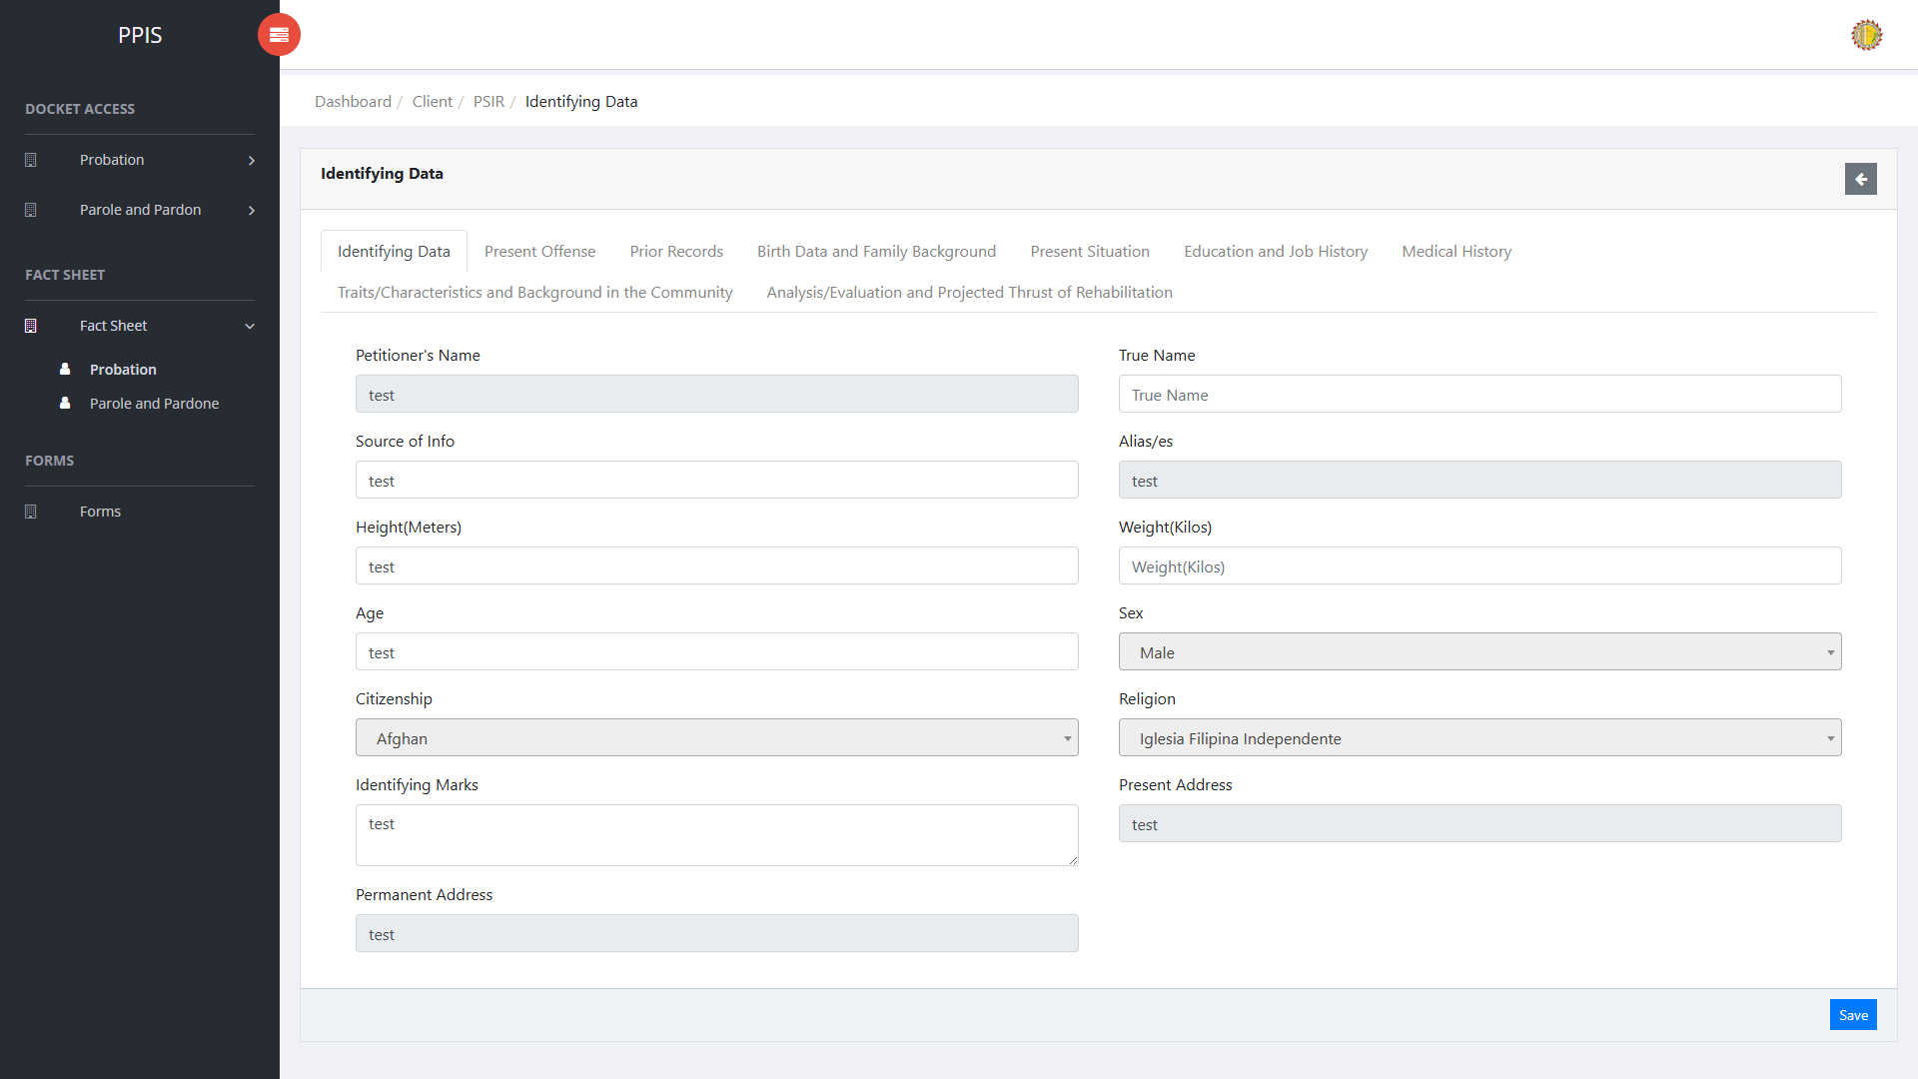
Fact Sheet Probation — Fill Out PSIR
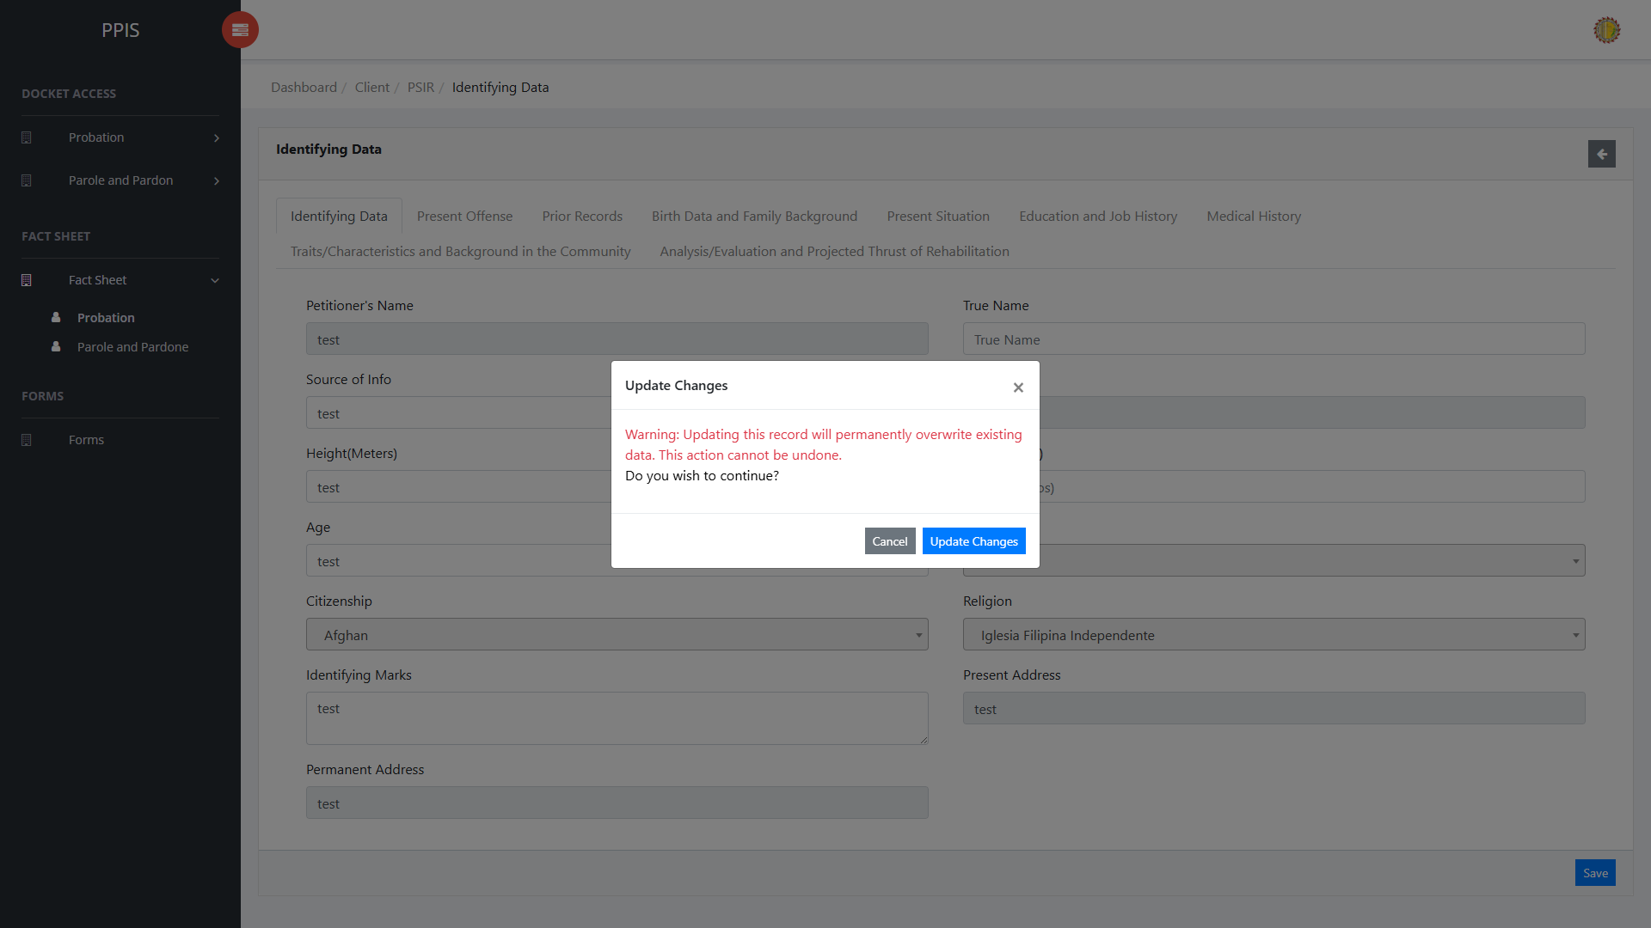
Confirmation dialog — Save Changes or Update Changes

Fact Sheet Probation (Print PSIR)
1. Access the Docket List tab from the Client View Profile, or return to it after completing and saving the PSIR data.
2. Locate the docket row for the PSIR to print.
3. In the PSIR column, choose Short to generate the short-form PSIR template, or Long to generate the comprehensive PSIR template with the transmittal letter and complete recommendation sections.
4. Wait for the print preview window to open and display the selected PSIR format.
5. Click Print in the preview header. The browser print window opens.
6. To save a copy of the PSIR file, click Download in the preview header when shown, then open the downloaded file if needed.
7. Review the print layout, choose the printer or Save as PDF, then click Print in the browser window to finish.
8. Click the close (×) button on the preview window when printing is finished.
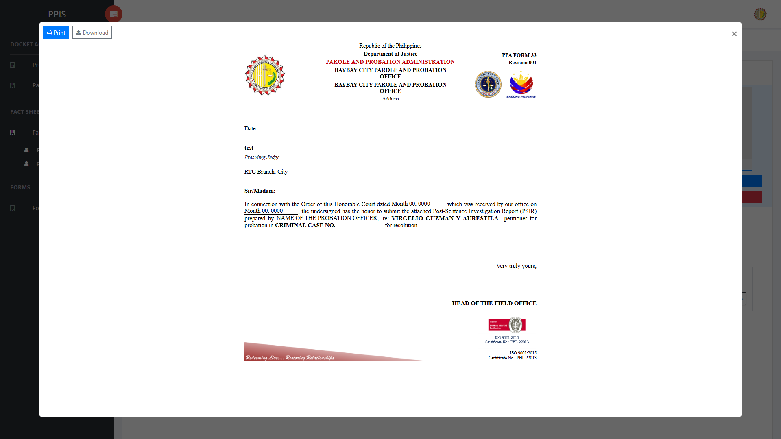
Fact Sheet Probation — PSIR Print Out Sample

Fact Sheet Role Workflows (CPPO, Field Officer, Clerk/Other)
The Probation Fact Sheet now applies a role-based workflow. The same client profile is shown to all authorized users, but photo, fingerprint, document, worksheet, and PSIR actions change depending on the signed-in role.
Use this section to confirm what each account type can do after opening a client from Fact Sheet Probation.

CPPO and other full-access accounts
Chief Probation and Parole Officers (CPPO) and other full-access roles can use every fact-sheet function on any client in their office. This group includes CPPO, System Administrator, and the other full-access office roles configured in PPIS.
1. Sign in with a CPPO or other full-access account.
2. Open Fact Sheet Probation and click the client name.
3. You can view or use Take Photo, Upload Photo, and Upload Fingerprint in the client photo area.
4. You can view or use Add Investigation Document/Report, Add Supervision Document/Report, and Add Note/Other Document when those buttons are shown.
5. Open the Docket List tab. Edit and print are available for Worksheet and PSIR for any docket, including records created by another officer.
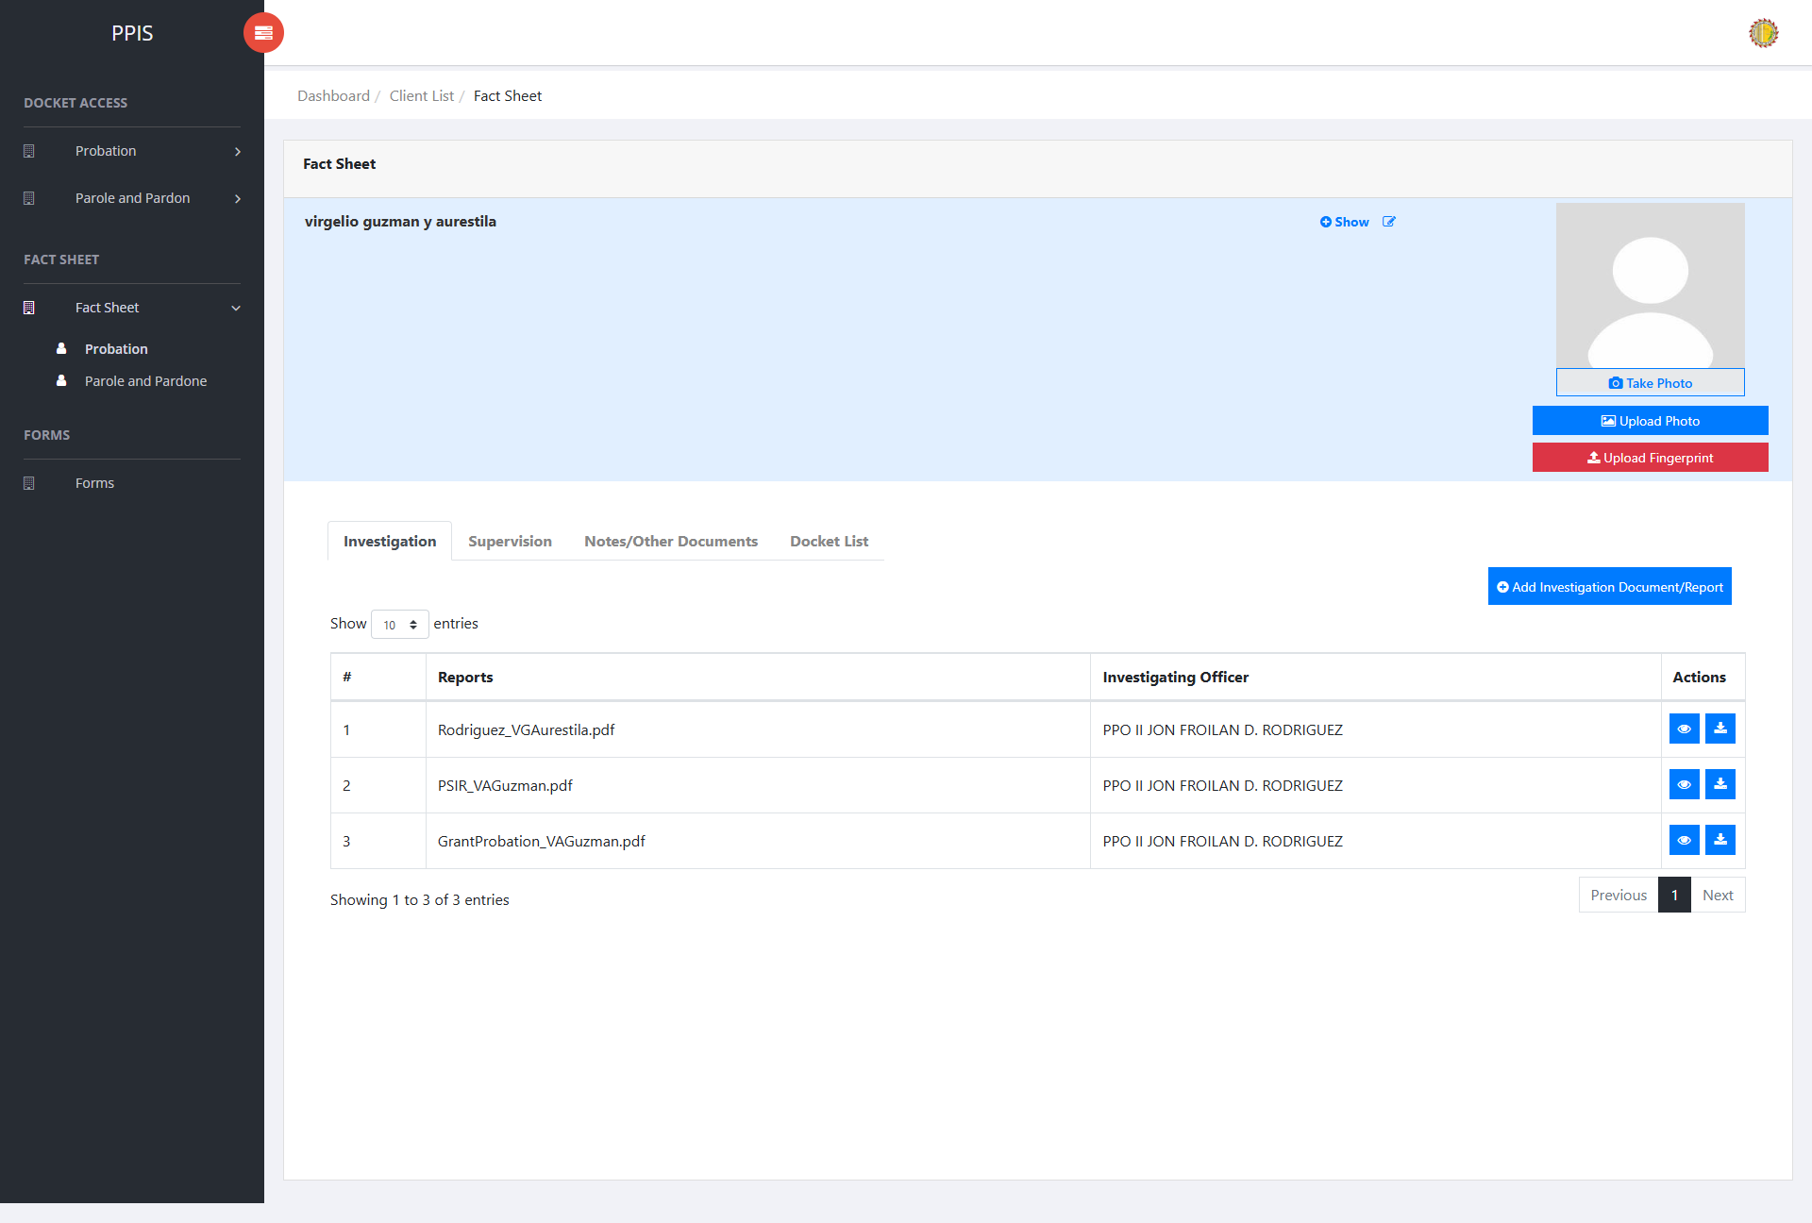
CPPO / full-access account — client profile with photo and document actions
CPPO / full-access account — Docket List with Edit and Print for Worksheet and PSIR

Field Officer accounts
Field Officer accounts can maintain the fact sheet, including photos, fingerprints, and supporting documents. Worksheet and PSIR edit or print is limited to records the signed-in officer created. If another officer created the worksheet or PSIR, the Docket List shows Owner only instead of Edit and Print.
1. Sign in with a Field Officer account.
2. Open Fact Sheet Probation and click the client name.
3. You can view or use photo, fingerprint, and document upload actions as needed.
4. Open the Docket List tab.
5. Click Edit or Print only on a Worksheet or PSIR. If the record was created by another field officer, the row shows Owner only.
6. To start a Worksheet or PSIR that does not yet exist, use Edit. The new record is saved under the signed-in field officer.
Field Officer account — client profile with fact-sheet actions available
Field Officer account — Docket List showing owner-only Worksheet/PSIR limits

Clerk and other accounts
Clerk and other accounts that are not CPPO/full-access or Field Officer can open the client fact sheet for viewing only. Photo, fingerprint, add-document, worksheet, and PSIR actions are hidden or shown as Restricted.
1. Sign in with a Clerk or other non-officer account.
2. Open Fact Sheet Probation and click the client name.
3. Review the client profile, tabs, and attached files. Take Photo, Upload Photo, Upload Fingerprint, and Add document buttons are not shown.
4. Open Investigation, Supervision, or other file tables. File actions appear as Restricted.
5. Open the Docket List tab to review docket status. Worksheet and PSIR Edit/Print controls are not available.
Clerk / other account — client profile without photo or add-document buttons
Clerk / other account — Docket List without Worksheet/PSIR edit and print

What each role can do
CPPO and other full-access roles: manage photos, fingerprints, documents, worksheets, and PSIRs for any client record in the office.
Field Officer: manage photos, fingerprints, and documents; create a Worksheet or PSIR when none exists; edit or print only the Worksheet or PSIR the officer created.
Clerk and other accounts: view the fact sheet and docket information only. The system does not allow photo capture, file uploads, or Worksheet/PSIR editing from these accounts.

Fact Sheet Parole and Pardon
Use this page to find and open parole and pardon client fact sheets. Click the client name, or click Fact Sheet, to open the client view profile.
1. From the left menu, open Fact Sheet Parole and Pardon.
2. If the page has tabs, select the needed tab, such as Parole, Pardon.
3. To find a record, enter the known information in Search Client.
4. In the Actions column, use Update, Fact Sheet, or Attachments for the selected row.
5. To filter and locate specific records, enter search terms in the search fields within the column headers or choose values from the corresponding drop-down filters. The table automatically refreshes to display records that match the applied criteria.
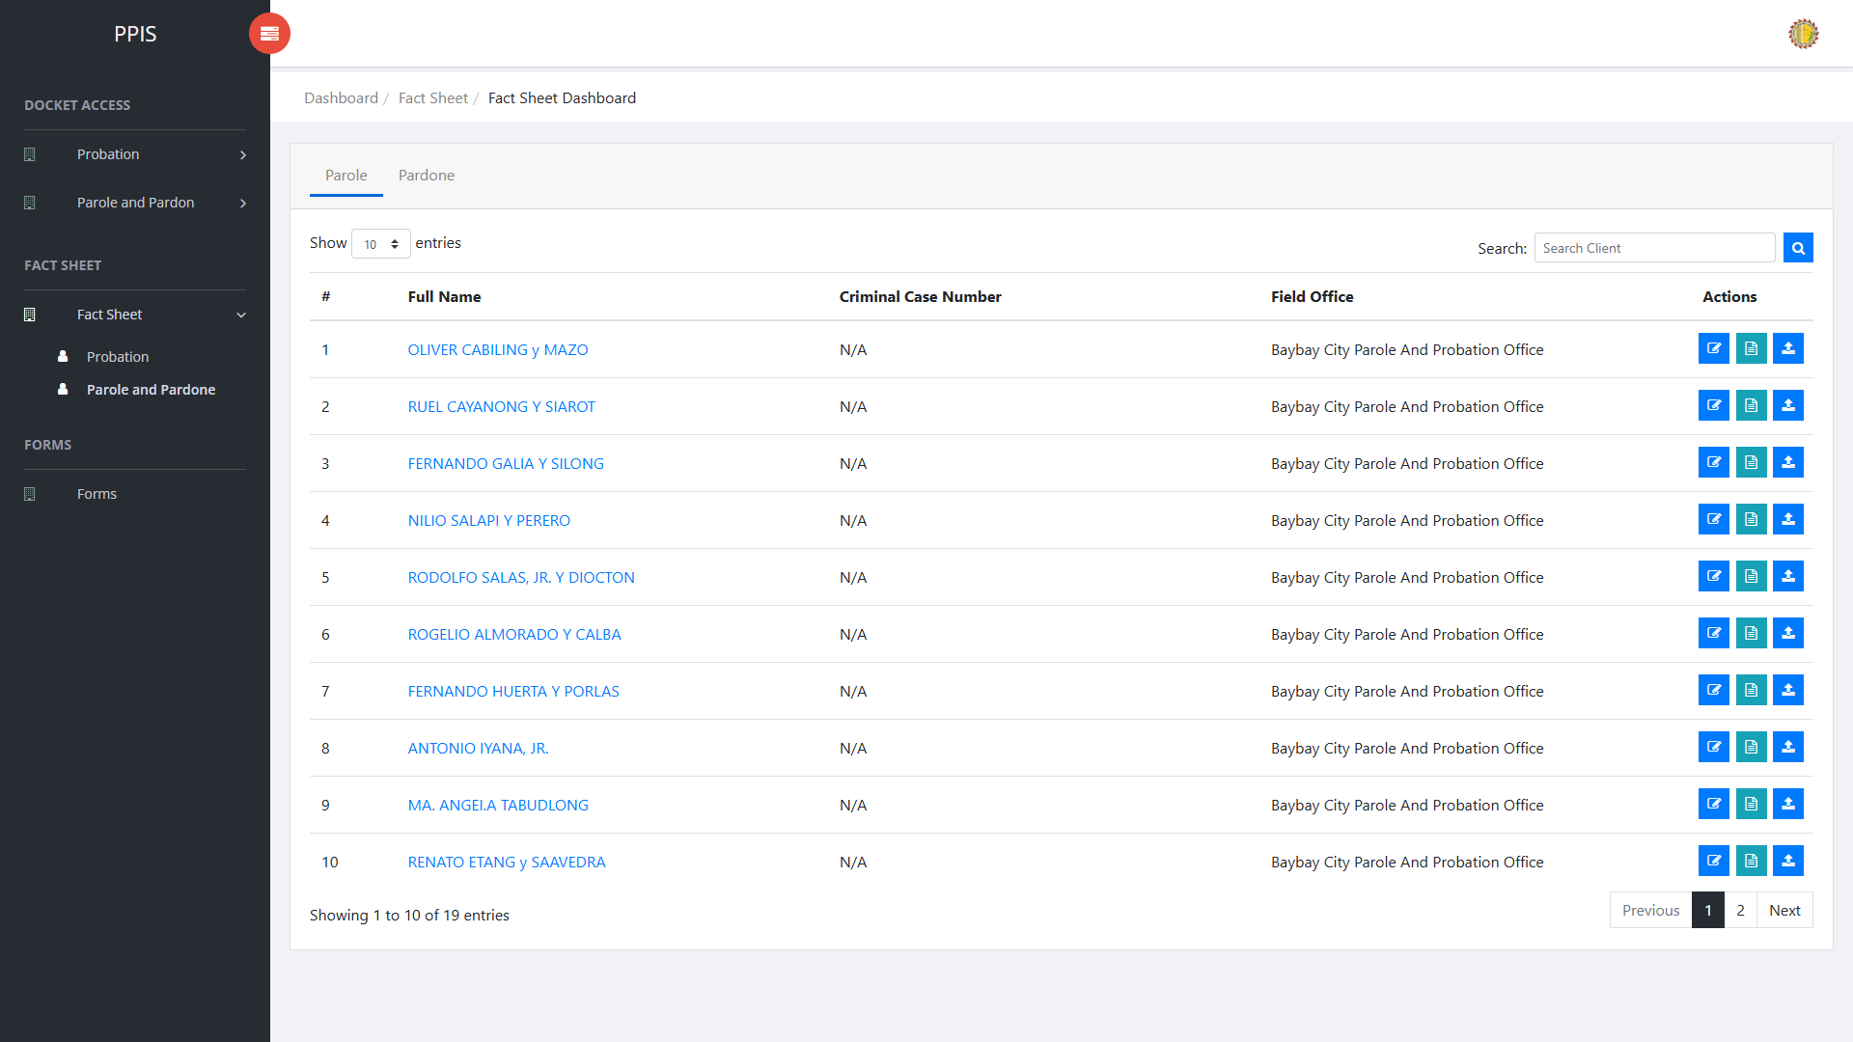
Fact Sheet Parole and Pardone list page

Fact Sheet Parole and Pardon (Open Client Profile)
The parole and pardon fact sheet uses a client view profile. Open it from the list by clicking the client name or Fact Sheet.
1. On the Fact Sheet Parole and Pardon list page, locate the client the end-user needs to open.
2. Click the client name in the Full Name column, or click Fact Sheet in the Actions column.
3. Wait for the client view profile to open. The page shows the client photo area, profile tabs, and tab content below.
Fact Sheet Parole and Pardon — client view profile

Fact Sheet Parole and Pardon (Client Profile Tabs)
Use the tabs in the Client View Profile to navigate through the different sections of the client's record.
Investigation — Review and upload investigation documents and reports related to the client. Use Add Investigation Document/Report when a new file must be attached.
Supervision — Review and upload supervision documents and reports for the client. Use Add Supervision Document/Report when a new file must be attached.
Notes/Other Documents — Keep supplementary notes and other supporting documents for the client. Use Add Note/Other Document to upload a file.
1. On the client view profile, read the tab labels across the top of the page.
2. Click the tab that matches the information the end-user needs to review or update.
3. Wait for the tab content to load before using any buttons or tables shown in that section.
Fact Sheet Parole and Pardon — client profile tabs

Fact Sheet Parole and Pardon (Upload or Take Photo)
Take Photo, Upload Photo, Upload Fingerprint, and Add document buttons are shown to the officer who created the client profile, a CPPO, or a System Administrator. Other accounts can review the profile. File actions appear as Restricted.
1. On the client view profile, locate the client photo area on the right side of the page.
2. To upload an existing image file, click Upload Photo.
3. In the Upload Profile dialog, choose an image file, then click Confirm.
4. To capture a new photo with the device camera, click Take Photo.
5. In the Capture Camera dialog, click Open cam, allow camera access if the browser asks for permission, then click Capture.
6. Review the captured image. Click Retake if the end-user needs another shot, or click Confirm to save the photo to the client profile.
7. Wait for the success message. The client photo area refreshes with the uploaded or captured image.
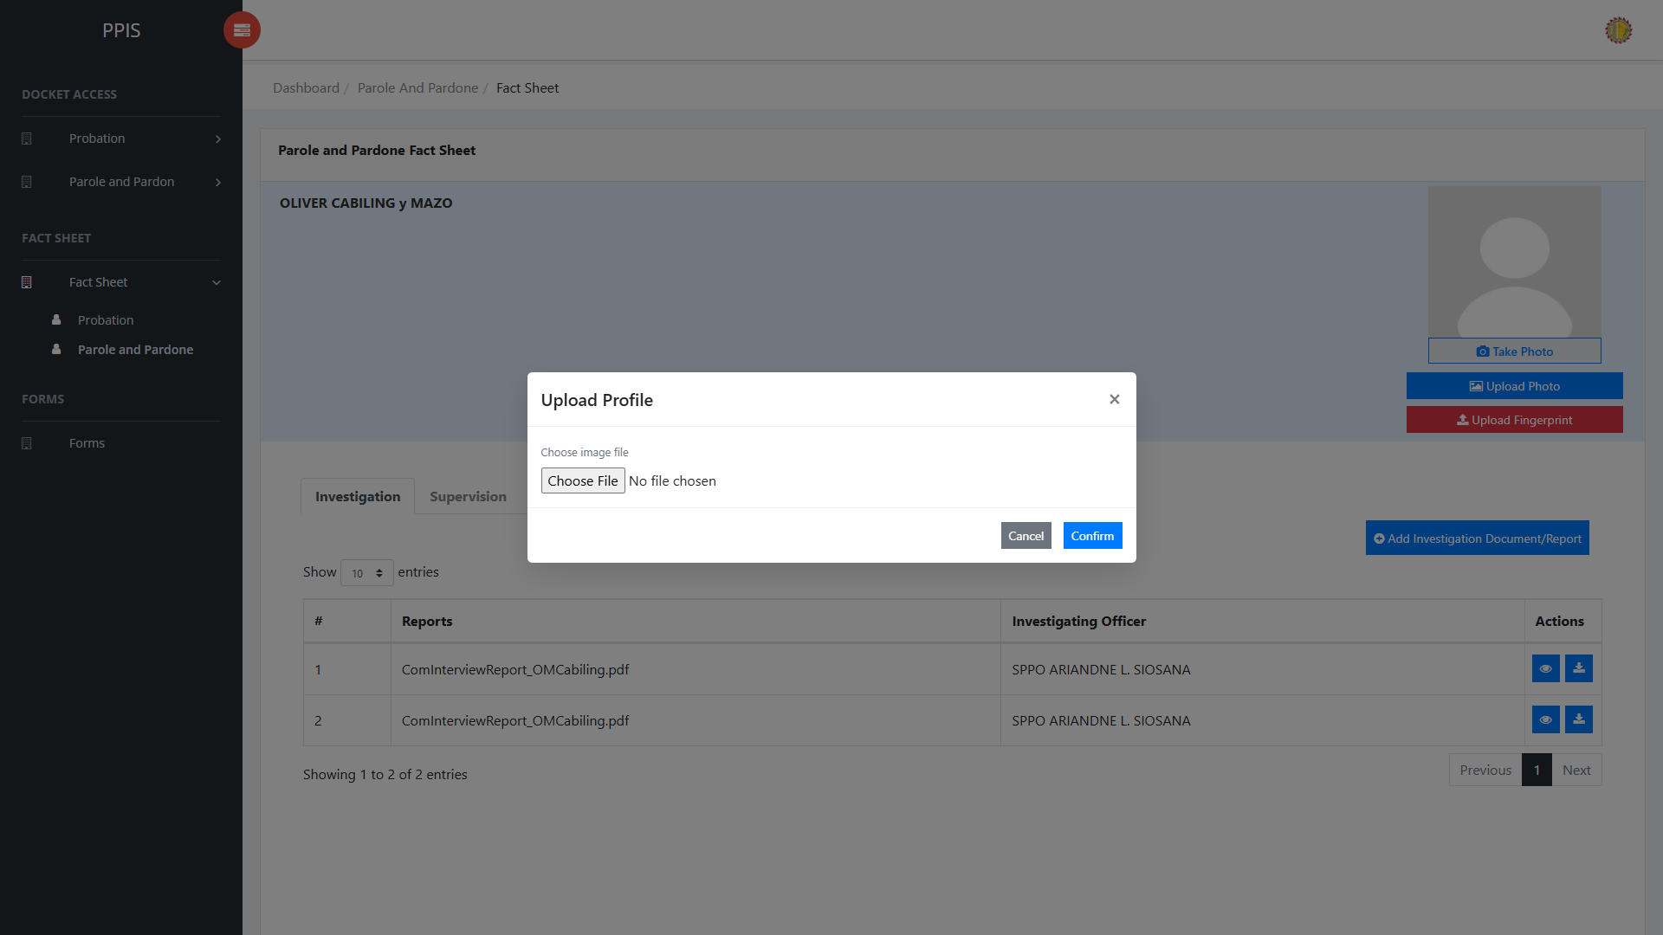
Fact Sheet Parole and Pardon — upload photo
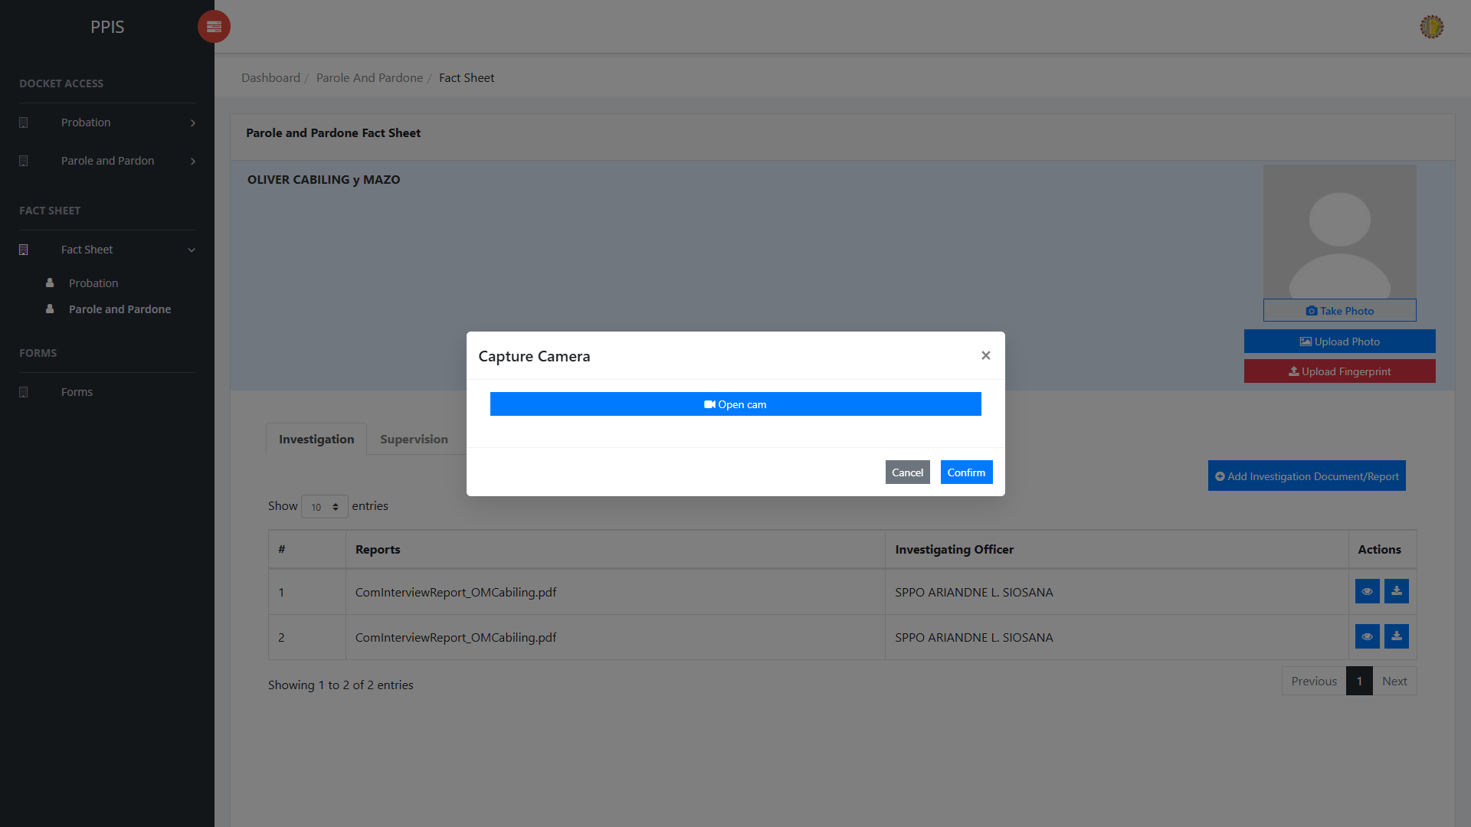
Fact Sheet Parole and Pardon — take photo

Fact Sheet Parole and Pardon (Upload Fingerprint)
1. On the client view profile, click Upload Fingerprint below the photo buttons.
2. Wait for the Upload Fingerprint dialog to open.
3. Click the fingerprint image for the finger the end-user needs to upload: Right Thumb, Right Index, Right Middle, Right Ring, or Right Little.
4. Select the fingerprint image file from the end-user's computer.
5. Repeat the finger selection for any additional fingerprints that must be uploaded.
6. Click Confirm to save the fingerprint files to the client profile.
7. Wait for the success message, then close the dialog when finished.

Fact Sheet Parole and Pardon (Update)
1. On the Fact Sheet Parole and Pardon list page, locate the record that needs to be updated.
2. Click Update in the Actions column.
3. Wait for the update screen to open.
4. Review the current details and update Client Type, Criminal Case No., First Name, Middle Name, Last Name, Suffix Name, Sex, Education.
5. Click Confirm to save after checking the information.
6. Wait for the system to return to the list page or refresh the record display.
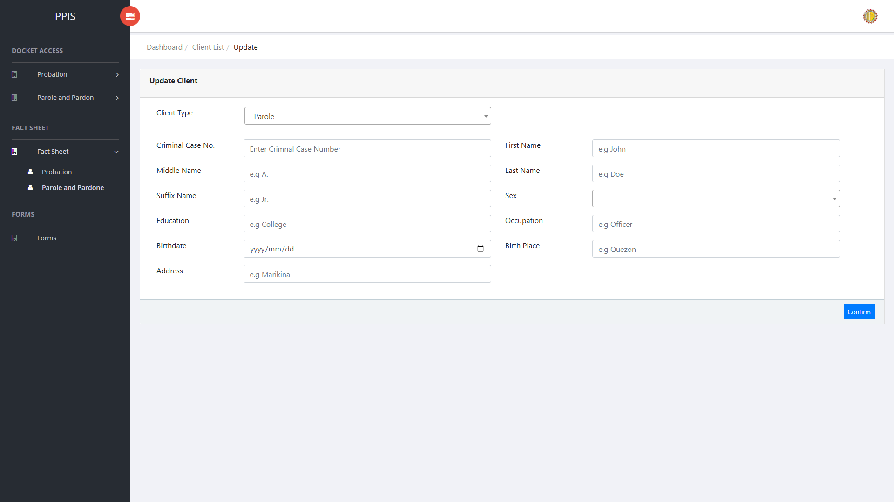
Fact Sheet Parole and Pardone (Update)

Fact Sheet Parole and Pardon (Attachments)
1. On the Fact Sheet Parole and Pardon list page, click Attachments for the record that needs the attachments.
2. Wait for the attachments screen to open.
3. Complete the attachment details, such as Kind, Type, and Upload File when shown.
4. Click Confirm to upload the file.
5. Use View, Download, or Delete only for the attachment listed in the table.
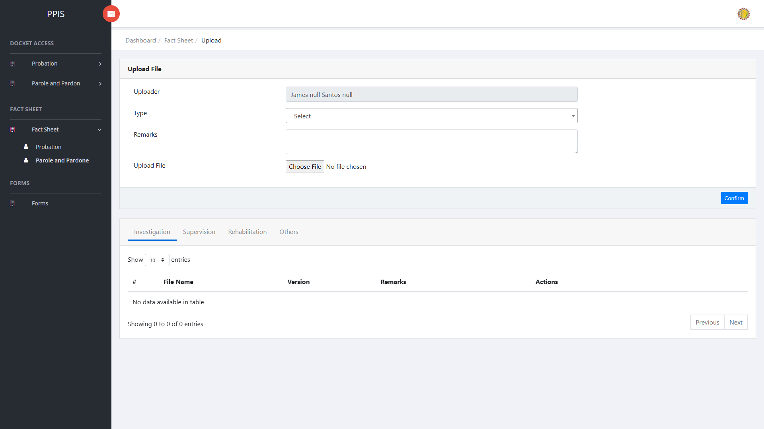
Fact Sheet Parole and Pardone (Attachments)

7. Forms

Forms
Use this page to view available forms and add documents when the account has permission.
1. From the left menu, open Forms.
2. To find a record, enter the known information in the Search field.
3. Review the records shown on the page and the end-user undertakes the necessary actions to be taken.
4. To filter the displayed records, enter search criteria in the inline search fields within the column headers or choose a value from the available drop-down filters. The table automatically refreshes to display the matching records.
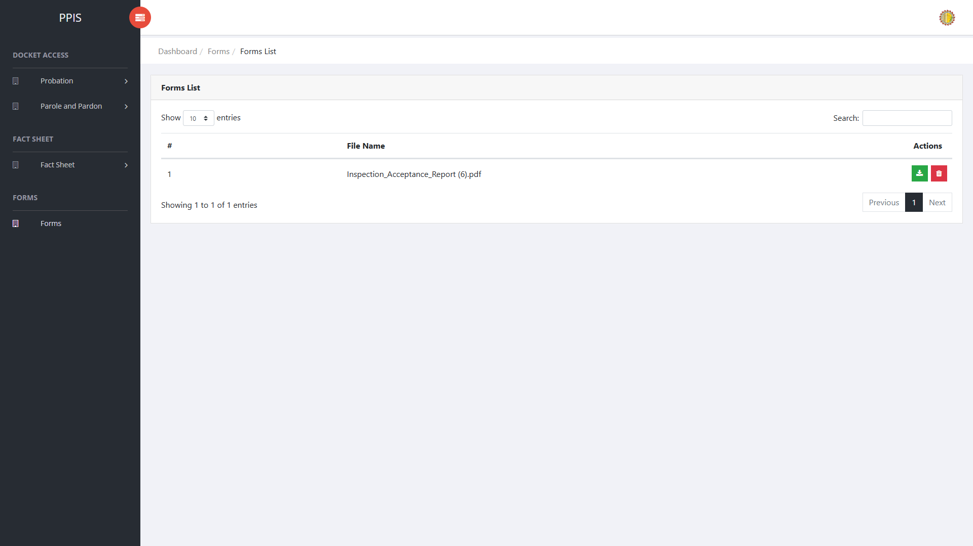
Forms list page

Forms (Add Document)
1. On the Forms list page, click Add Document.
2. Wait for the upload screen to open.
3. Enter Uploader, Kind, and select a file in Upload File.
4. Click Confirm to save after checking the entry.
5. Wait for the system to confirm the upload and return to the forms list.
Forms (Add Document)

8. My Organization

User Accounts (For Administrator of the System)
Use this page to create and maintain user accounts.
1. From the left menu, open User Accounts.
2. To find a record, enter the known information in Enter Username.
3. Click Search to apply the search.
4. In the Actions column, use Update, Remove, Deactivate, Restrict, Activate for the selected row.
5. To filter the displayed records, enter search criteria in the inline search fields within the column headers or choose a value from the available drop-down filters. The table automatically refreshes to display the matching records.
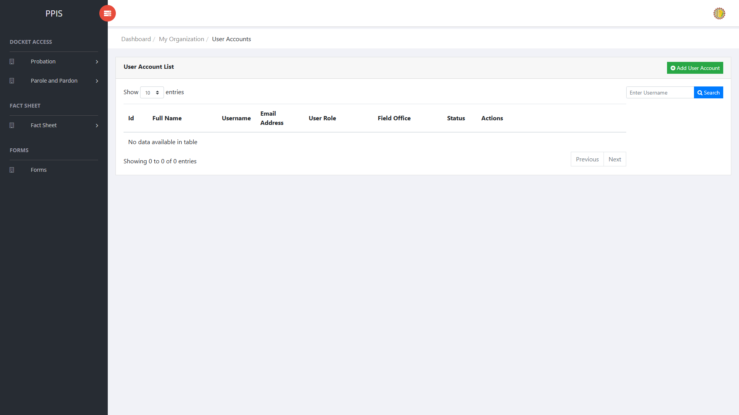
User Accounts list page

User Accounts (Update) (For Administrator of the System)
1. On the User Accounts list page, locate the record that needs correction.
2. Click Update in the Actions column.
3. Wait for the modal dialog box to appear on the screen.
4. Review the current details and update First Name *, Middle Name *, Last Name *, Suffix, Birthday, Contact No., Email Address *, Field Office * inside the modal dialog.
5. Click Confirm inside the modal dialog to submit the changes.
6. If the system displays a confirmation prompt, review the information and click Confirm to save the updated record.
7. Wait for the modal dialog to close. The table refreshes and displays the updated record.
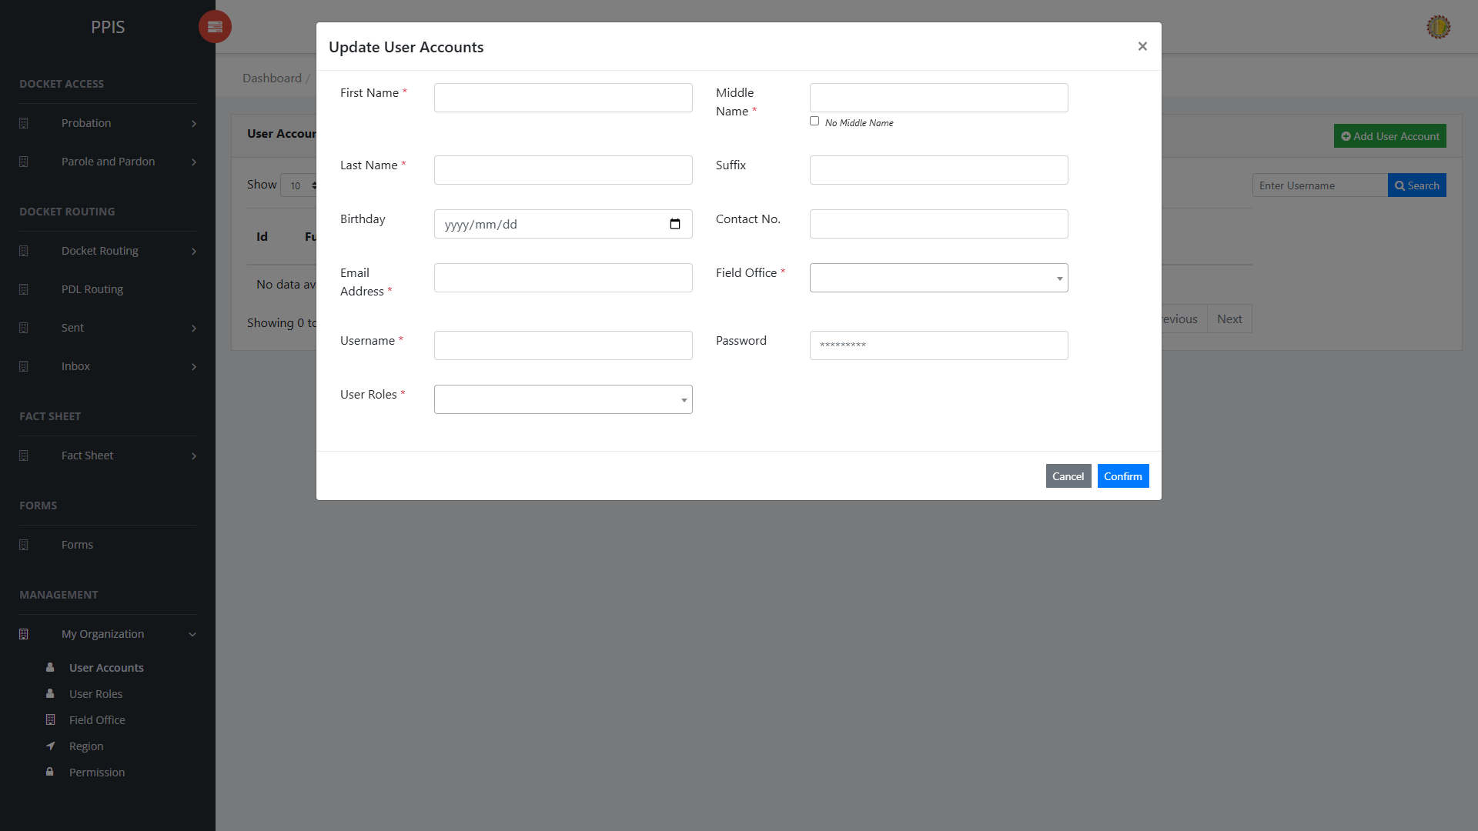
User Accounts (Update)

User Accounts (Delete) (For Administrator of the System)
Deletion warning: Use Remove only for records approved for deletion. For documentation, stop at the confirmation dialog unless removal is required.

1. On the User Accounts list page, locate the record to be deleted.
2. Click Remove in the Actions column.
3. Wait for the confirmation modal dialog box to appear.
4. Read the confirmation message carefully. The system warns that removal cannot be undone.
5. Click Cancel inside the modal dialog to stop, or click Remove inside the modal dialog only when deletion is authorized.
6. Wait for the modal dialog to close. The table refreshes to reflect the remaining records.
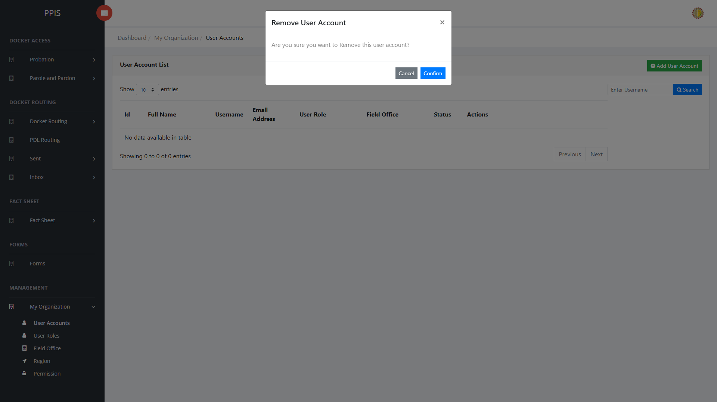
User Accounts (Delete)

User Accounts (Add Record) (For Administrator of the System)
1. On the User Accounts page, click Add User Account.
2. Wait for the modal dialog box to appear on the screen.
3. Enter First Name *, Middle Name *, Last Name *, Suffix, Birthday, Contact No., Email Address *, Field Office * inside the modal dialog.
4. Click Confirm inside the modal dialog to submit the new record.
5. If the system displays a confirmation prompt, review the information and click Confirm to save the entry.
6. Wait for the modal dialog to close. The table refreshes and displays the newly added record.
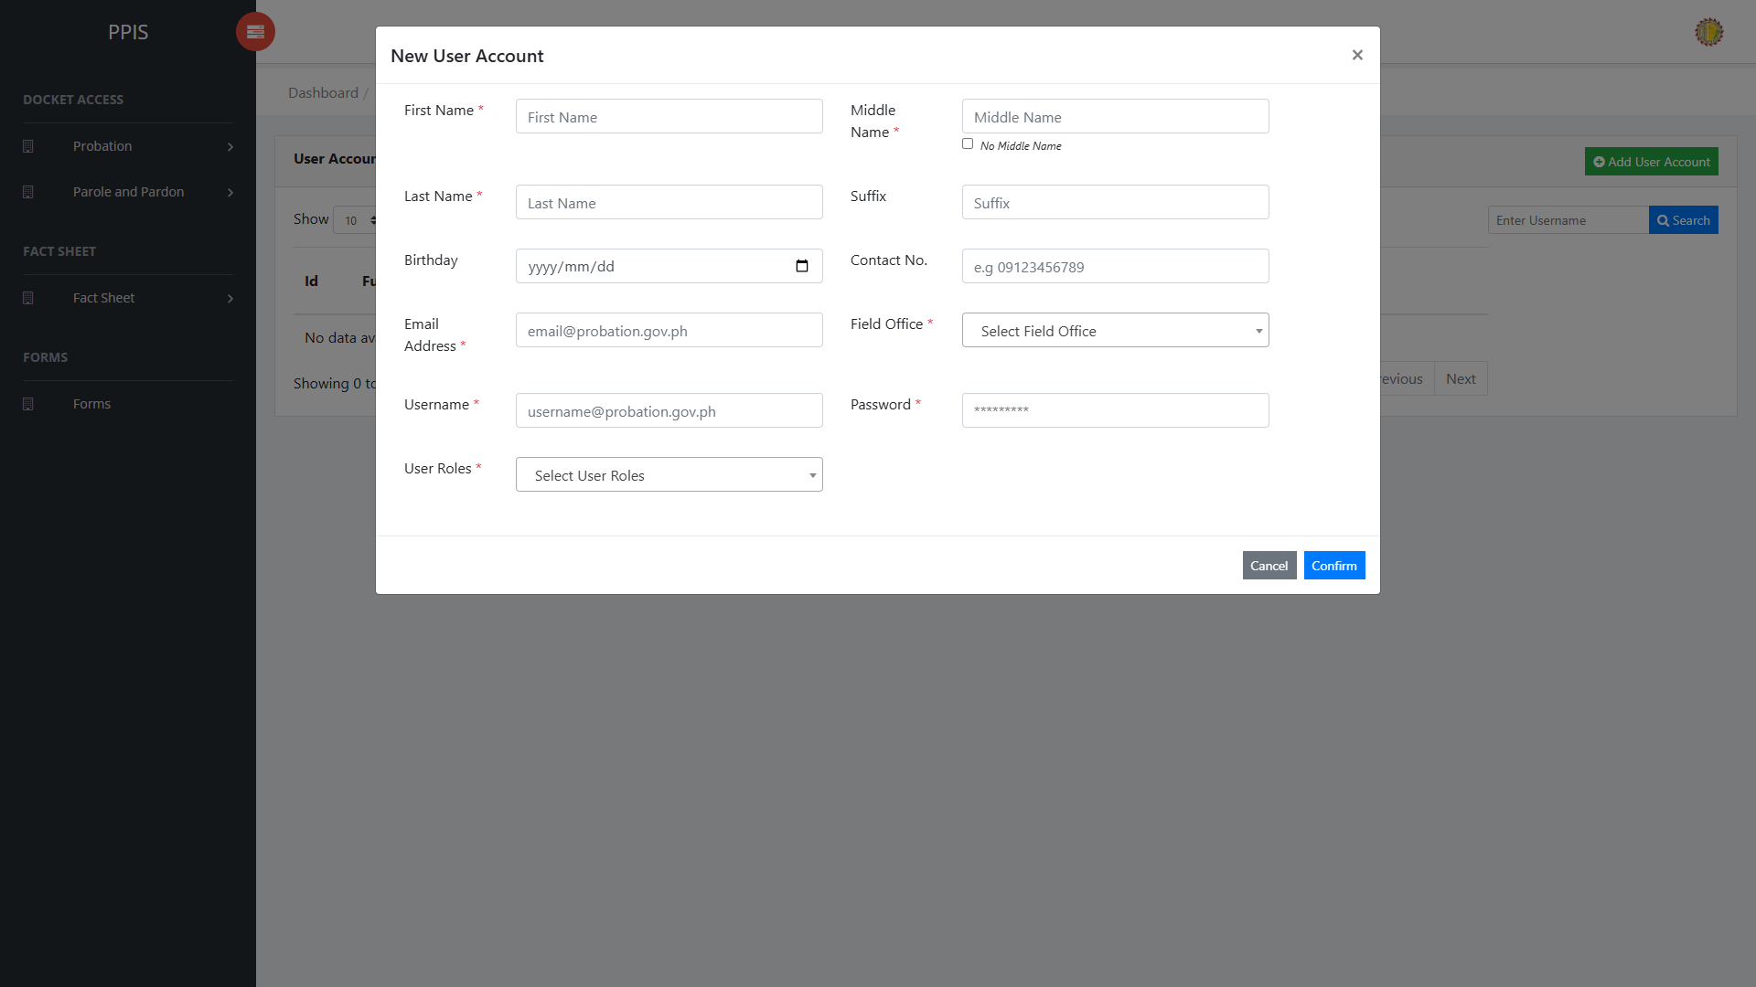
User Accounts (Add Record)

User Roles (For Administrator of the System)
Use this page to create and maintain user’s roles and update permissions assigned to these roles.
1. From the left menu, open User Roles.
2. To find a record, enter the known information in Search.
3. In the Actions column, use Update for the selected row.
4. To filter the displayed records, enter search criteria in the inline search fields within the column headers or choose a value from the available drop-down filters. The table automatically refreshes to display the matching records.
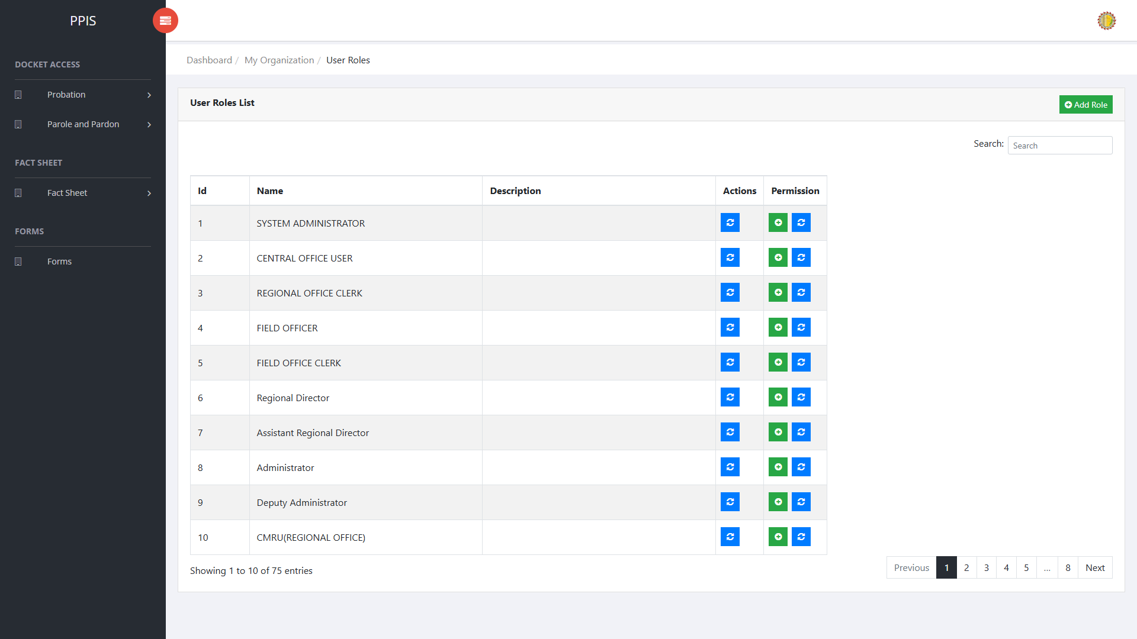
User Roles list page

User Roles (Update) (For Administrator of the System)
1. On the User Roles list page, locate the record that needs to be updated.
2. Click Update in the Actions column.
3. Wait for the modal dialog box to appear on the screen.
4. Review the current details and update User Role Name, Search inside the modal dialog.
5. Click Confirm inside the modal dialog to submit the changes.
6. If the system displays a confirmation prompt, review the information and click Confirm to save the updated record.
7. Wait for the modal dialog to close. The table refreshes and displays the updated record.
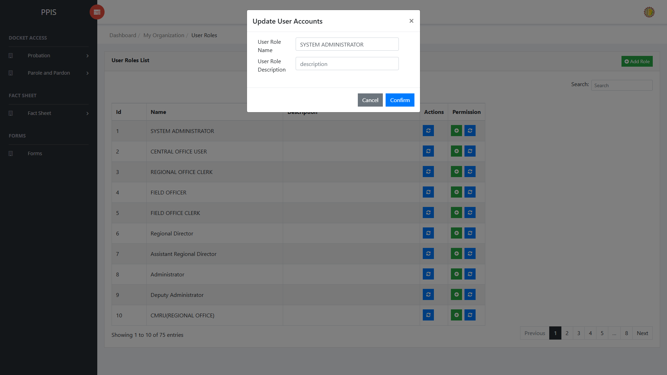
User Roles (Update)

User Roles (Add Record) (For Administrator of the System)
1. On the User Roles page, click Add Role.
2. Wait for the modal dialog box to appear on the screen.
3. Enter User Role Name, User Role Description, Search inside the modal dialog.
4. Click Confirm inside the modal dialog to submit the new record.
5. If the system displays a confirmation prompt, review the information and click Confirm to save the entry.
6. Wait for the modal dialog to close. The table refreshes and displays the newly added record.
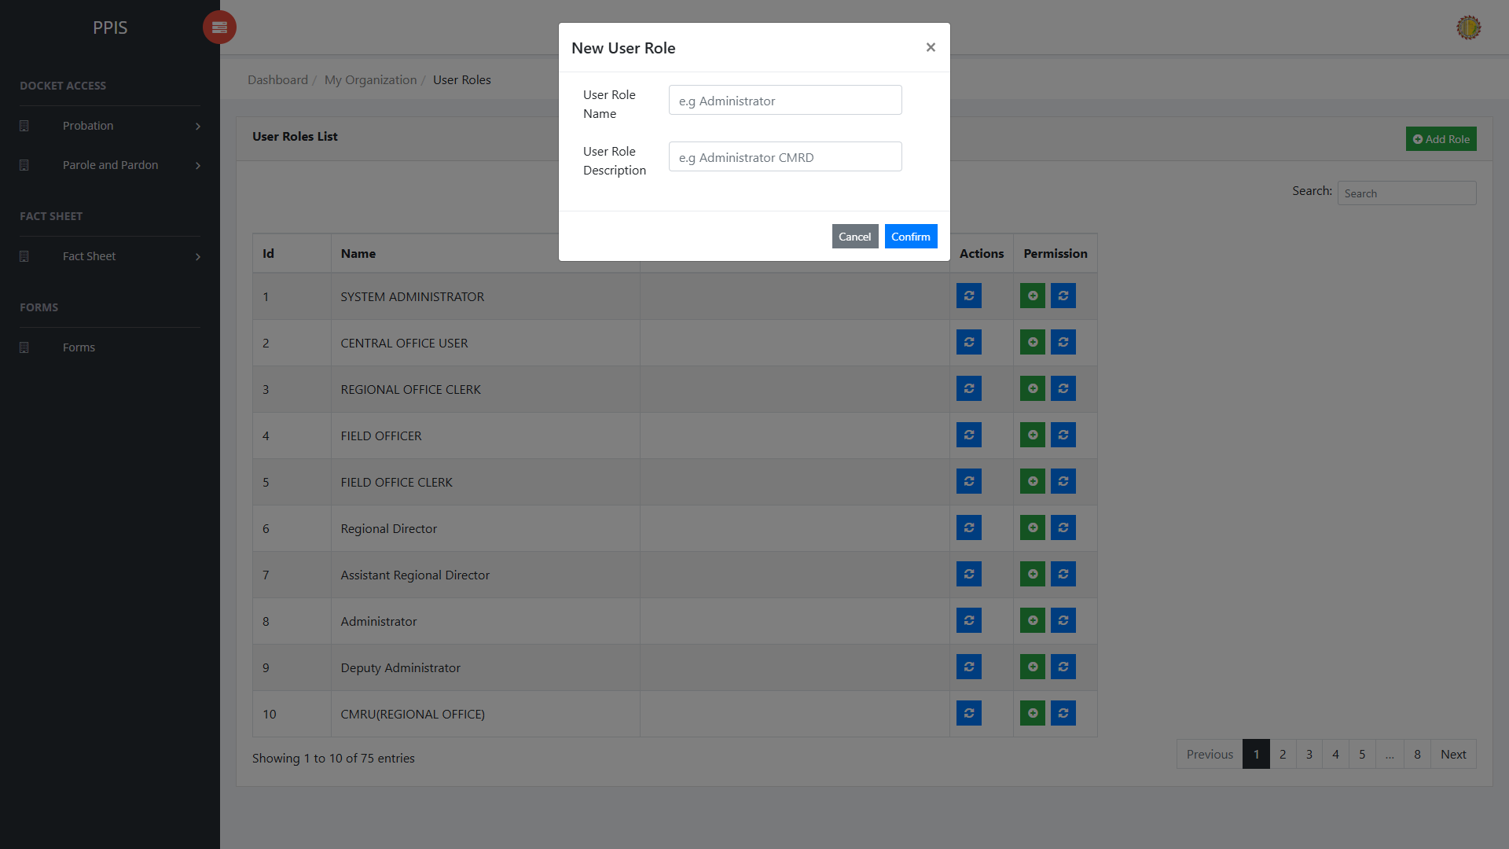
User Roles (Add Record)

Field Office (For Administrator of the System)
Use this page to maintain field office records.
1. From the left menu, open Field Office.
2. To find a record, enter the known information in Search field.
3. In the Actions column, use View, Update, Remove for the selected row.
4. To filter the displayed records, enter search criteria in the inline search fields within the column headers or choose a value from the available drop-down filters. The table automatically refreshes to display the matching records.
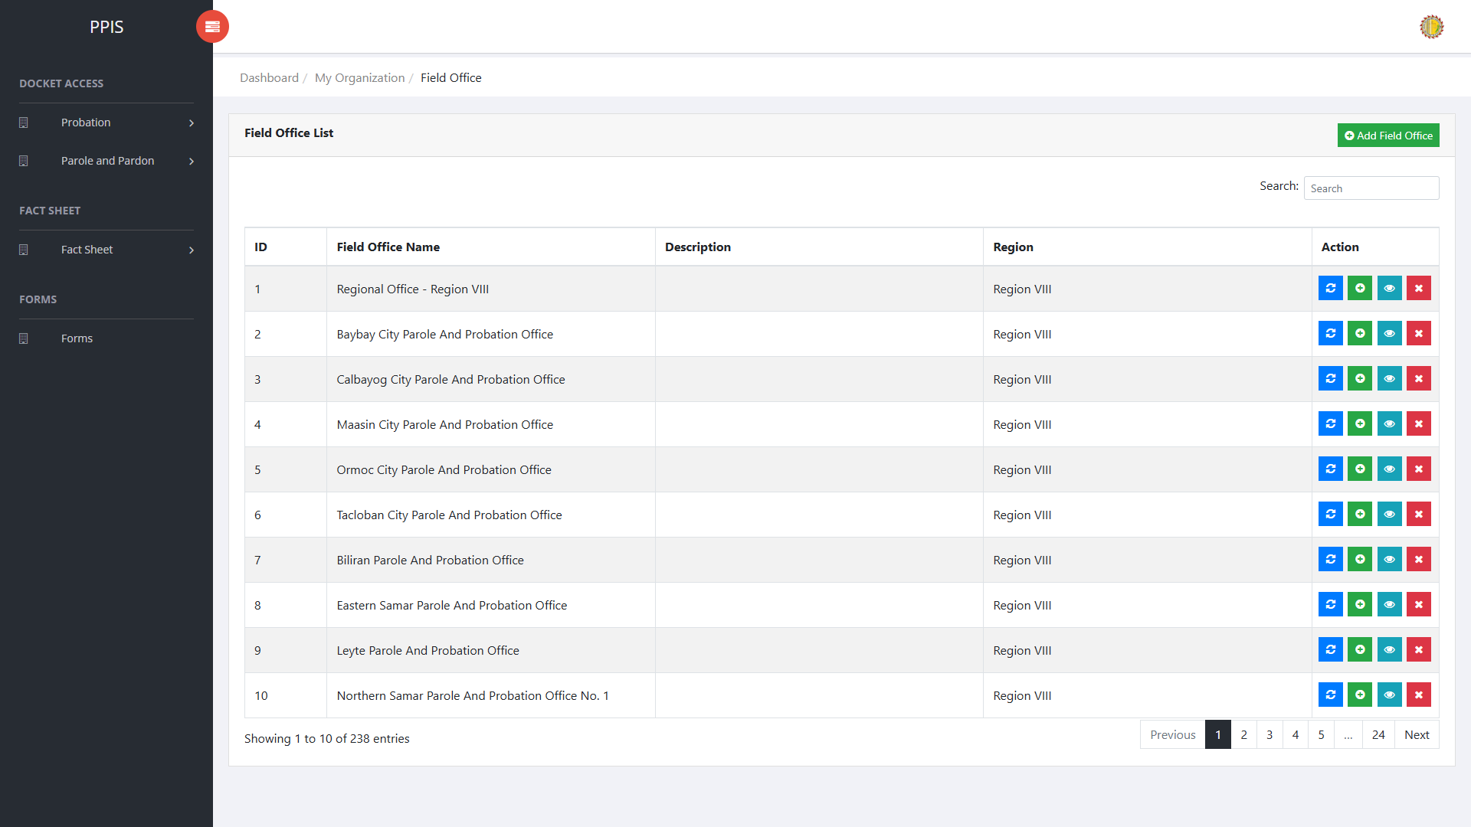
Field Office list page

Field Office (View) (For Administrator of the System)
1. On the Field Office list page, locate the record that needs to be reviewed.
2. Click View in the Actions column.
3. Read the details on the view page. Use this screen for checking information before making any changes.
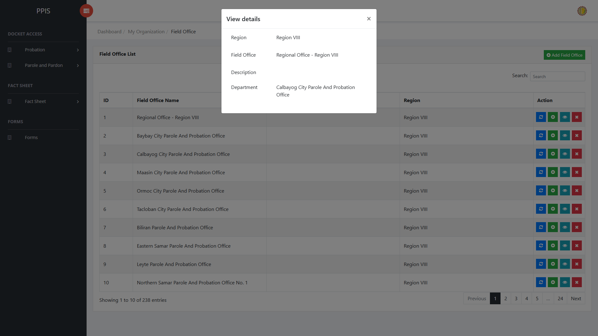
Field Office (View)

Field Office (Update) (For Administrator of the System)
1. On the Field Office list page, locate the record that needs correction.
2. Click Update in the Actions column.
3. Wait for the modal dialog box to appear on the screen.
4. Review the current details and update Region, Field Office, Description, Search inside the modal dialog.
5. Click Confirm inside the modal dialog to submit the changes.
6. If the system displays a confirmation prompt, review the information and click Confirm to save the updated record.
7. Wait for the modal dialog to close. The table refreshes and displays the updated record.
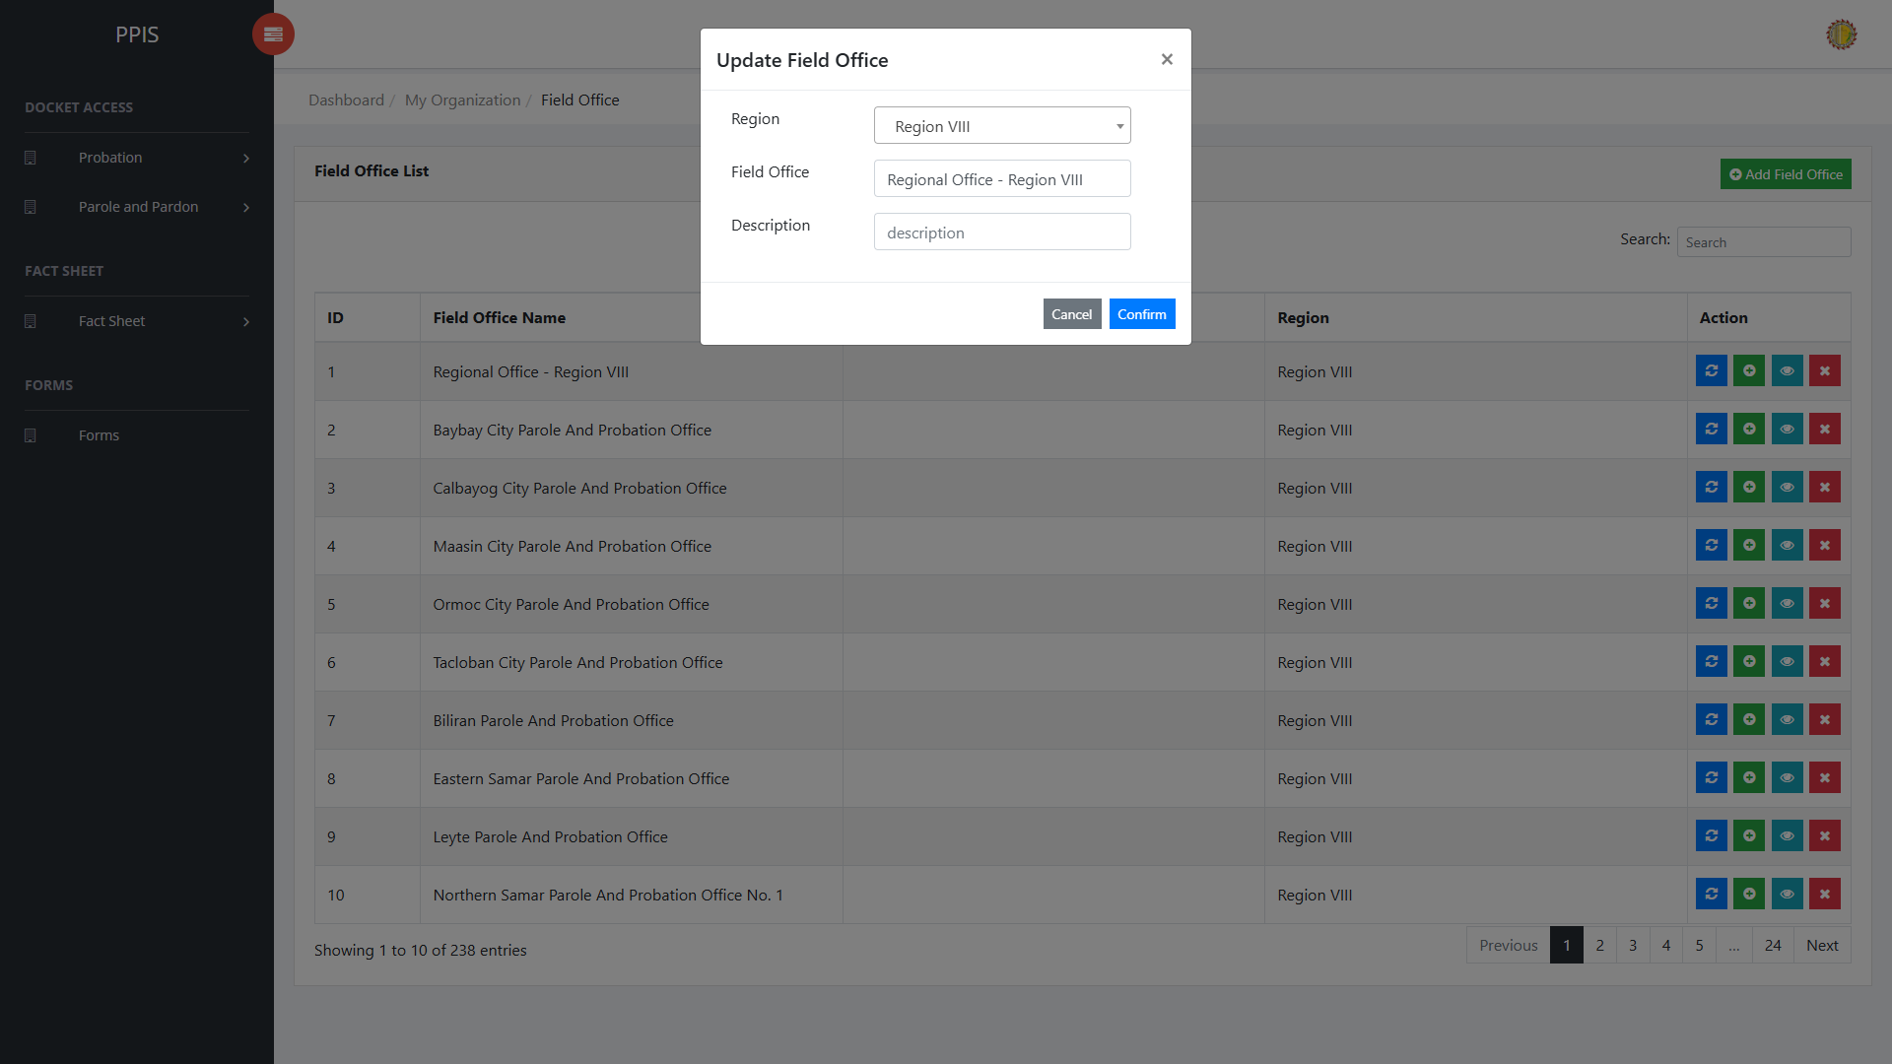
Field Office (Update)

Field Office (Delete) (For Administrator of the System)
Deletion warning: Use Remove only for records approved for deletion. For documentation, stop at the confirmation dialog unless removal is required.

1. On the Field Office list page, locate the record to be deleted.
2. Click Remove in the Actions column.
3. Wait for the confirmation modal dialog box to appear.
4. Read the confirmation message carefully. The system warns that removal cannot be undone.
5. Click Cancel inside the modal dialog to stop, or click Remove inside the modal dialog only when deletion is authorized.
6. Wait for the modal dialog to close. The table refreshes to reflect the remaining records.
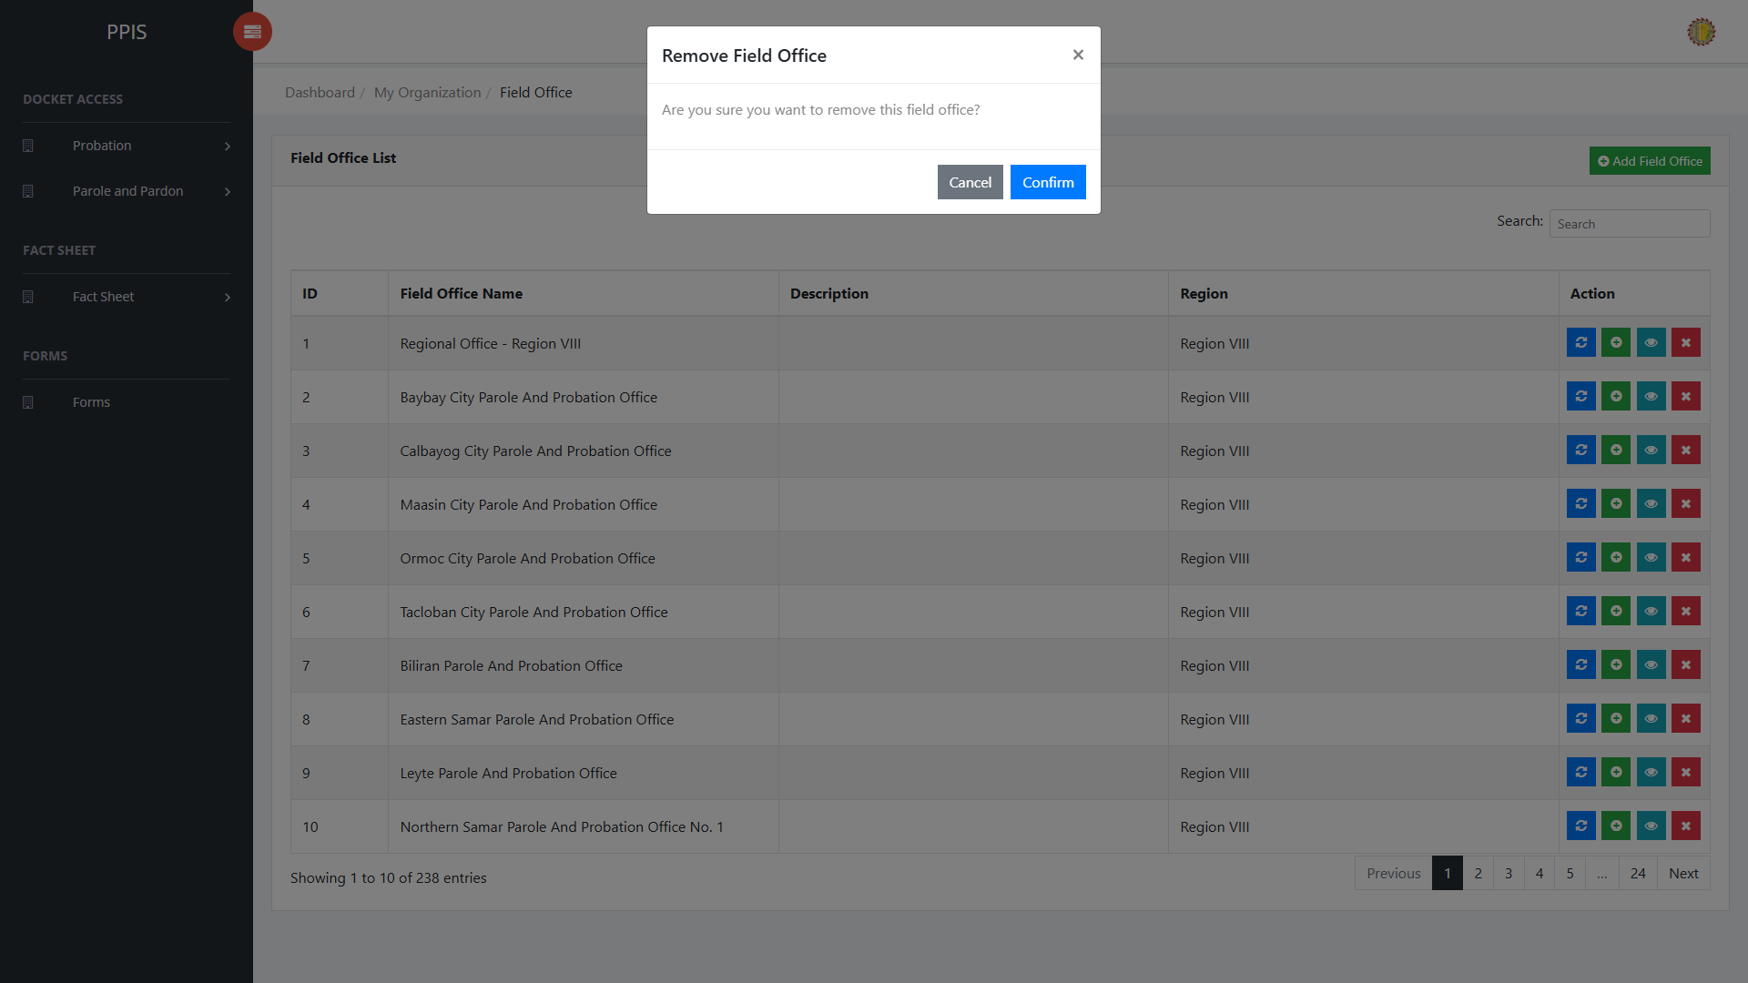
Field Office (Delete)

Field Office (Add Record) (For Administrator of the System)
1. On the Field Office page, click Add Field Office.
2. Wait for the modal dialog box to appear on the screen.
3. Enter Region, Field Office, Description, Search inside the modal dialog.
4. Click Confirm inside the modal dialog to submit the new record.
5. If the system displays a confirmation prompt, review the information and click Confirm to save the entry.
6. Wait for the modal dialog to close. The table refreshes and displays the newly added record.
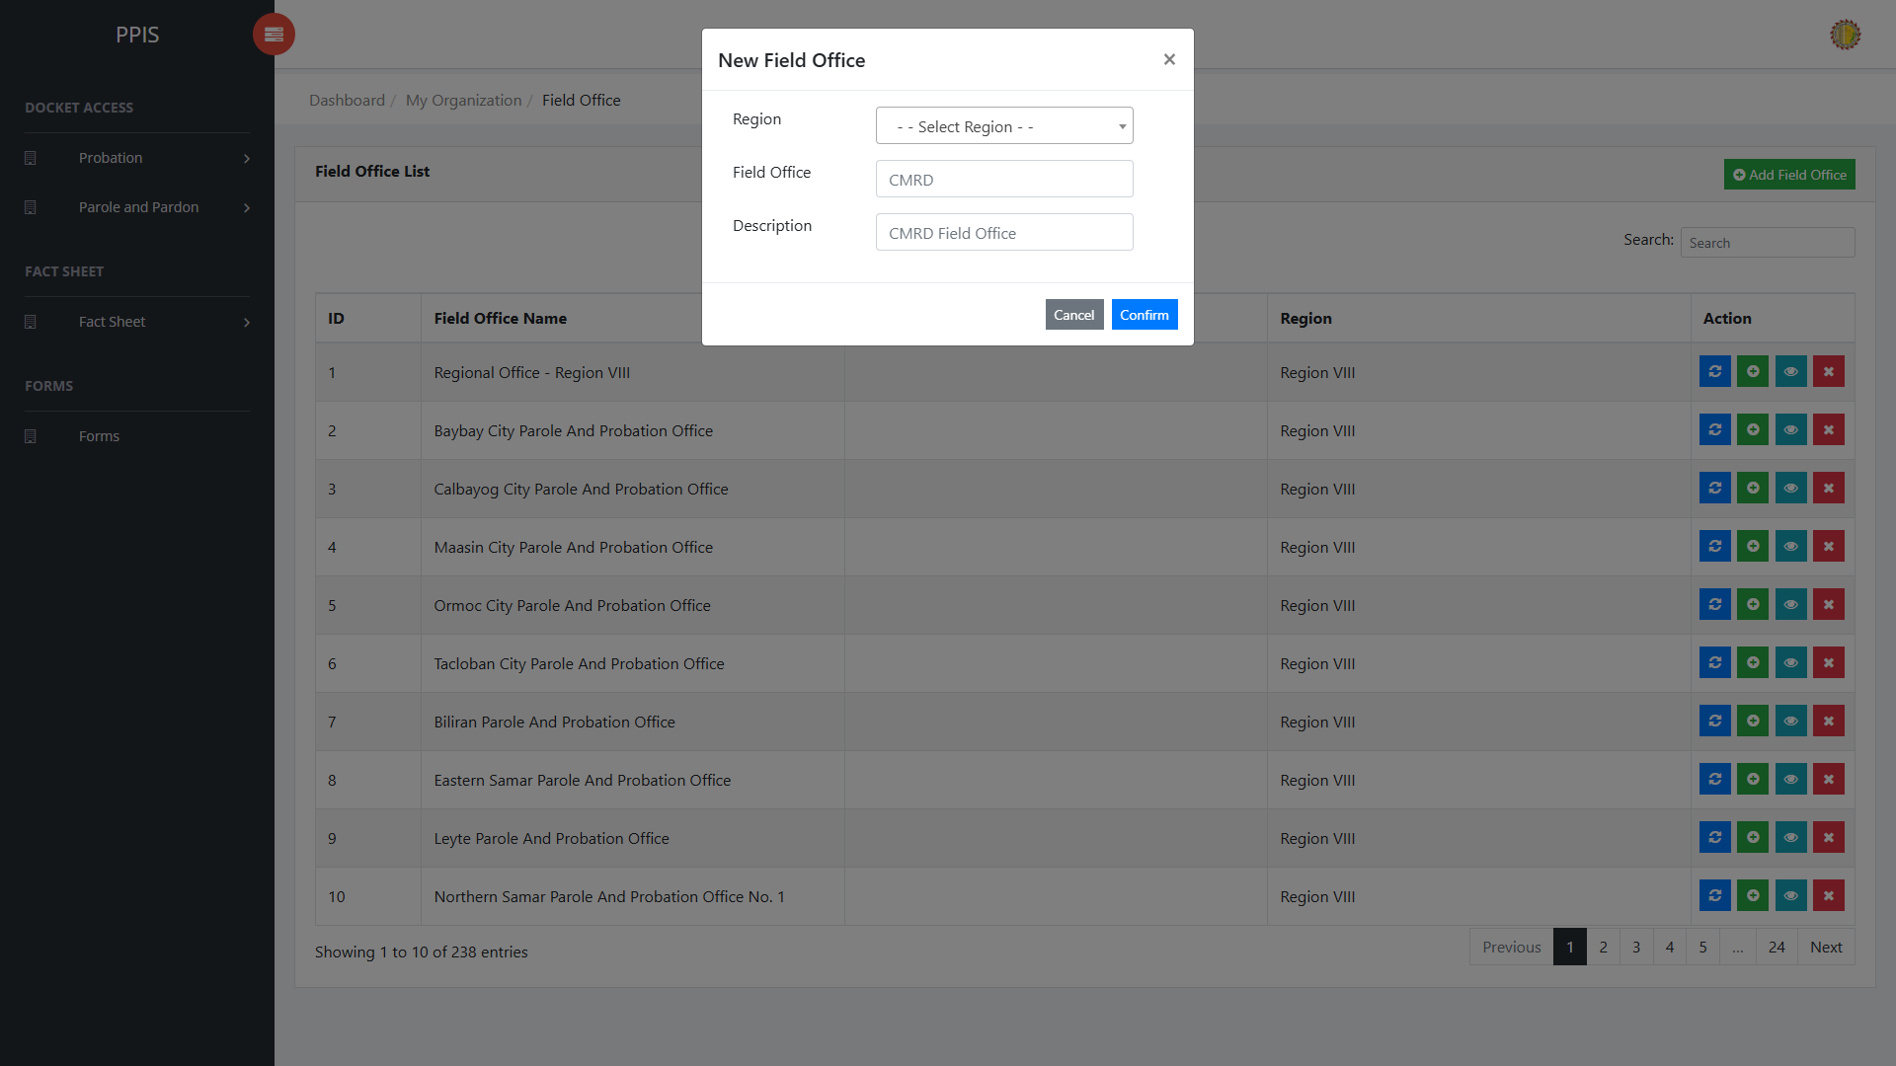
Field Office (Add Record)

Region (For Administrator of the System)
Use this page to maintain region records.
1. From the left menu, open Region.
2. To find a record, enter the known information in Search field.
3. In the Actions column, use Update, Remove for the selected row.
4. Use the inline search fields in the column headers to enter search criteria, or apply the available drop-down filters above the columns. The table dynamically updates to display matching records as search terms are entered or filter values are selected.
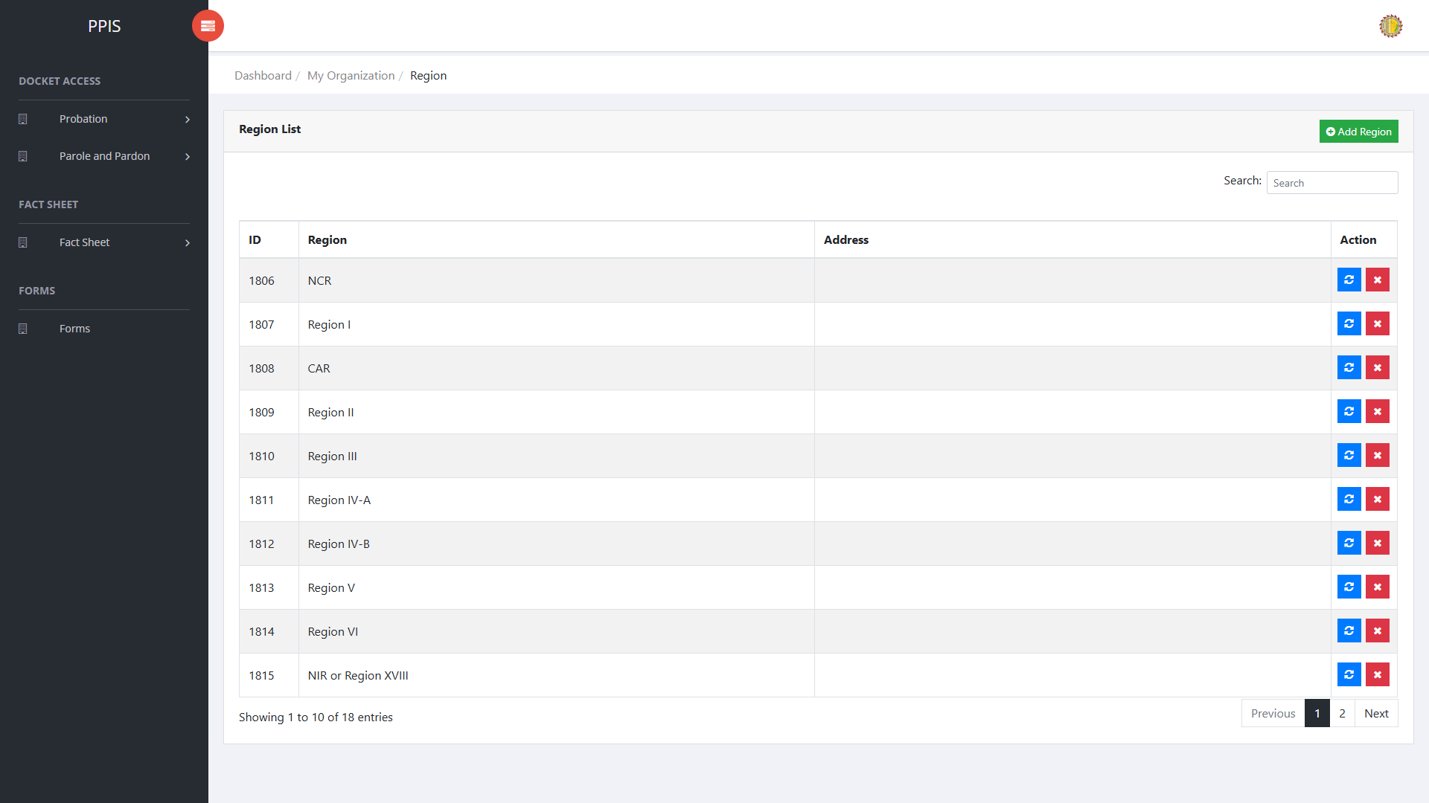
Region list page

Region (Update) (For Administrator of the System)
1. On the Region list page, locate the record that needs to be updated
2. Click Update in the Actions column.
3. Wait for the modal dialog box to appear on the screen.
4. Review the current details and update Region Name, Search inside the modal dialog.
5. Click Confirm inside the modal dialog to submit the changes.
6. If the system displays a confirmation prompt, review the information and click Confirm to save the updated record.
7. Wait for the modal dialog to close. The table refreshes and displays the updated record.
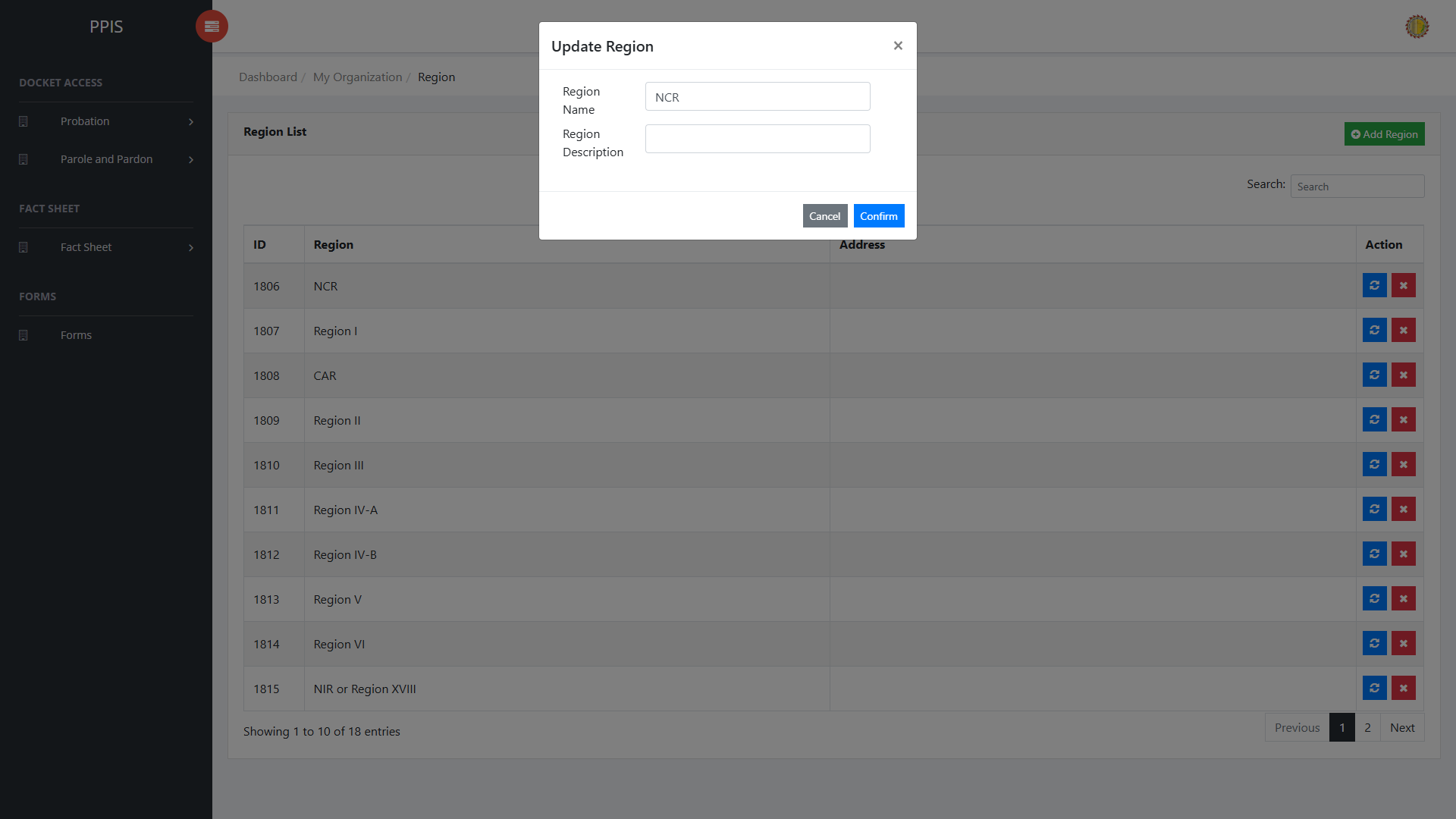
Region (Update)

Region (Delete) (For Administrator of the System)
Deletion warning: Use Remove only for records approved for deletion. For documentation, stop at the confirmation dialog unless removal is required.

1. On the Region list page, locate the record to be deleted.
2. Click Remove in the Actions column.
3. Wait for the confirmation modal dialog box to appear.
4. Read the confirmation message carefully. The system warns that removal cannot be undone.
5. Click Cancel inside the modal dialog to stop, or click Remove inside the modal dialog only when deletion is authorized.
6. Wait for the modal dialog to close. The table refreshes to reflect the remaining records.
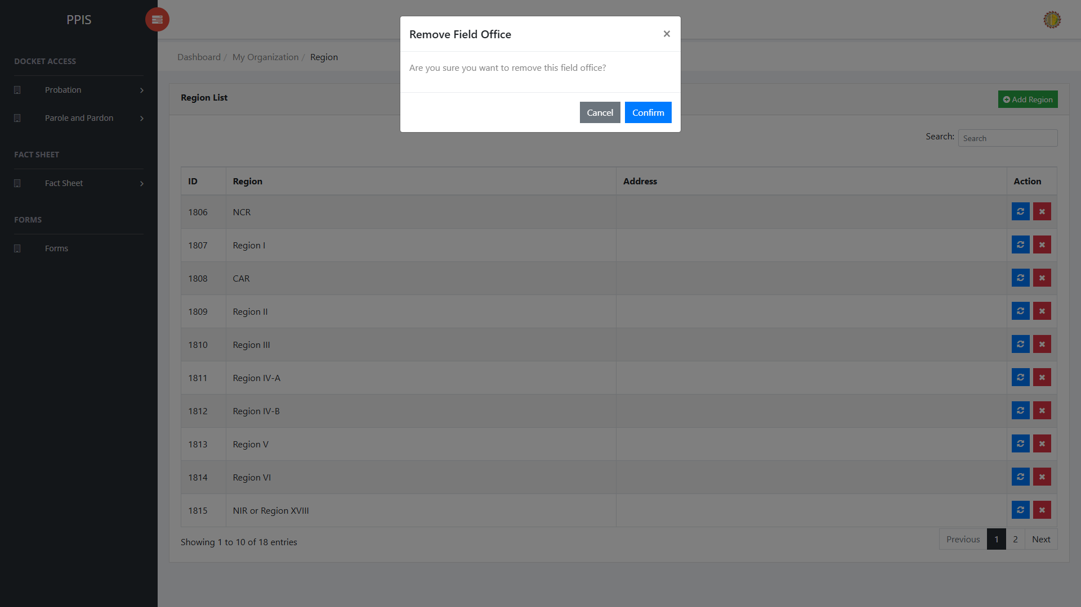
Region (Delete)

Region (Add Record) (For Administrator of the System)
1. On the Region page, click Add Region.
2. Wait for the modal dialog box to appear on the screen.
3. Enter Region, Description, Search inside the modal dialog.
4. Click Confirm inside the modal dialog to submit the new record.
5. If the system displays a confirmation prompt, review the information and click Confirm to save the entry.
6. Wait for the modal dialog to close. The table refreshes and displays the newly added record.
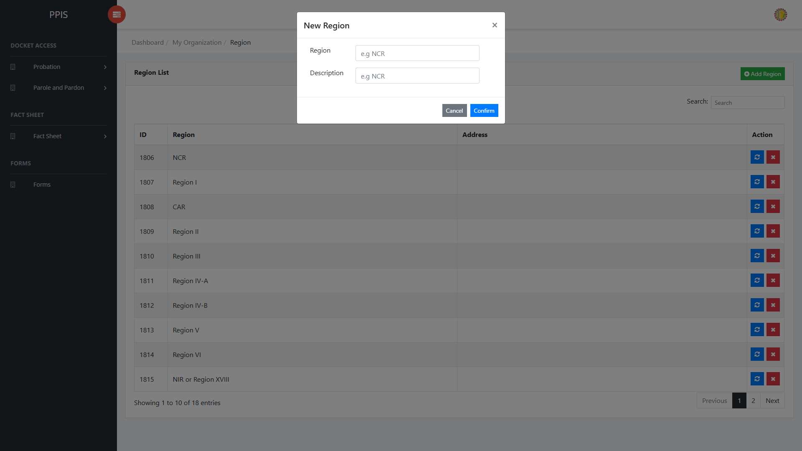
Region (Add Record)

Permission (For Administrator of the System)
Use this page to maintain permission records used by the system.
1. From the left menu, open Permission.
2. To find a record, enter the known information in Search field.
3. In the Actions column, use Update for the selected row.
4. To filter the displayed records, enter search criteria in the inline search fields within the column headers or choose a value from the available drop-down filters. The table automatically refreshes to display the matching records.
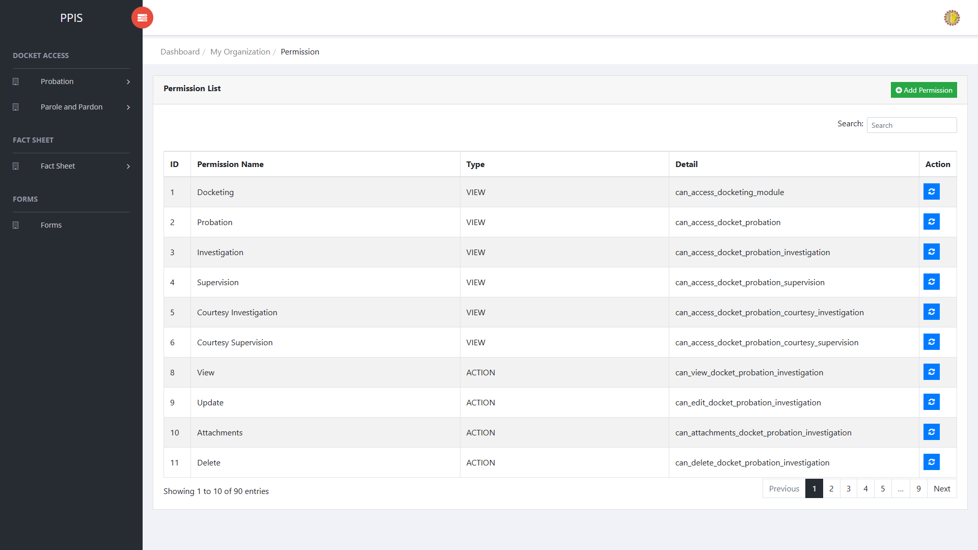
Permission list page

Permission (Update) (For Administrator of the System)
1. On the Permission list page, locate the record that needs to be updated.
2. Click Update in the Actions column.
3. Wait for the modal dialog box to appear on the screen.
4. Review the current details and update Permission Name, Type, Detail, Search inside the modal dialog.
5. Click Confirm inside the modal dialog to submit the changes.
6. If the system displays a confirmation prompt, review the information and click Confirm to save the updated record.
7. Wait for the modal dialog to close. The table refreshes and displays the updated record.
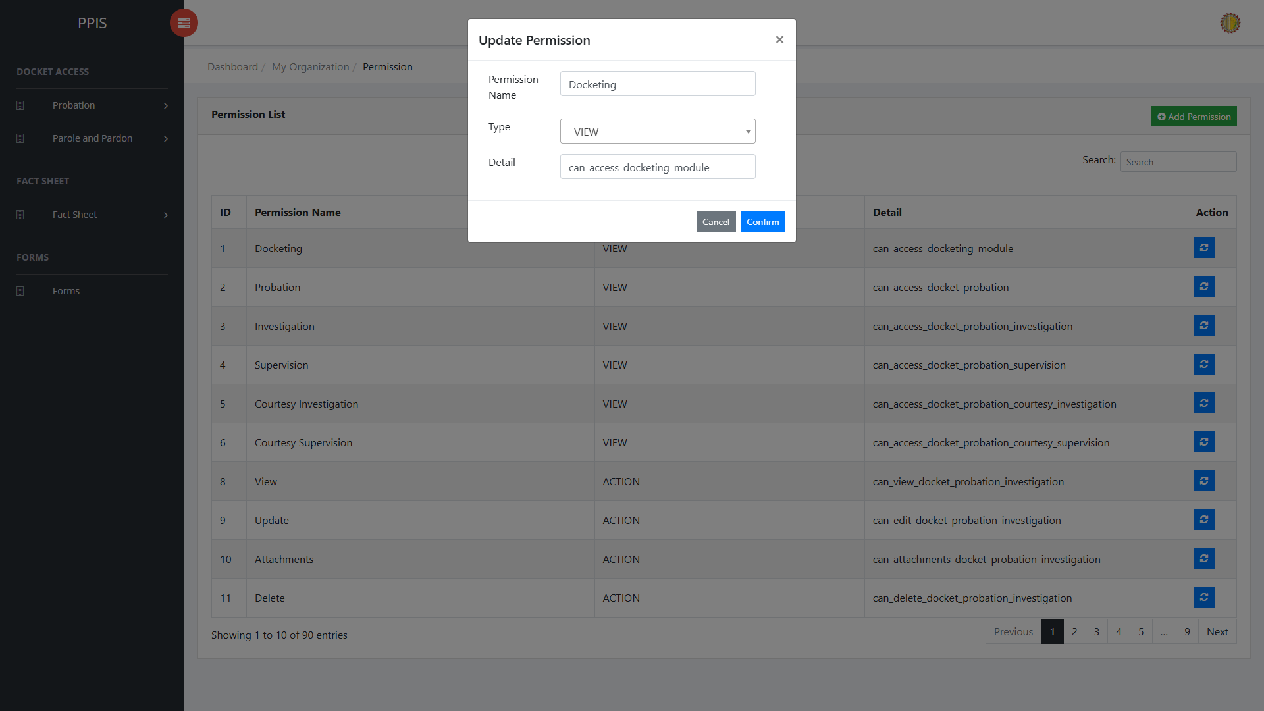
Permission (Update)

Permission (Add Record) (For Administrator of the System)
1. On the Permission page, click Add Permission.
2. Wait for the modal dialog box to appear on the screen.
3. Enter Permission Name, Type, Detail, Search inside the modal dialog.
4. Click Confirm inside the modal dialog to submit the new record.
5. If the system displays a confirmation prompt, review the information and click Confirm to save the entry.
6. Wait for the modal dialog to close. The table refreshes and displays the newly added record.
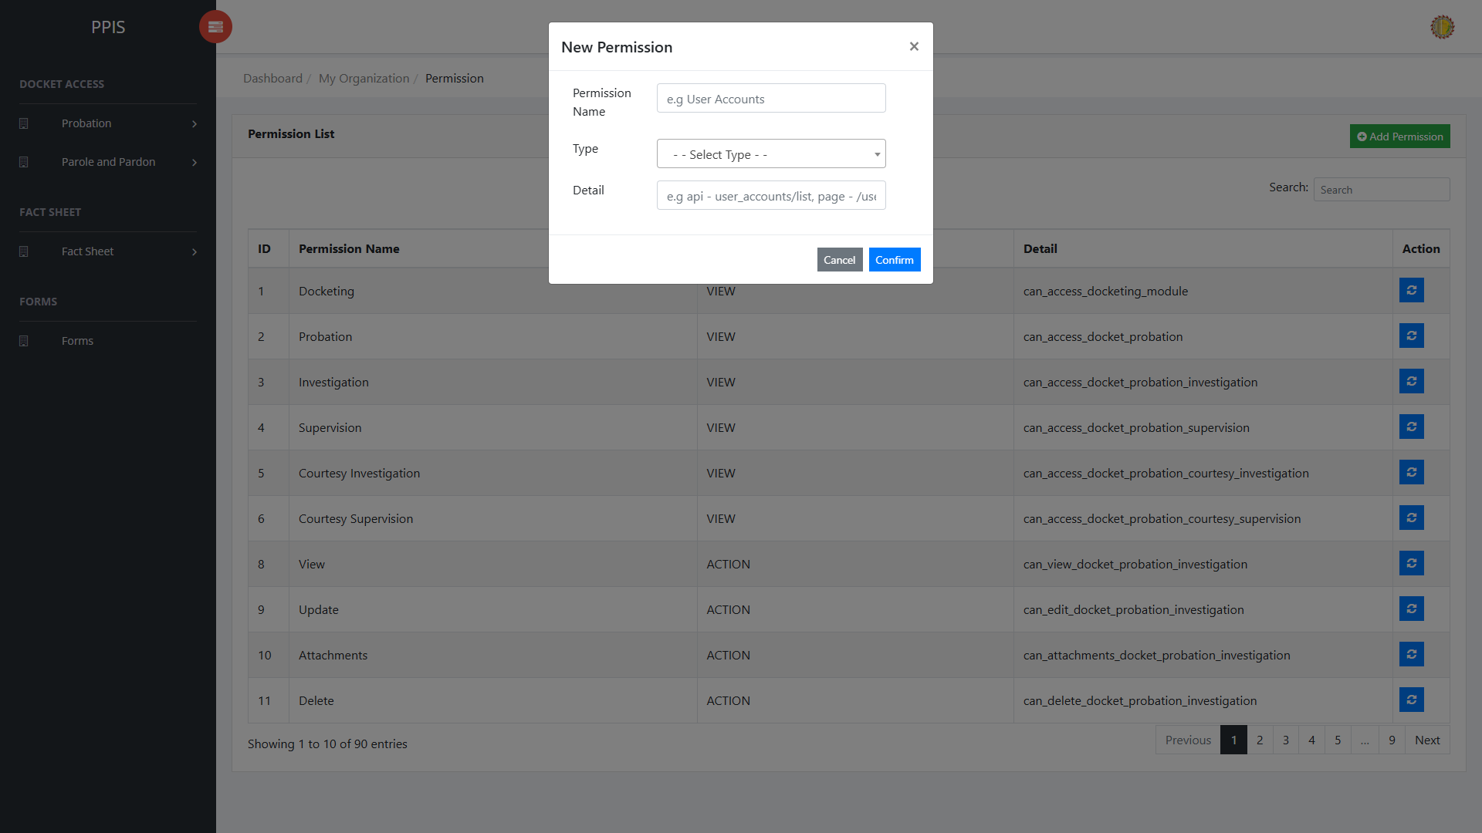
Permission (Add Record)

