PIS End User Manual
Probation and Parole Information System
End-User Operating Guide
Website: http://localhost/pis/
Document Date: June 29, 2026

Table of Contents
• 1. What is PIS?
• 2. System Modules
• 3. Logging In
• 4. Navigation
• 5. Docket Access
• 6. Docket Routing
• 7. Sent and Inbox
• 8. Fact Sheet
• 9. Forms
• 10. My Organization
• 11. Safe Editing, Deleting, and Troubleshooting

1. What is PIS?
PIS stands for Probation and Parole Information System. As the name implies, the system is used for managing probation, parole, and pardon docketing, routing, fact sheets, and organizational records across field offices and workflow queues.
The system automatically processes and aggregates tracking and docketing workflows. Users can search, view, update, attach files to, route, and remove records according to their assigned role and permissions.
Users can add, update, and delete records after selecting the corresponding module and action. They can export visible table data through CSV, PDF, and EXCEL buttons, and print records through the Print button where those controls appear on data tables.
Users can filter records instantly by typing directly into inline column search headers or by selecting values from drop-down filters above table columns. Filtered results update automatically as criteria are entered.
Manual purpose: This manual guides probation and parole staff through the PIS website using the actual screens and labels shown in the system.

Role access: Menus may vary by user role. If a module is not visible, ask the system administrator to check your account permissions.

Screenshot indicators: Red boxes and arrows labeled Click show the control to select in each screenshot.

2. System Modules
• Docket Access - Work with probation, parole, and pardon docket records.
• Docket Routing - Route dockets between offices or workflow queues.
• Sent and Inbox - Review items that were sent or received.
• Fact Sheet - Open and maintain client fact sheet records.
• Forms - View and add documents when permitted.
• My Organization - Maintain users, roles, field offices, regions, and permissions.

3. Logging In
1. Open http://localhost/pis/ in a supported browser.
2. Type your username in the Email address field.
3. Type your password in the password field.
4. Click SIGN IN.
5. Wait for PIS to open the first page allowed for your account.
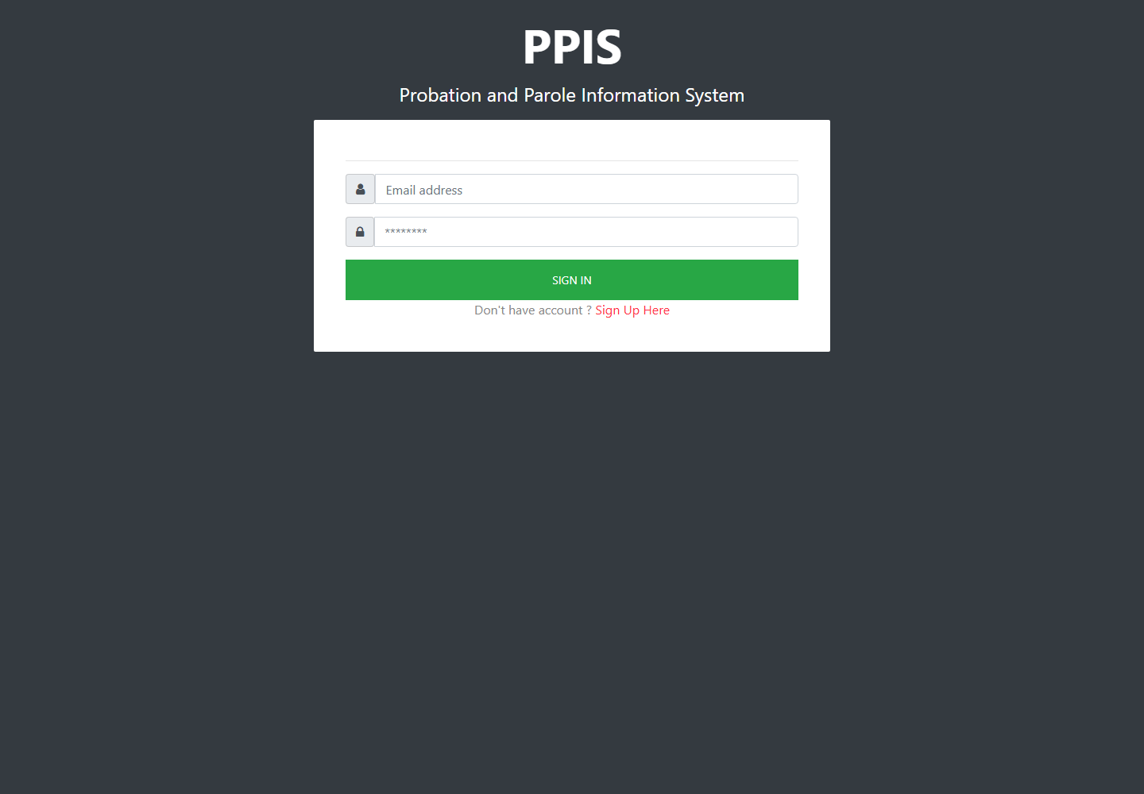
Login page

4. Navigation
1. Use the left menu to move between Docket Access, Docket Routing, Fact Sheet, Forms, and My Organization.
2. Click a menu group such as Probation, Sent, Inbox, or My Organization to show its submenu.
3. Click the exact module name you need to open.
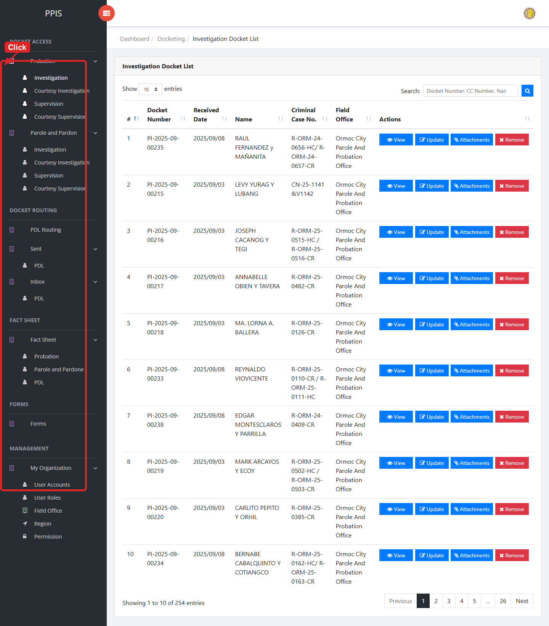
Main navigation

5. Docket Access

Probation Investigation
Use this page to find, review, update, attach files to, or remove probation investigation dockets.
1. From the left menu, open Probation Investigation.
2. To find a record, enter the known information in Docket Number, CC Number, Name.
3. Click Run search to apply the search.
4. In the Actions column, use View, Update, Attachments, Remove for the selected row.
5. To filter the table instantly, type characters directly into the inline search boxes in the column headers, or select a value from any drop-down filter shown above a column. The table updates automatically as you type or select.
6. To export the currently displayed table data, click CSV, PDF, or EXCEL above the table when those buttons are shown. The system downloads the visible records in the selected format.
7. To print the table, click Print. The native browser print window opens. Review the layout settings, then click Print in that window to complete printing.
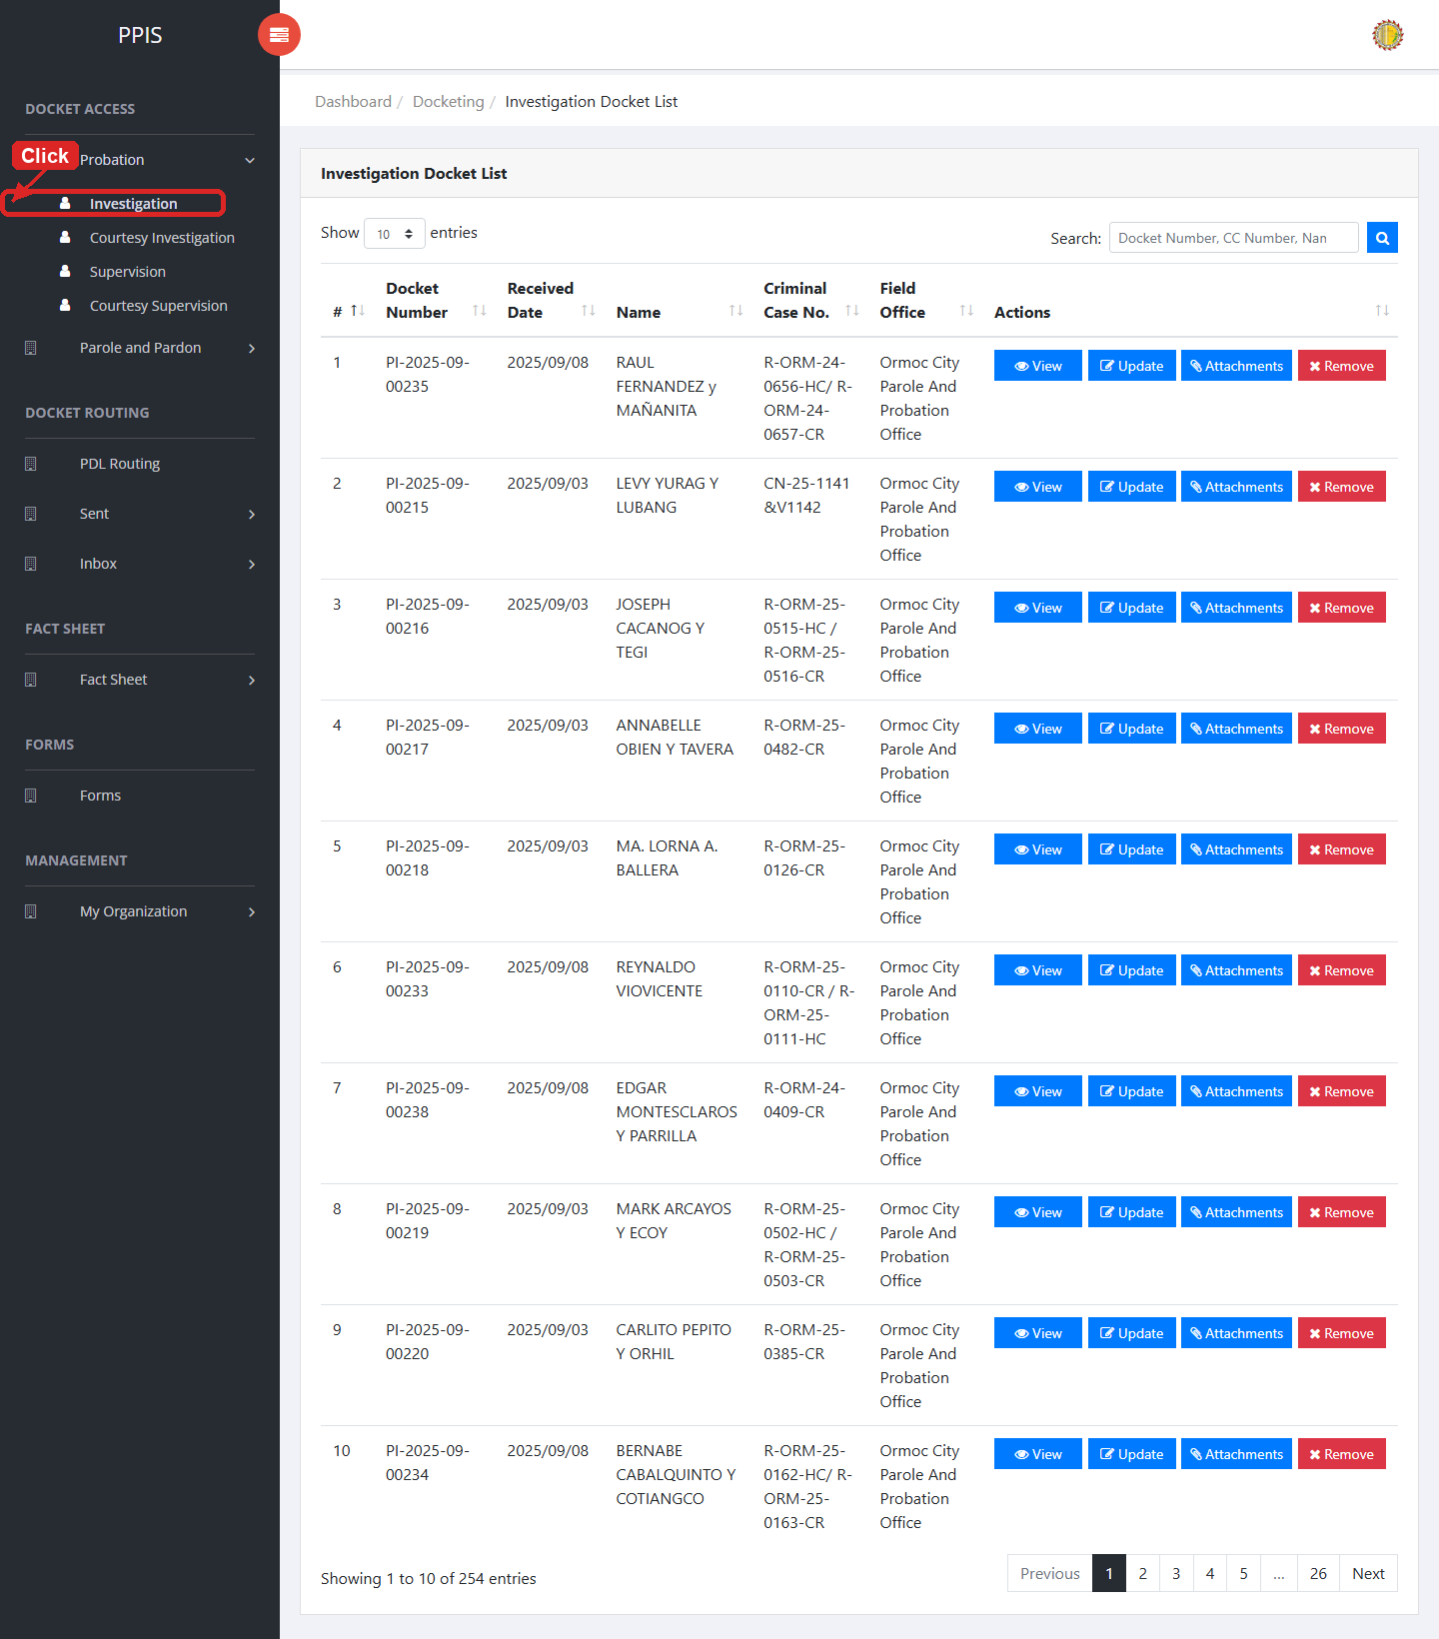
Probation Investigation list page

Probation Investigation (View)
1. On the Probation Investigation list page, locate the record you need to review.
2. Click View in the Actions column.
3. Read the details on the view page. Use this screen for checking information before making any changes.
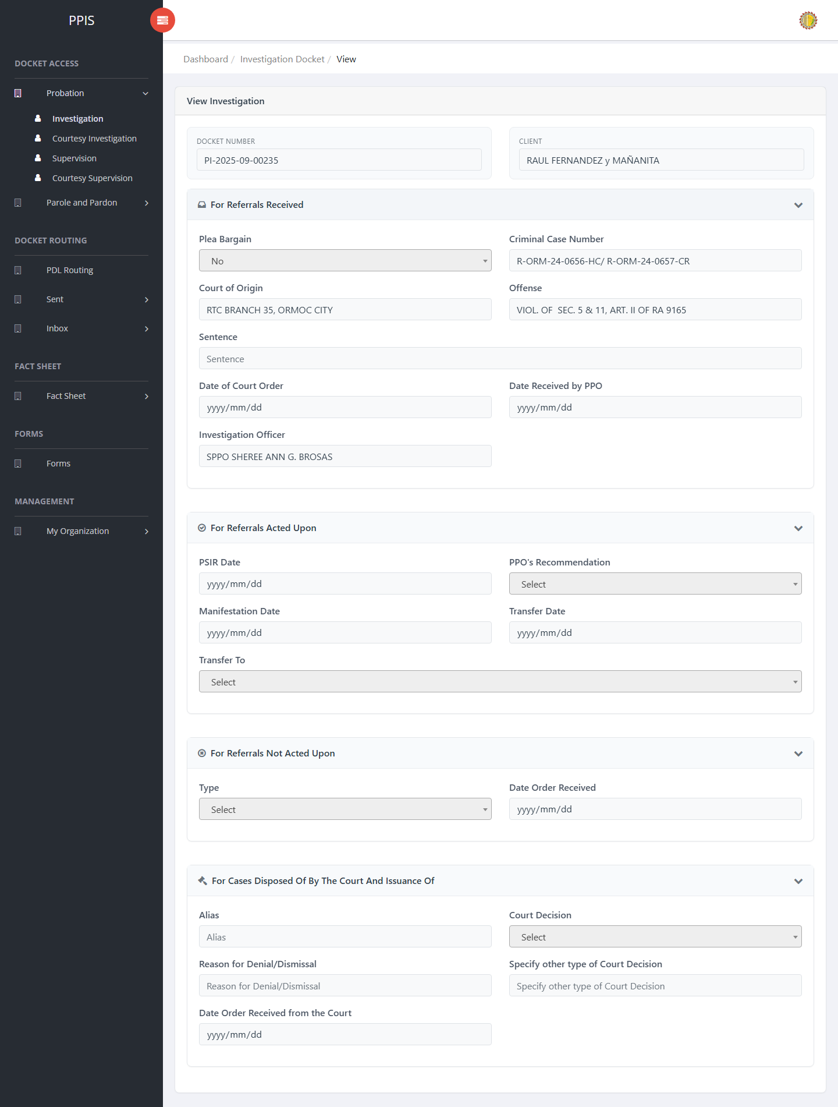
Probation Investigation (View)

Probation Investigation (Update)
1. On the Probation Investigation list page, locate the record that needs correction.
2. Click Update in the Actions column.
3. Wait for the update screen to open.
4. Review the current details and update Docket Number, Client Name, Plea Bargain, Criminal Case Number, Court of Origin, Offense, Sentence, Date of Court Order.
5. Click Confirm to save after checking the information.
6. Wait for the system to return to the list page or refresh the record display.
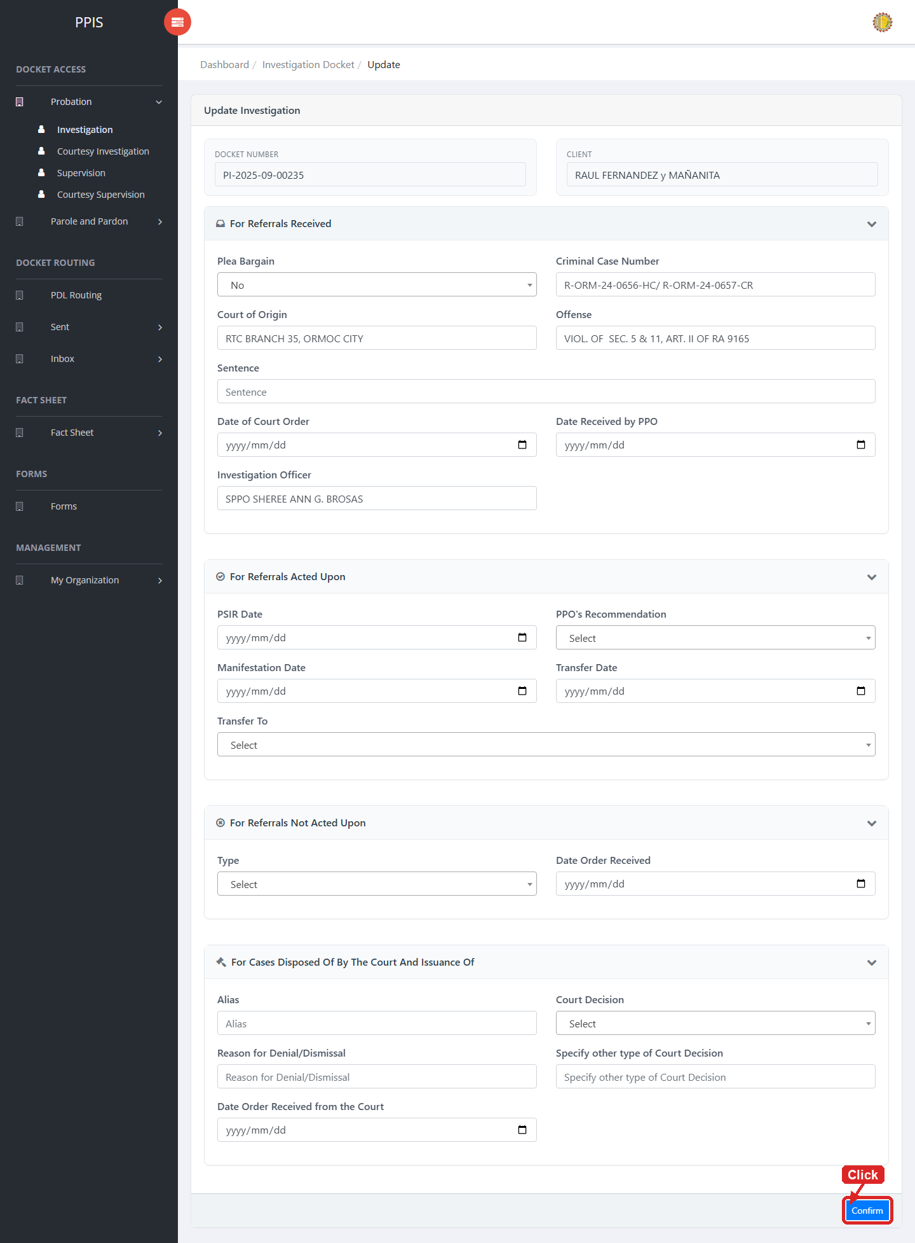
Probation Investigation (Update)

Probation Investigation (Attachments)
1. On the Probation Investigation list page, click Attachments for the correct record.
2. Wait for the attachments screen to open.
3. Complete the attachment details, such as Kind, Type, and Upload File when shown.
4. Click Confirm to upload the file.
5. Use View, Download, or Delete only for the attachment listed in the table.
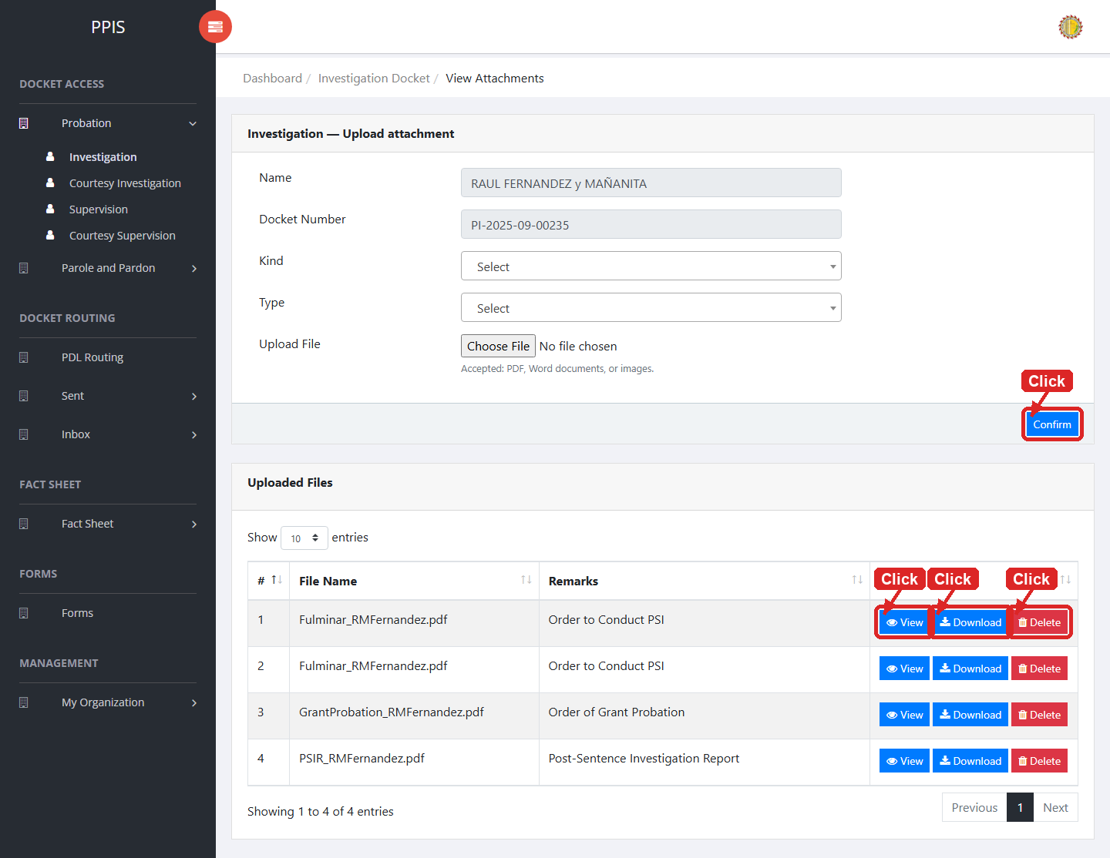
Probation Investigation (Attachments)

Probation Investigation (Delete)
Deletion warning: Use Remove only for sample/test records or records approved for deletion. For documentation, stop at the confirmation dialog unless removal is required.

1. On the Probation Investigation list page, locate the sample, test, or authorized record.
2. Click Remove in the Actions column.
3. Wait for the confirmation modal dialog box to appear.
4. Read the confirmation message carefully. The system warns that removal cannot be undone.
5. Click Cancel inside the modal dialog to stop, or click Remove permanently inside the modal dialog only when deletion is authorized.
6. Wait for the modal dialog to close. The table refreshes to reflect the remaining records.
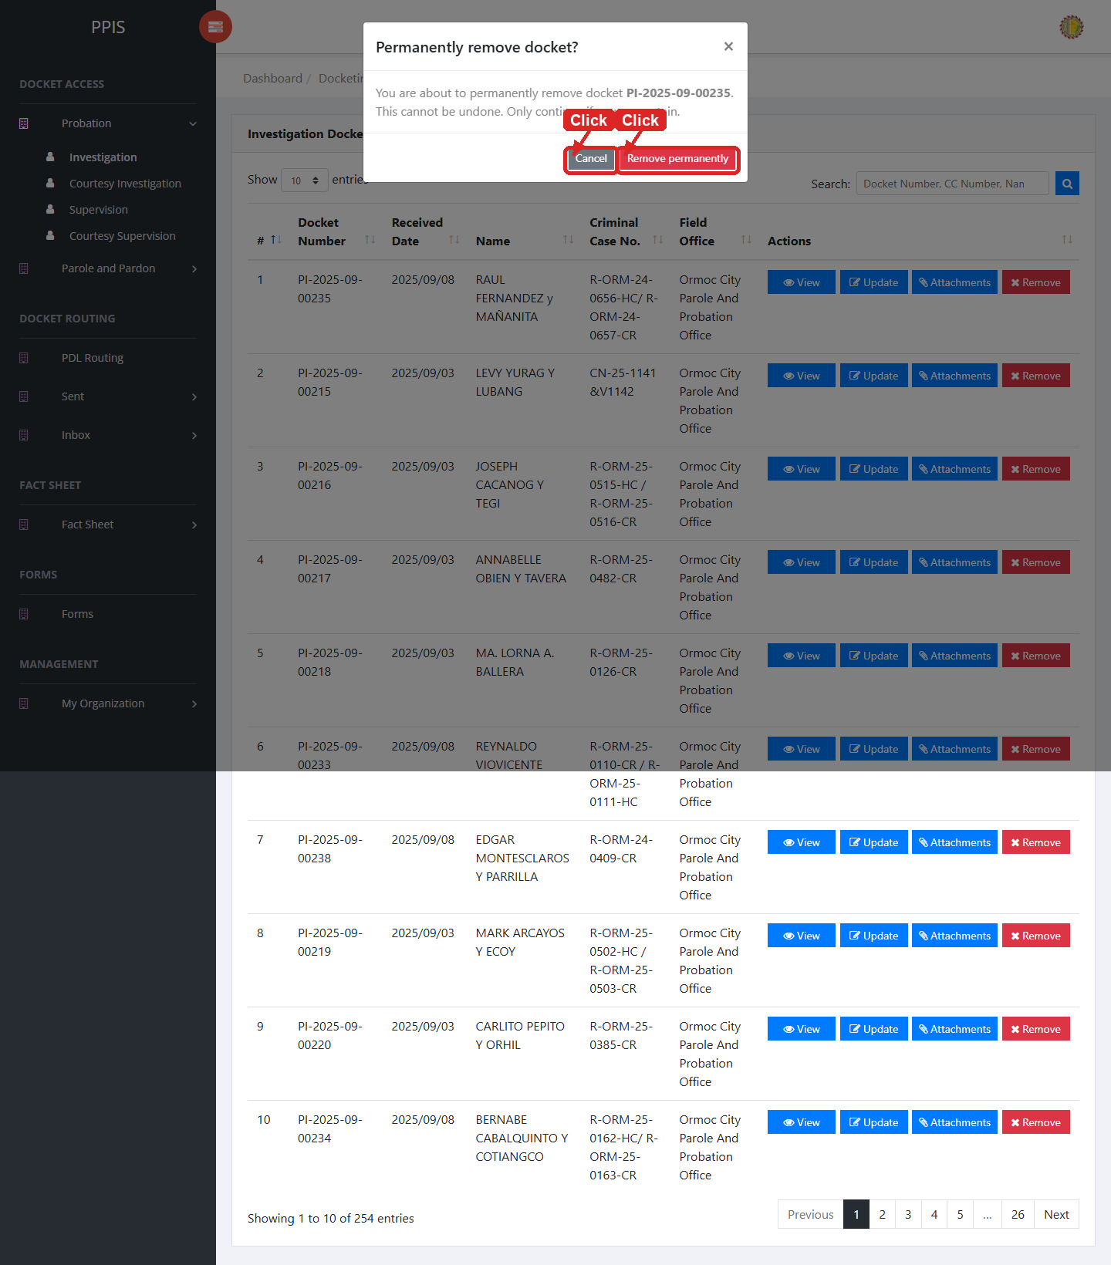
Probation Investigation (Delete)

Probation Courtesy Investigation
Use this page to manage courtesy investigation dockets under the probation workflow.
1. From the left menu, open Probation Courtesy Investigation.
2. To find a record, enter the known information in Search docket / name.
3. Click Run search to apply the search.
4. In the Actions column, use View, Update, Attachments, Remove for the selected row.
5. To filter the table instantly, type characters directly into the inline search boxes in the column headers, or select a value from any drop-down filter shown above a column. The table updates automatically as you type or select.
6. To export the currently displayed table data, click CSV, PDF, or EXCEL above the table when those buttons are shown. The system downloads the visible records in the selected format.
7. To print the table, click Print. The native browser print window opens. Review the layout settings, then click Print in that window to complete printing.
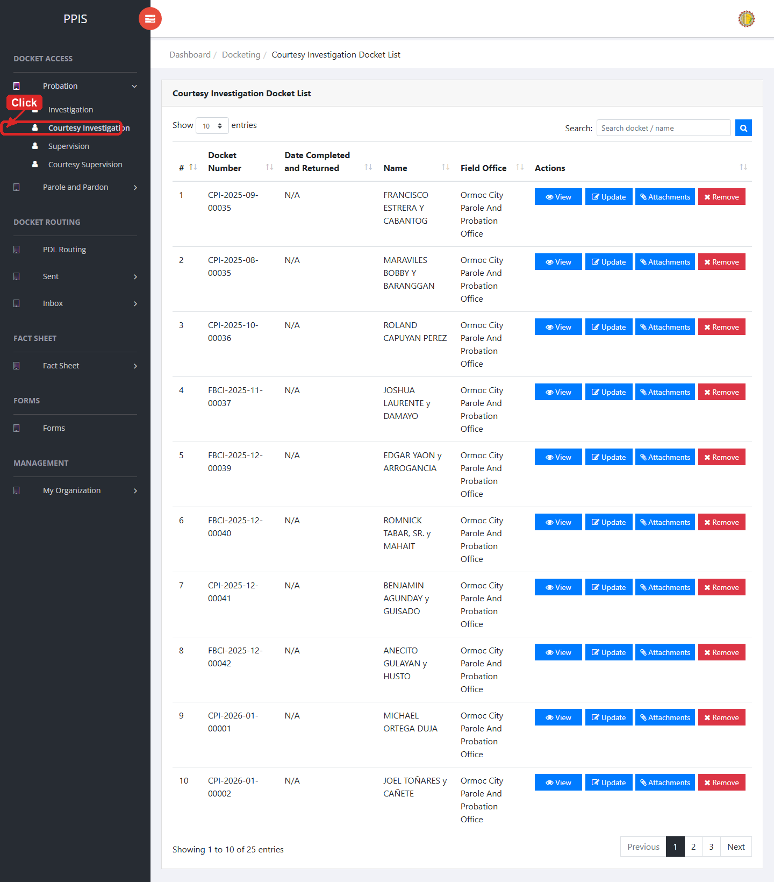
Probation Courtesy Investigation list page

Probation Courtesy Investigation (View)
1. On the Probation Courtesy Investigation list page, locate the record you need to review.
2. Click View in the Actions column.
3. Read the details on the view page. Use this screen for checking information before making any changes.
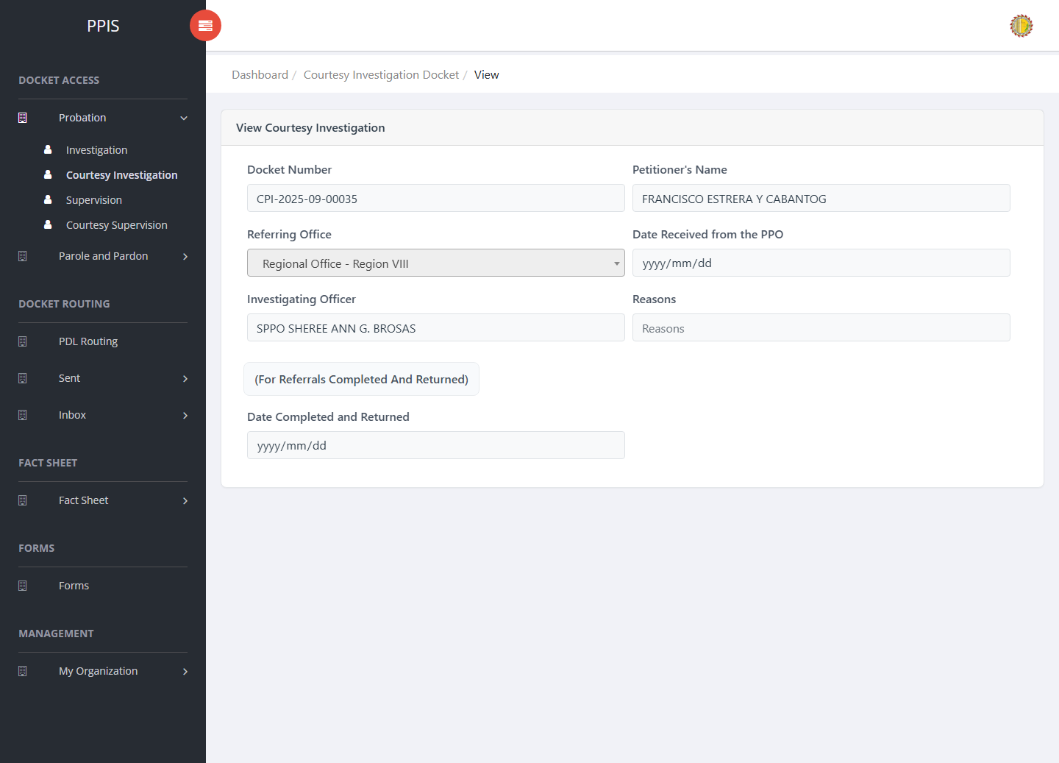
Probation Courtesy Investigation (View)

Probation Courtesy Investigation (Update)
1. On the Probation Courtesy Investigation list page, locate the record that needs correction.
2. Click Update in the Actions column.
3. Wait for the update screen to open.
4. Review the current details and update Docket Number, Petitioner's Name, Referring Office, Date Received from the PPO, Investigating Officer, Reasons, Date Completed and Returned.
5. Click Confirm to save after checking the information.
6. Wait for the system to return to the list page or refresh the record display.
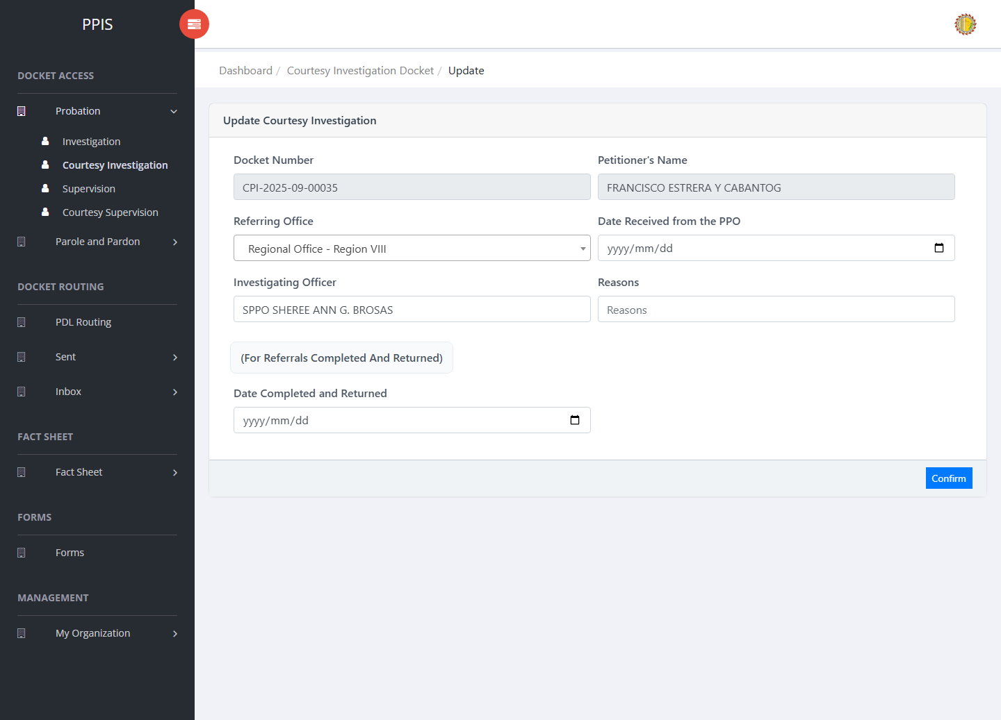
Probation Courtesy Investigation (Update)

Probation Courtesy Investigation (Attachments)
1. On the Probation Courtesy Investigation list page, click Attachments for the correct record.
2. Wait for the attachments screen to open.
3. Complete the attachment details, such as Kind, Type, and Upload File when shown.
4. Click Confirm to upload the file.
5. Use View, Download, or Delete only for the attachment listed in the table.
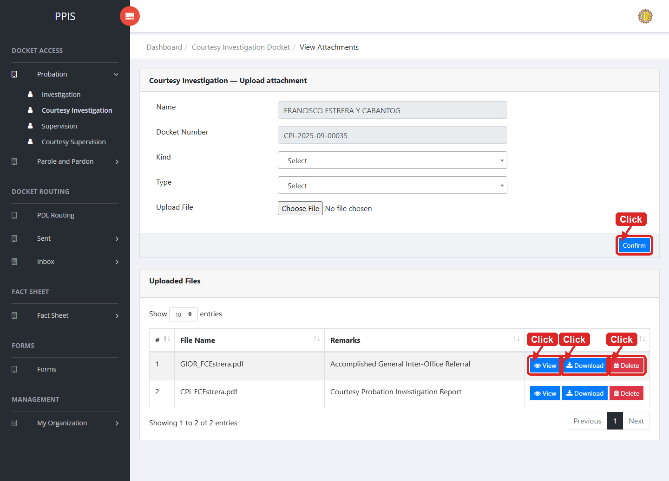
Probation Courtesy Investigation (Attachments)

Probation Courtesy Investigation (Delete)
Deletion warning: Use Remove only for sample/test records or records approved for deletion. For documentation, stop at the confirmation dialog unless removal is required.

1. On the Probation Courtesy Investigation list page, locate the sample, test, or authorized record.
2. Click Remove in the Actions column.
3. Wait for the confirmation modal dialog box to appear.
4. Read the confirmation message carefully. The system warns that removal cannot be undone.
5. Click Cancel inside the modal dialog to stop, or click Remove permanently inside the modal dialog only when deletion is authorized.
6. Wait for the modal dialog to close. The table refreshes to reflect the remaining records.
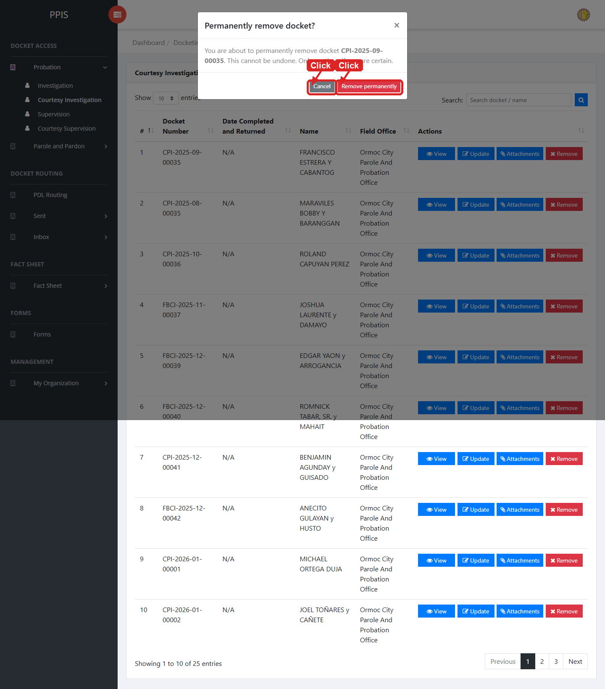
Probation Courtesy Investigation (Delete)

Probation Supervision
Use this page to manage probation supervision dockets and related record actions.
1. From the left menu, open Probation Supervision.
2. To find a record, enter the known information in Search docket / name.
3. Click Run search to apply the search.
4. In the Actions column, use View, Update, Attachments, Remove for the selected row.
5. To filter the table instantly, type characters directly into the inline search boxes in the column headers, or select a value from any drop-down filter shown above a column. The table updates automatically as you type or select.
6. To export the currently displayed table data, click CSV, PDF, or EXCEL above the table when those buttons are shown. The system downloads the visible records in the selected format.
7. To print the table, click Print. The native browser print window opens. Review the layout settings, then click Print in that window to complete printing.
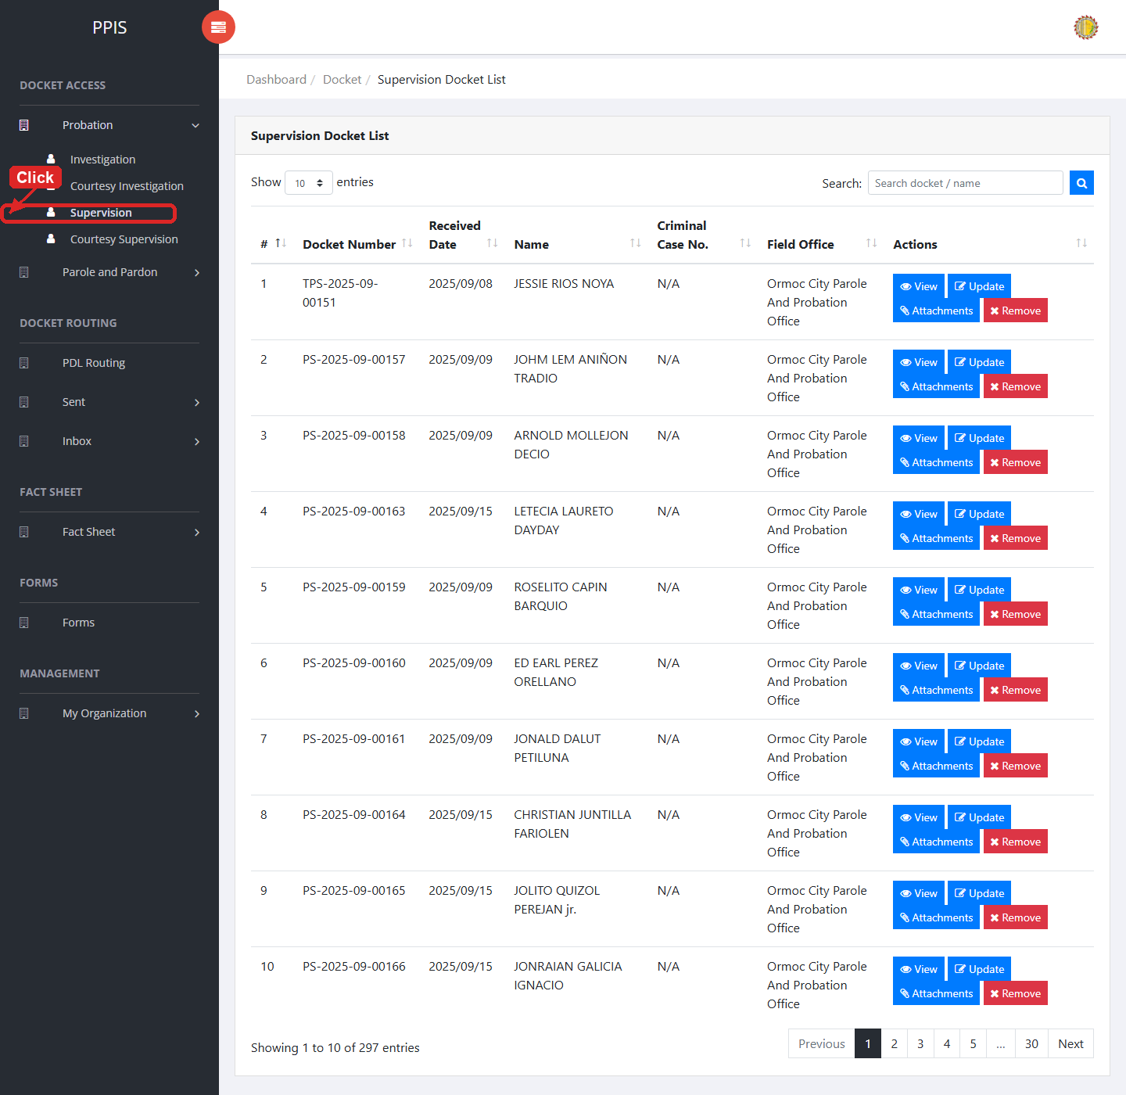
Probation Supervision list page

Probation Supervision (View)
1. On the Probation Supervision list page, locate the record you need to review.
2. Click View in the Actions column.
3. Read the details on the view page. Use this screen for checking information before making any changes.
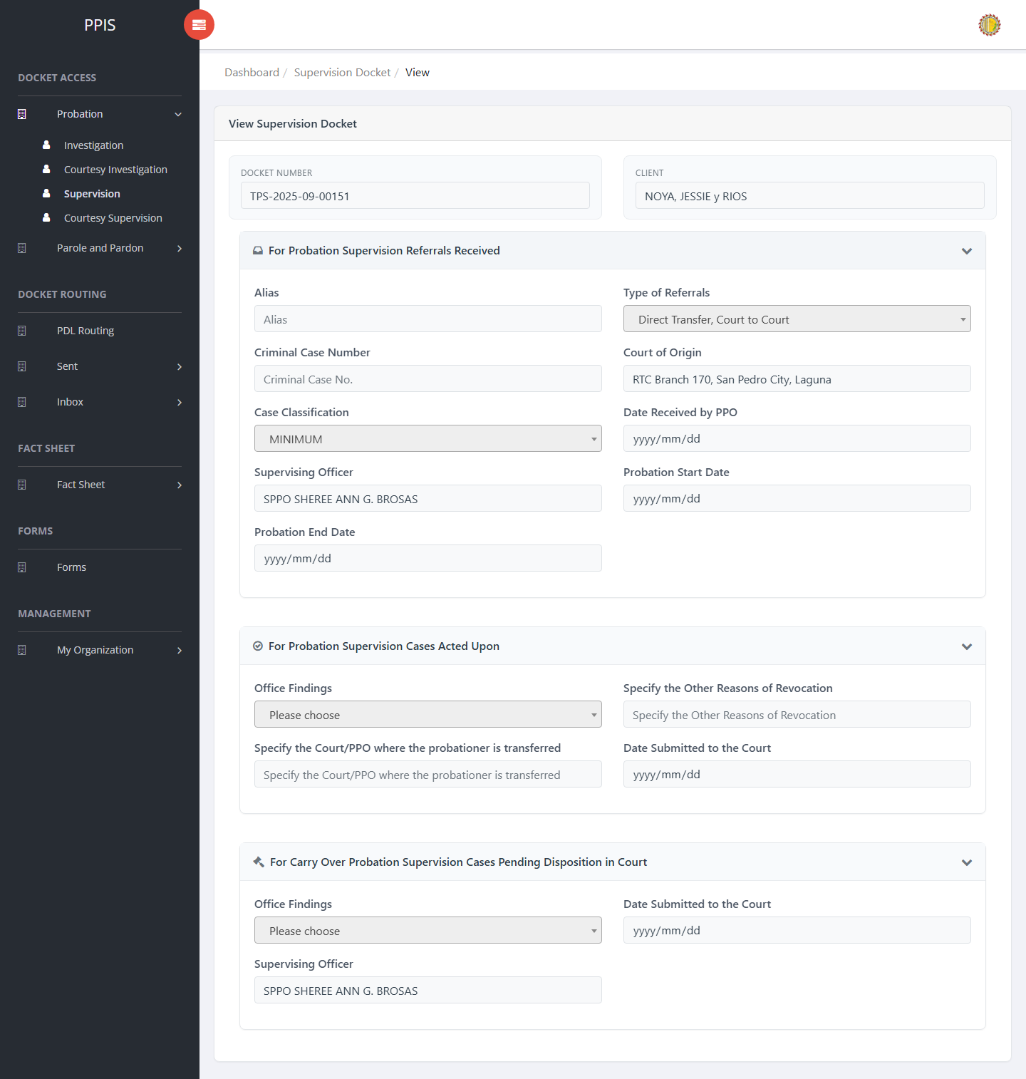
Probation Supervision (View)

Probation Supervision (Update)
1. On the Probation Supervision list page, locate the record that needs correction.
2. Click Update in the Actions column.
3. Wait for the update screen to open.
4. Review the current details and update Docket Number, Client Name, Alias, Type of Referrals, Criminal Case Number, Court of Origin, Case Classification, Date Received by PPO.
5. Click Confirm to save after checking the information.
6. Wait for the system to return to the list page or refresh the record display.
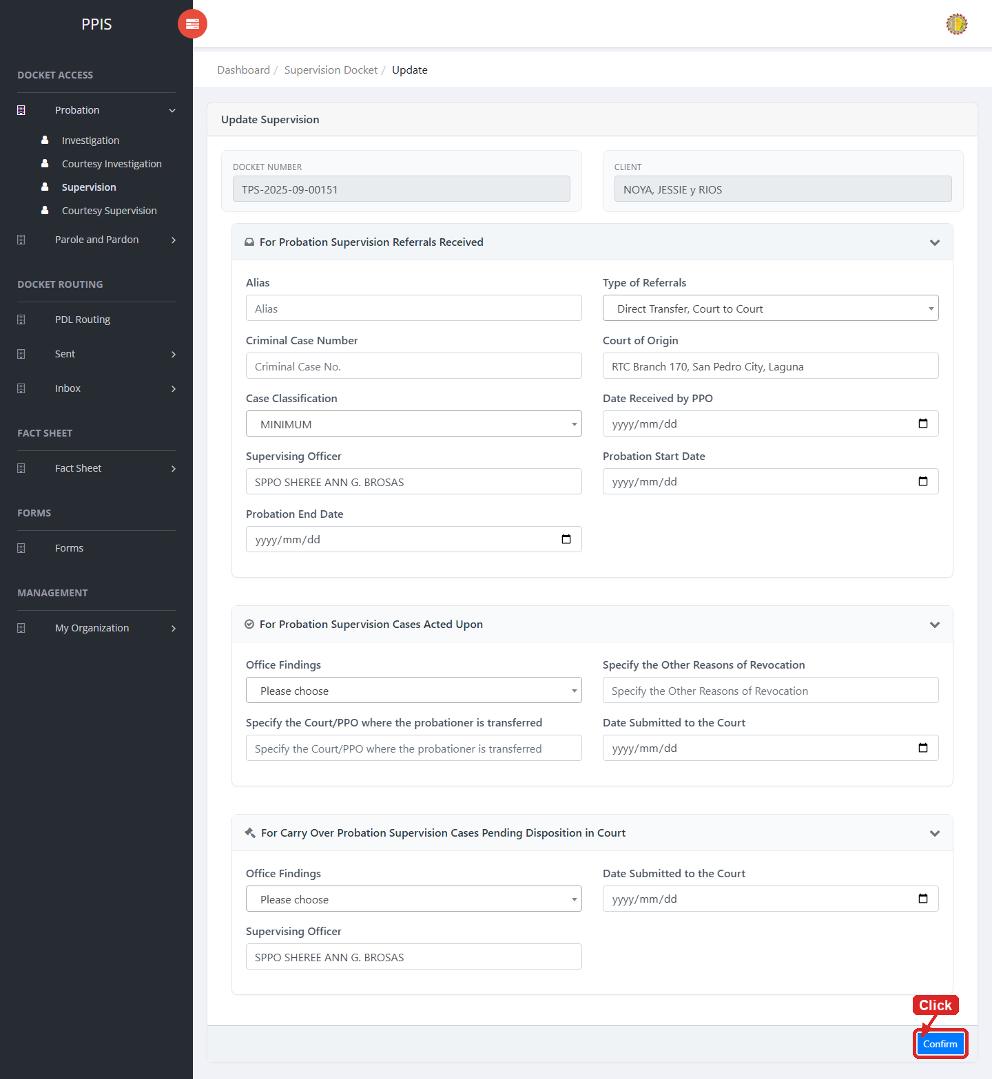
Probation Supervision (Update)

Probation Supervision (Attachments)
1. On the Probation Supervision list page, click Attachments for the correct record.
2. Wait for the attachments screen to open.
3. Complete the attachment details, such as Kind, Type, and Upload File when shown.
4. Click Confirm to upload the file.
5. Use View, Download, or Delete only for the attachment listed in the table.
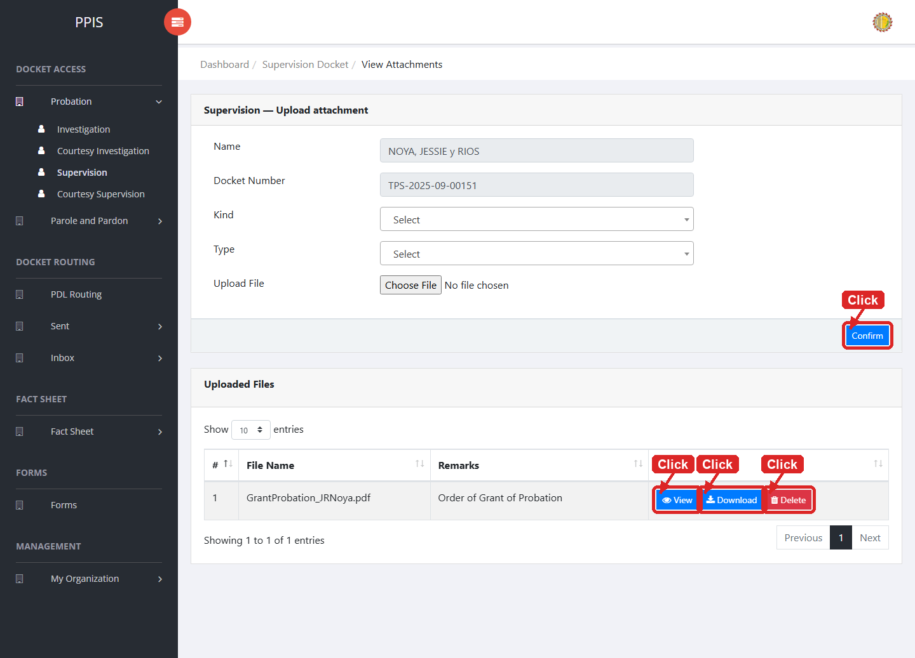
Probation Supervision (Attachments)

Probation Supervision (Delete)
Deletion warning: Use Remove only for sample/test records or records approved for deletion. For documentation, stop at the confirmation dialog unless removal is required.

1. On the Probation Supervision list page, locate the sample, test, or authorized record.
2. Click Remove in the Actions column.
3. Wait for the confirmation modal dialog box to appear.
4. Read the confirmation message carefully. The system warns that removal cannot be undone.
5. Click Cancel inside the modal dialog to stop, or click Remove permanently inside the modal dialog only when deletion is authorized.
6. Wait for the modal dialog to close. The table refreshes to reflect the remaining records.
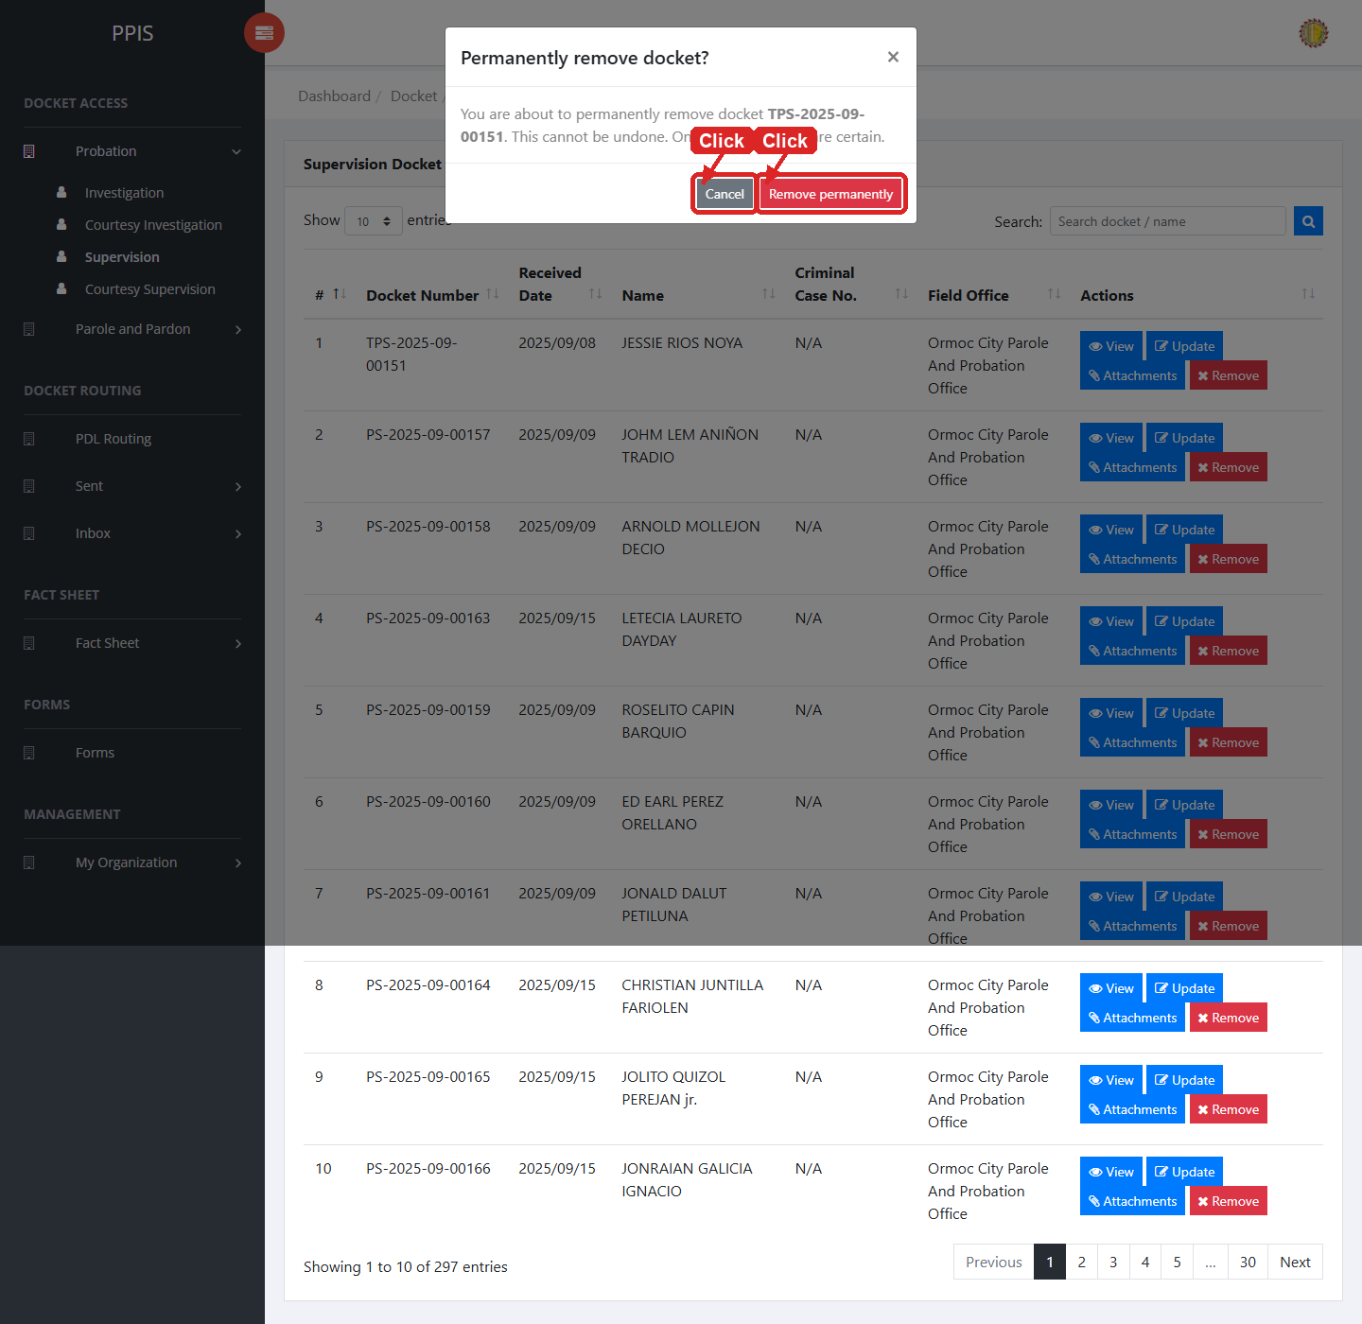
Probation Supervision (Delete)

Probation Courtesy Supervision
Use this page to manage courtesy supervision dockets under the probation workflow.
1. From the left menu, open Probation Courtesy Supervision.
2. To find a record, enter the known information in Search docket / name.
3. Click Run search to apply the search.
4. In the Actions column, use View, Update, Attachments, Remove for the selected row.
5. To filter the table instantly, type characters directly into the inline search boxes in the column headers, or select a value from any drop-down filter shown above a column. The table updates automatically as you type or select.
6. To export the currently displayed table data, click CSV, PDF, or EXCEL above the table when those buttons are shown. The system downloads the visible records in the selected format.
7. To print the table, click Print. The native browser print window opens. Review the layout settings, then click Print in that window to complete printing.
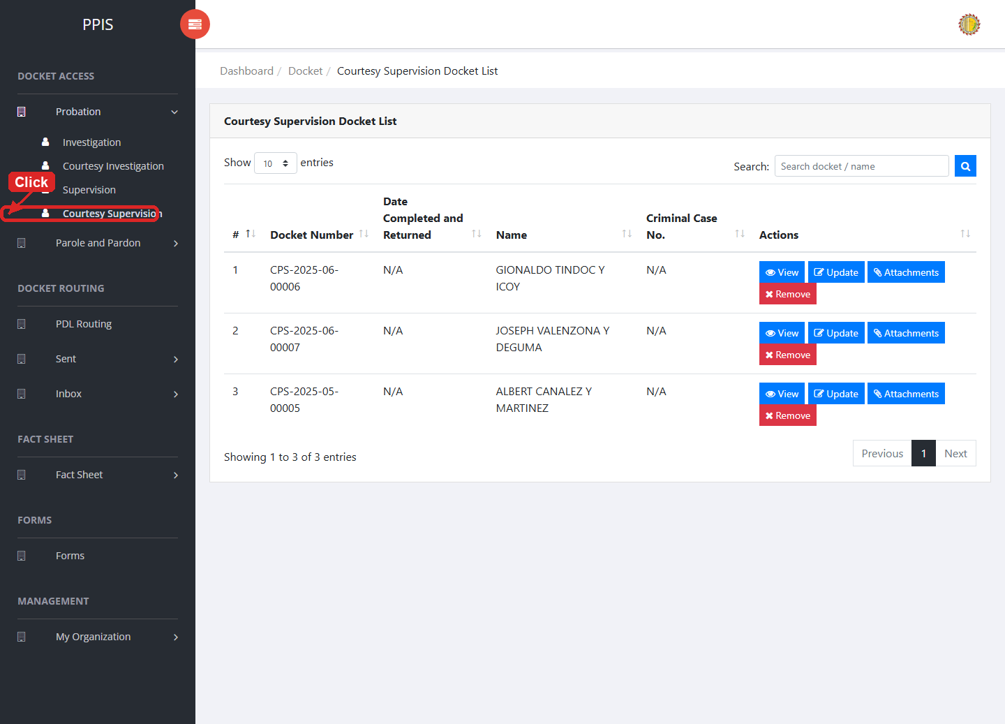
Probation Courtesy Supervision list page

Probation Courtesy Supervision (View)
1. On the Probation Courtesy Supervision list page, locate the record you need to review.
2. Click View in the Actions column.
3. Read the details on the view page. Use this screen for checking information before making any changes.
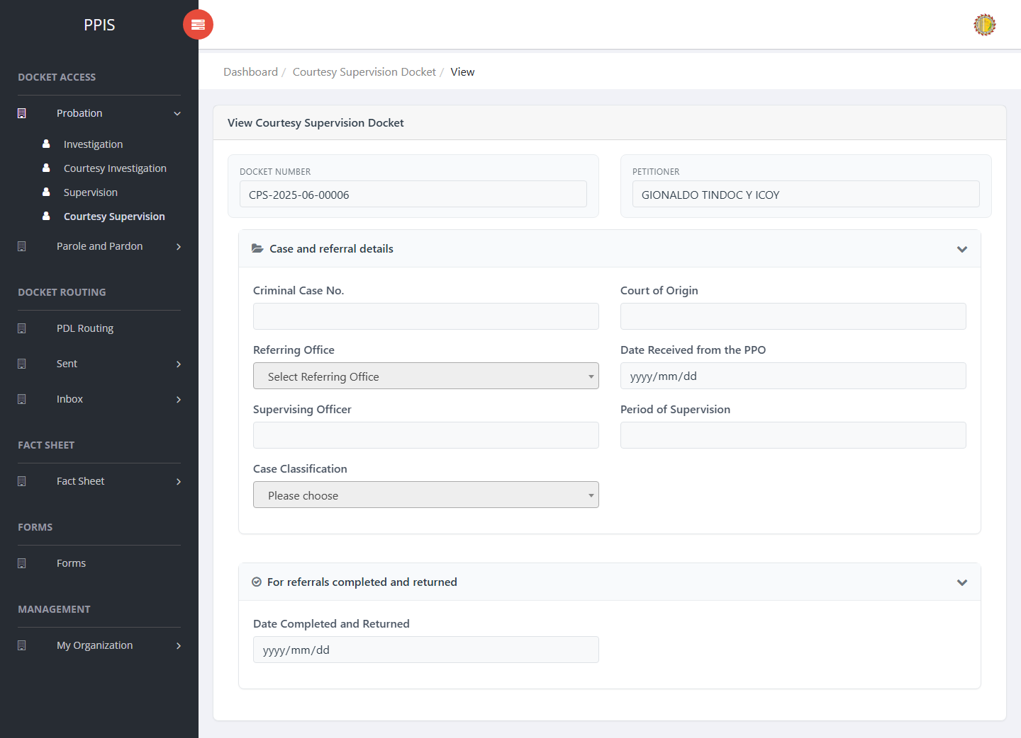
Probation Courtesy Supervision (View)

Probation Courtesy Supervision (Update)
1. On the Probation Courtesy Supervision list page, locate the record that needs correction.
2. Click Update in the Actions column.
3. Wait for the update screen to open.
4. Review the current details and update Docket Number, Client Name, Criminal Case No., Court of Origin, Referring Office, Date Received from the PPO, Supervising Officer, Period of Supervision.
5. Click Confirm to save after checking the information.
6. Wait for the system to return to the list page or refresh the record display.
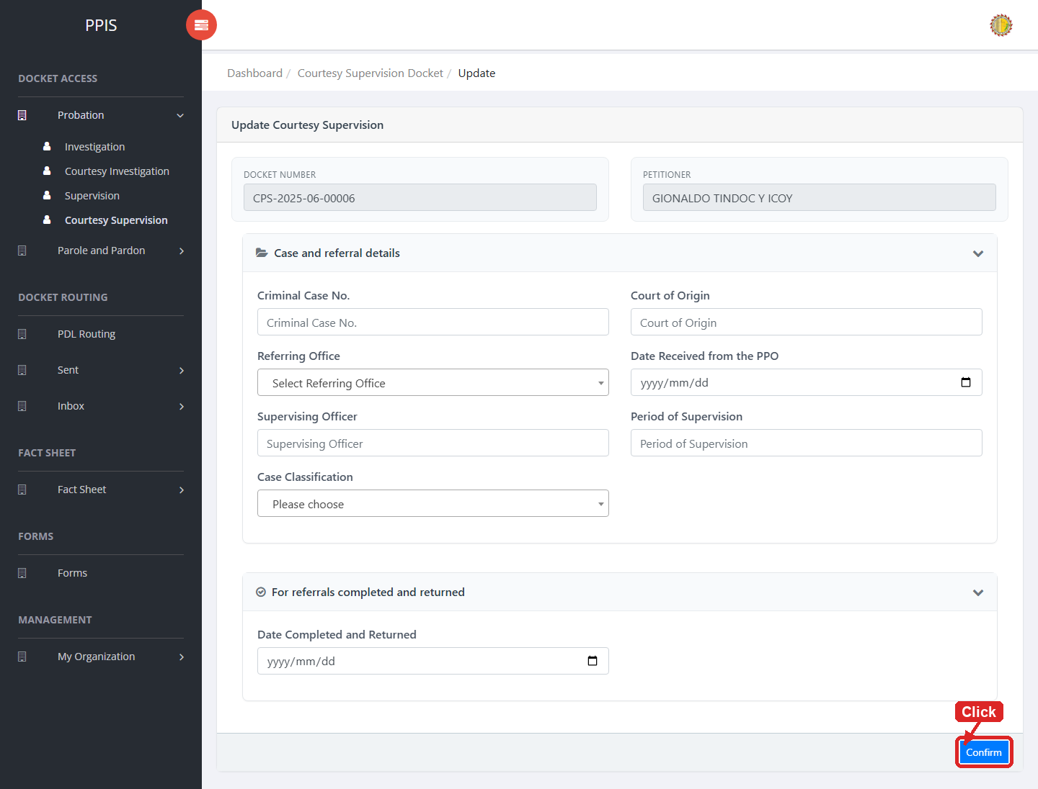
Probation Courtesy Supervision (Update)

Probation Courtesy Supervision (Attachments)
1. On the Probation Courtesy Supervision list page, click Attachments for the correct record.
2. Wait for the attachments screen to open.
3. Complete the attachment details, such as Kind, Type, and Upload File when shown.
4. Click Confirm to upload the file.
5. Use View, Download, or Delete only for the attachment listed in the table.
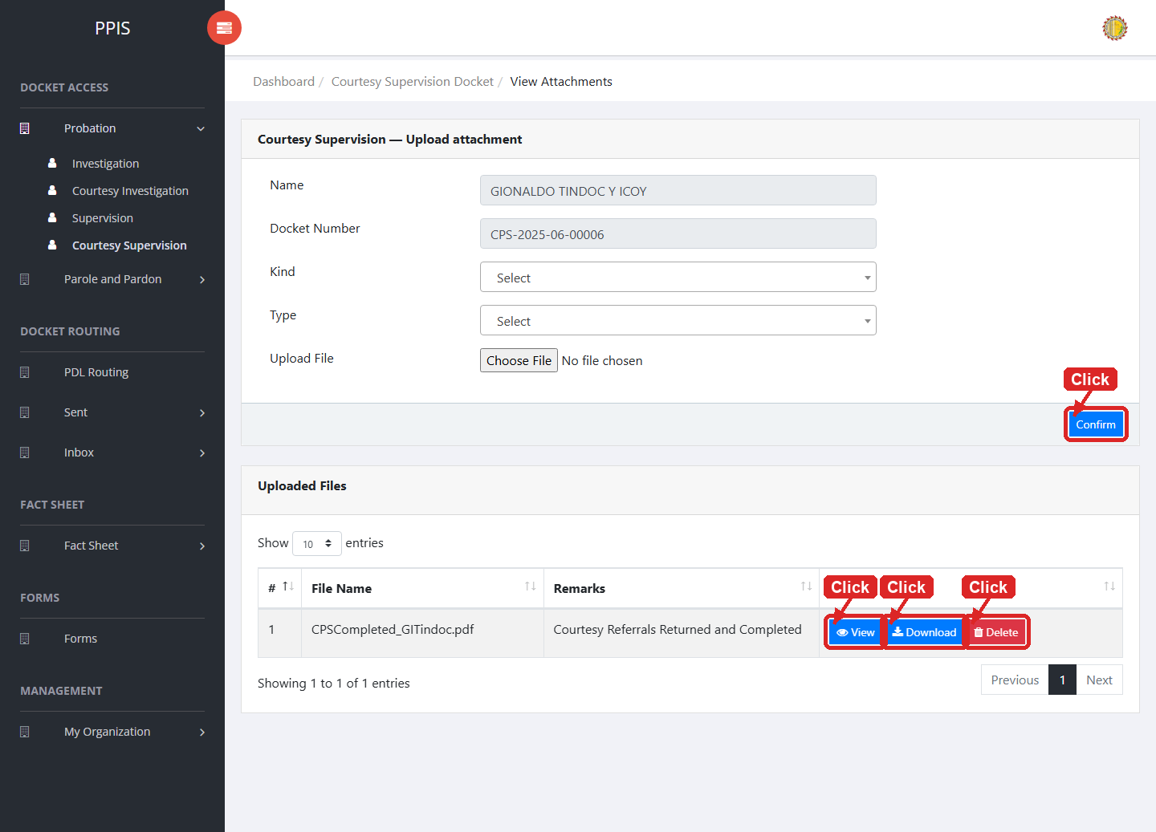
Probation Courtesy Supervision (Attachments)

Probation Courtesy Supervision (Delete)
Deletion warning: Use Remove only for sample/test records or records approved for deletion. For documentation, stop at the confirmation dialog unless removal is required.

1. On the Probation Courtesy Supervision list page, locate the sample, test, or authorized record.
2. Click Remove in the Actions column.
3. Wait for the confirmation modal dialog box to appear.
4. Read the confirmation message carefully. The system warns that removal cannot be undone.
5. Click Cancel inside the modal dialog to stop, or click Remove permanently inside the modal dialog only when deletion is authorized.
6. Wait for the modal dialog to close. The table refreshes to reflect the remaining records.
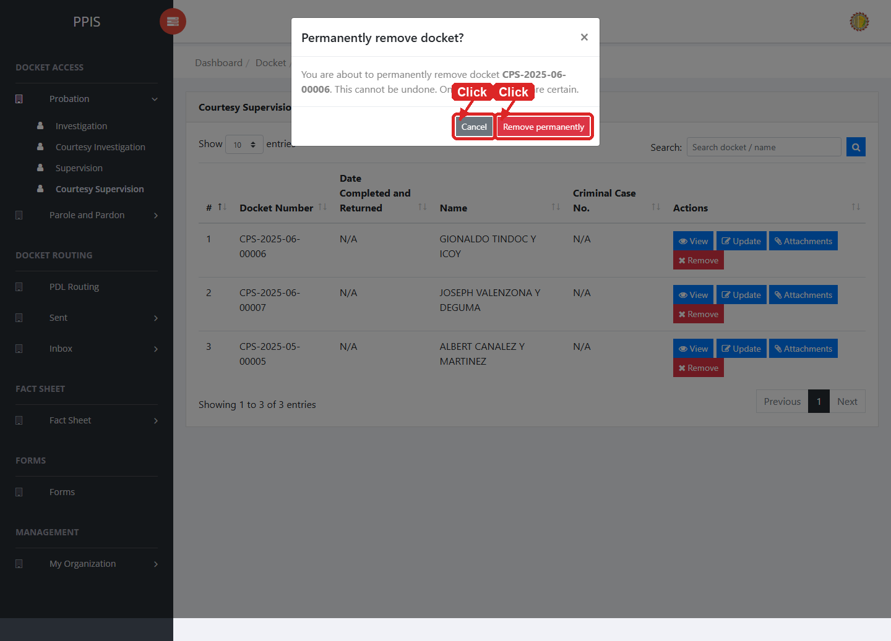
Probation Courtesy Supervision (Delete)

Parole and Pardon Investigation
Use this page to find, review, update, attach files to, or remove parole and pardon investigation dockets.
1. From the left menu, open Parole and Pardon Investigation.
2. To find a record, enter the known information in Docket Number, CC Number, Name.
3. Click Run search to apply the search.
4. In the Actions column, use View, Update, Attachments, Remove for the selected row.
5. To filter the table instantly, type characters directly into the inline search boxes in the column headers, or select a value from any drop-down filter shown above a column. The table updates automatically as you type or select.
6. To export the currently displayed table data, click CSV, PDF, or EXCEL above the table when those buttons are shown. The system downloads the visible records in the selected format.
7. To print the table, click Print. The native browser print window opens. Review the layout settings, then click Print in that window to complete printing.
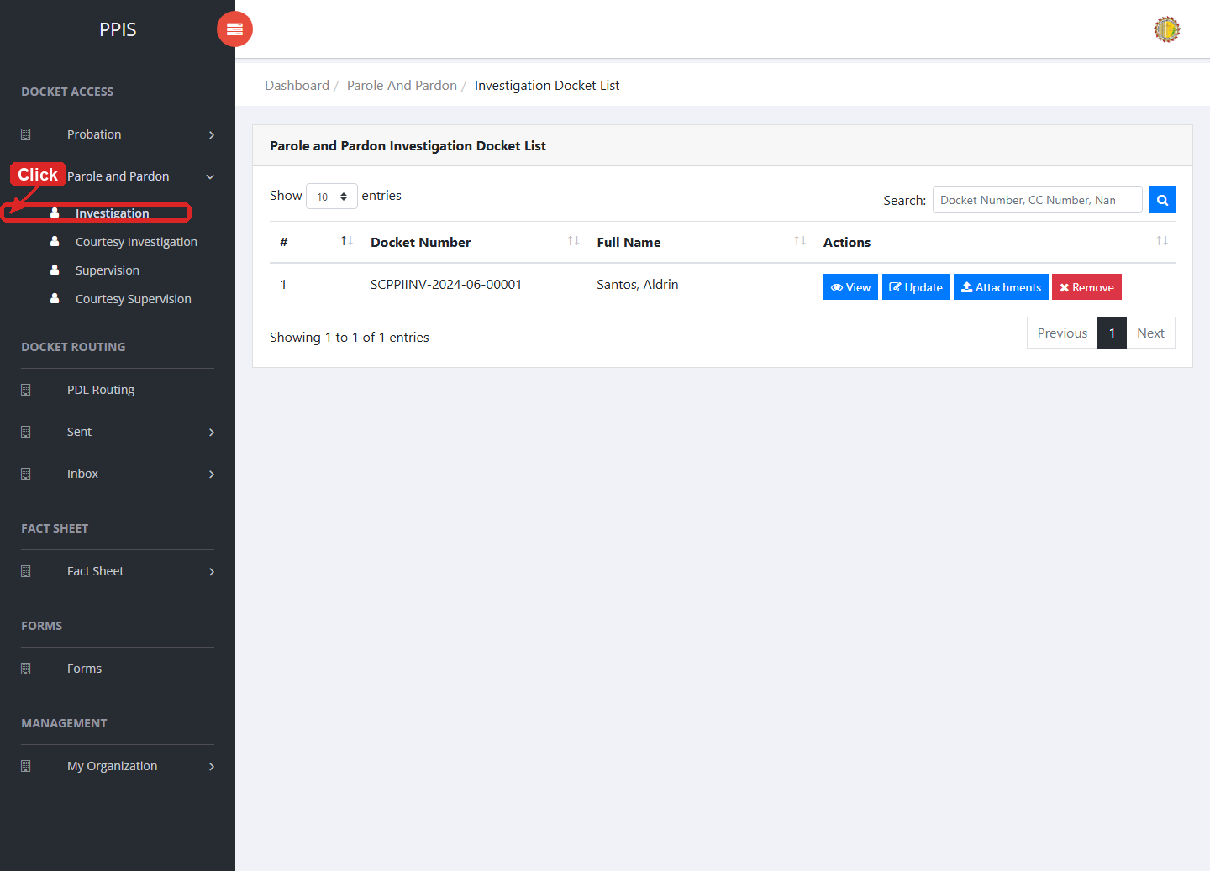
Parole and Pardon Investigation list page

Parole and Pardon Investigation (View)
1. On the Parole and Pardon Investigation list page, locate the record you need to review.
2. Click View in the Actions column.
3. Read the details on the view page. Use this screen for checking information before making any changes.
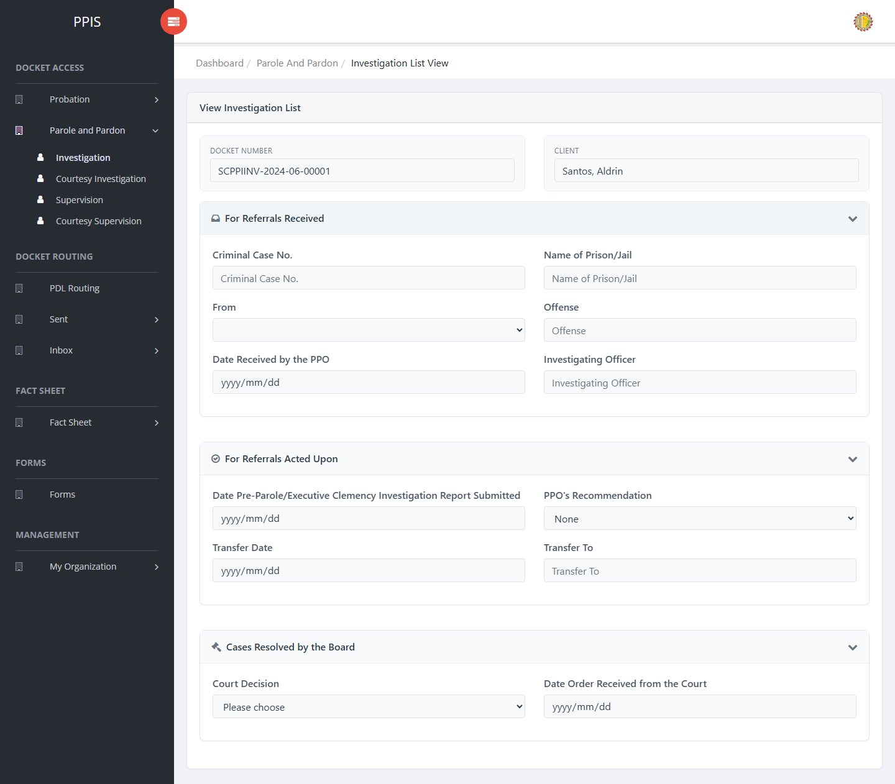
Parole and Pardon Investigation (View)

Parole and Pardon Investigation (Update)
1. On the Parole and Pardon Investigation list page, locate the record that needs correction.
2. Click Update in the Actions column.
3. Wait for the update screen to open.
4. Review the current details and update Docket No., Client Name, Criminal Case No., Name of Prison/Jail, From, Offense, Date Received by the PPO, Investigating Officer.
5. Click Update to save after checking the information.
6. Wait for the system to return to the list page or refresh the record display.
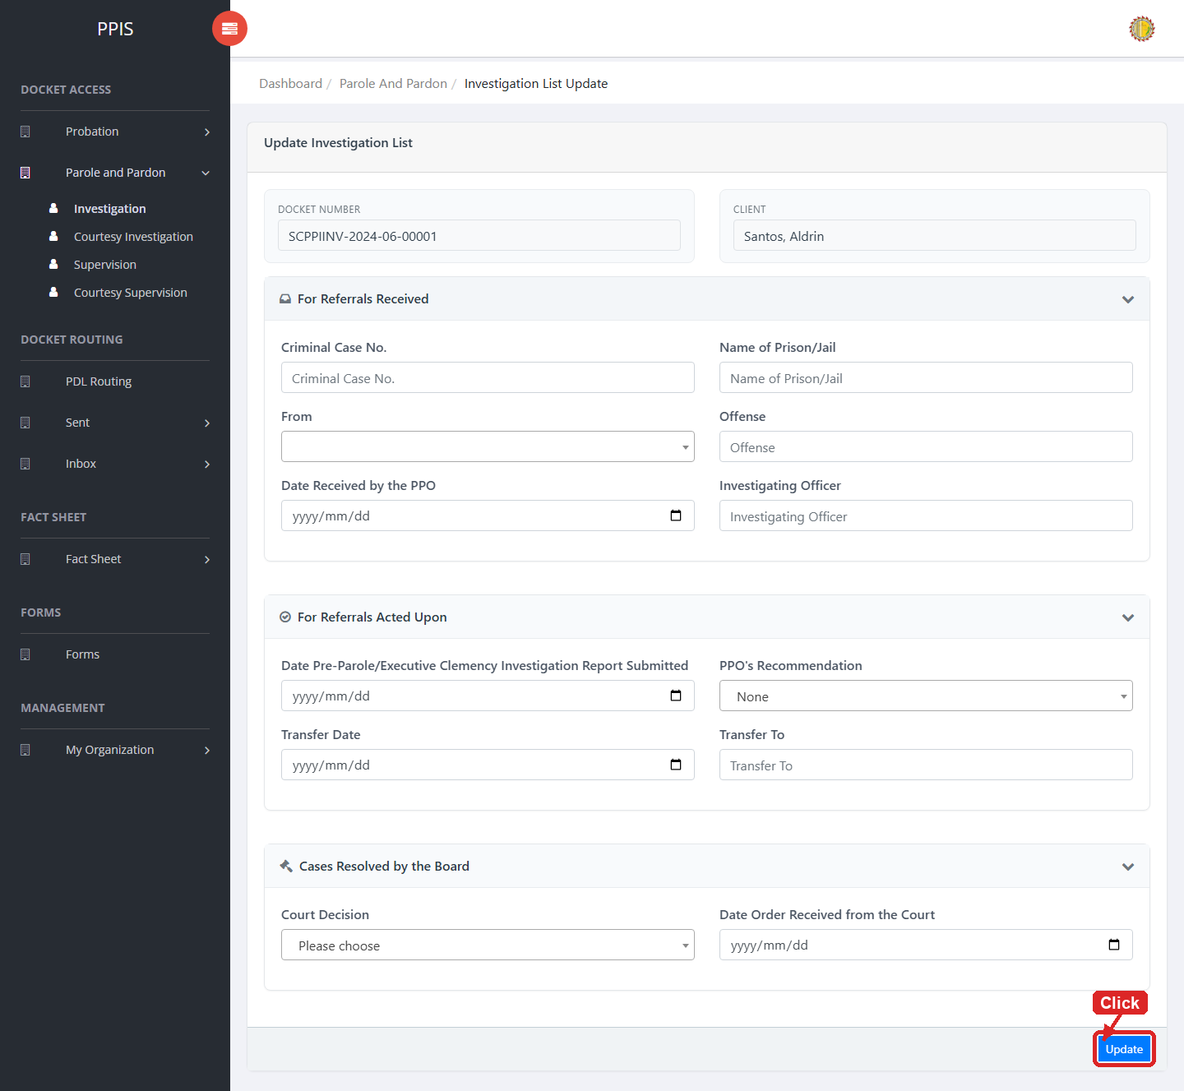
Parole and Pardon Investigation (Update)

Parole and Pardon Investigation (Attachments)
1. On the Parole and Pardon Investigation list page, click Attachments for the correct record.
2. Wait for the attachments screen to open.
3. Complete the attachment details, such as Kind, Type, and Upload File when shown.
4. Click Confirm to upload the file.
5. Use View, Download, or Delete only for the attachment listed in the table.
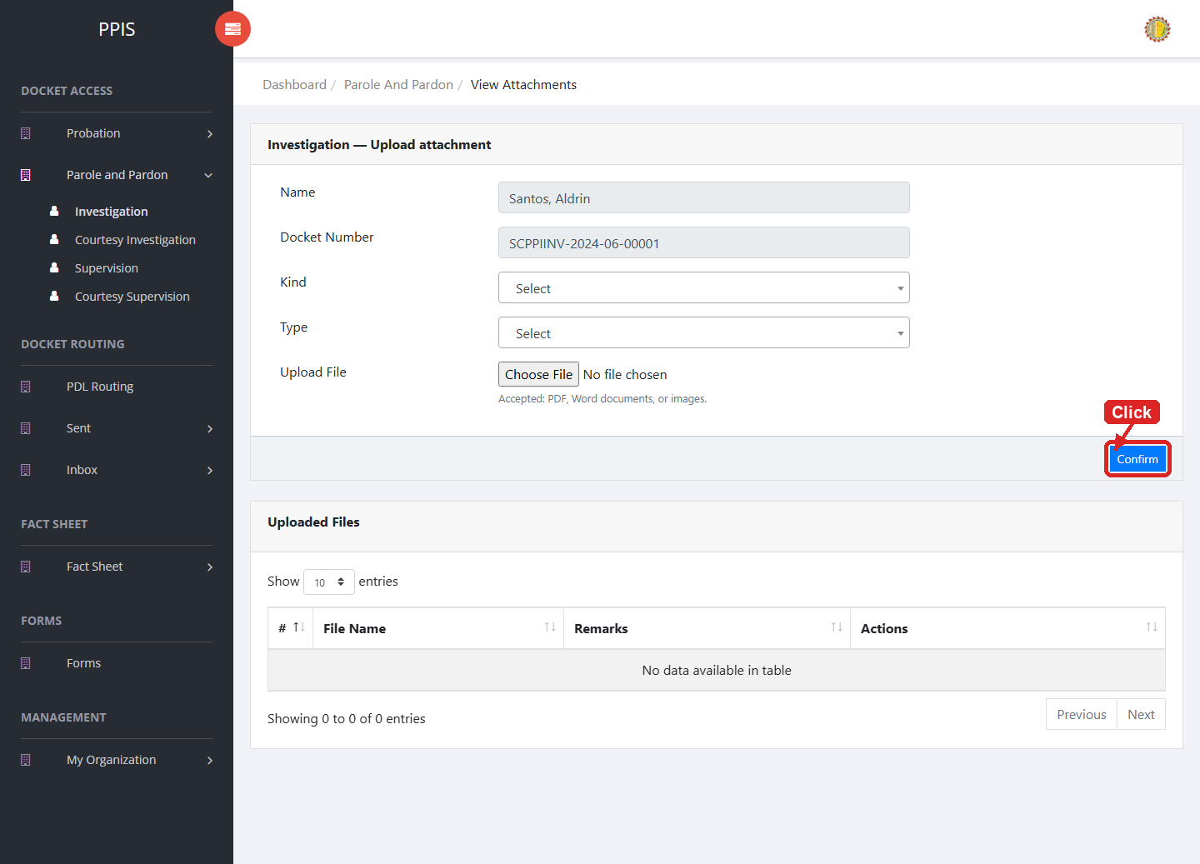
Parole and Pardon Investigation (Attachments)

Parole and Pardon Investigation (Delete)
Deletion warning: Use Remove only for sample/test records or records approved for deletion. For documentation, stop at the confirmation dialog unless removal is required.

1. On the Parole and Pardon Investigation list page, locate the sample, test, or authorized record.
2. Click Remove in the Actions column.
3. Wait for the confirmation modal dialog box to appear.
4. Read the confirmation message carefully. The system warns that removal cannot be undone.
5. Click Cancel inside the modal dialog to stop, or click Remove permanently inside the modal dialog only when deletion is authorized.
6. Wait for the modal dialog to close. The table refreshes to reflect the remaining records.
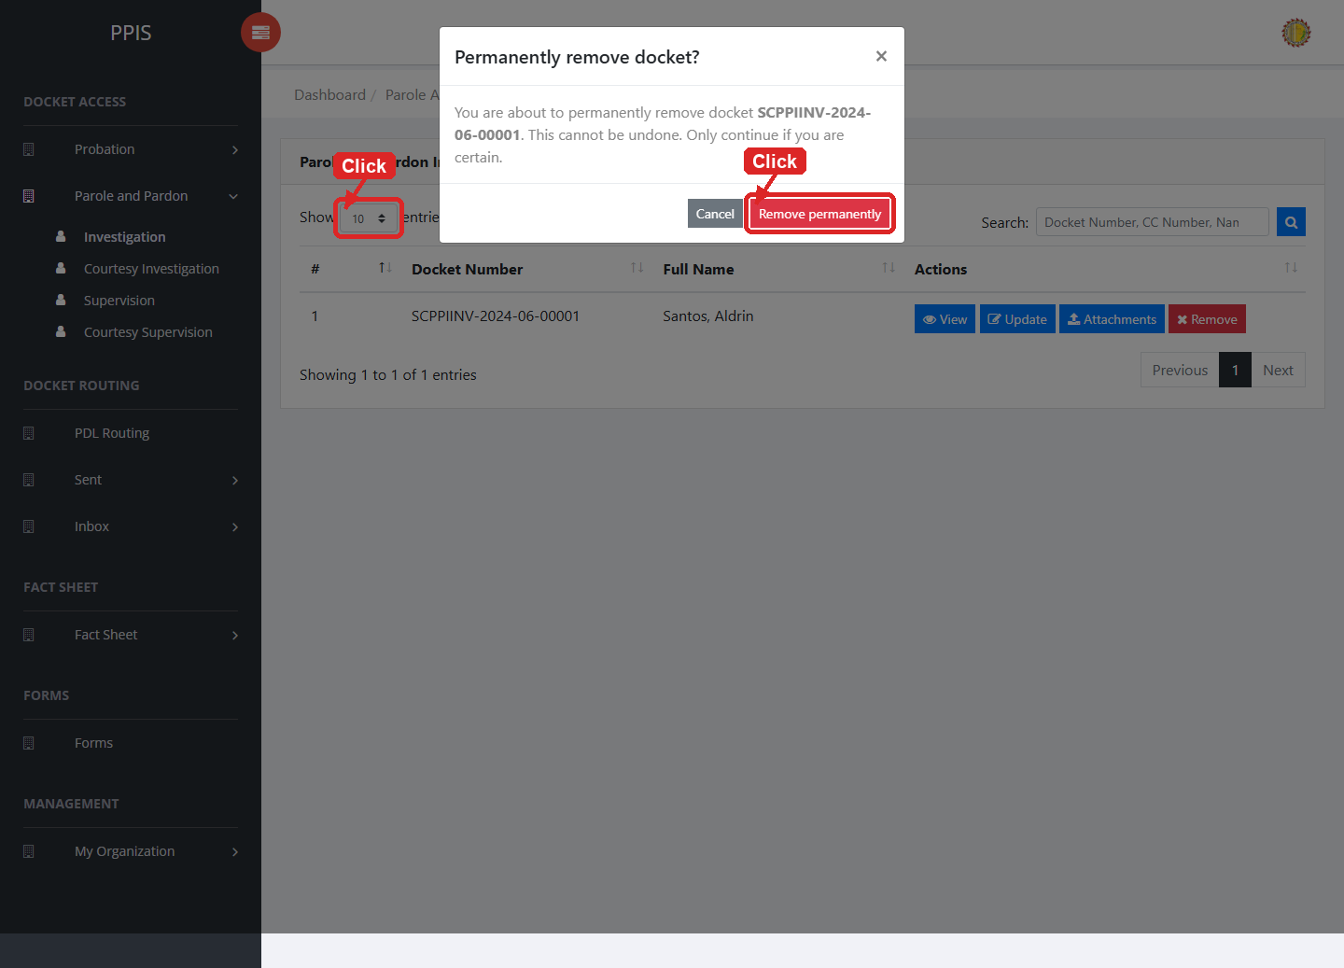
Parole and Pardon Investigation (Delete)

Parole and Pardon Courtesy Investigation
Use this page to manage courtesy investigation records for parole and pardon cases.
1. From the left menu, open Parole and Pardon Courtesy Investigation.
2. To find a record, enter the known information in Search docket / name.
3. Click Run search to apply the search.
4. In the Actions column, use View, Update, Attachments, Remove for the selected row.
5. To filter the table instantly, type characters directly into the inline search boxes in the column headers, or select a value from any drop-down filter shown above a column. The table updates automatically as you type or select.
6. To export the currently displayed table data, click CSV, PDF, or EXCEL above the table when those buttons are shown. The system downloads the visible records in the selected format.
7. To print the table, click Print. The native browser print window opens. Review the layout settings, then click Print in that window to complete printing.
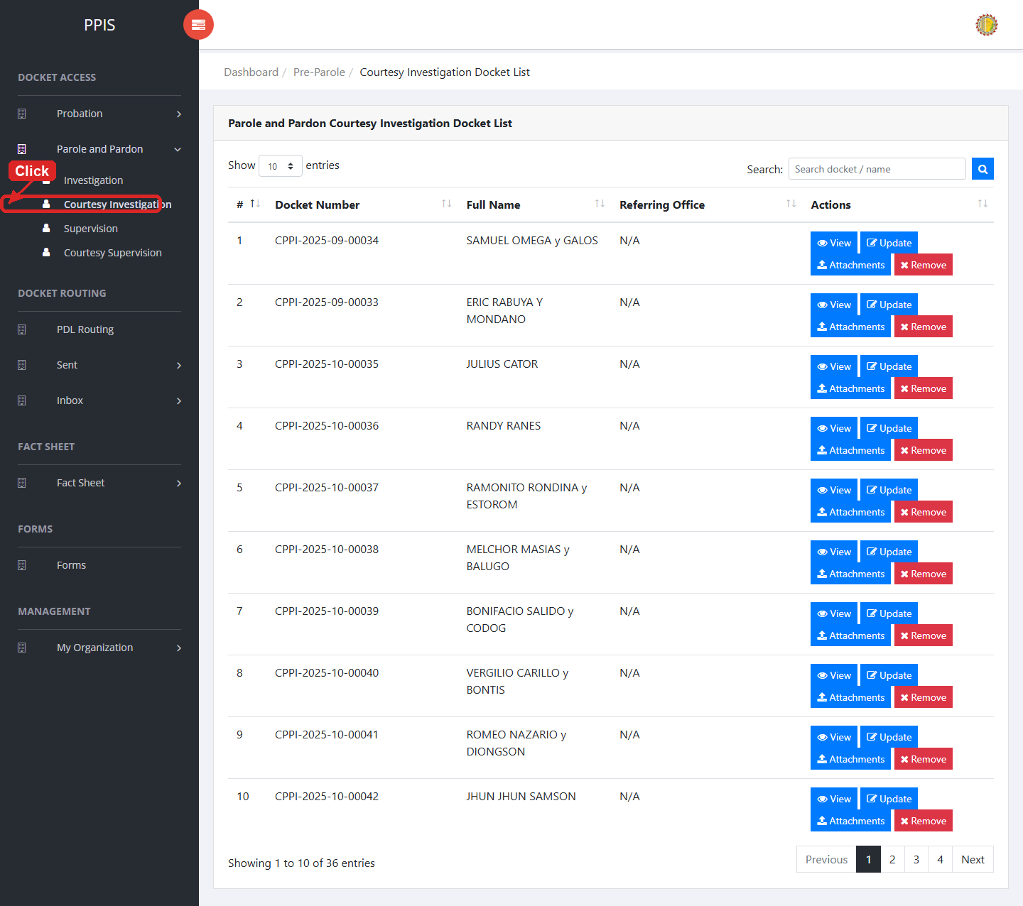
Parole and Pardon Courtesy Investigation list page

Parole and Pardon Courtesy Investigation (View)
1. On the Parole and Pardon Courtesy Investigation list page, locate the record you need to review.
2. Click View in the Actions column.
3. Read the details on the view page. Use this screen for checking information before making any changes.
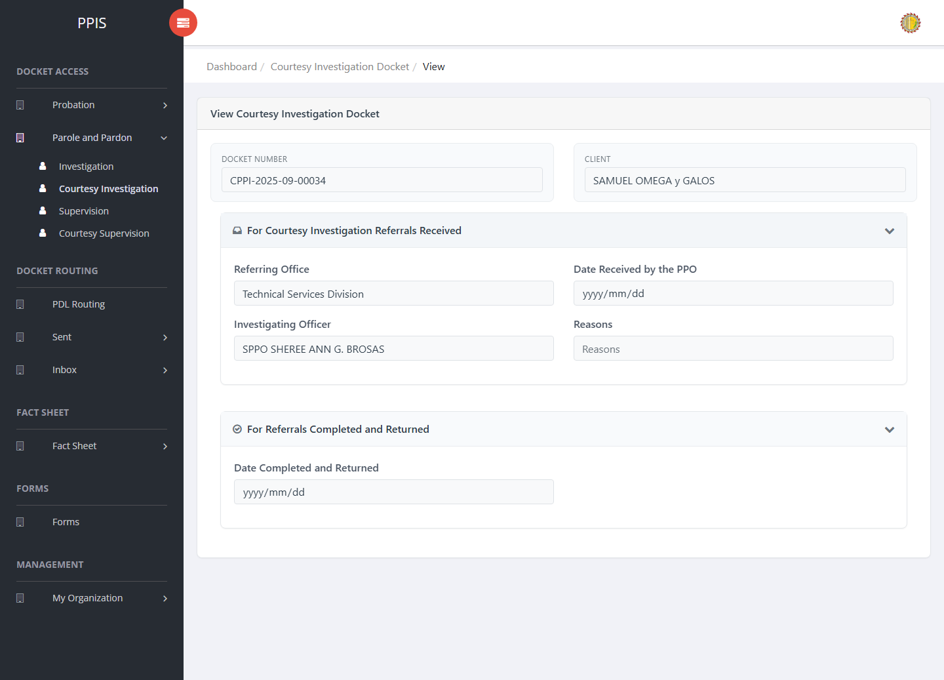
Parole and Pardon Courtesy Investigation (View)

Parole and Pardon Courtesy Investigation (Update)
1. On the Parole and Pardon Courtesy Investigation list page, locate the record that needs correction.
2. Click Update in the Actions column.
3. Wait for the update screen to open.
4. Review the current details and update Docket Number, Client Name, Referring Office, Date Received by the PPO, Investigating Officer, Reasons, Date Completed and Returned.
5. Click Confirm to save after checking the information.
6. Wait for the system to return to the list page or refresh the record display.
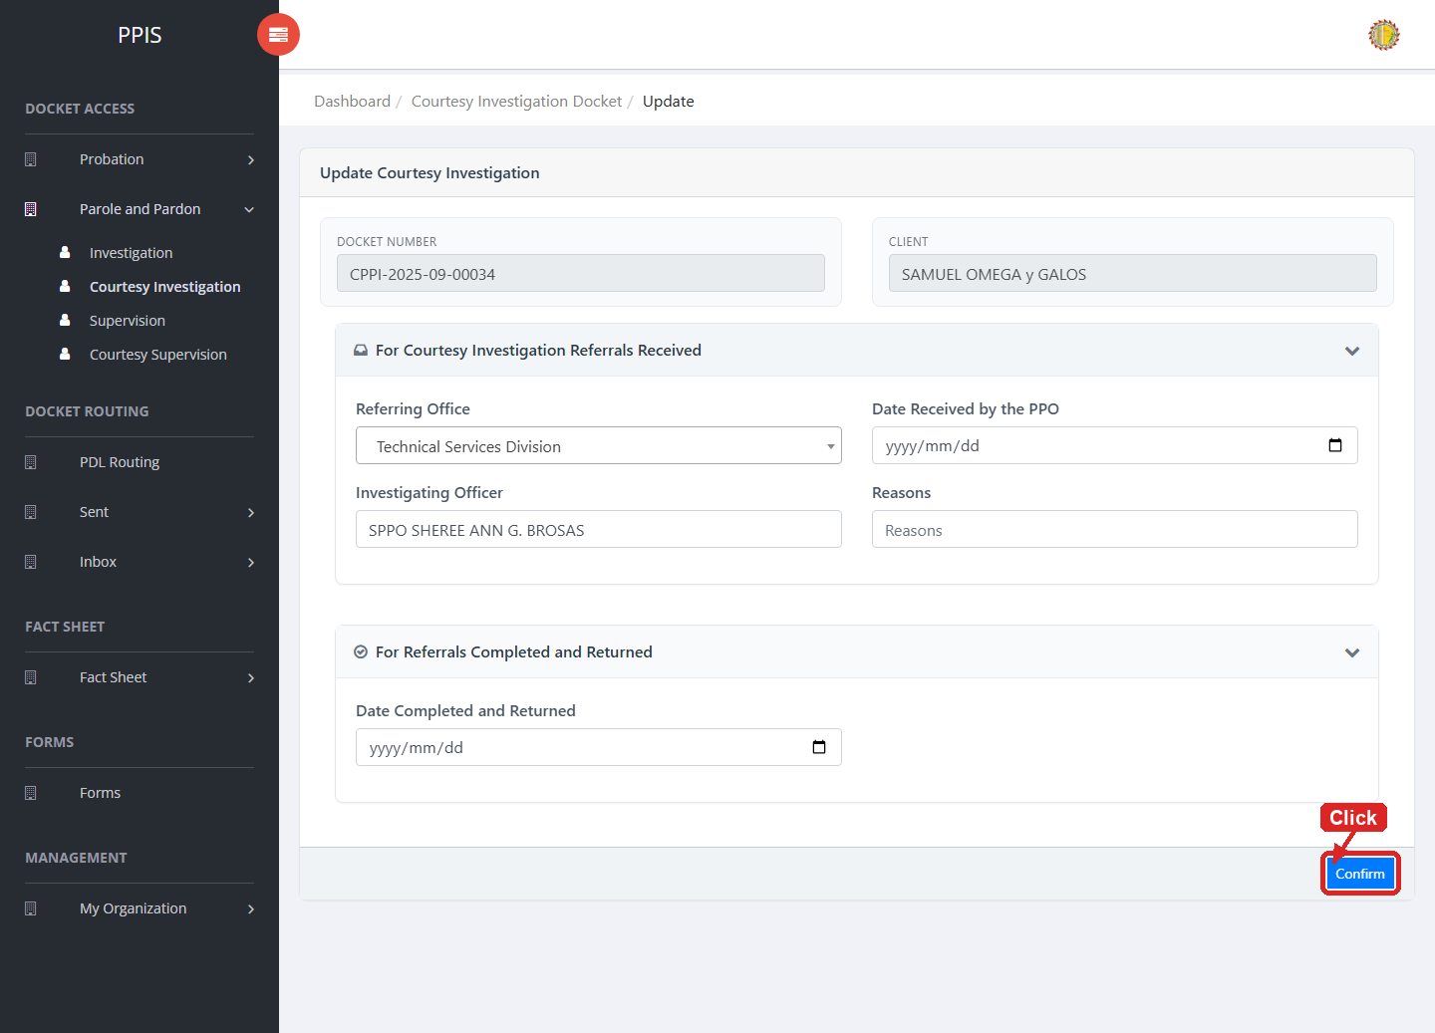
Parole and Pardon Courtesy Investigation (Update)

Parole and Pardon Courtesy Investigation (Attachments)
1. On the Parole and Pardon Courtesy Investigation list page, click Attachments for the correct record.
2. Wait for the attachments screen to open.
3. Complete the attachment details, such as Kind, Type, and Upload File when shown.
4. Click Confirm to upload the file.
5. Use View, Download, or Delete only for the attachment listed in the table.
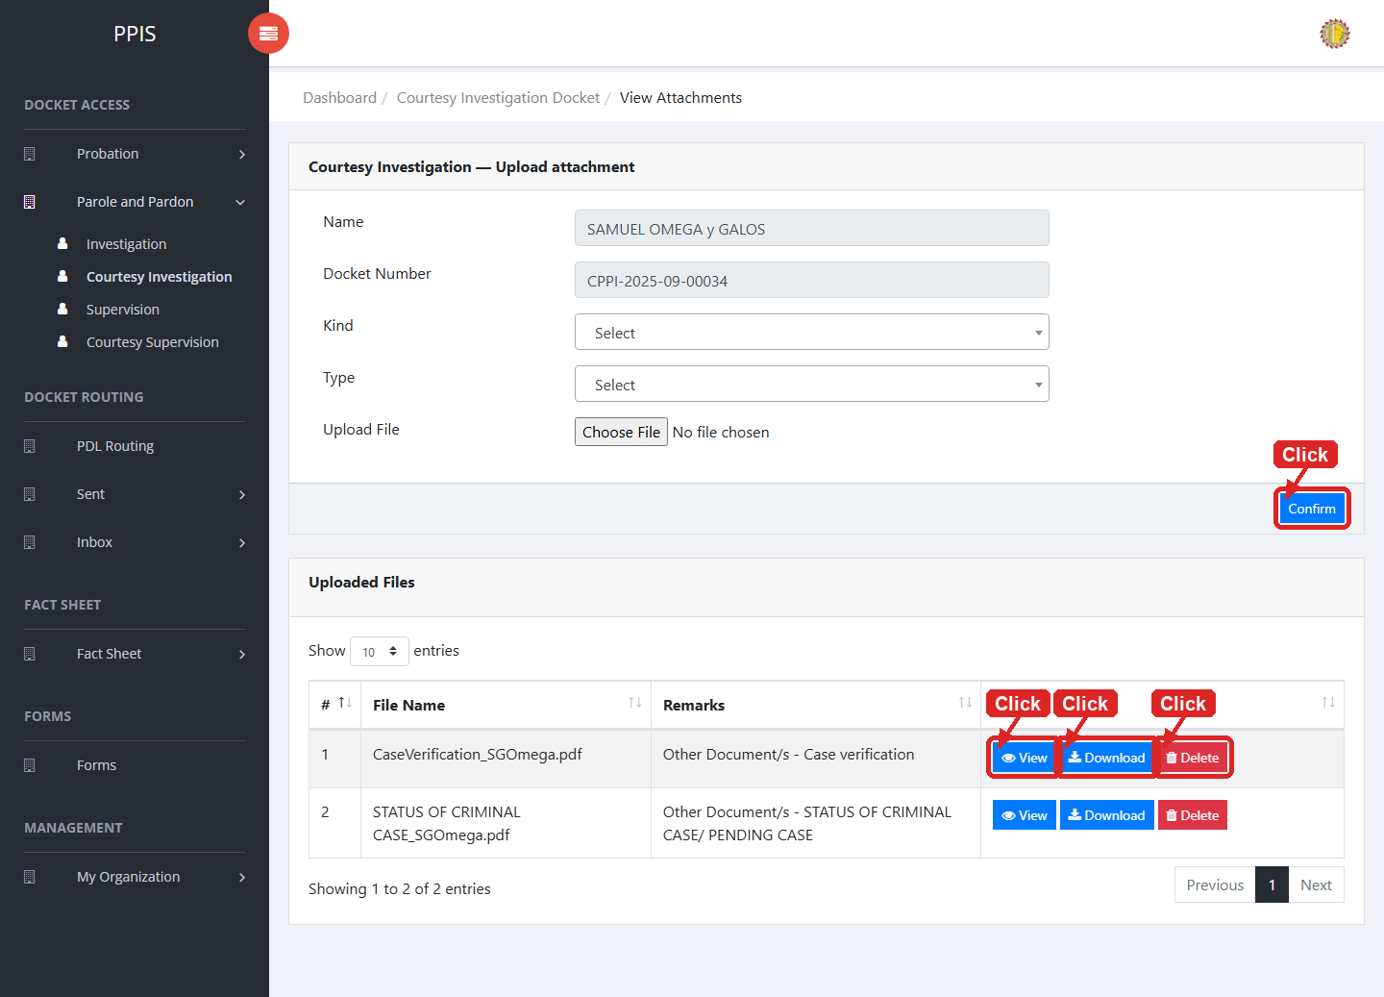
Parole and Pardon Courtesy Investigation (Attachments)

Parole and Pardon Courtesy Investigation (Delete)
Deletion warning: Use Remove only for sample/test records or records approved for deletion. For documentation, stop at the confirmation dialog unless removal is required.

1. On the Parole and Pardon Courtesy Investigation list page, locate the sample, test, or authorized record.
2. Click Remove in the Actions column.
3. Wait for the confirmation modal dialog box to appear.
4. Read the confirmation message carefully. The system warns that removal cannot be undone.
5. Click Cancel inside the modal dialog to stop, or click Remove permanently inside the modal dialog only when deletion is authorized.
6. Wait for the modal dialog to close. The table refreshes to reflect the remaining records.
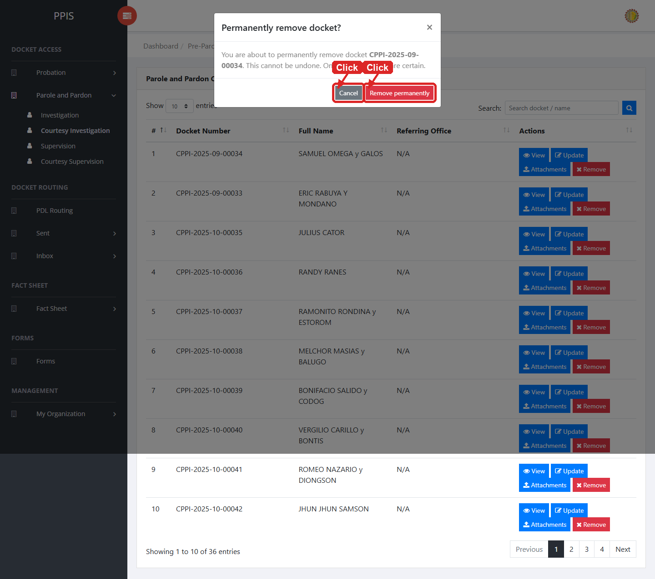
Parole and Pardon Courtesy Investigation (Delete)

Parole and Pardon Supervision
Use this page to manage parole and pardon supervision records.
1. From the left menu, open Parole and Pardon Supervision.
2. To find a record, enter the known information in Search docket / name.
3. Click Run search to apply the search.
4. In the Actions column, use View, Update, Attachments, Remove for the selected row.
5. To filter the table instantly, type characters directly into the inline search boxes in the column headers, or select a value from any drop-down filter shown above a column. The table updates automatically as you type or select.
6. To export the currently displayed table data, click CSV, PDF, or EXCEL above the table when those buttons are shown. The system downloads the visible records in the selected format.
7. To print the table, click Print. The native browser print window opens. Review the layout settings, then click Print in that window to complete printing.
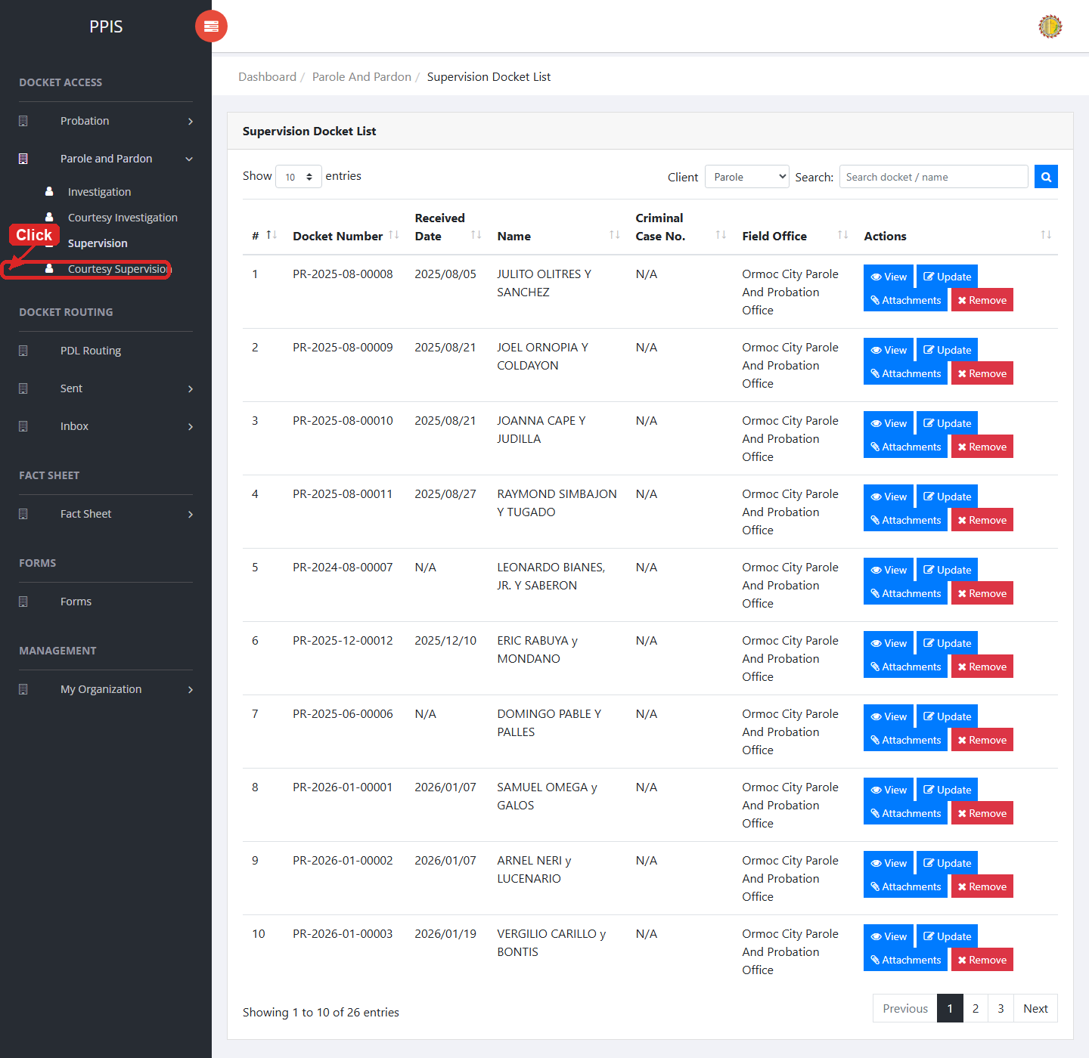
Parole and Pardon Supervision list page

Parole and Pardon Supervision (View)
1. On the Parole and Pardon Supervision list page, locate the record you need to review.
2. Click View in the Actions column.
3. Read the details on the view page. Use this screen for checking information before making any changes.
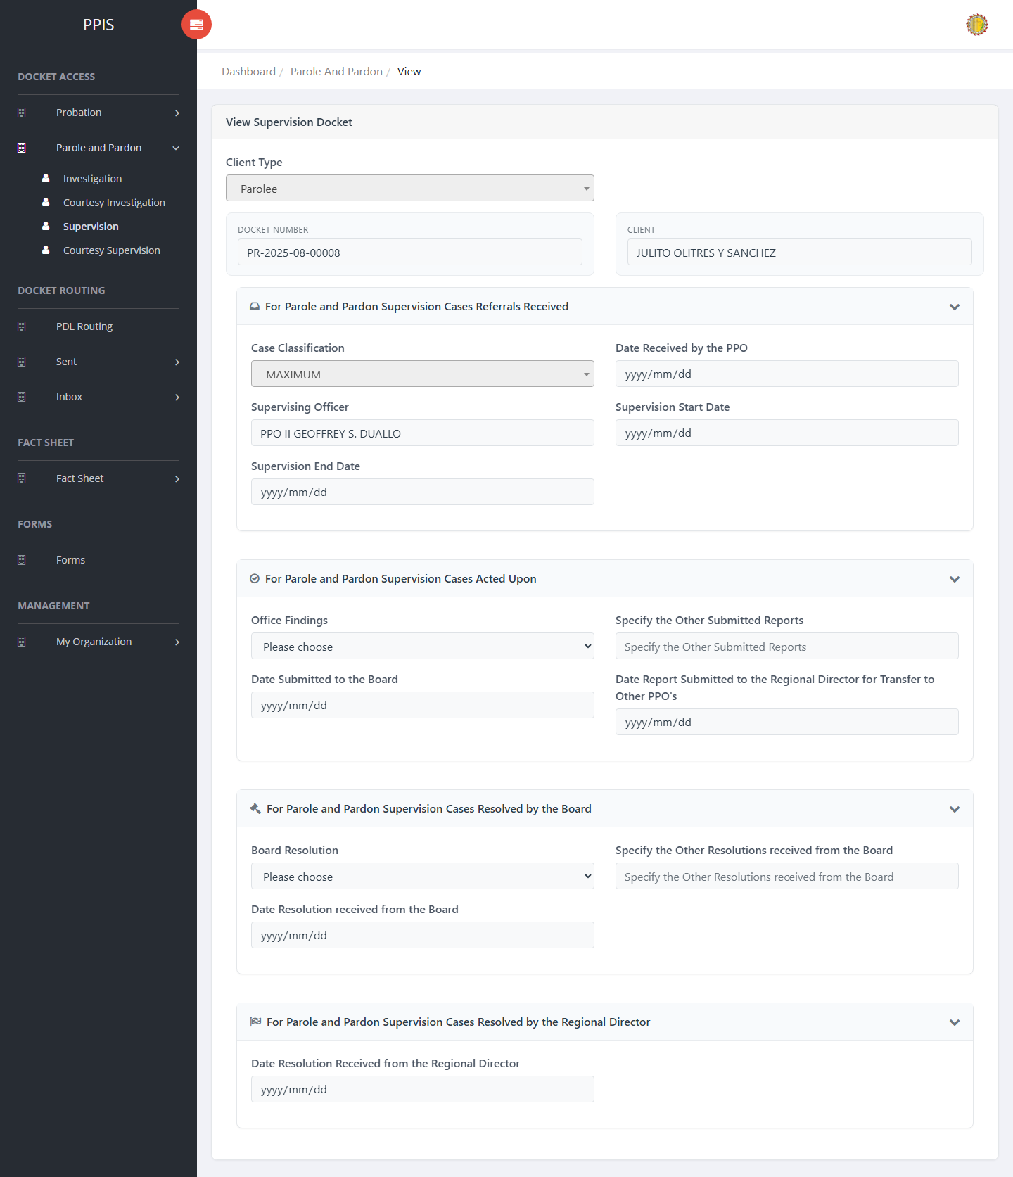
Parole and Pardon Supervision (View)

Parole and Pardon Supervision (Update)
1. On the Parole and Pardon Supervision list page, locate the record that needs correction.
2. Click Update in the Actions column.
3. Wait for the update screen to open.
4. Review the current details and update Client Type, Docket No., Client, Case Classification, Date Received by the PPO, Supervising Officer, Supervision Start Date, Supervision End Date.
5. Click Confirm to save after checking the information.
6. Wait for the system to return to the list page or refresh the record display.
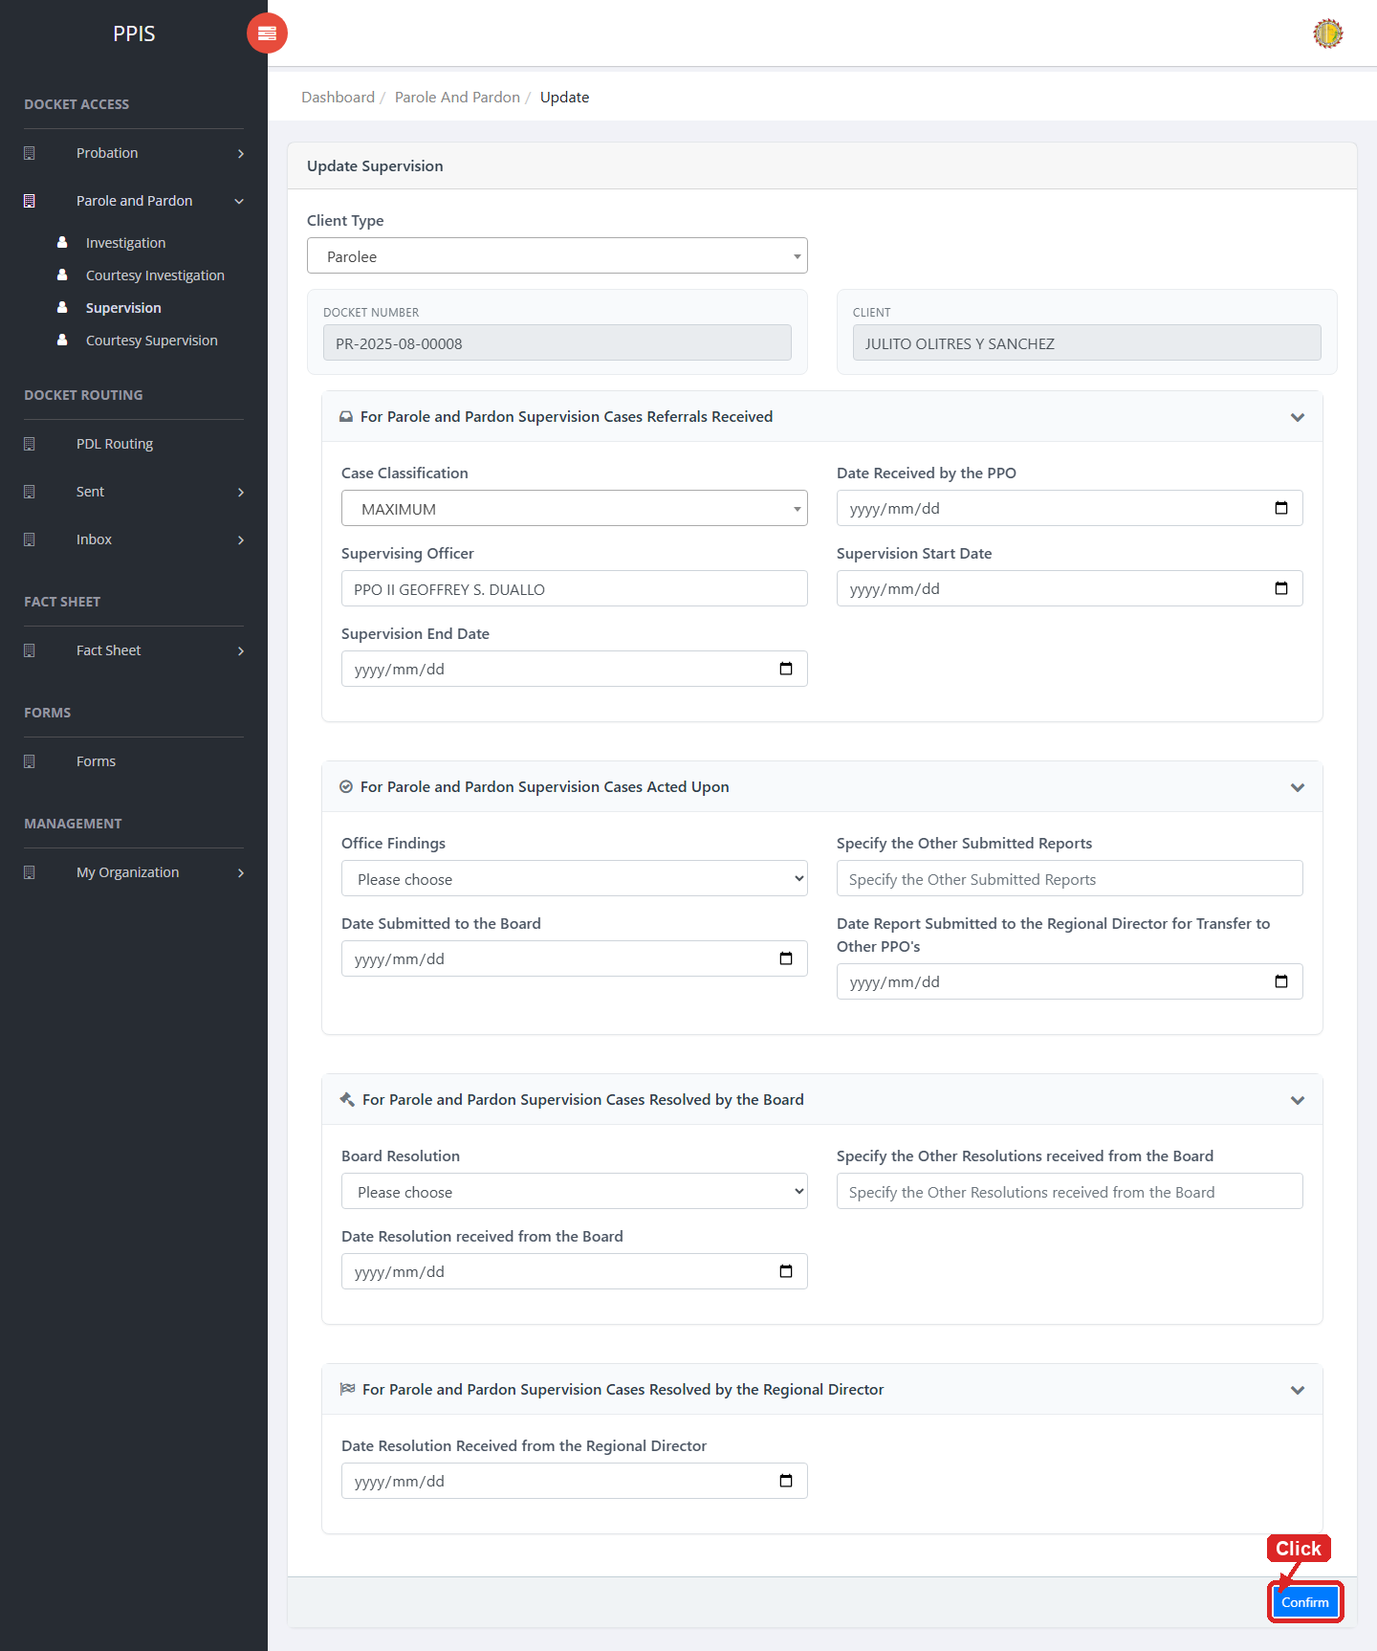
Parole and Pardon Supervision (Update)

Parole and Pardon Supervision (Attachments)
1. On the Parole and Pardon Supervision list page, click Attachments for the correct record.
2. Wait for the attachments screen to open.
3. Complete the attachment details, such as Kind, Type, and Upload File when shown.
4. Click Confirm to upload the file.
5. Use View, Download, or Delete only for the attachment listed in the table.
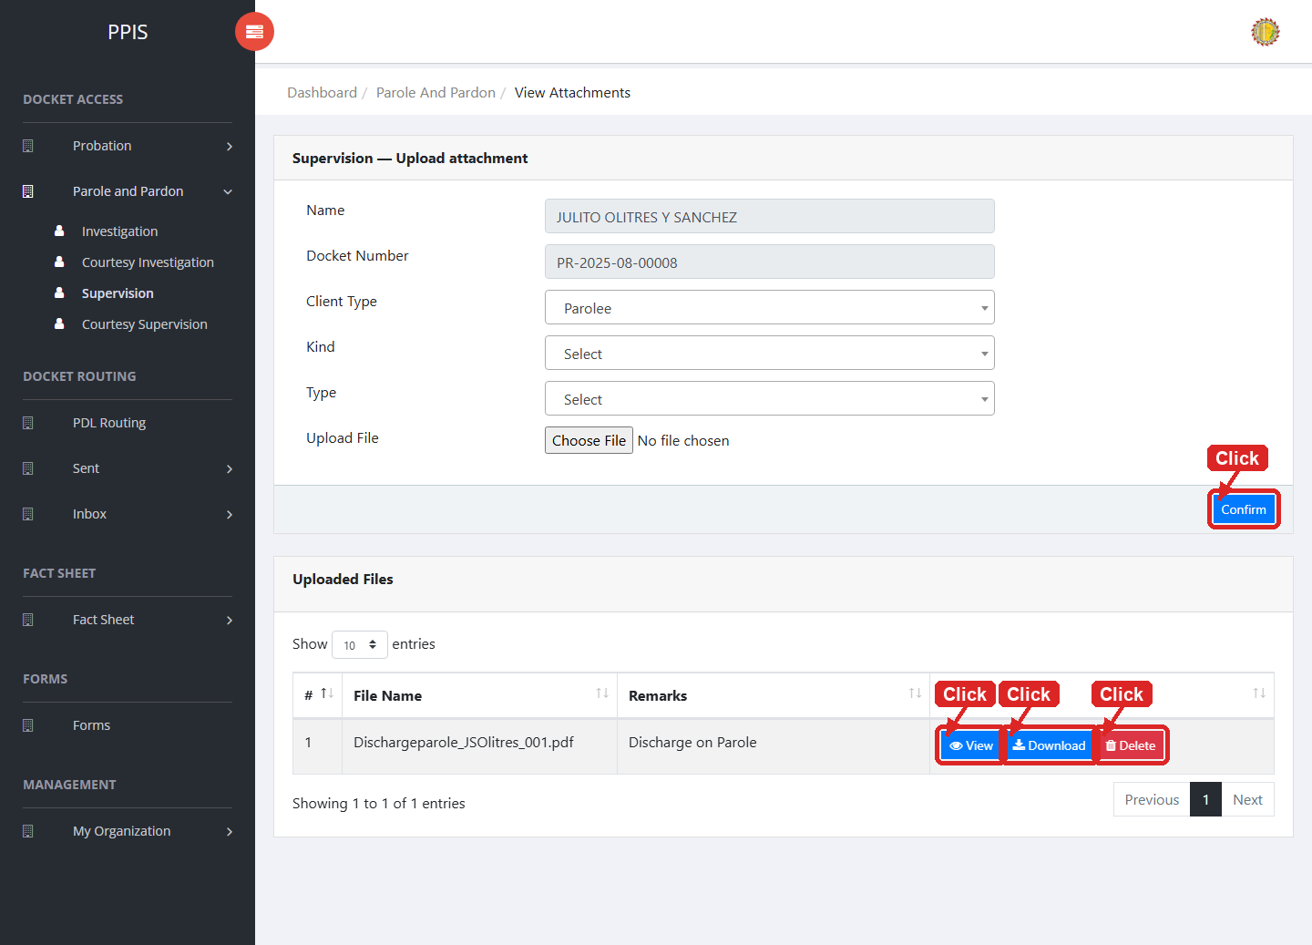
Parole and Pardon Supervision (Attachments)

Parole and Pardon Supervision (Delete)
Deletion warning: Use Remove only for sample/test records or records approved for deletion. For documentation, stop at the confirmation dialog unless removal is required.

1. On the Parole and Pardon Supervision list page, locate the sample, test, or authorized record.
2. Click Remove in the Actions column.
3. Wait for the confirmation modal dialog box to appear.
4. Read the confirmation message carefully. The system warns that removal cannot be undone.
5. Click Cancel inside the modal dialog to stop, or click Remove permanently inside the modal dialog only when deletion is authorized.
6. Wait for the modal dialog to close. The table refreshes to reflect the remaining records.
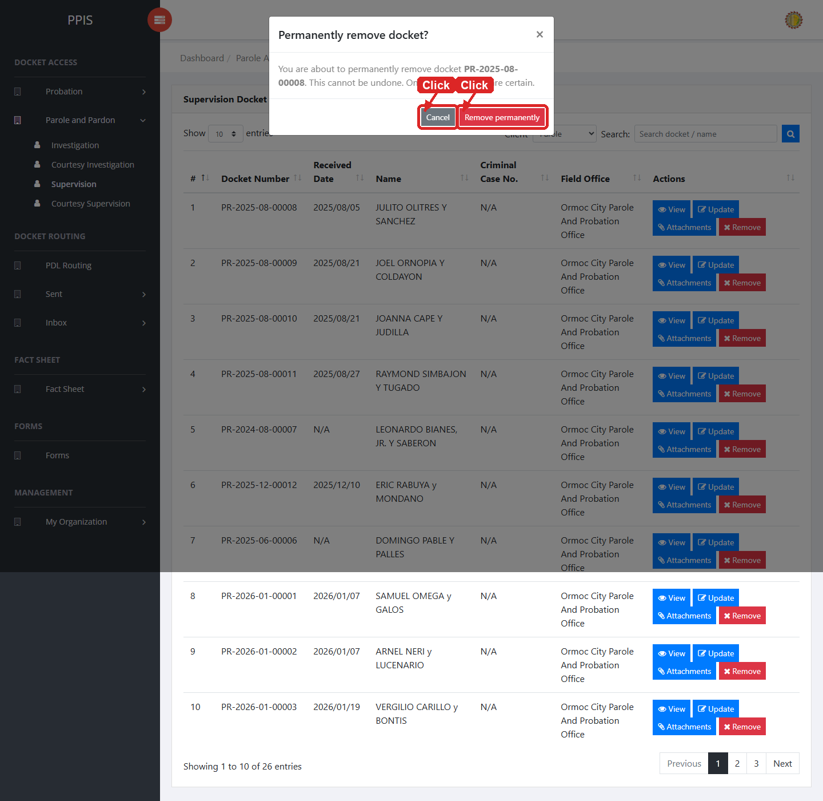
Parole and Pardon Supervision (Delete)

Parole and Pardon Courtesy Supervision
Use this page to manage courtesy supervision records for parole and pardon cases.
1. From the left menu, open Parole and Pardon Courtesy Supervision.
2. To find a record, enter the known information in Search docket / name.
3. Click Run search to apply the search.
4. In the Actions column, use View, Update, Attachments, Remove for the selected row.
5. To filter the table instantly, type characters directly into the inline search boxes in the column headers, or select a value from any drop-down filter shown above a column. The table updates automatically as you type or select.
6. To export the currently displayed table data, click CSV, PDF, or EXCEL above the table when those buttons are shown. The system downloads the visible records in the selected format.
7. To print the table, click Print. The native browser print window opens. Review the layout settings, then click Print in that window to complete printing.
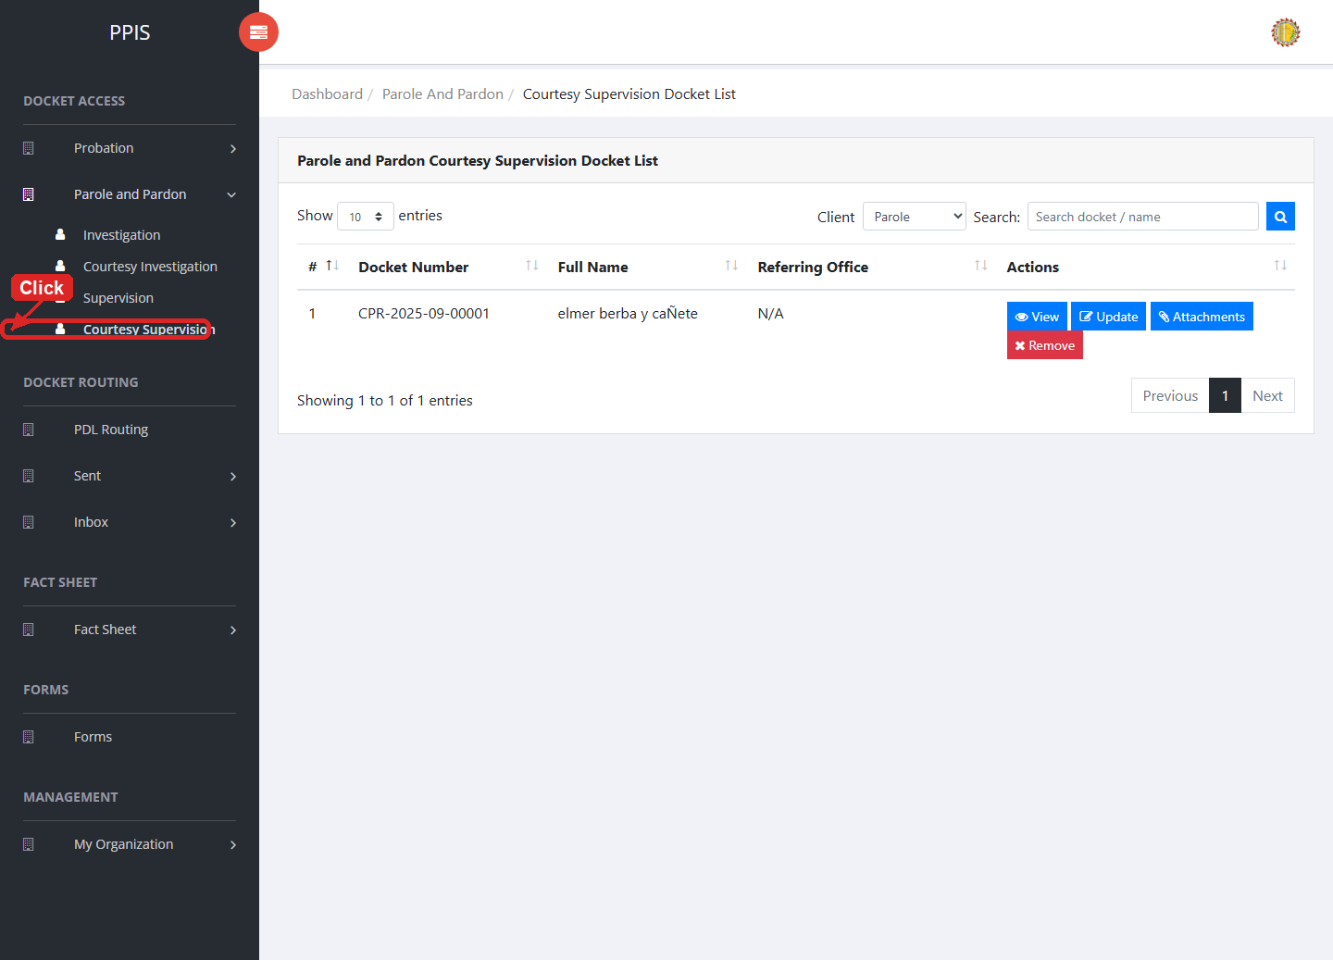
Parole and Pardon Courtesy Supervision list page

Parole and Pardon Courtesy Supervision (View)
1. On the Parole and Pardon Courtesy Supervision list page, locate the record you need to review.
2. Click View in the Actions column.
3. Read the details on the view page. Use this screen for checking information before making any changes.
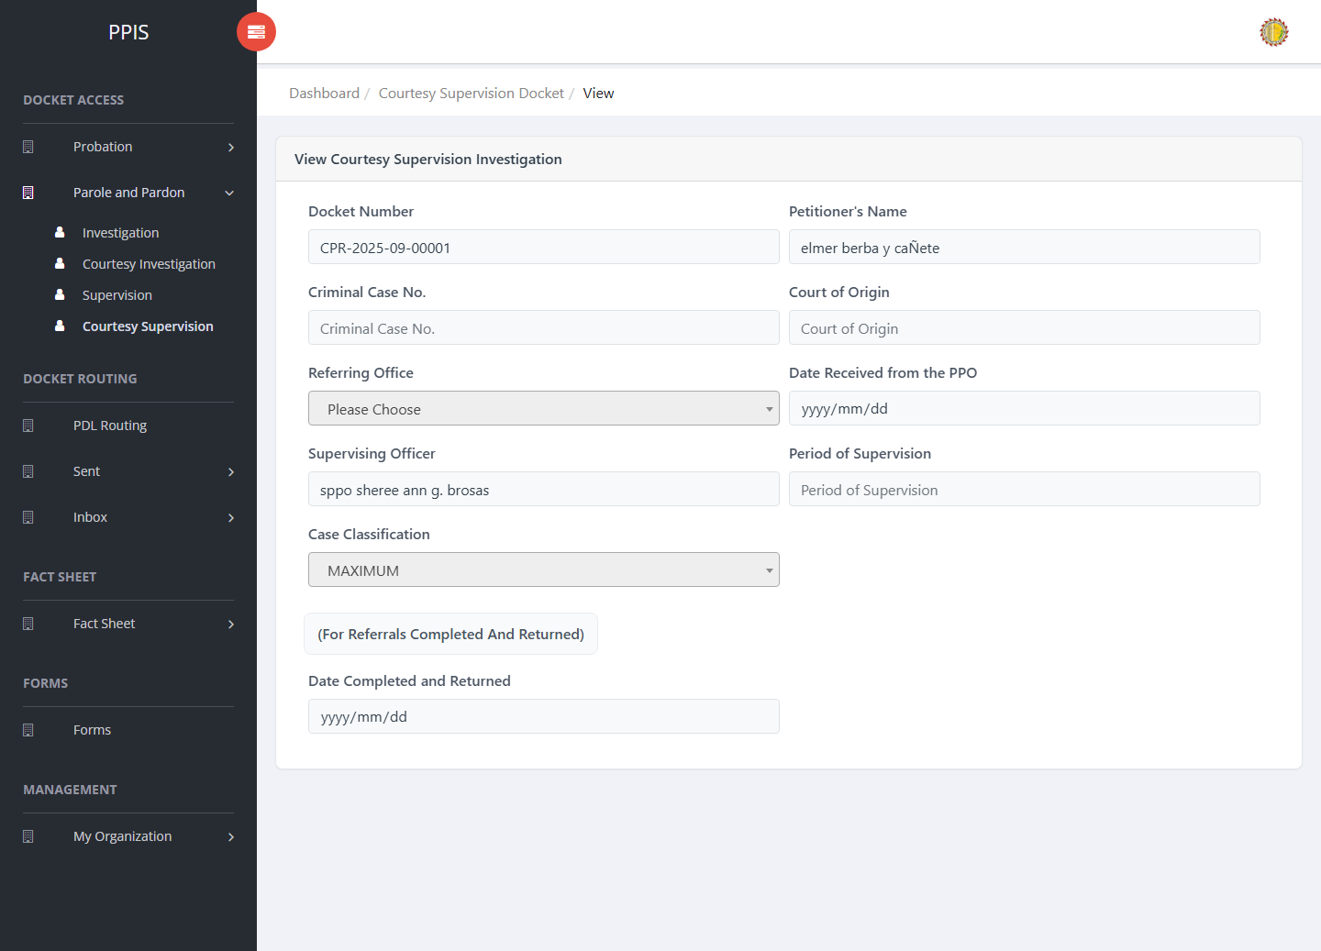
Parole and Pardon Courtesy Supervision (View)

Parole and Pardon Courtesy Supervision (Update)
1. On the Parole and Pardon Courtesy Supervision list page, locate the record that needs correction.
2. Click Update in the Actions column.
3. Wait for the update screen to open.
4. Review the current details and update Client Type, Docket Number, Petitioner's Name, Criminal Case No., Court of Origin, Referring Office, Date Received from the PPO, Supervising Officer.
5. Click Update to save after checking the information.
6. Wait for the system to return to the list page or refresh the record display.
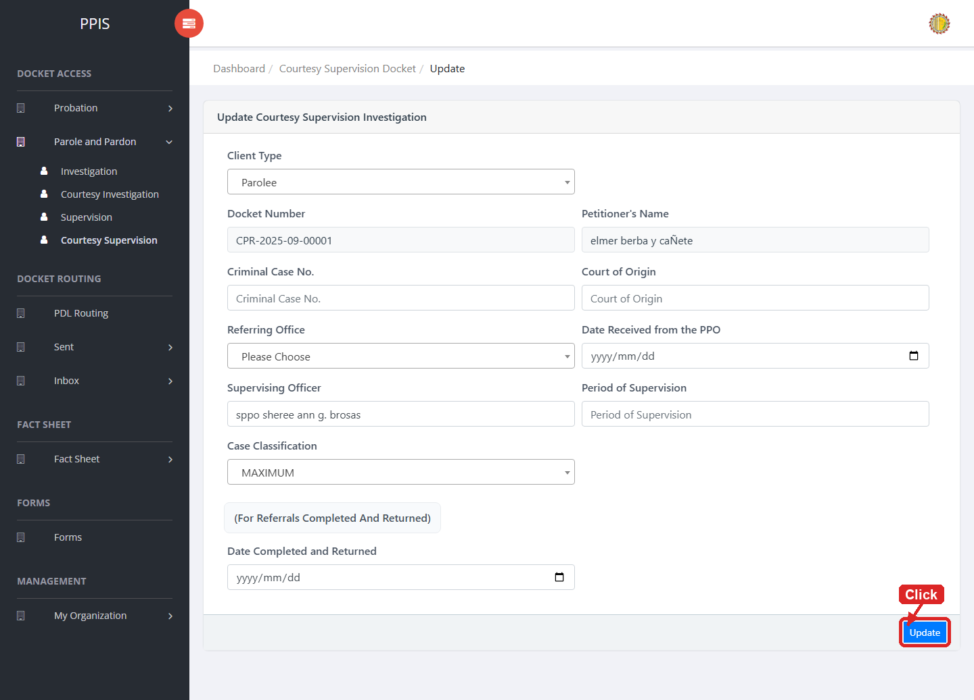
Parole and Pardon Courtesy Supervision (Update)

Parole and Pardon Courtesy Supervision (Attachments)
1. On the Parole and Pardon Courtesy Supervision list page, click Attachments for the correct record.
2. Wait for the attachments screen to open.
3. Complete the attachment details, such as Kind, Type, and Upload File when shown.
4. Click Confirm to upload the file.
5. Use View, Download, or Delete only for the attachment listed in the table.
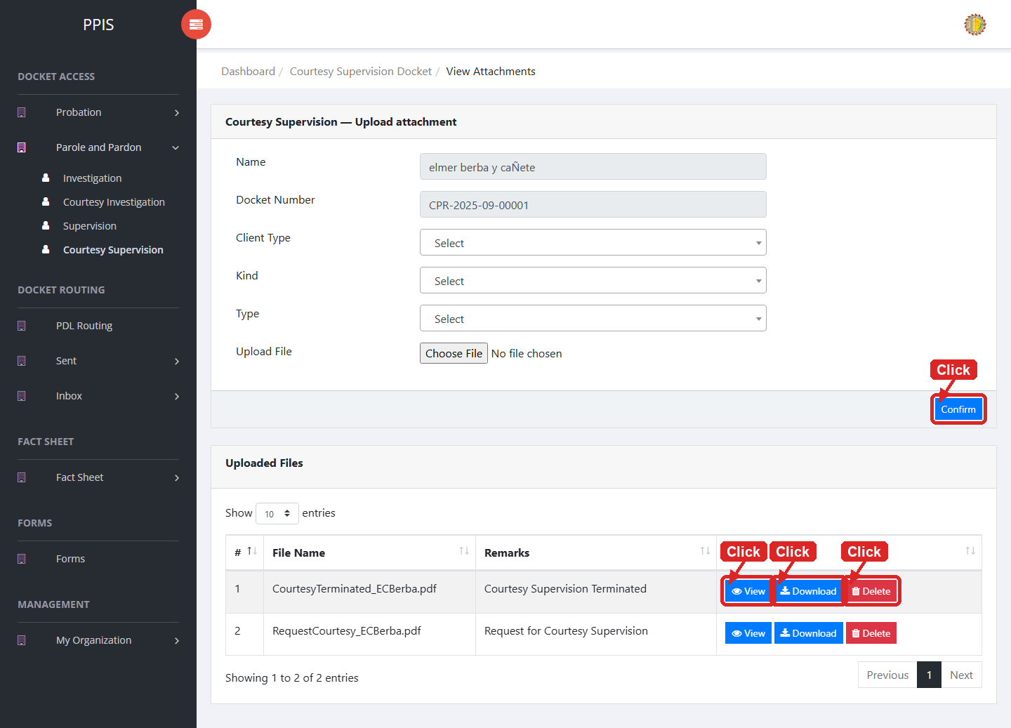
Parole and Pardon Courtesy Supervision (Attachments)

Parole and Pardon Courtesy Supervision (Delete)
Deletion warning: Use Remove only for sample/test records or records approved for deletion. For documentation, stop at the confirmation dialog unless removal is required.

1. On the Parole and Pardon Courtesy Supervision list page, locate the sample, test, or authorized record.
2. Click Remove in the Actions column.
3. Wait for the confirmation modal dialog box to appear.
4. Read the confirmation message carefully. The system warns that removal cannot be undone.
5. Click Cancel inside the modal dialog to stop, or click Remove permanently inside the modal dialog only when deletion is authorized.
6. Wait for the modal dialog to close. The table refreshes to reflect the remaining records.
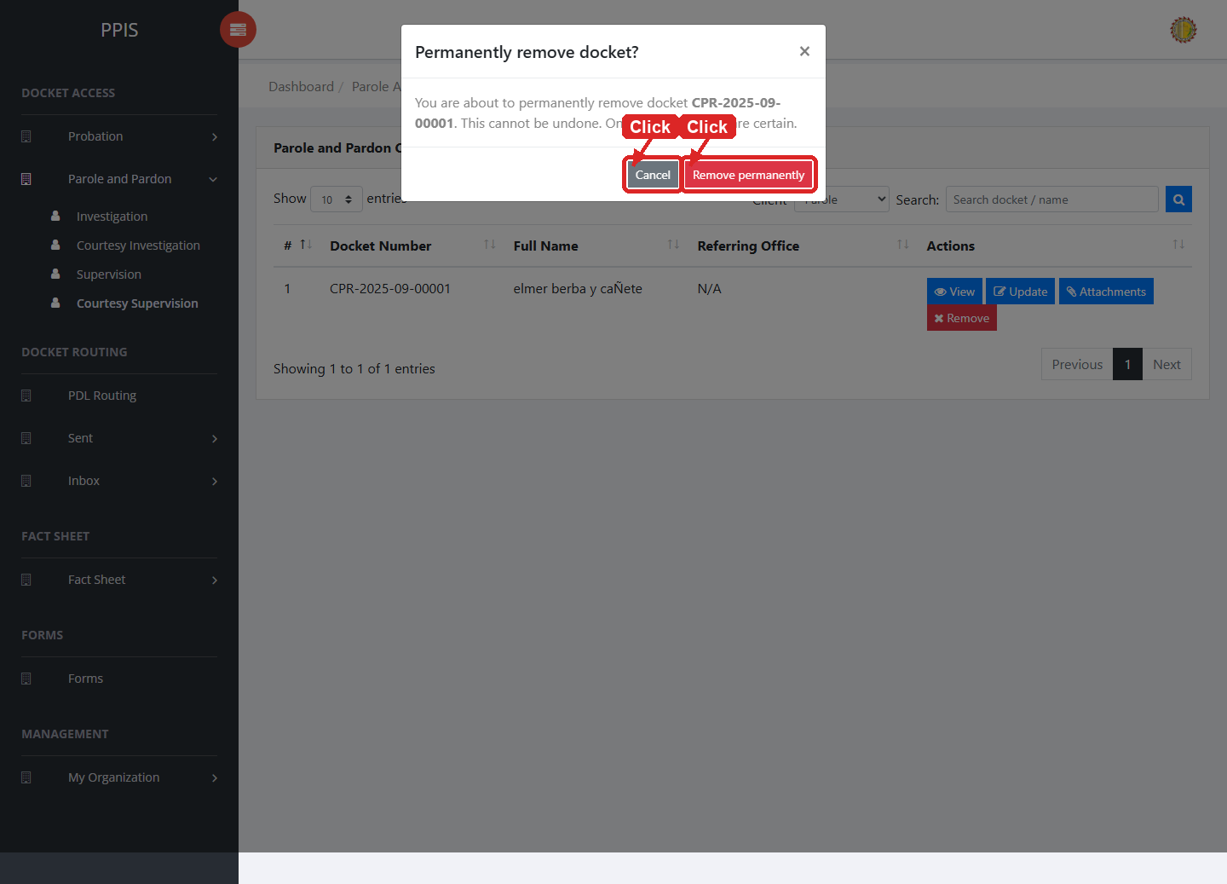
Parole and Pardon Courtesy Supervision (Delete)

6. Docket Routing

PDL Routing
Use this page for PDL routing actions available to the signed-in account.
1. From the left menu, open PDL Routing.
2. To find a record, enter the known information in Client Type, Client, User Account, Subject.
3. Review the records shown on the page and follow any visible office procedure for the selected queue.
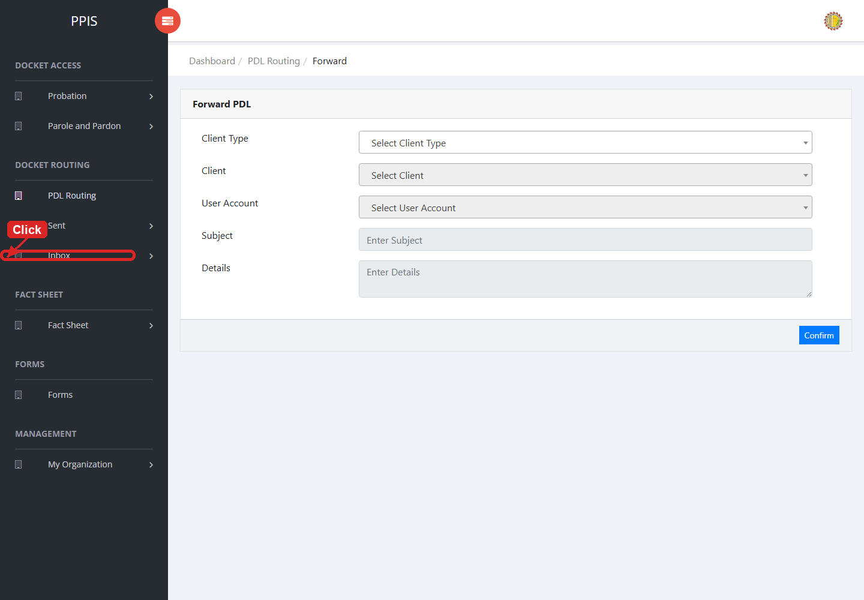
PDL Routing list page

7. Sent and Inbox

Sent PDL
Use this page to check PDL items that have already been sent.
1. From the left menu, open Sent PDL.
2. To find a record, enter the known information in the Search field.
3. Review the records shown on the page and follow any visible office procedure for the selected queue.
4. To filter the table instantly, type characters directly into the inline search boxes in the column headers, or select a value from any drop-down filter shown above a column. The table updates automatically as you type or select.
5. To export the currently displayed table data, click CSV, PDF, or EXCEL above the table when those buttons are shown. The system downloads the visible records in the selected format.
6. To print the table, click Print. The native browser print window opens. Review the layout settings, then click Print in that window to complete printing.
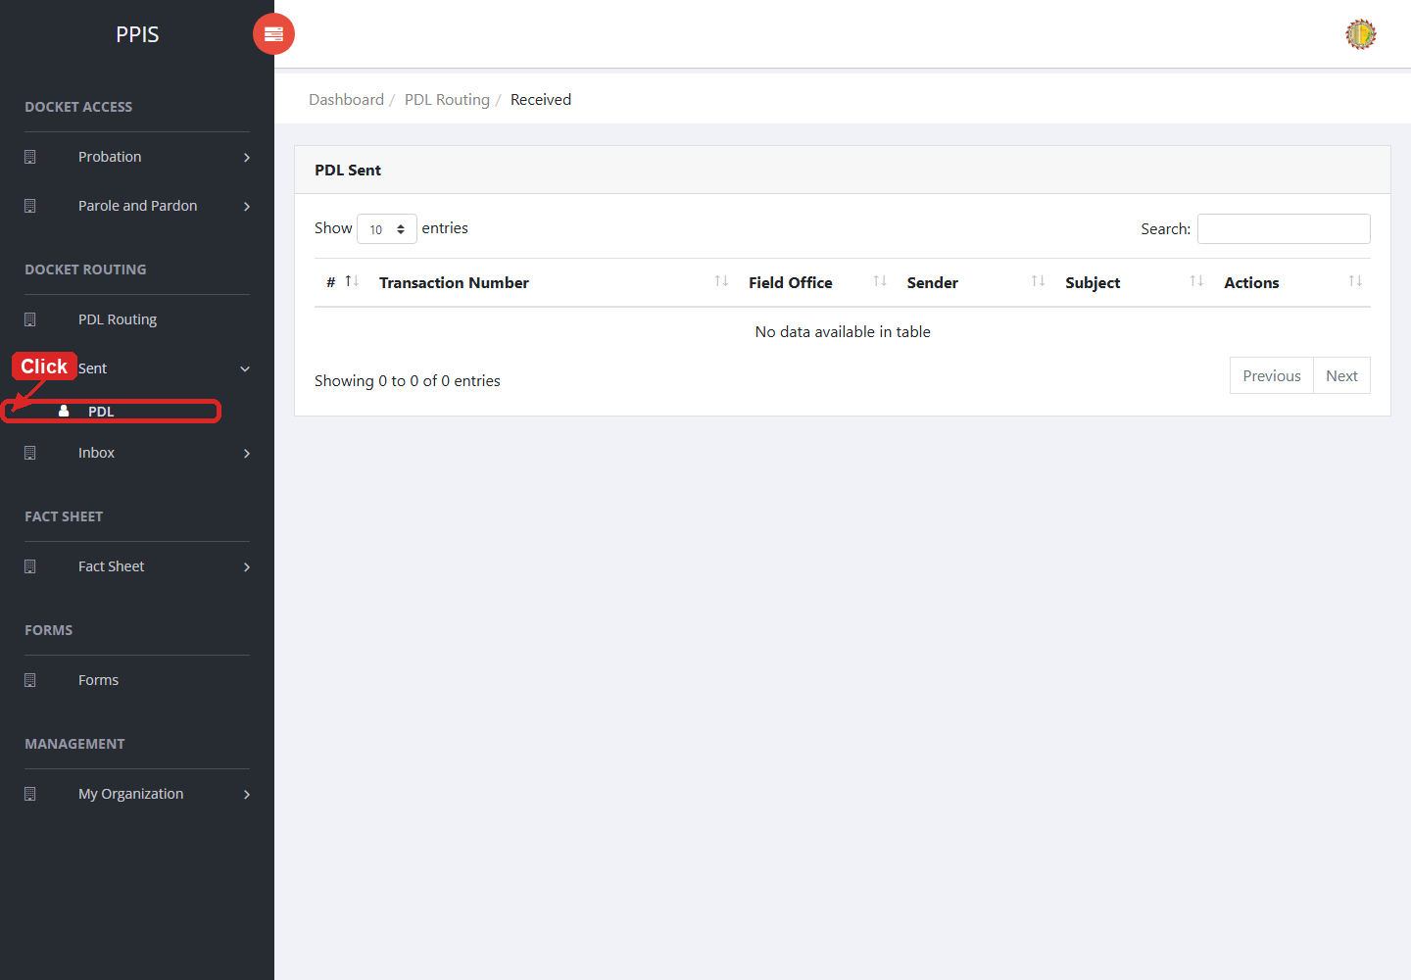
Sent PDL list page

Inbox PDL
Use this page to review PDL items received by the office.
1. From the left menu, open Inbox PDL.
2. If the page has tabs, select the needed tab, such as Investigation, Supervision.
3. Review the records shown on the page and follow any visible office procedure for the selected queue.
4. To filter the table instantly, type characters directly into the inline search boxes in the column headers, or select a value from any drop-down filter shown above a column. The table updates automatically as you type or select.
5. To export the currently displayed table data, click CSV, PDF, or EXCEL above the table when those buttons are shown. The system downloads the visible records in the selected format.
6. To print the table, click Print. The native browser print window opens. Review the layout settings, then click Print in that window to complete printing.
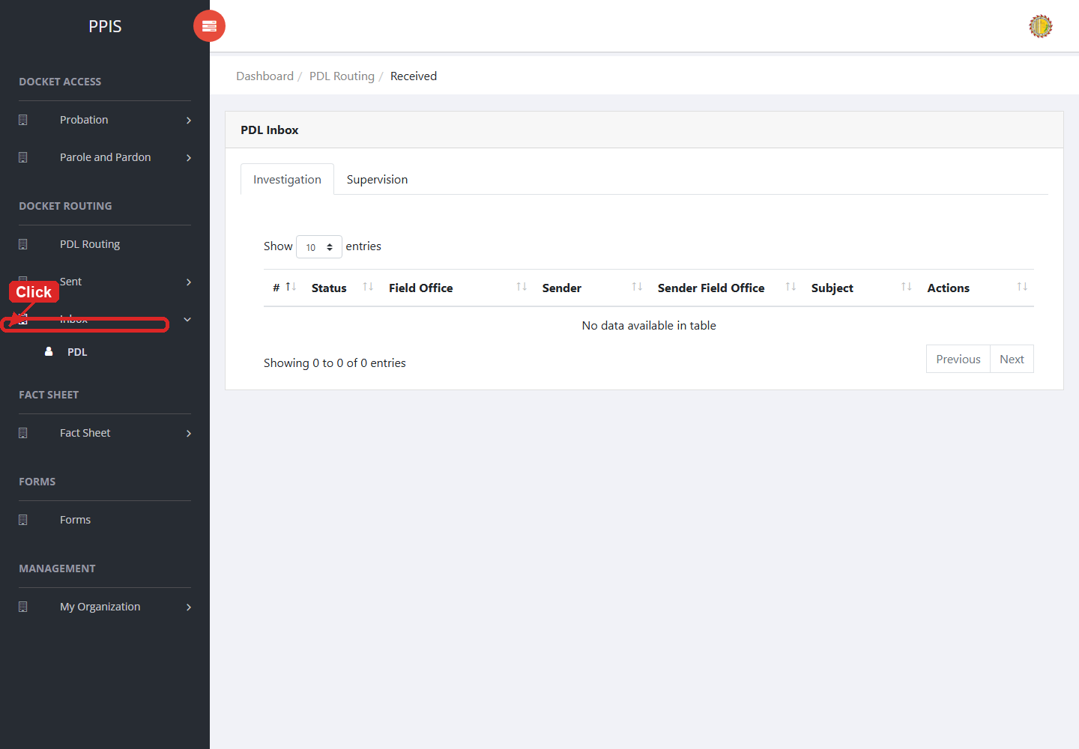
Inbox PDL list page

8. Fact Sheet

Fact Sheet Probation
Use this page to find and open probation client fact sheets.
1. From the left menu, open Fact Sheet Probation.
2. To find a client, enter the known name or case number in Name or case number.
3. Click Run search to filter the client list.
4. In the Full Name column, click the client name link to open the client view profile.
5. To filter the table instantly, type characters directly into the inline search boxes in the column headers, or select a value from any drop-down filter shown above a column. The table updates automatically as you type or select.
6. To export the currently displayed table data, click CSV, PDF, or EXCEL above the table when those buttons are shown. The system downloads the visible records in the selected format.
7. To print the table, click Print. The native browser print window opens. Review the layout settings, then click Print in that window to complete printing.
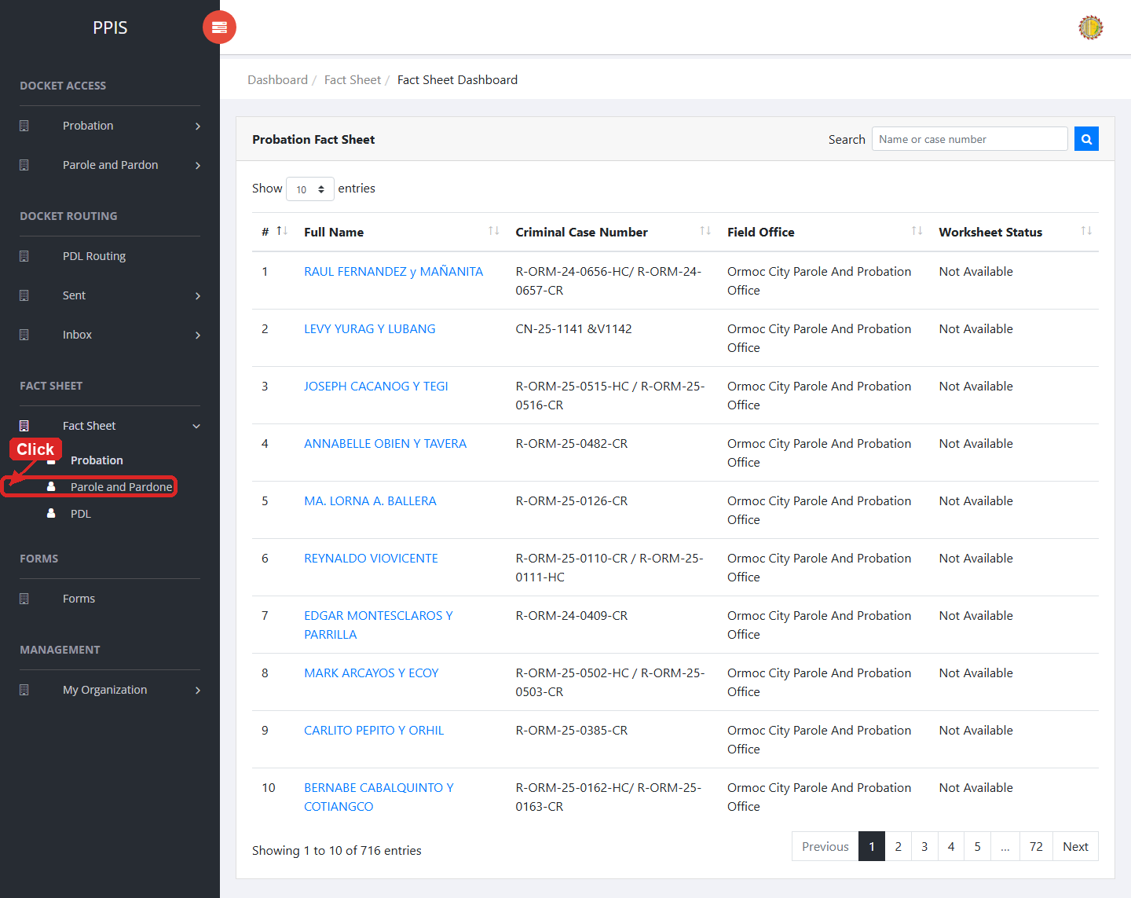
Fact Sheet Probation list page

Fact Sheet Probation (Open Client Profile)
1. On the Fact Sheet Probation list page, locate the client you need.
2. Click the client name in the Full Name column.
3. Wait for the client view profile to open. The page shows the client photo area, profile tabs, and tab content below.
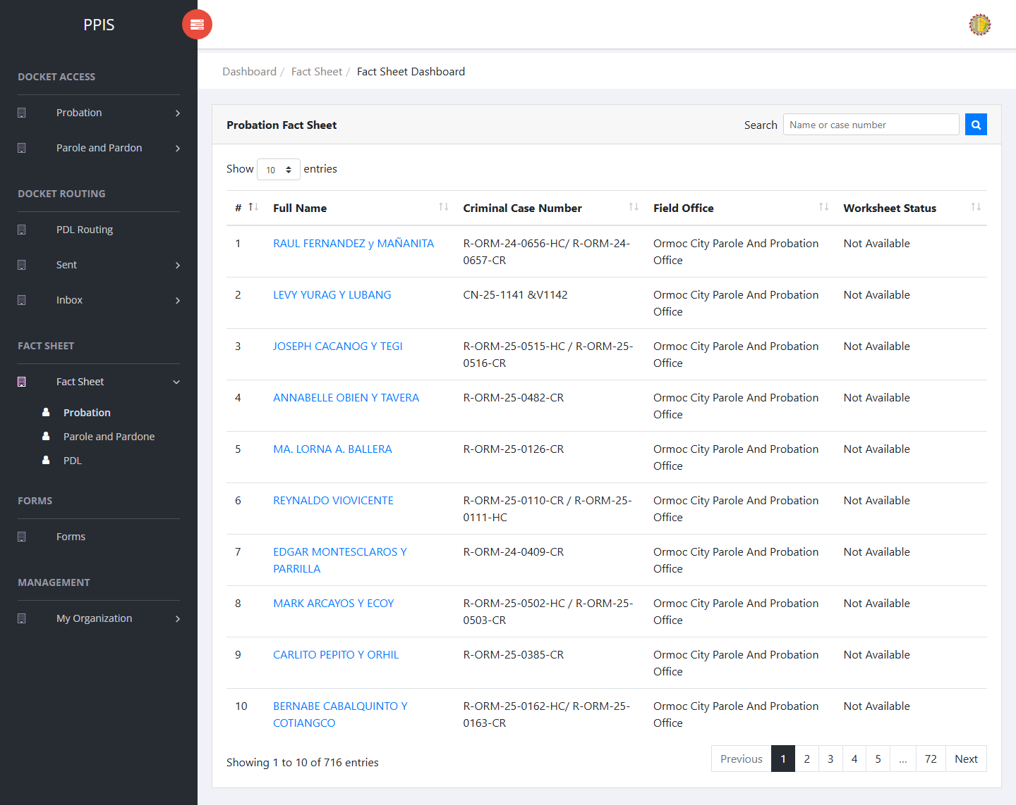
Fact Sheet Probation — click client name
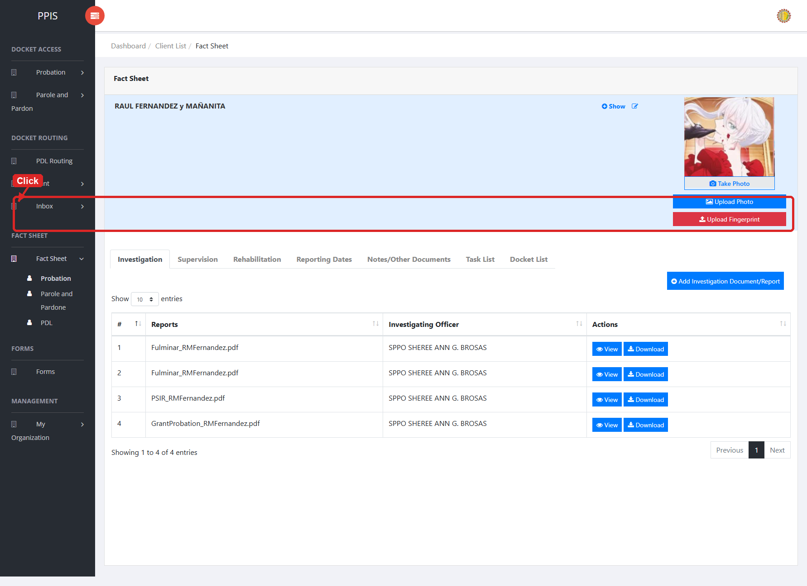
Fact Sheet Probation — client view profile

Fact Sheet Probation (Client Profile Tabs)
Each tab in the client view profile is used for a different part of the client record.
• Investigation — Review and upload investigation documents and reports tied to the client. Use Add Investigation Document/Report when a new file must be attached.
• Supervision — Review and upload supervision documents and reports for the client. Use Add Supervision Document/Report when a new file must be attached.
• Rehabilitation — View therapeutic community and restorative justice activities, including dates, venues, phases, stakeholders, and outcomes.
• Reporting Dates — Review reporting-date photos and records. Use Add Reporting Date when a new reporting entry or photo must be recorded.
• Notes/Other Documents — Store supplementary notes and other supporting documents for the client. Use Add Note/Other Document to upload a file.
• Task List — Review tasks assigned to the client or office, including assignment date, assigned user, and status.
• Docket List — Review dockets linked to the client from investigation, supervision, and related workflows.
1. On the client view profile, read the tab labels across the top of the page.
2. Click the tab that matches the information you need to review or update.
3. Wait for the tab content to load before using any buttons or tables shown in that section.

Fact Sheet Probation (Upload or Take Photo)
1. On the client view profile, locate the client photo area on the left side of the page.
2. To upload an existing image file, click Upload Photo.
3. In the Upload Profile dialog, choose an image file, then click Confirm.
4. To capture a new photo with the device camera, click Take Photo.
5. In the Capture Camera dialog, click Open cam, allow camera access if the browser asks for permission, then click Capture.
6. Review the captured image. Click Retake if you need another shot, or click Confirm to save the photo to the client profile.
7. Wait for the success message. The client photo area refreshes with the uploaded or captured image.
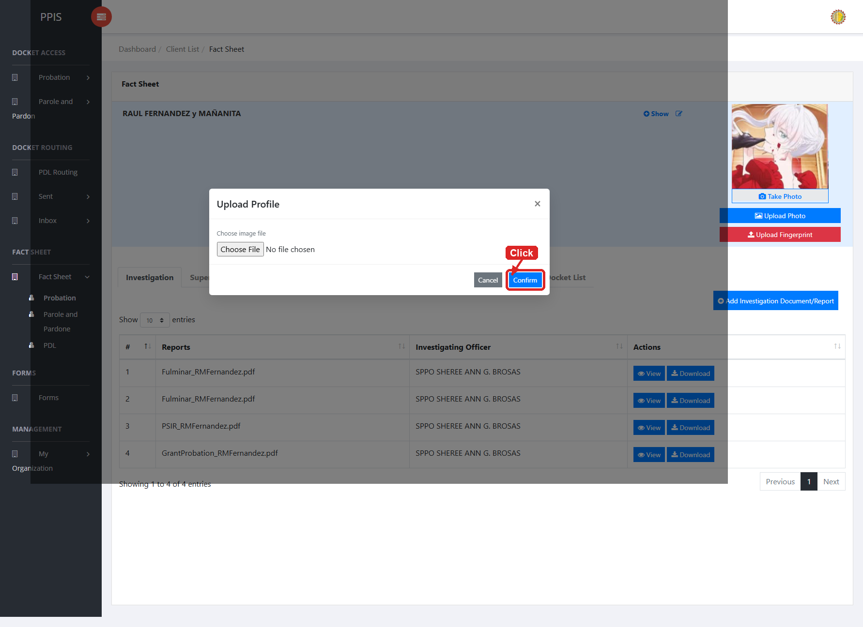
Fact Sheet Probation — upload photo
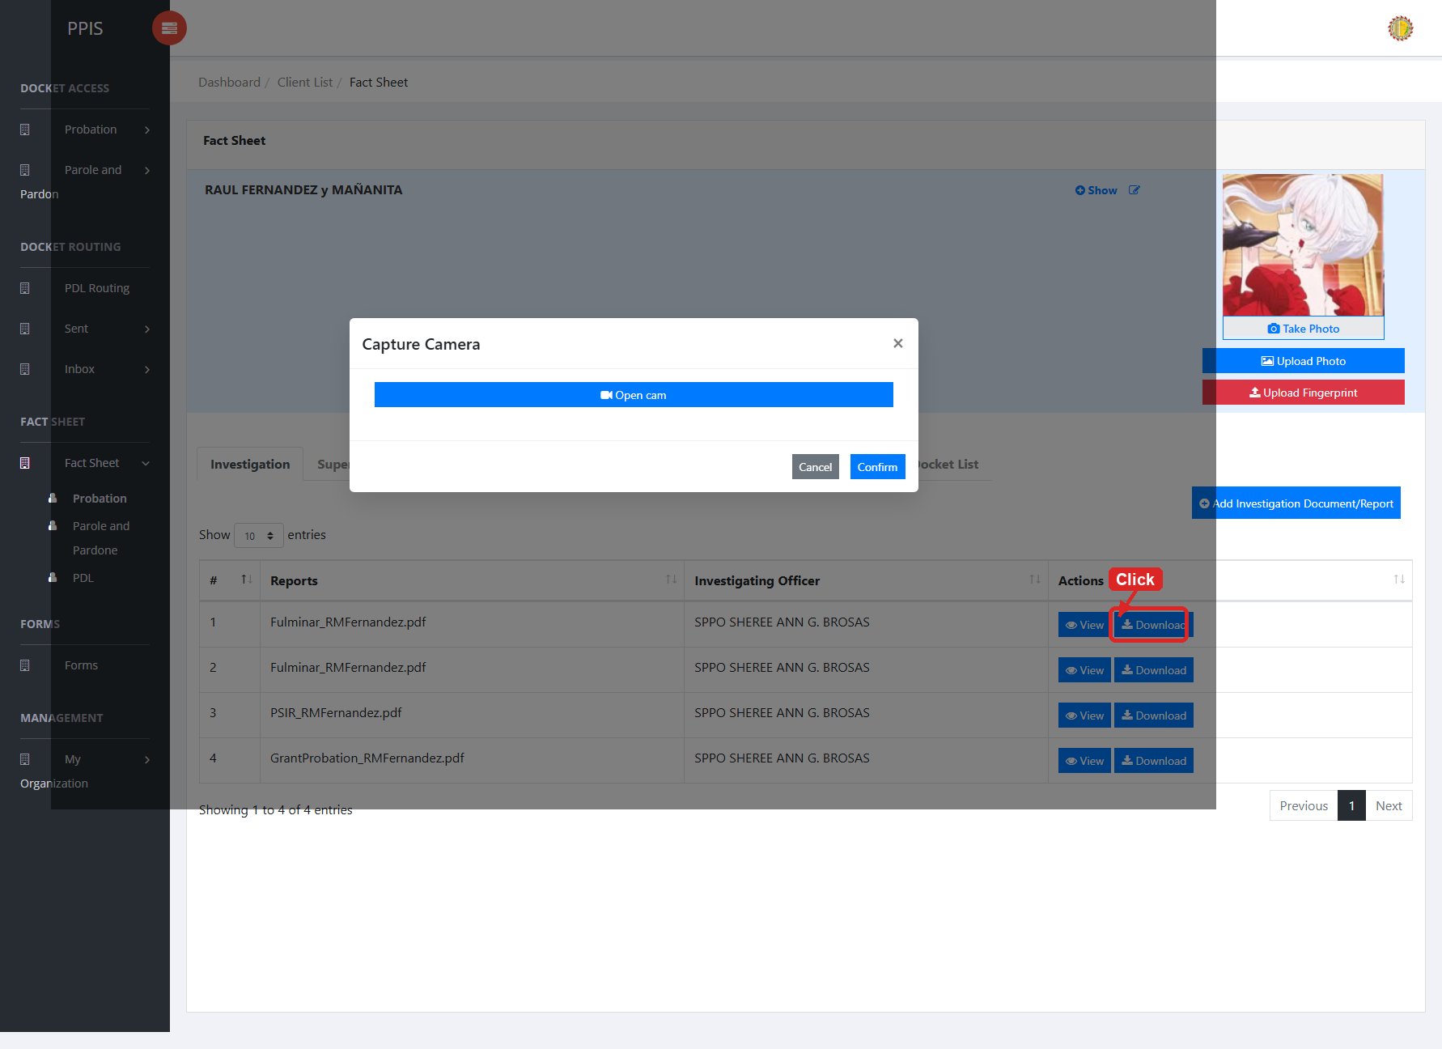
Fact Sheet Probation — take photo

Fact Sheet Probation (Upload Fingerprint)
1. On the client view profile, click Upload Fingerprint below the photo buttons.
2. Wait for the Upload Fingerprint dialog to open.
3. Click the fingerprint image for the finger you need to upload: Right Thumb, Right Index, Right Middle, Right Ring, or Right Little.
4. Select the fingerprint image file from your computer.
5. Repeat the finger selection for any additional fingerprints that must be uploaded.
6. Click Confirm to save the fingerprint files to the client profile.
7. Wait for the success message, then close the dialog when finished.
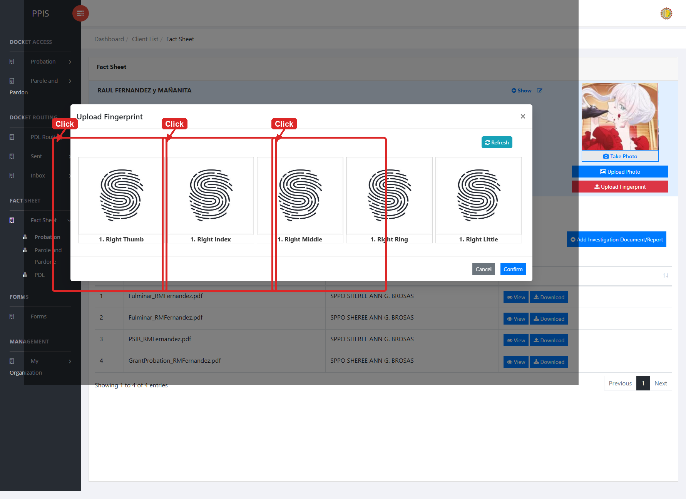
Fact Sheet Probation — upload fingerprint

Fact Sheet Parole and Pardone
Use this page to manage client records for parole and pardone workflows.
1. From the left menu, open Fact Sheet Parole and Pardone.
2. If the page has tabs, select the needed tab, such as Parole, Pardone.
3. To find a record, enter the known information in Search Client.
4. In the Actions column, use Update, Attachments for the selected row.
5. To filter the table instantly, type characters directly into the inline search boxes in the column headers, or select a value from any drop-down filter shown above a column. The table updates automatically as you type or select.
6. To export the currently displayed table data, click CSV, PDF, or EXCEL above the table when those buttons are shown. The system downloads the visible records in the selected format.
7. To print the table, click Print. The native browser print window opens. Review the layout settings, then click Print in that window to complete printing.
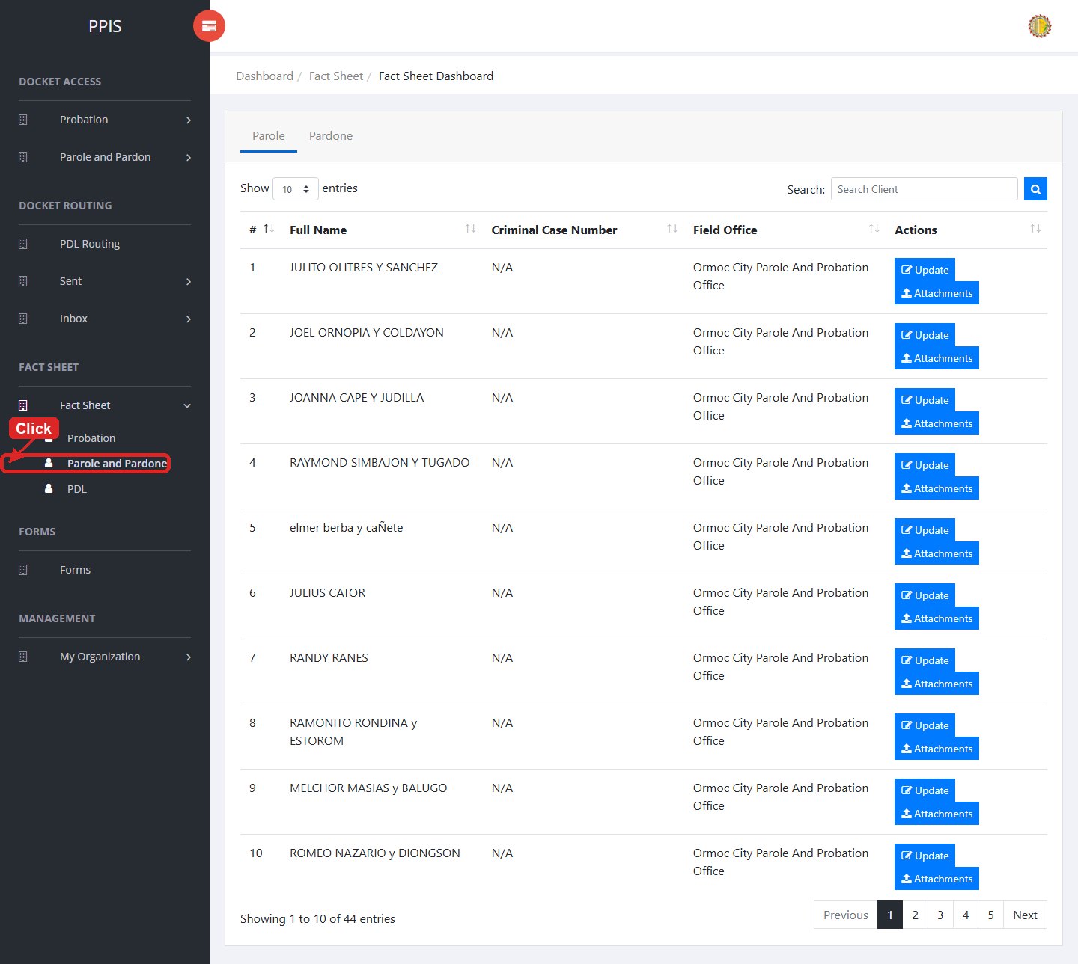
Fact Sheet Parole and Pardone list page

Fact Sheet Parole and Pardone (Create Client)
1. Open Fact Sheet Parole and Pardone from the left menu.
2. When your role allows client creation, open the Create New Client page.
3. Select Client Type as Parole or Pardone.
4. Enter Client Type, Criminal Case No., First Name, Middle Name, Last Name, Suffix Name, Sex, Educ. Attainment, Occupation, Birthdate, Birth Place, Address.
5. Click Confirm to save the new client record.
6. Wait for the success message. The new client appears in the Parole or Pardone tab on the fact sheet list.
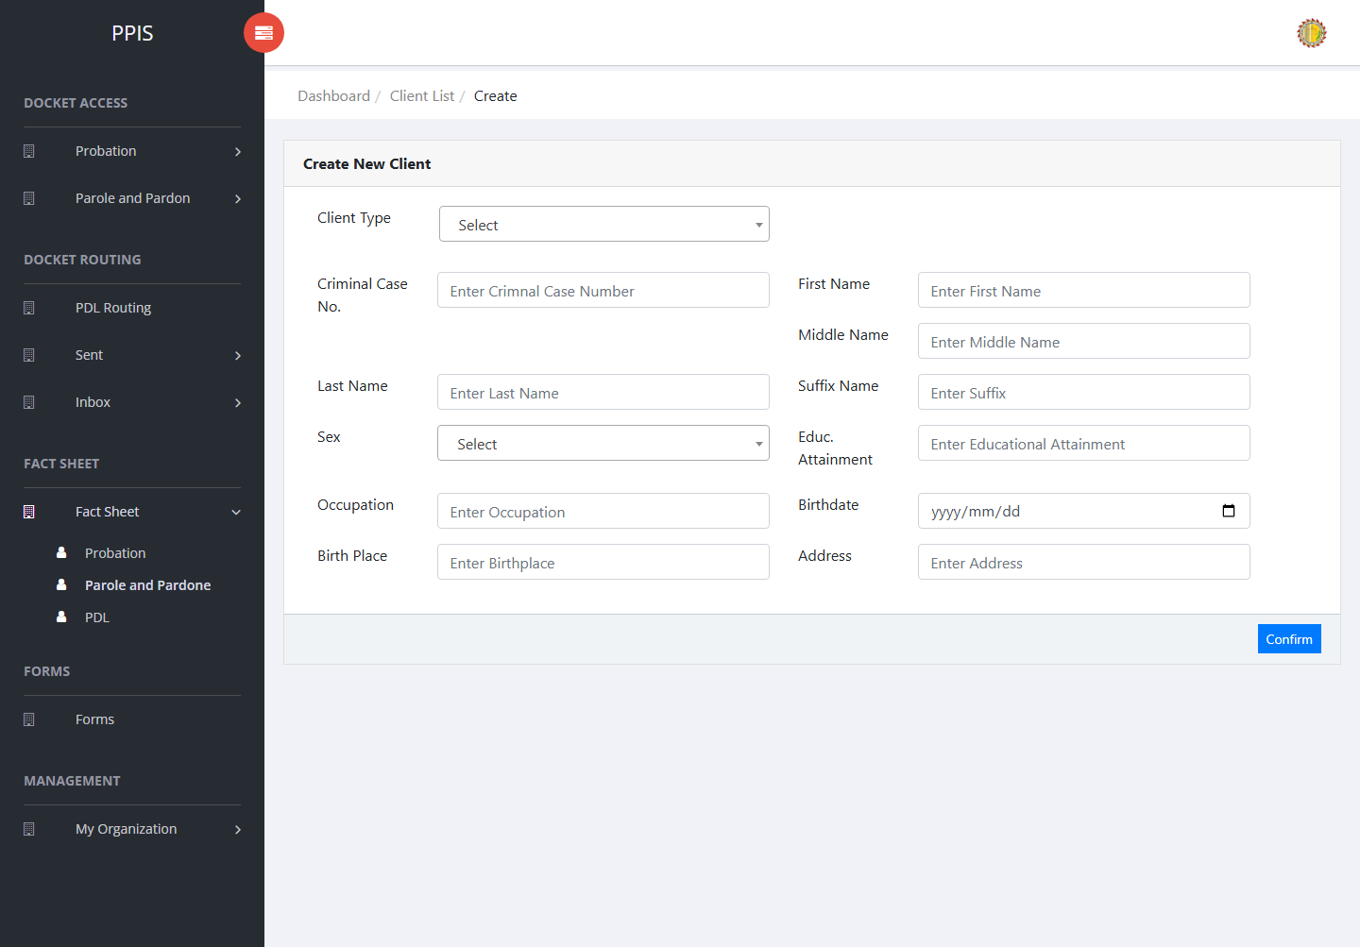
Fact Sheet Parole and Pardone (Create Client)

Fact Sheet Parole and Pardone (Update)
1. On the Fact Sheet Parole and Pardone list page, locate the record that needs correction.
2. Click Update in the Actions column.
3. Wait for the update screen to open.
4. Review the current details and update Client Type, Criminal Case No., First Name, Middle Name, Last Name, Suffix Name, Sex, Education.
5. Click Confirm to save after checking the information.
6. Wait for the system to return to the list page or refresh the record display.
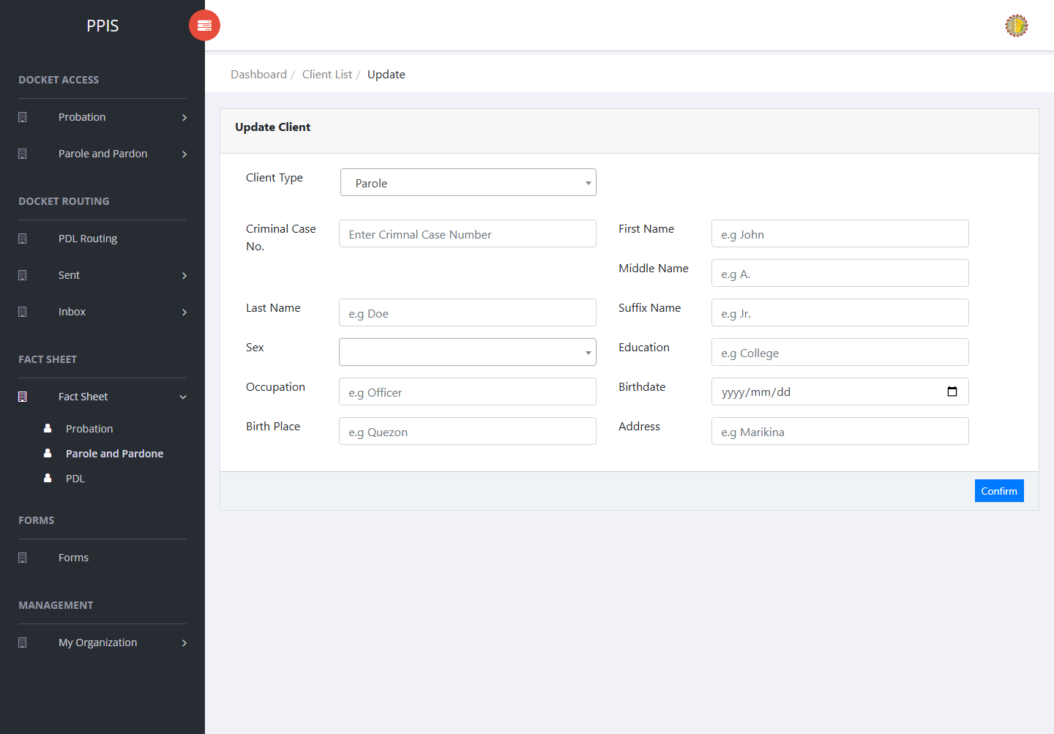
Fact Sheet Parole and Pardone (Update)

Fact Sheet Parole and Pardone (Attachments)
1. On the Fact Sheet Parole and Pardone list page, click Attachments for the correct record.
2. Wait for the attachments screen to open.
3. Complete the attachment details, such as Kind, Type, and Upload File when shown.
4. Click Confirm to upload the file.
5. Use View, Download, or Delete only for the attachment listed in the table.
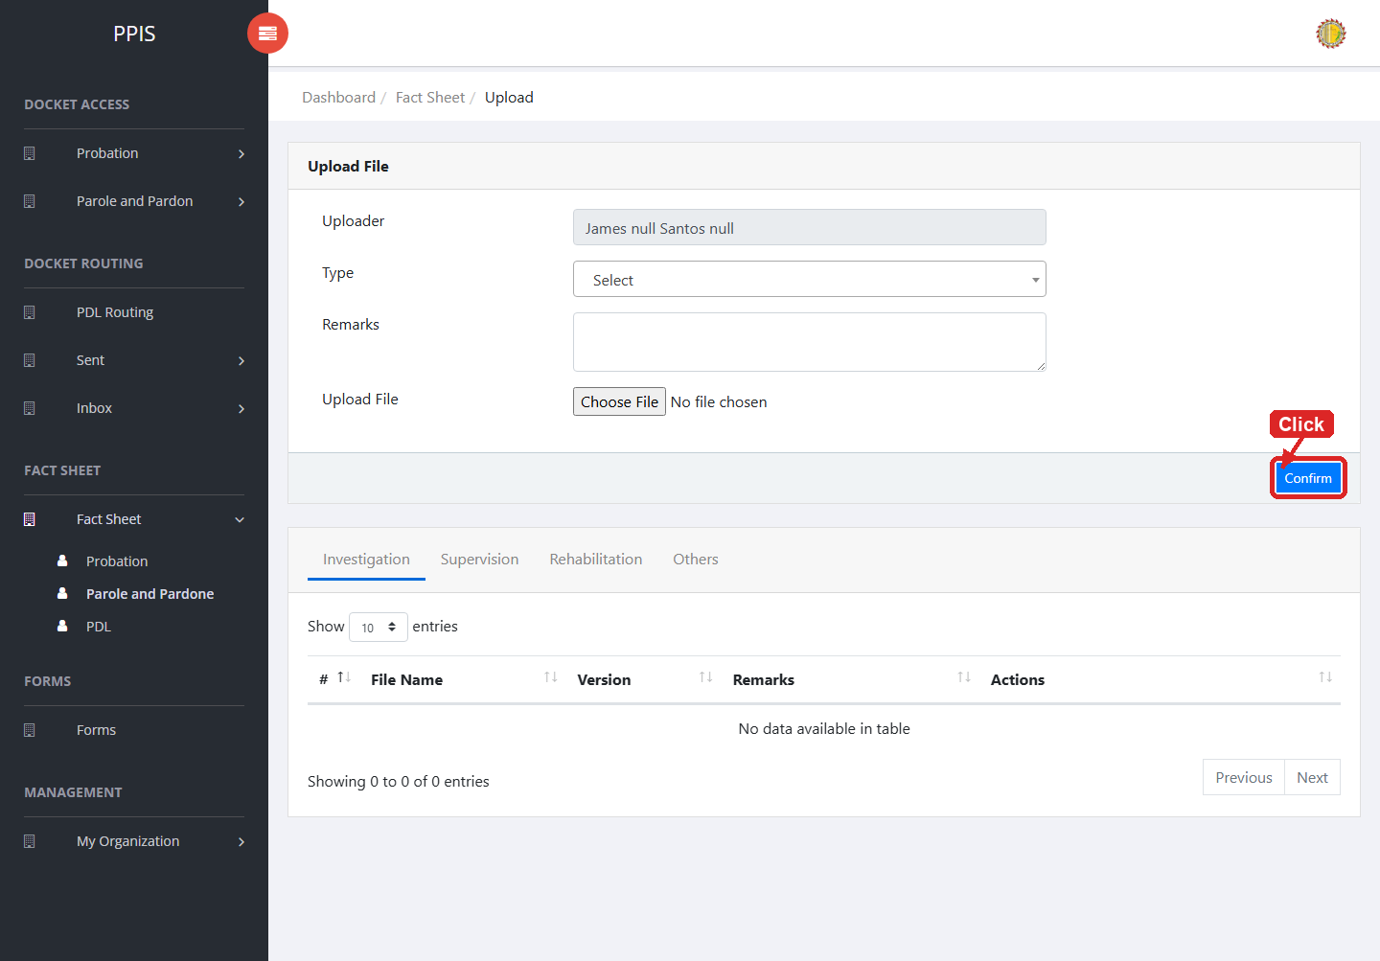
Fact Sheet Parole and Pardone (Attachments)

Fact Sheet PDL
Use this page to manage PDL client records.
1. From the left menu, open Fact Sheet PDL.
2. If the page has tabs, select the needed tab, such as Investigation or Supervision.
3. To find a record, enter the known information in Search Client when shown.
4. In the Actions column, use View, Update, Attachments for the selected row.
5. To filter the table instantly, type characters directly into the inline search boxes in the column headers, or select a value from any drop-down filter shown above a column. The table updates automatically as you type or select.
6. To export the currently displayed table data, click CSV, PDF, or EXCEL above the table when those buttons are shown. The system downloads the visible records in the selected format.
7. To print the table, click Print. The native browser print window opens. Review the layout settings, then click Print in that window to complete printing.
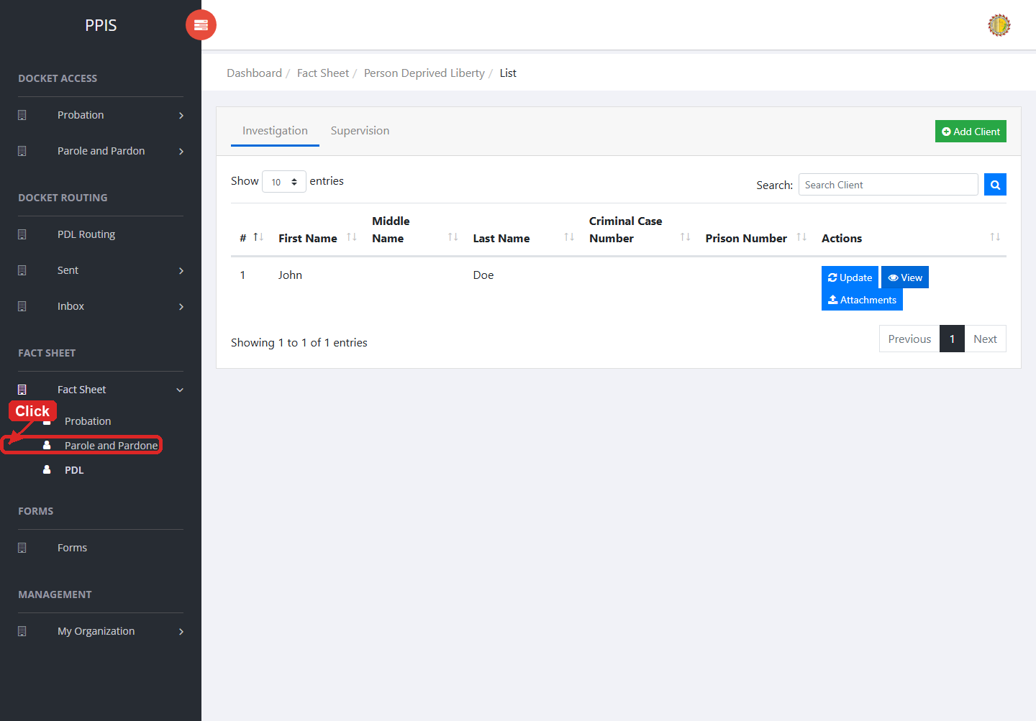
Fact Sheet PDL list page

Fact Sheet PDL (View)
1. On the Fact Sheet PDL list page, locate the record you need to review.
2. Click View in the Actions column.
3. Read the details on the view page. Use this screen for checking information before making any changes.
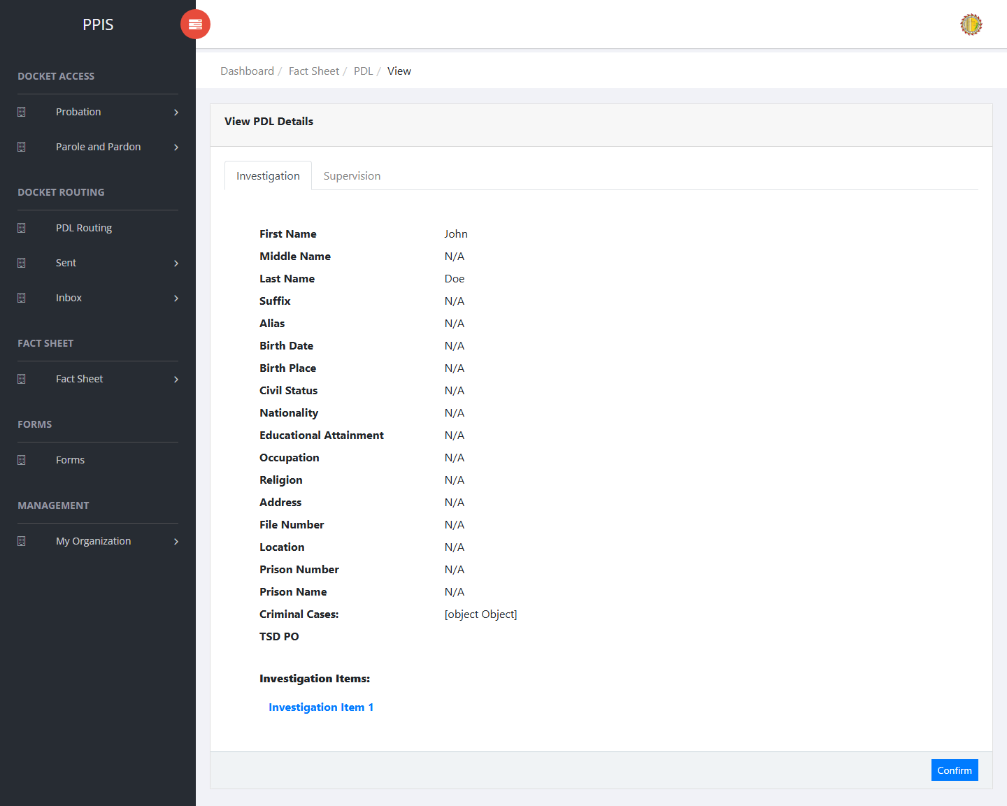
Fact Sheet PDL (View)

Fact Sheet PDL (Update)
1. On the Fact Sheet PDL list page, locate the record that needs correction.
2. Click Update in the Actions column.
3. Wait for the update screen to open.
4. Review the current details and update First Name, Middle Name, Last Name, Suffix Name, Alias, Sex, Birthdate, Birth Place.
5. Click Confirm to save after checking the information.
6. Wait for the system to return to the list page or refresh the record display.
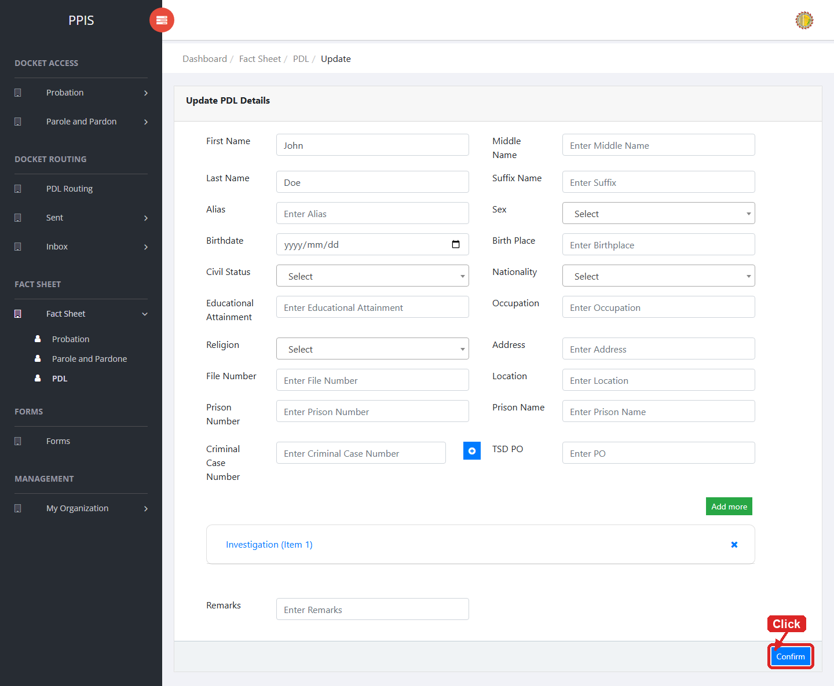
Fact Sheet PDL (Update)

Fact Sheet PDL (Attachments)
1. On the Fact Sheet PDL list page, click Attachments for the correct record.
2. Wait for the attachments screen to open.
3. Complete the attachment details, such as Kind, Type, and Upload File when shown.
4. Click Confirm to upload the file.
5. Use View, Download, or Delete only for the attachment listed in the table.
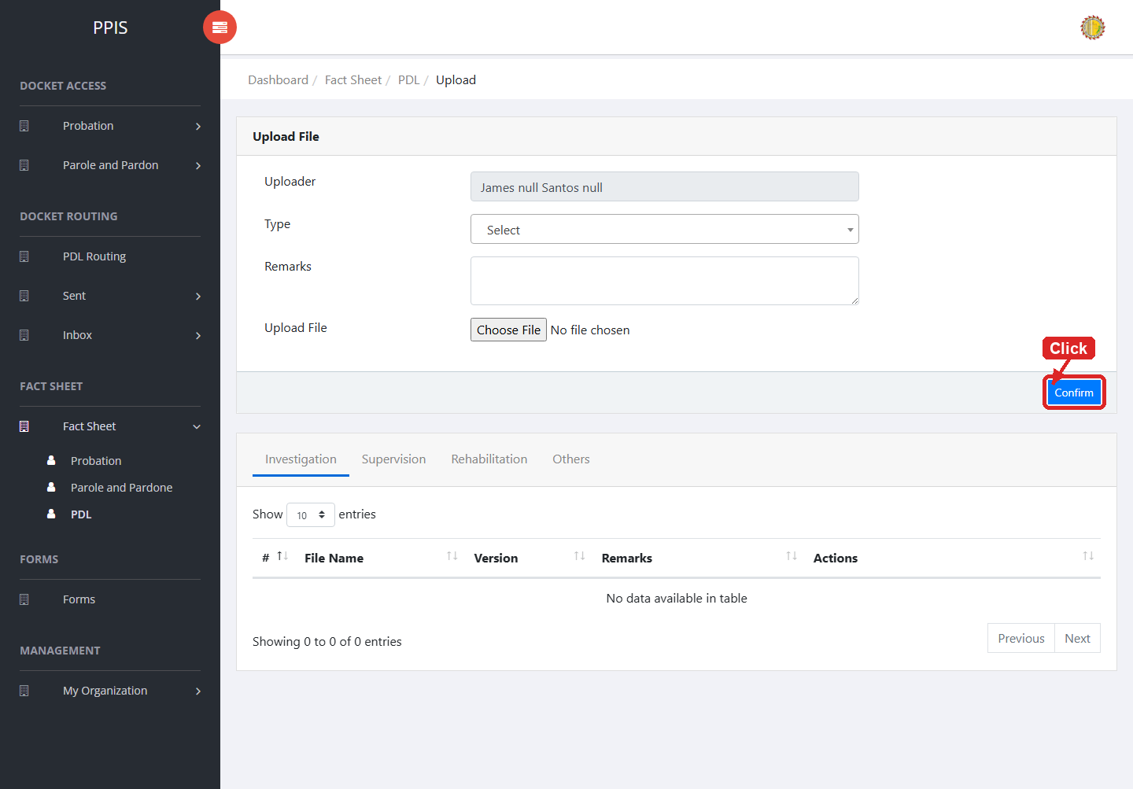
Fact Sheet PDL (Attachments)

Fact Sheet PDL (Add Record)
1. On the Fact Sheet PDL page, click Add Client.
2. Wait for the modal dialog box to appear on the screen.
3. Enter First Name, Middle Name, Last Name, Suffix Name, Alias, Sex, Birthdate, Birth Place inside the modal dialog.
4. Click Confirm inside the modal dialog to submit the new record.
5. If the system displays a confirmation prompt, review the information and click Confirm to save the entry.
6. Wait for the modal dialog to close. The table refreshes and displays the newly added record.
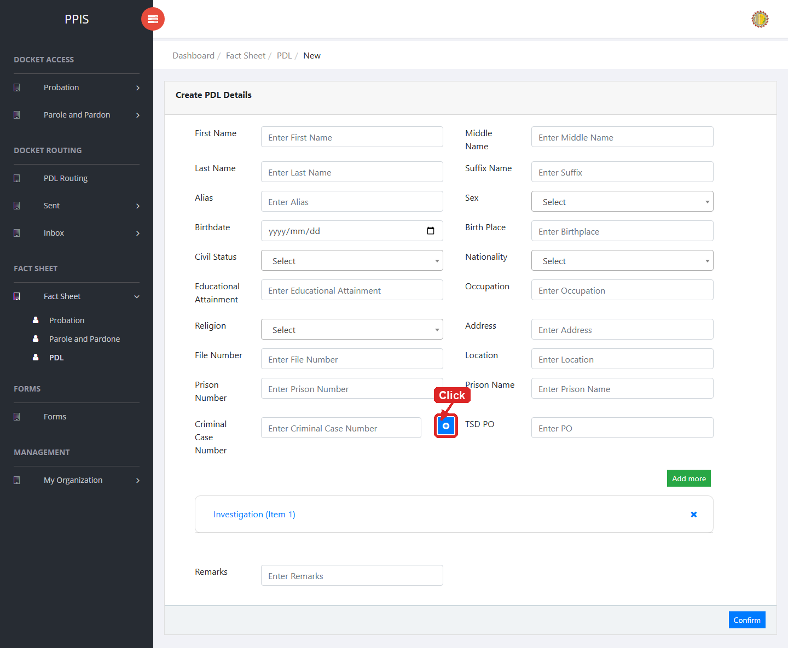
Fact Sheet PDL (Add Record)

9. Forms

Forms
Use this page to view available forms and add documents when the account has permission.
1. From the left menu, open Forms.
2. To find a record, enter the known information in the Search field.
3. Review the records shown on the page and follow any visible office procedure for the selected queue.
4. To filter the table instantly, type characters directly into the inline search boxes in the column headers, or select a value from any drop-down filter shown above a column. The table updates automatically as you type or select.
5. To export the currently displayed table data, click CSV, PDF, or EXCEL above the table when those buttons are shown. The system downloads the visible records in the selected format.
6. To print the table, click Print. The native browser print window opens. Review the layout settings, then click Print in that window to complete printing.
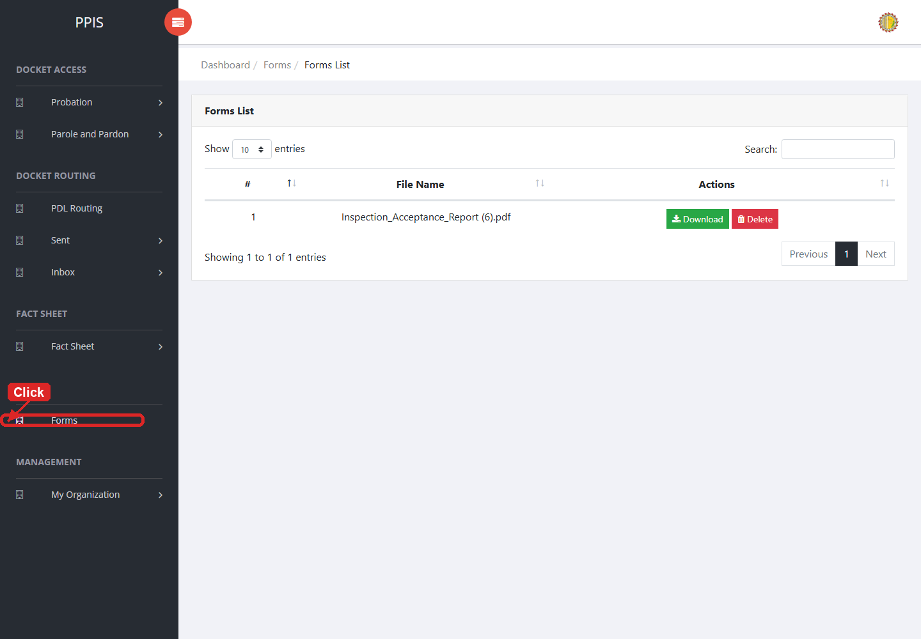
Forms list page

Forms (Add Record)
1. On the Forms list page, click Add Document.
2. Wait for the upload screen to open.
3. Enter Uploader, Kind, and select a file in Upload File.
4. Click Confirm to save after checking the entry.
5. Wait for the system to confirm the upload and return to the forms list.
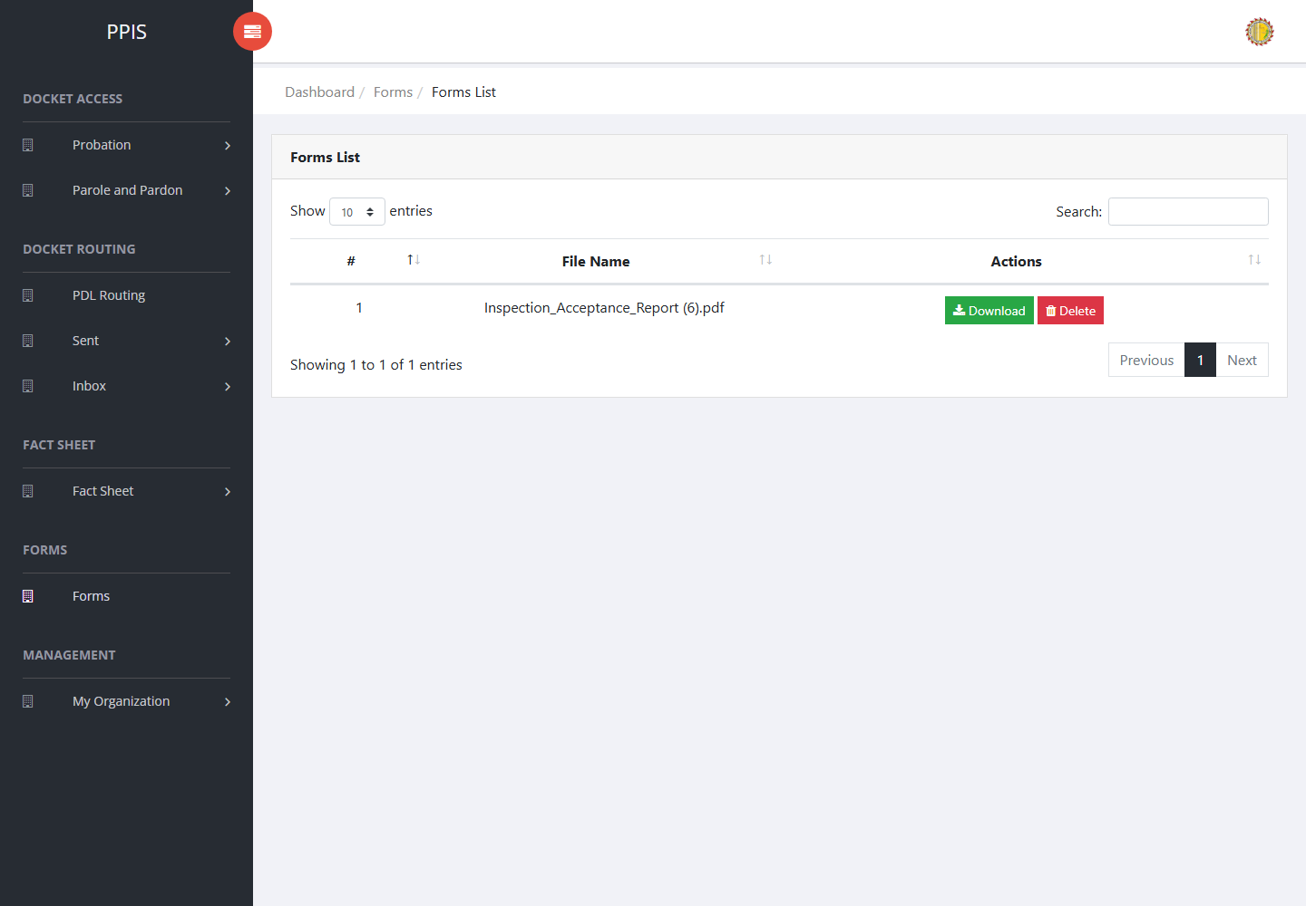
Forms (Add Record)

10. My Organization

User Accounts
Use this page to create and maintain user accounts.
1. From the left menu, open User Accounts.
2. To find a record, enter the known information in Enter Username.
3. Click Search to apply the search.
4. In the Actions column, use Update, Remove for the selected row.
5. To filter the table instantly, type characters directly into the inline search boxes in the column headers, or select a value from any drop-down filter shown above a column. The table updates automatically as you type or select.
6. To export the currently displayed table data, click CSV, PDF, or EXCEL above the table when those buttons are shown. The system downloads the visible records in the selected format.
7. To print the table, click Print. The native browser print window opens. Review the layout settings, then click Print in that window to complete printing.
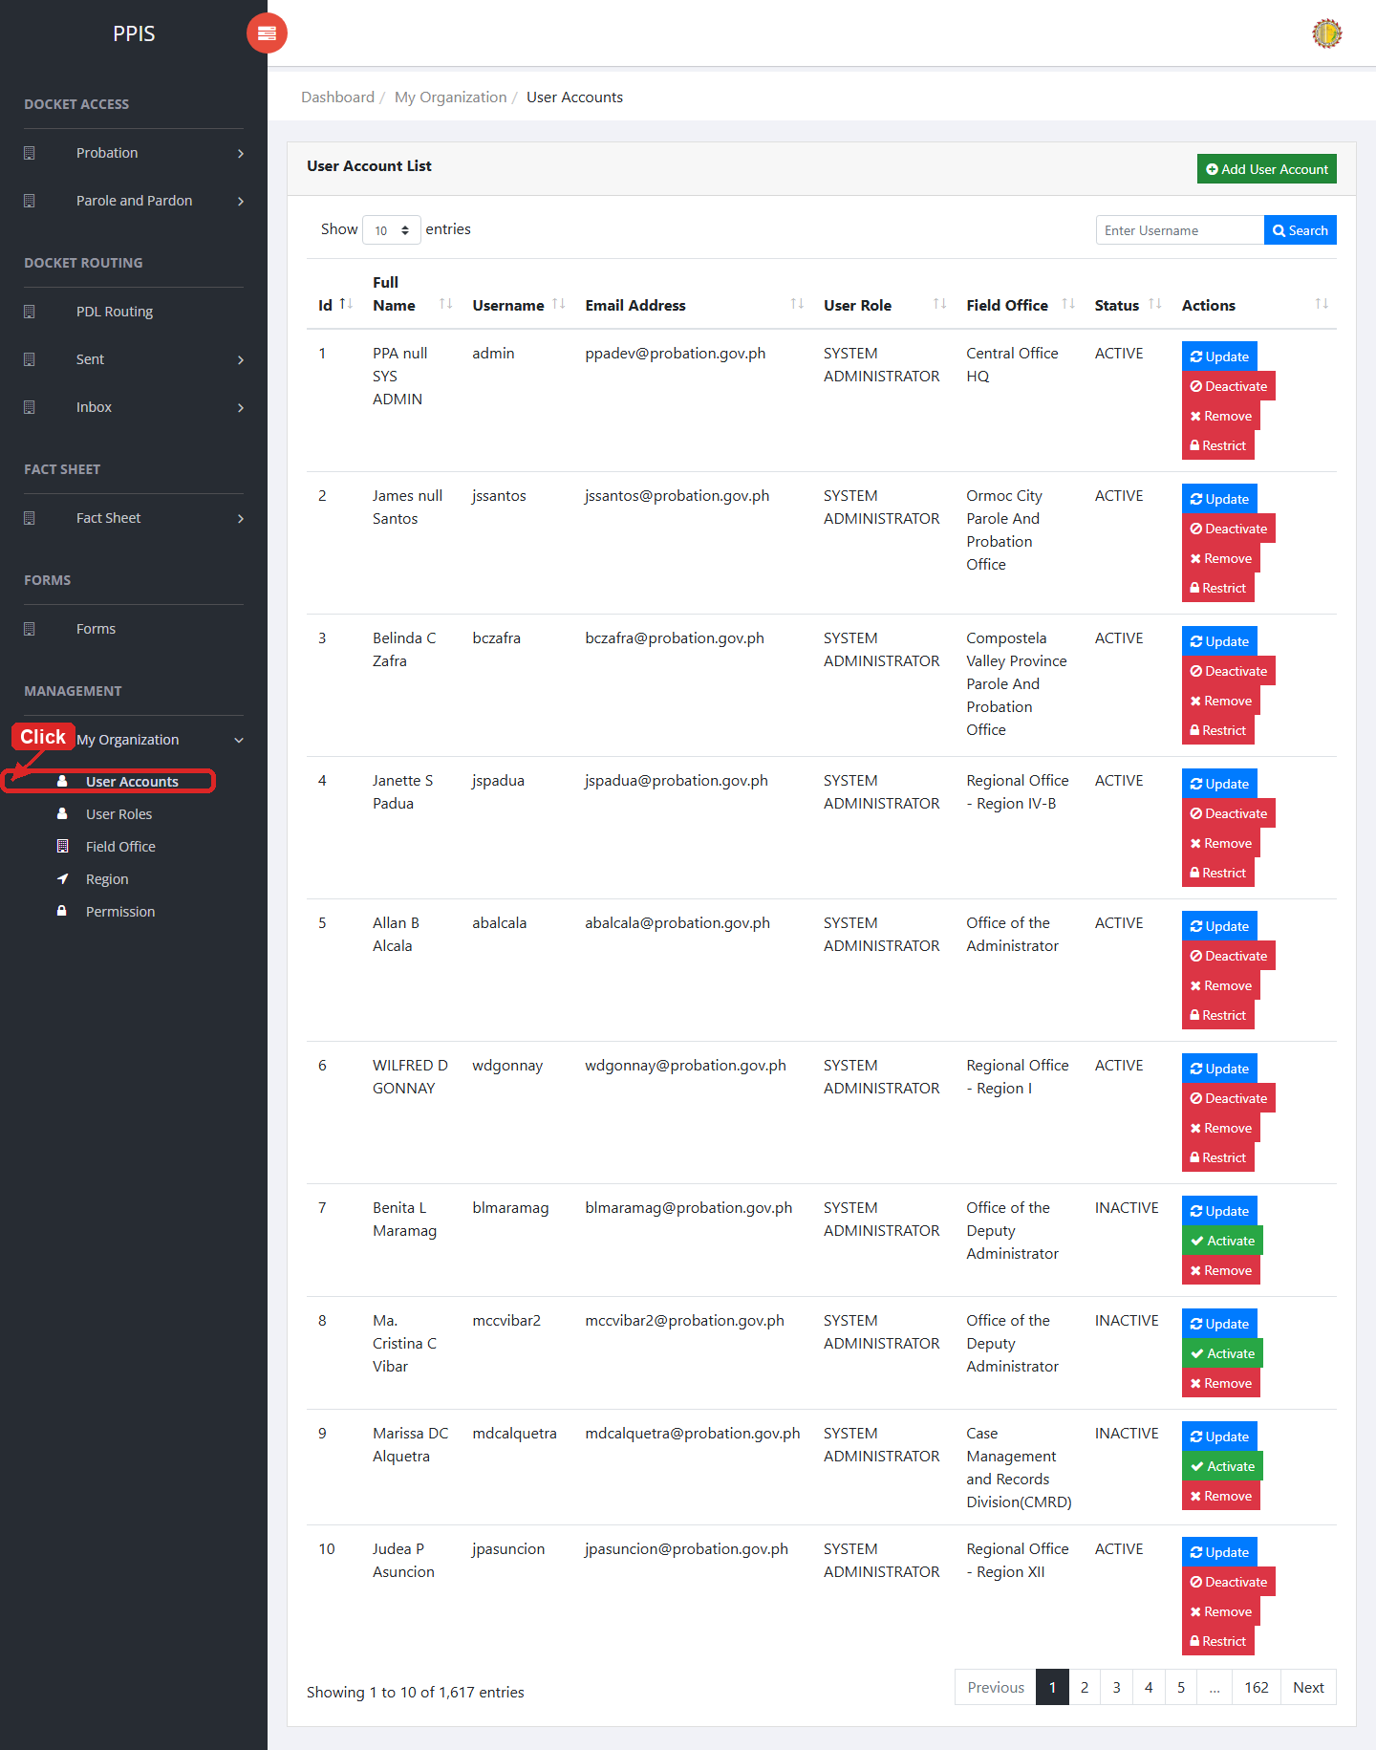
User Accounts list page

User Accounts (Update)
1. On the User Accounts list page, locate the record that needs correction.
2. Click Update in the Actions column.
3. Wait for the modal dialog box to appear on the screen.
4. Review the current details and update First Name *, Middle Name *, Last Name *, Suffix, Birthday, Contact No., Email Address *, Field Office * inside the modal dialog.
5. Click Confirm inside the modal dialog to submit the changes.
6. If the system displays a confirmation prompt, review the information and click Confirm to save the updated record.
7. Wait for the modal dialog to close. The table refreshes and displays the updated record.
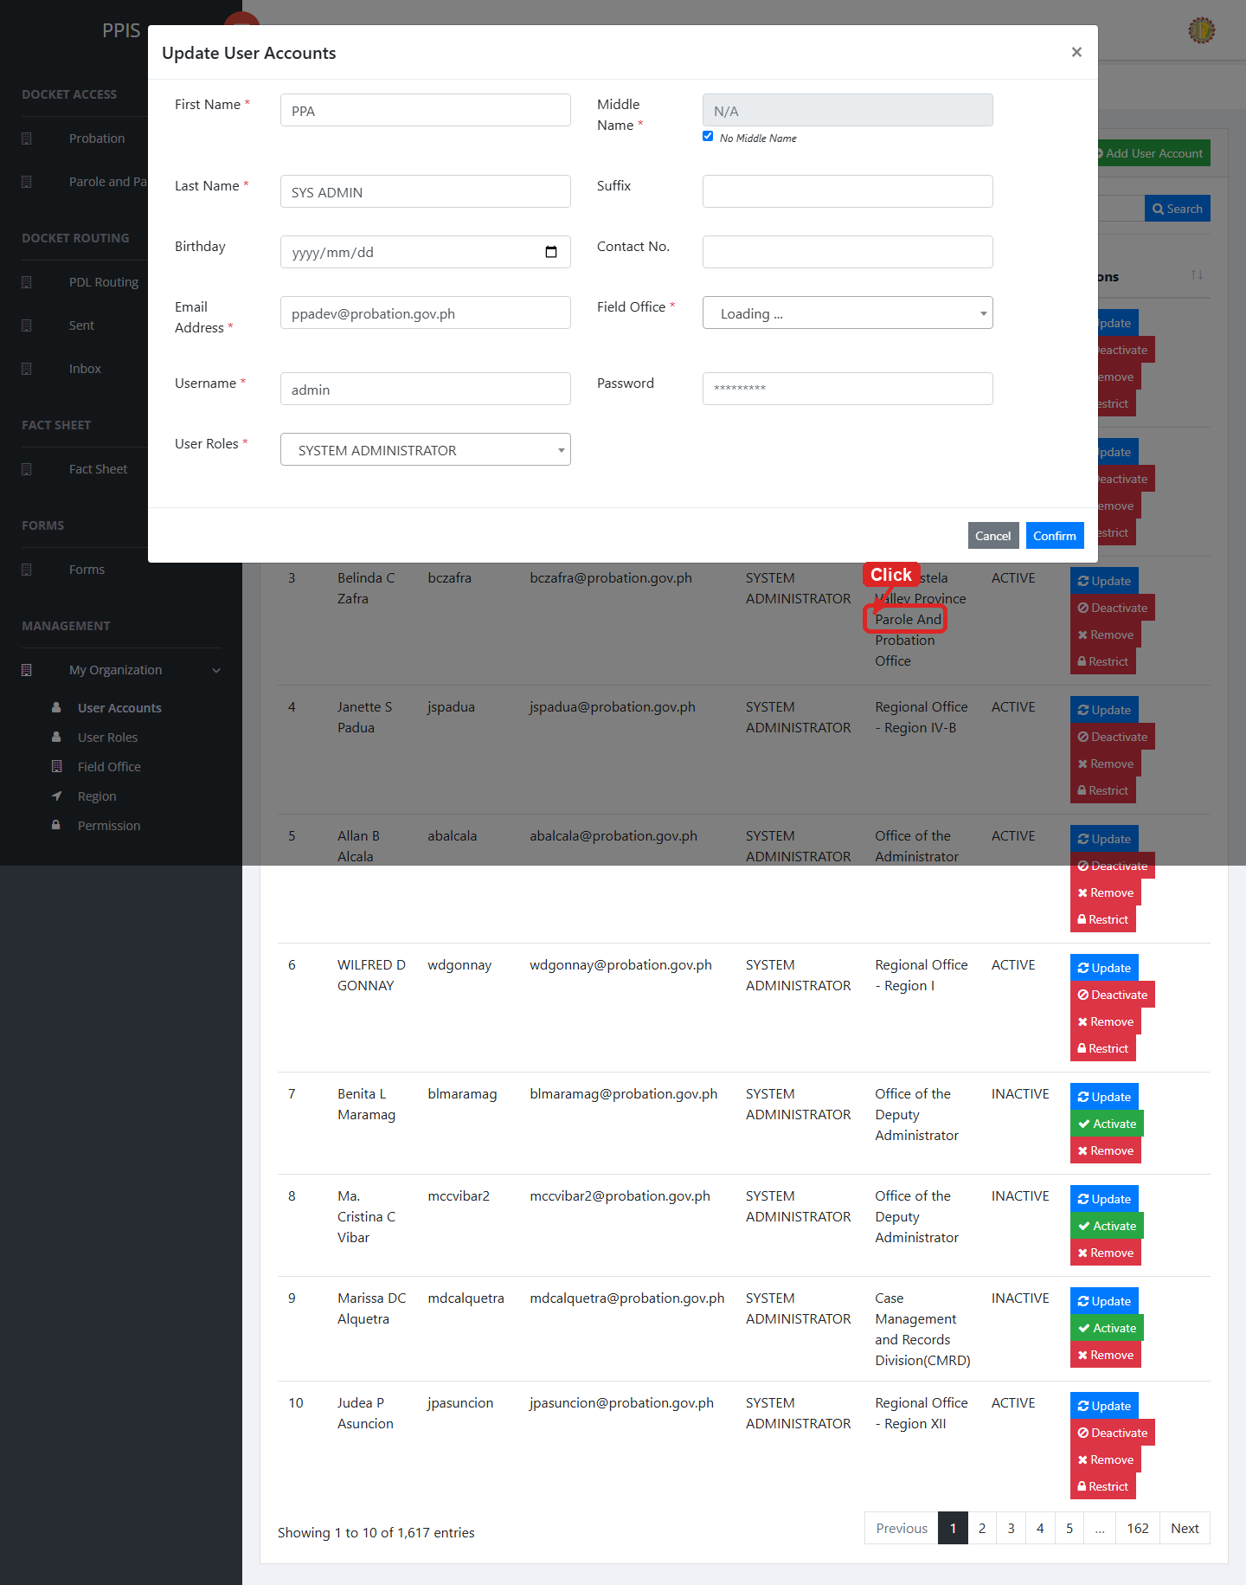
User Accounts (Update)

User Accounts (Delete)
Deletion warning: Use Remove only for sample/test records or records approved for deletion. For documentation, stop at the confirmation dialog unless removal is required.

1. On the User Accounts list page, locate the sample, test, or authorized record.
2. Click Remove in the Actions column.
3. Wait for the confirmation modal dialog box to appear.
4. Read the confirmation message carefully. The system warns that removal cannot be undone.
5. Click Cancel inside the modal dialog to stop, or click Remove inside the modal dialog only when deletion is authorized.
6. Wait for the modal dialog to close. The table refreshes to reflect the remaining records.
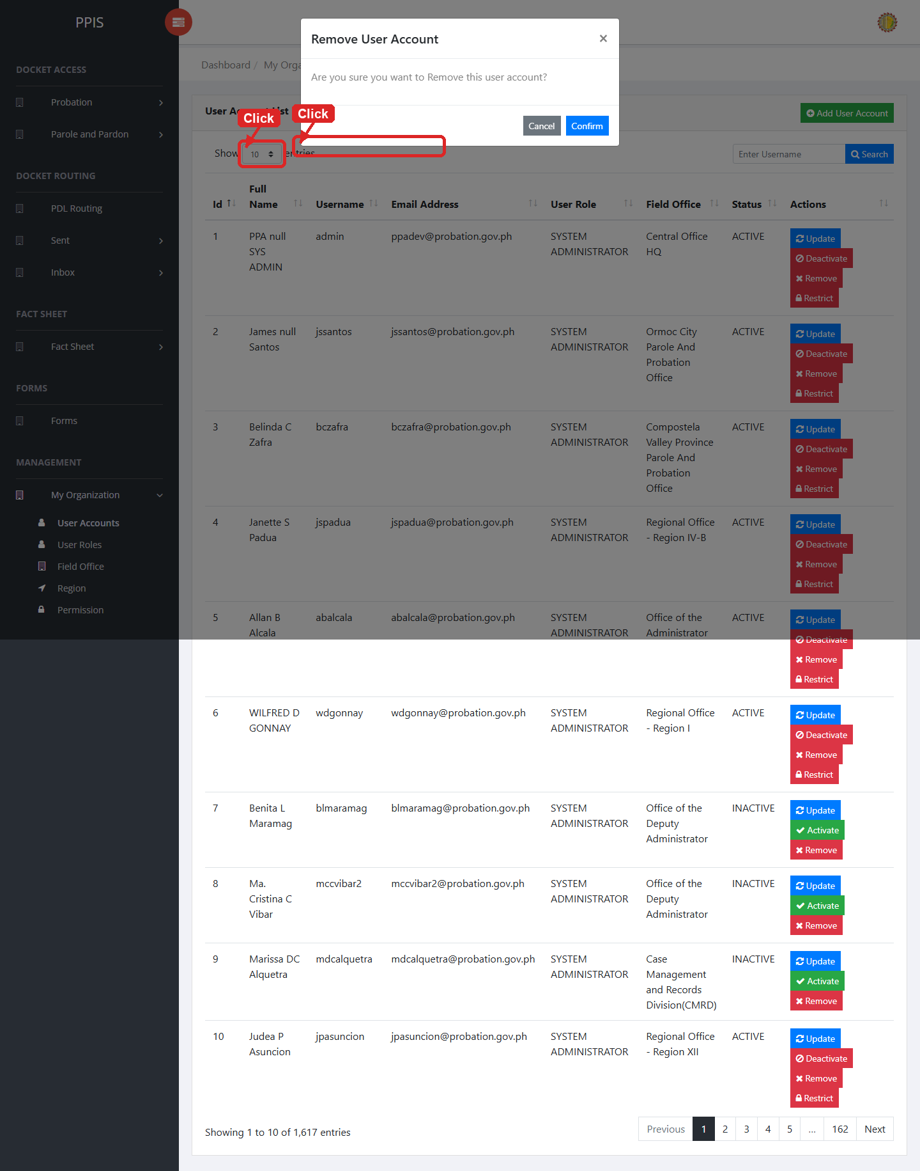
User Accounts (Delete)

User Accounts (Add Record)
1. On the User Accounts page, click Add User Account.
2. Wait for the modal dialog box to appear on the screen.
3. Enter First Name *, Middle Name *, Last Name *, Suffix, Birthday, Contact No., Email Address *, Field Office * inside the modal dialog.
4. Click Confirm inside the modal dialog to submit the new record.
5. If the system displays a confirmation prompt, review the information and click Confirm to save the entry.
6. Wait for the modal dialog to close. The table refreshes and displays the newly added record.
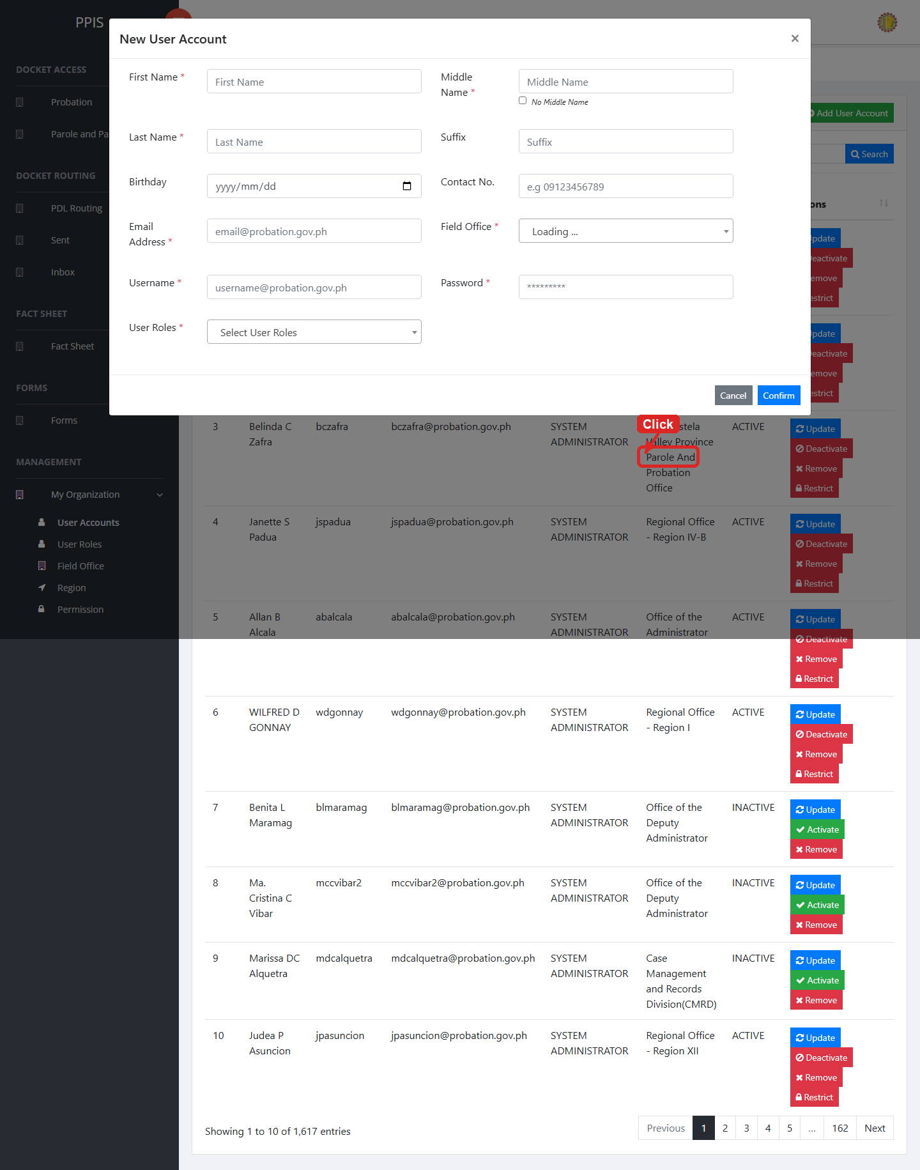
User Accounts (Add Record)

User Roles
Use this page to create and maintain user roles and update permissions assigned to those roles.
1. From the left menu, open User Roles.
2. To find a record, enter the known information in Search.
3. In the Actions column, use Update for the selected row.
4. To filter the table instantly, type characters directly into the inline search boxes in the column headers, or select a value from any drop-down filter shown above a column. The table updates automatically as you type or select.
5. To export the currently displayed table data, click CSV, PDF, or EXCEL above the table when those buttons are shown. The system downloads the visible records in the selected format.
6. To print the table, click Print. The native browser print window opens. Review the layout settings, then click Print in that window to complete printing.
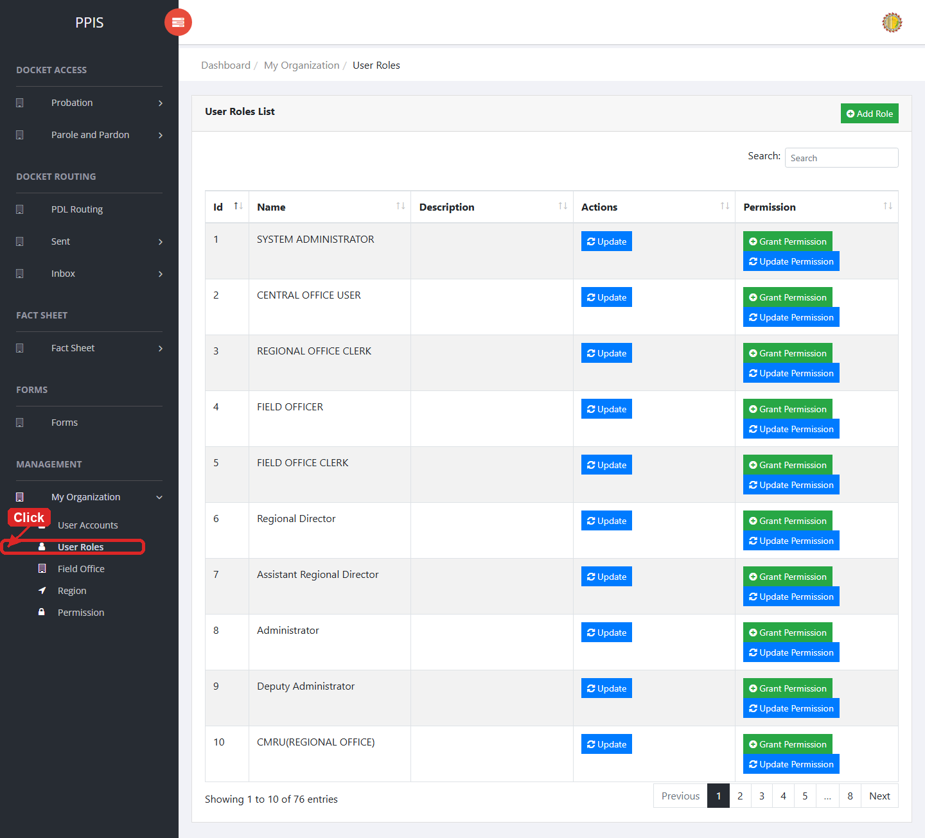
User Roles list page

User Roles (Update)
1. On the User Roles list page, locate the record that needs correction.
2. Click Update in the Actions column.
3. Wait for the modal dialog box to appear on the screen.
4. Review the current details and update User Role Name, Search inside the modal dialog.
5. Click Confirm inside the modal dialog to submit the changes.
6. If the system displays a confirmation prompt, review the information and click Confirm to save the updated record.
7. Wait for the modal dialog to close. The table refreshes and displays the updated record.
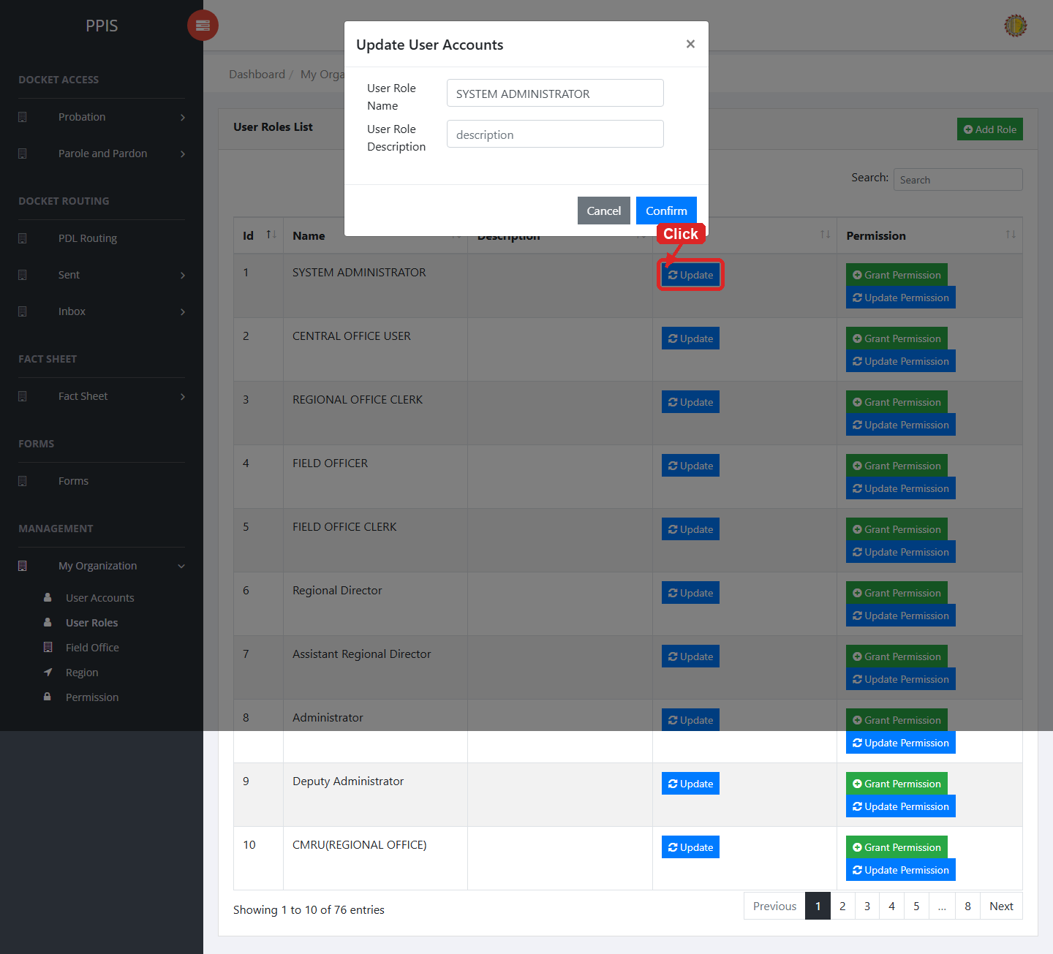
User Roles (Update)

User Roles (Add Record)
1. On the User Roles page, click Add Role.
2. Wait for the modal dialog box to appear on the screen.
3. Enter User Role Name, User Role Description, Search inside the modal dialog.
4. Click Confirm inside the modal dialog to submit the new record.
5. If the system displays a confirmation prompt, review the information and click Confirm to save the entry.
6. Wait for the modal dialog to close. The table refreshes and displays the newly added record.
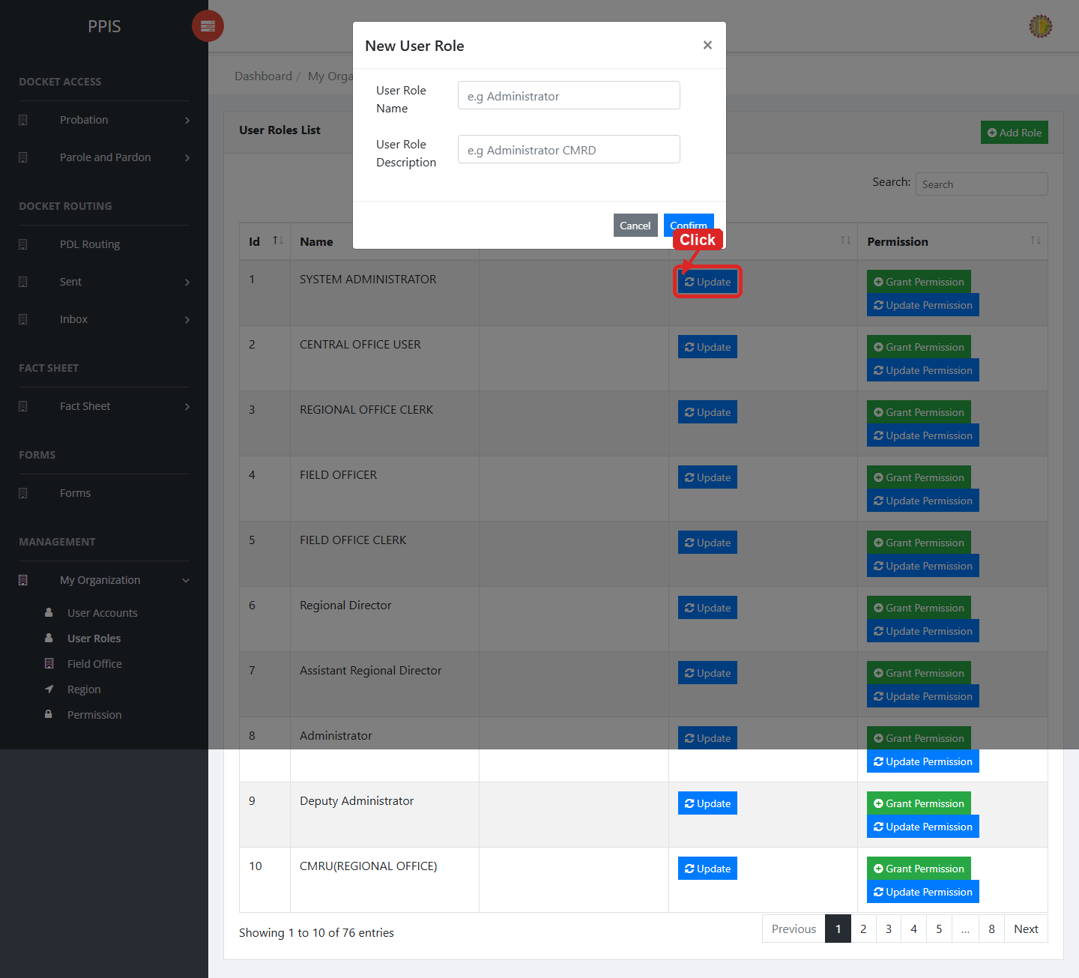
User Roles (Add Record)

Field Office
Use this page to maintain field office records.
1. From the left menu, open Field Office.
2. To find a record, enter the known information in Search.
3. In the Actions column, use View, Update, Remove for the selected row.
4. To filter the table instantly, type characters directly into the inline search boxes in the column headers, or select a value from any drop-down filter shown above a column. The table updates automatically as you type or select.
5. To export the currently displayed table data, click CSV, PDF, or EXCEL above the table when those buttons are shown. The system downloads the visible records in the selected format.
6. To print the table, click Print. The native browser print window opens. Review the layout settings, then click Print in that window to complete printing.
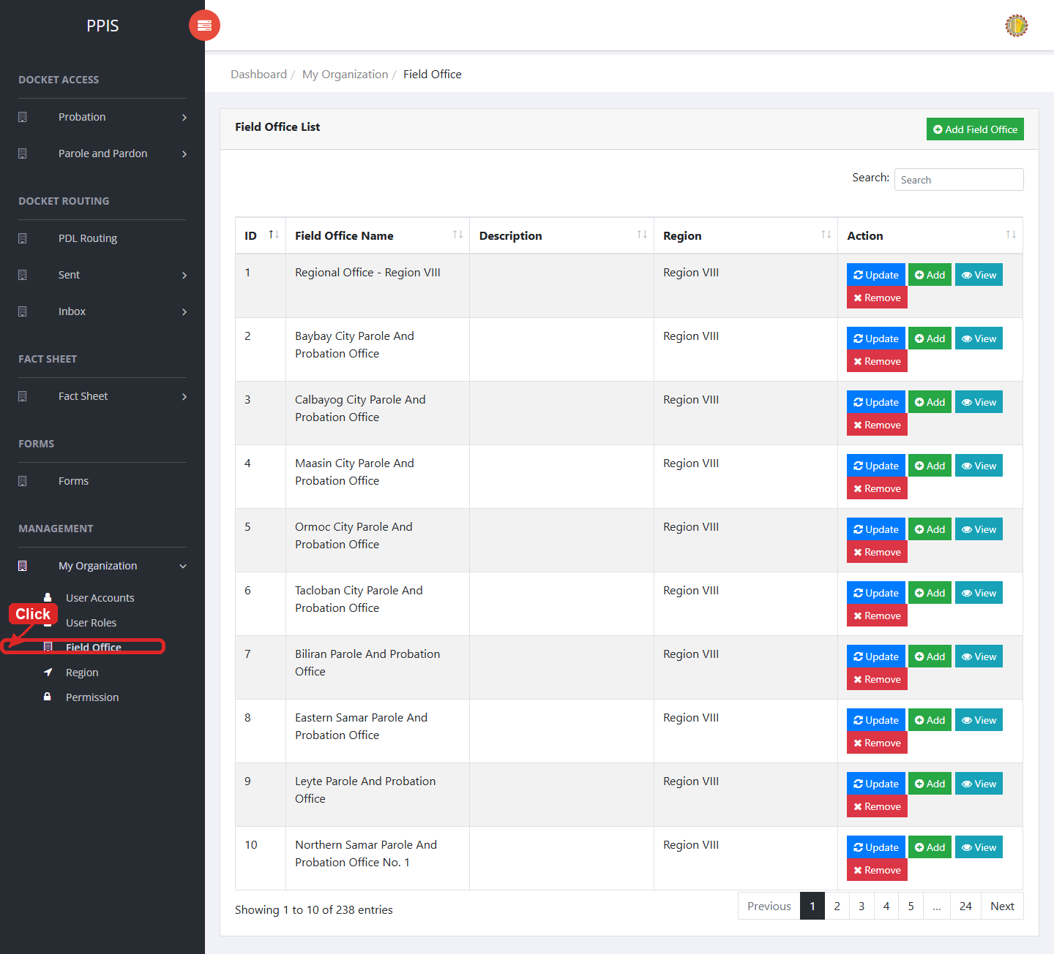
Field Office list page

Field Office (View)
1. On the Field Office list page, locate the record you need to review.
2. Click View in the Actions column.
3. Read the details on the view page. Use this screen for checking information before making any changes.
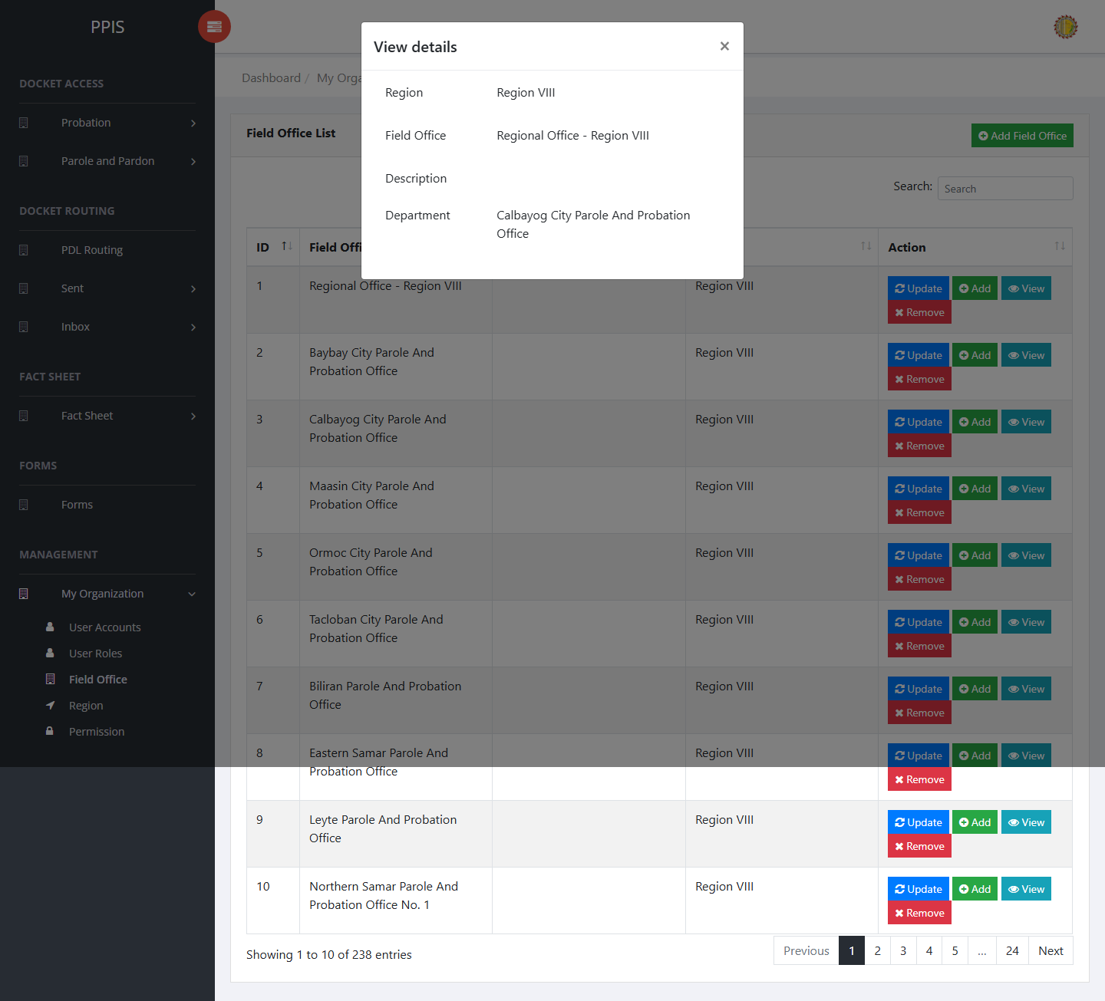
Field Office (View)

Field Office (Update)
1. On the Field Office list page, locate the record that needs correction.
2. Click Update in the Actions column.
3. Wait for the modal dialog box to appear on the screen.
4. Review the current details and update Region, Field Office, Description, Search inside the modal dialog.
5. Click Confirm inside the modal dialog to submit the changes.
6. If the system displays a confirmation prompt, review the information and click Confirm to save the updated record.
7. Wait for the modal dialog to close. The table refreshes and displays the updated record.
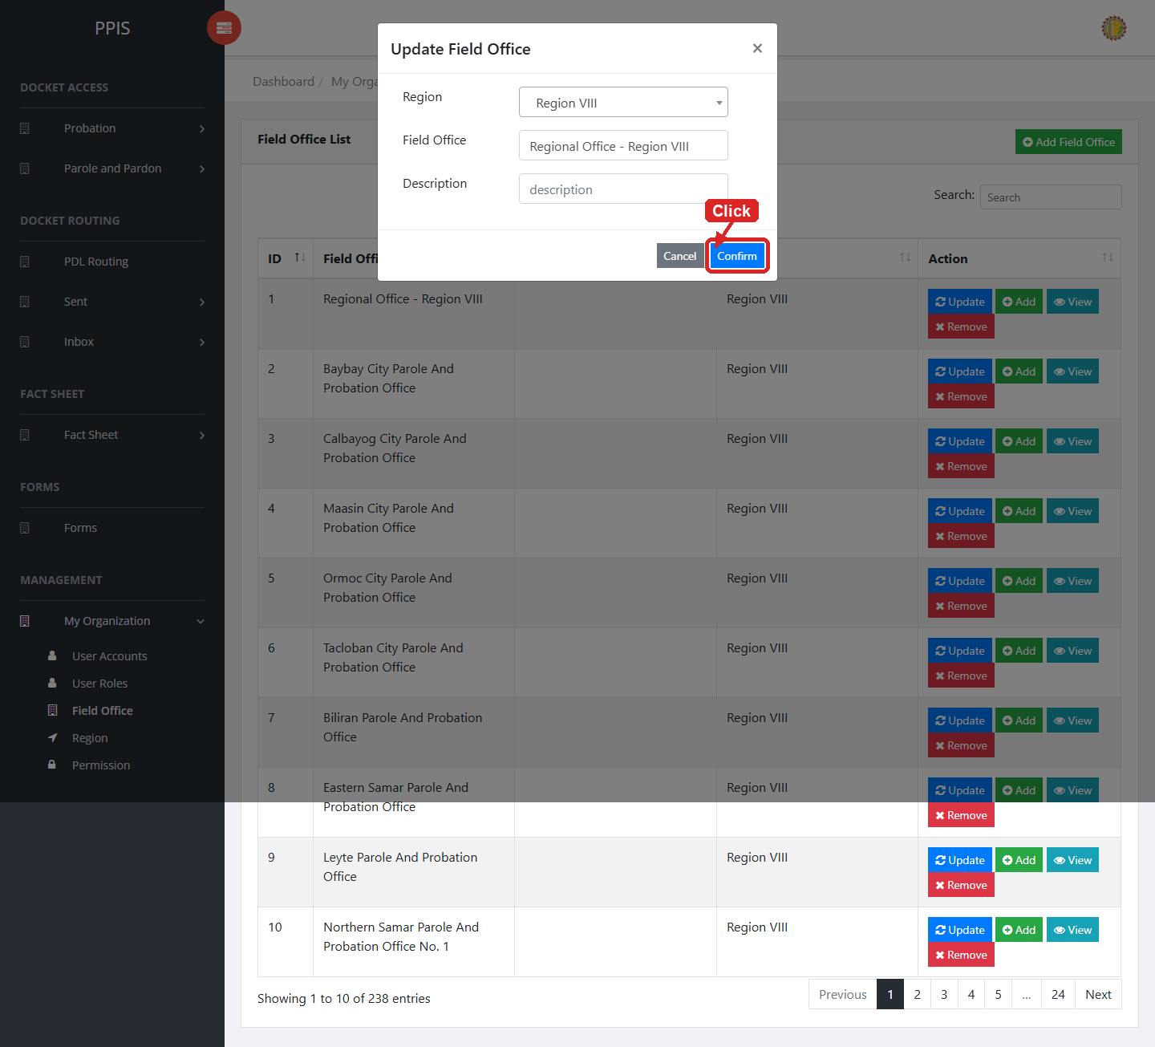
Field Office (Update)

Field Office (Delete)
Deletion warning: Use Remove only for sample/test records or records approved for deletion. For documentation, stop at the confirmation dialog unless removal is required.

1. On the Field Office list page, locate the sample, test, or authorized record.
2. Click Remove in the Actions column.
3. Wait for the confirmation modal dialog box to appear.
4. Read the confirmation message carefully. The system warns that removal cannot be undone.
5. Click Cancel inside the modal dialog to stop, or click Remove inside the modal dialog only when deletion is authorized.
6. Wait for the modal dialog to close. The table refreshes to reflect the remaining records.
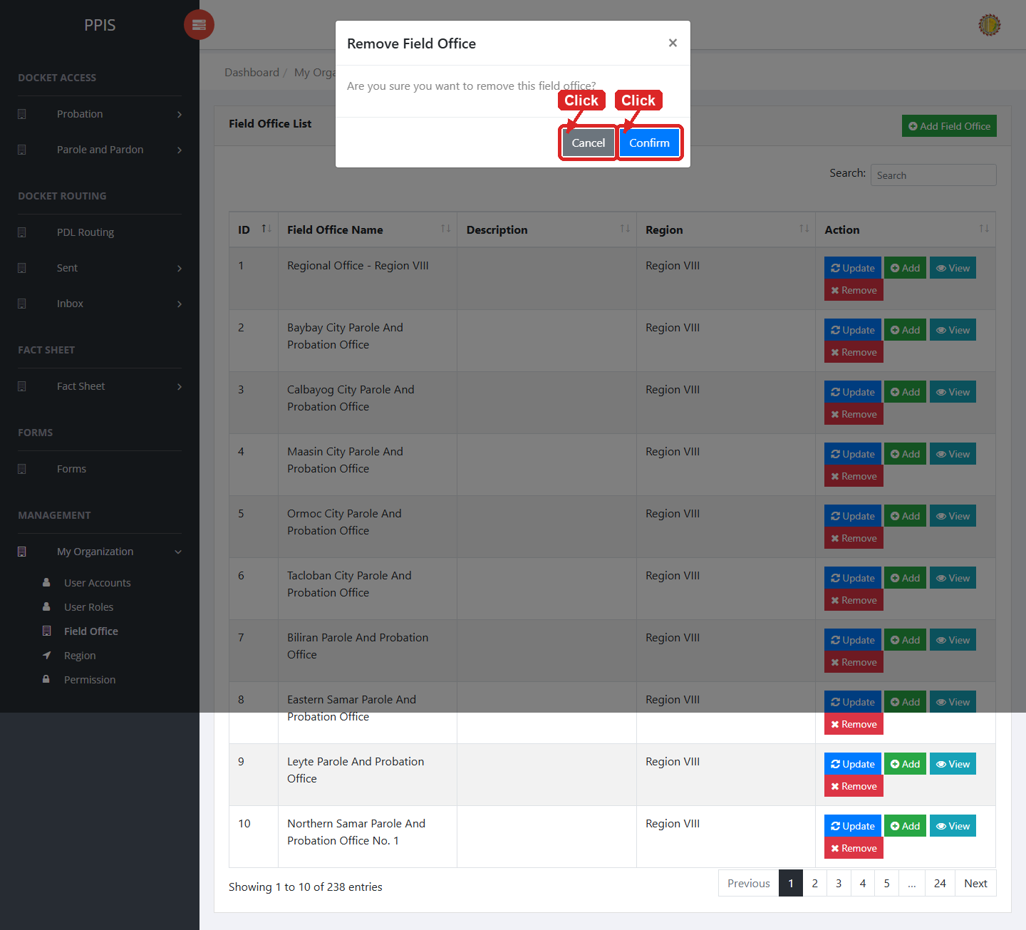
Field Office (Delete)

Field Office (Add Record)
1. On the Field Office page, click Add Field Office.
2. Wait for the modal dialog box to appear on the screen.
3. Enter Region, Field Office, Description, Search inside the modal dialog.
4. Click Confirm inside the modal dialog to submit the new record.
5. If the system displays a confirmation prompt, review the information and click Confirm to save the entry.
6. Wait for the modal dialog to close. The table refreshes and displays the newly added record.
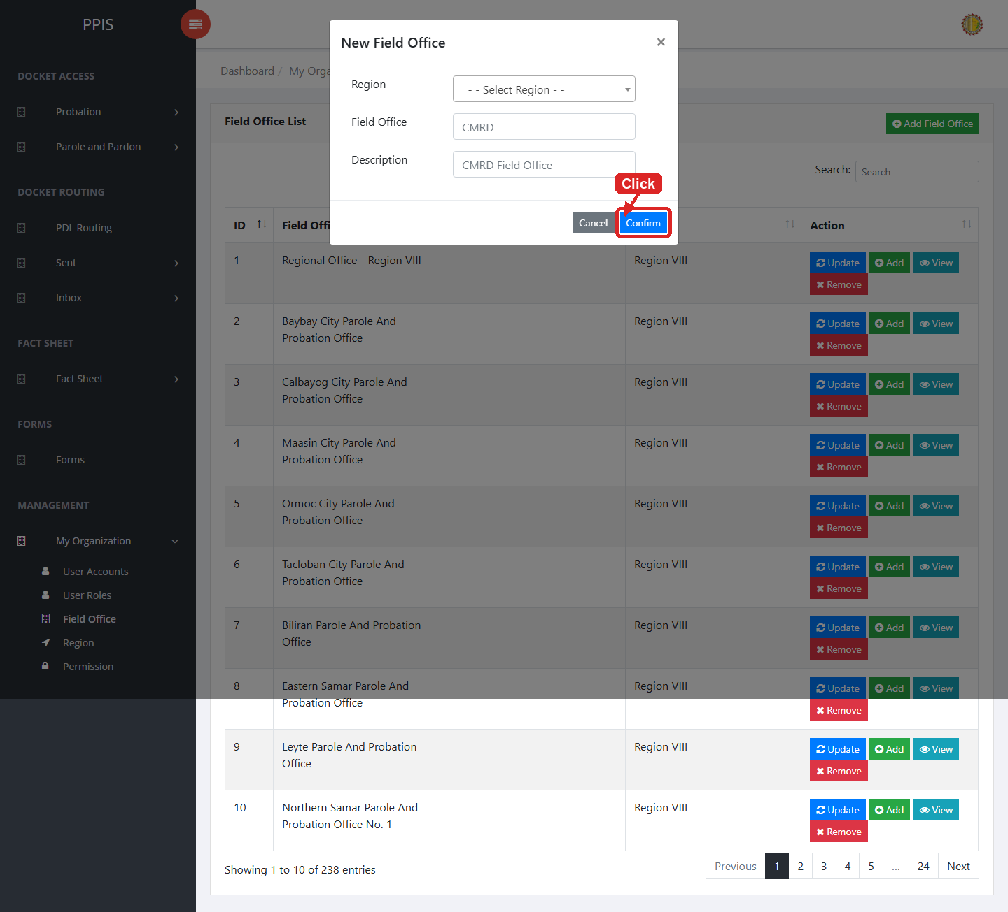
Field Office (Add Record)

Region
Use this page to maintain region records.
1. From the left menu, open Region.
2. To find a record, enter the known information in Search.
3. In the Actions column, use Update, Remove for the selected row.
4. To filter the table instantly, type characters directly into the inline search boxes in the column headers, or select a value from any drop-down filter shown above a column. The table updates automatically as you type or select.
5. To export the currently displayed table data, click CSV, PDF, or EXCEL above the table when those buttons are shown. The system downloads the visible records in the selected format.
6. To print the table, click Print. The native browser print window opens. Review the layout settings, then click Print in that window to complete printing.
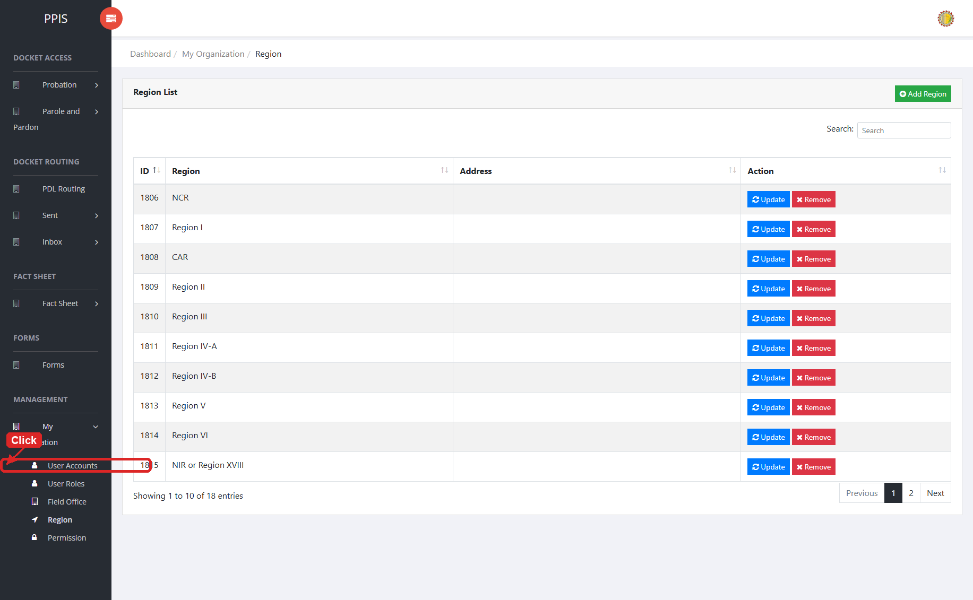
Region list page

Region (Update)
1. On the Region list page, locate the record that needs correction.
2. Click Update in the Actions column.
3. Wait for the modal dialog box to appear on the screen.
4. Review the current details and update Region Name, Search inside the modal dialog.
5. Click Confirm inside the modal dialog to submit the changes.
6. If the system displays a confirmation prompt, review the information and click Confirm to save the updated record.
7. Wait for the modal dialog to close. The table refreshes and displays the updated record.
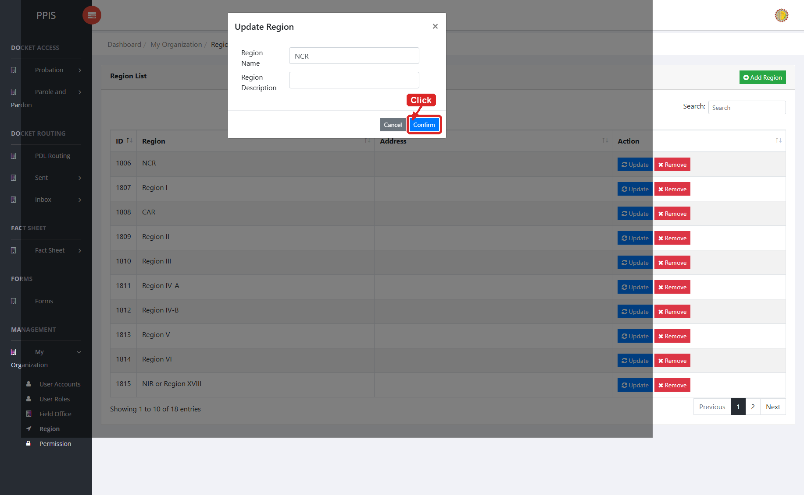
Region (Update)

Region (Delete)
Deletion warning: Use Remove only for sample/test records or records approved for deletion. For documentation, stop at the confirmation dialog unless removal is required.

1. On the Region list page, locate the sample, test, or authorized record.
2. Click Remove in the Actions column.
3. Wait for the confirmation modal dialog box to appear.
4. Read the confirmation message carefully. The system warns that removal cannot be undone.
5. Click Cancel inside the modal dialog to stop, or click Remove inside the modal dialog only when deletion is authorized.
6. Wait for the modal dialog to close. The table refreshes to reflect the remaining records.
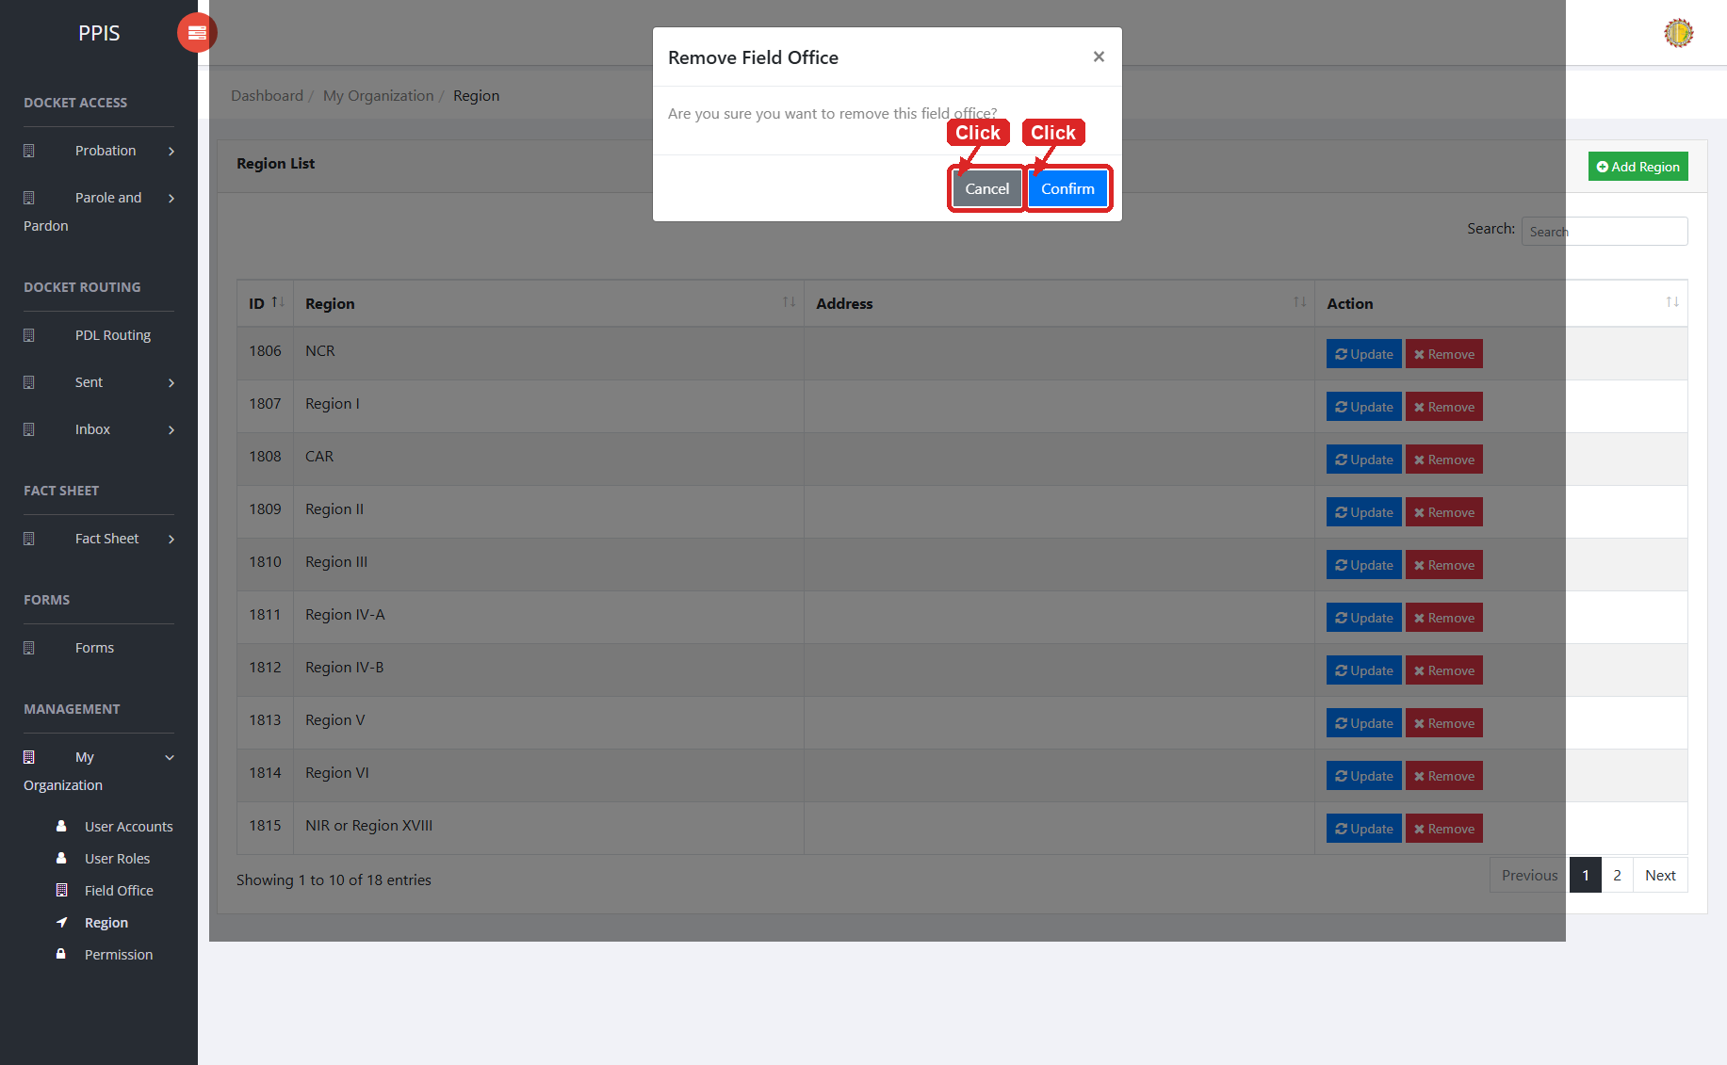
Region (Delete)

Region (Add Record)
1. On the Region page, click Add Region.
2. Wait for the modal dialog box to appear on the screen.
3. Enter Region, Description, Search inside the modal dialog.
4. Click Confirm inside the modal dialog to submit the new record.
5. If the system displays a confirmation prompt, review the information and click Confirm to save the entry.
6. Wait for the modal dialog to close. The table refreshes and displays the newly added record.
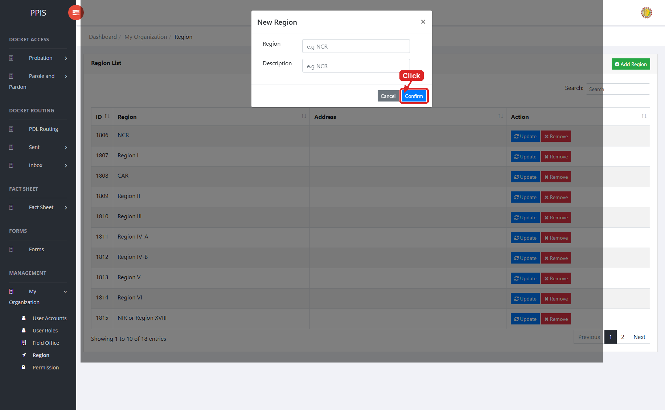
Region (Add Record)

Permission
Use this page to maintain permission records used by the system.
1. From the left menu, open My Organization, then click Permission.
2. Review the Permission List table with columns ID, Permission Name, Type, Detail, and Action.
3. To find a permission, type in the Search box at the top right of the list.
4. Use Update in the Action column to edit a permission, or click Add Permission to create a new one.
5. To filter the table instantly, type characters directly into the inline search boxes in the column headers, or select a value from any drop-down filter shown above a column. The table updates automatically as you type or select.
6. To export the currently displayed table data, click CSV, PDF, or EXCEL above the table when those buttons are shown. The system downloads the visible records in the selected format.
7. To print the table, click Print. The native browser print window opens. Review the layout settings, then click Print in that window to complete printing.
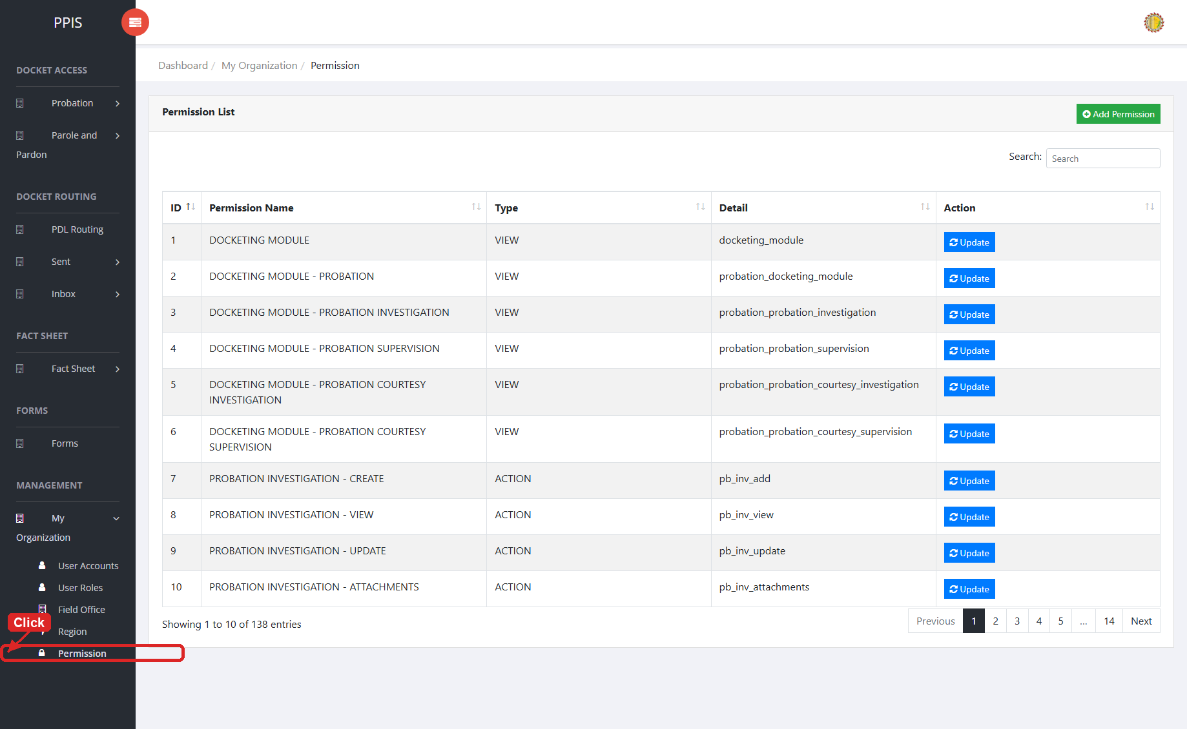
Permission list page

Permission (Update)
1. On the Permission list page, locate the permission record that needs correction.
2. Click Update in the Action column.
3. Wait for the Update Permission modal dialog to appear.
4. Review and update Permission Name, Type, and Detail as needed.
5. Click Confirm inside the modal dialog to save the changes.
6. Wait for the modal dialog to close. The permission list refreshes with the updated record.
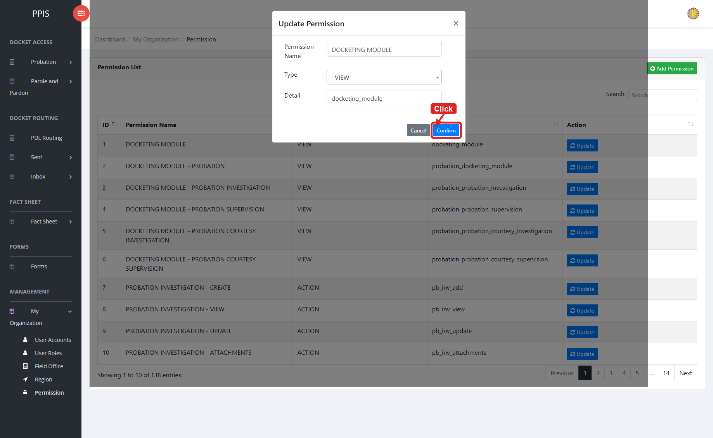
Permission (Update)

Permission (Add Record)
1. On the Permission list page, click Add Permission at the top right.
2. Wait for the New Permission modal dialog to appear.
3. Enter Permission Name, select Type (VIEW or ACTION), and enter Detail.
4. The Detail field identifies the page, API, or action controlled by the permission.
5. Click Confirm inside the modal dialog to save the new permission.
6. Wait for the success message and for the modal dialog to close. The new permission appears in the list.
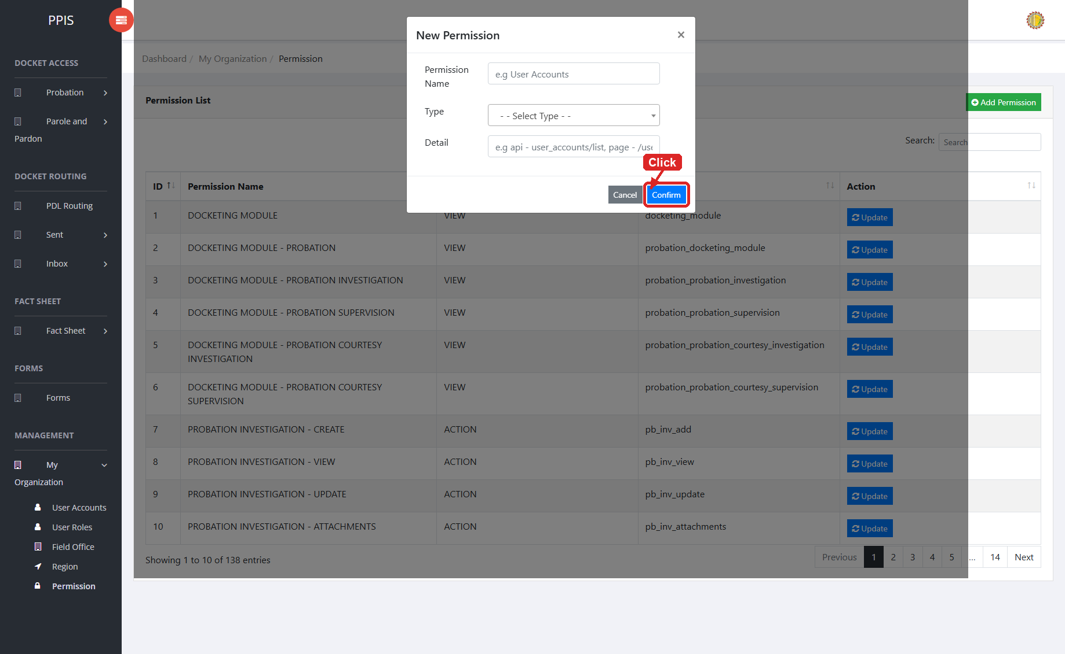
Permission (Add Record)

11. Safe Editing, Deleting, and Troubleshooting
• Use View when you only need to check record details.
• Use Update only when you are authorized to change the selected record. Review the fields inside the update screen or modal dialog, then click Confirm or Update to save.
• Use Attachments to upload, view, download, or delete supporting files tied to the selected record.
• Use Remove only for records approved for deletion. For training, use sample/test records and click Cancel inside the confirmation modal unless deletion is required.
• To filter a table instantly, type in the inline column search headers or use drop-down filters above the columns.
• To export table data, click CSV, PDF, or EXCEL when those buttons appear above the table.
• To print table data, click Print, review the browser print layout settings, then execute print from the browser print window.
• If search results look wrong, clear the search field and click Run search again.
• If a menu is missing, ask the administrator to check your role and permission settings.
Screenshot folder: The annotated screenshots used in this manual are saved in the PIS_End_User_Manual_Screenshots_Annotated folder.

Submitted by:
Project Management Team
Appcentric Solutions Inc.
Parole and Probation Administration

