PAROLE AND PROBATION
INFORMATION SYSTEM
(PPIS)
End User and Administrator Manual
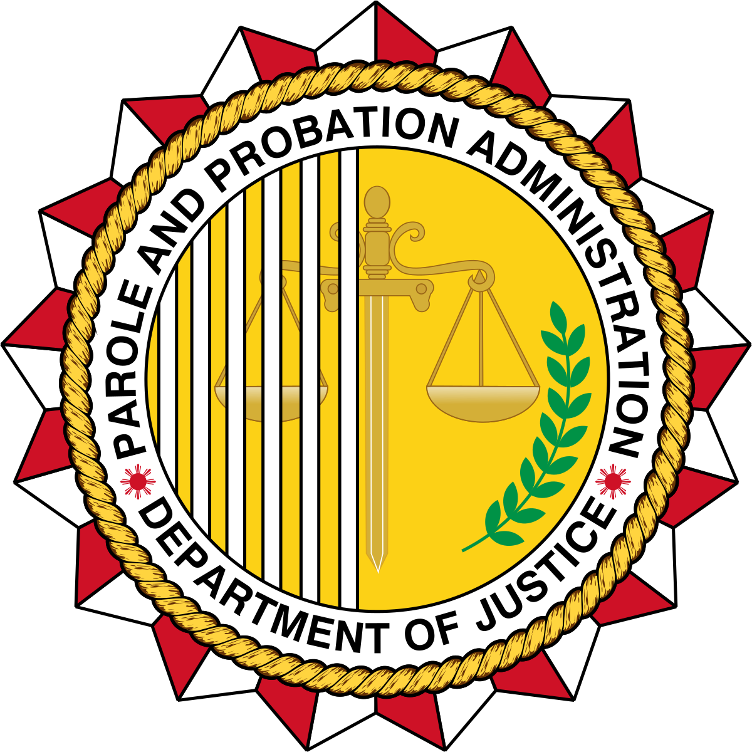

Table of Contents
Table of Contents
Table of Contents 2
1. Understanding the PPIS: Overview 5
2. System Modules 5
3. Logging In (Modify by using the UAMS) 5
4. Navigation 6
5. Docket Access 7
Probation Investigation 7
Probation Investigation (View) 8
Probation Investigation (Update) 10
Probation Investigation (Attachments) 11
Probation Investigation (Delete) 11
Probation Courtesy Investigation 12
Probation Courtesy Investigation (View) 14
Probation Courtesy Investigation (Update) 14
Probation Courtesy Investigation (Attachments) 15
Probation Courtesy Investigation (Delete) 16
Probation Supervision 17
Probation Supervision (View) 18
Probation Supervision (Update) 19
Probation Supervision (Attachments) 20
Probation Supervision (Delete) 21
Probation Courtesy Supervision 22
Probation Courtesy Supervision (View) 23
Probation Courtesy Supervision (Update) 24
Probation Courtesy Supervision (Attachments) 25
Probation Courtesy Supervision (Delete) 26
Parole and Pardon Investigation 27
Parole and Pardon Investigation (View) 28
Parole and Pardon Investigation (Update) 29
Parole and Pardon Investigation (Attachments) 29
Parole and Pardon Investigation (Delete) 30
Parole and Pardon Courtesy Investigation 31
Parole and Pardon Courtesy Investigation (View) 32
Parole and Pardon Courtesy Investigation (Update) 33
Parole and Pardon Courtesy Investigation (Attachments) 34
Parole and Pardon Courtesy Investigation (Delete) 35
Parole and Pardon Supervision 36
Parole and Pardon Supervision (View) 37
Parole and Pardon Supervision (Update) 38
Parole and Pardon Supervision (Attachments) 40
Parole and Pardon Supervision (Delete) 40
Parole and Pardon Courtesy Supervision 41
Parole and Pardon Courtesy Supervision (View) 42
Parole and Pardon Courtesy Supervision (Update) 43
Parole and Pardon Courtesy Supervision (Attachments) 44
Parole and Pardon Courtesy Supervision (Delete) 45
8. Fact Sheet 46
Fact Sheet Probation 46
Fact Sheet Probation (Open Client Profile) 47
Fact Sheet Probation (Client Profile Tabs) 50
Fact Sheet Probation (Upload or Take Photo) 51
Fact Sheet Probation (Upload Fingerprint) 52
Fact Sheet Probation (Worksheet and PSIR Overview) 53
Fact Sheet Probation (Navigate to Worksheet) 54
Fact Sheet Probation (Fill Out Worksheet) 55
Fact Sheet Probation (Print Worksheet) 56
Fact Sheet Probation (Navigate to PSIR) 57
Fact Sheet Probation (Fill Out PSIR) 57
Fact Sheet Probation (Print PSIR) 58
Fact Sheet Parole and Pardon 59
Fact Sheet Parole and Pardon (Update) 60
Fact Sheet Parole and Pardon (Attachments) 61
9. Forms 62
Forms 62
Forms (Add Document) 63
10. My Organization 64
User Accounts (For Administrator of the System) 64
User Accounts (Update) (For Administrator of the System) 65
User Accounts (Delete) (For Administrator of the System) 67
User Accounts (Add Record) (For Administrator of the System) 68
User Roles (For Administrator of the System) 70
User Roles (Update) (For Administrator of the System) 70
User Roles (Add Record) (For Administrator of the System) 71
Field Office (For Administrator of the System) 72
Field Office (View) (For Administrator of the System) 73
Field Office (Update) (For Administrator of the System) 74
Field Office (Delete) (For Administrator of the System) 75
Field Office (Add Record) (For Administrator of the System) 76
Region (For Administrator of the System) 77
Region (Update) (For Administrator of the System) 78
Region (Delete) 79
Region (Add Record) (For Administrator of the System) 80
Permission (For Administrator of the System) 81
Permission (Update) (For Administrator of the System) 82
Permission (Add Record) (For Administrator of the System) 83

1. Understanding the PPIS: Overview
PPIS stands for Probation and Parole Information System. As the name implies, the system is used for managing records pertinent to probation, parole, and pardon. This system as an interoperability to the Expanded Parole and Probation Information System.
Users can add, update, and delete records after selecting the corresponding module and action. They can export visible table data through CSV, PDF, and EXCEL buttons, and print records through the Print button where those controls appear on data tables.
Users can filter records instantly by typing directly into inline column search headers or by selecting values from drop-down filters above table columns. Filtered results update automatically as criteria are entered.

Manual purpose: This manual guides end users through the PPIS website using the actual screens and labels shown in the system.

Role access: Menus may vary by user role.

Screenshot indicators: Red boxes and arrows labeled Click show the control to select in each screenshot.

2. System Modules
- Docket Access – Shows the docket records of probation, parole, and pardon
- Fact Sheet - Open and maintain client fact sheet records. This serves as the eCase Folder of the client
- Forms - View and add documents when permitted.
- My Organization - Maintain users, roles, field offices, regions, and permissions.

3. Logging In (Modify by using the UAMS)
- Open http://localhost/pis/ in a supported browser.
- Type the end user’s username in the Email address field.
- Type the end user’s password in the password field.
- Click SIGN IN.
- Wait for PPIS to open the first page allowed for the end user account.
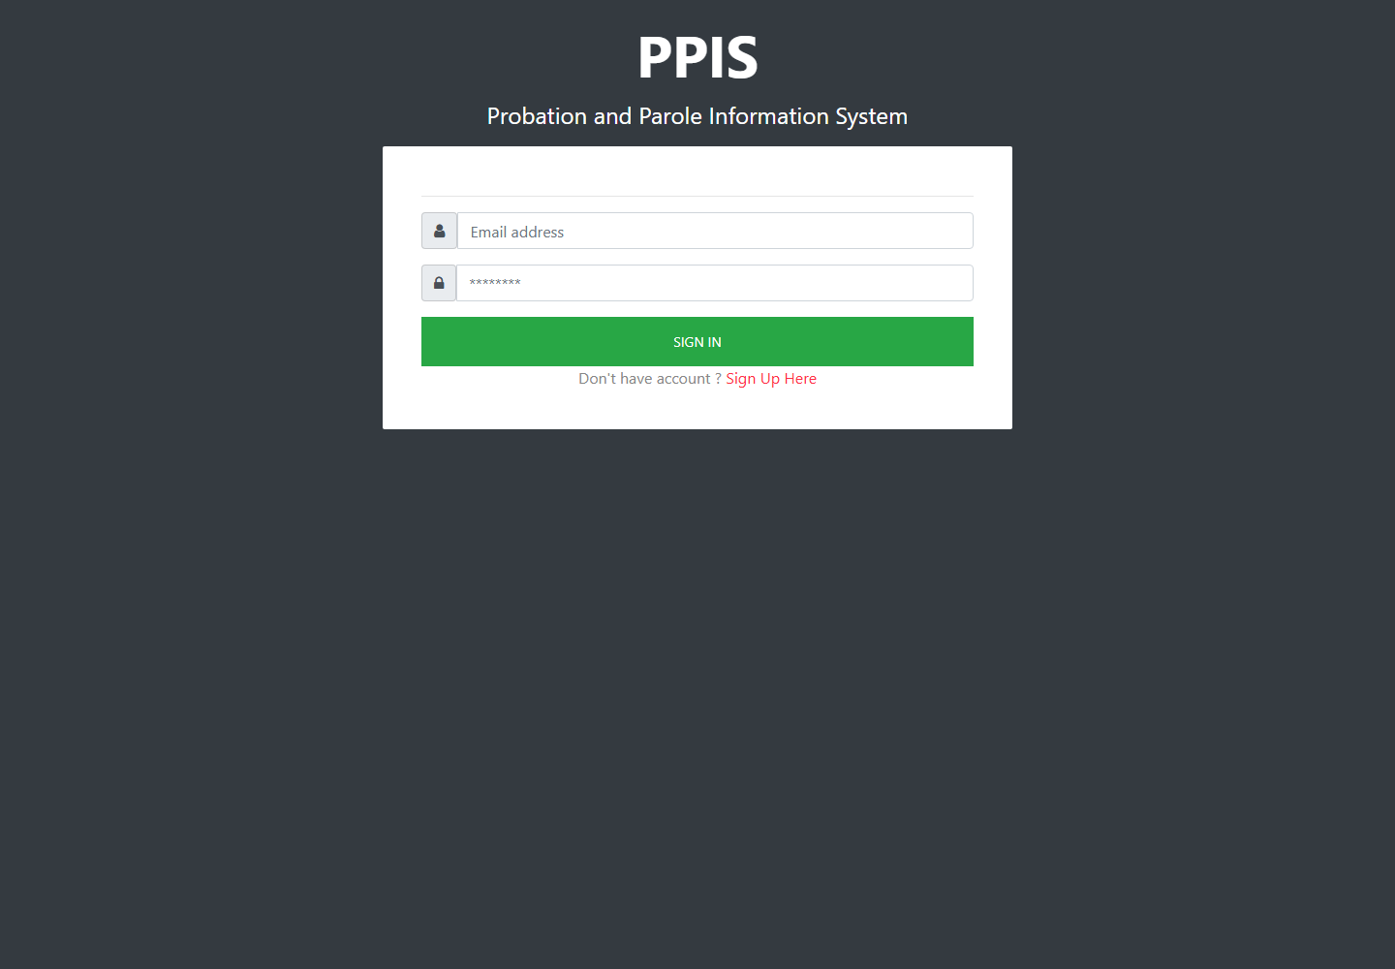
Login page

4. Navigation
1. Use the left menu to move between Docketing, Fact Sheet, Forms, and My Organization.
2. Click a menu group such as Probation, Sent, Inbox, or My Organization to show its submenu.
3. Click the exact module name the end user needs to open.
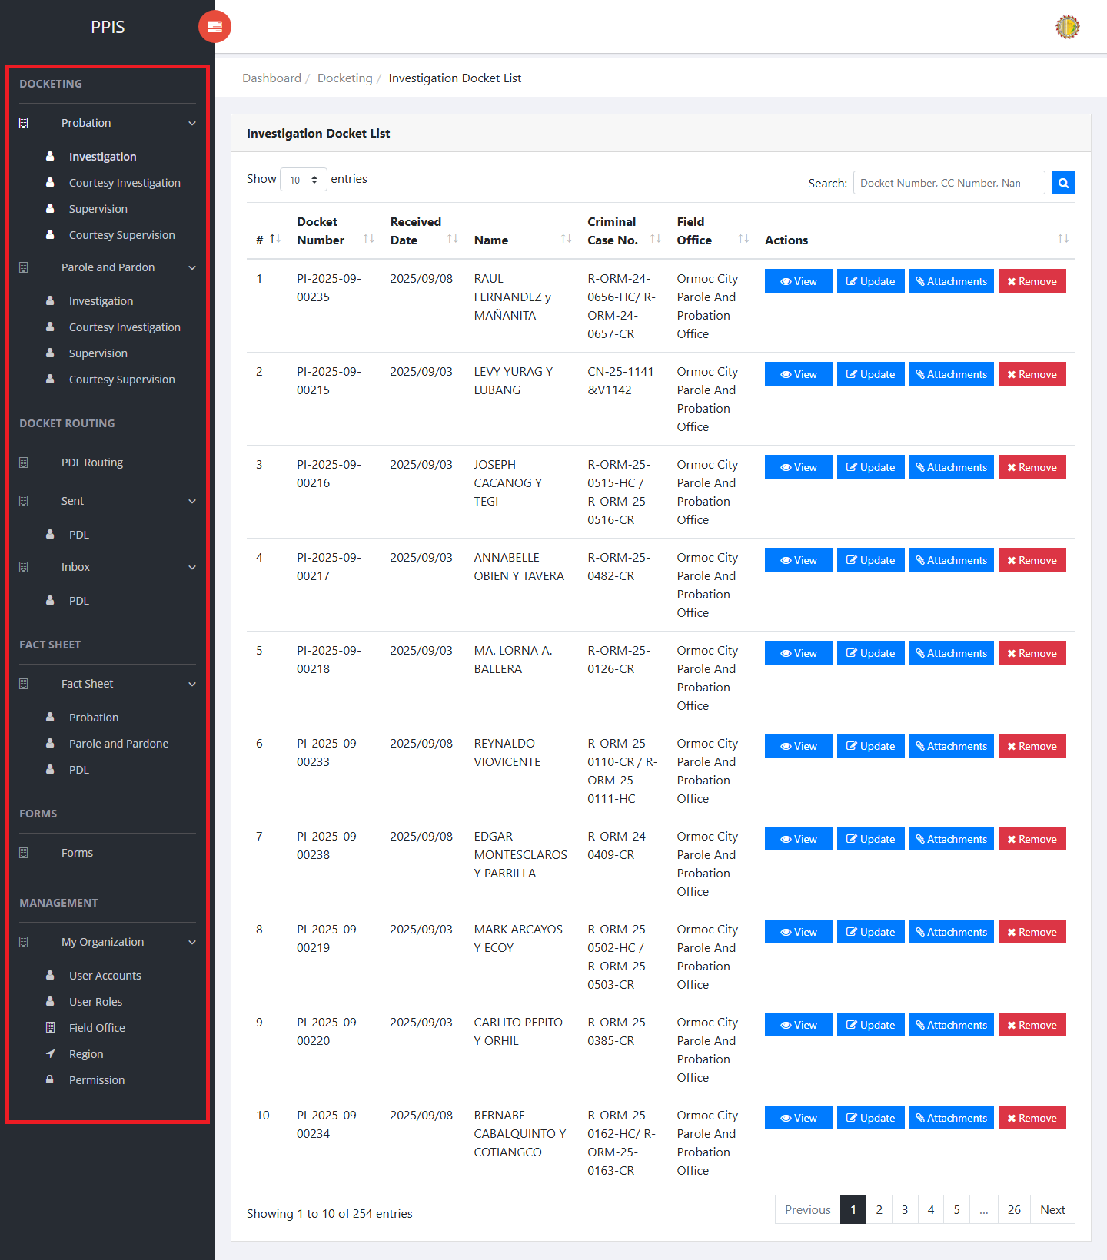
Main navigation

5. Docket Access

Probation Investigation
Use this page to find, review, update, attach files to, or remove probation investigation dockets.
1. From the left menu, open Probation Investigation.
2. To find a record, enter the known information in Docket Number, CC Number, Name.
3. Click Run search to apply the search.
4. In the Actions column, use View, Update, Attachments, Remove for the selected row.
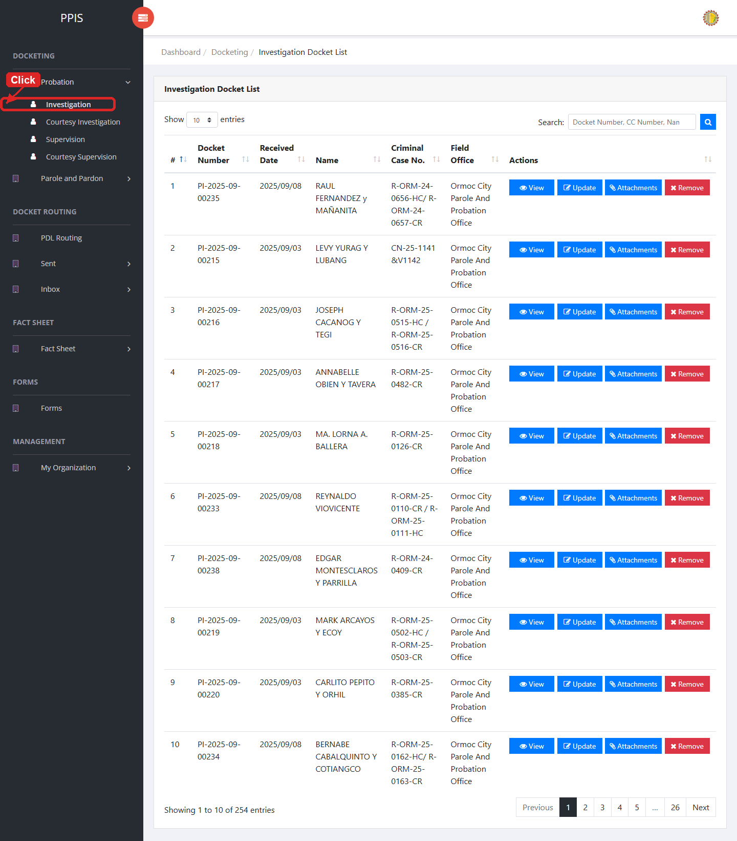
Probation Investigation list page

Probation Investigation (View)
1. On the Probation Investigation list page, locate the record the end user needs to review.
2. Click View in the Actions column.
3. Read the details on the view page. Use this screen for checking information before making any changes.
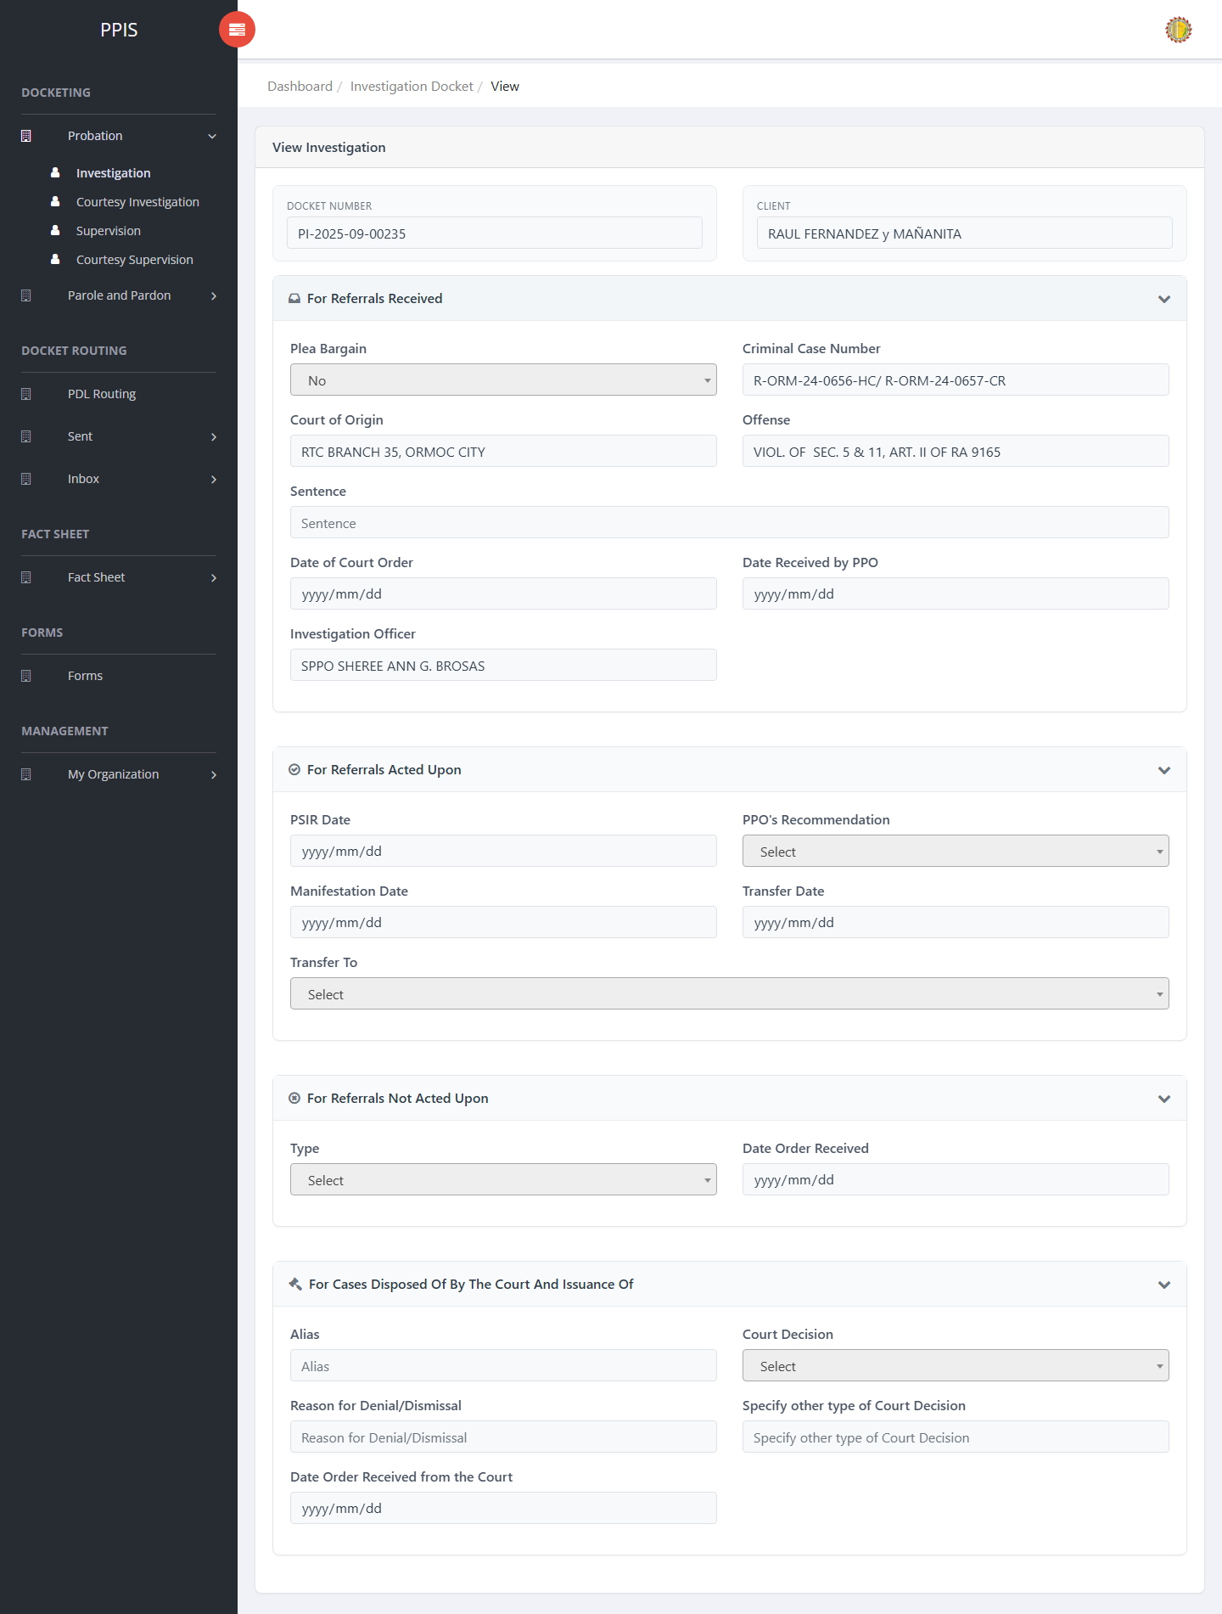
Probation Investigation (View)

Probation Investigation (Update)
1. On the Probation Investigation list page, locate the record that needs correction.
2. Click Update in the Actions column.
3. Wait for the update screen to open.
4. Review the current details and update Docket Number, Client Name, Plea Bargain, Criminal Case Number, Court of Origin, Offense, Sentence, Date of Court Order.
5. Click Confirm to save after checking the information.
6. Wait for the system to return to the list page or refresh the record display.
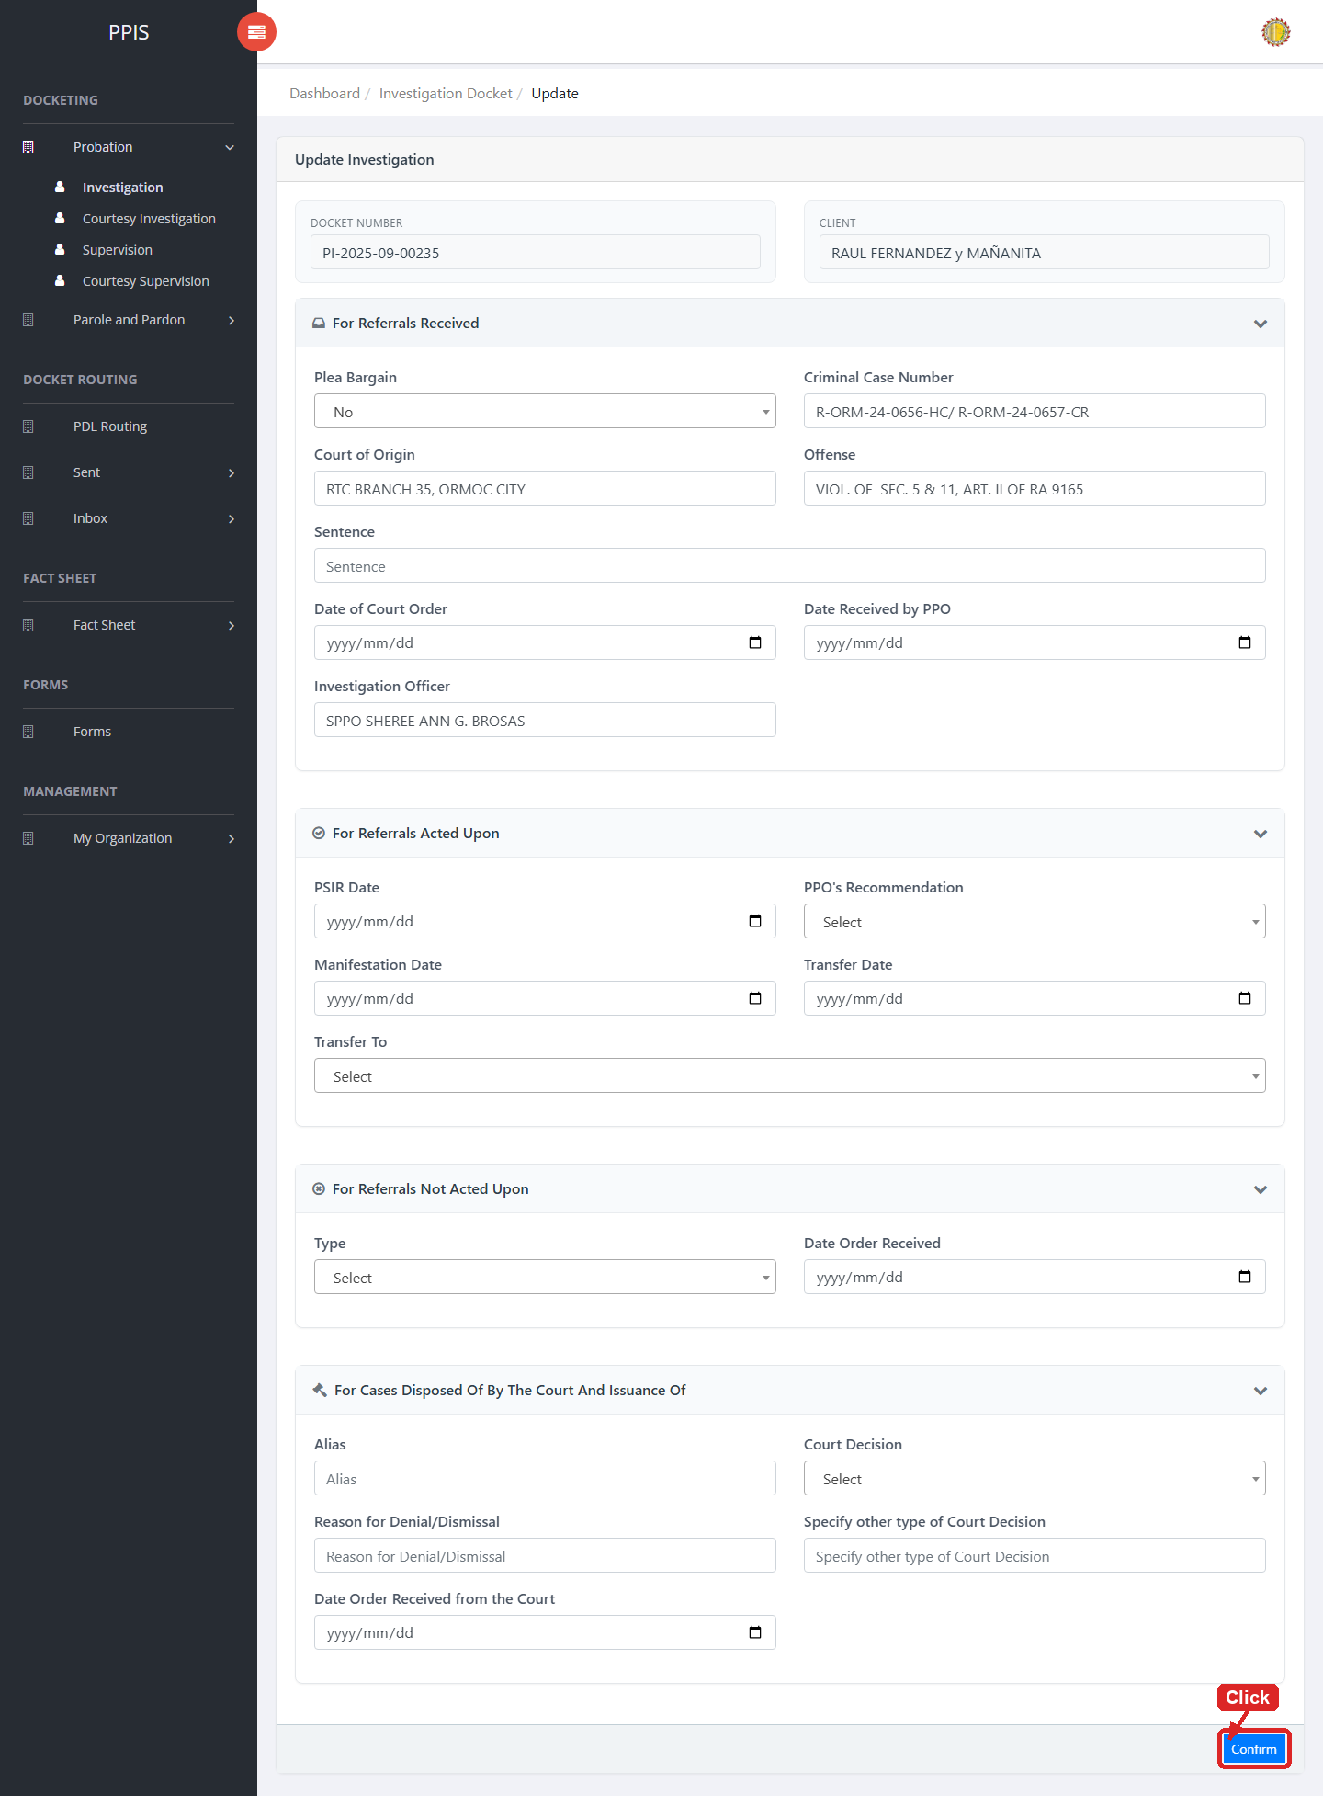
Probation Investigation (Update)

Probation Investigation (Attachments)
1. On the Probation Investigation list page, click Attachments for the correct record.
2. Wait for the attachments screen to open.
3. Complete the attachment details, such as Kind, Type, and Upload File when shown.
4. Click Confirm to upload the file.
5. Use View, Download, or Delete only for the attachment listed in the table.
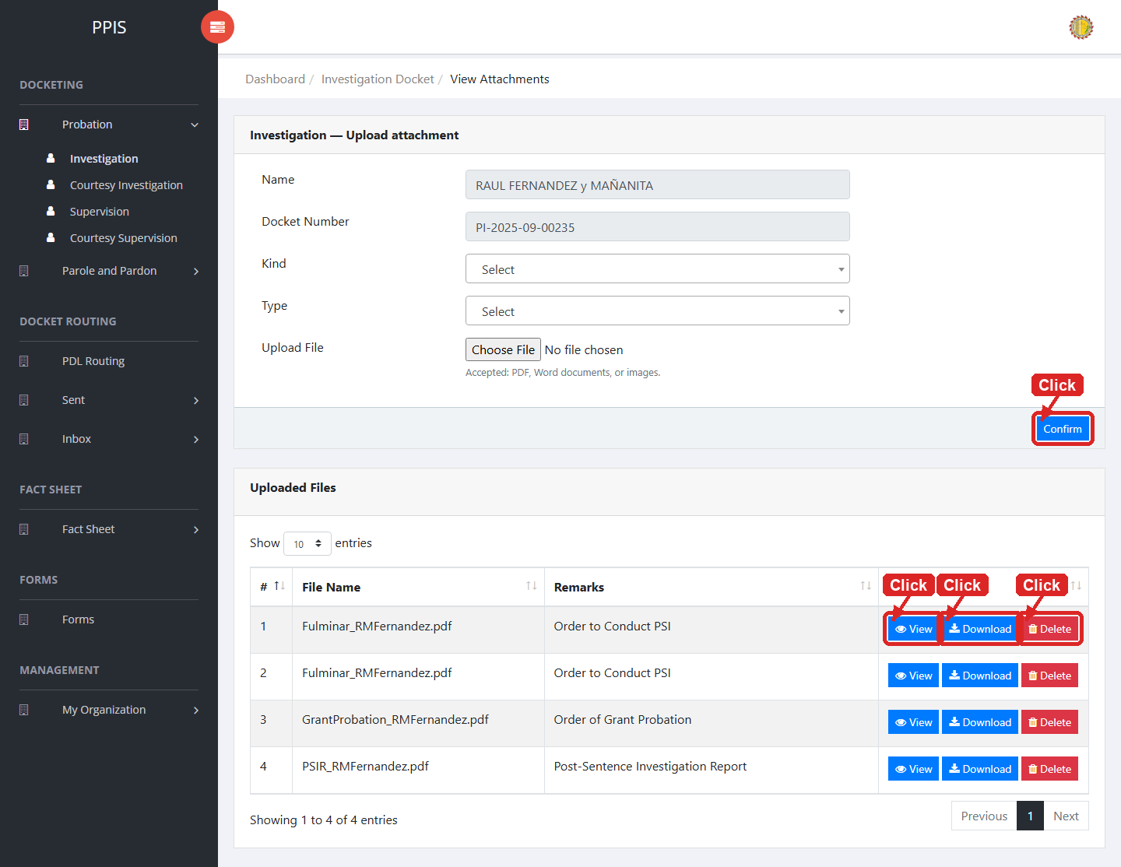
Probation Investigation (Attachments)

Probation Investigation (Delete)
Deletion warning: Use Remove only for sample/test records or records approved for deletion. For documentation, stop at the confirmation dialog unless removal is required.

1. On the Probation Investigation list page, locate the sample, test, or authorized record.
2. Click Remove in the Actions column.
3. Wait for the confirmation modal dialog box to appear.
4. Read the confirmation message carefully. The system warns that removal cannot be undone.
5. Click Cancel inside the modal dialog to stop, or click Remove permanently inside the modal dialog only when deletion is authorized.
6. Wait for the modal dialog to close. The table refreshes to reflect the remaining records.
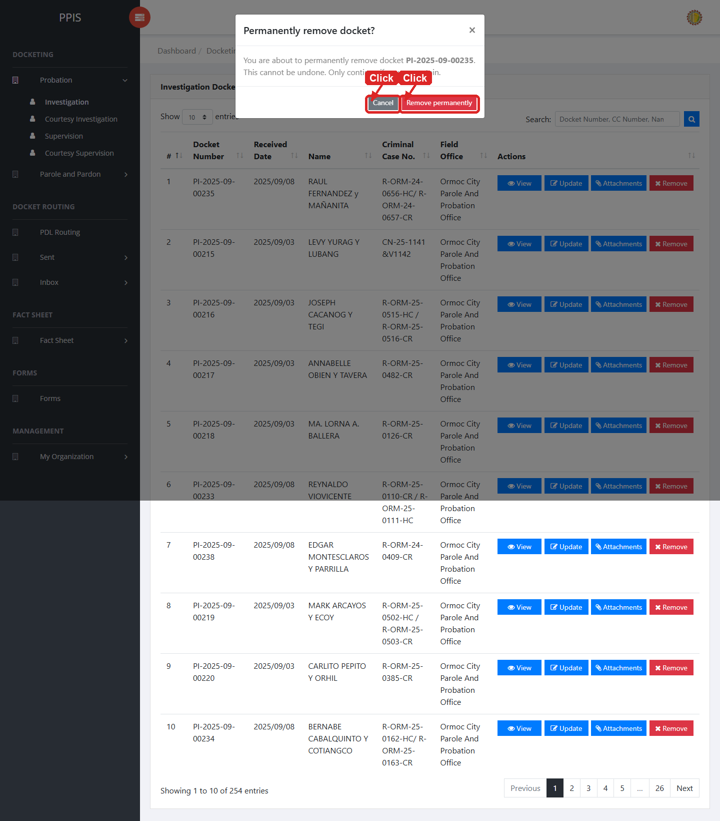
Probation Investigation (Delete)

Probation Courtesy Investigation
Use this page to manage courtesy investigation dockets under the probation workflow.
1. From the left menu, open Probation Courtesy Investigation.
2. To find a record, enter the known information in Search docket / name.
3. Click Run search to apply the search.
4. In the Actions column, use View, Update, Attachments, Remove for the selected row.
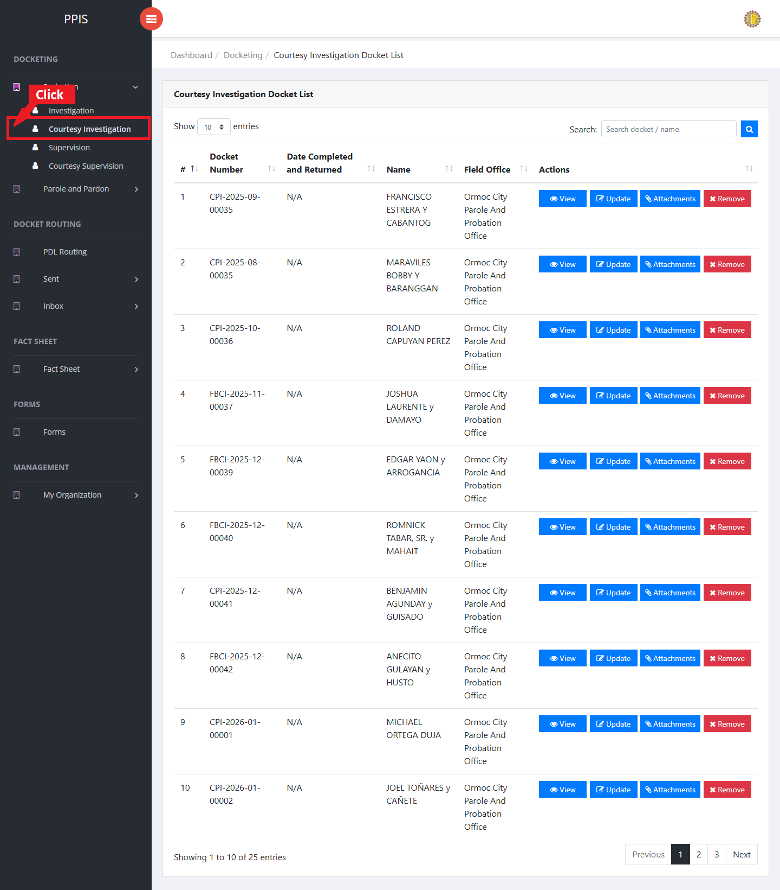
Probation Courtesy Investigation list page

Probation Courtesy Investigation (View)
1. On the Probation Courtesy Investigation list page, locate the record the end user needs to review.
2. Click View in the Actions column.
3. Read the details on the view page. Use this screen for checking information before making any changes.
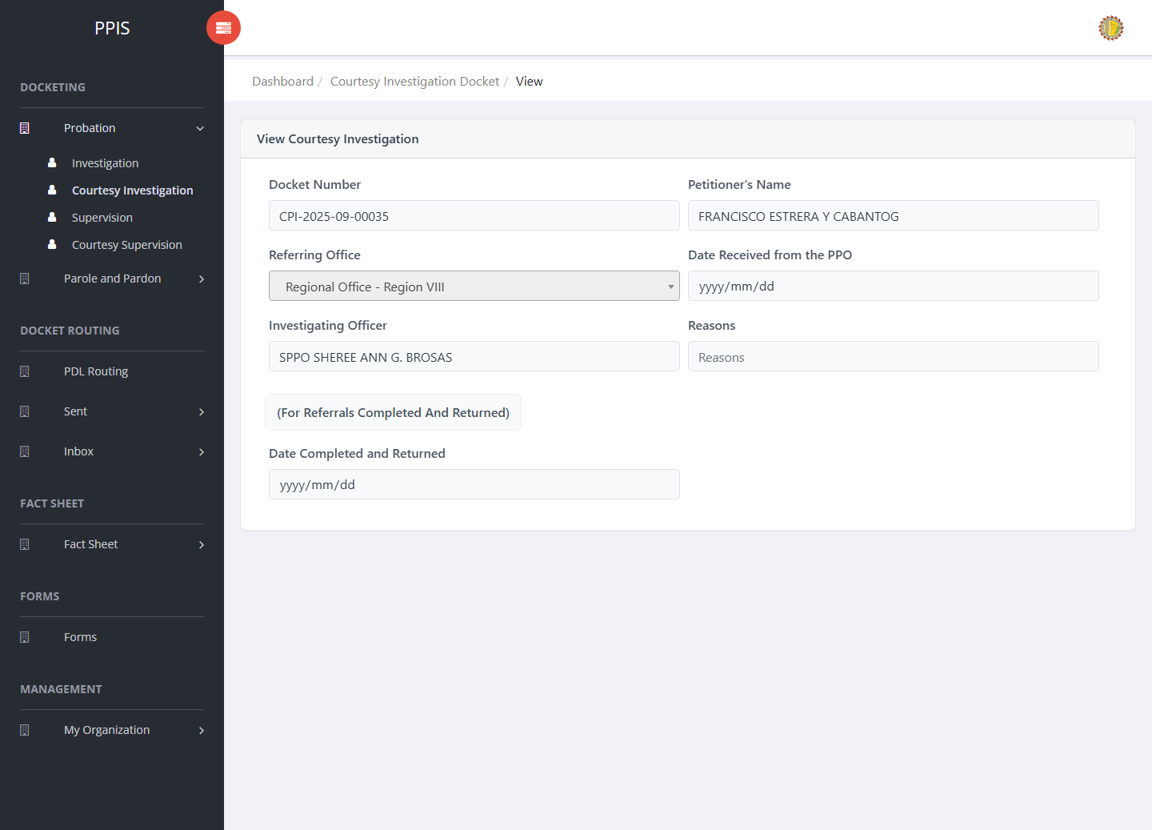
Probation Courtesy Investigation (View)

Probation Courtesy Investigation (Update)
1. On the Probation Courtesy Investigation list page, locate the record that needs correction.
2. Click Update in the Actions column.
3. Wait for the update screen to open.
4. Review the current details and update Docket Number, Petitioner's Name, Referring Office, Date Received from the PPO, Investigating Officer, Reasons, Date Completed and Returned.
5. Click Confirm to save after checking the information.
6. Wait for the system to return to the list page or refresh the record display.
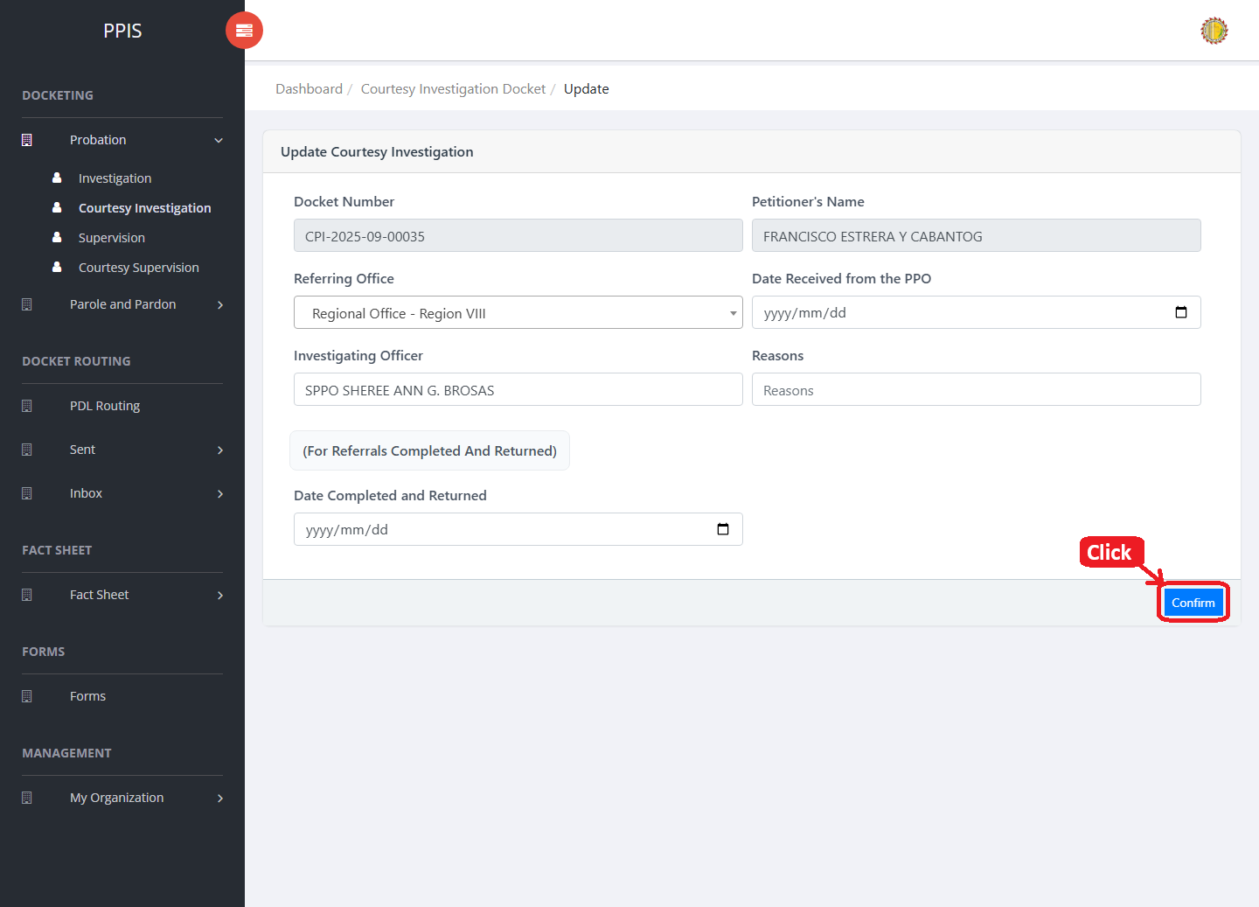
Probation Courtesy Investigation (Update)

Probation Courtesy Investigation (Attachments)
1. On the Probation Courtesy Investigation list page, click Attachments for the correct record.
2. Wait for the attachments screen to open.
3. Complete the attachment details, such as Kind, Type, and Upload File when shown.
4. Click Confirm to upload the file.
5. Use View, Download, or Delete only for the attachment listed in the table.
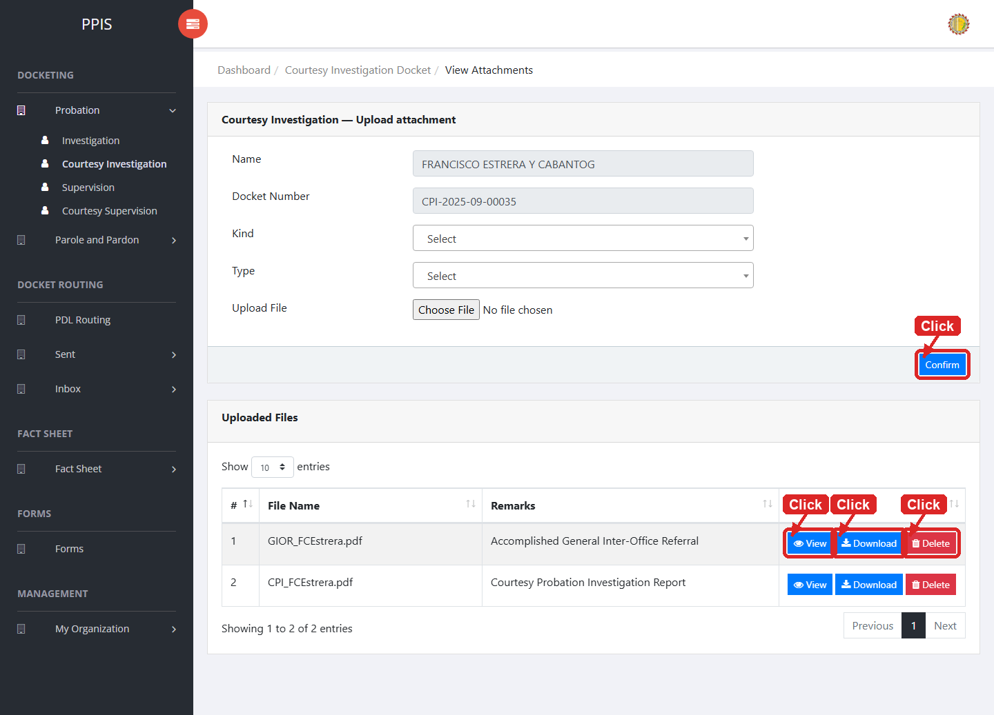
Probation Courtesy Investigation (Attachments)

Probation Courtesy Investigation (Delete)
Deletion warning: Use Remove only for sample/test records or records approved for deletion. For documentation, stop at the confirmation dialog unless removal is required.

1. On the Probation Courtesy Investigation list page, locate the sample, test, or authorized record.
2. Click Remove in the Actions column.
3. Wait for the confirmation modal dialog box to appear.
4. Read the confirmation message carefully. The system warns that removal cannot be undone.
5. Click Cancel inside the modal dialog to stop, or click Remove permanently inside the modal dialog only when deletion is authorized.
6. Wait for the modal dialog to close. The table refreshes to reflect the remaining records.
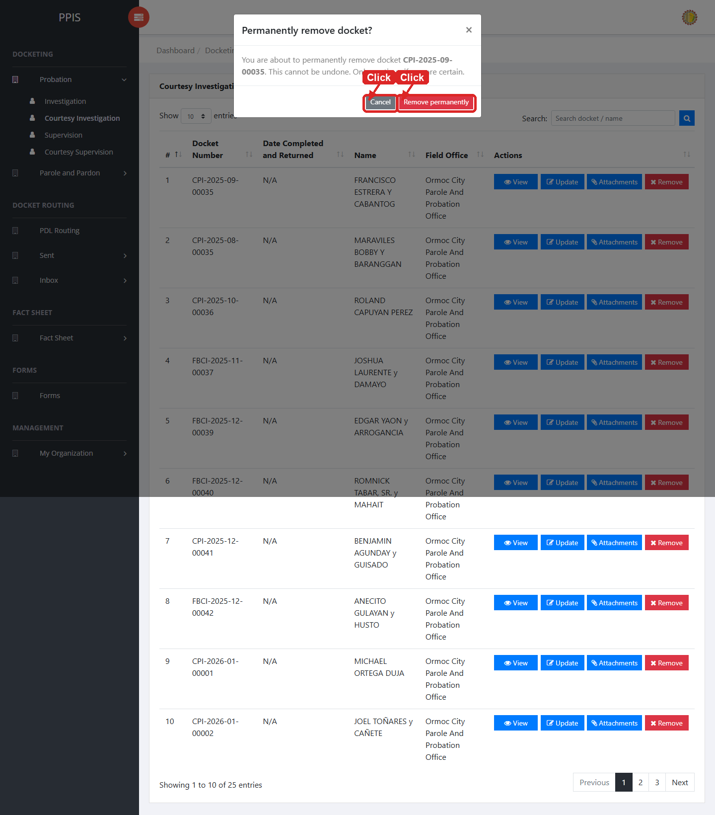
Probation Courtesy Investigation (Delete)

Probation Supervision
Use this page to manage probation supervision dockets and related record actions.
1. From the left menu, open Probation Supervision.
2. To find a record, enter the known information in Search docket / name.
3. Click Run search to apply the search.
4. In the Actions column, use View, Update, Attachments, Remove for the selected row.
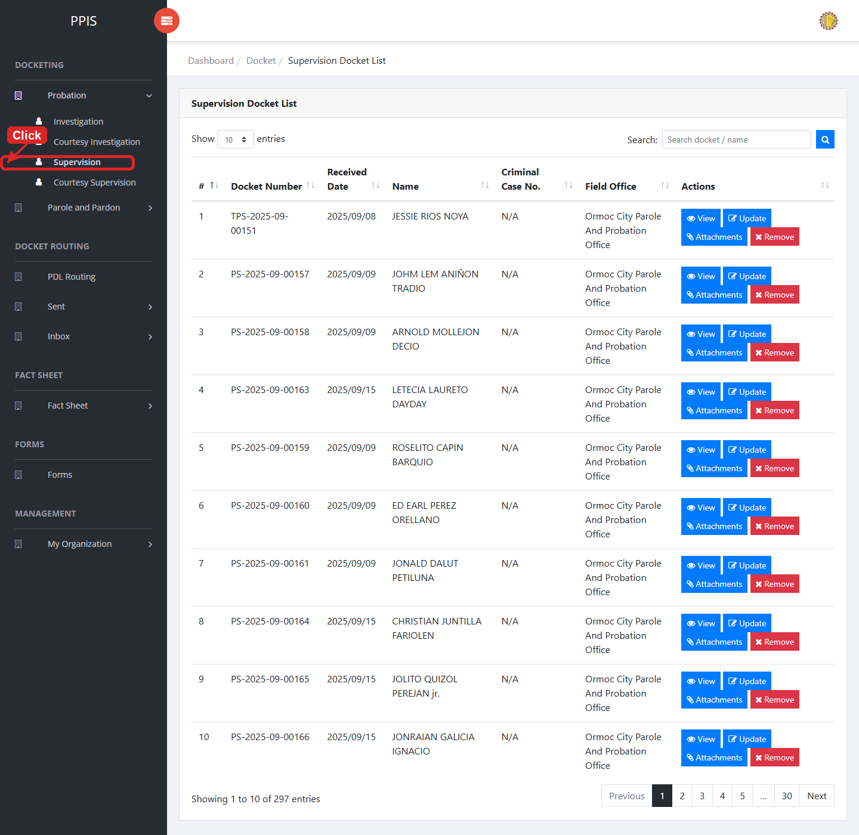
Probation Supervision list page

Probation Supervision (View)
1. On the Probation Supervision list page, locate the record the end user needs to review.
2. Click View in the Actions column.
3. Read the details on the view page. Use this screen for checking information before making any changes.
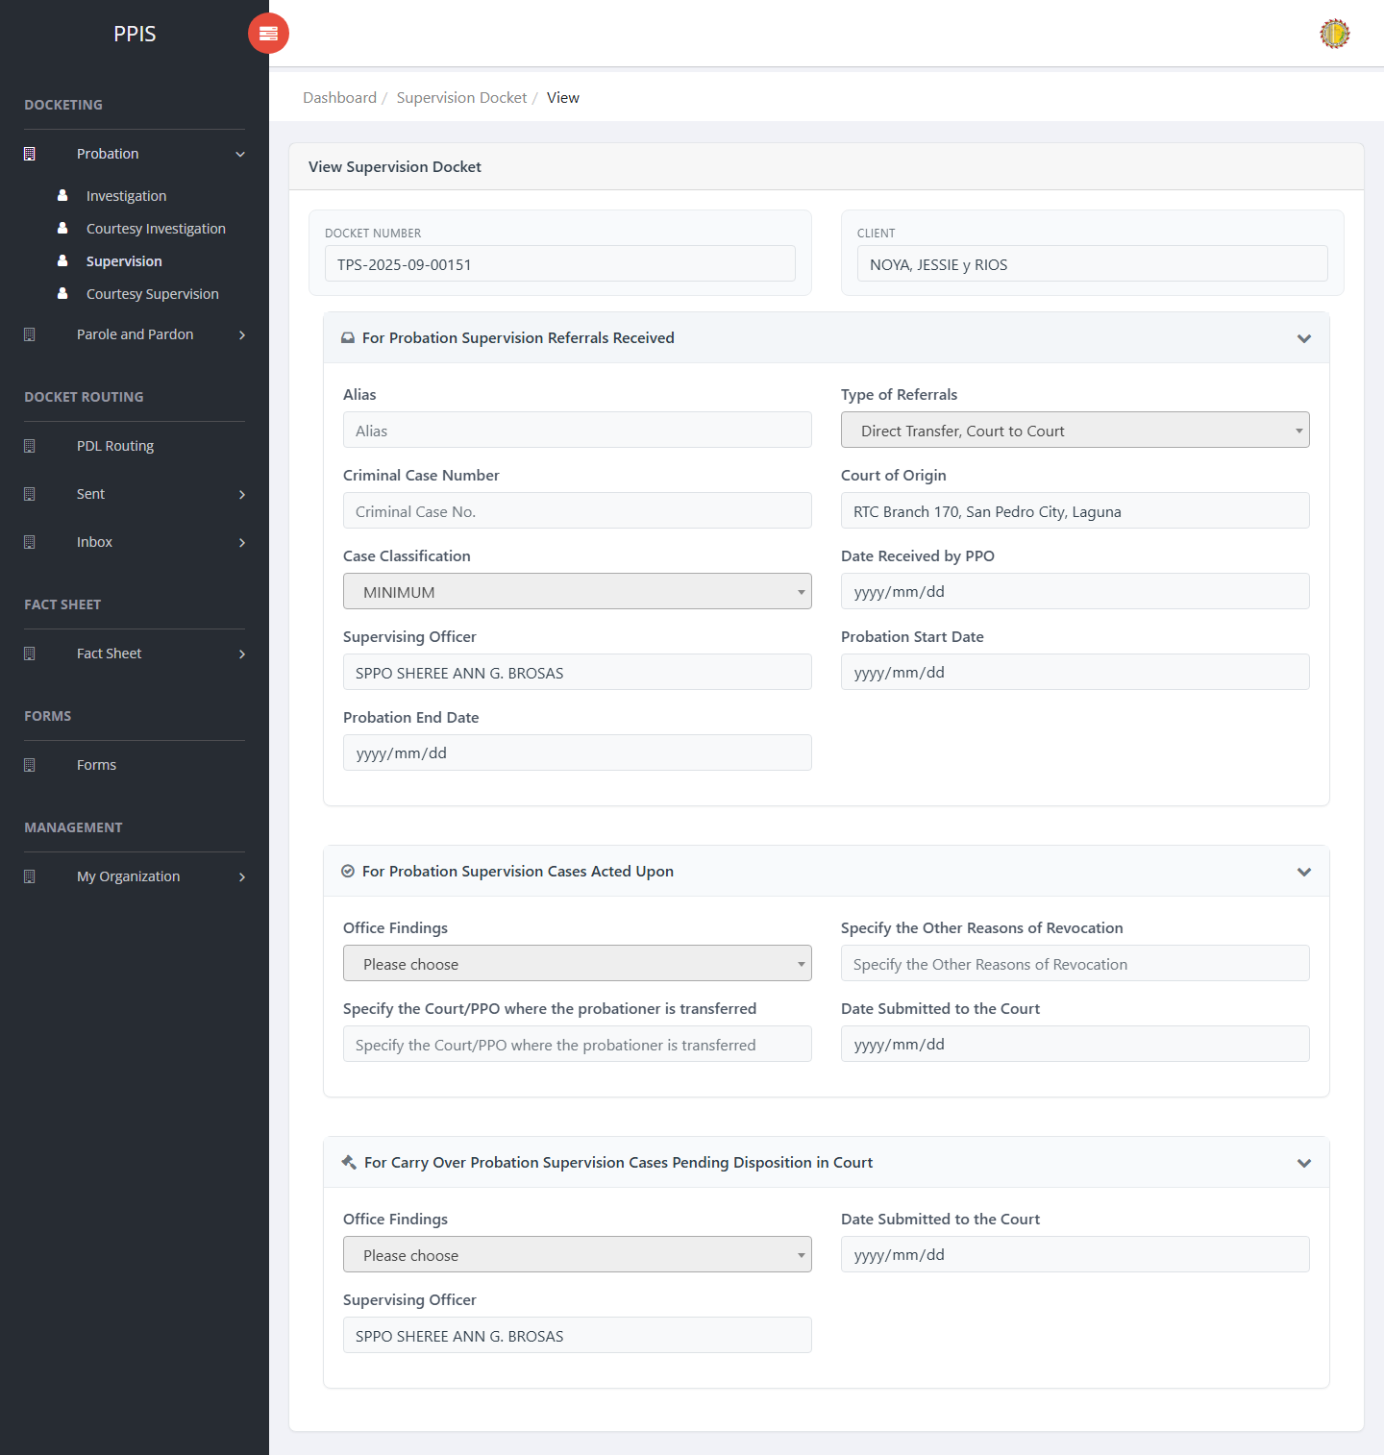
Probation Supervision (View)

Probation Supervision (Update)
1. On the Probation Supervision list page, locate the record that needs correction.
2. Click Update in the Actions column.
3. Wait for the update screen to open.
4. Review the current details and update Docket Number, Client Name, Alias, Type of Referrals, Criminal Case Number, Court of Origin, Case Classification, Date Received by PPO.
5. Click Confirm to save after checking the information.
6. Wait for the system to return to the list page or refresh the record display.
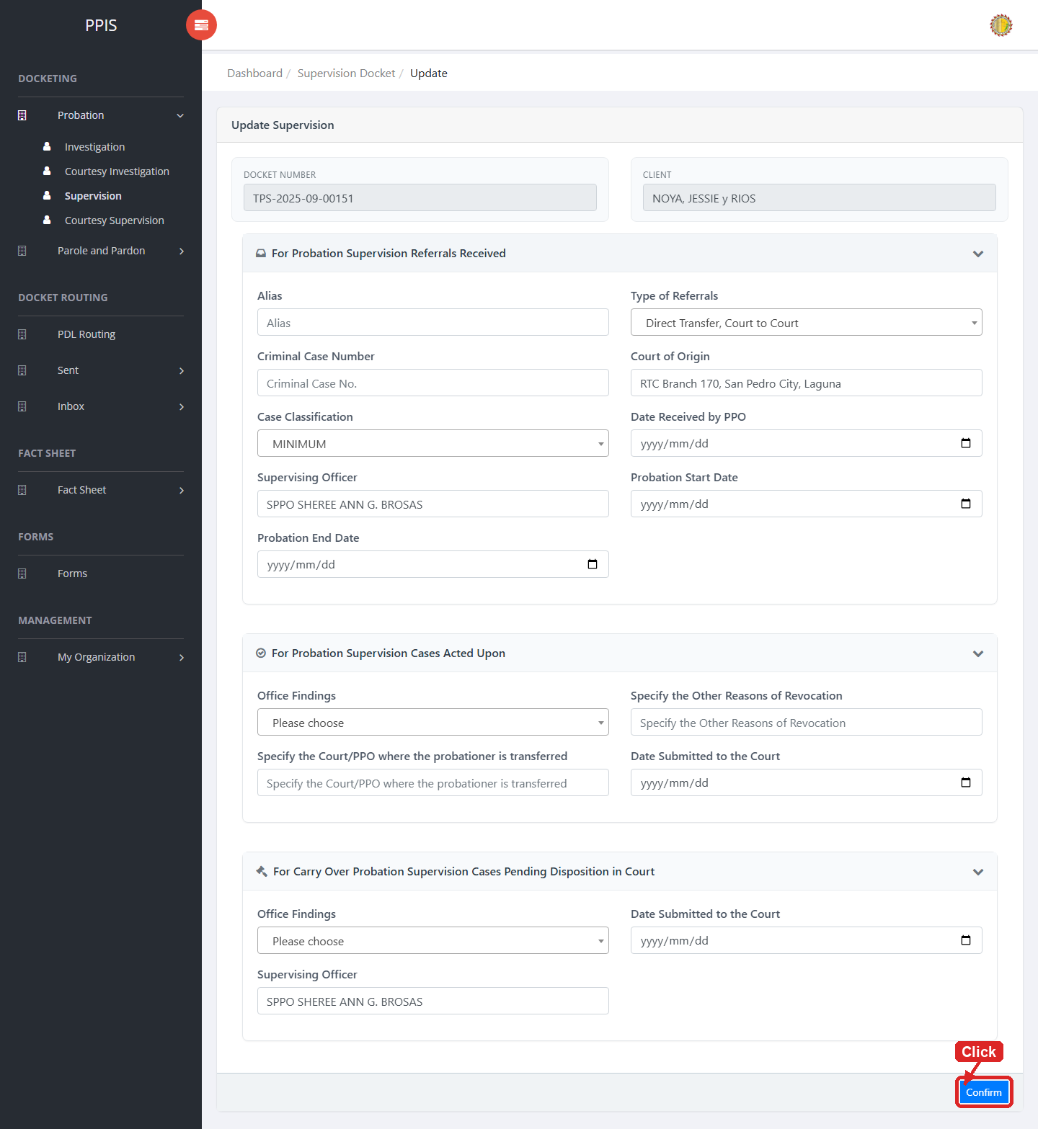
Probation Supervision (Update)

Probation Supervision (Attachments)
1. On the Probation Supervision list page, click Attachments for the correct record.
2. Wait for the attachments screen to open.
3. Complete the attachment details, such as Kind, Type, and Upload File when shown.
4. Click Confirm to upload the file.
5. Use View, Download, or Delete only for the attachment listed in the table.
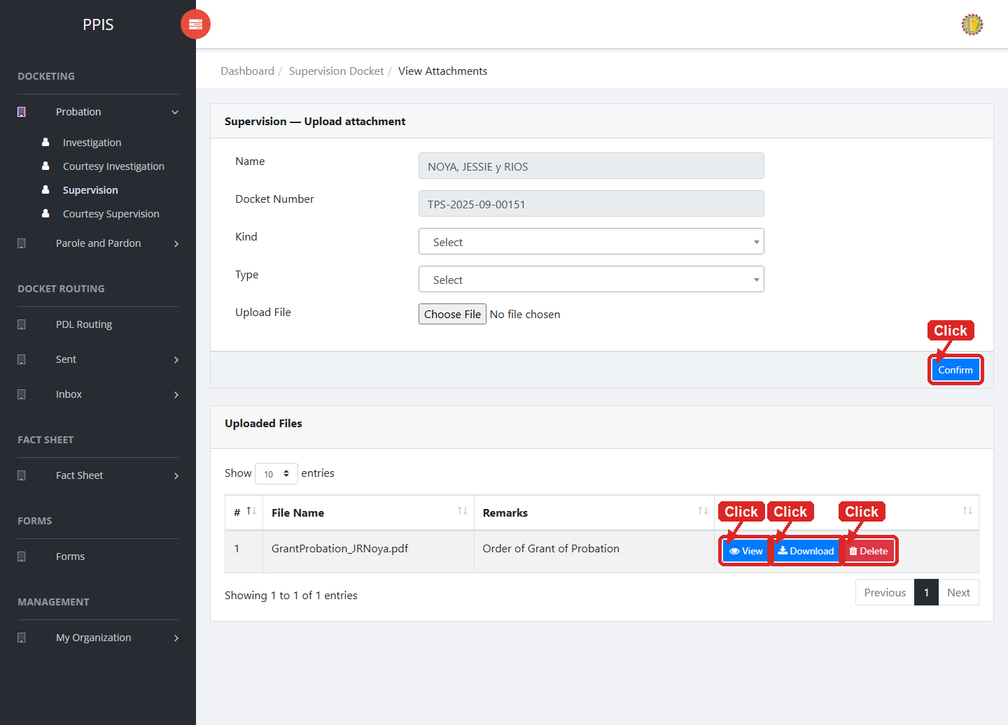
Probation Supervision (Attachments)

Probation Supervision (Delete)
Deletion warning: Use Remove only for sample/test records or records approved for deletion. For documentation, stop at the confirmation dialog unless removal is required.

1. On the Probation Supervision list page, locate the sample, test, or authentic record.
2. Click Remove in the Actions column.
3. Wait for the confirmation modal dialog box to appear.
4. Read the confirmation message carefully. The system warns that removal cannot be undone.
5. Click Cancel inside the modal dialog to stop, or click Remove permanently inside the modal dialog only when deletion is authorized.
6. Wait for the modal dialog to close. The table refreshes to reflect the remaining records.
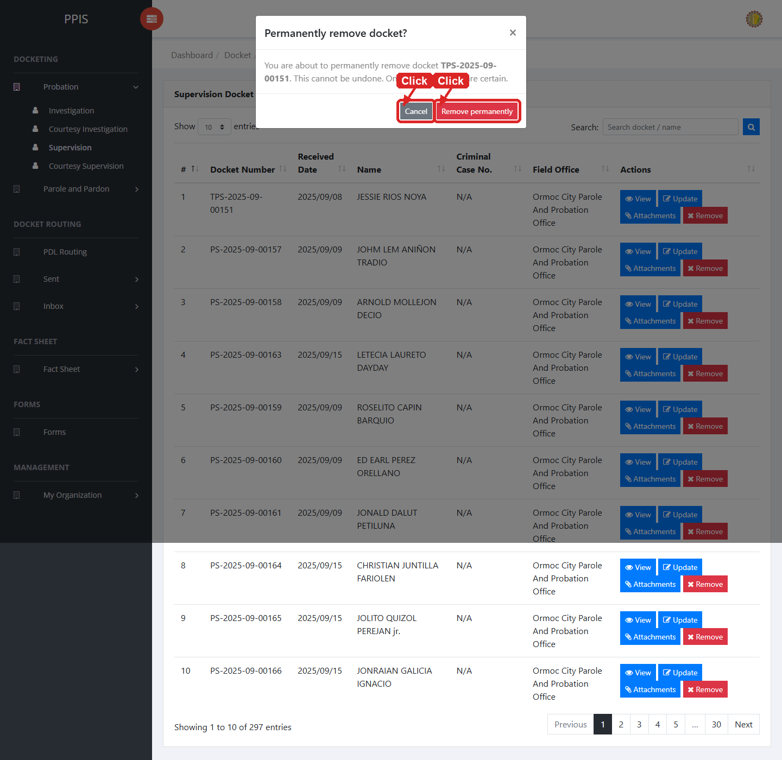
Probation Supervision (Delete)

Probation Courtesy Supervision
Use this page to manage courtesy supervision dockets under the probation workflow.
1. From the left menu, open Probation Courtesy Supervision.
2. To find a record, enter the known information in Search docket / name.
3. Click Run search to apply the search.
4. In the Actions column, use View, Update, Attachments, Remove for the selected row.
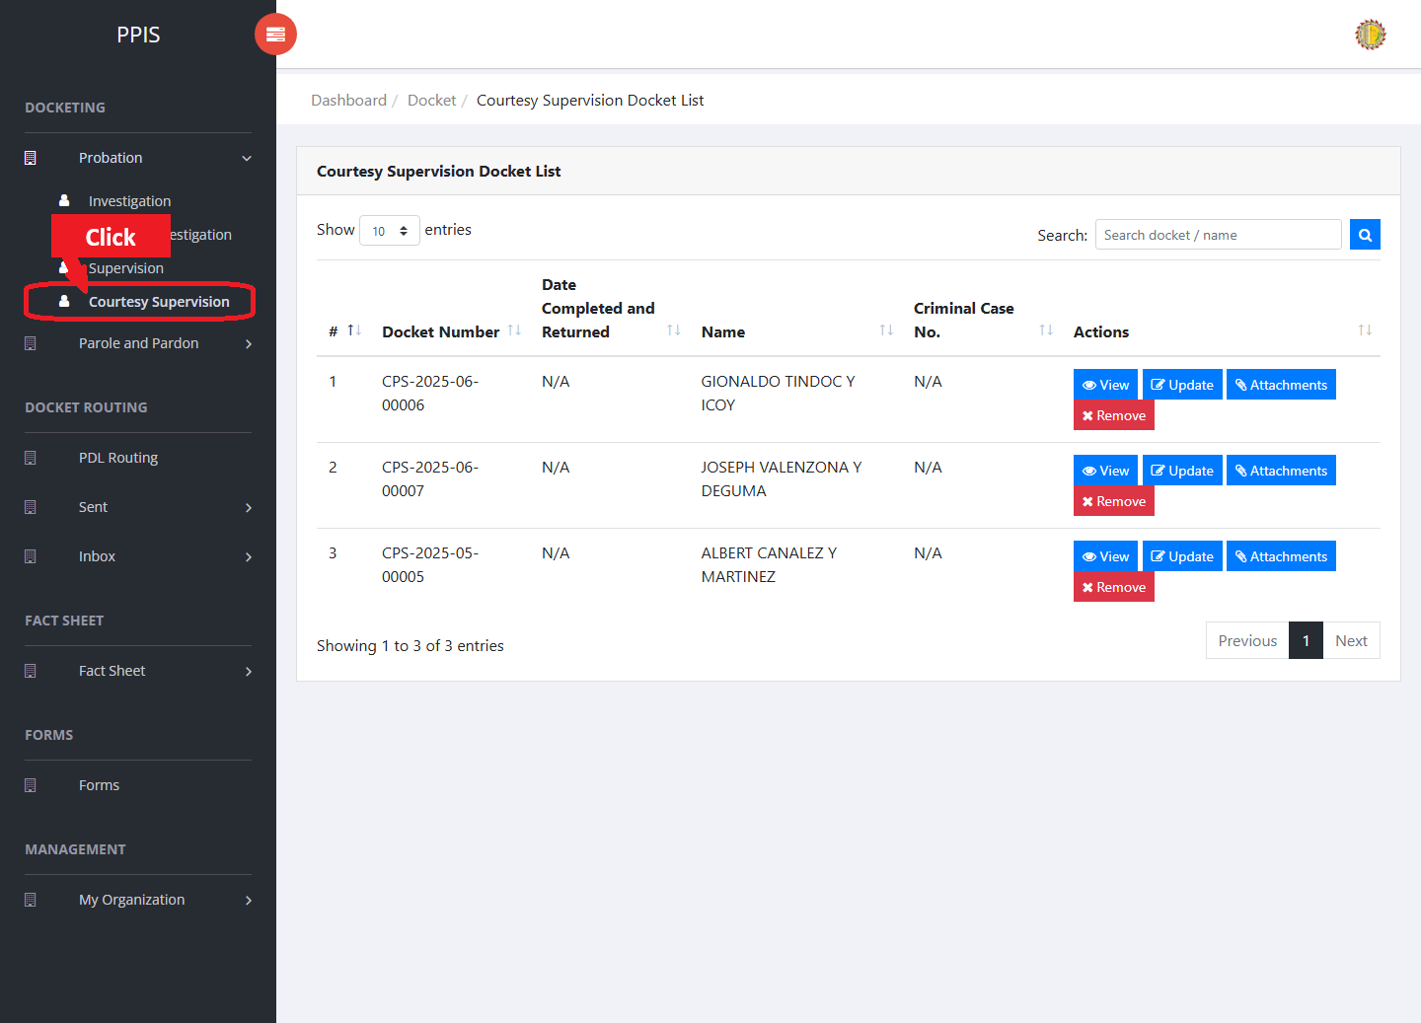
Probation Courtesy Supervision list page

Probation Courtesy Supervision (View)
1. On the Probation Courtesy Supervision list page, locate the record the end user needs to review.
2. Click View in the Actions column.
3. Read the details on the view page. Use this screen for checking information before making any changes.
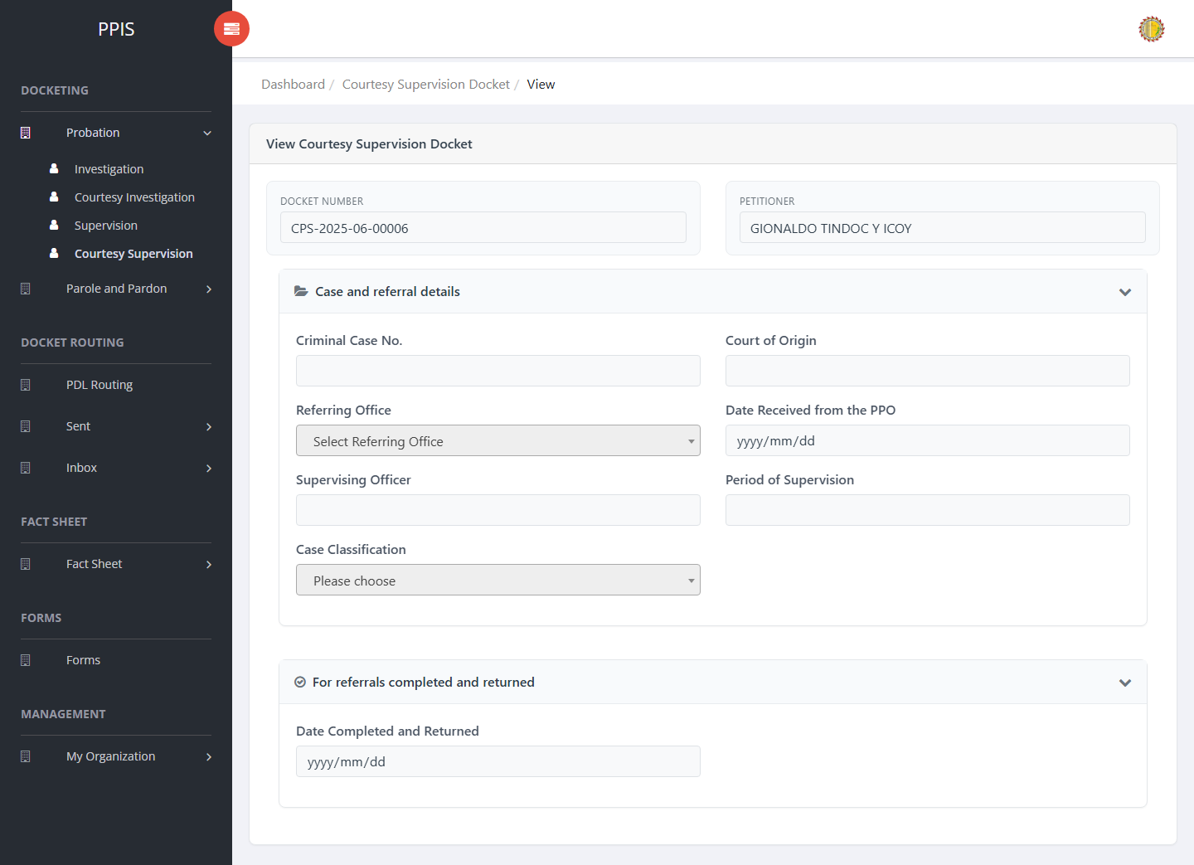
Probation Courtesy Supervision (View)

Probation Courtesy Supervision (Update)
1. On the Probation Courtesy Supervision list page, locate the record that needs correction.
2. Click Update in the Actions column.
3. Wait for the update screen to open.
4. Review the current details and update Docket Number, Client Name, Criminal Case No., Court of Origin, Referring Office, Date Received from the PPO, Supervising Officer, Period of Supervision.
5. Click Confirm to save after checking the information.
6. Wait for the system to return to the list page or refresh the record display.
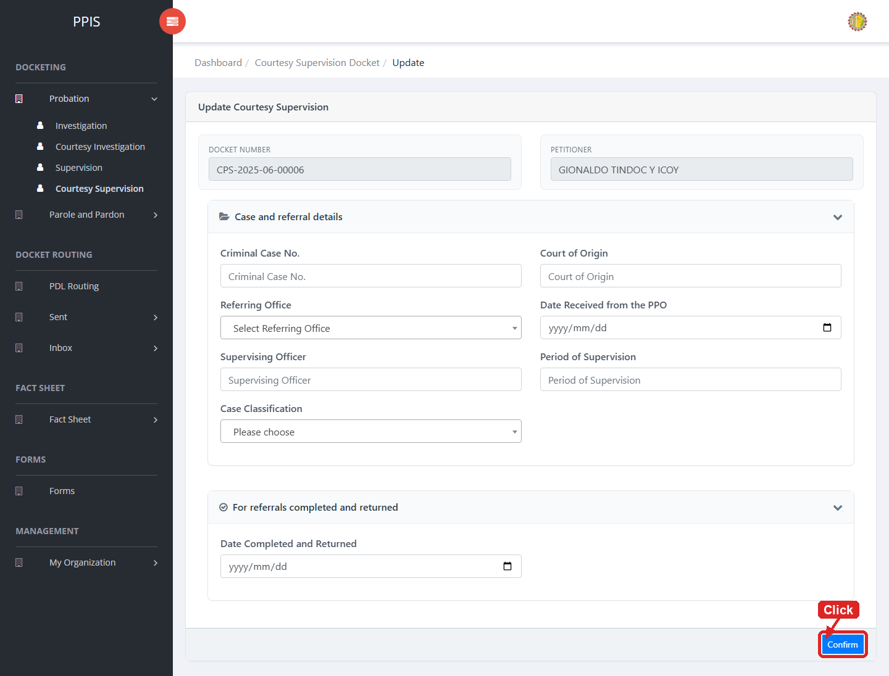
Probation Courtesy Supervision (Update)

Probation Courtesy Supervision (Attachments)
1. On the Probation Courtesy Supervision list page, click Attachments for the correct record.
2. Wait for the attachments screen to open.
3. Complete the attachment details, such as Kind, Type, and Upload File when shown.
4. Click Confirm to upload the file.
5. Use View, Download, or Delete only for the attachment listed in the table.
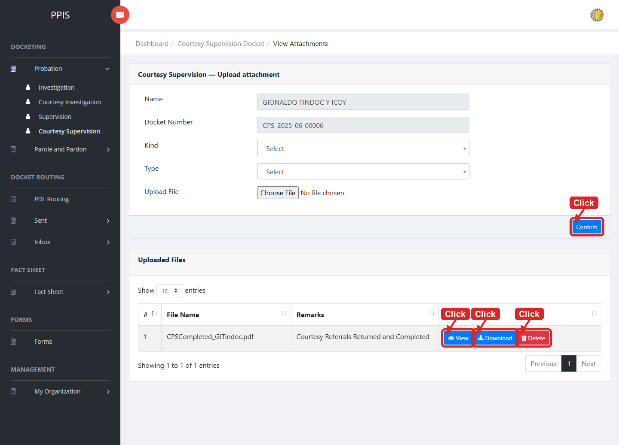
Probation Courtesy Supervision (Attachments)

Probation Courtesy Supervision (Delete)
Deletion warning: Use Remove only for sample/test records or records approved for deletion. For documentation, stop at the confirmation dialog unless removal is required.

1. On the Probation Courtesy Supervision list page, locate the sample, test, or authorized record.
2. Click Remove in the Actions column.
3. Wait for the confirmation modal dialog box to appear.
4. Read the confirmation message carefully. The system warns that removal cannot be undone.
5. Click Cancel inside the modal dialog to stop, or click Remove permanently inside the modal dialog only when deletion is authorized.
6. Wait for the modal dialog to close. The table refreshes to reflect the remaining records.
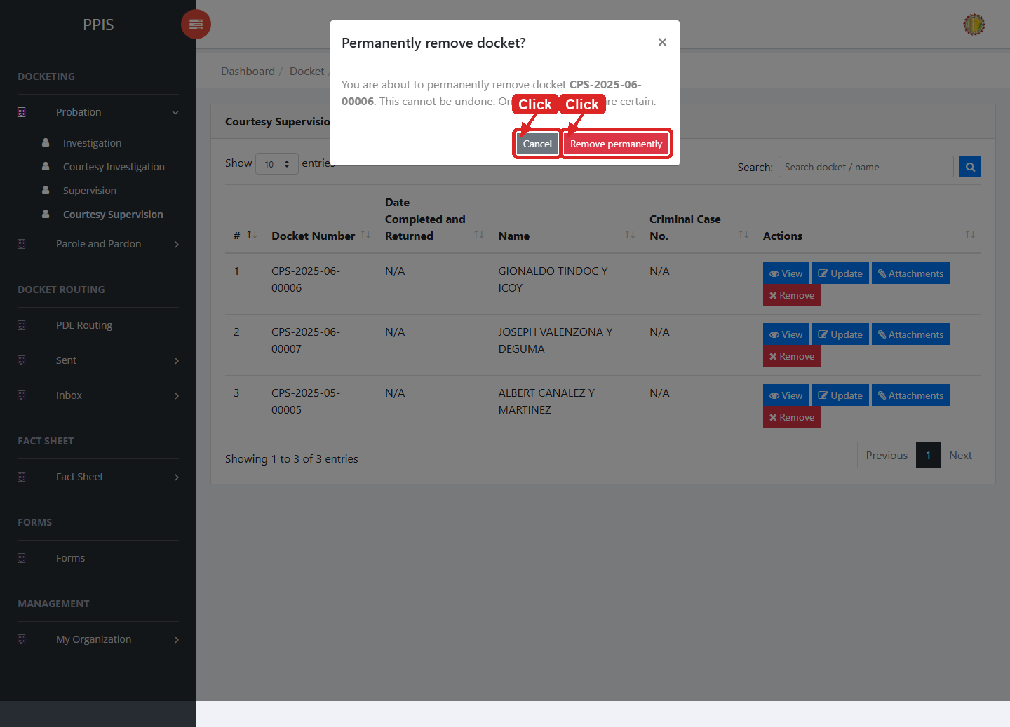
Probation Courtesy Supervision (Delete)

Parole and Pardon Investigation
Use this page to find, review, update, attach files to, or remove parole and pardon investigation dockets.
1. From the left menu, open Parole and Pardon Investigation.
2. To find a record, enter the known information in Docket Number, CC Number, Name.
3. Click Run search to apply the search.
4. In the Actions column, use View, Update, Attachments, Remove for the selected row.
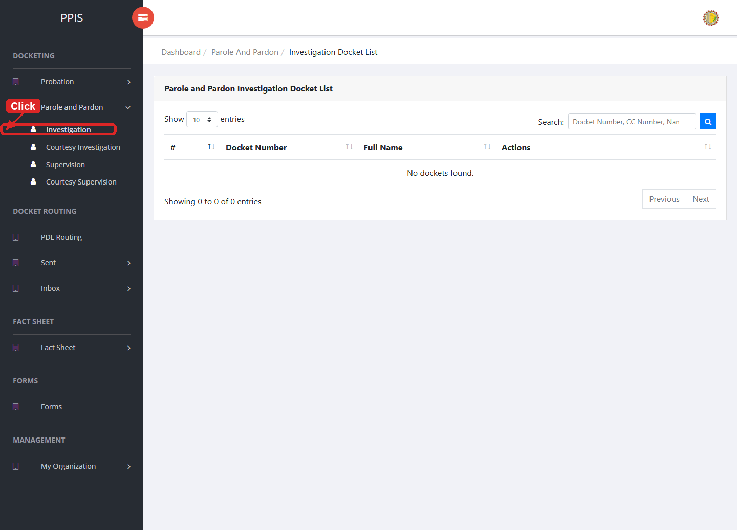
Parole and Pardon Investigation list page

Parole and Pardon Investigation (View)
1. On the Parole and Pardon Investigation list page, locate the record the end user needs to review.
2. Click View in the Actions column.
3. Read the details on the view page. Use this screen for checking information before making any changes.
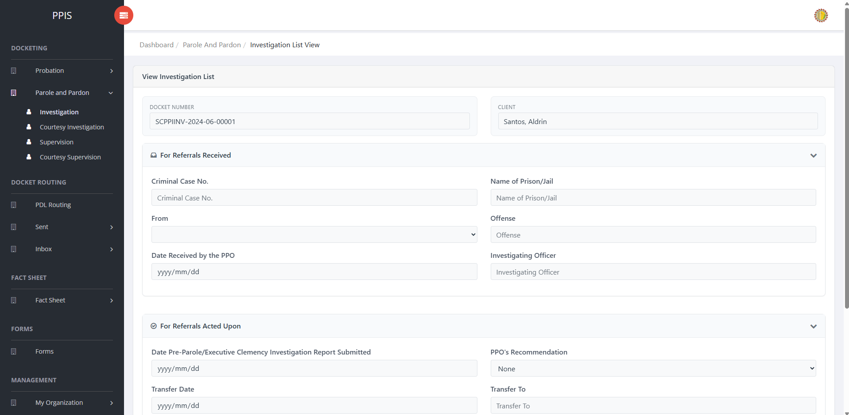
Parole and Pardon Investigation view page

Parole and Pardon Investigation (Update)
1. On the Parole and Pardon Investigation list page, locate the record that needs correction.
2. Click Update in the Actions column.
3. Wait for the update screen to open.
4. Review the current details and update Docket Number, Full Name, Referring Office, Date Received by the PPO, Investigating Officer.
5. Click Confirm to save after checking the information.
6. Wait for the system to return to the list page or refresh the record display.
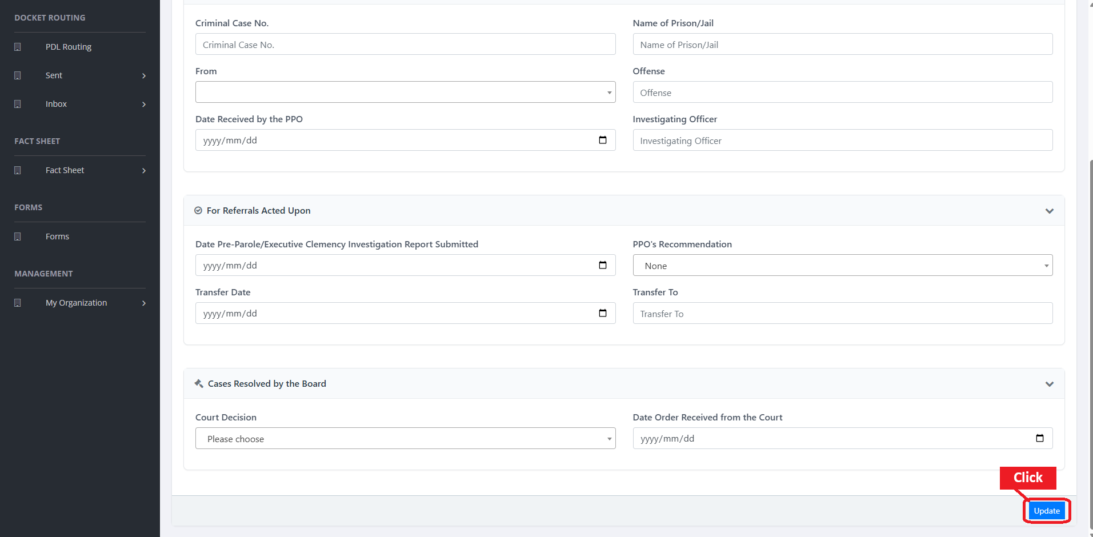
Parole and Pardon Investigation update page

Parole and Pardon Investigation (Attachments)
1. On the Parole and Pardon Investigation list page, click Attachments for the correct record.
2. Wait for the attachments screen to open.
3. Complete the attachment details, such as Kind, Type, and Upload File when shown.
4. Click Confirm to upload the file.
5. Use View, Download, or Delete only for the attachment listed in the table.
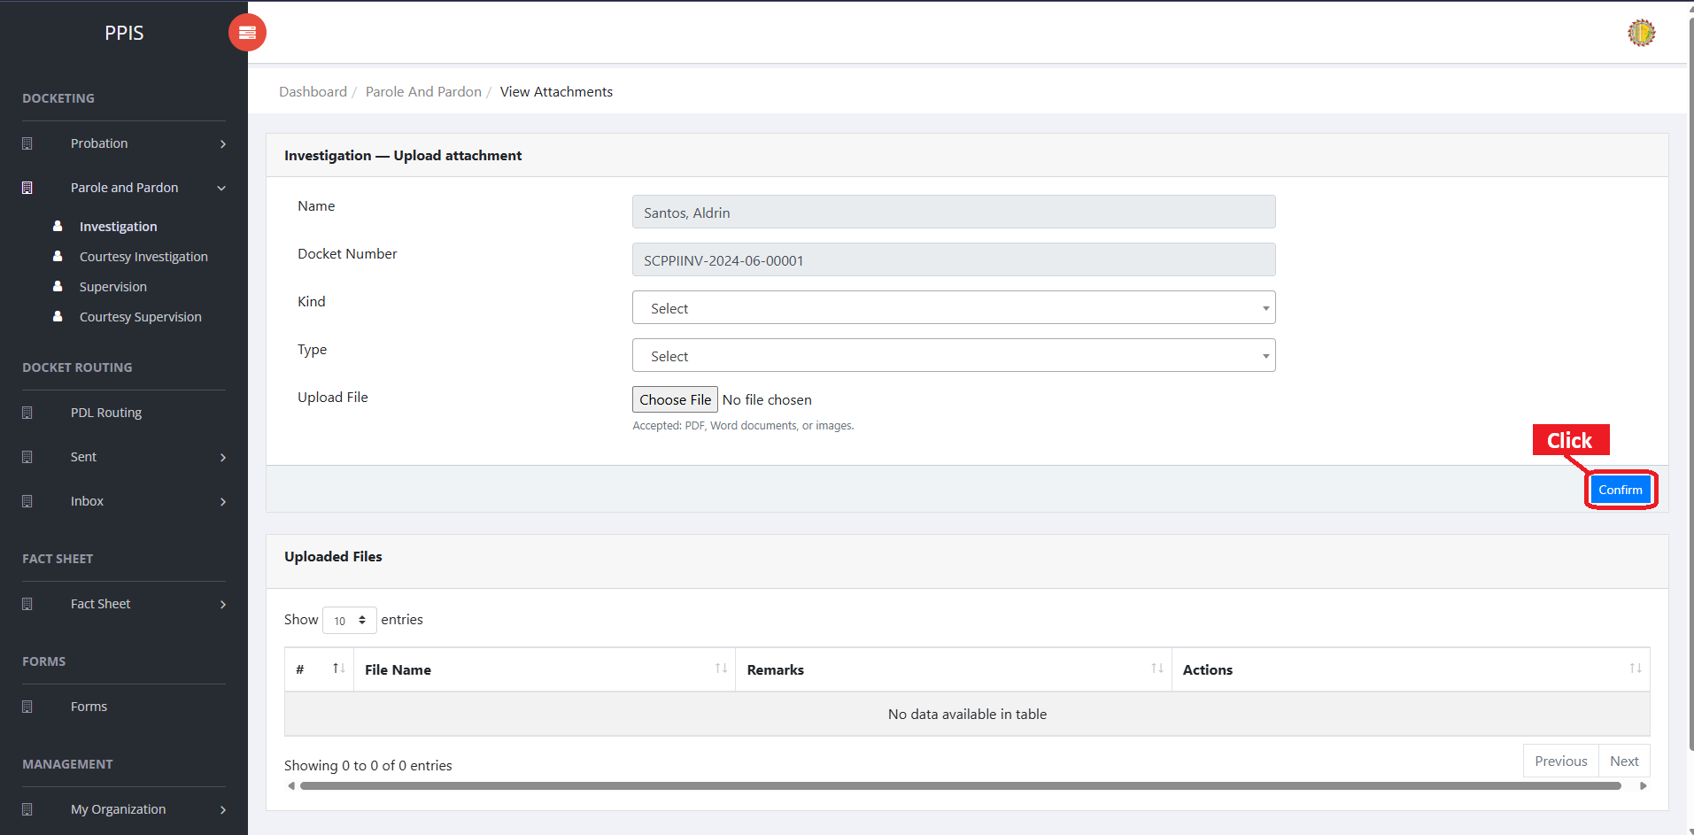
Parole and Pardon Investigation attachment page

Parole and Pardon Investigation (Delete)
Deletion warning: Use Remove only for sample/test records or records approved for deletion. For documentation, stop at the confirmation dialog unless removal is required.

1. On the Parole and Pardon Investigation list page, locate the sample, test, or authorized record.
2. Click Remove in the Actions column.
3. Wait for the confirmation modal dialog box to appear.
4. Read the confirmation message carefully. The system warns that removal cannot be undone.
5. Click Cancel inside the modal dialog to stop, or click Remove permanently inside the modal dialog only when deletion is authorized.
6. Wait for the modal dialog to close. The table refreshes to reflect the remaining records.
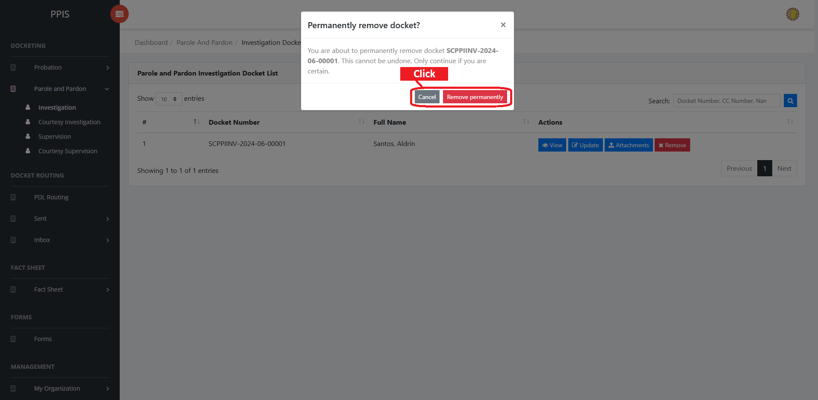
Parole and Pardon Investigation delete page

Parole and Pardon Courtesy Investigation
Use this page to manage courtesy investigation records for parole and pardon cases.
1. From the left menu, open Parole and Pardon Courtesy Investigation.
2. To find a record, enter the known information in Search docket / name.
3. Click Run search to apply the search.
4. In the Actions column, use View, Update, Attachments, Remove for the selected row.
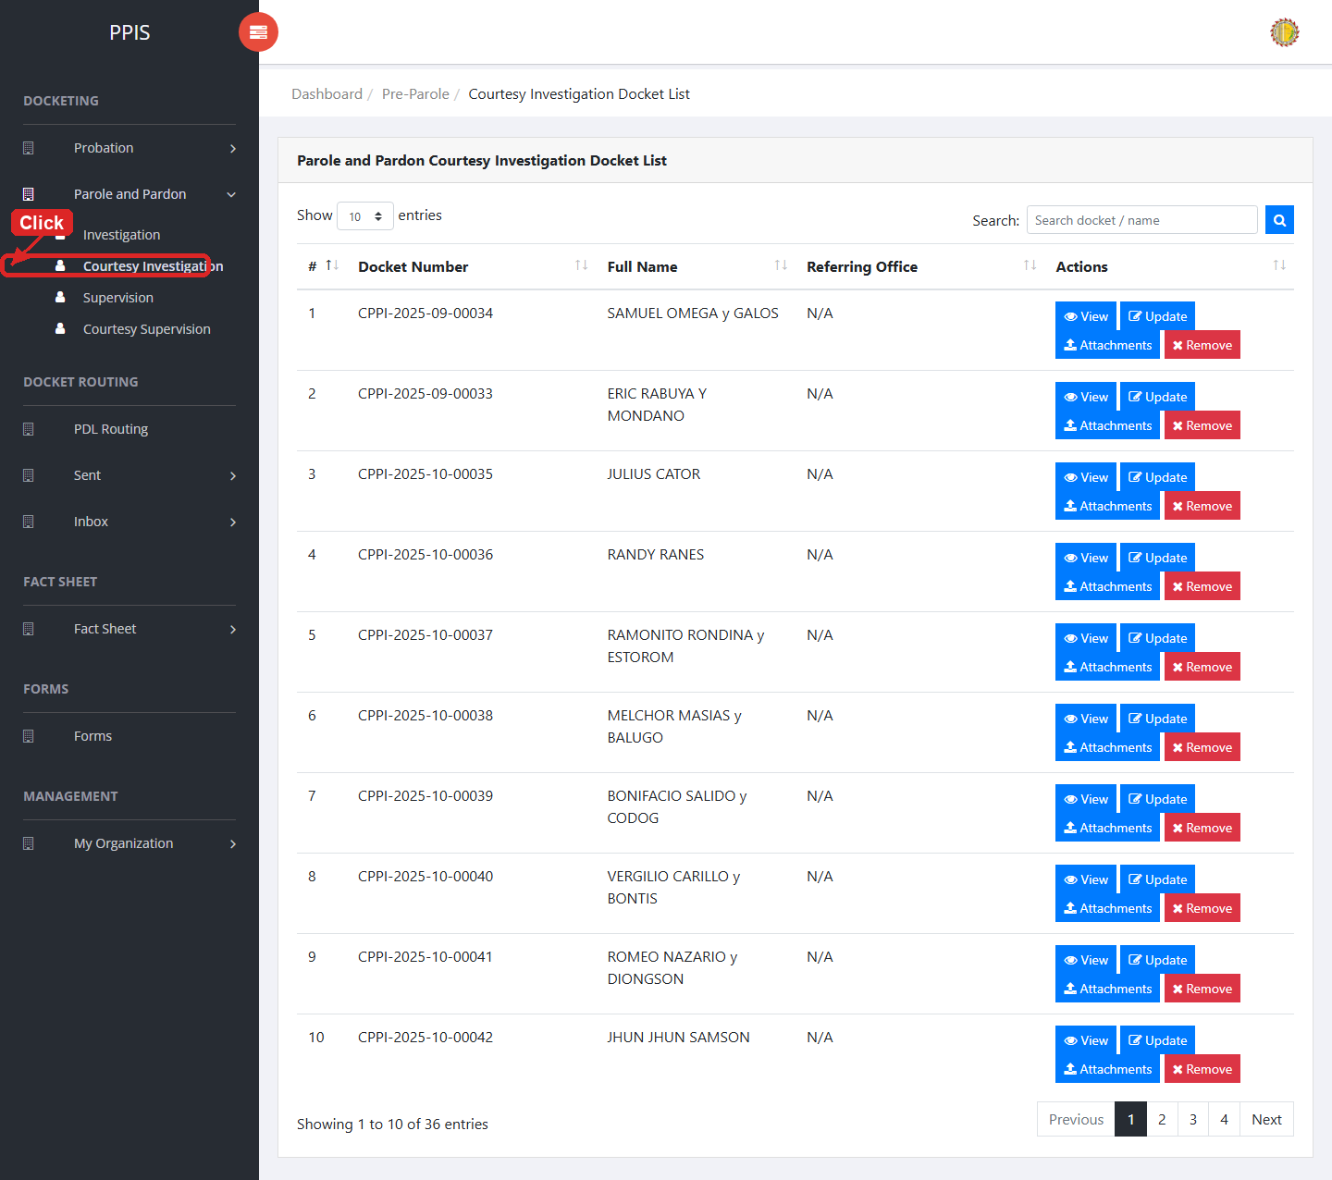
Parole and Pardon Courtesy Investigation list page

Parole and Pardon Courtesy Investigation (View)
1. On the Parole and Pardon Courtesy Investigation list page, locate the record the end user needs to review.
2. Click View in the Actions column.
3. Read the details on the view page. Use this screen for checking information before making any changes.
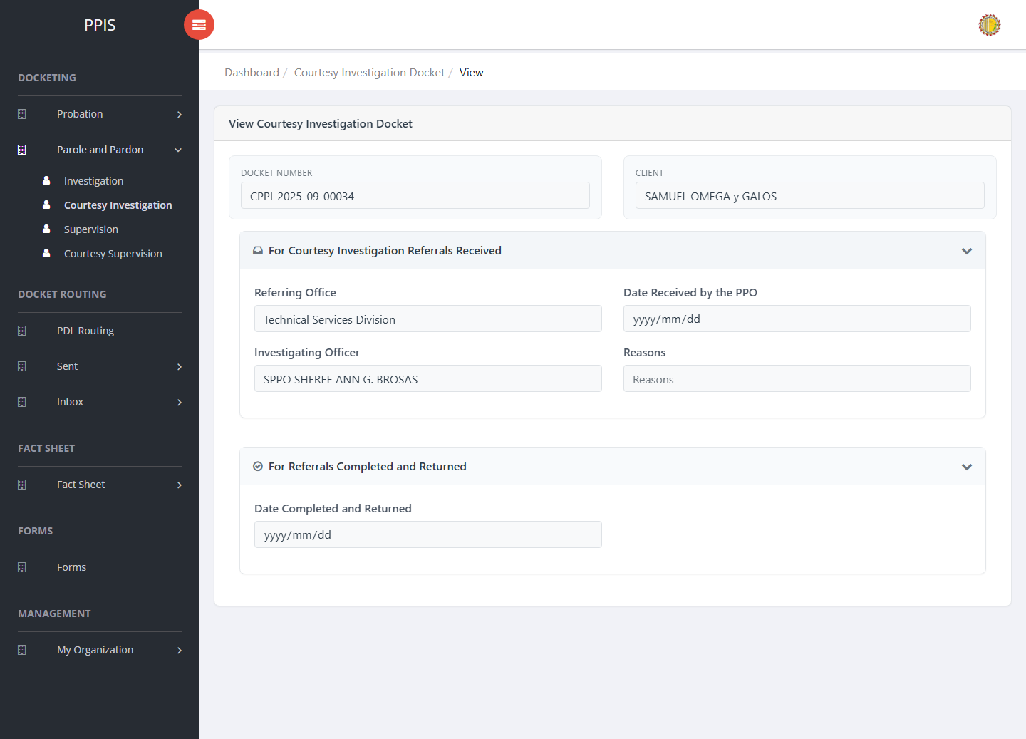
Parole and Pardon Courtesy Investigation (View)

Parole and Pardon Courtesy Investigation (Update)
1. On the Parole and Pardon Courtesy Investigation list page, locate the record that needs correction.
2. Click Update in the Actions column.
3. Wait for the update screen to open.
4. Review the current details and update Docket Number, Client Name, Referring Office, Date Received by the PPO, Investigating Officer, Reasons, Date Completed and Returned.
5. Click Confirm to save after checking the information.
6. Wait for the system to return to the list page or refresh the record display.
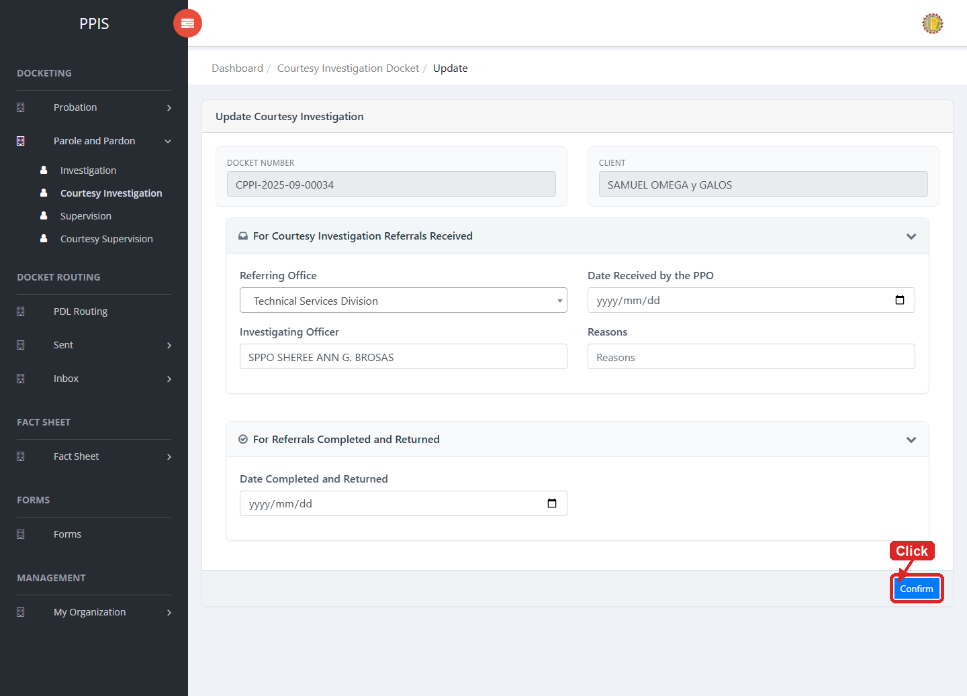
Parole and Pardon Courtesy Investigation (Update)

Parole and Pardon Courtesy Investigation (Attachments)
1. On the Parole and Pardon Courtesy Investigation list page, click Attachments for the correct record.
2. Wait for the attachments screen to open.
3. Complete the attachment details, such as Kind, Type, and Upload File when shown.
4. Click Confirm to upload the file.
5. Use View, Download, or Delete only for the attachment listed in the table.
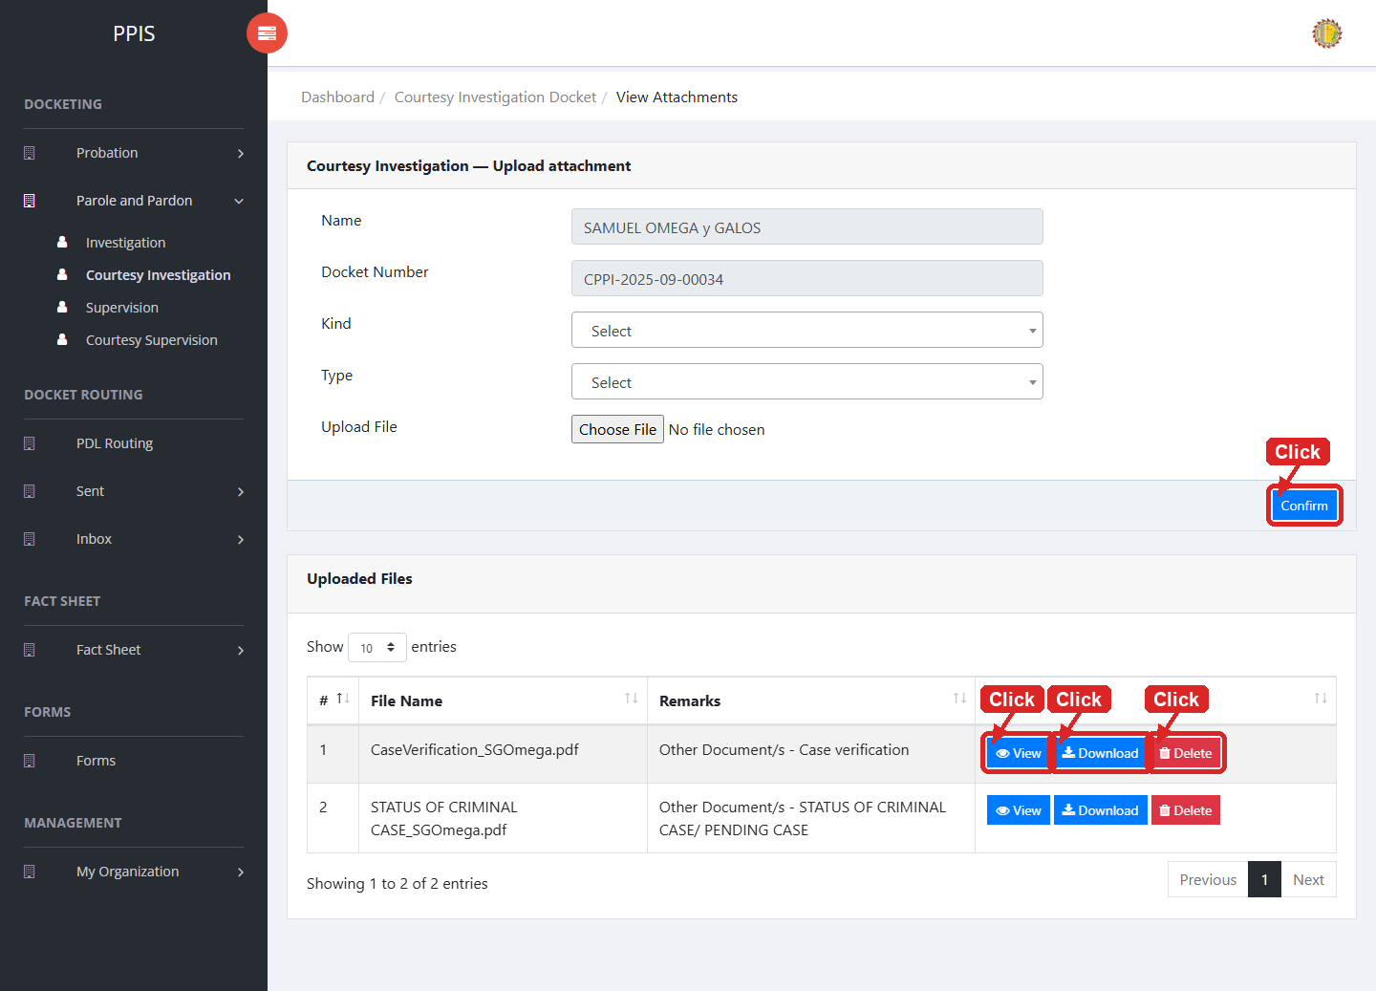
Parole and Pardon Courtesy Investigation (Attachments)

Parole and Pardon Courtesy Investigation (Delete)
Deletion warning: Use Remove only for sample/test records or records approved for deletion. For documentation, stop at the confirmation dialog unless removal is required.

1. On the Parole and Pardon Courtesy Investigation list page, locate the sample, test, or authorized record.
2. Click Remove in the Actions column.
3. Wait for the confirmation modal dialog box to appear.
4. Read the confirmation message carefully. The system warns that removal cannot be undone.
5. Click Cancel inside the modal dialog to stop, or click Remove permanently inside the modal dialog only when deletion is authorized.
6. Wait for the modal dialog to close. The table refreshes to reflect the remaining records.
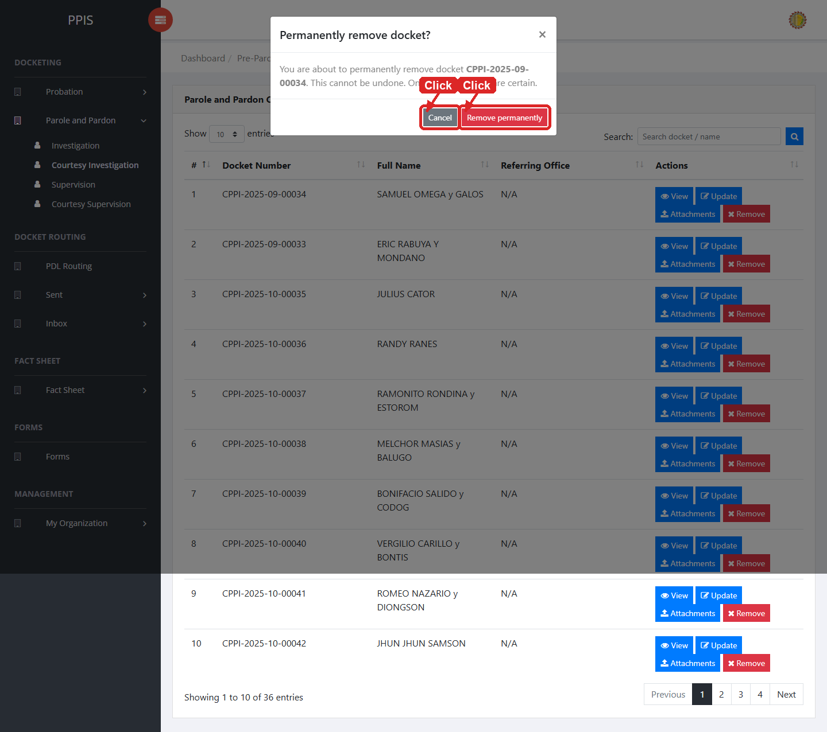
Parole and Pardon Courtesy Investigation (Delete)

Parole and Pardon Supervision
Use this page to manage parole and pardon supervision records.
1. From the left menu, open Parole and Pardon Supervision.
2. To find a record, enter the known information in Search docket / name.
3. Click Run search to apply the search.
4. In the Actions column, use View, Update, Attachments, Remove for the selected row.
5. To filter the table instantly, type characters directly into the inline search boxes in the column headers, or select a value from any drop-down filter shown above a column. The table updates automatically as the end user types or selects.
6. To export the currently displayed table data, click CSV, PDF, or EXCEL above the table when those buttons are shown. The system downloads the visible records in the selected format.
7. To print the table, click Print. The native browser print window opens. Review the layout settings, then click Print in that window to complete printing.
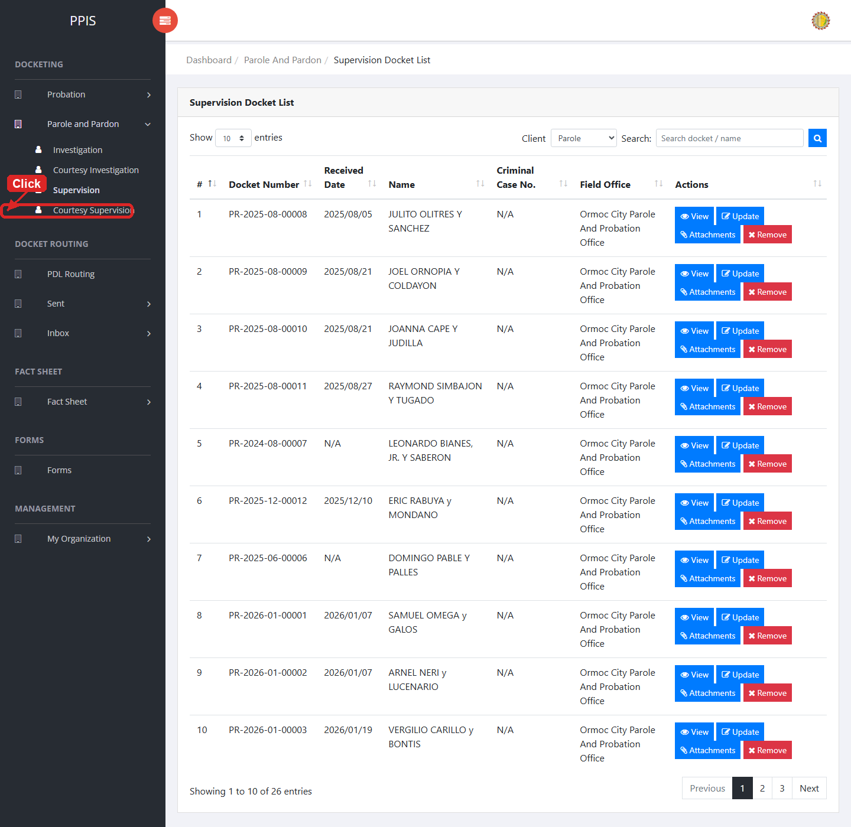
Parole and Pardon Supervision list page

Parole and Pardon Supervision (View)
1. On the Parole and Pardon Supervision list page, locate the record the end user needs to review.
2. Click View in the Actions column.
3. Read the details on the view page. Use this screen for checking information before making any changes.
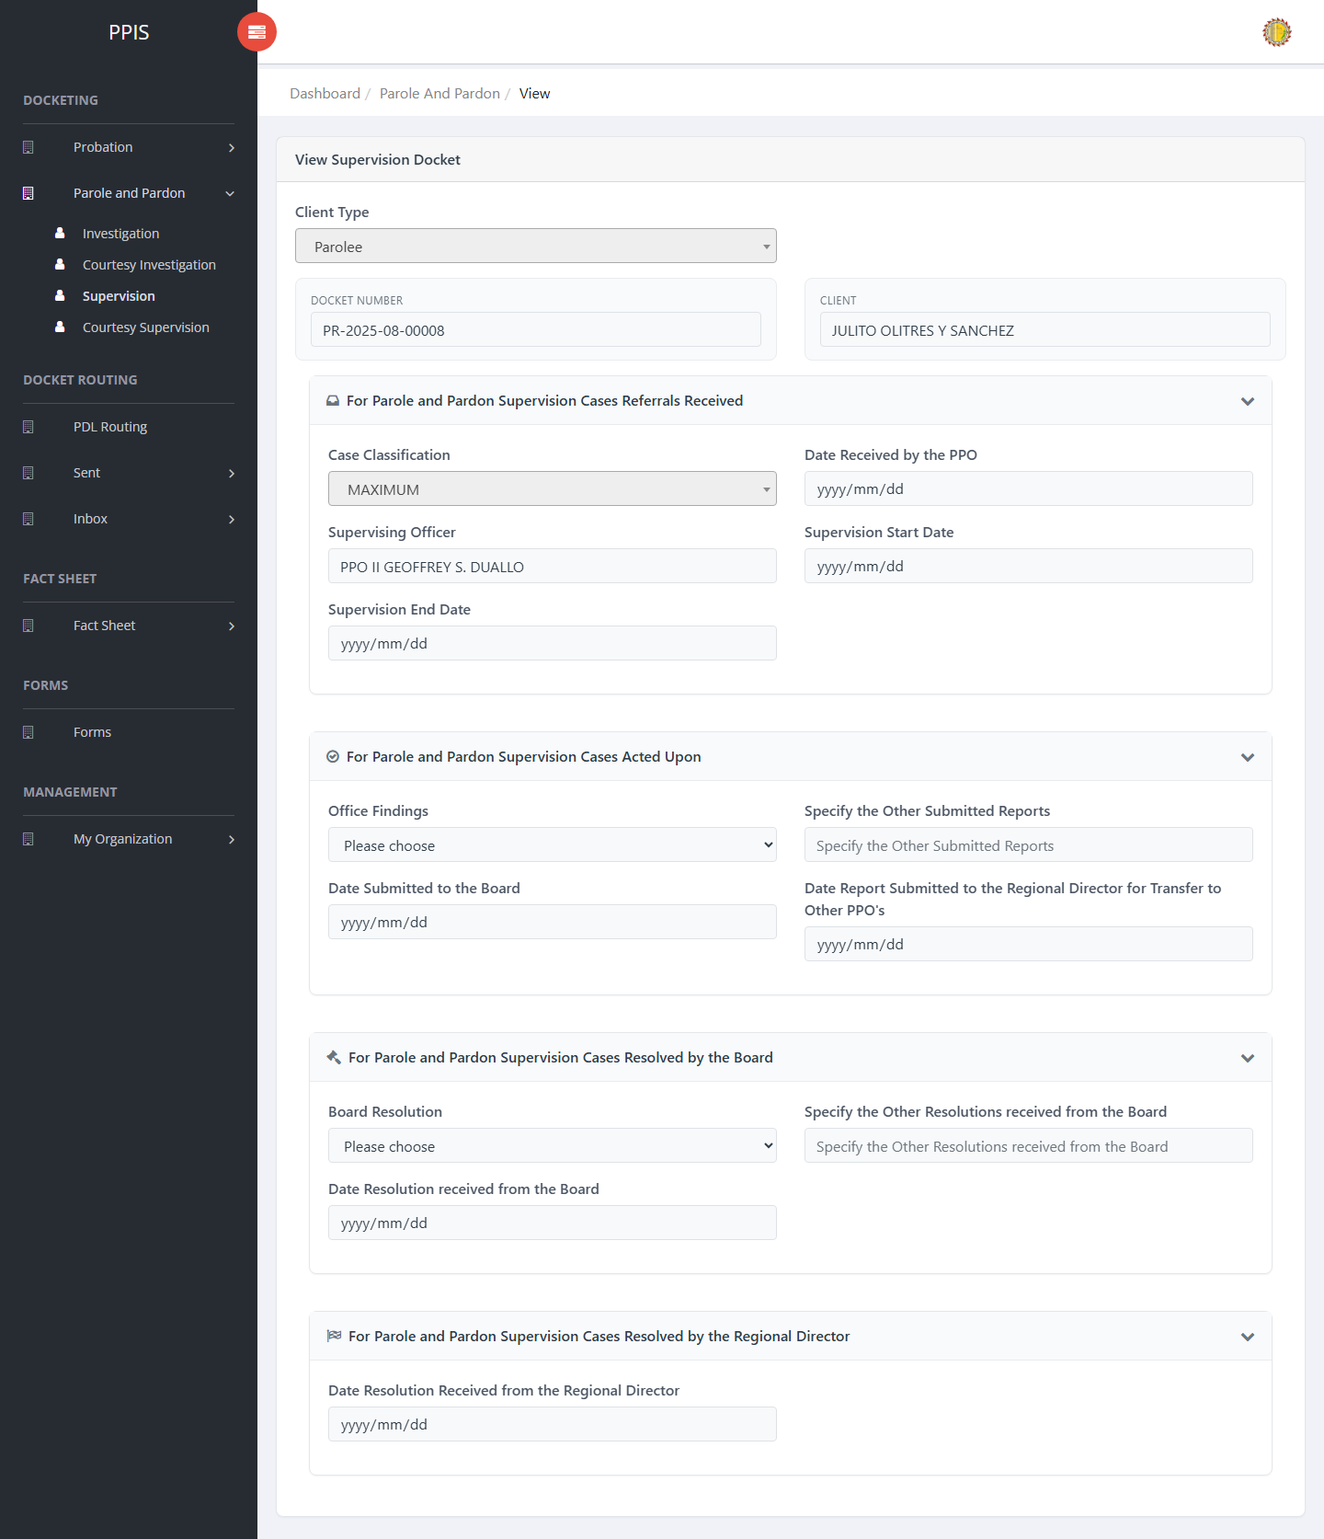
Parole and Pardon Supervision (View)

Parole and Pardon Supervision (Update)
1. On the Parole and Pardon Supervision list page, locate the record that needs correction.
2. Click Update in the Actions column.
3. Wait for the update screen to open.
4. Review the current details and update Client Type, Docket No., Client, Case Classification, Date Received by the PPO, Supervising Officer, Supervision Start Date, Supervision End Date.
5. Click Confirm to save after checking the information.
6. Wait for the system to return to the list page or refresh the record display.
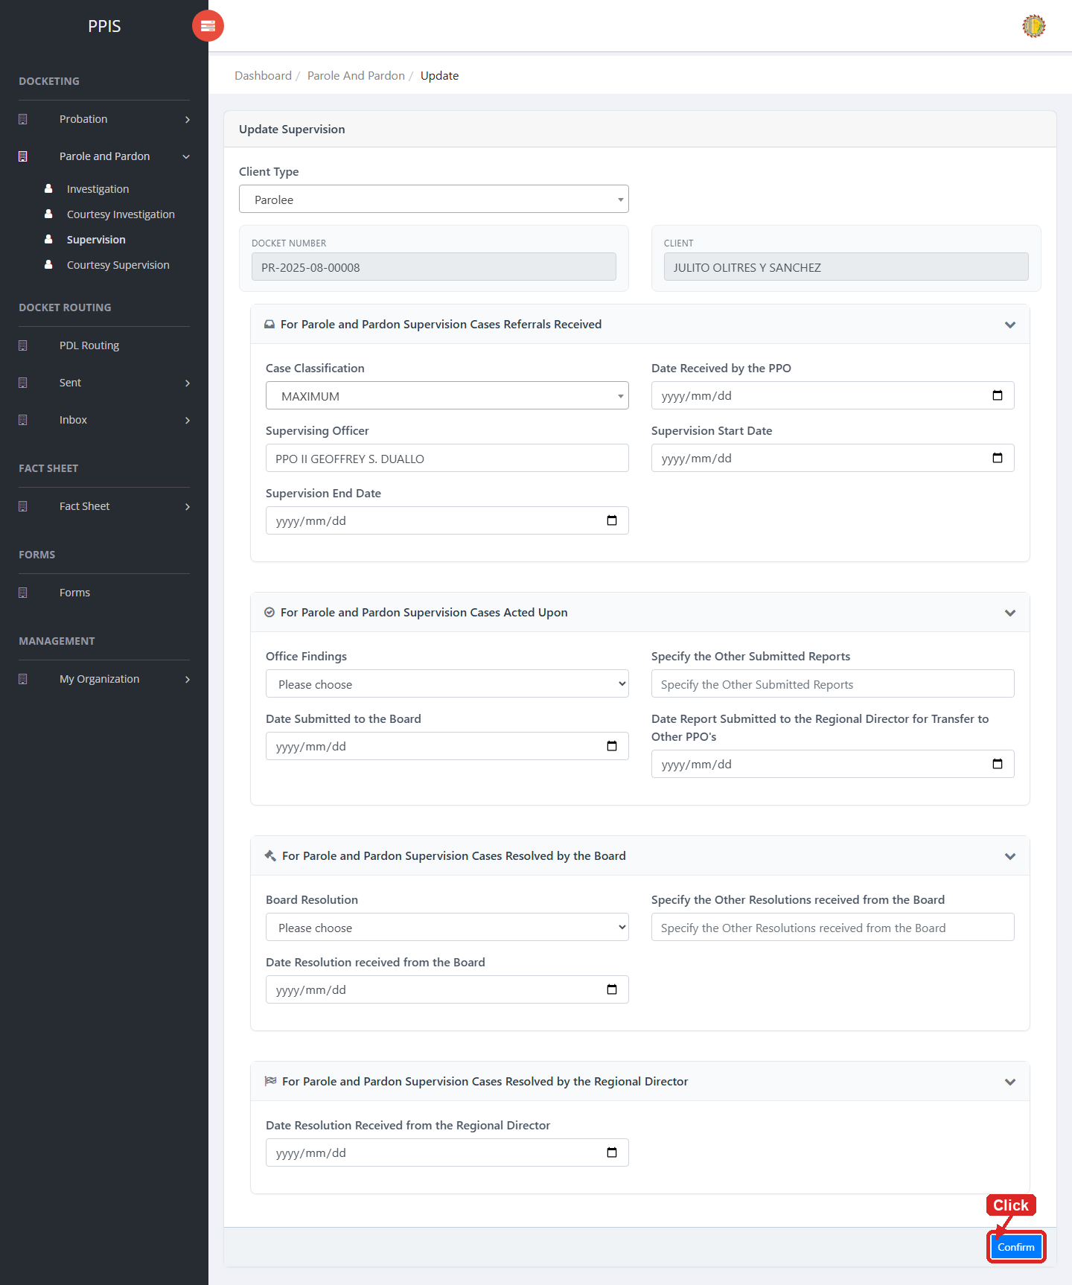
Parole and Pardon Supervision (Update)

Parole and Pardon Supervision (Attachments)
1. On the Parole and Pardon Supervision list page, click Attachments for the correct record.
2. Wait for the attachments screen to open.
3. Complete the attachment details, such as Kind, Type, and Upload File when shown.
4. Click Confirm to upload the file.
5. Use View, Download, or Delete only for the attachment listed in the table.
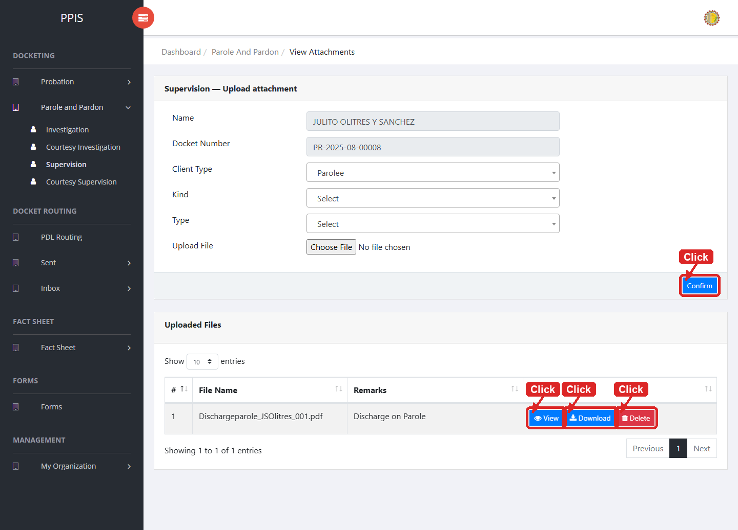
Parole and Pardon Supervision (Attachments)

Parole and Pardon Supervision (Delete)
Deletion warning: Use Remove only for sample/test records or records approved for deletion. For documentation, stop at the confirmation dialog unless removal is required.

1. On the Parole and Pardon Supervision list page, locate the sample, test, or authorized record.
2. Click Remove in the Actions column.
3. Wait for the confirmation modal dialog box to appear.
4. Read the confirmation message carefully. The system warns that removal cannot be undone.
5. Click Cancel inside the modal dialog to stop, or click Remove permanently inside the modal dialog only when deletion is authorized.
6. Wait for the modal dialog to close. The table refreshes to reflect the remaining records.
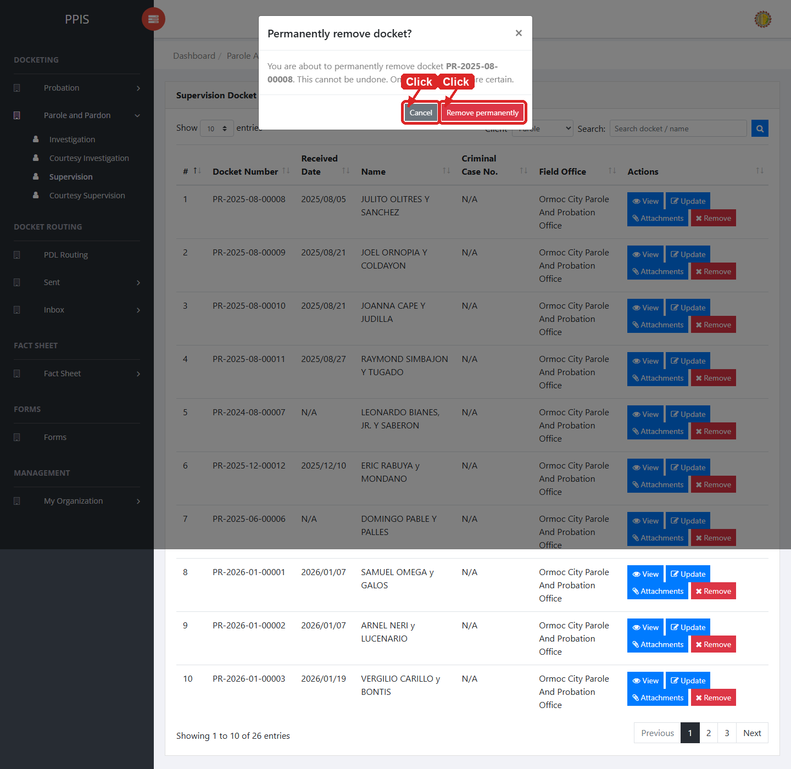
Parole and Pardon Supervision (Delete)

Parole and Pardon Courtesy Supervision
Use this page to manage courtesy supervision records for parole and pardon cases.
1. From the left menu, open Parole and Pardon Courtesy Supervision.
2. To find a record, enter the known information in Search docket / name.
3. Click Run search to apply the search.
4. In the Actions column, use View, Update, Attachments, Remove for the selected row.
5. To filter the table instantly, type characters directly into the inline search boxes in the column headers, or select a value from any drop-down filter shown above a column. The table updates automatically as the end user types or selects.
6. To export the currently displayed table data, click CSV, PDF, or EXCEL above the table when those buttons are shown. The system downloads the visible records in the selected format.
7. To print the table, click Print. The native browser print window opens. Review the layout settings, then click Print in that window to complete printing.
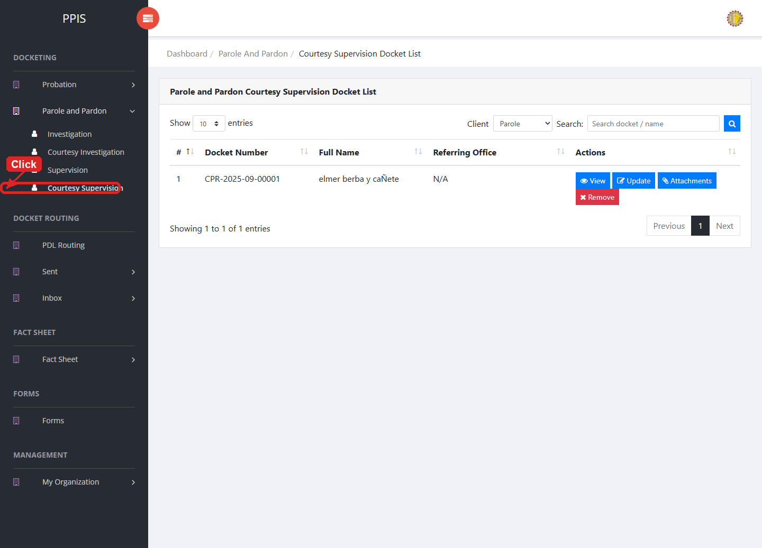
Parole and Pardon Courtesy Supervision list page

Parole and Pardon Courtesy Supervision (View)
1. On the Parole and Pardon Courtesy Supervision list page, locate the record the end user needs to review.
2. Click View in the Actions column.
3. Read the details on the view page. Use this screen for checking information before making any changes.
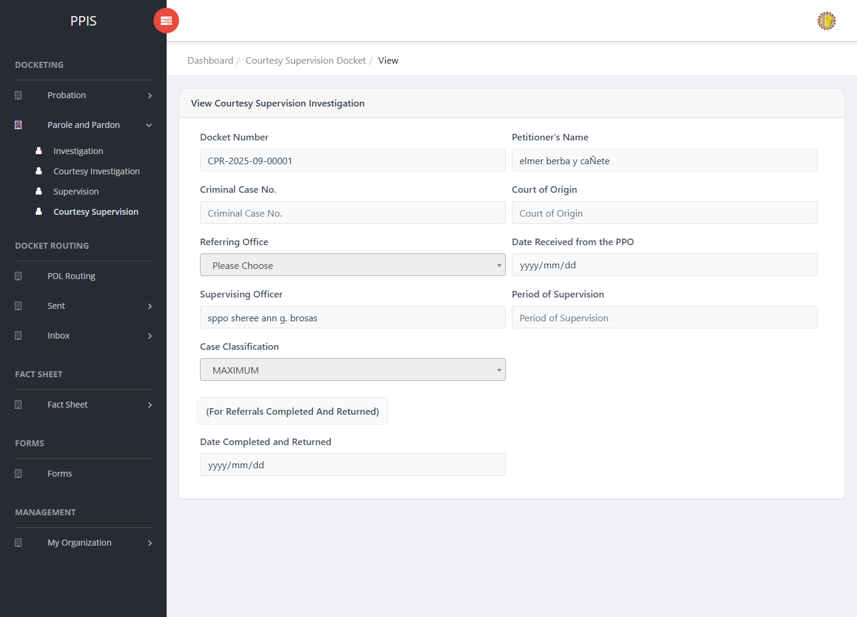
Parole and Pardon Courtesy Supervision (View)

Parole and Pardon Courtesy Supervision (Update)
1. On the Parole and Pardon Courtesy Supervision list page, locate the record that needs correction.
2. Click Update in the Actions column.
3. Wait for the update screen to open.
4. Review the current details and update Client Type, Docket Number, Petitioner's Name, Criminal Case No., Court of Origin, Referring Office, Date Received from the PPO, Supervising Officer.
5. Click Update to save after checking the information.
6. Wait for the system to return to the list page or refresh the record display.
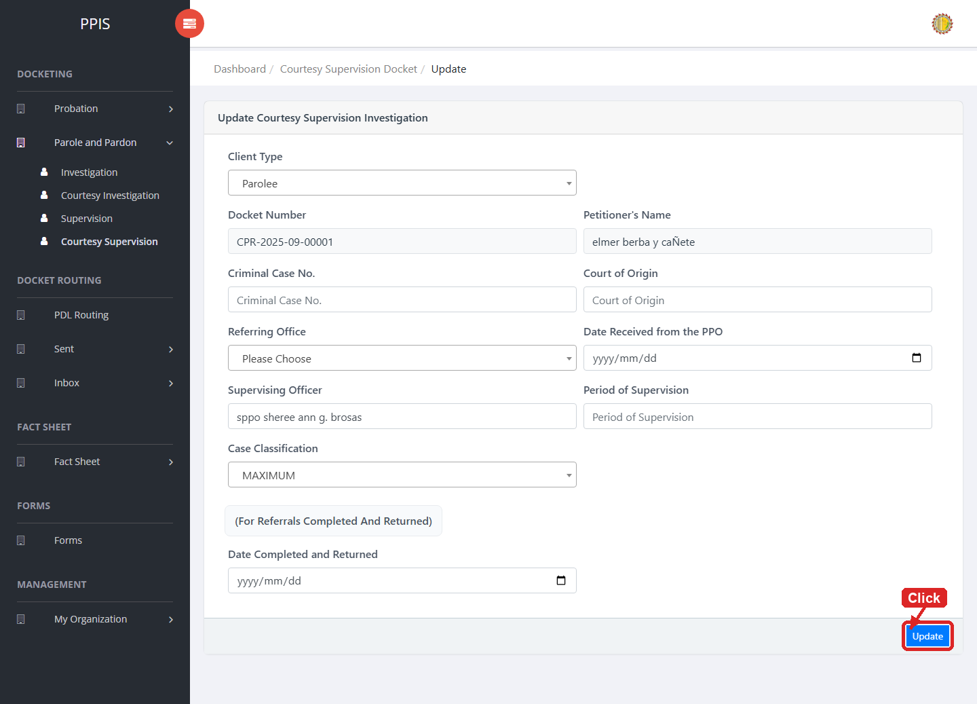
Parole and Pardon Courtesy Supervision (Update)

Parole and Pardon Courtesy Supervision (Attachments)
1. On the Parole and Pardon Courtesy Supervision list page, click Attachments for the correct record.
2. Wait for the attachments screen to open.
3. Complete the attachment details, such as Kind, Type, and Upload File when shown.
4. Click Confirm to upload the file.
5. Use View, Download, or Delete only for the attachment listed in the table.
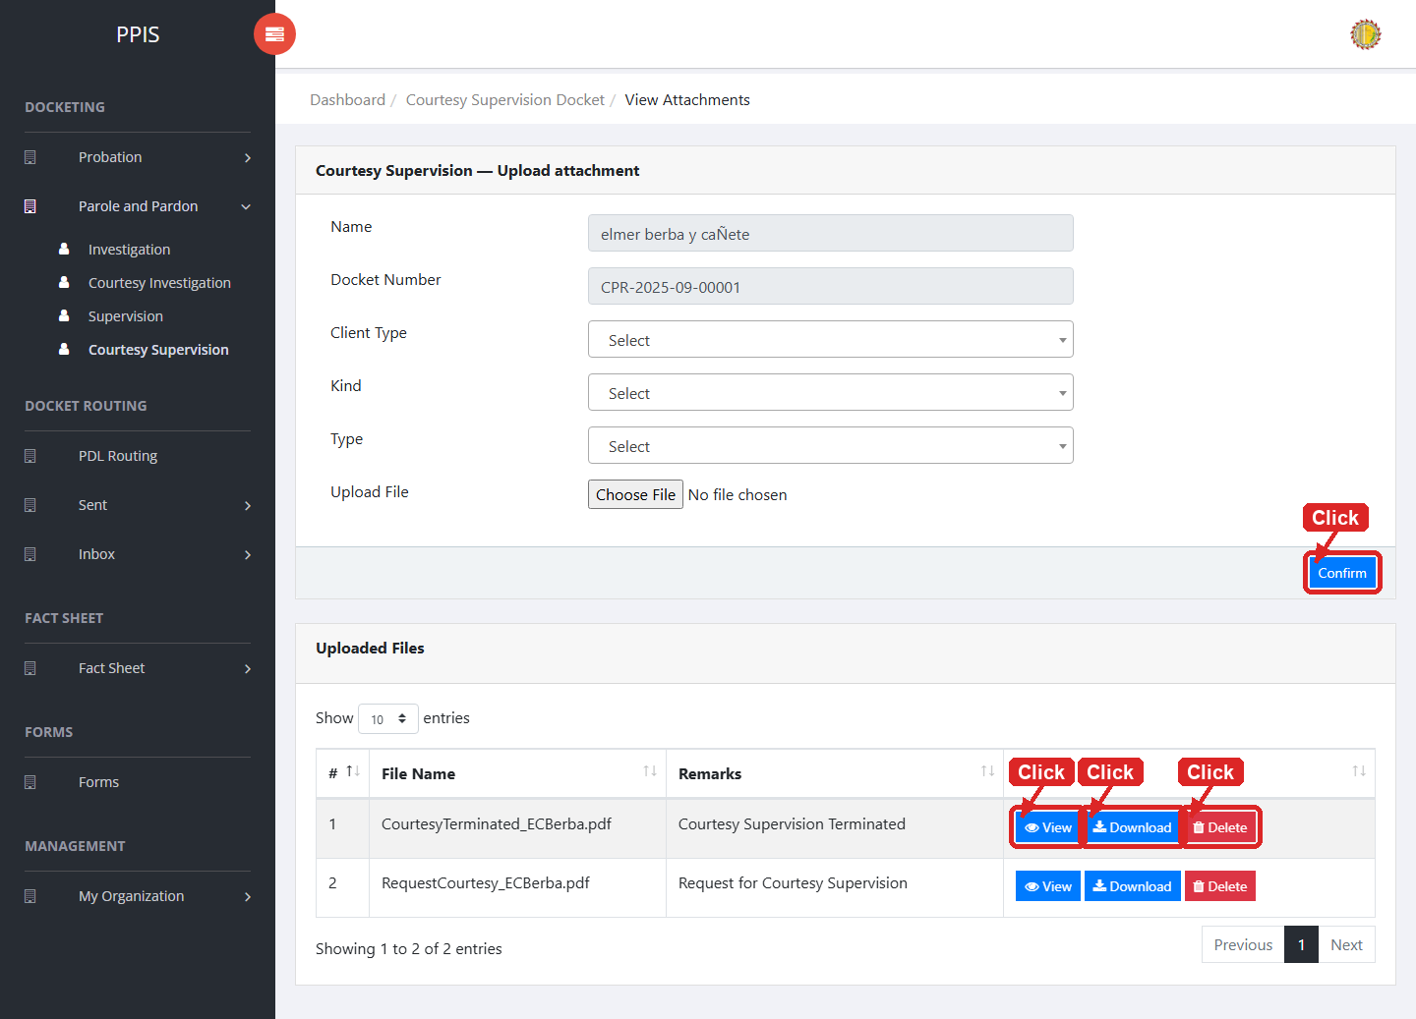
Parole and Pardon Courtesy Supervision (Attachments)

Parole and Pardon Courtesy Supervision (Delete)
Deletion warning: Use Remove only for sample/test records or records approved for deletion. For documentation, stop at the confirmation dialog unless removal is required.

1. On the Parole and Pardon Courtesy Supervision list page, locate the sample, test, or authorized record.
2. Click Remove in the Actions column.
3. Wait for the confirmation modal dialog box to appear.
4. Read the confirmation message carefully. The system warns that removal cannot be undone.
5. Click Cancel inside the modal dialog to stop, or click Remove permanently inside the modal dialog only when deletion is authorized.
6. Wait for the modal dialog to close. The table refreshes to reflect the remaining records.
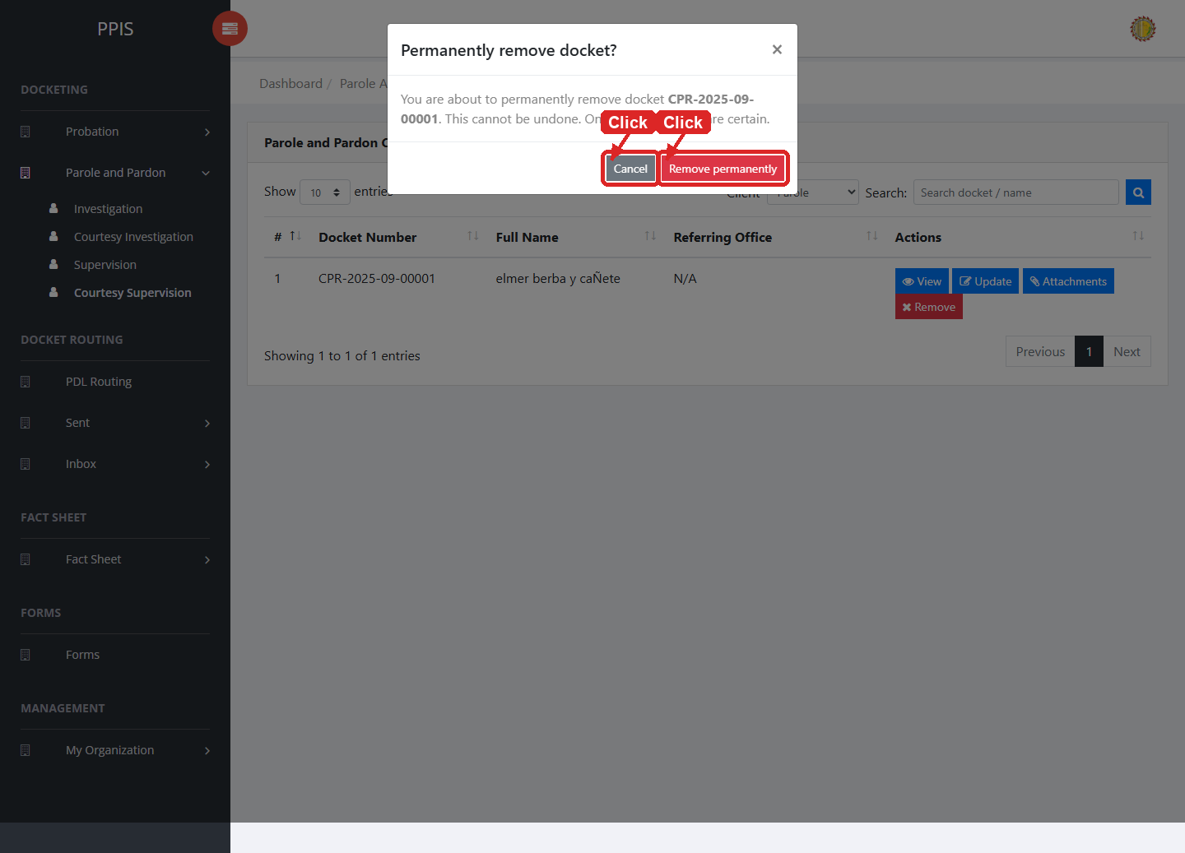
Parole and Pardon Courtesy Supervision (Delete)

8. Fact Sheet

Fact Sheet Probation
Use this page to find and open probation client fact sheets.
1. From the left menu, open Fact Sheet Probation.
2. To find a record, enter the known information in Name or case number.
3. Click Run search to apply the search.
4. Review the records shown on the page and the end-user undertake the necessary actions to be taken.
5. To filter the table instantly, type characters directly into the inline search boxes in the column headers, or select a value from any drop-down filter shown above a column. The table updates automatically as the end user types or selects.
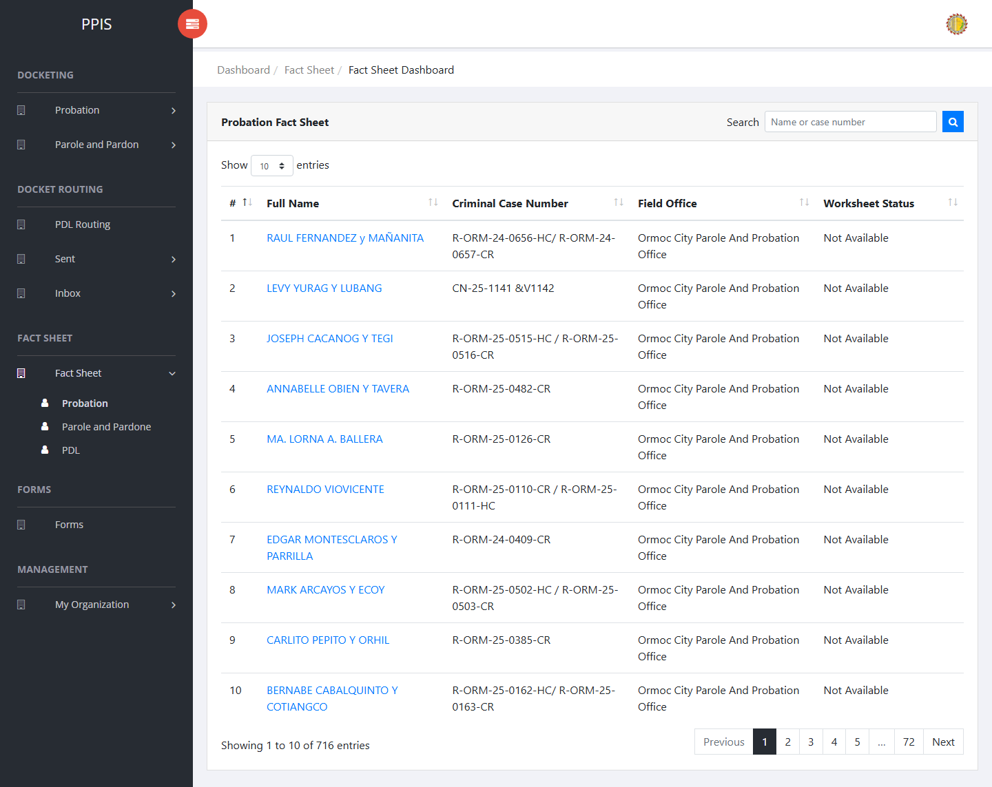
Fact Sheet Probation list page

Fact Sheet Probation (Open Client Profile)
1. On the Fact Sheet Probation list page, locate the client the end user needs to open.
2. Click the client name in the Full Name column.
3. Wait for the client view profile to open. The page shows the client photo area, profile tabs, and tab content below.
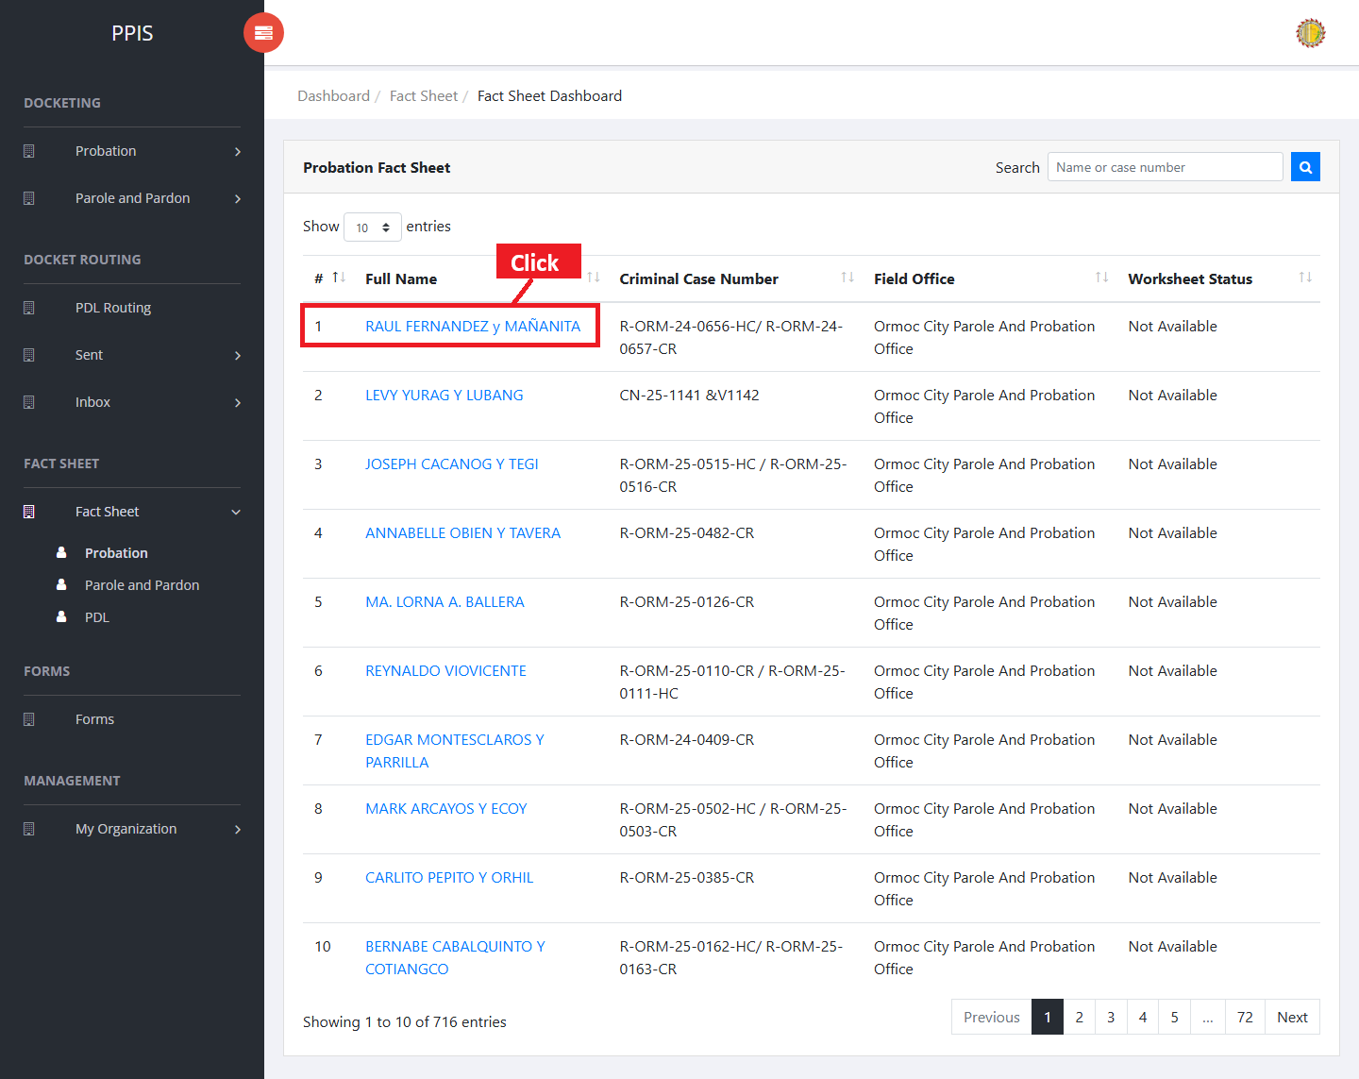
Fact Sheet Probation — click client name
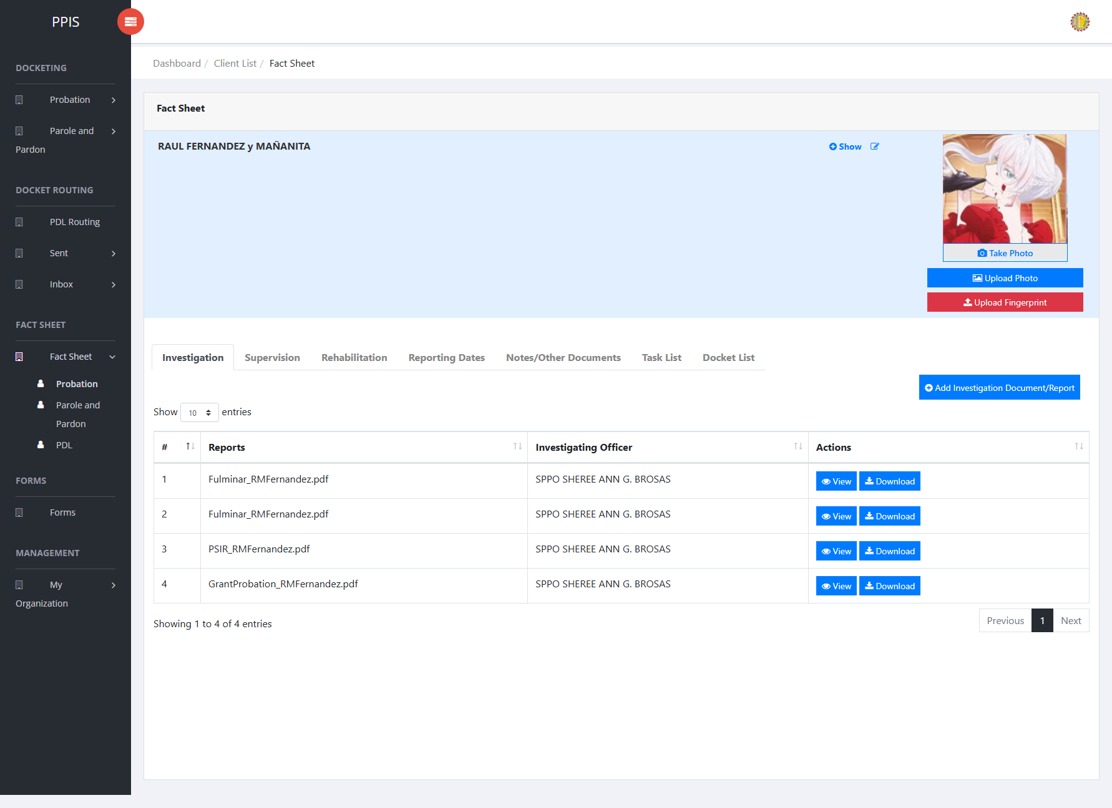

Fact Sheet Probation — client view profile

Fact Sheet Probation (Client Profile Tabs)
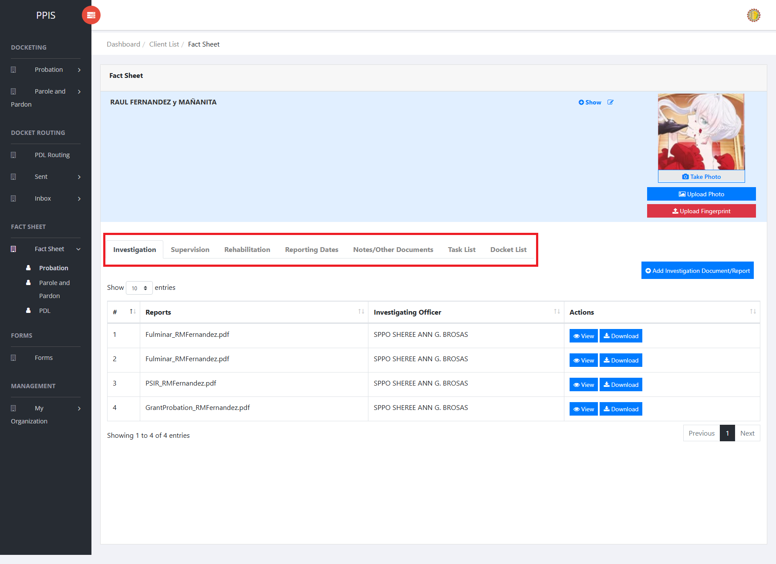
Fact Sheet Tabs
Each tab in the client view profile is used for a different part of the client record.
• Investigation — Review and upload investigation documents and reports related to the client. Use Add Investigation Document/Report when a new file must be attached.
• Supervision — Review and upload supervision documents and reports for the client. Use Add Supervision Document/Report when a new file must be attached.
• Rehabilitation — View therapeutic community and restorative justice activities, including dates, venues, phases, stakeholders, and outcomes.
• Reporting Dates — Review reporting-date photos and records. Use Add Reporting Date when a new reporting entry or photo must be recorded.
• Notes/Other Documents — Keep supplementary notes and other supporting documents for the client. Use Add Note/Other Document to upload a file.
• Task List — Review tasks assigned to the client or office, including assignment date, assigned user, and status.
• Docket List — Review dockets linked to the client from investigation, supervision, and related workflows.
1. On the client view profile, read the tab labels across the top of the page.
2. Click the tab that matches the information the end user needs to review or update.
3. Wait for the tab content to load before using any buttons or tables shown in that section.

Fact Sheet Probation (Upload or Take Photo)
1. On the client view profile, locate the client photo area on the left side of the page.
2. To upload an existing image file, click Upload Photo.
3. In the Upload Profile dialog, choose an image file, then click Confirm.
4. To capture a new photo with the device camera, click Take Photo.
5. In the Capture Camera dialog, click Open cam, allow camera access if the browser asks for permission, then click Capture.
6. Review the captured image. Click Retake if the end user needs another shot, or click Confirm to save the photo to the client profile.
7. Wait for the success message. The client photo area refreshes with the uploaded or captured image.
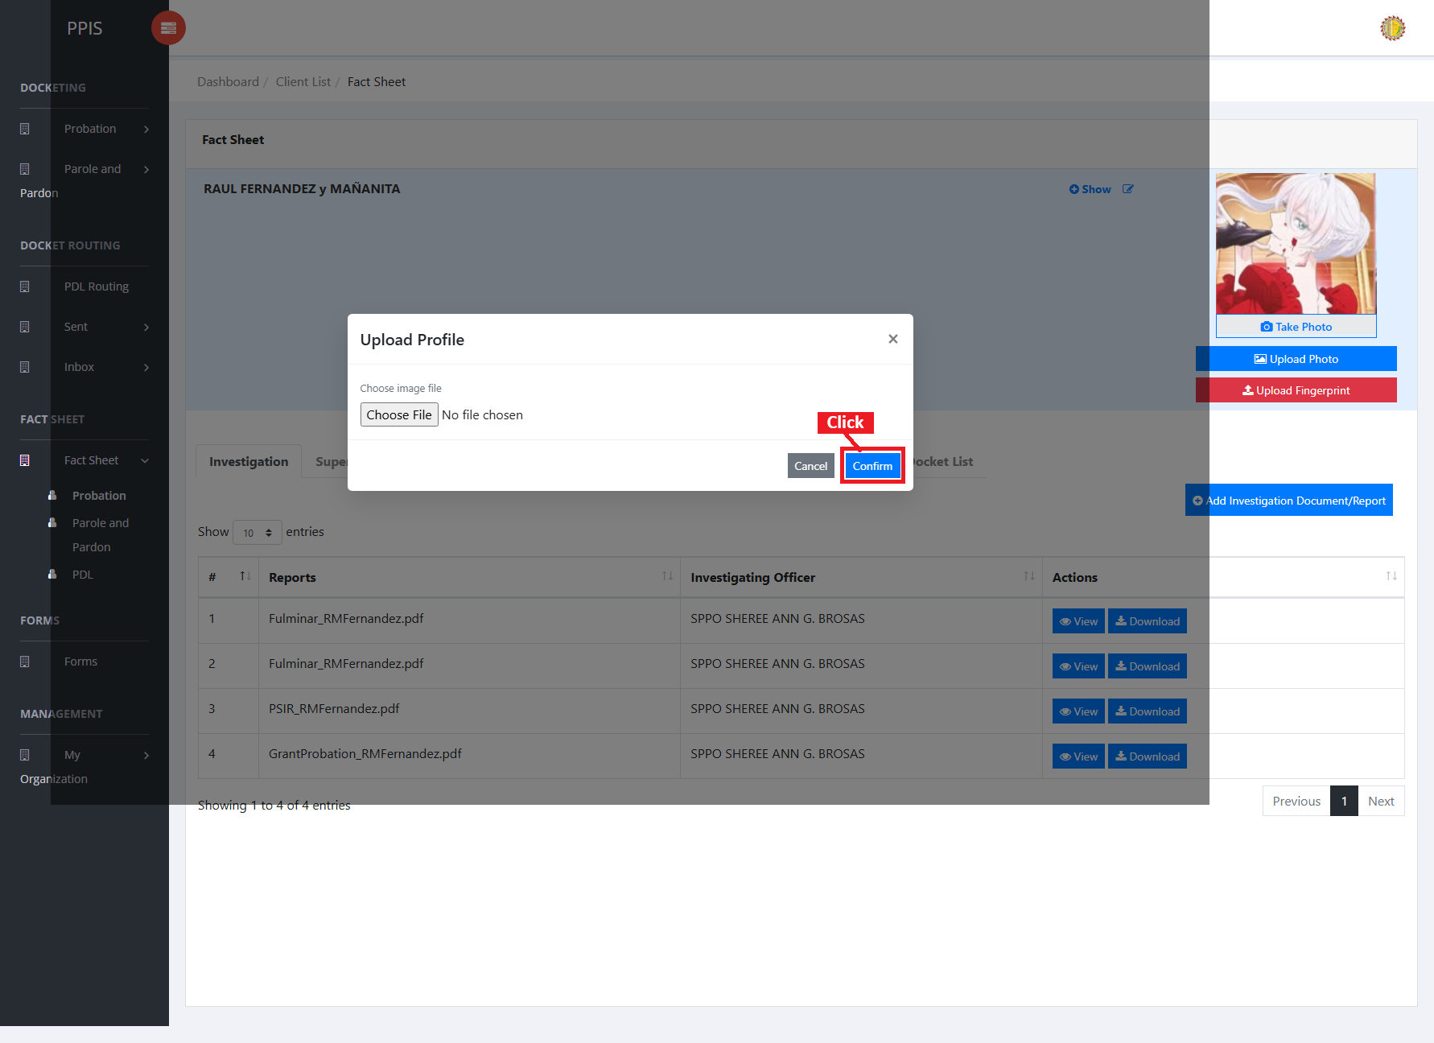
Fact Sheet Probation — upload photo
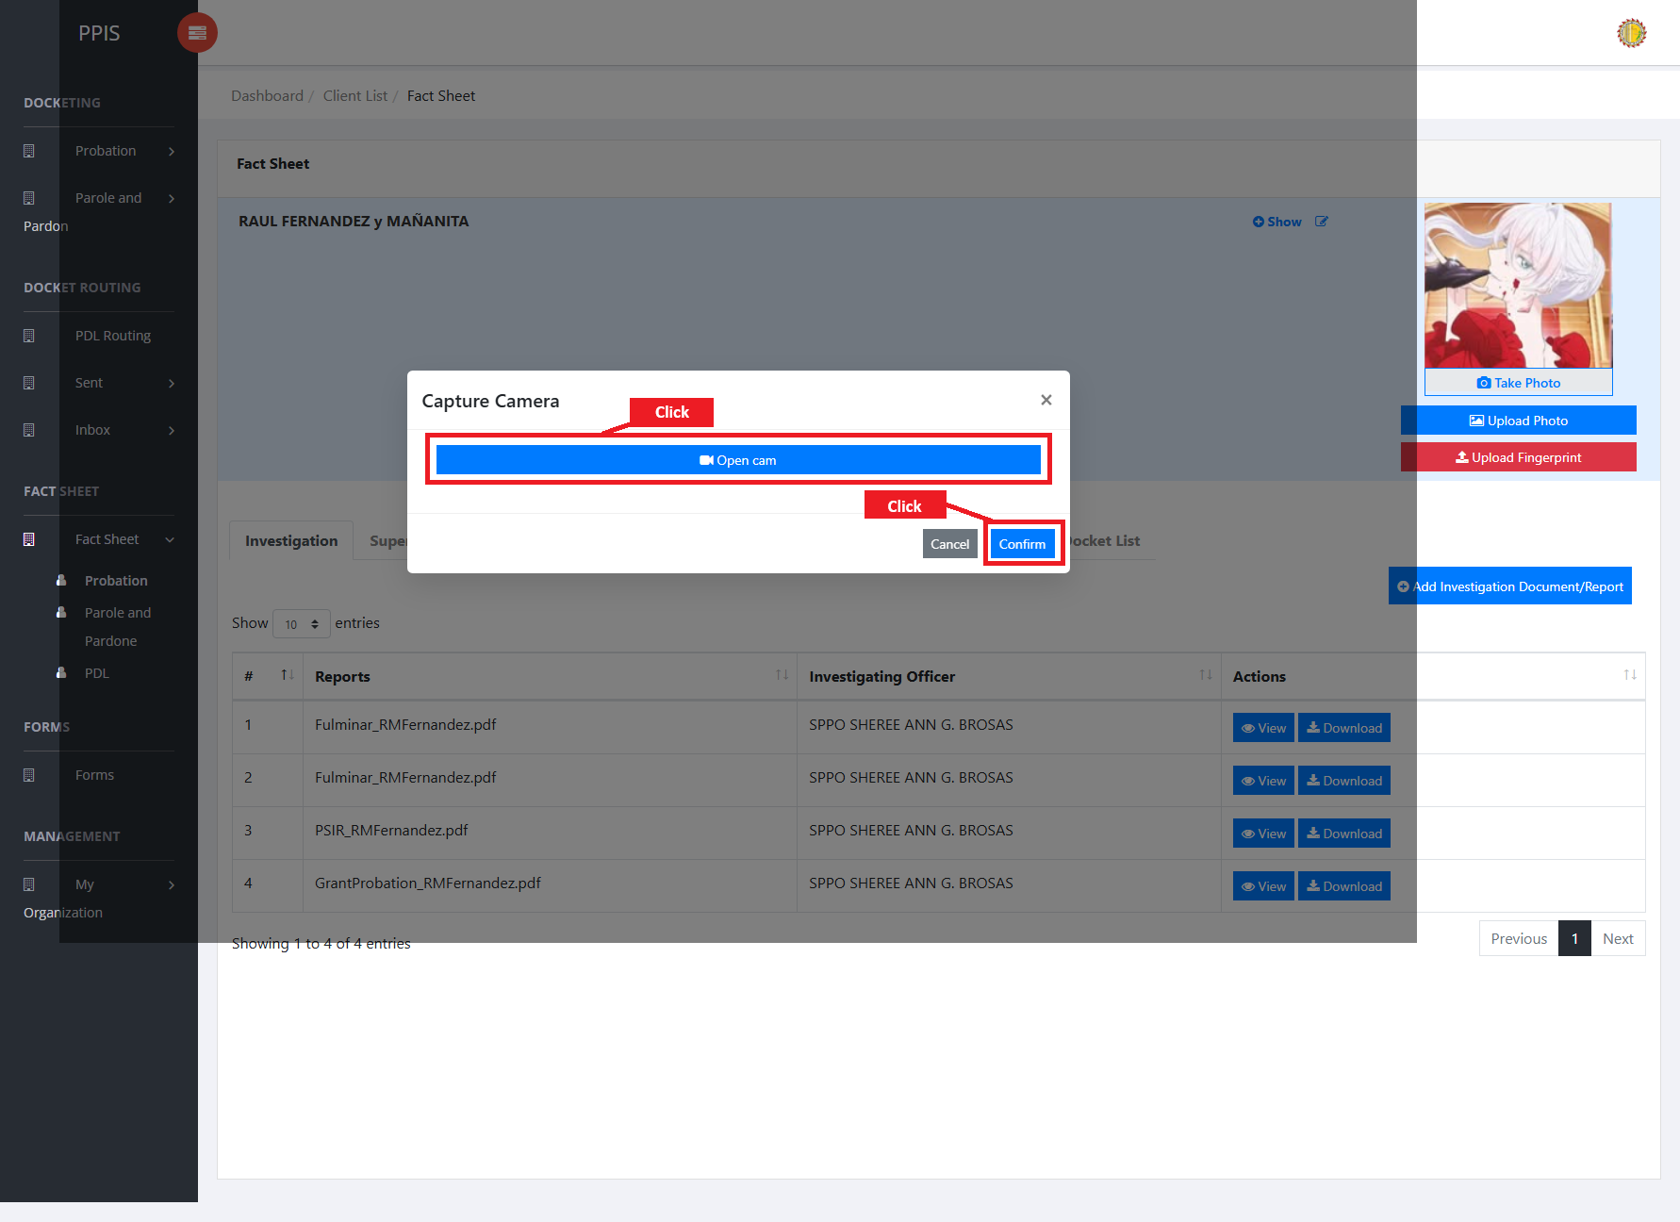
Fact Sheet Probation — take photo

Fact Sheet Probation (Upload Fingerprint)
1. On the client view profile, click Upload Fingerprint below the photo buttons.
2. Wait for the Upload Fingerprint dialog to open.
3. Click the fingerprint image for the finger the end user needs to upload: Right Thumb, Right Index, Right Middle, Right Ring, or Right Little.
4. Select the fingerprint image file from the end user computer.
5. Repeat the finger selection for any additional fingerprints that must be uploaded.
6. Click Confirm to save the fingerprint files to the client profile.
7. Wait for the success message, then close the dialog when finished.
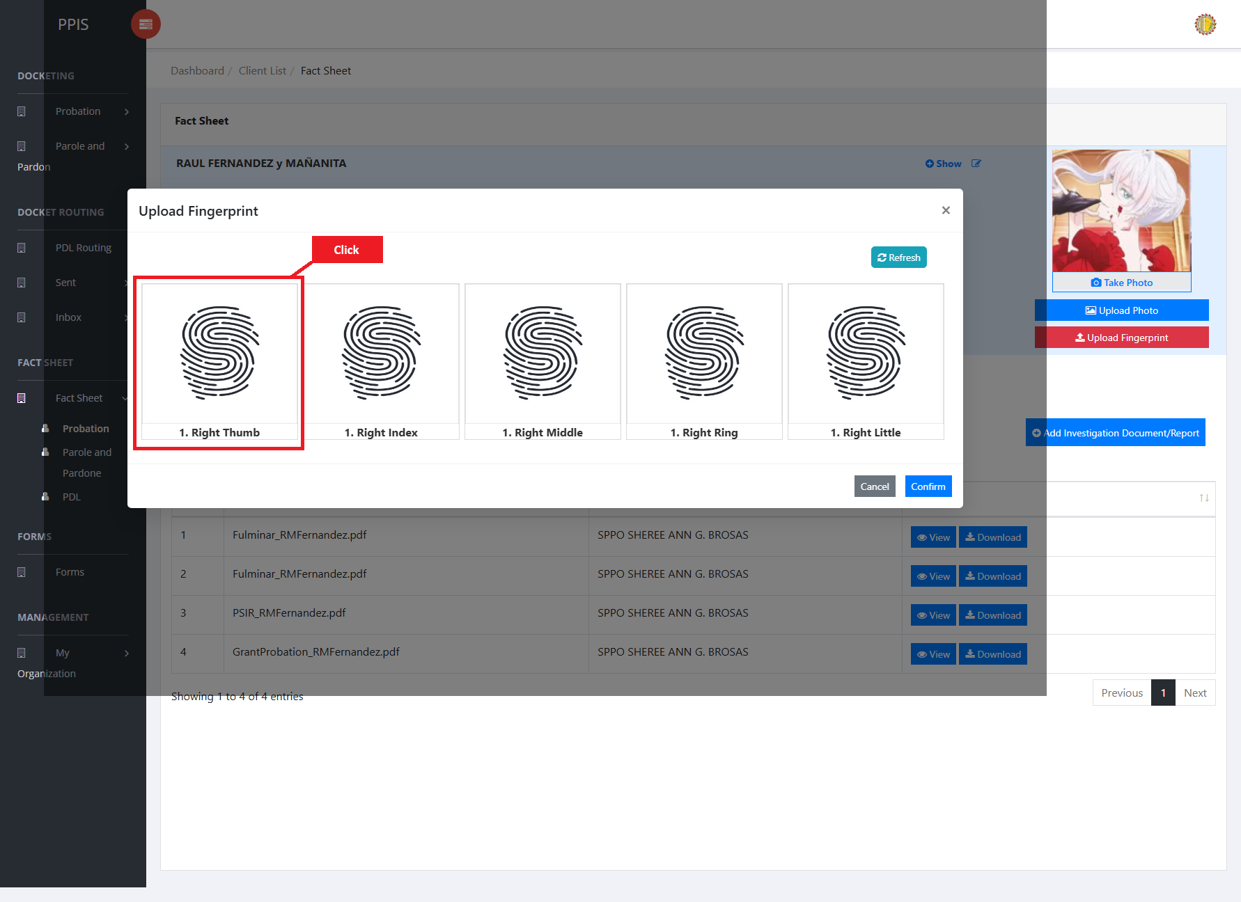
Fact Sheet Probation — upload fingerprint

Fact Sheet Probation (Worksheet and PSIR Overview)
The Worksheet and Post-Sentence Investigation Report (PSIR) are prepared for a client from the client profile. Open the Docket List tab on the client view profile to see each docket row with Worksheet and PSIR status, Edit controls, and print buttons.
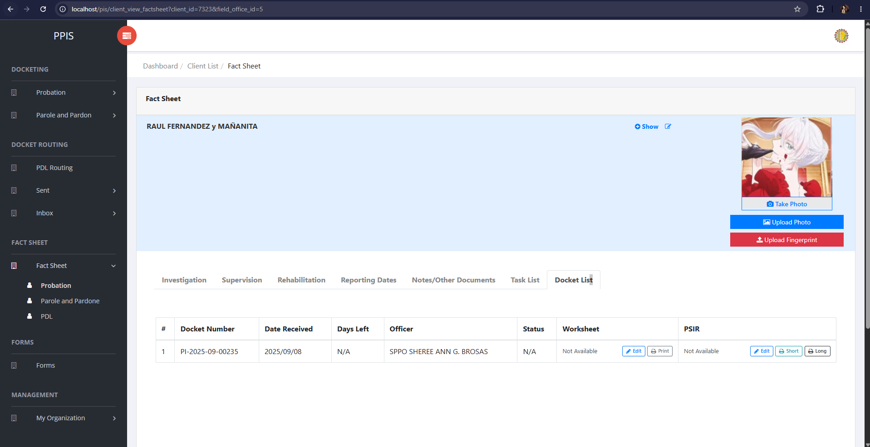
Fact Sheet Probation — Worksheet and PSIR Overview

Fact Sheet Probation (Navigate to Worksheet)
1. From the left menu, open Fact Sheet Probation.
2. Locate the client, then click the client name to open the client view profile.
3. On the client view profile, click the Docket List tab.
4. Review the docket table. Each row shows Docket Number, Date Received, Investigating Officer, Status, and the Worksheet and PSIR columns.
5. In the Worksheet column, note the current status (for example, complete, incomplete, or Not Available).
6. Click Edit in the Worksheet column for the docket that needs the worksheet.
7. Wait for the worksheet editor to open on the Identifying Data section.
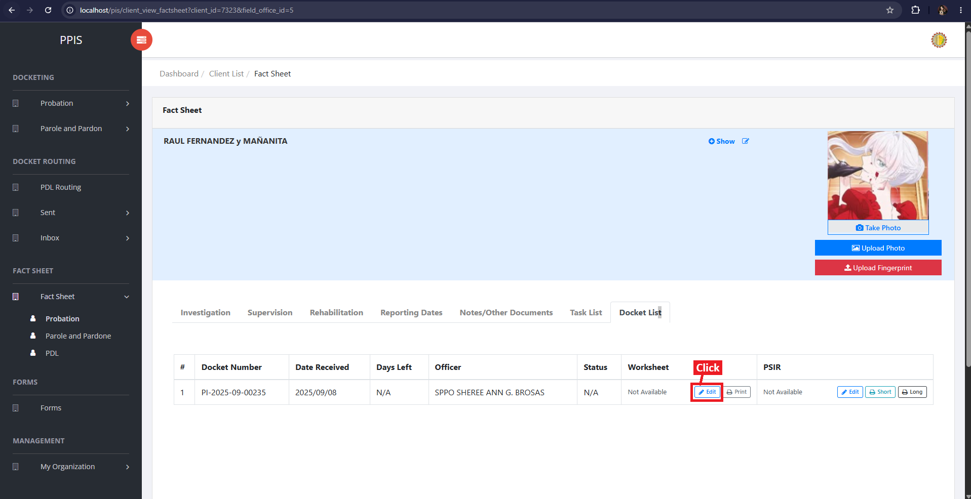
Fact Sheet Probation — Navigate to Worksheet

Fact Sheet Probation (Fill Out Worksheet)
1. On the worksheet screen, use the tabs across the top to move between sections. Complete each section in order:
Identifying Data, Present Offense, Prior Records, Identification Data, Family Background, Present Situation, Educational History, Employment History, and Community Background/Environmental Factor.
2. On the active tab, enter the required information in the fields shown (for example, Petitioner's Name, Alias/es, Date of Initial Interview, Interviewed By, Present Address, and Permanent Address on Identifying Data).
3. When the current section is complete, click Save at the top right of the form.
4. In the confirmation dialog, click Save Changes when creating a new worksheet, or Update Changes when updating an existing worksheet.
5. Wait for the success message. The system saves the section and may open the next worksheet section automatically.
6. To open another worksheet tab without using Save, click the tab name. When the warning dialog appears, click Proceed to open the selected tab.
7. Repeat data entry and save steps for every worksheet tab until all sections are filled. The Worksheet status on the Docket List tab updates to complete when all required sections contain data.
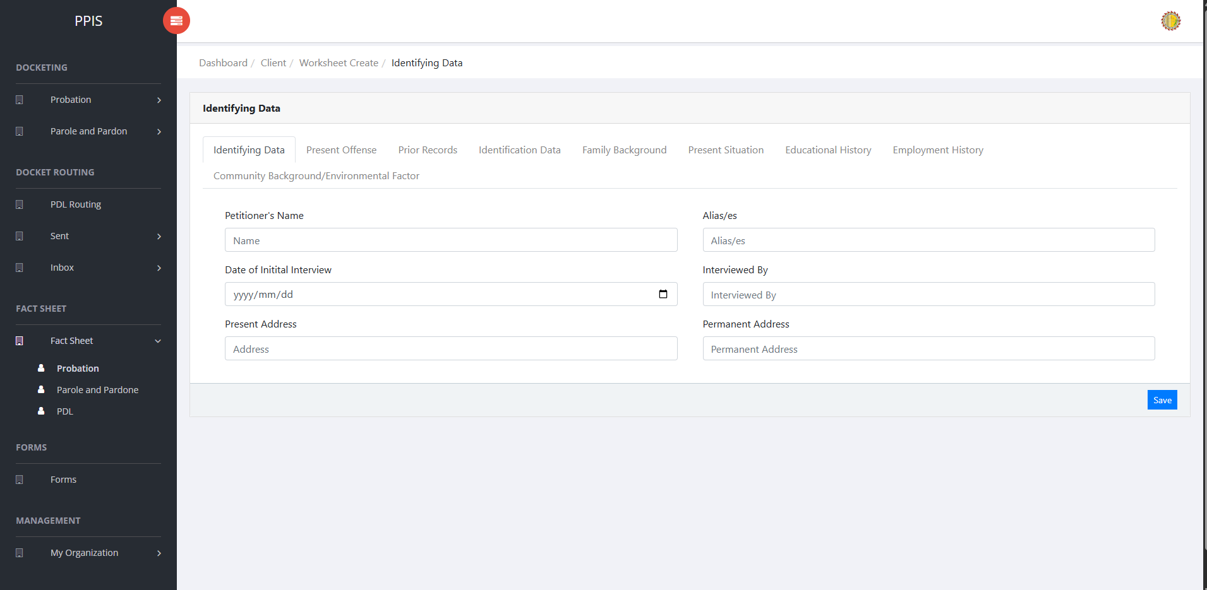
Fact Sheet Probation — Fill Out Worksheet

Fact Sheet Probation (Print Worksheet)
1. Open the client view profile and click the Docket List tab, or return to it after saving worksheet data.
2. Locate the docket row for the worksheet to print.
3. In the Worksheet column, click Print.
4. Wait for the print preview window to open and display the formatted worksheet.
5. Click Print in the preview header. The browser print window opens.
6. Review the print layout, choose the printer or Save as PDF, then click Print in the browser window to finish.
7. Click the close (×) button on the preview window when printing is finished.
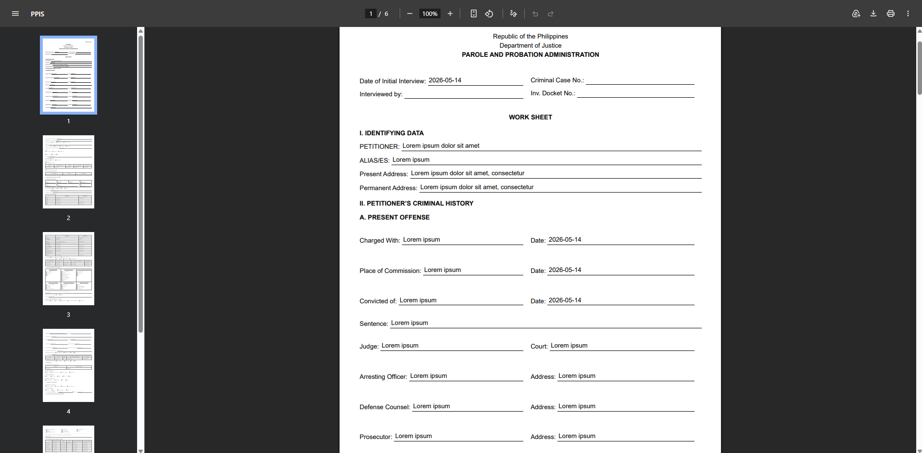
Fact Sheet Probation — Worksheet Print Out Sample

Fact Sheet Probation (Navigate to PSIR)
1. From the left menu, open Fact Sheet Probation.
2. Click the client name to open the client view profile.
3. Click the Docket List tab.
4. In the PSIR column, note the current status (for example, complete, incomplete, or Not Available).
5. Click Edit in the PSIR column for the docket that needs the PSIR.
6. Wait for the PSIR editor to open on the Identifying Data section.
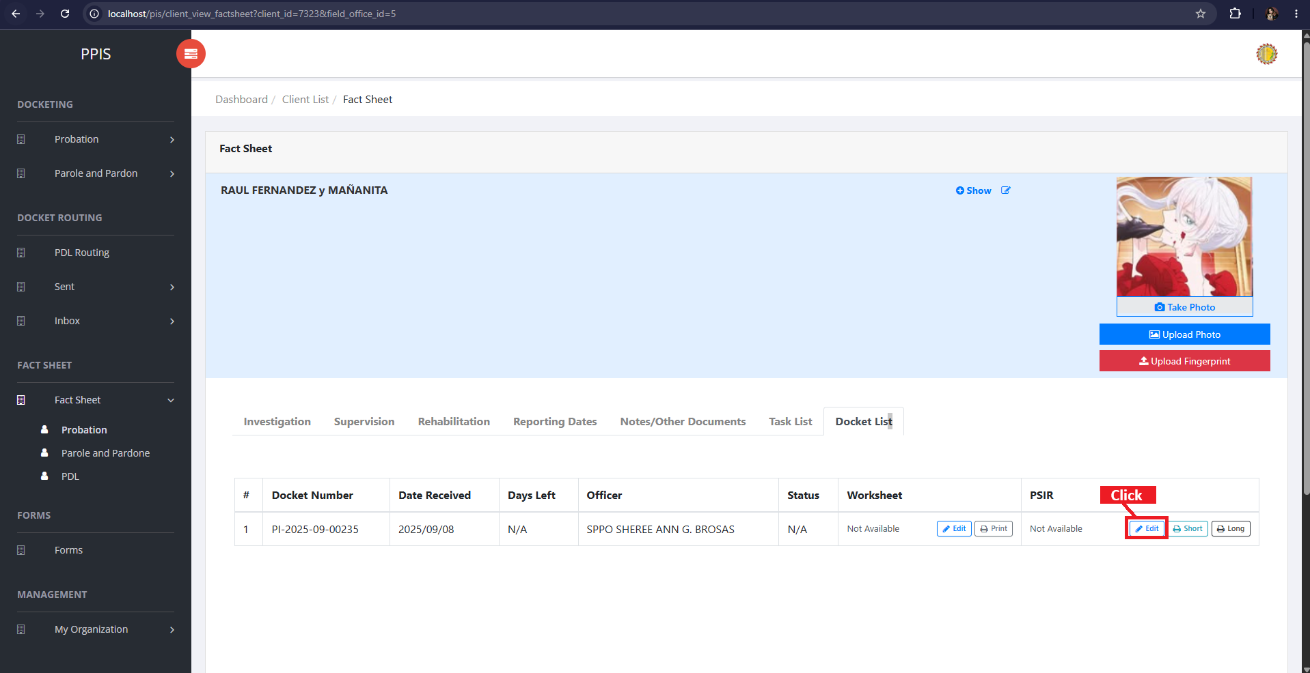
Fact Sheet Probation — Navigate to PSIR

Fact Sheet Probation (Fill Out PSIR)
1. On the PSIR screen, use the tabs across the top to move between sections. Complete each section in order:
Identifying Data, Present Offense, Prior Records, Birth Data and Family Background, Present Situation, Education and Job History, Medical History, Traits/Characteristics and Background in the Community, Analysis/Evaluation and Projected Thrust of Rehabilitation, and Recommendation.
2. On the active tab, enter the required information in the fields shown (for example, Petitioner's Name, True Name, Source of Information, Alias, Height, Weight, Age, Sex, Citizenship, Religion, Identifying Marks, Present Address, and Permanent Address on Identifying Data).
3. When the current section is complete, click Save at the top right of the form.
4. In the confirmation dialog, click Save Changes when creating a new PSIR, or Update Changes when updating an existing PSIR.
5. Wait for the success message. The system saves the section and may open the next PSIR section automatically.
6. To open another PSIR tab without using Save, click the tab name. When the warning dialog appears, click Proceed to open the selected tab.
7. Repeat data entry and save steps for every PSIR tab until all required sections are filled. The PSIR status on the Docket List tab updates when the required sections contain data.
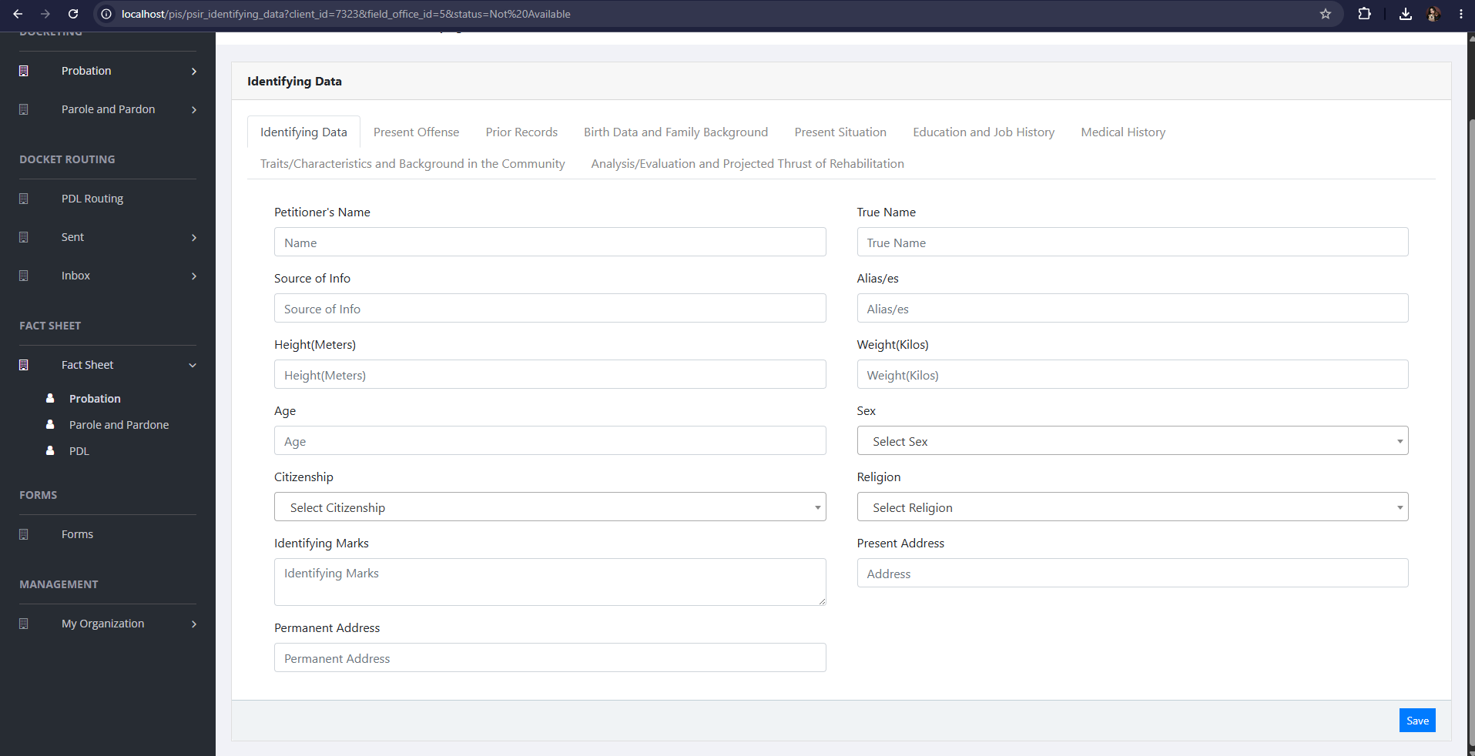
Fact Sheet Probation — Fill Out PSIR

Fact Sheet Probation (Print PSIR)
1. Open the client view profile and click the Docket List tab, or return to it after saving PSIR data.
2. Locate the docket row for the PSIR to print.
3. In the PSIR column, click Short for the condensed PSIR layout, or Long for the full PSIR that includes the transmittal letter and complete recommendation blocks.
4. Wait for the print preview window to open and display the selected PSIR format.
5. Click Print in the preview header. The browser print window opens.
6. To save a copy of the PSIR file, click Download in the preview header when shown, then open the downloaded file if needed.
7. Review the print layout, choose the printer or Save as PDF, then click Print in the browser window to finish.
8. Click the close (×) button on the preview window when printing is finished.
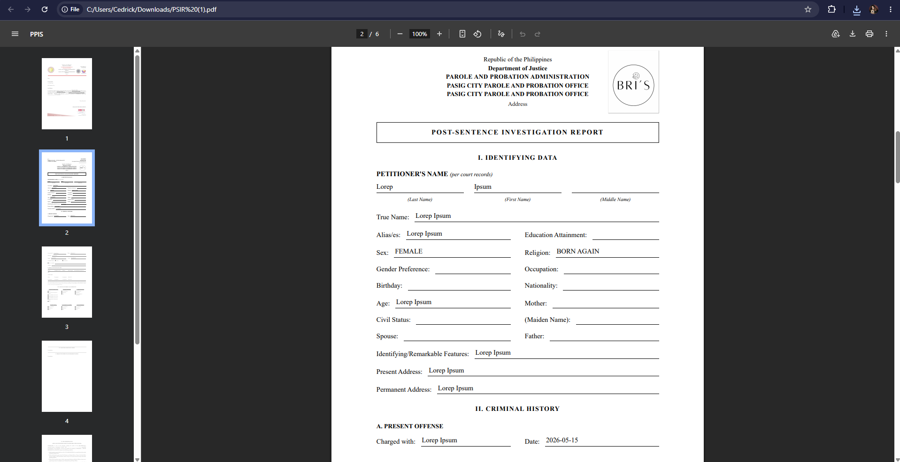
Fact Sheet Probation — PSIR Print Out Sample

Fact Sheet Parole and Pardon
Use this page to manage client records for parole and pardon workflows.
1. From the left menu, open Fact Sheet Parole and Pardon.
2. If the page has tabs, select the needed tab, such as Parole, Pardon.
3. To find a record, enter the known information in Search Client.
4. In the Actions column, use Update, Attachments for the selected row.
5. To filter the table instantly, type characters directly into the inline search boxes in the column headers, or select a value from any drop-down filter shown above a column. The table updates automatically as the end user types or selects.
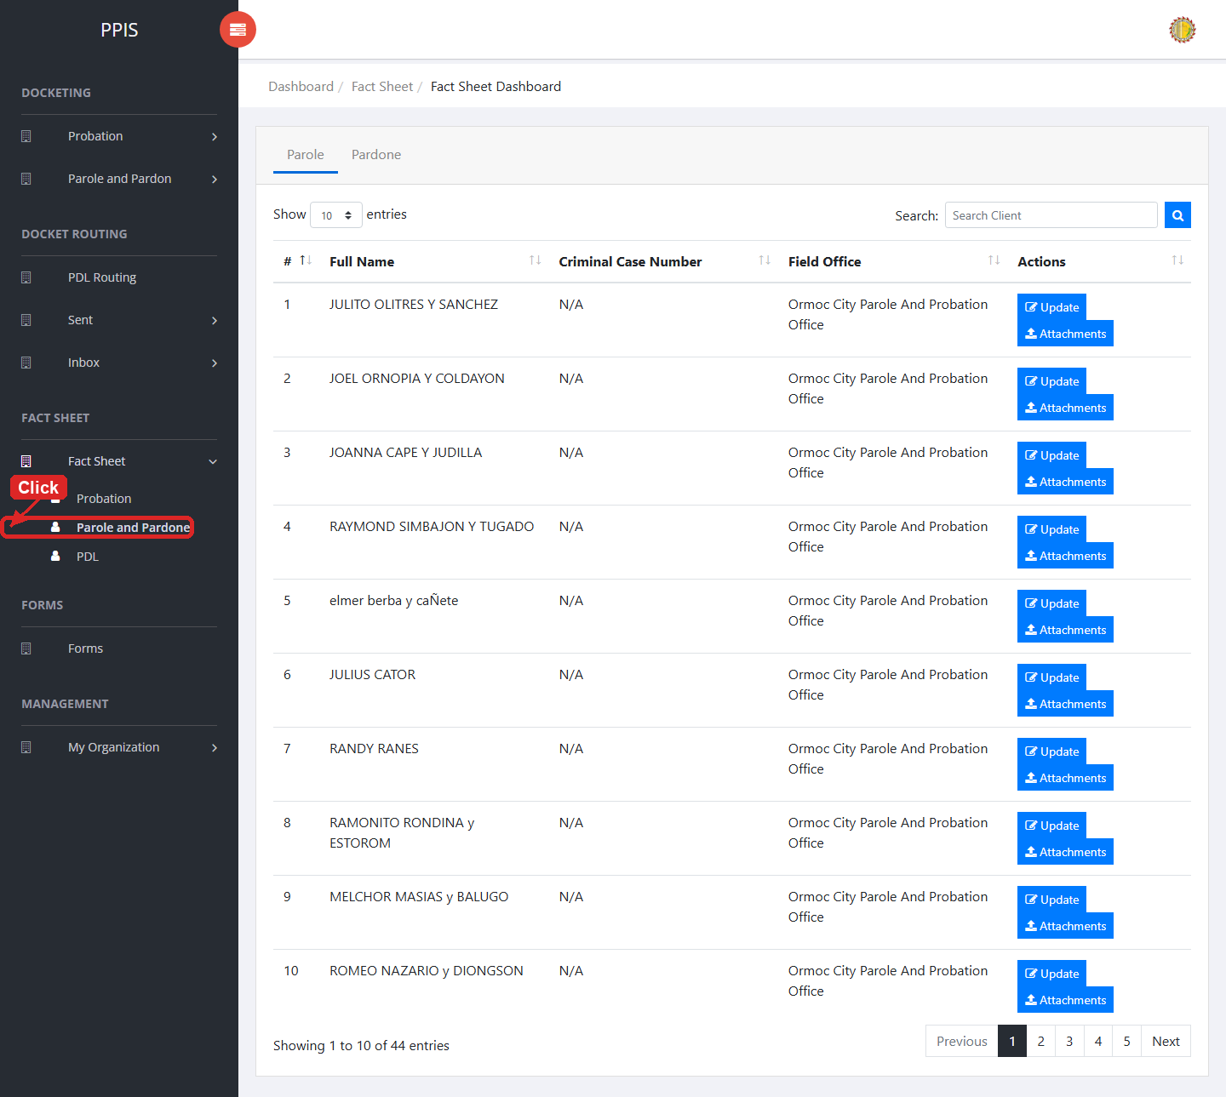
Fact Sheet Parole and Pardone list page

Fact Sheet Parole and Pardon (Update)
1. On the Fact Sheet Parole and Pardon list page, locate the record that needs correction.
2. Click Update in the Actions column.
3. Wait for the update screen to open.
4. Review the current details and update Client Type, Criminal Case No., First Name, Middle Name, Last Name, Suffix Name, Sex, Education.
5. Click Confirm to save after checking the information.
6. Wait for the system to return to the list page or refresh the record display.
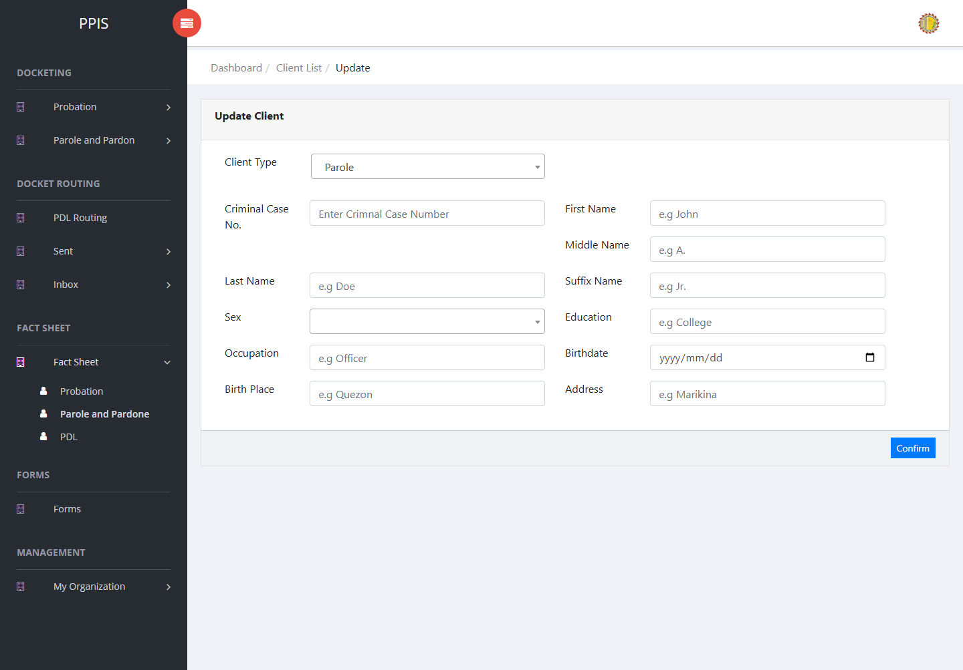
Fact Sheet Parole and Pardone (Update)

Fact Sheet Parole and Pardon (Attachments)
1. On the Fact Sheet Parole and Pardon list page, click Attachments for the correct record.
2. Wait for the attachments screen to open.
3. Complete the attachment details, such as Kind, Type, and Upload File when shown.
4. Click Confirm to upload the file.
5. Use View, Download, or Delete only for the attachment listed in the table.
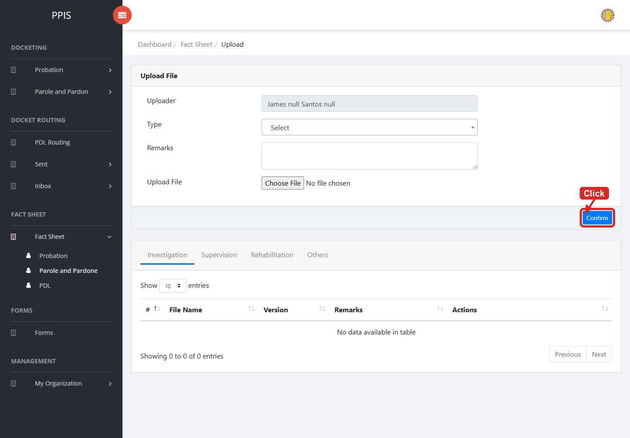
Fact Sheet Parole and Pardone (Attachments)

9. Forms

Forms
Use this page to view available forms and add documents when the account has permission.
1. From the left menu, open Forms.
2. To find a record, enter the known information in the Search field.
3. Review the records shown on the page and the end-user undertake the necessary actions to be taken.
4. To filter the table instantly, type characters directly into the inline search boxes in the column headers, or select a value from any drop-down filter shown above a column. The table updates automatically as the end user types or selects.
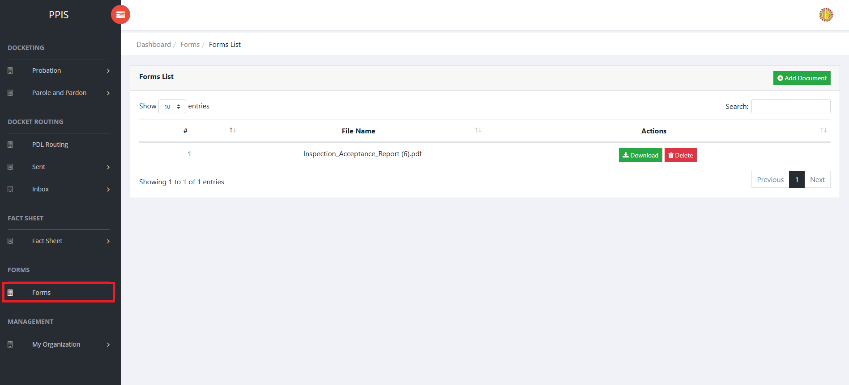
Forms list page

Forms (Add Document)
1. On the Forms list page, click Add Document.
2. Wait for the upload screen to open.
3. Enter Uploader, Kind, and select a file in Upload File.
4. Click Confirm to save after checking the entry.
5. Wait for the system to confirm the upload and return to the forms list.
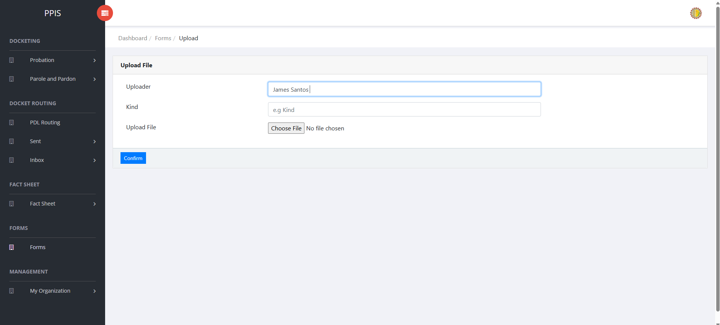
Forms (Add Document)

10. My Organization

User Accounts (For Administrator of the System)
Use this page to create and maintain user accounts.
1. From the left menu, open User Accounts.
2. To find a record, enter the known information in Enter Username.
3. Click Search to apply the search.
4. In the Actions column, use Update, Remove, Deactivate, Restrict, Activate for the selected row.
5. To filter the table instantly, type characters directly into the inline search boxes in the column headers, or select a value from any drop-down filter shown above a column. The table updates automatically as the end user types or selects.
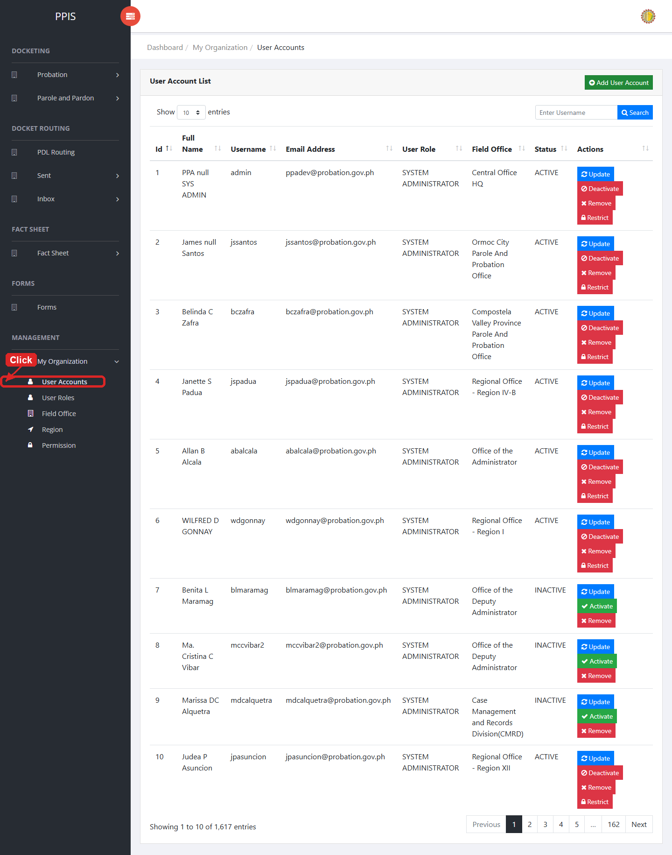
User Accounts list page

User Accounts (Update) (For Administrator of the System)
1. On the User Accounts list page, locate the record that needs correction.
2. Click Update in the Actions column.
3. Wait for the modal dialog box to appear on the screen.
4. Review the current details and update First Name *, Middle Name *, Last Name *, Suffix, Birthday, Contact No., Email Address *, Field Office * inside the modal dialog.
5. Click Confirm inside the modal dialog to submit the changes.
6. If the system displays a confirmation prompt, review the information and click Confirm to save the updated record.
7. Wait for the modal dialog to close. The table refreshes and displays the updated record.
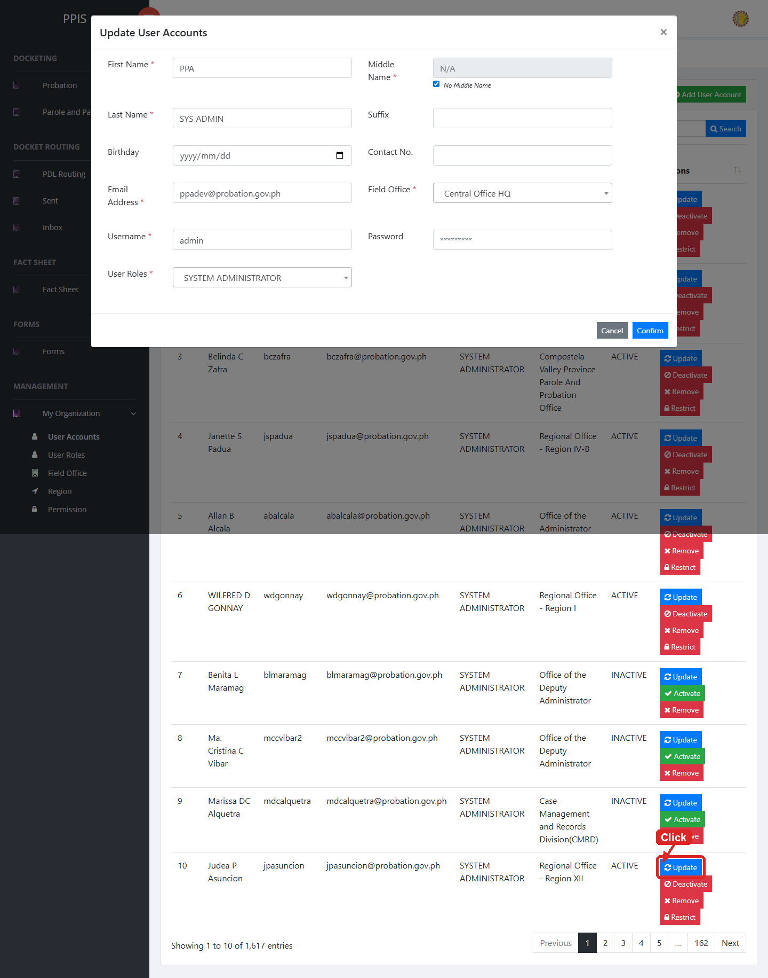
User Accounts (Update)

User Accounts (Delete) (For Administrator of the System)
Deletion warning: Use Remove only for sample/test records or records approved for deletion. For documentation, stop at the confirmation dialog unless removal is required.

1. On the User Accounts list page, locate the sample, test, or authorized record.
2. Click Remove in the Actions column.
3. Wait for the confirmation modal dialog box to appear.
4. Read the confirmation message carefully. The system warns that removal cannot be undone.
5. Click Cancel inside the modal dialog to stop, or click Remove inside the modal dialog only when deletion is authorized.
6. Wait for the modal dialog to close. The table refreshes to reflect the remaining records.
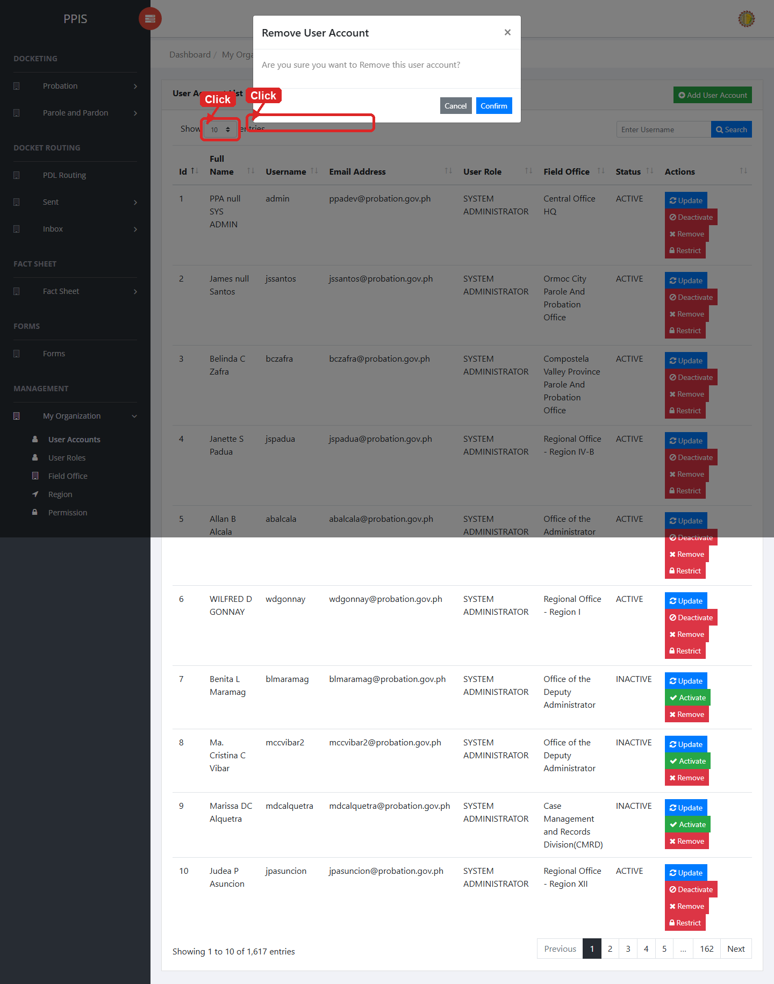
User Accounts (Delete)

User Accounts (Add Record) (For Administrator of the System)
1. On the User Accounts page, click Add User Account.
2. Wait for the modal dialog box to appear on the screen.
3. Enter First Name *, Middle Name *, Last Name *, Suffix, Birthday, Contact No., Email Address *, Field Office * inside the modal dialog.
4. Click Confirm inside the modal dialog to submit the new record.
5. If the system displays a confirmation prompt, review the information and click Confirm to save the entry.
6. Wait for the modal dialog to close. The table refreshes and displays the newly added record.
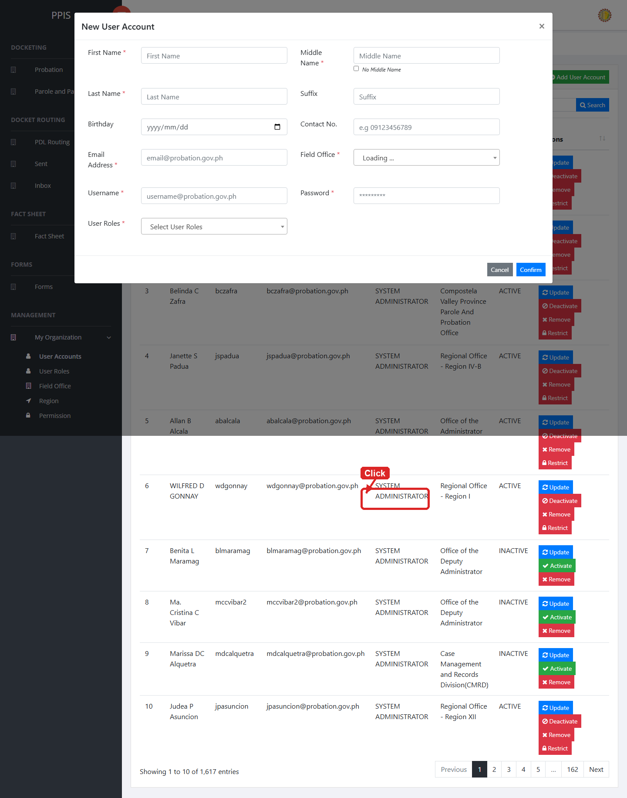
User Accounts (Add Record)

User Roles (For Administrator of the System)
Use this page to create and maintain user roles and update permissions assigned to those roles.
1. From the left menu, open User Roles.
2. To find a record, enter the known information in Search.
3. In the Actions column, use Update for the selected row.
4. To filter the table instantly, type characters directly into the inline search boxes in the column headers, or select a value from any drop-down filter shown above a column. The table updates automatically as the end user types or selects.
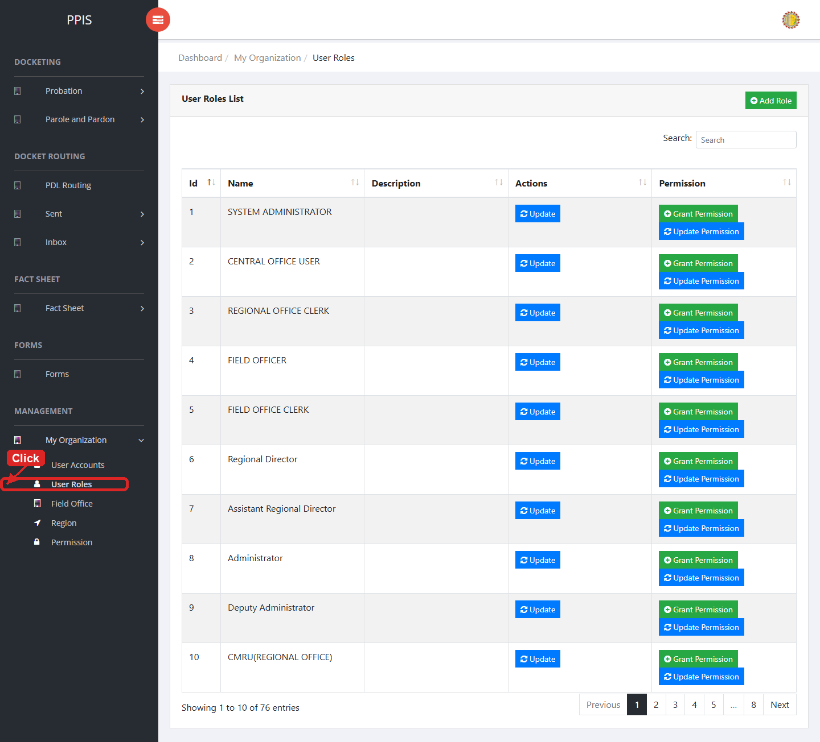
User Roles list page

User Roles (Update) (For Administrator of the System)
1. On the User Roles list page, locate the record that needs correction.
2. Click Update in the Actions column.
3. Wait for the modal dialog box to appear on the screen.
4. Review the current details and update User Role Name, Search inside the modal dialog.
5. Click Confirm inside the modal dialog to submit the changes.
6. If the system displays a confirmation prompt, review the information and click Confirm to save the updated record.
7. Wait for the modal dialog to close. The table refreshes and displays the updated record.
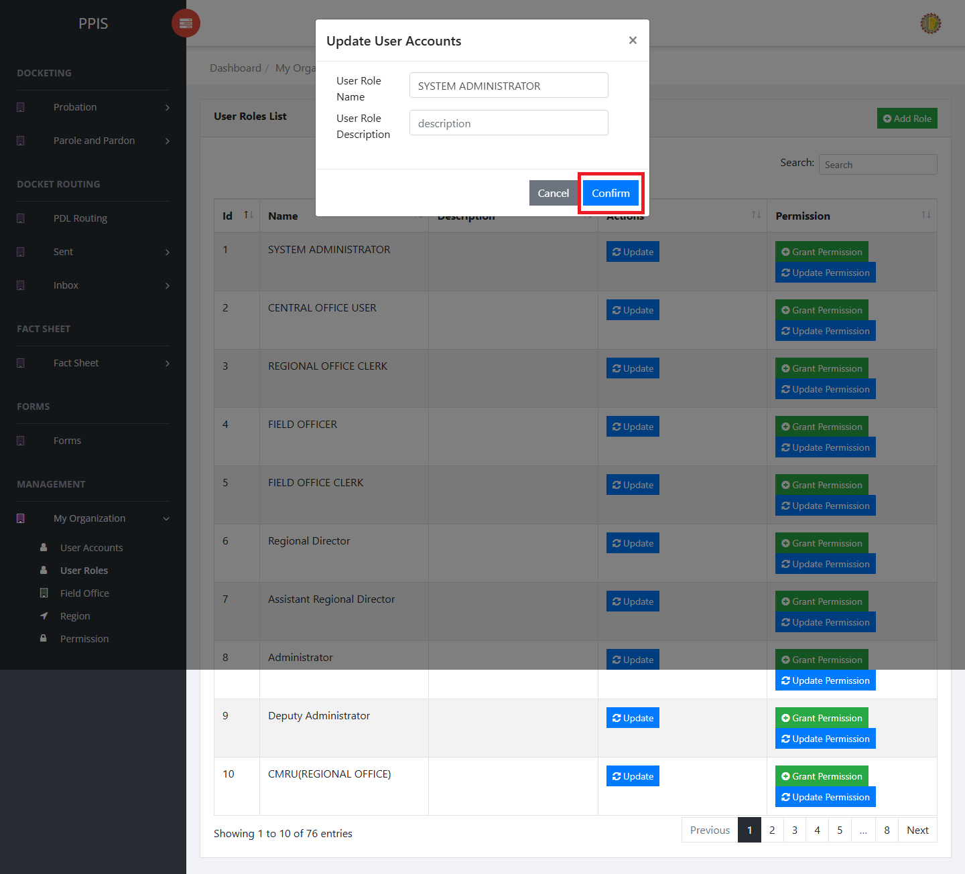
User Roles (Update)

User Roles (Add Record) (For Administrator of the System)
1. On the User Roles page, click Add Role.
2. Wait for the modal dialog box to appear on the screen.
3. Enter User Role Name, User Role Description, Search inside the modal dialog.
4. Click Confirm inside the modal dialog to submit the new record.
5. If the system displays a confirmation prompt, review the information and click Confirm to save the entry.
6. Wait for the modal dialog to close. The table refreshes and displays the newly added record.
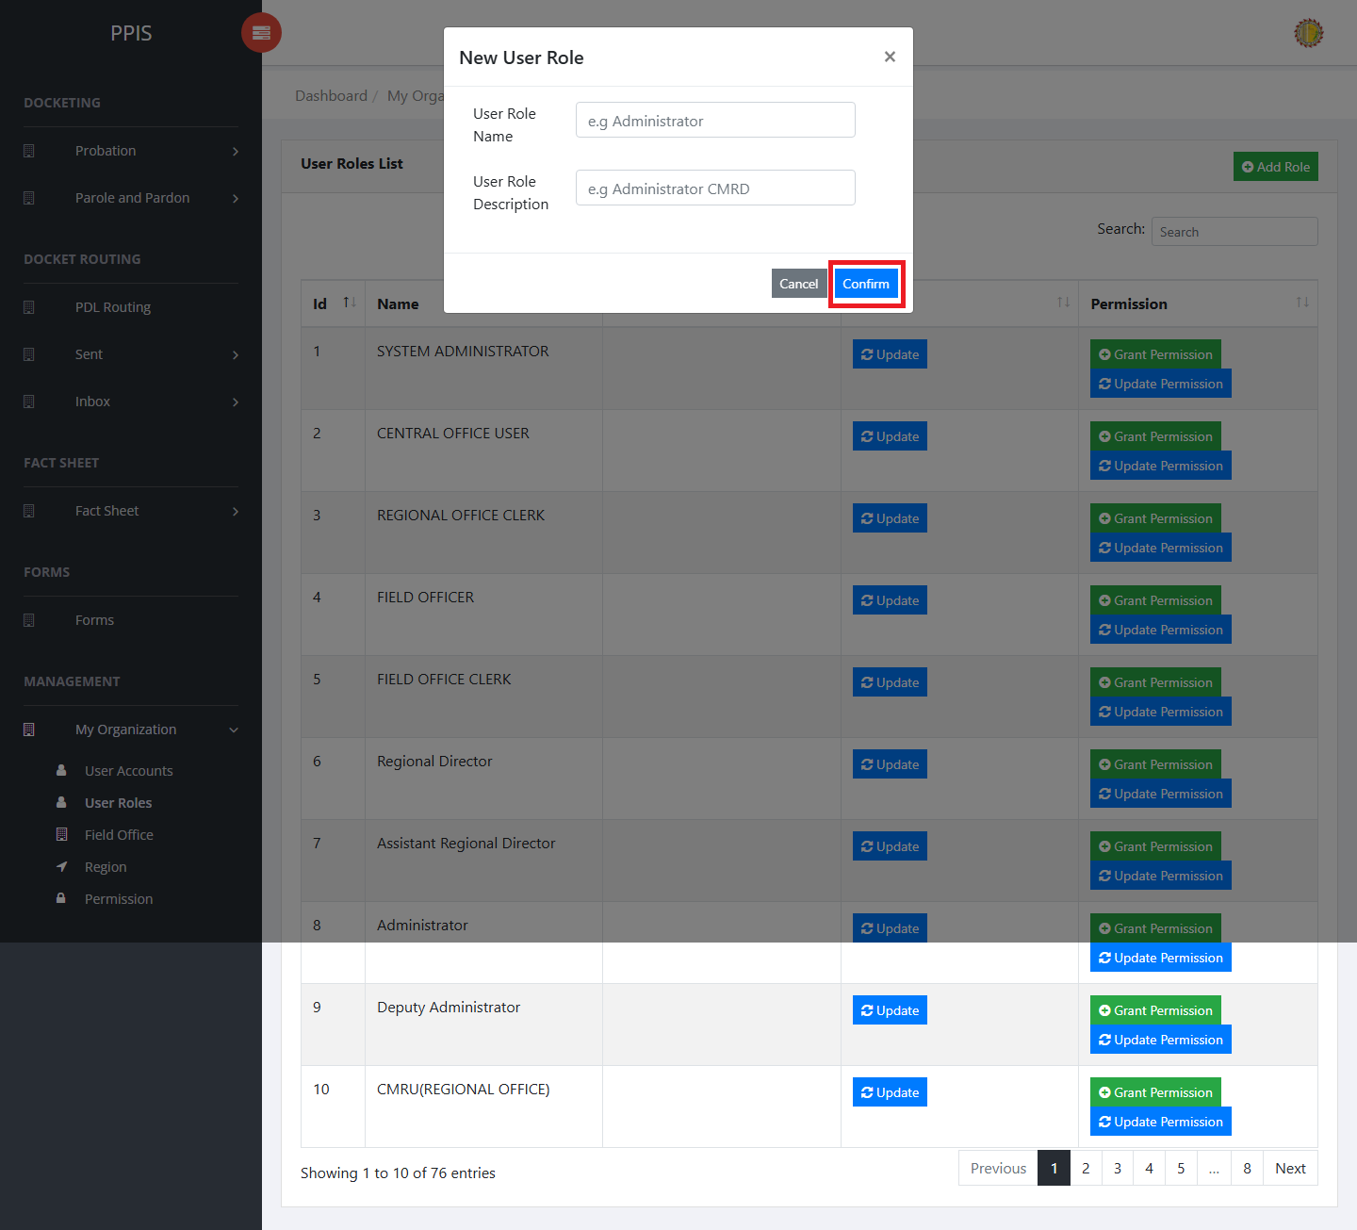
User Roles (Add Record)

Field Office (For Administrator of the System)
Use this page to maintain field office records.
1. From the left menu, open Field Office.
2. To find a record, enter the known information in Search.
3. In the Actions column, use View, Update, Remove for the selected row.
4. To filter the table instantly, type characters directly into the inline search boxes in the column headers, or select a value from any drop-down filter shown above a column. The table updates automatically as the end user types or selects.
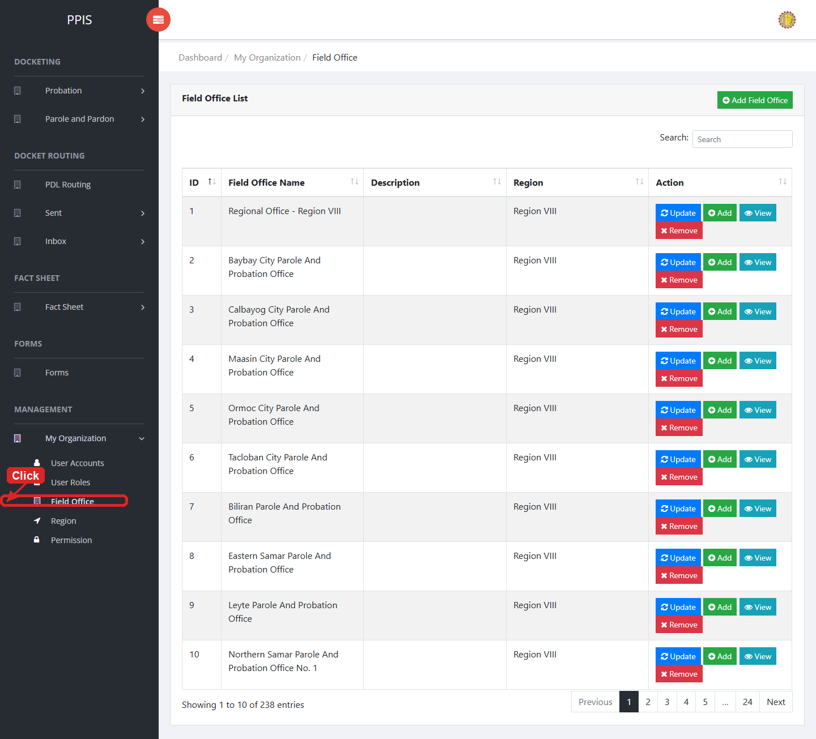
Field Office list page

Field Office (View) (For Administrator of the System)
1. On the Field Office list page, locate the record that needs to be reviewed.
2. Click View in the Actions column.
3. Read the details on the view page. Use this screen for checking information before making any changes.
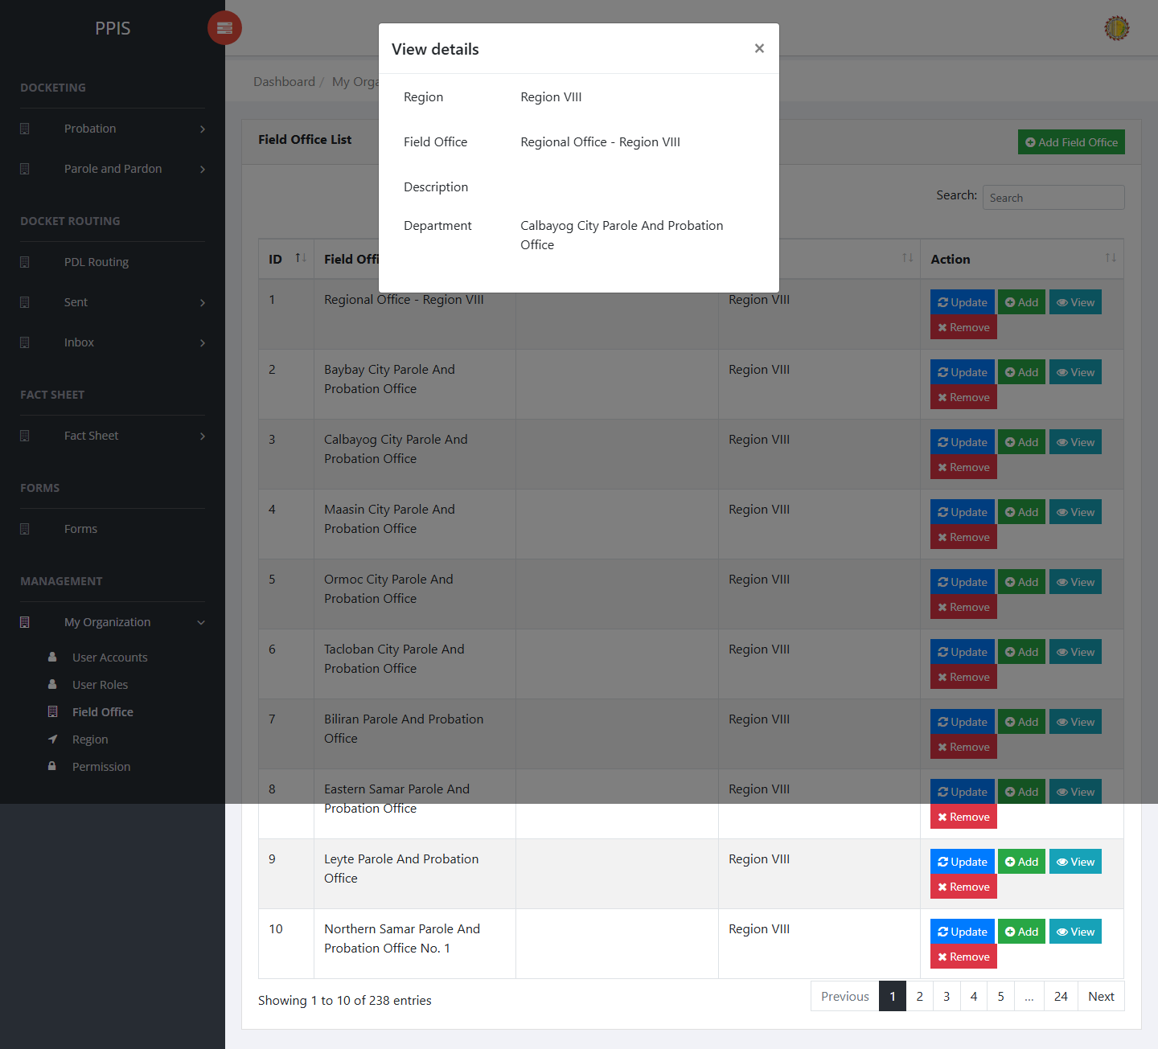
Field Office (View)

Field Office (Update) (For Administrator of the System)
1. On the Field Office list page, locate the record that needs correction.
2. Click Update in the Actions column.
3. Wait for the modal dialog box to appear on the screen.
4. Review the current details and update Region, Field Office, Description, Search inside the modal dialog.
5. Click Confirm inside the modal dialog to submit the changes.
6. If the system displays a confirmation prompt, review the information and click Confirm to save the updated record.
7. Wait for the modal dialog to close. The table refreshes and displays the updated record.
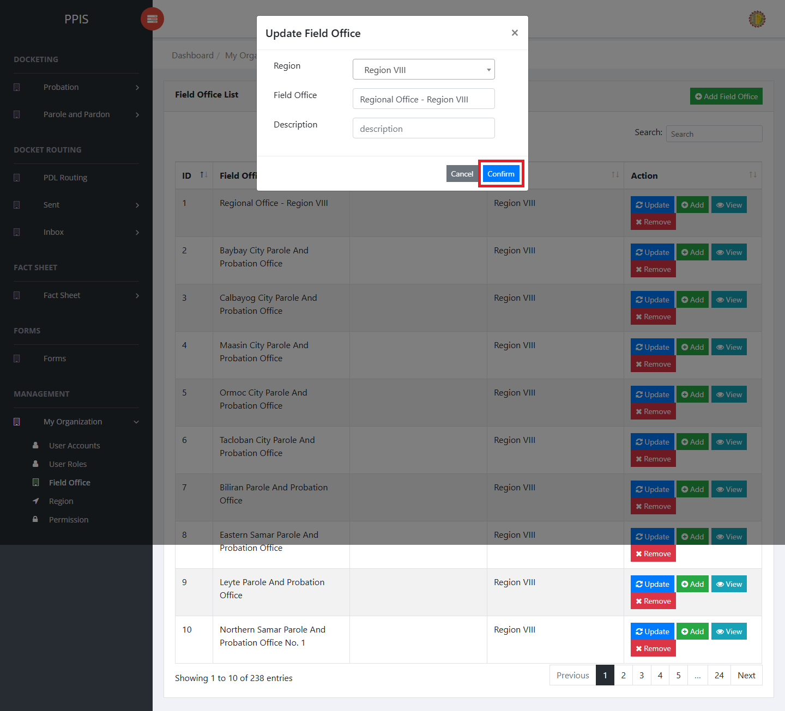
Field Office (Update)

Field Office (Delete) (For Administrator of the System)
Deletion warning: Use Remove only for sample/test records or records approved for deletion. For documentation, stop at the confirmation dialog unless removal is required.

1. On the Field Office list page, locate the sample, test, or authorized record.
2. Click Remove in the Actions column.
3. Wait for the confirmation modal dialog box to appear.
4. Read the confirmation message carefully. The system warns that removal cannot be undone.
5. Click Cancel inside the modal dialog to stop, or click Remove inside the modal dialog only when deletion is authorized.
6. Wait for the modal dialog to close. The table refreshes to reflect the remaining records.
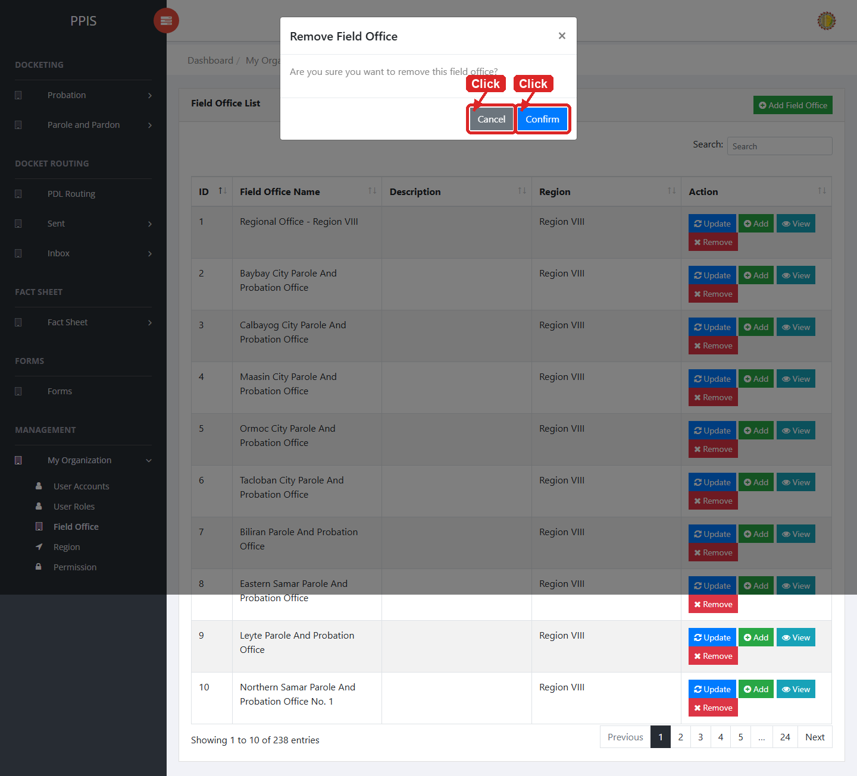
Field Office (Delete)

Field Office (Add Record) (For Administrator of the System)
1. On the Field Office page, click Add Field Office.
2. Wait for the modal dialog box to appear on the screen.
3. Enter Region, Field Office, Description, Search inside the modal dialog.
4. Click Confirm inside the modal dialog to submit the new record.
5. If the system displays a confirmation prompt, review the information and click Confirm to save the entry.
6. Wait for the modal dialog to close. The table refreshes and displays the newly added record.
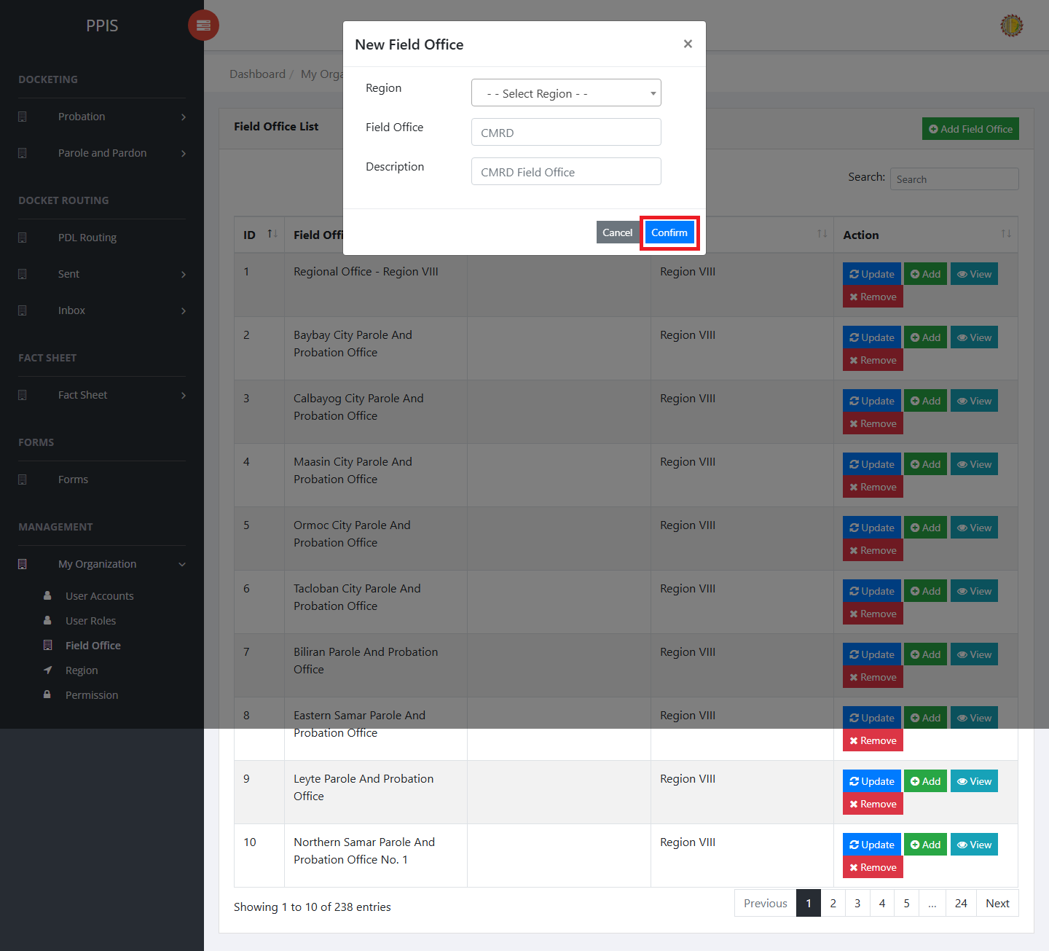
Field Office (Add Record)

Region (For Administrator of the System)
Use this page to maintain region records.
1. From the left menu, open Region.
2. To find a record, enter the known information in Search.
3. In the Actions column, use Update, Remove for the selected row.
4. To filter the table instantly, type characters directly into the inline search boxes in the column headers, or select a value from any drop-down filter shown above a column. The table updates automatically as the end user types or selects.
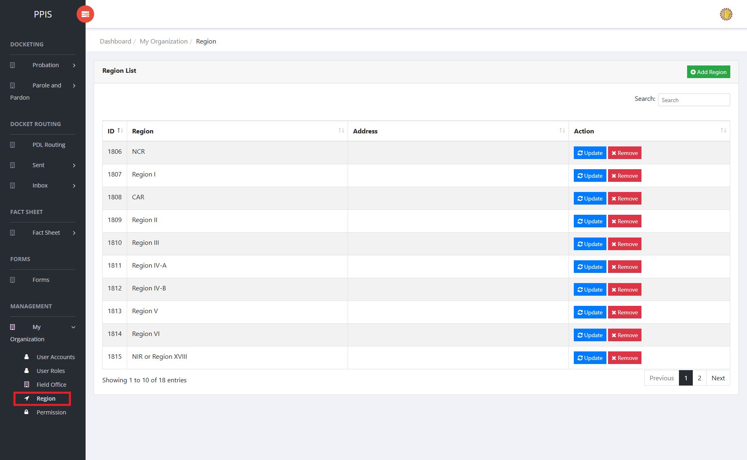
Region list page

Region (Update) (For Administrator of the System)
1. On the Region list page, locate the record that needs correction.
2. Click Update in the Actions column.
3. Wait for the modal dialog box to appear on the screen.
4. Review the current details and update Region Name, Search inside the modal dialog.
5. Click Confirm inside the modal dialog to submit the changes.
6. If the system displays a confirmation prompt, review the information and click Confirm to save the updated record.
7. Wait for the modal dialog to close. The table refreshes and displays the updated record.
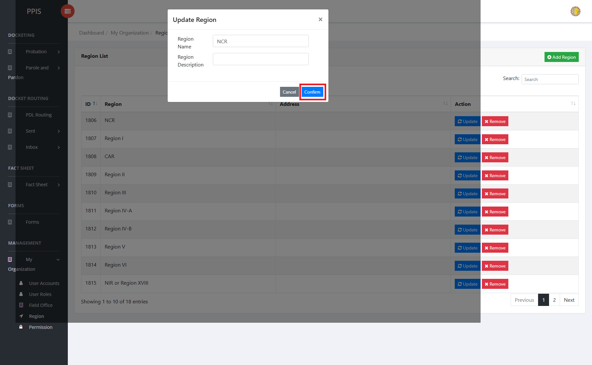
Region (Update)

Region (Delete)
Deletion warning: Use Remove only for sample/test records or records approved for deletion. For documentation, stop at the confirmation dialog unless removal is required.

1. On the Region list page, locate the sample, test, or authorized record.
2. Click Remove in the Actions column.
3. Wait for the confirmation modal dialog box to appear.
4. Read the confirmation message carefully. The system warns that removal cannot be undone.
5. Click Cancel inside the modal dialog to stop, or click Remove inside the modal dialog only when deletion is authorized.
6. Wait for the modal dialog to close. The table refreshes to reflect the remaining records.
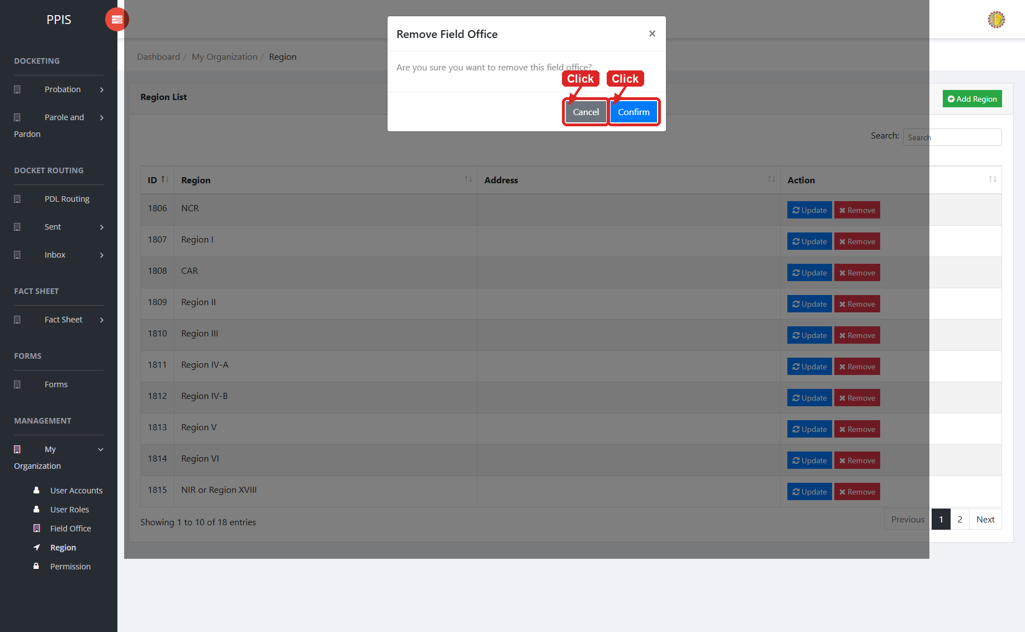
Region (Delete)

Region (Add Record) (For Administrator of the System)
1. On the Region page, click Add Region.
2. Wait for the modal dialog box to appear on the screen.
3. Enter Region, Description, Search inside the modal dialog.
4. Click Confirm inside the modal dialog to submit the new record.
5. If the system displays a confirmation prompt, review the information and click Confirm to save the entry.
6. Wait for the modal dialog to close. The table refreshes and displays the newly added record.
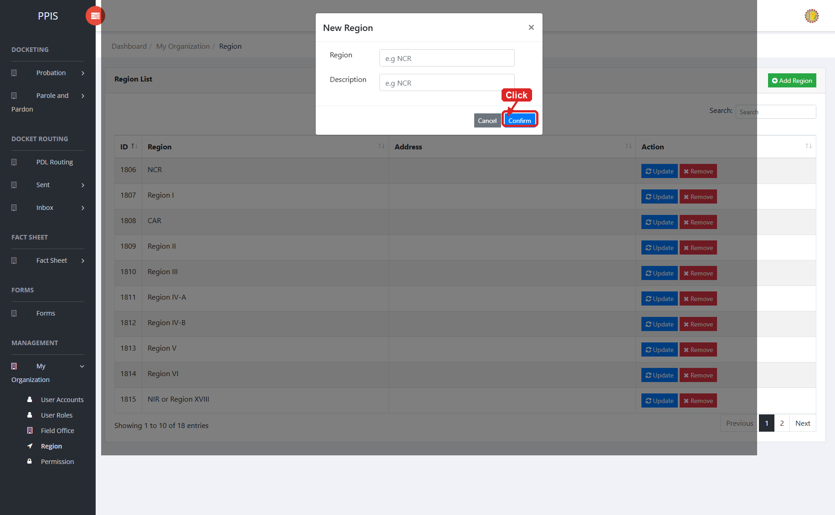
Region (Add Record)

Permission (For Administrator of the System)
Use this page to maintain permission records used by the system.
1. From the left menu, open Permission.
2. To find a record, enter the known information in Search.
3. In the Actions column, use Update for the selected row.
4. To filter the table instantly, type characters directly into the inline search boxes in the column headers, or select a value from any drop-down filter shown above a column. The table updates automatically as the end user types or selects.
5. To export the currently displayed table data, click CSV, PDF, or EXCEL above the table when those buttons are shown. The system downloads the visible records in the selected format.
6. To print the table, click Print. The native browser print window opens. Review the layout settings, then click Print in that window to complete printing.
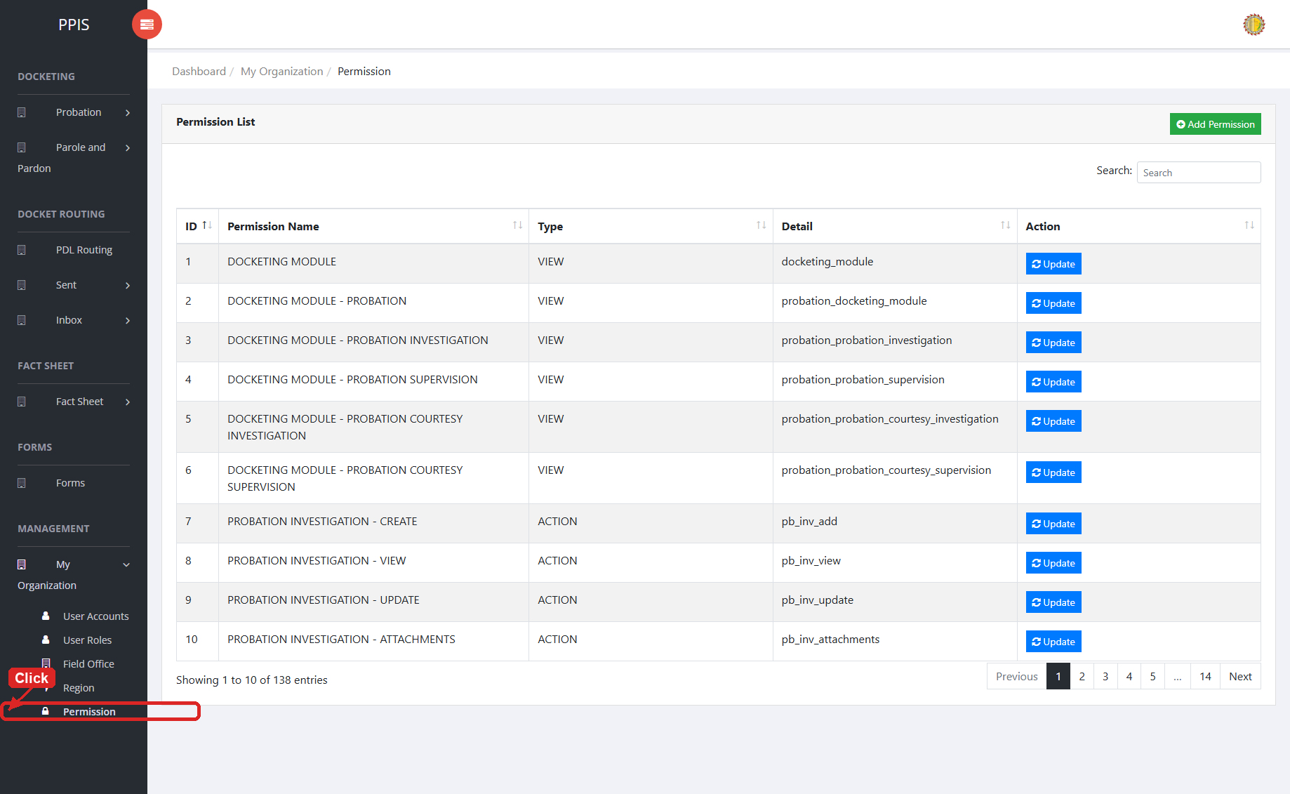
Permission list page

Permission (Update) (For Administrator of the System)
1. On the Permission list page, locate the record that needs correction.
2. Click Update in the Actions column.
3. Wait for the modal dialog box to appear on the screen.
4. Review the current details and update Permission Name, Type, Detail, Search inside the modal dialog.
5. Click Confirm inside the modal dialog to submit the changes.
6. If the system displays a confirmation prompt, review the information and click Confirm to save the updated record.
7. Wait for the modal dialog to close. The table refreshes and displays the updated record.
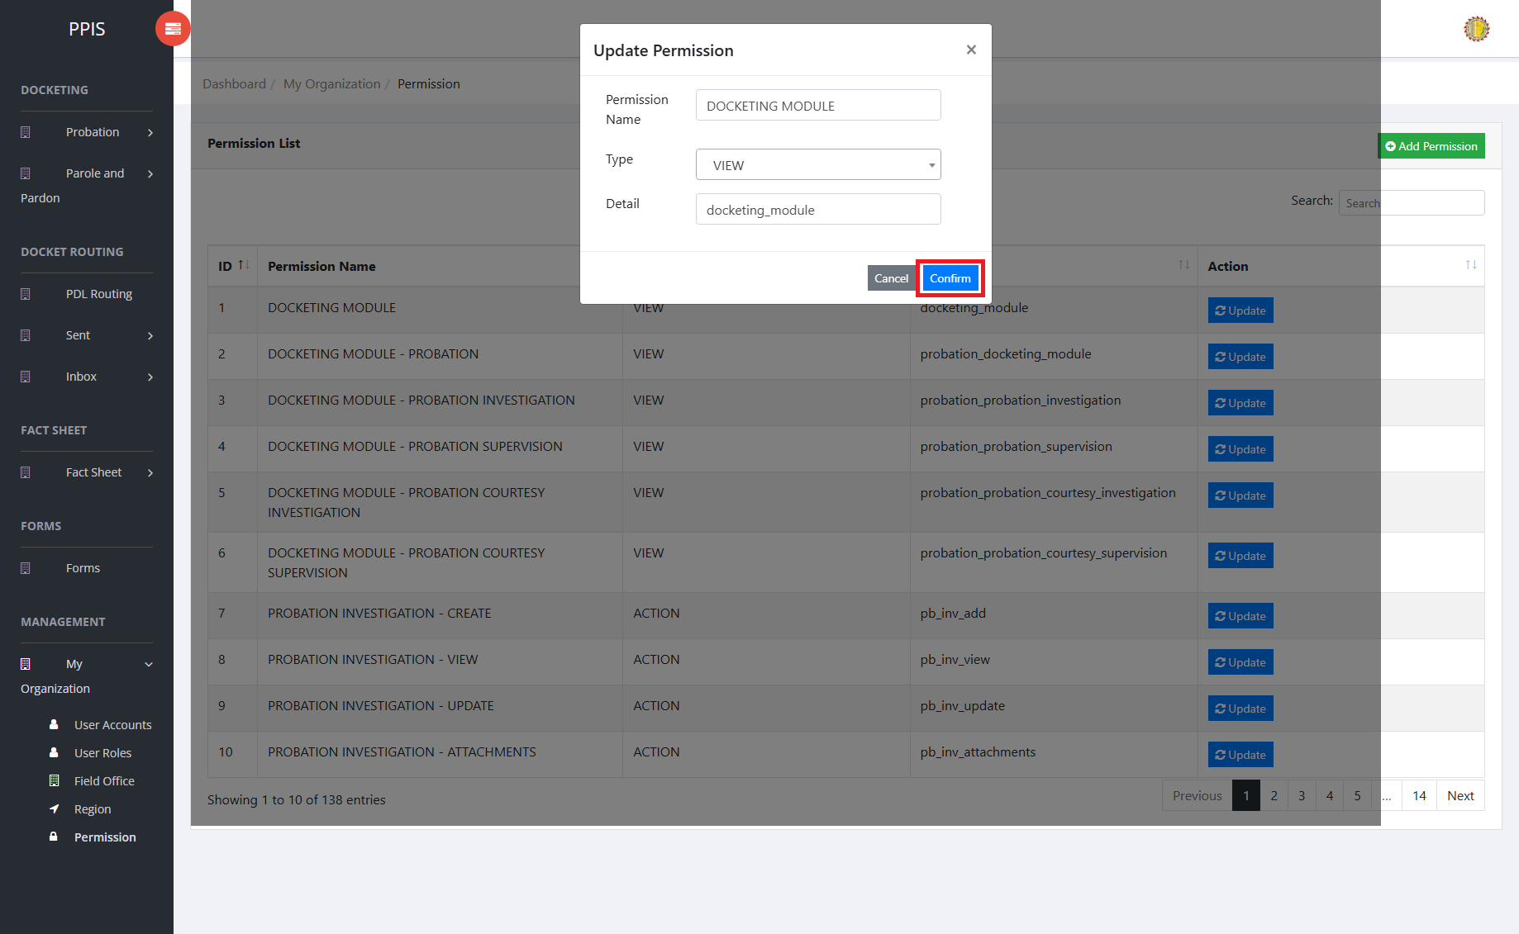
Permission (Update)

Permission (Add Record) (For Administrator of the System)
1. On the Permission page, click Add Permission.
2. Wait for the modal dialog box to appear on the screen.
3. Enter Permission Name, Type, Detail, Search inside the modal dialog.
4. Click Confirm inside the modal dialog to submit the new record.
5. If the system displays a confirmation prompt, review the information and click Confirm to save the entry.
6. Wait for the modal dialog to close. The table refreshes and displays the newly added record.
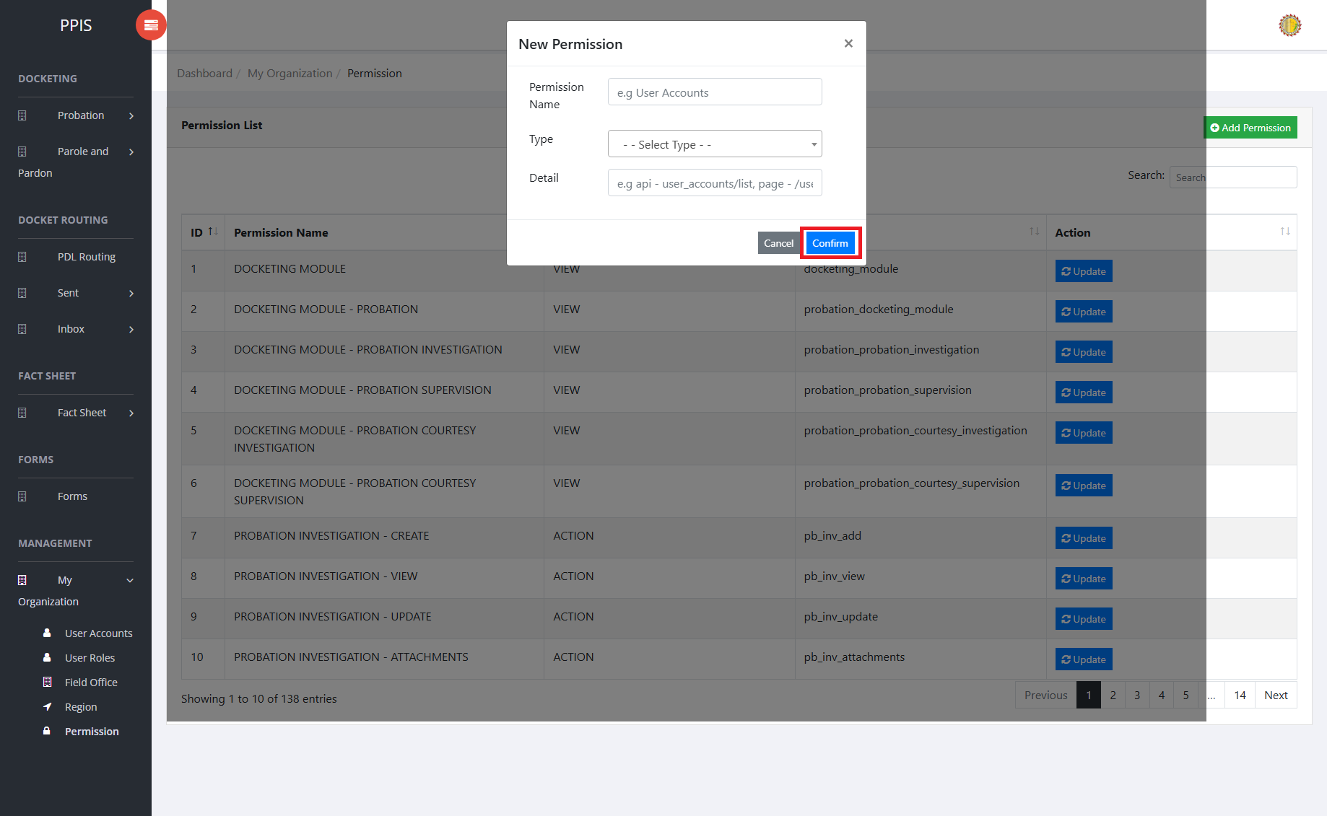
Permission (Add Record)

