Parole and Probation Information System (PPIS)
────────────────────────────────────────────────────────
End-User Manual
Version: 1.0
Organization: Parole and Probation Administration (PPA), Department of Justice, Republic of the Philippines
Document Date: May 2026
Classification: Official Use – Operational Staff
────────────────────────────────────────────────────────
This manual is written for day-to-day users of the web-based Parole and Probation Information System (PPIS). It explains how to sign in, move through menus, record docket information, work with fact sheets and forms, print reports, and solve common problems.

Table of Contents
- Introduction
- System Requirements
- Logging In
- Dashboard Overview
- Navigation and Screen Layout
- Module Documentation
- Data Encoding Procedures
- Printing and Reports
- User Roles and Permissions
- Troubleshooting
- Frequently Asked Questions
- Glossary of Terms
- Contact and Support
────────────────────────────────────────────────────────

1. Introduction

1.1 Purpose of the System
PPIS supports the processing and tracking of probation, parole, pardon, and related persons deprived of liberty (PDL) workflows in one place. It helps your office:
Benefit | What it means for staff
Central records | Dockets and supporting documents stay tied to the correct client and case.
Fewer paper errors | Required fields and lists reduce missing information before a case advances.
Faster retrieval | Search and filters help locate a docket or client without browsing every paper folder.

1.2 Overview of the Workflow (Typical Office Flow)
- A staff member logs in with the account issued by your administrator.
- Depending on the unit, users create or open a docket (investigation or supervision, probation or parole track).
- Details are encoded (names, numbers, tasks, dates, remarks). Supporting files are uploaded when required.
- Fact sheets, worksheets, and PSIR sections (where enabled) capture structured assessment information.
- Reports or printable documents are generated from the appropriate screens (print preview or export, depending on the module).
Exact steps depend on your role and field office. Not every user sees every menu item.

1.3 Intended Users
User type | Typical responsibilities
PPA Personnels | Day-to-day data entry and uploads allowed by your role.
Administrator | Maintains user accounts, roles, permissions, offices, and regions.
────────────────────────────────────────────────────────

2. System Requirements

2.1 Browser Requirements
- Use a current, supported web browser (for example, recent versions of Microsoft Edge, Google Chrome, or Mozilla Firefox).
- Enable JavaScript (it is on by default in standard installations).
- Allow the site to use cookies and local storage for your PPIS address. The system stores session-related preferences (such as permission flags) in the browser after login.
Warning: Private or “strict” blocking modes can prevent login or hide menus correctly. If menus look empty after login, ask IT to check browser privacy settings for your PPIS site.

2.2 Internet and Network Requirements
- Connect through a reliable network (office LAN or approved VPN such as OpenVPN), as PPIS is normally hosted on your agency server or data center.
- If the screen shows connection errors or endless loading, confirm with IT whether the application server and API address configured for your office are reachable.
Tip: Note your office’s official PPIS web address (URL). Bookmark it only on secure, staff-only computers.

2.3 Recommended Screen Resolution
- Use a desktop or laptop display at 1366×768 or higher.
- On smaller screens, use the menu toggle (horizontal lines icon) in the header to open the left navigation panel.
────────────────────────────────────────────────────────

3. Logging In
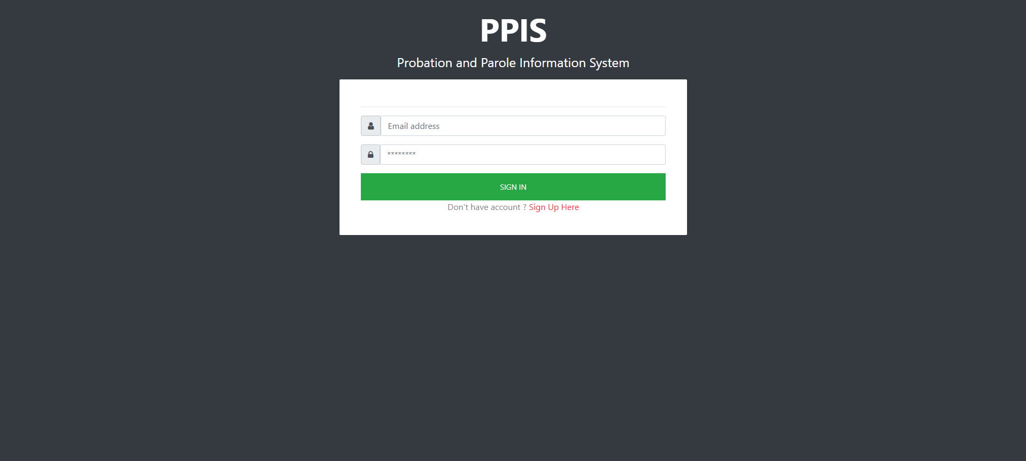
Figure 6 — Login: Login

3.1 Username and Password (Email Sign-In)
- Open your browser and go to the PPIS address provided by your administrator.
- On the sign-in page, locate the Email address field. Enter the email address registered for your account (this is your username for PPIS).
- Enter your password in the Password field. Characters appear hidden for security.
- Select Sign in.
- Wait for the confirmation message. If login succeeds, the system opens the Dashboard after a short pause.
Tip: You can press the Enter key after typing your password to submit the form, the same as clicking Sign in.

3.2 One-Time Password (OTP) – Special Sign-In Links
PPIS use a special login link that includes a secure key. In that situation:
- After the first step succeeds, the screen may switch to OTP entry.
- A code is sent to your registered mobile number and/or email.
- Type the code and select Enter OTP.
- If the code expires, use Resend OTP when it appears.
Warning: Never share OTP codes. Treat them like cash passwords.

3.3 New Account Request (Sign Up Here)
- Creating of new accounts must be performed in the UAMS website. (Contact your Administrator to create a new account).

3.4 Forgot Password or Locked Account
The standard login screen is focused on email and password. If you forget your password, or see a message that your account is locked:
- Stop trying random passwords (multiple failures can lock the account).
- Contact your PPIS administrator or IT help desk for a password reset or unlock.
- Do not ask another employee to sign in on your behalf.

3.5 Security Reminders
- Log out when you finish, especially on a shared computer (use Logout under your name on the top right).
- Do not save passwords in the browser on public or shared PCs.
- Report suspected unauthorized access immediately to your supervisor.
Warning: Sharing your password violates agency policy and exposes client data.
────────────────────────────────────────────────────────

4. Overview

4.1 What You See After Login
- Your name appears in the top-right header next to your profile image.
- The left side shows the main PPIS menu (brand “PPIS” at the top of the panel when visible).

4.2 Main Menu Sections (What They Represent)
Menus are grouped to match how work moves through the agency:
Menu group | What it is for
Docketing – Probation | Investigation, supervision, and courtesy variants under the probation program track.
Docketing – Parole and Pardon | Investigation, supervision, and courtesy variants for parole / pre-parole style workflows.
PDL Routing | PDL-specific routing screen when your office uses that workflow.
Sent | Lists of items your office has sent out (PDL).
Inbox | Items received or pending intake.
Fact Sheet | Client fact sheets for Probation, Parole/Pardone, and PDL (Single Carpeta) lists.
Forms | Agency form templates and uploads.
My Organization | Administrative screens (accounts, roles, field office, region, permission).
Important: If you do not see a section, your role permissions hide it. This is normal.

4.3 Header Controls and Profile Menu
- Menu toggle (top left): Shows or hides the left navigation on smaller screens.
- Profile image / name: Open the drop-down and select Logout to end your session.
────────────────────────────────────────────────────────

5. Navigation and Screen Layout

5.1 Breadcrumbs
Near the top of many screens, breadcrumbs show where you are (for example, Dashboard › Docket Routing › Forward). Select a breadcrumb link to go back one level.

5.2 Cards, Tables, and Buttons
- Cards group related information (titles like “View Attachments” or “Investigation Docket List”).
- Tables list dockets or clients. The list is divided into pages to make it easier to view and manage the information. You can also choose how many records or entries will be displayed on each page. (click column headers if your browser shows sort arrows).
- Buttons use plain language: View, Update, Attachments / Upload, Remove, Search, Forward, Return, and so on.

5.3 Search Fields
Many lists provide a Search box. Typical behavior:
- Type part of a docket number, CC number, or client name (exact behavior is printed on the placeholder inside the box).
- Select the search (magnifying glass) button or follow on-screen instructions.
- Use clear (×) inside the box, when shown, to reset.
Tip: Start with the smallest unique part of a docket number (for example, the numeric suffix) if full matches fail.
────────────────────────────────────────────────────────

6. Module Documentation
The sections below follow the same order as the left menu, for easier lookup.

6.1 Probation – Investigation Docketing
Purpose: Create and maintain probation investigation dockets for your field office.
How to access: Left menu Probation › Investigation (opens Investigation docketing list).
Typical steps:
- Open the Investigation list.
- Dockets shown in the list comes from another system which is the EPPCMIS.
- Use View to read details without changing them.
- Use Update to change names, numbers, tasks, dates, or remarks as allowed.
- Use Attachments (or Upload) to add PDFs, images, or documents the office requires.
- Use Remove only when your procedure allows removal; confirm any warning message.
Fields and controls (general patterns): Lists show columns such as Docket Number, Client Name, CC Number, Status, and Actions. Forms for update/view repeat the same data in labeled fields.
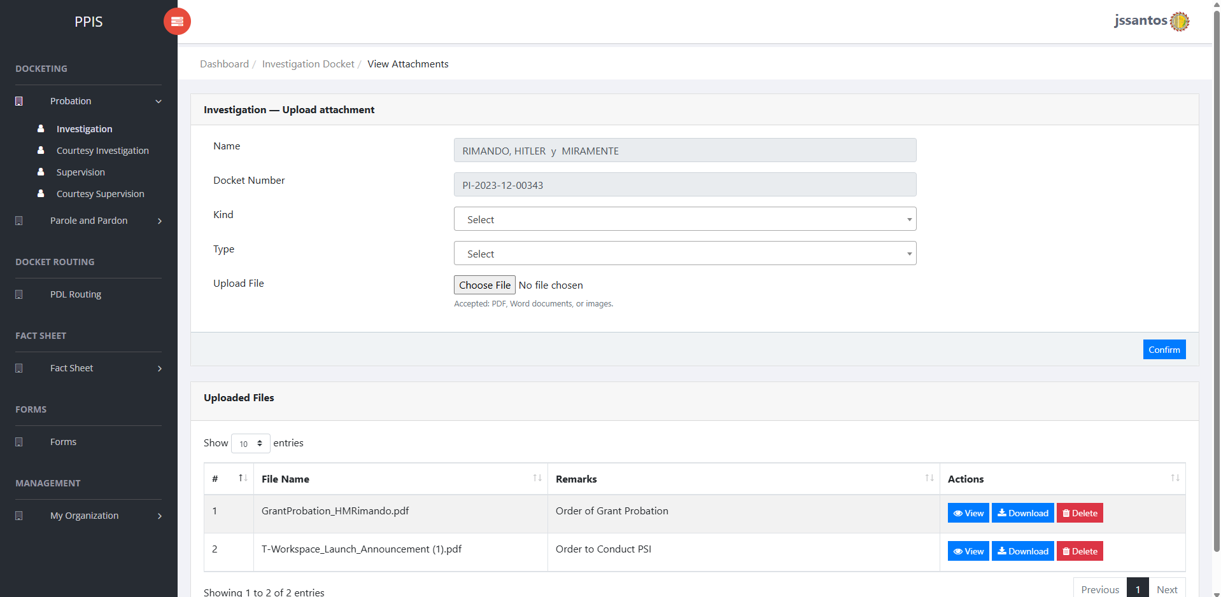
Figure 7 — Probation-Investigation: Attachements Investigation Docket
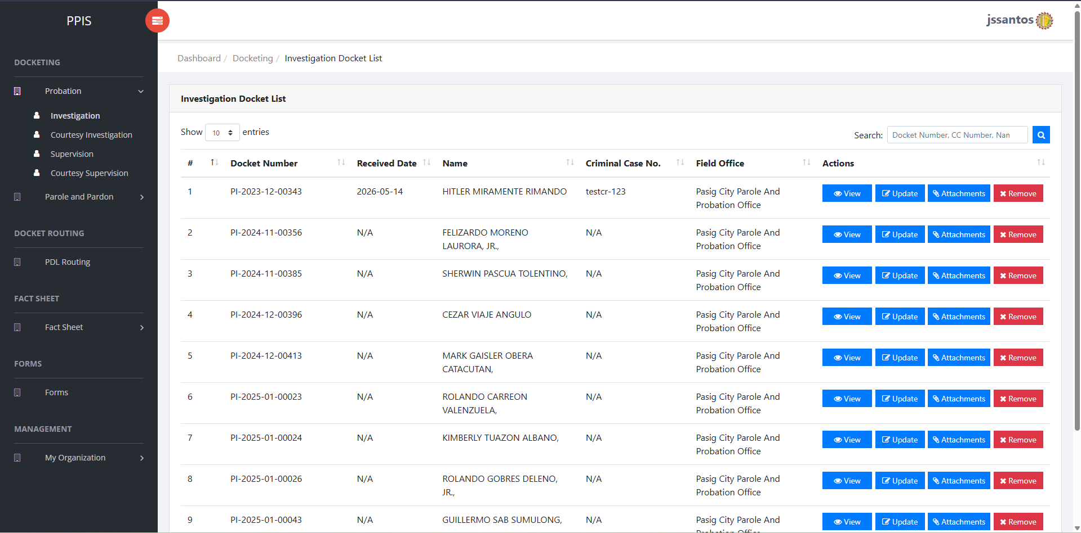
Figure 8 — Probation-Investigation: Investigation Docket List
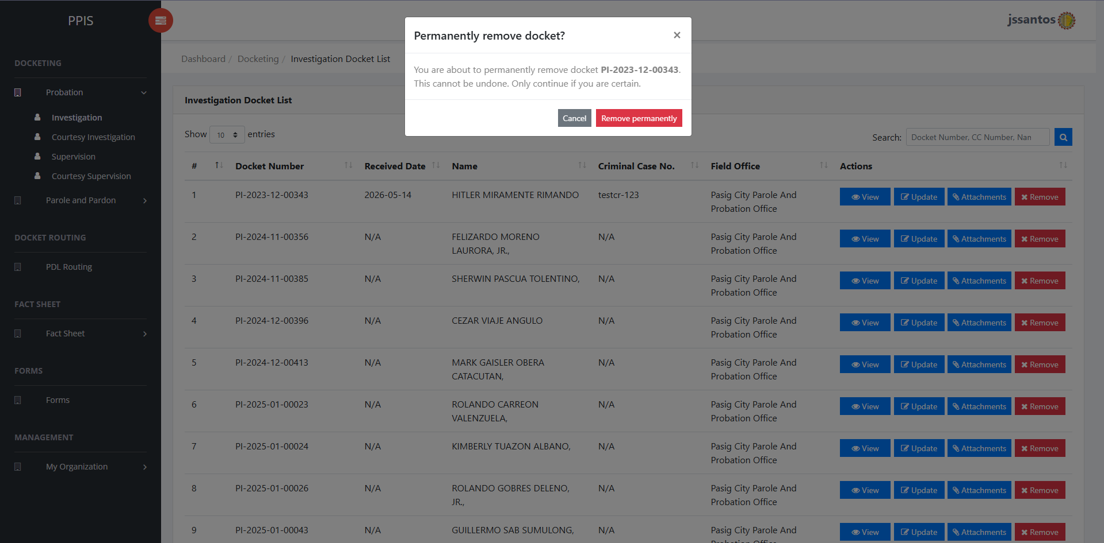
Figure 9 — Probation-Investigation: Remove Investigation Docket
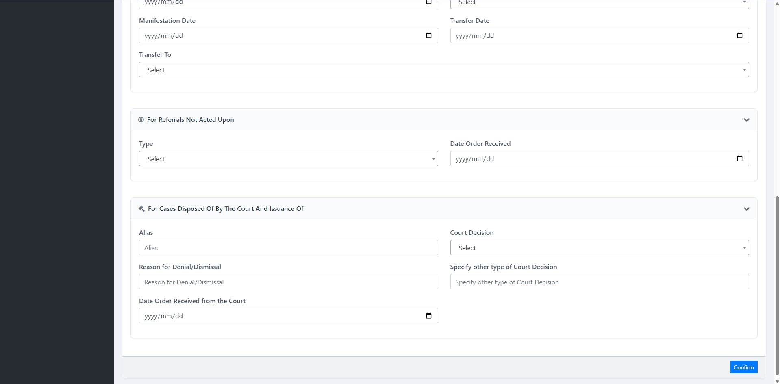
Figure 10 — Probation-Investigation: Update Investigation Docket Part 2
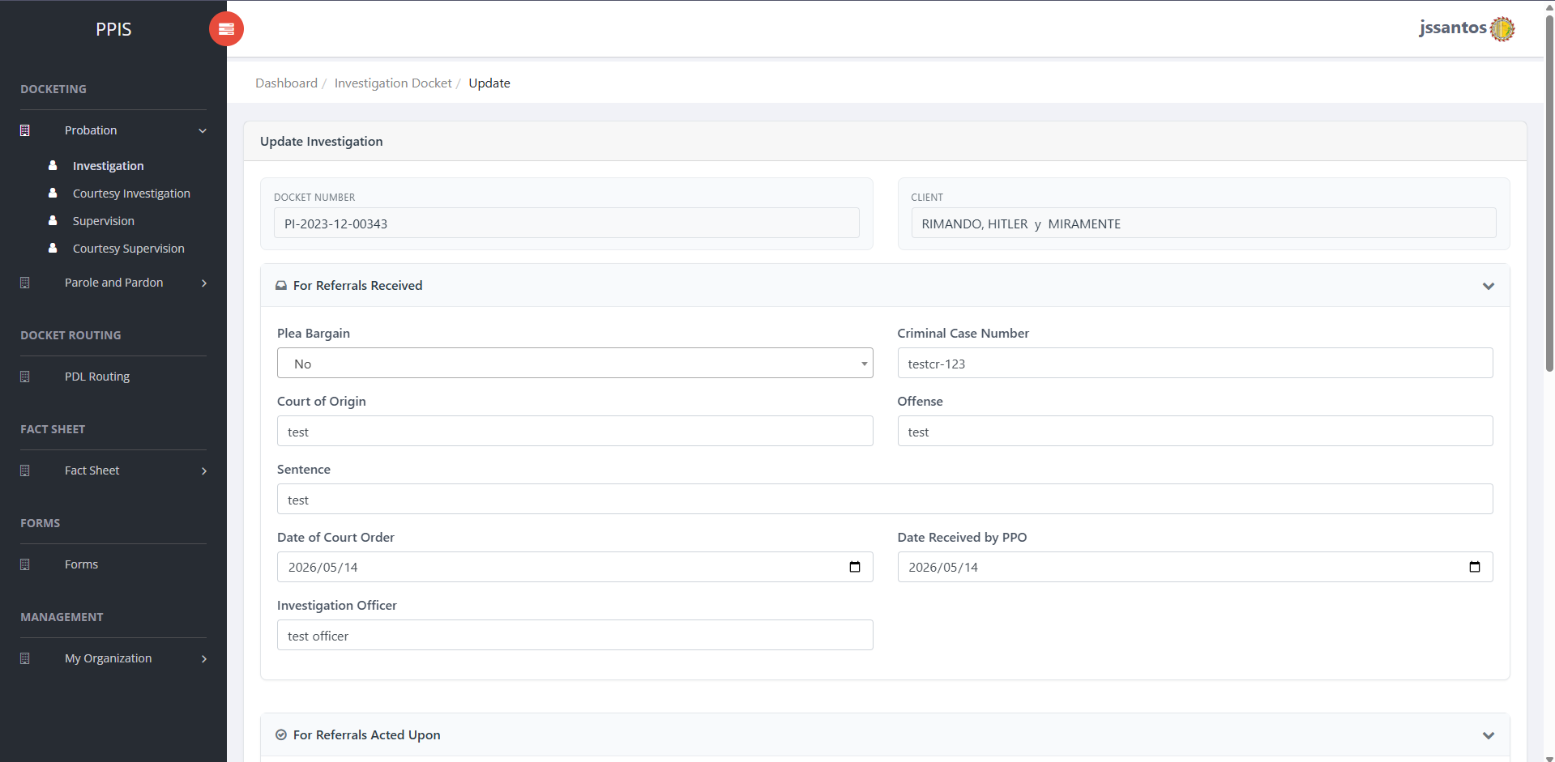
Figure 11 — Probation-Investigation: Update Investigation Docket
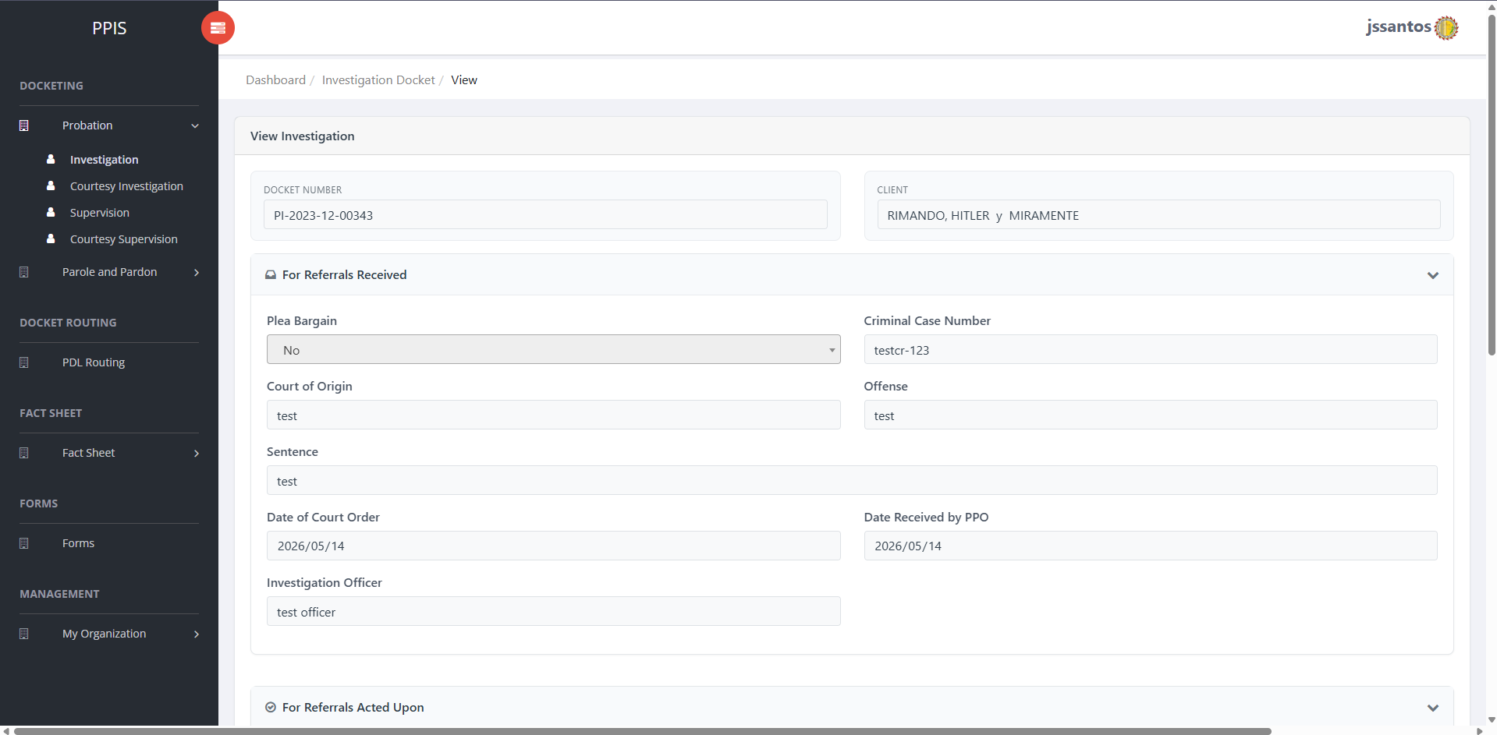
Figure 12 — Probation-Investigation: View Investigation
────────────────────────────────────────────────────────

6.2 Probation – Courtesy Investigation
Purpose: Handle courtesy investigation cases referred between offices or programs under probation rules.
How to access: Probation › Courtesy Investigation.
Usage: Same pattern as #6.1 (list, view, update, attachments, remove). Tasks and labels follow courtesy workflows.
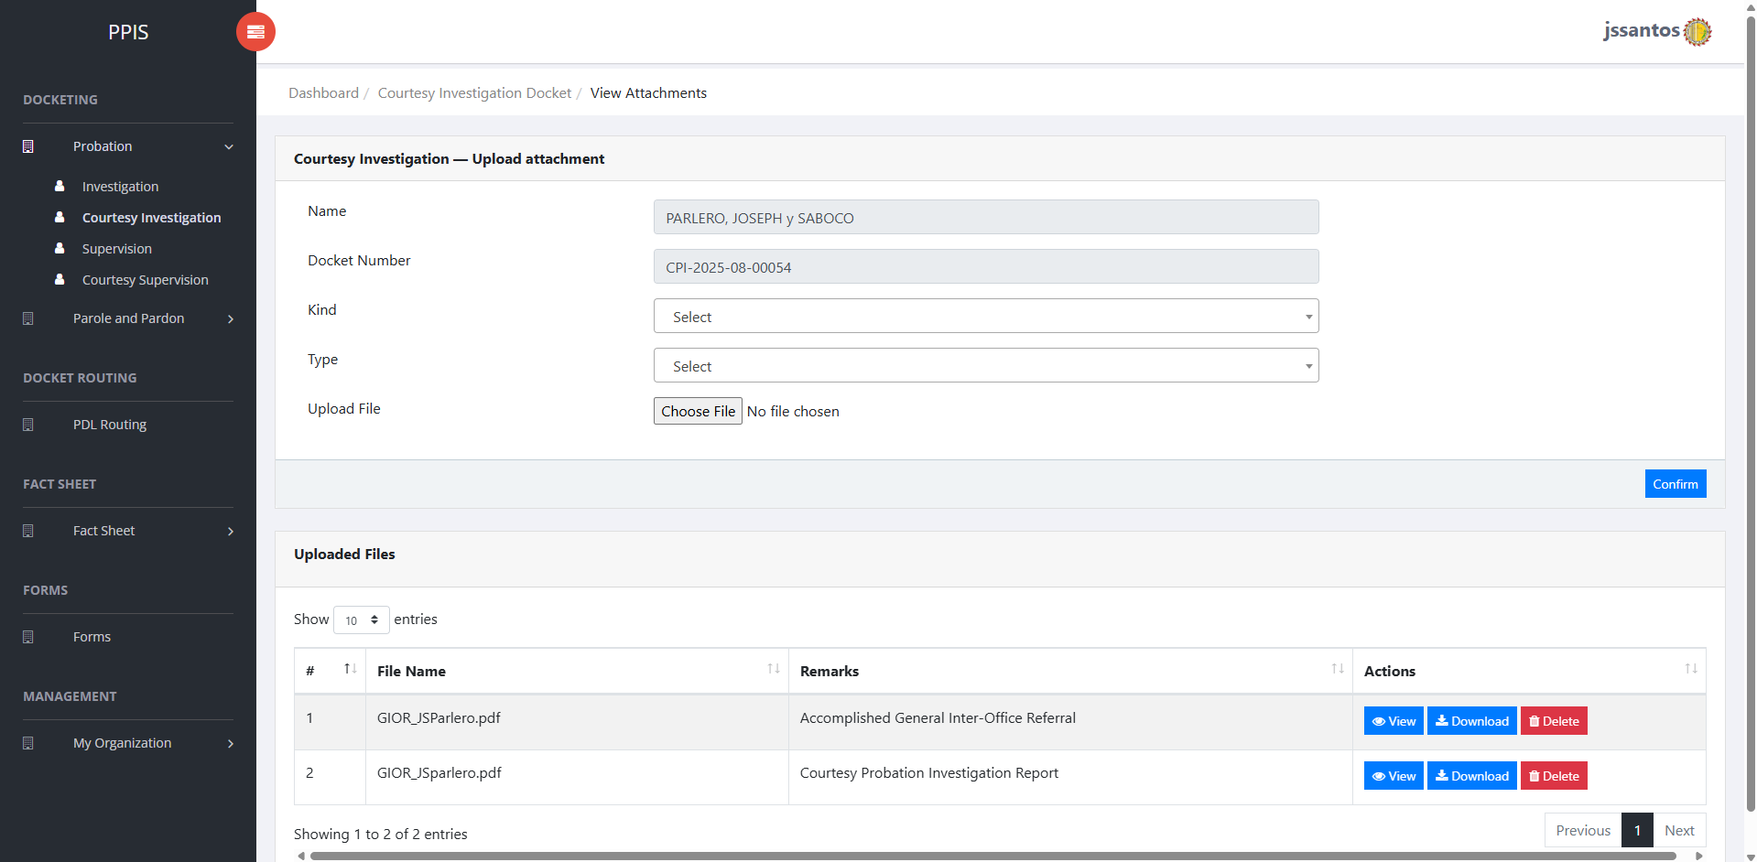
Figure 13 — Probation-Courtesy Investigation: Attachments
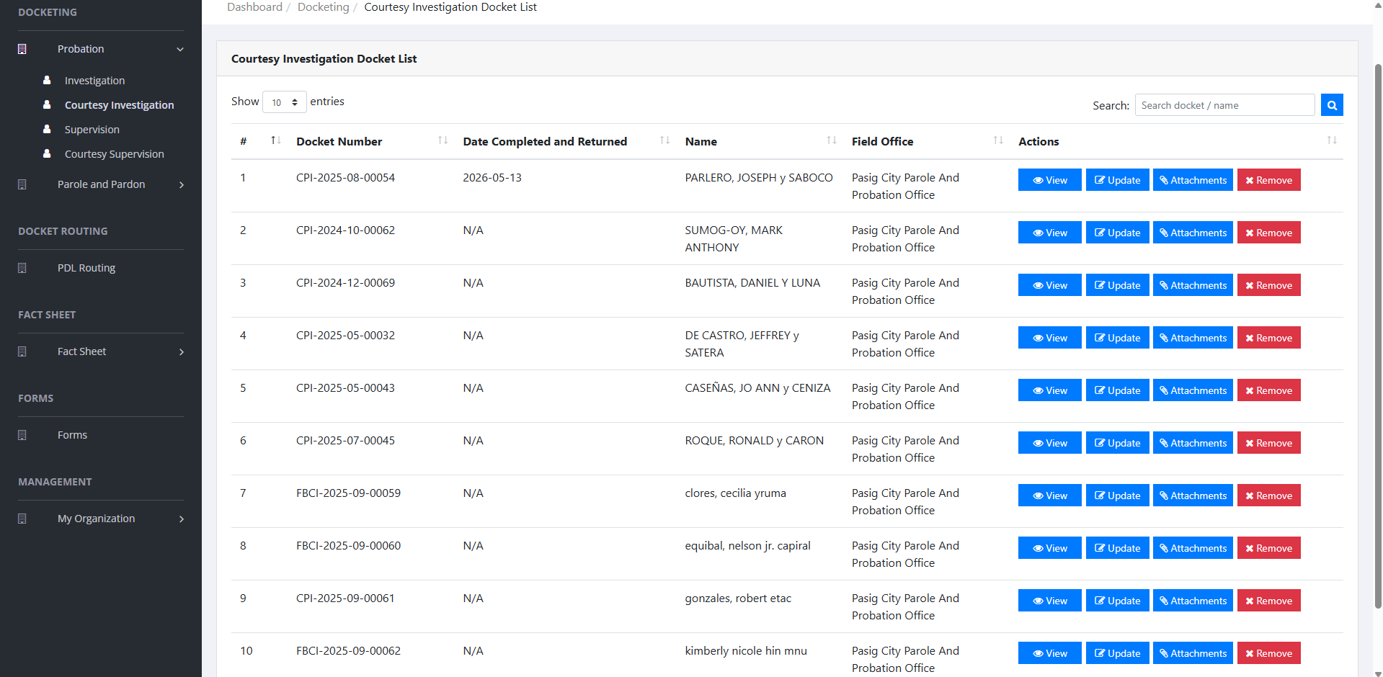
Figure 14 — Probation-Courtesy Investigation: Docket List
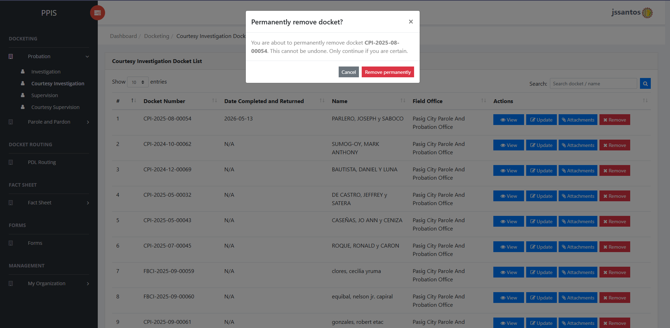
Figure 15 — Probation-Courtesy Investigation: Remove
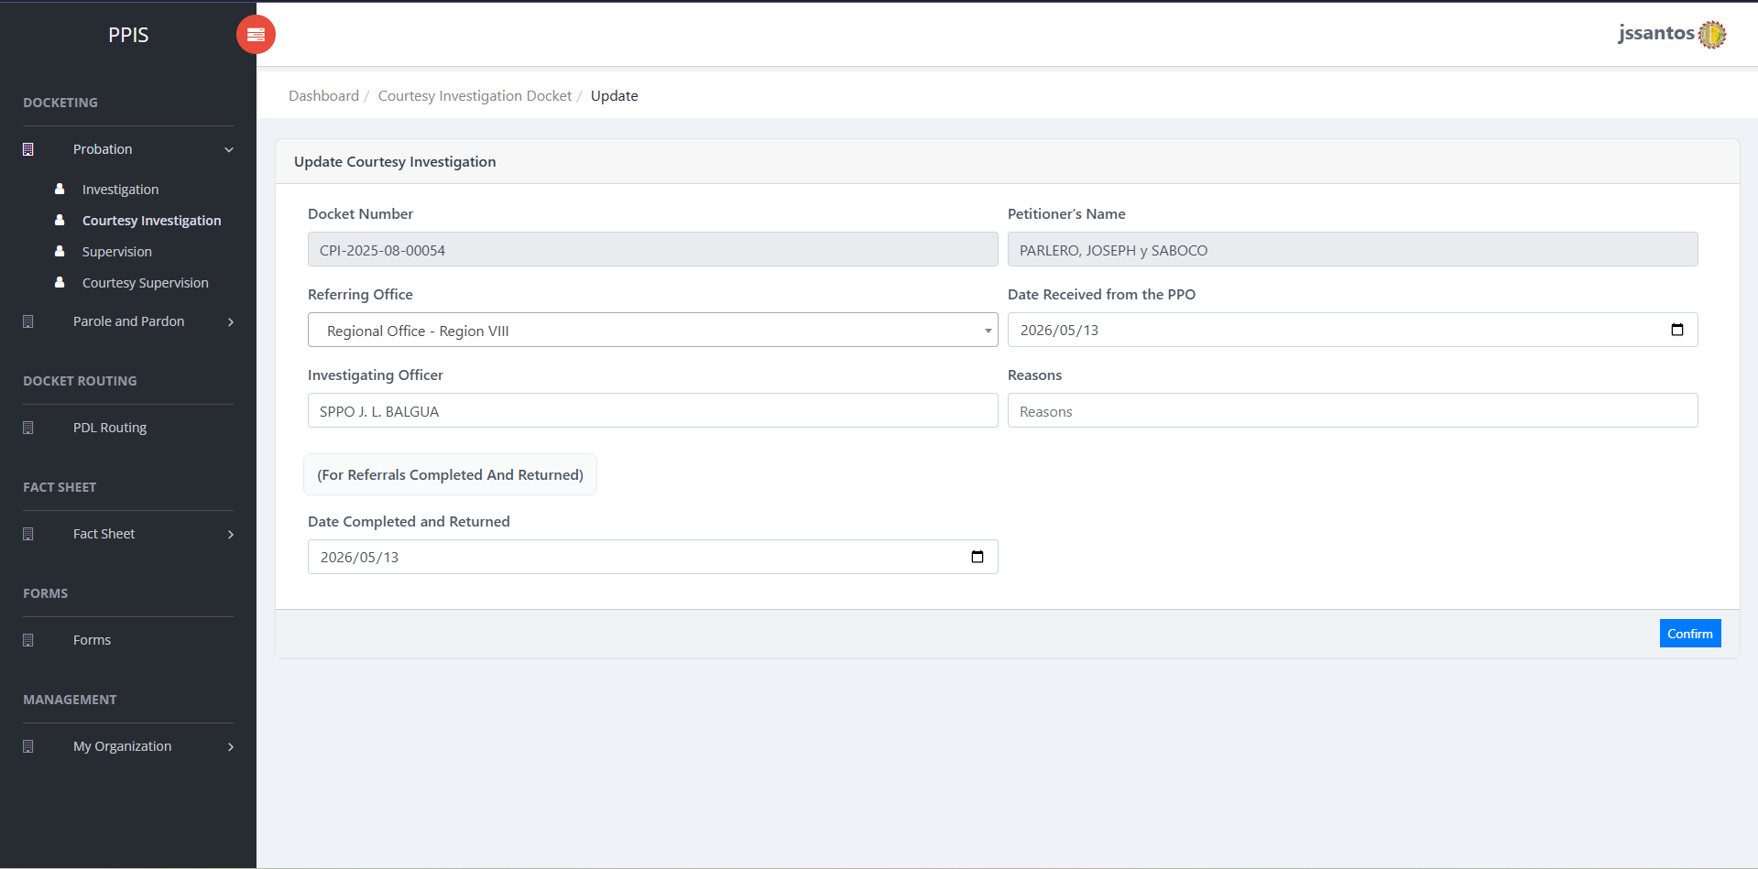
Figure 16 — Probation-Courtesy Investigation: Update
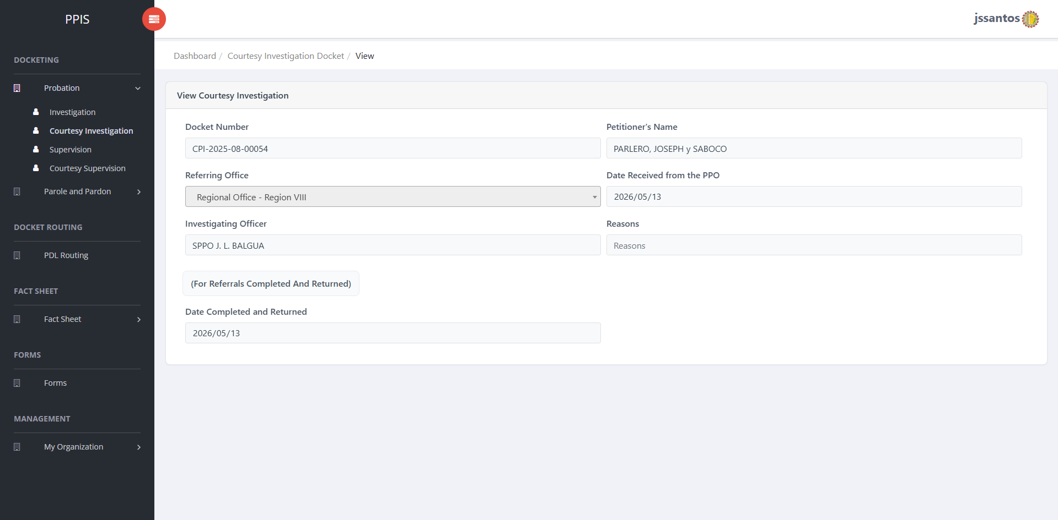
Figure 17 — Probation-Courtesy Investigation: View
────────────────────────────────────────────────────────

6.3 Probation – Supervision Docketing
Purpose: Maintain supervision dockets (ongoing supervision after sentencing or program placement, per office rules).
How to access: Probation › Supervision.
Usage: List and row actions mirror investigation screens; supervision-specific task lists appear in routing and update screens.
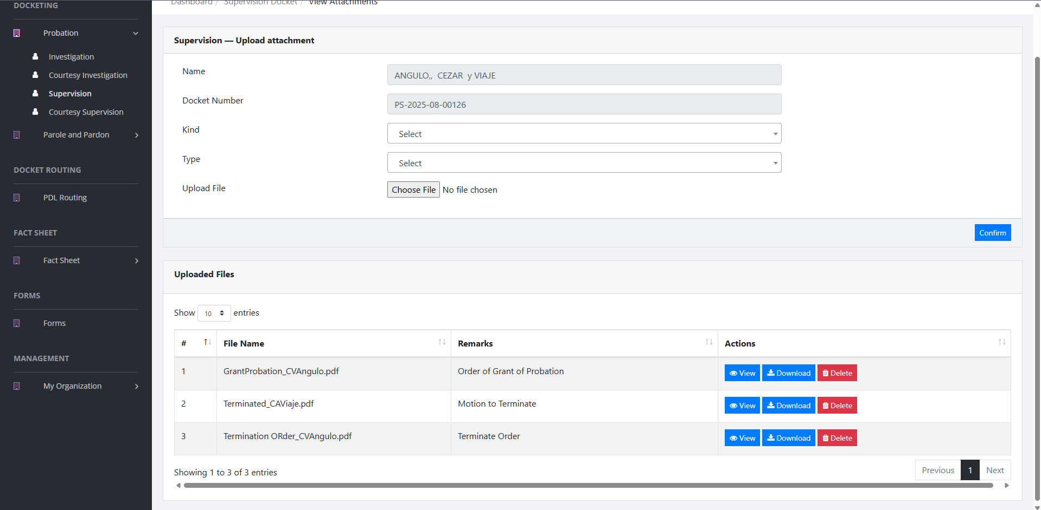
Figure 18 — Probation-Supervision: Attachments
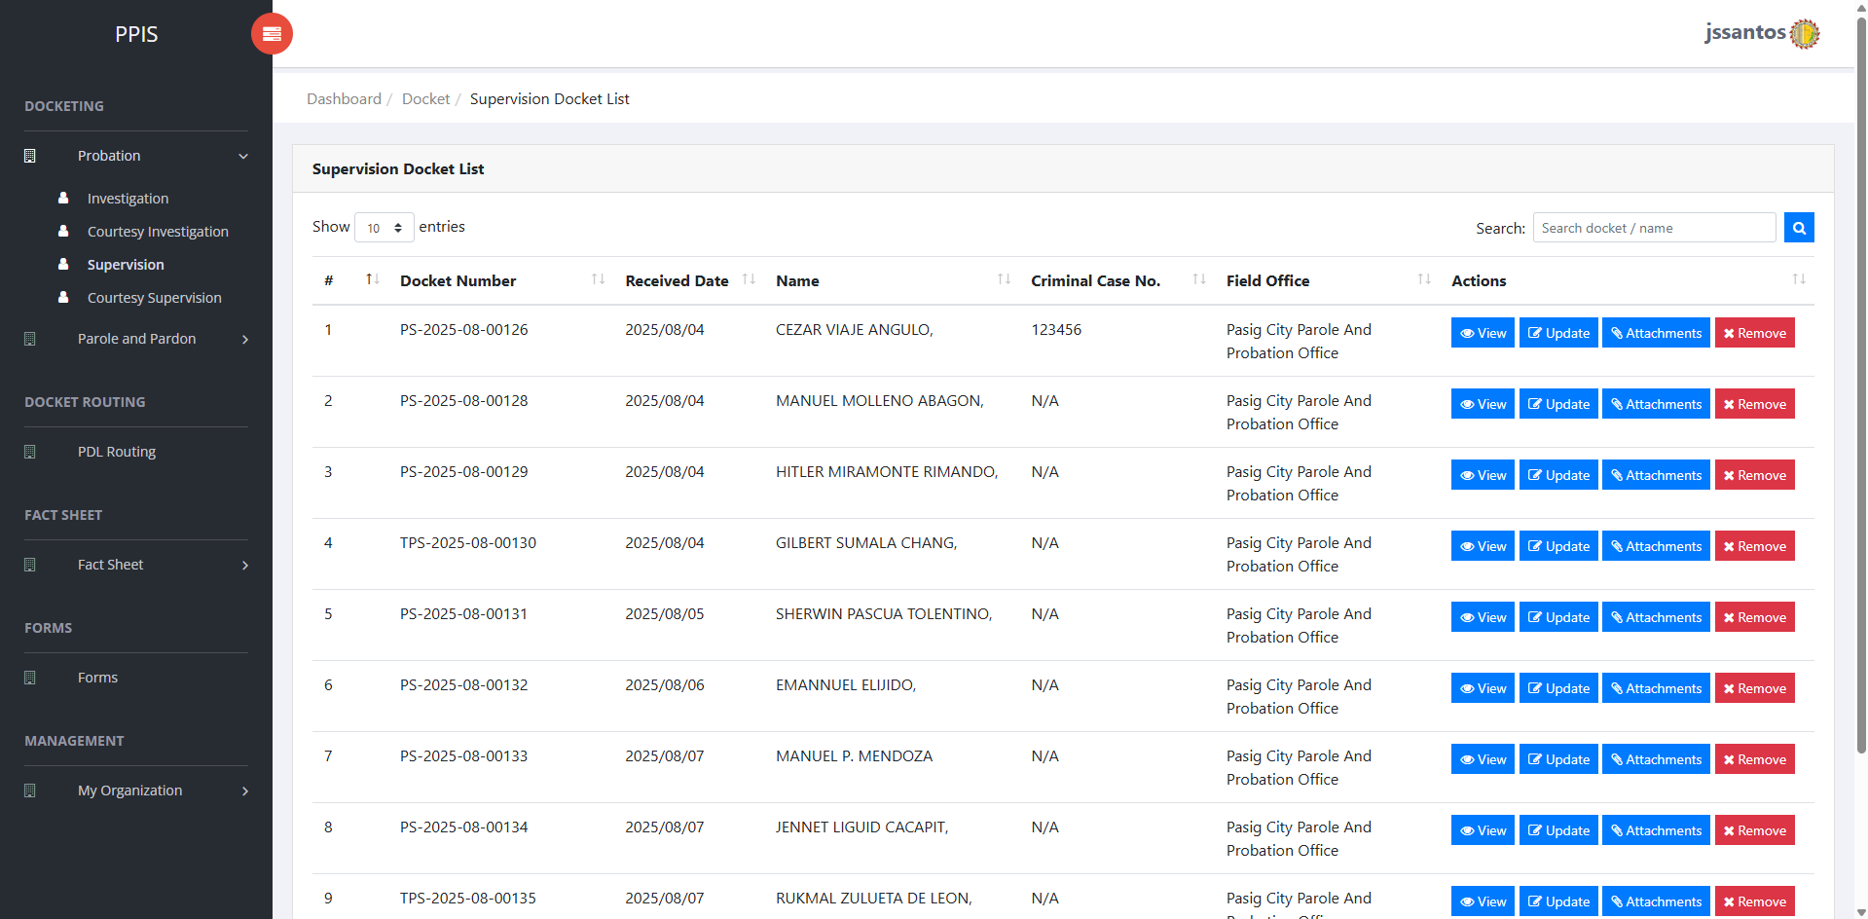
Figure 19 — Probation-Supervision: Docket List
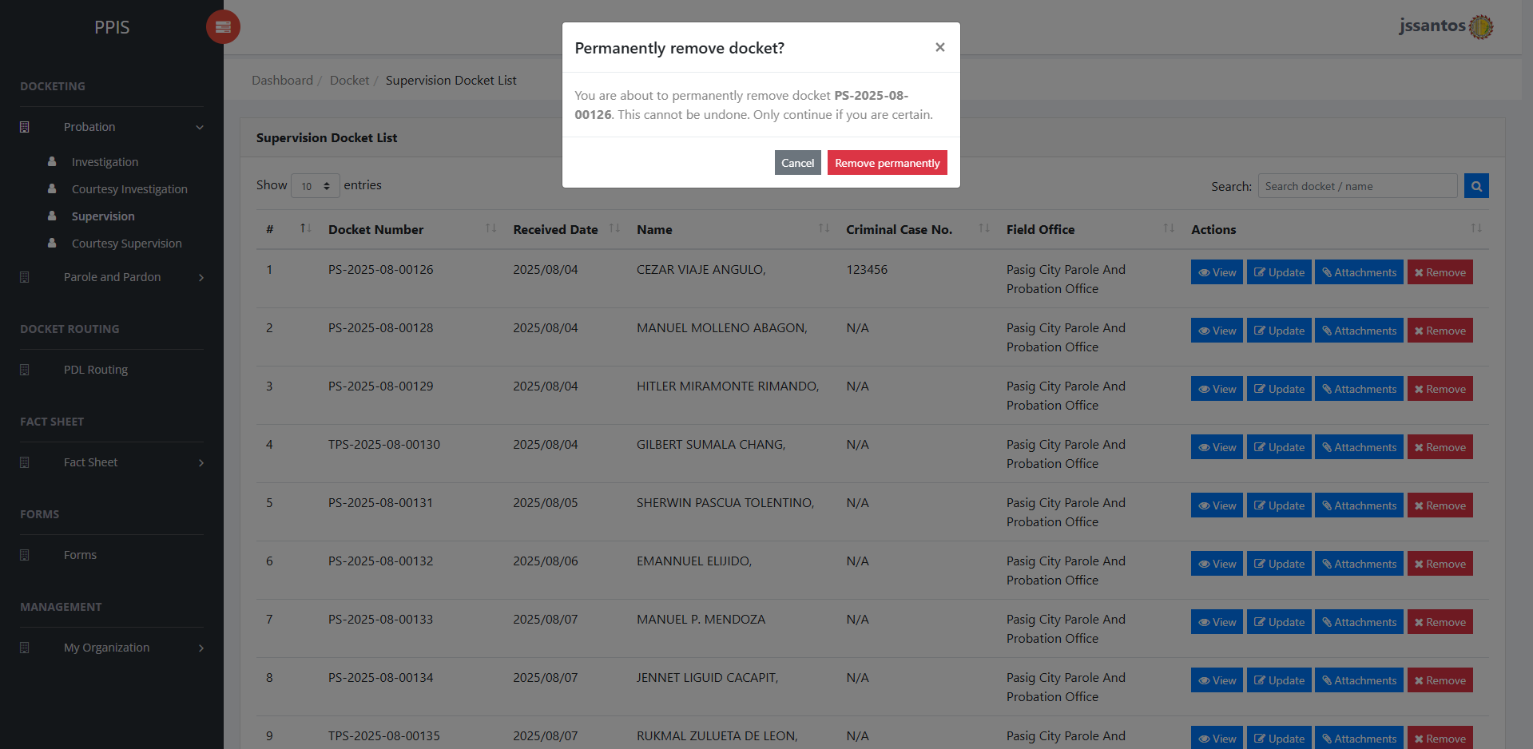
Figure 20 — Probation-Supervision: Remove
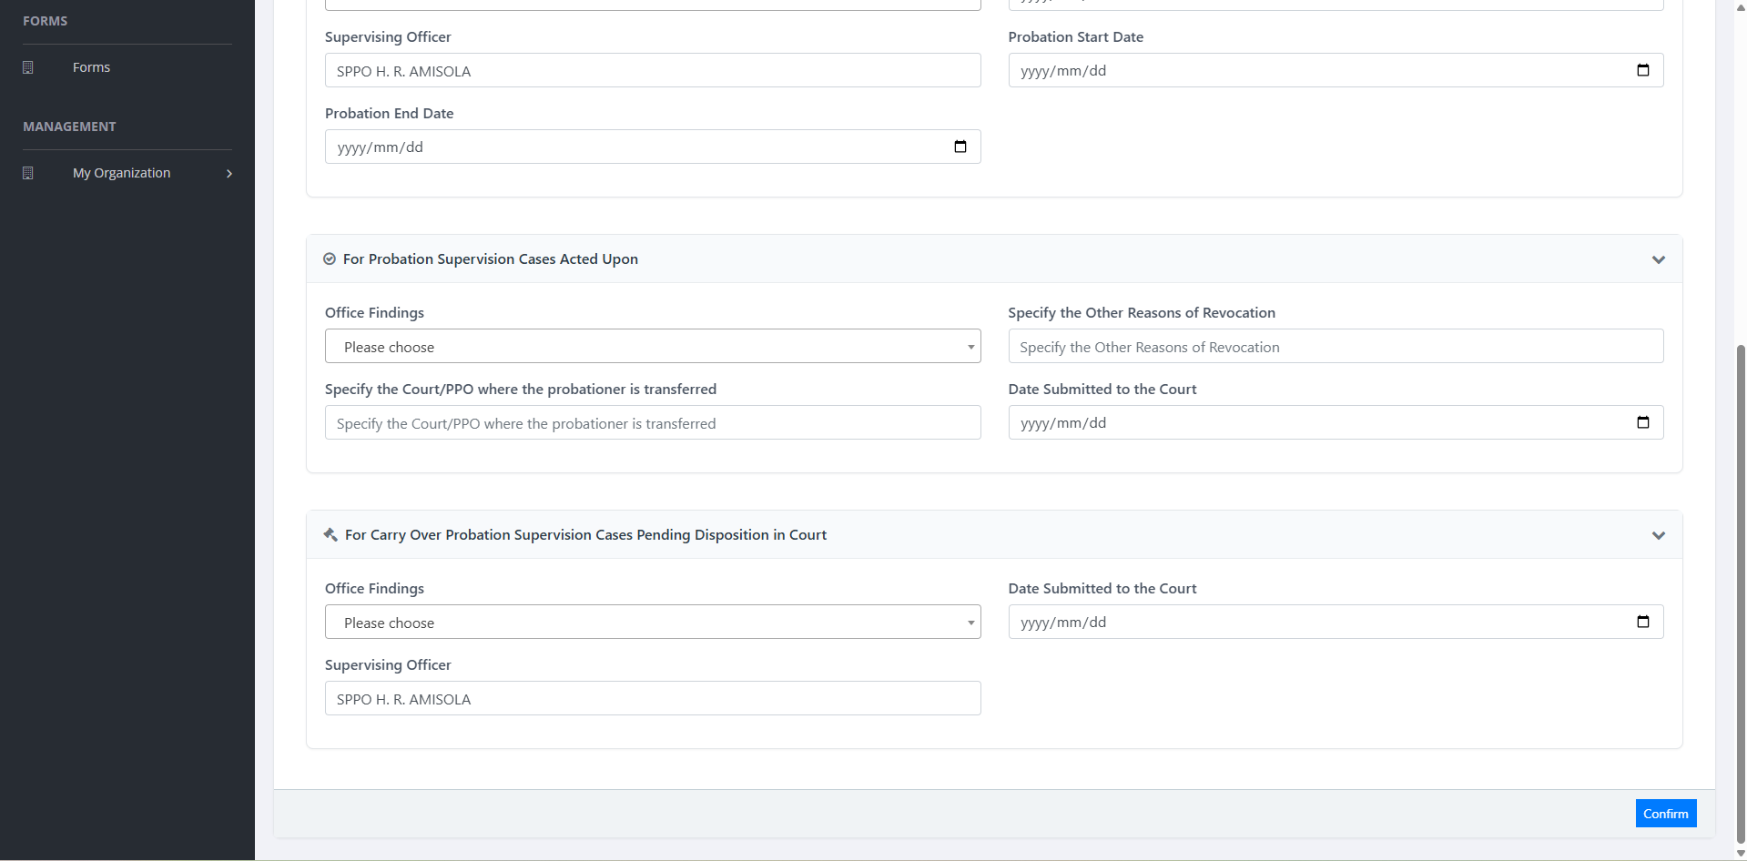
Figure 21 — Probation-Supervision: Update Part 2
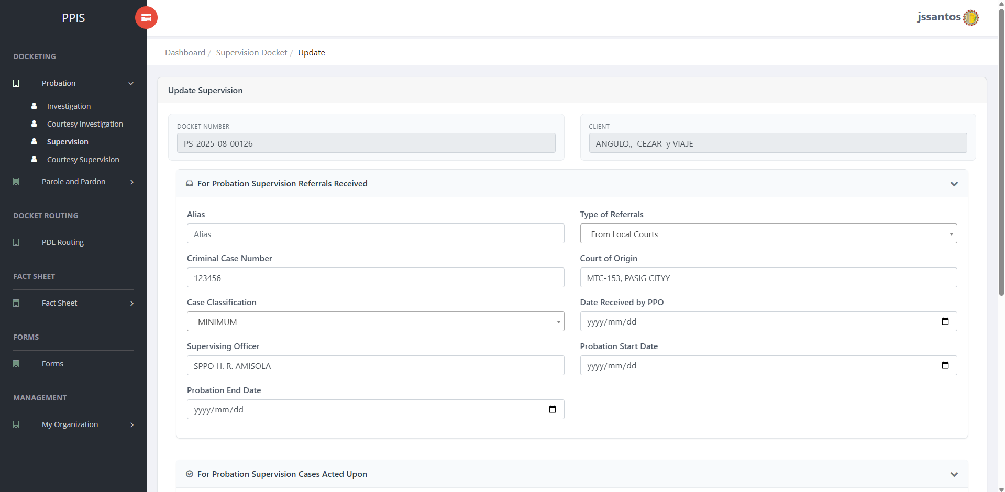
Figure 22 — Probation-Supervision: Update
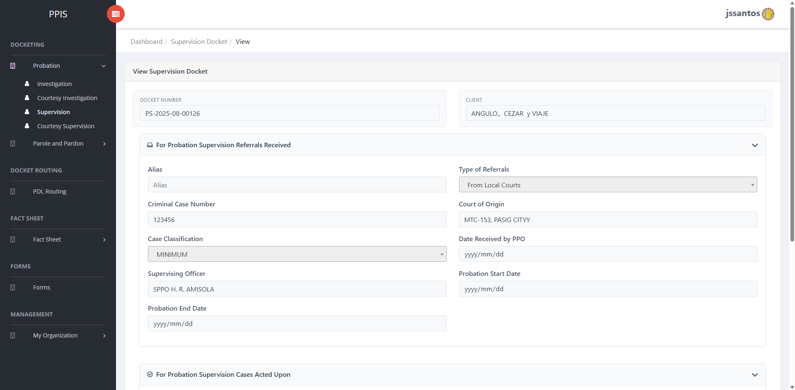
Figure 23 — Probation-Supervision: View
────────────────────────────────────────────────────────

6.4 Probation – Courtesy Supervision
Purpose: Courtesy supervision tracking for probation.
How to access: Probation › Courtesy Supervision.
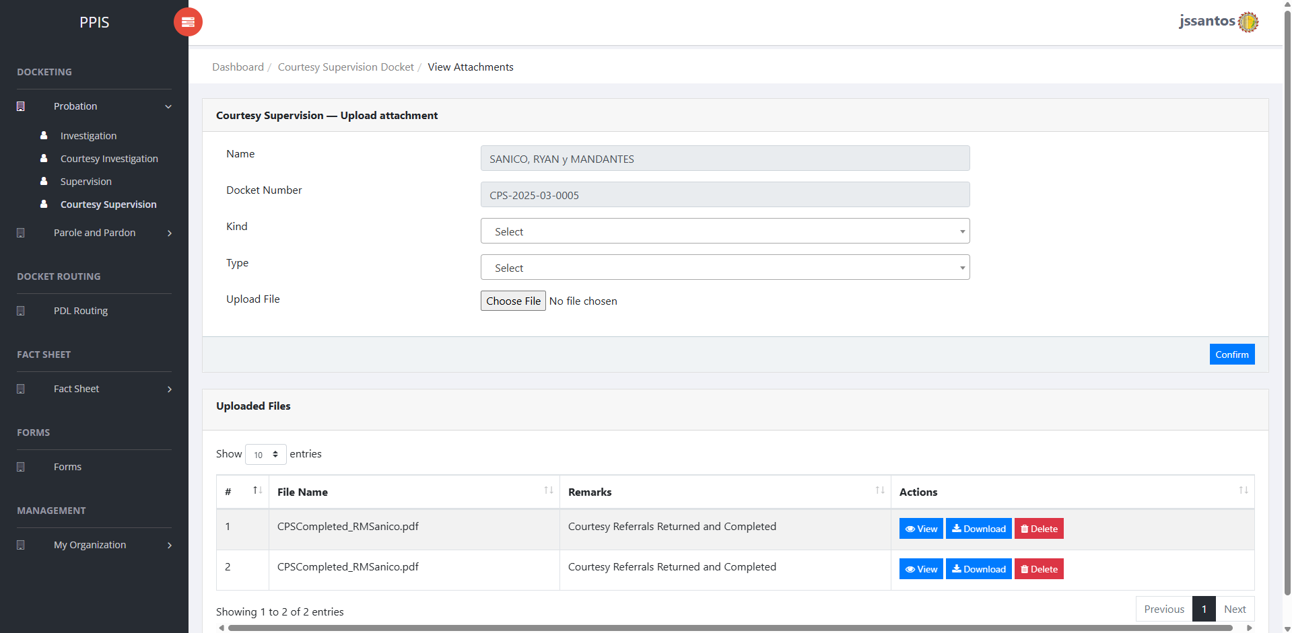
Figure 24 — Probation-Courtesy Supervision: Attachments
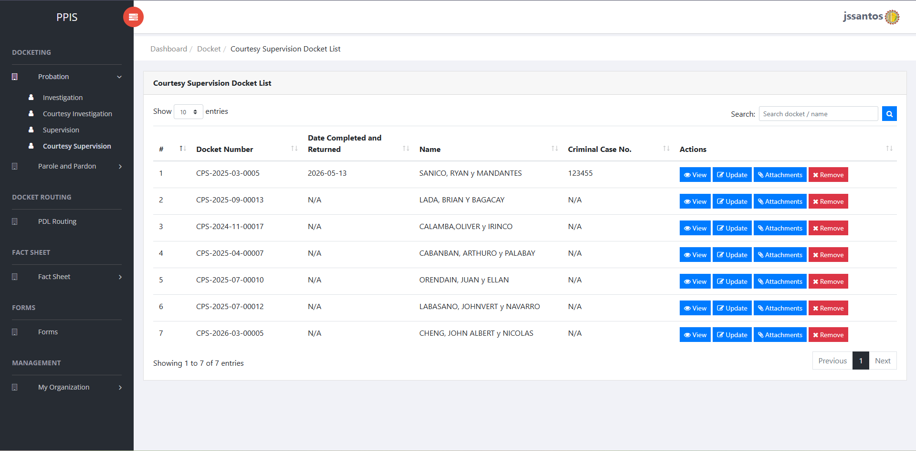
Figure 25 — Probation-Courtesy Supervision: Docket List
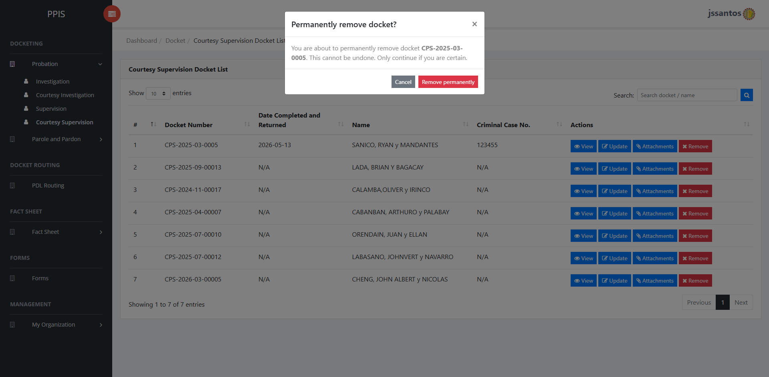
Figure 26 — Probation-Courtesy Supervision: Remove
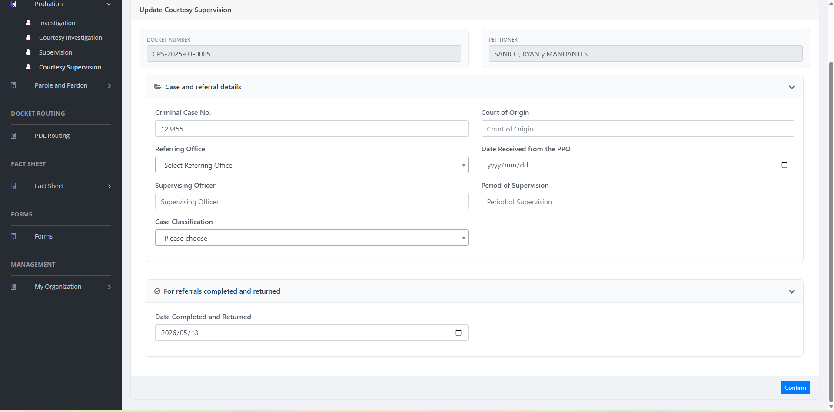
Figure 27 — Probation-Courtesy Supervision: Update
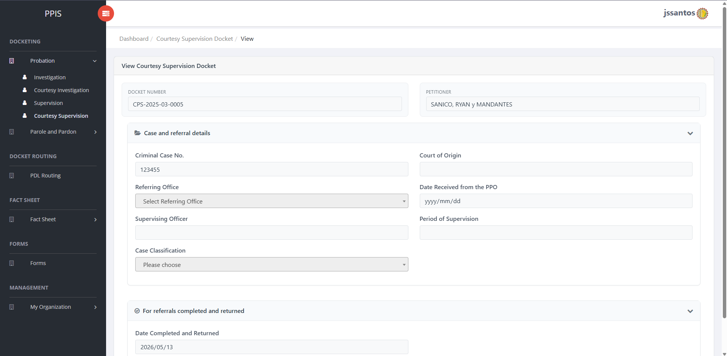
Figure 28 — Probation-Courtesy Supervision: View
────────────────────────────────────────────────────────

6.5 Parole and Pardon – Investigation
Purpose: Docketing for parole / pre-parole investigation style work under the Parole and Pardon branch menu.
How to access: Parole and Pardon › Investigation.
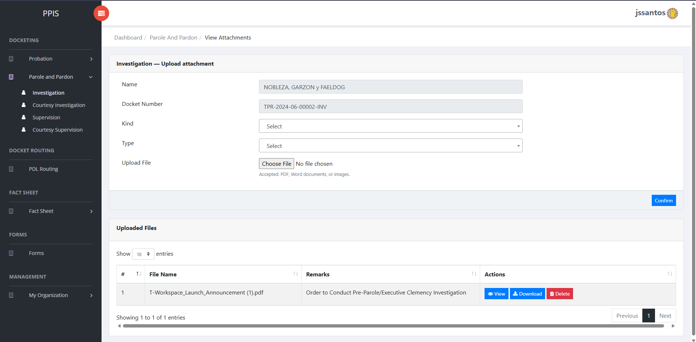
Figure 29 — Parole and Pardon - Investigation: Attachments
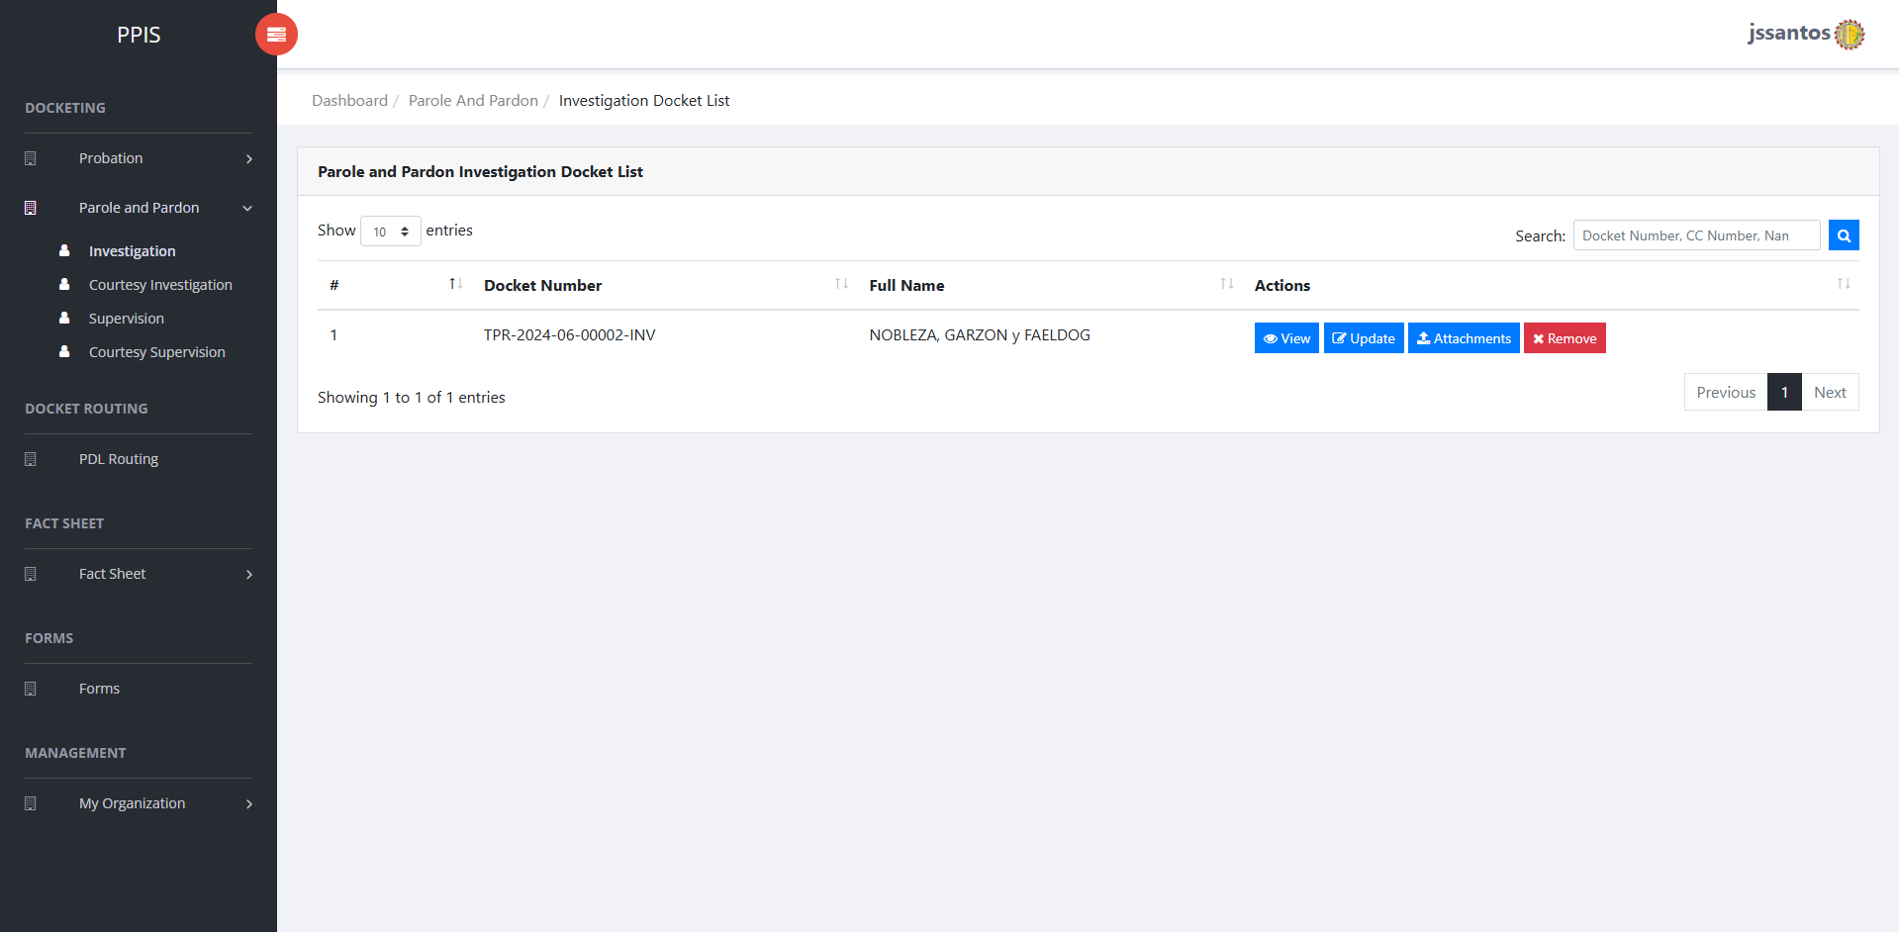
Figure 30 — Parole and Pardon - Investigation: Docket List
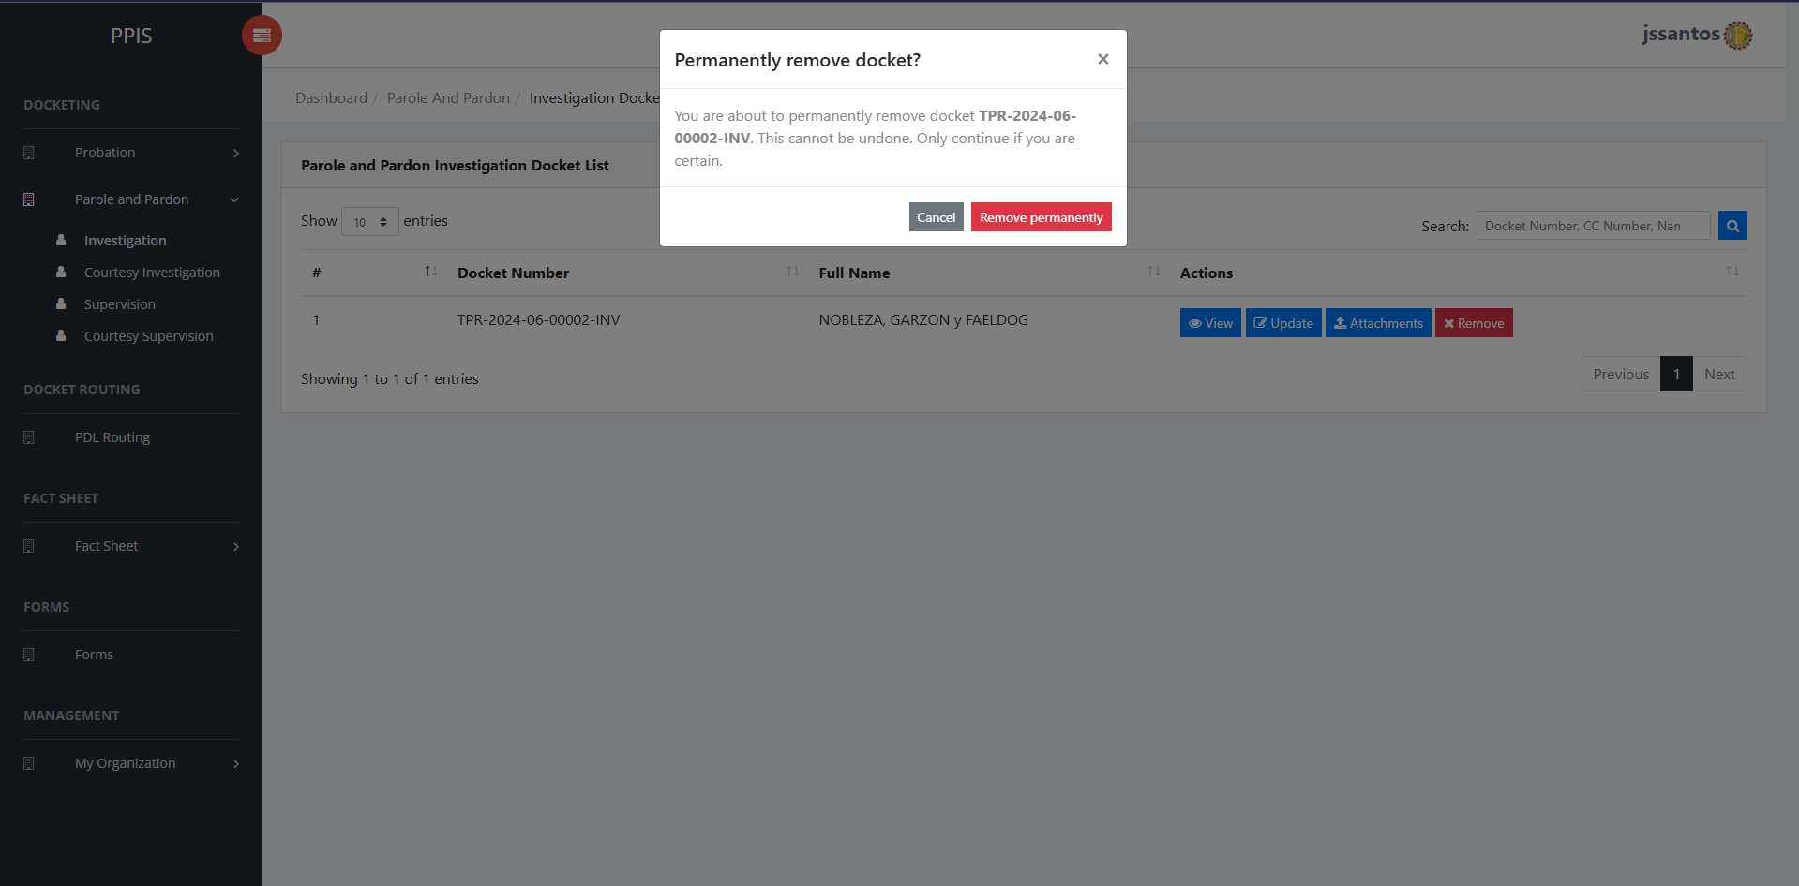
Figure 31 — Parole and Pardon - Investigation: Remove
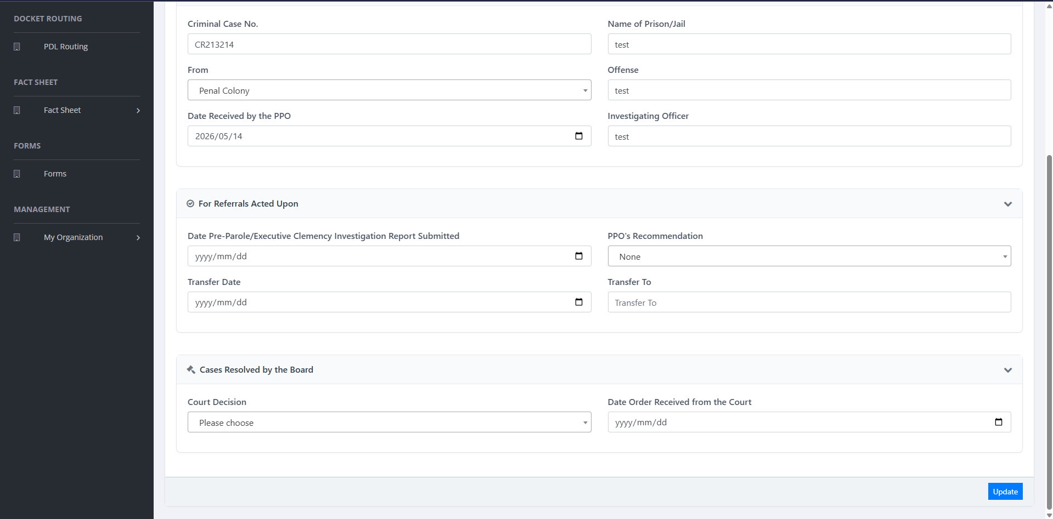
Figure 32 — Parole and Pardon - Investigation: Update 2
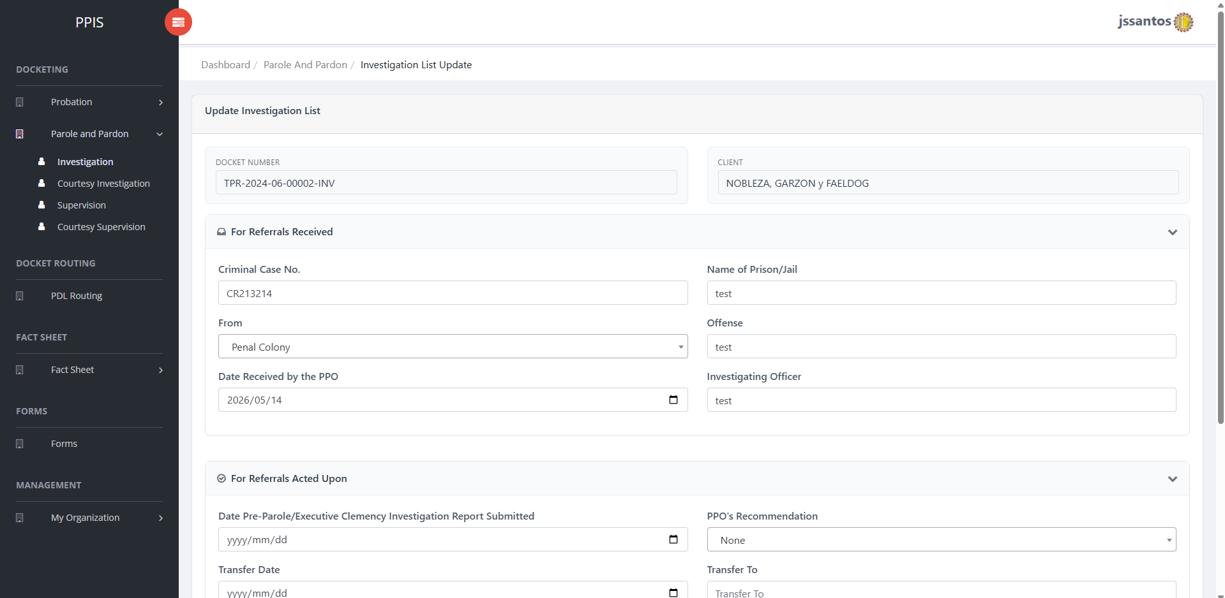
Figure 33 — Parole and Pardon - Investigation: Update
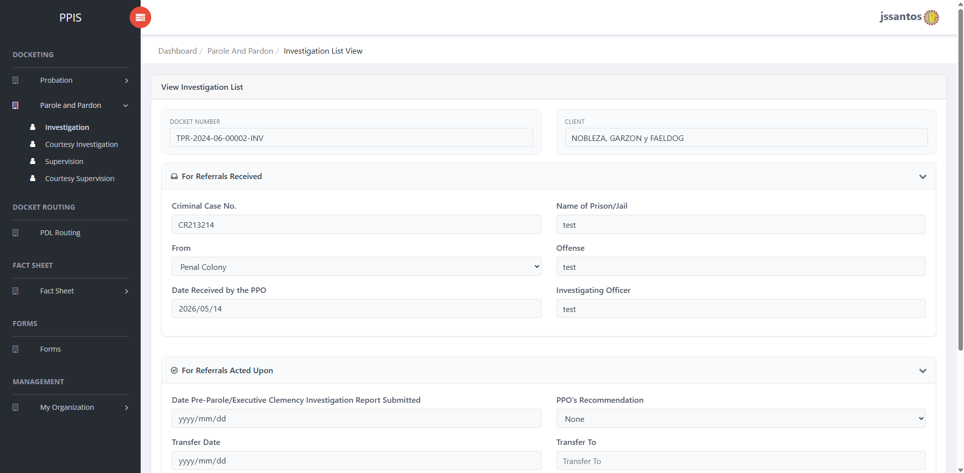
Figure 34 — Parole and Pardon - Investigation: View
────────────────────────────────────────────────────────

6.6 Parole and Pardon – Courtesy Investigation
Purpose: Courtesy investigation under the Parole and Pardon menu.
How to access: Parole and Pardon › Courtesy Investigation.
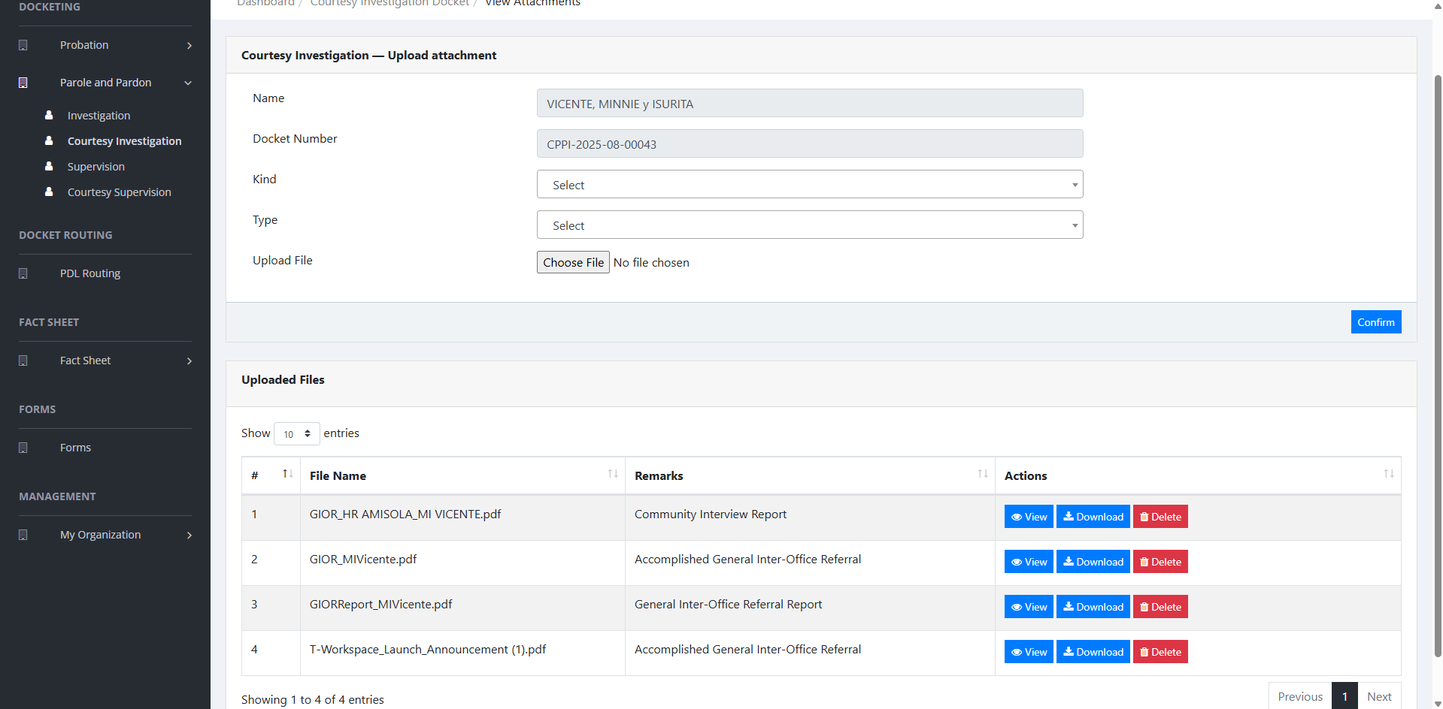
Figure 35 — Parole and Pardon - Courtesy Investigation: Attachments
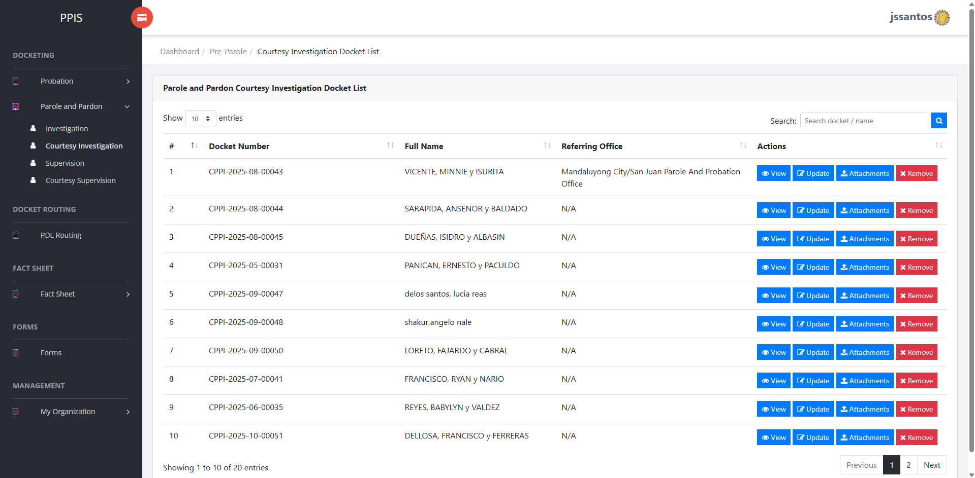
Figure 36 — Parole and Pardon - Courtesy Investigation: Docket List
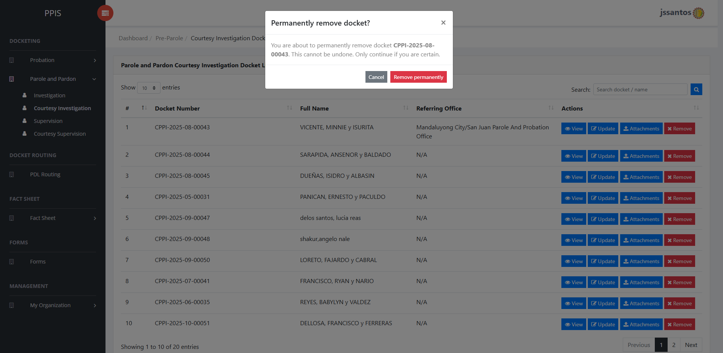
Figure 37 — Parole and Pardon - Courtesy Investigation: Remove
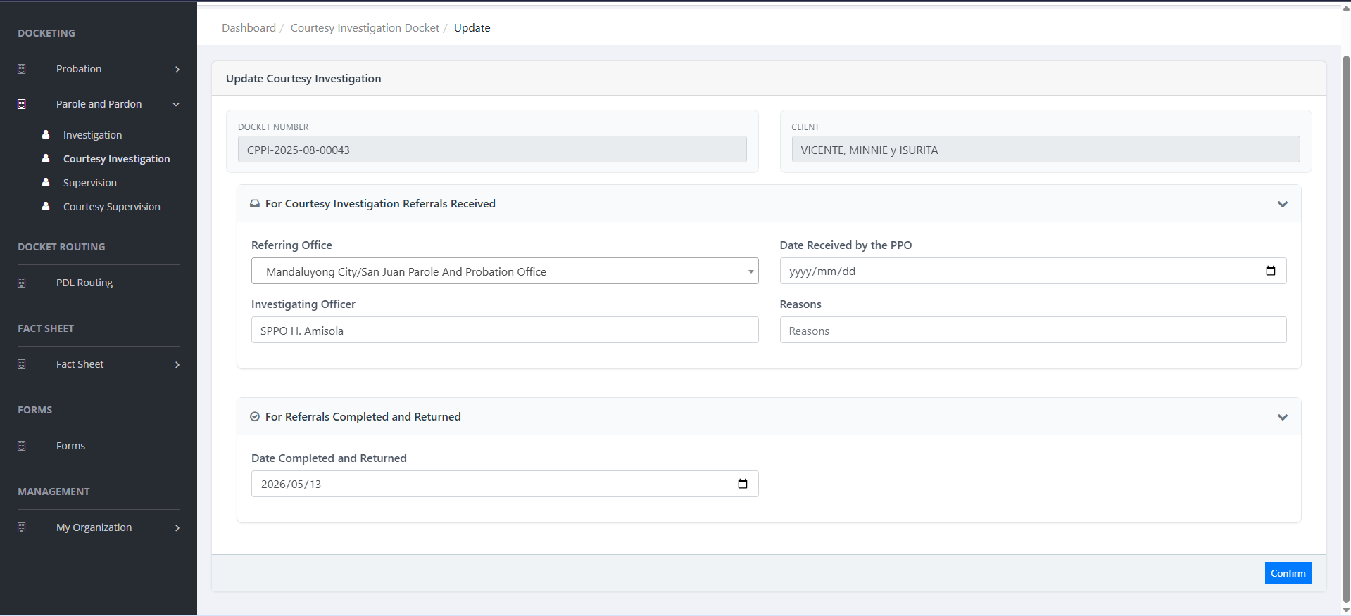
Figure 38 — Parole and Pardon - Courtesy Investigation: Update
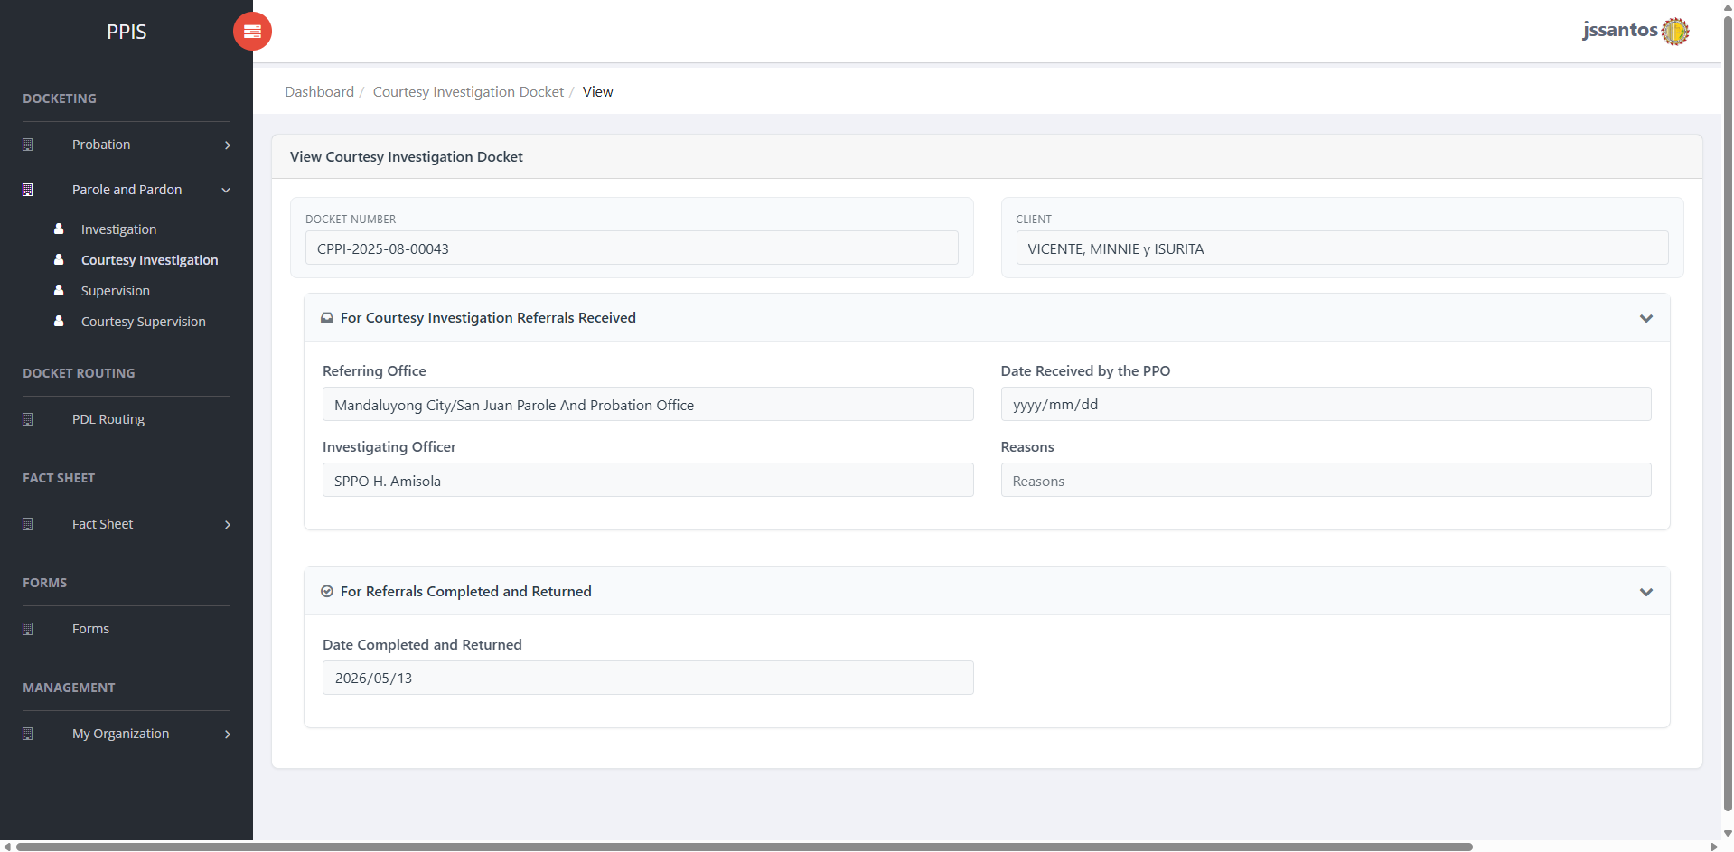
Figure 39 — Parole and Pardon - Courtesy Investigation: View
────────────────────────────────────────────────────────

6.7 Parole and Pardon – Supervision
Purpose: Supervision dockets for the Parole and Pardon menu.
How to access: Parole and Pardon › Supervision.
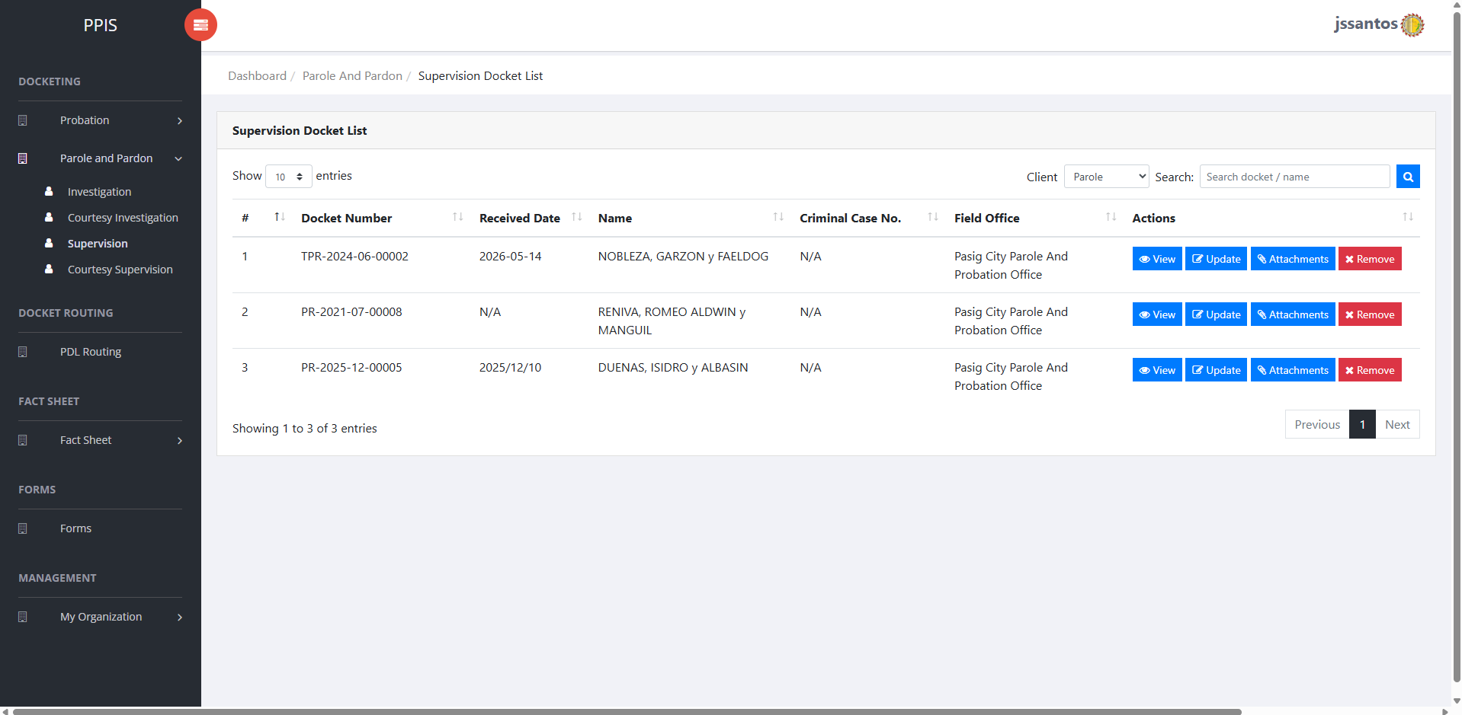
Figure 40 — Parole and Pardon - Supervision: Docket List
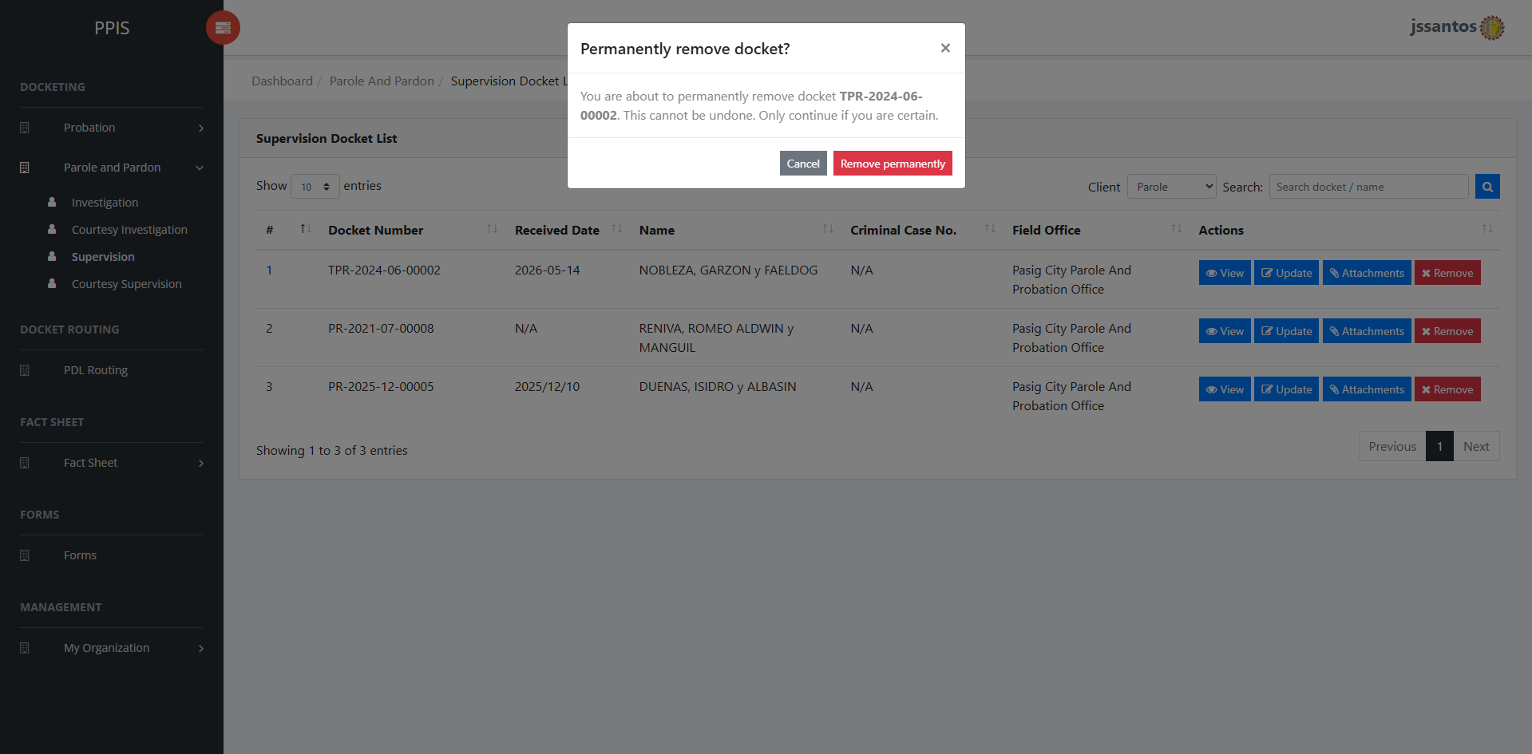
Figure 41 — Parole and Pardon - Supervision: Remove
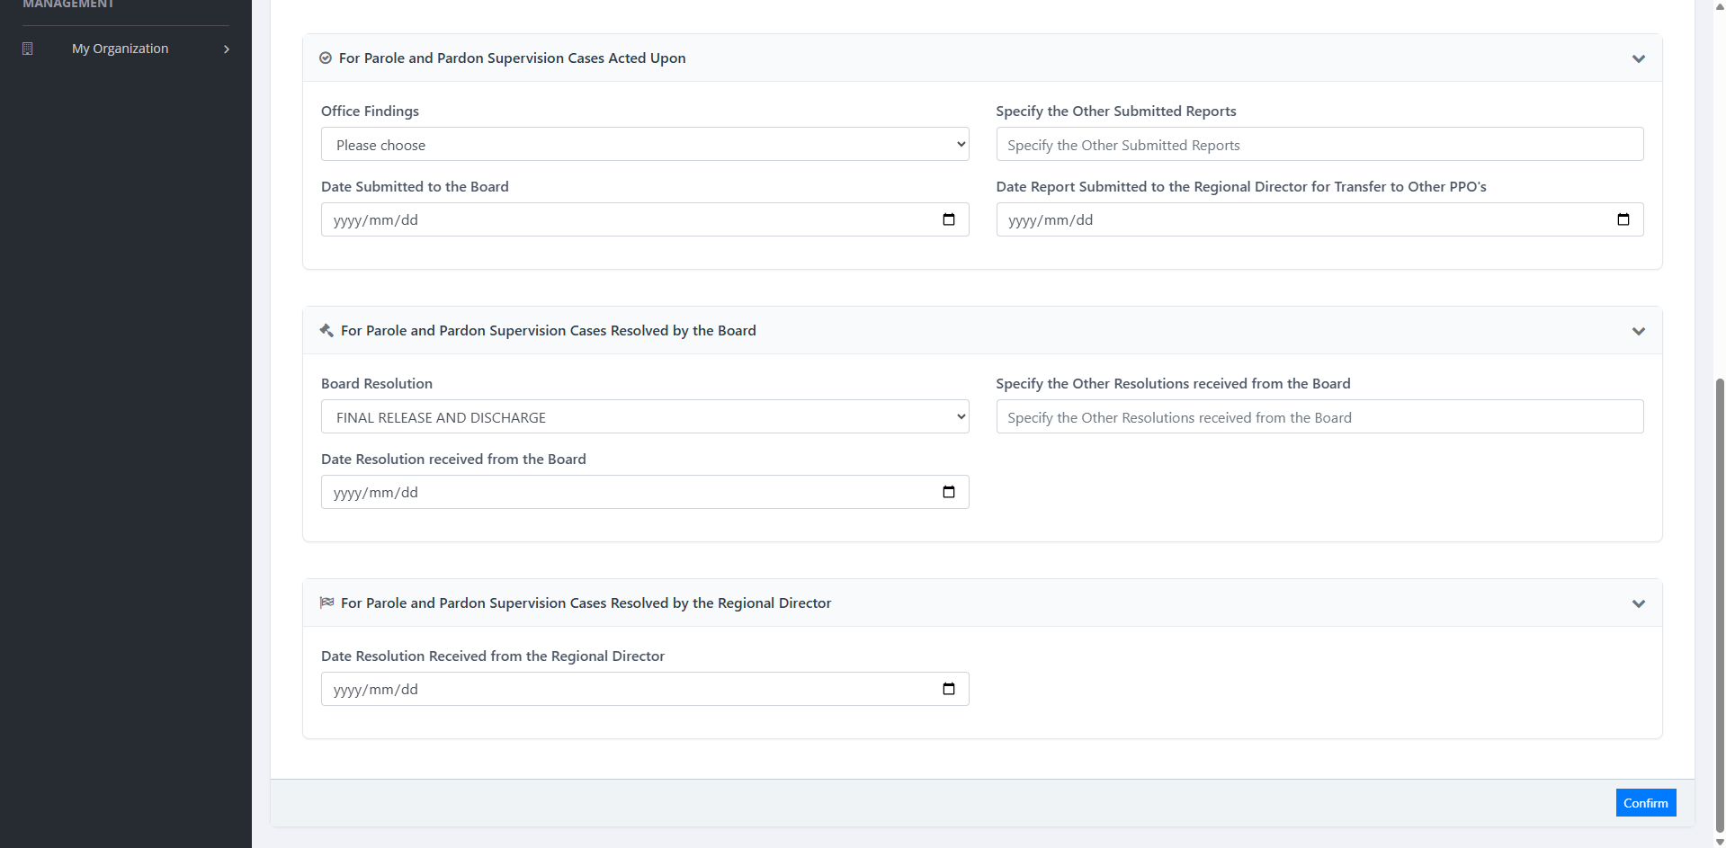
Figure 42 — Parole and Pardon - Supervision: Update 2
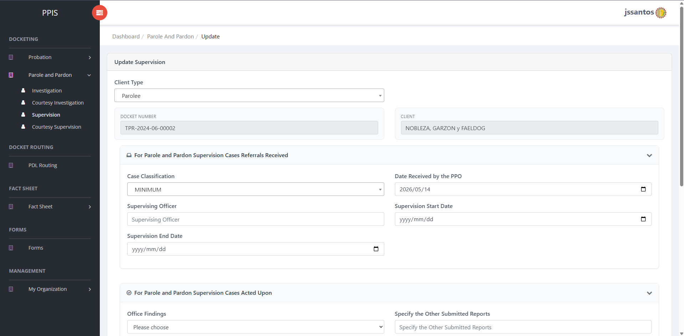
Figure 43 — Parole and Pardon - Supervision: Update
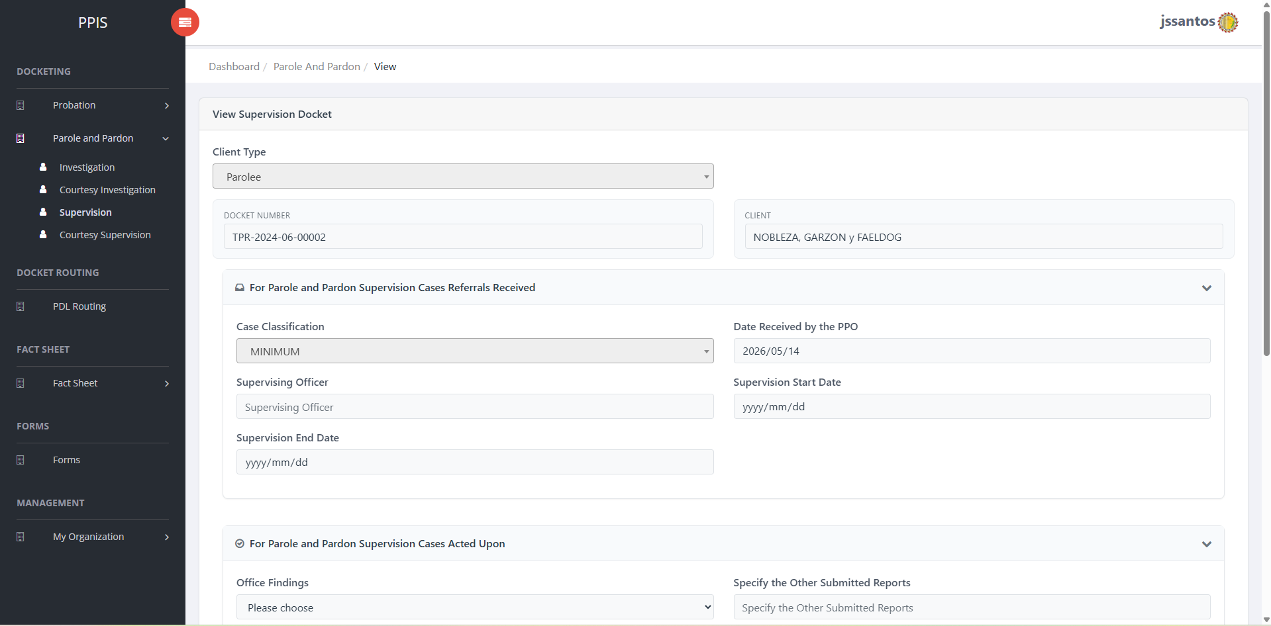
Figure 44 — Parole and Pardon - Supervision: View
────────────────────────────────────────────────────────

6.8 Parole and Pardon – Courtesy Supervision
Purpose: Courtesy supervision under Parole and Pardon.
How to access: Parole and Pardon › Courtesy Supervision.
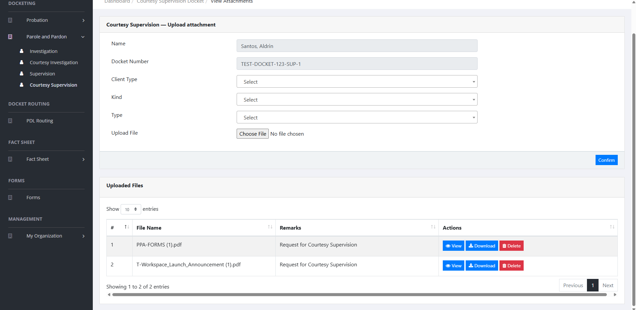
Figure 45 — Parole and Pardon - Courtesy Supervision: Attachments
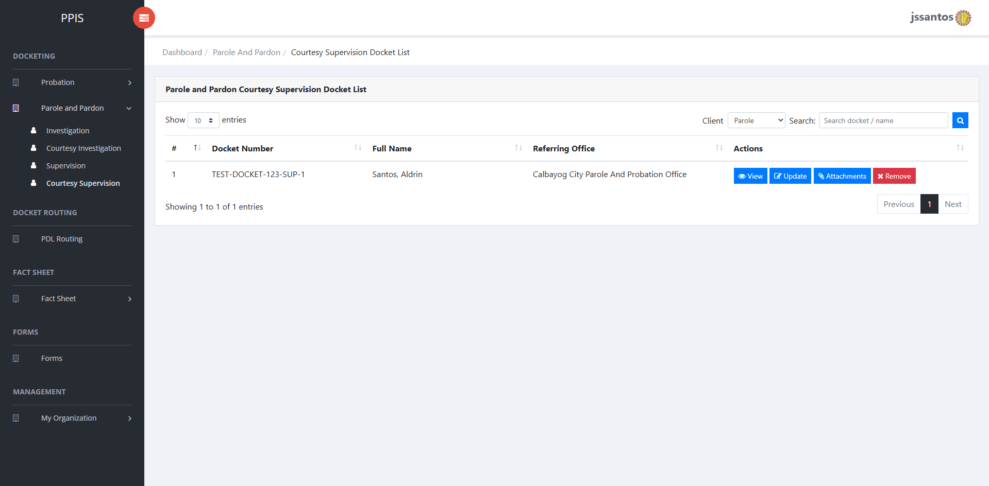
Figure 46 — Parole and Pardon - Courtesy Supervision: Docket List
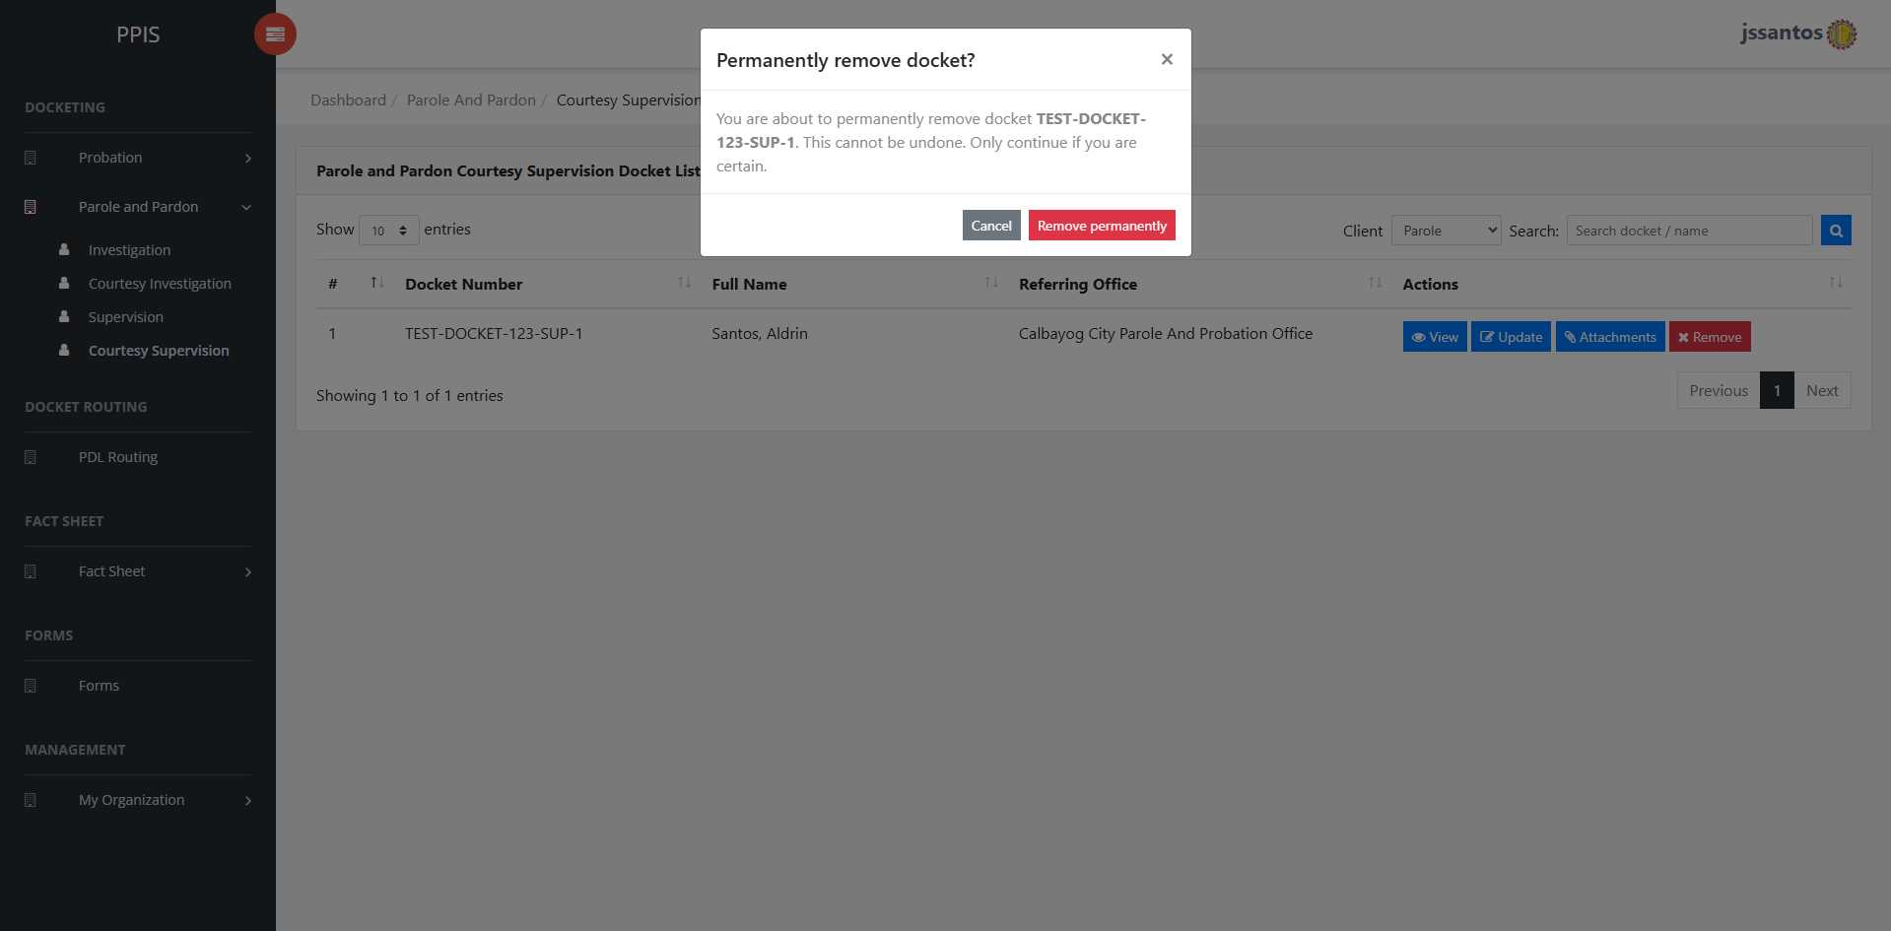
Figure 47 — Parole and Pardon - Courtesy Supervision: Remove
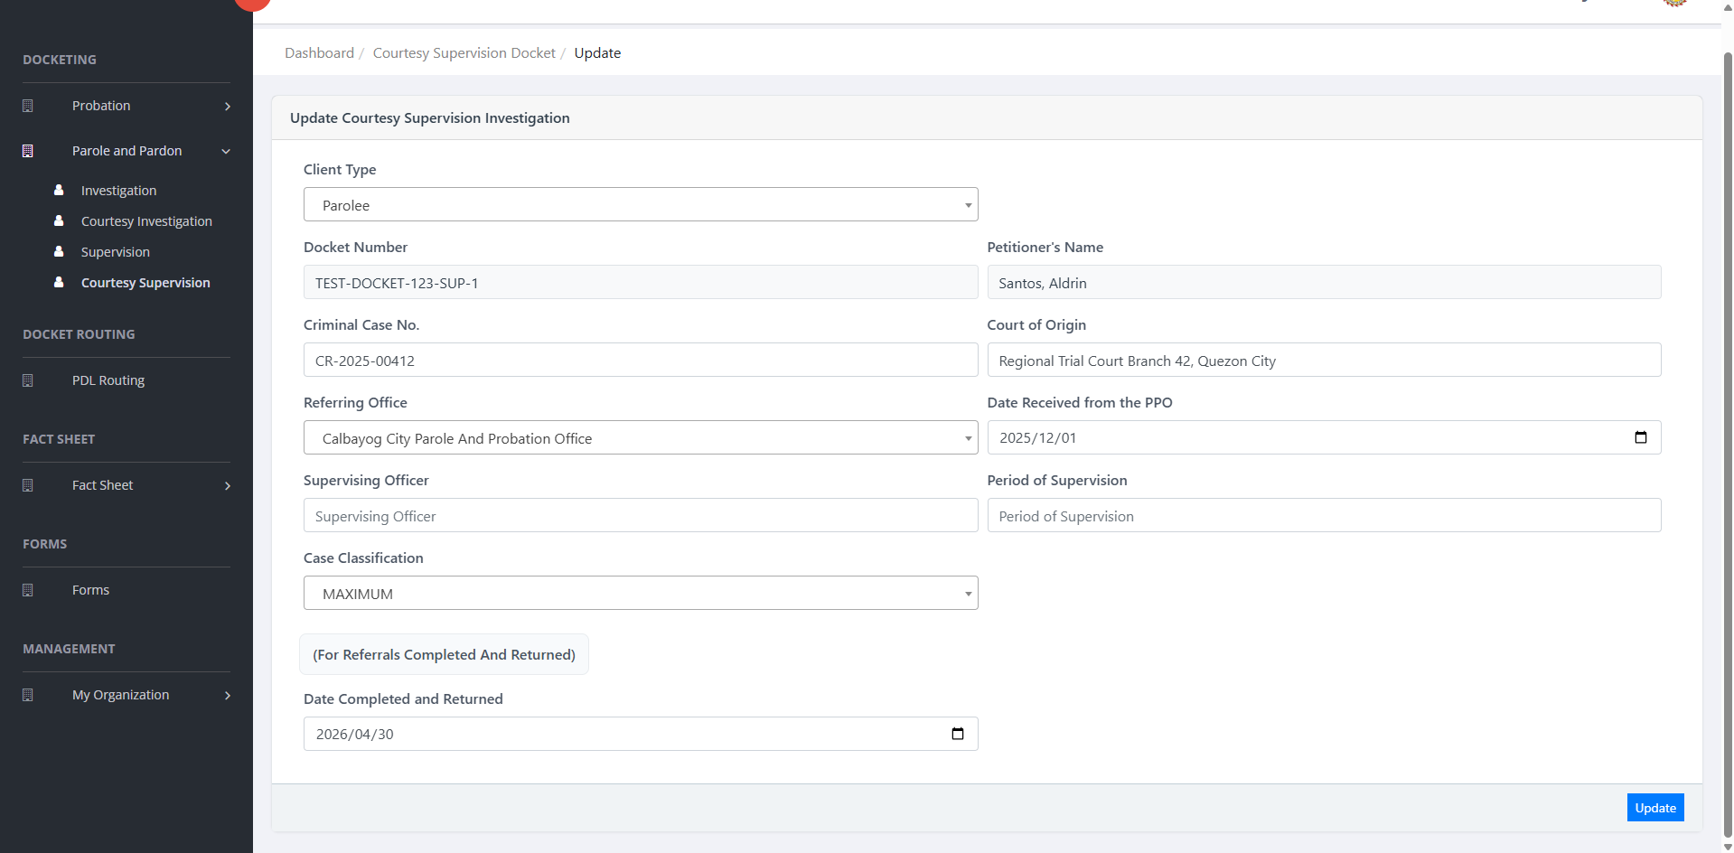
Figure 48 — Parole and Pardon - Courtesy Supervision: Update
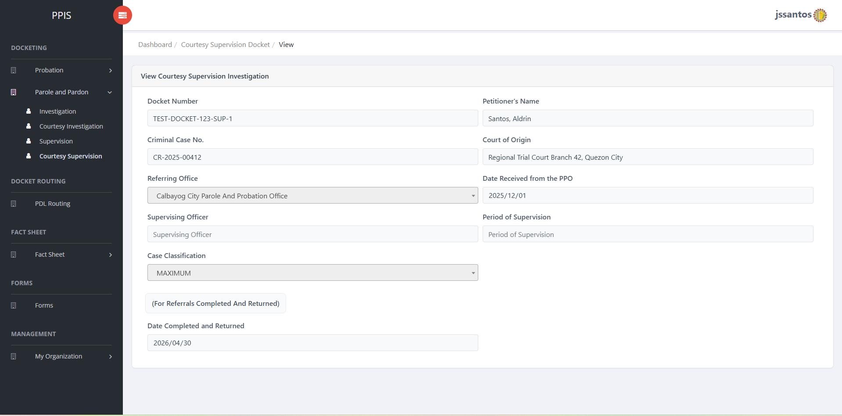
Figure 49 — Parole and Pardon - Courtesy Supervision: View
────────────────────────────────────────────────────────

6.9 PDL Routing
Purpose: Routing dedicated to PDL (Persons Deprived of Liberty) clients movement when your office enables it.
How to access: PDL Routing in the left menu.
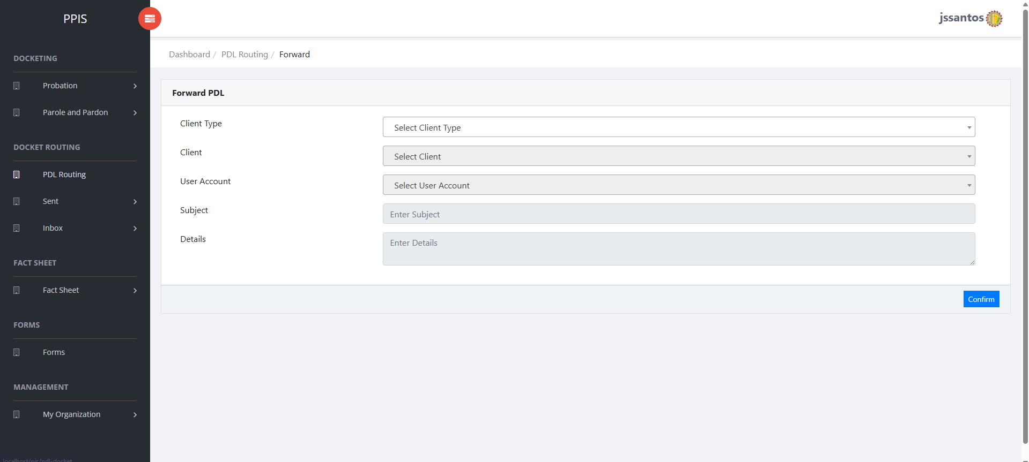
Screenshots for PDL routing.
────────────────────────────────────────────────────────

6.10 Sent (PDL)
Purpose: Review items your office has transmitted or marked as sent, filtered by program track.
How to access: Sent submenu and choose the matching line (Probation, Pre-Parole, Parole, Pardone, PDL).
Typical use: Verify date/time, destination, and reference numbers before answering audit or status questions.
────────────────────────────────────────────────────────

6.12 Inbox (Received)
Purpose: Review items received or awaiting action, by the same program tracks, plus PDL receive from TSD when applicable.
How to access: Inbox submenu.
Typical use: Acknowledge receipt in PPIS according to local procedure, then route or assign internally.
────────────────────────────────────────────────────────

6.13 Fact Sheet (Probation, Parole and Pardone, PDL)
Purpose: Central client lists and fact sheet workflows—creating clients, updating demographic and case facts, uploads, and viewing consolidated information.
How to access: Fact Sheet menu:
Submenu | Use
Probation | Probation client list and fact sheet.
Parole and Pardone | Combined parole/pardone client list.
PDL (Single Carpeta) | PDL / Single Carpeta client list.
Common actions:
- Client list – search or browse; open a row to view or update.
- New client (For PDL’s) – where enabled, use the new client flow from the list screen.
- Worksheet / PSIR – multi-step tabs or routes (Identifying Data, Present Offense, Family Background, and other sections). Complete tabs in order unless your supervisor directs otherwise.
- Uploads – attach required PDFs or scans from the client’s folder.
Warning: Never create duplicate client records for the same person to “fix” a typo—ask an administrator how to correct identifiers.
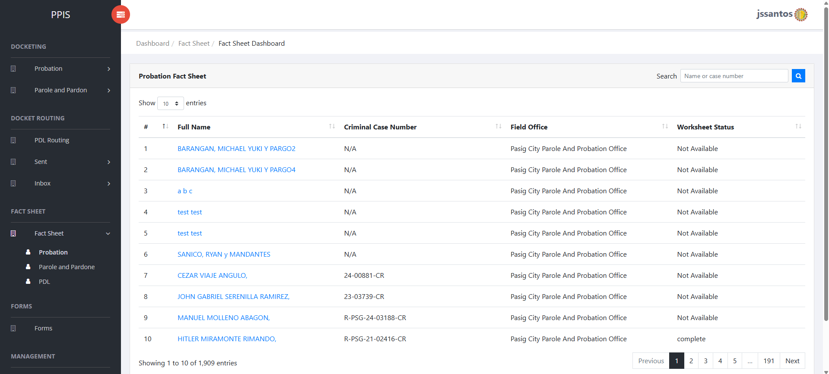
Screenshot for Fact Sheet - Probation.
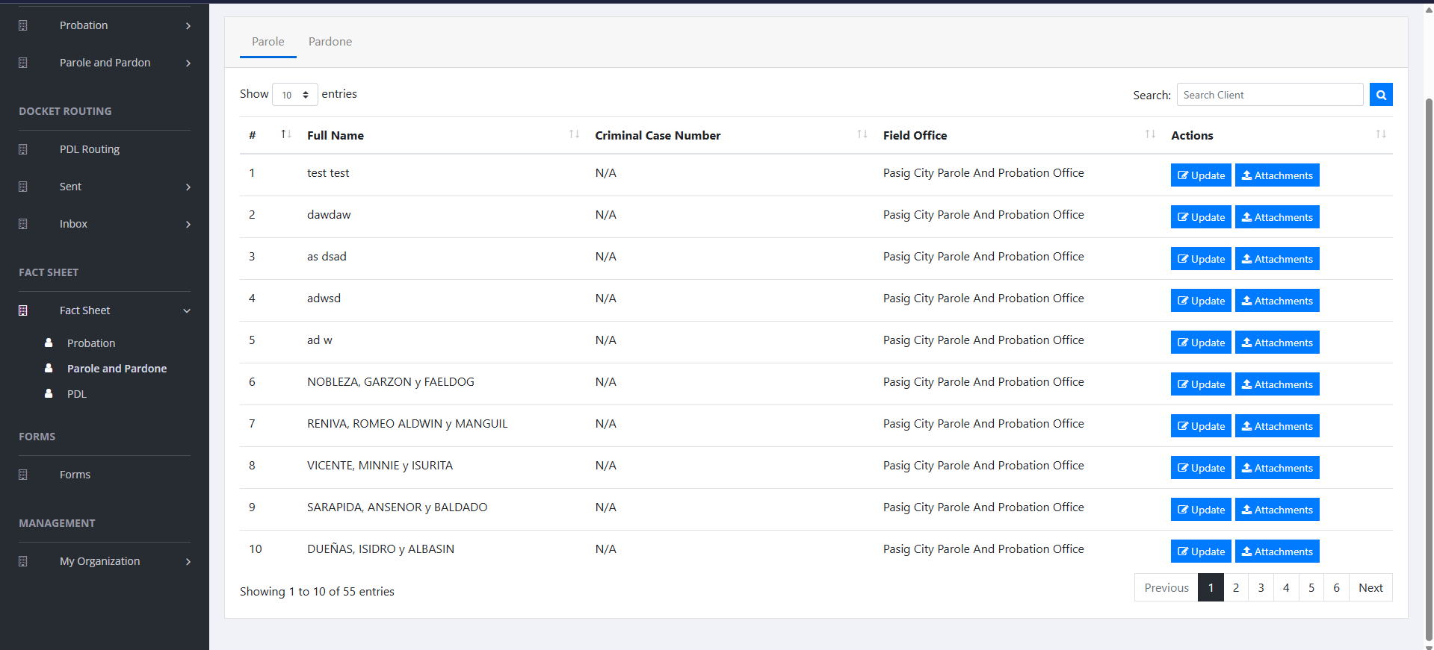
Screenshot for Fact Sheet - Parole and Pardon.
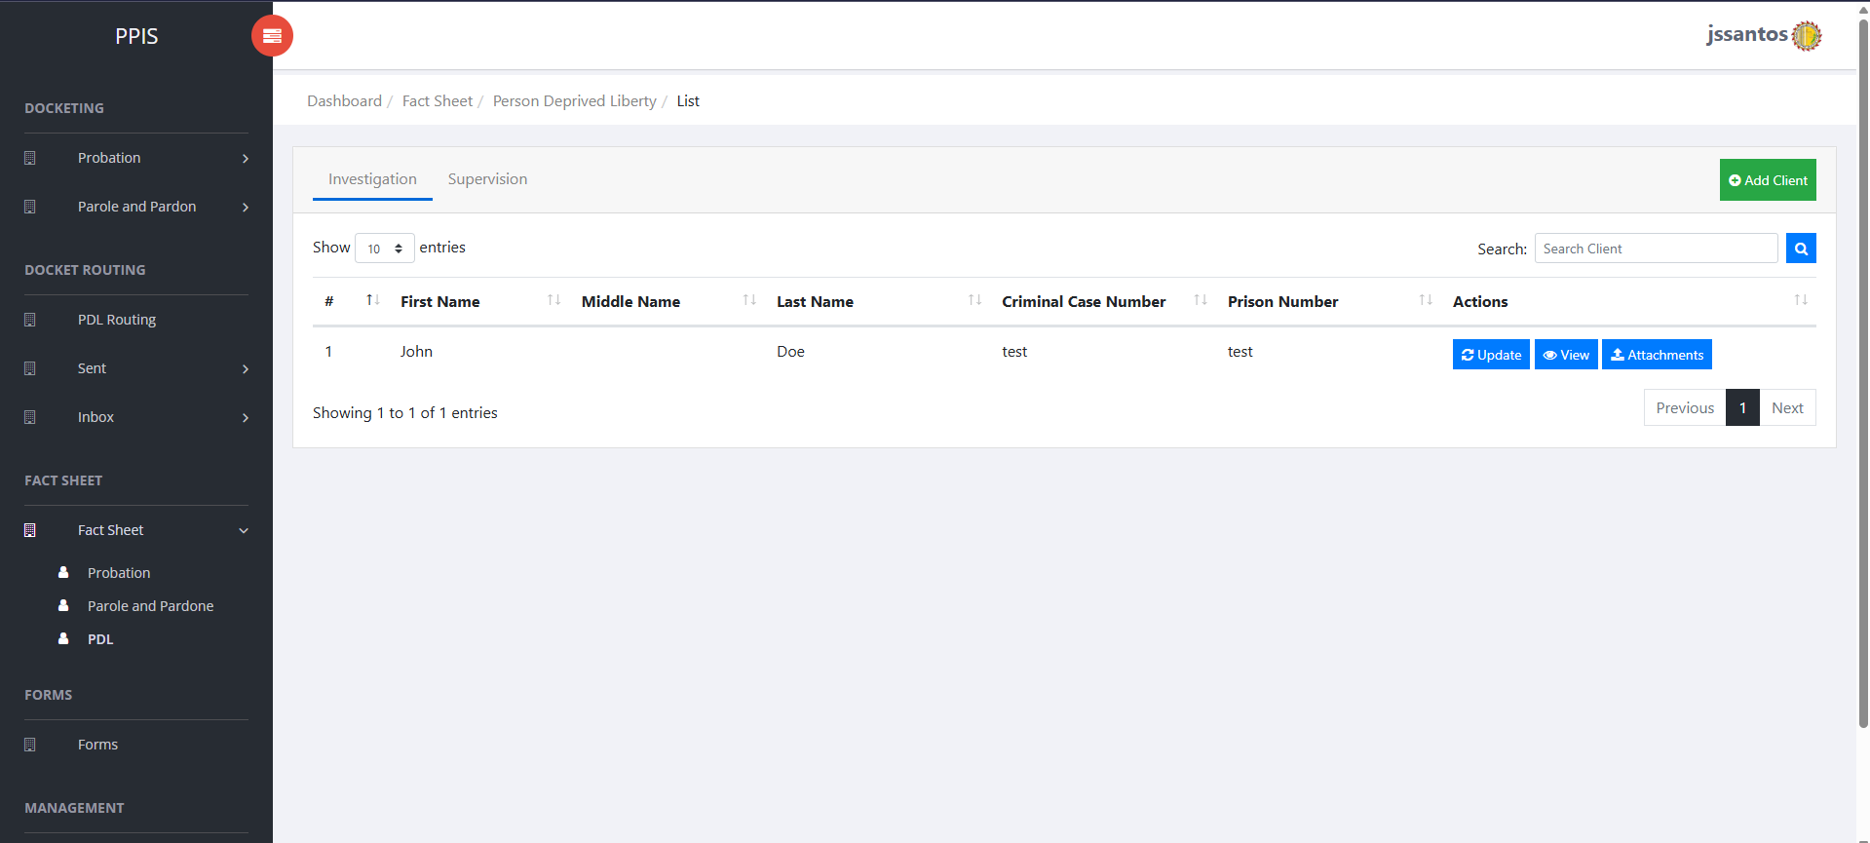
Screenshot for Fact Sheet - PDL.
────────────────────────────────────────────────────────

6.14 Forms
Purpose: Access agency forms list and upload completed forms where the module is used.
How to access: Forms in the left menu.
Screenshot folder empty or missing: «Forms». Capture from the live PPIS site and save this folder under PIS ScreenshotsManual.
────────────────────────────────────────────────────────

6.15 My Organization – User Accounts
Purpose: Create and maintain staff login accounts (administrators only).
How to access: My Organization › User Accounts.
Screenshot folder empty or missing: «My Organization - User Accounts». Capture from the live PPIS site and save this folder under PIS ScreenshotsManual.
────────────────────────────────────────────────────────

6.16 My Organization – User Roles
Purpose: Define roles and bundle permissions for PPIS menus and actions.
How to access: My Organization › User Roles.
Screenshot folder empty or missing: «My Organization - User Roles». Capture from the live PPIS site and save this folder under PIS ScreenshotsManual.
────────────────────────────────────────────────────────

6.17 My Organization – Field Office
Purpose: Maintain field office records tied to routing and assignments.
How to access: My Organization › Field Office.
Screenshot folder empty or missing: «My Organization - Field Office». Capture from the live PPIS site and save this folder under PIS ScreenshotsManual.
────────────────────────────────────────────────────────

6.18 My Organization – Region
Purpose: Maintain region reference data used with offices and routing.
How to access: My Organization › Region.
Screenshot folder empty or missing: «My Organization - Region». Capture from the live PPIS site and save this folder under PIS ScreenshotsManual.
────────────────────────────────────────────────────────

6.19 My Organization – Permission
Purpose: View or adjust permission catalog entries that can be assigned to roles (administrator function).
How to access: My Organization › Permission.
Screenshot folder empty or missing: «My Organization - Permission». Capture from the live PPIS site and save this folder under PIS ScreenshotsManual.
────────────────────────────────────────────────────────

7. Data Encoding Procedures

7.1 Adding Records
- Navigate to the correct module (for example, Investigation docketing or Fact Sheet client list).
- Select New, Create, or Add (exact label depends on the screen).
- Fill required fields first (usually marked or validated on save).
- Save. Note the system-generated number (docket or reference) shown in the confirmation or list.
Tip: Keep a scratch paper checklist of required attachments before you start—this reduces half-finished records.

7.2 Editing Records
- Locate the record through search or paging.
- Open View to confirm you have the correct person or docket.
- Select Update; change only fields your role allows.
- Save and wait for the success message.
Warning: Some fields may be locked after routing or approval. If a field cannot be edited, do not attempt workarounds—escalate to a supervisor.

7.3 Removing or Archiving Records
- Remove appears only where policy allows.
- Select Remove, read the confirmation text, and confirm only if authorized.
- If your office uses archive instead of delete, follow the on-screen wording exactly.

7.4 Uploading Files and Documents
- Open Attachments, Upload, or File upload from the row actions.
- Choose Browse / Choose File and pick a supported file from your computer.
- Wait until the progress or success message appears.
- Repeat for each required document.
Best practices:
- Prefer PDF for official submissions; use clear file names (Docket_CCIS_ClientName.pdf).
- Scan legibly; ocr may not be available—human readers must be able to read the scan.
- Avoid extremely large images; compress scans if the system warns about size.
Warning: Uploading the wrong client’s document is a serious records error. Double-check the docket number in the page title before selecting Upload.
────────────────────────────────────────────────────────

8. Printing and Reports

8.1 Generating Reports
- Open the module that holds the report (for example, fact sheet view, PSIR section, or worksheet).
- Look for Print, Preview, Generate PDF, or Export buttons.

8.2 Print Preview
- Select Print or Preview; your browser may open a preview window.
- Check headers, page breaks, and margins before choosing the printer.
Tip: Use landscape orientation for wide tables if the preview cuts off columns (printer dialog or page setup).

8.3 Export to PDF or Excel (Where Available)
- Export to PDF or Download PDF saves a portable file suitable for email or e-filing (if permitted).
- Excel export, when present, is useful for sortable working lists—do not treat exported spreadsheets as the official record unless your policy says so.
Warning: Exported files may contain personal data. Store them only on approved drives and share only through secure channels.
────────────────────────────────────────────────────────

9. User Roles and Permissions
Access is controlled by User Roles and Permissions configured in My Organization. Names below are typical; your deployment may rename them.
Role | What they usually do
Administrator | Creates users; assigns roles; configures offices, regions, permissions; may access all modules.
Supervisor | Oversees queues; may have broader routing rights; approves sensitive corrections per policy.
Encoder | Creates and updates daily operational records; uploads attachments; performs routing actions. assigned by office.
Viewer | Read-only access to assigned modules—no create/update/remove.
Important: If a button never appears, assume permission, not a system fault—request access through your administrator.
────────────────────────────────────────────────────────

10. Troubleshooting
Problem | What to try
Cannot log in | Check caps lock; confirm email; reset password through admin; verify account not locked.
OTP not received | Confirm mobile signal; check spam folder; wait for resend window; contact admin if repeated.
Menus hidden | Log out and log in; clear site data only with IT guidance; verify role still active.
List will not load | Reload page; try another browser; verify network; check if API/server maintenance.
Validation errors | Read field message; fill mandatory items; remove stray spaces; match date format on screen.
Upload fails | Reduce file size; try PDF; verify file type allowed; retry off-peak hours if network is slow.
Print alignment wrong | Use print preview; adjust margins; disable browser headers/footers if they collide with letterhead.
────────────────────────────────────────────────────────

11. Frequently Asked Questions
Q1. Why does my colleague see menus I do not see?
A: Your roles differ. Request the same permission only if your job requires it.
Q2. Can I use one account for the whole team?
A: No. Individual accounts preserve audit accountability.
Q3. I picked the wrong task on forwarding—what now?
A: Notify your supervisor immediately; follow your office’s correction process (return docket or administrative fix).
Q4. Can I work from home?
A: Only through approved devices and VPN per agency IT policy.
Q5. Where do I print PSIR or worksheets?
A: From the Fact Sheet / worksheet / PSIR screens once data is complete—exact buttons vary by section.
────────────────────────────────────────────────────────

12. Glossary of Terms
Term | Plain meaning
PPIS | Parole and Probation Information System (this web application).
Docket | Electronic case folder tracked in PPIS with a unique number.
Investigation | Fact-finding stage before or during supervision (usage depends on program).
Supervision | Ongoing monitoring and reporting after disposition.
Courtesy case | Case handled on behalf of or in coordination with another office.
Routing | Official movement of a docket between units or offices.
Fact Sheet | Structured summary of identifying and case facts for a client.
PSIR | Pre-Sentence Investigation Report sections (when enabled).
PDL | Persons Deprived of Liberty track.
OTP | One-time password used on special login paths.
Field Office | Your parole and probation district or sub-office entity in the system.
────────────────────────────────────────────────────────

13. Contact and Support
- Application / account access: PPIS System Administrator at your Field Office or Regional Office.
- Password reset / locked account: Same administrator or internal IT help desk.
- Network, VPN, browser: Agency Information Technology unit.
- Policy questions (what to encode, routing, legal sufficiency): Your immediate supervisor or legal unit—this manual does not interpret law or local memoranda.
Office use record (optional):
Field | Entry
Issued to | _________________________
Date received | _________________________
Contact number | _________________________
────────────────────────────────────────────────────────
End of document.

