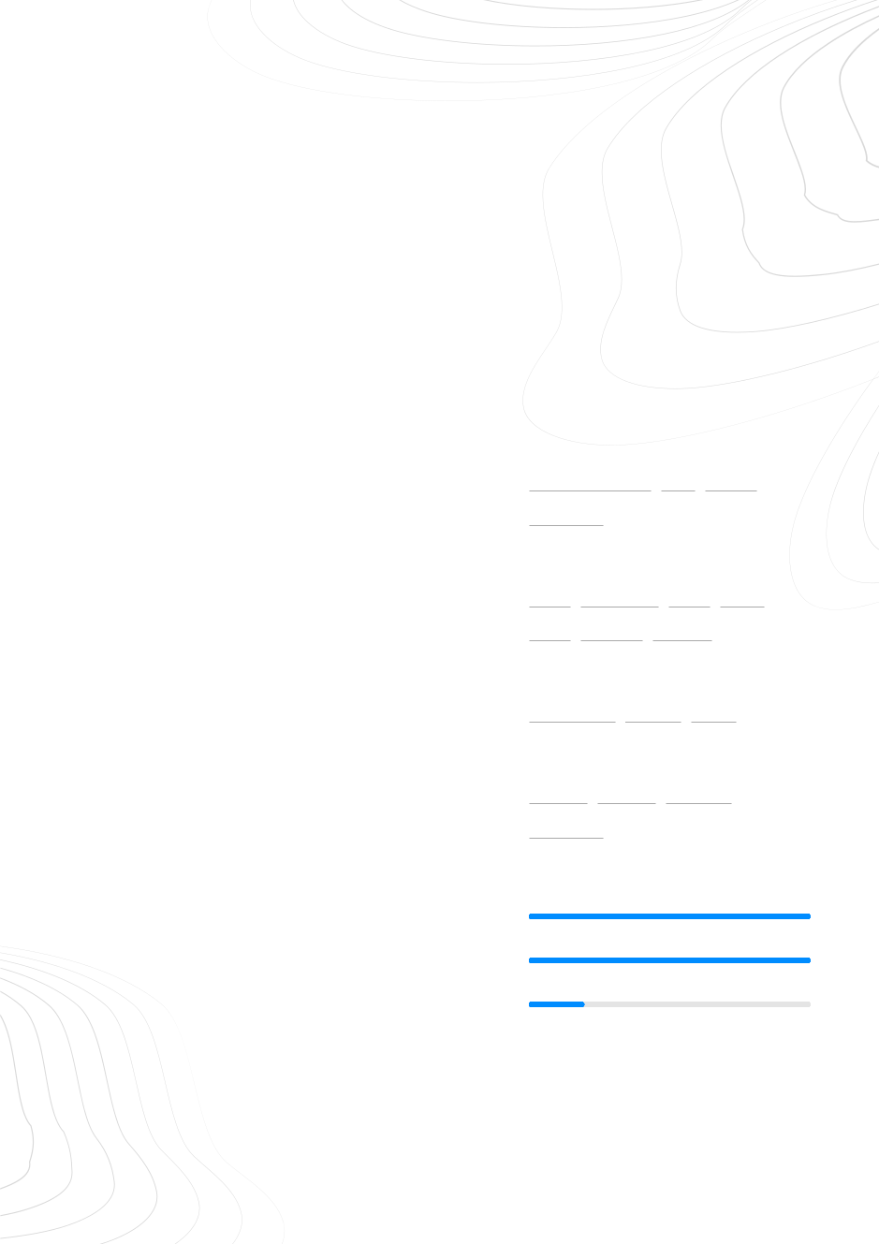TCHINDA FEZE CEDRICK VANEL

Full Stack Developper

+237693118109 cedrickfeze24@gmail.com [https://maxburger.cm](https://maxburger.cm/)

**E** **q**

SUMMARY

As a Full Stack Developer with 2 years of experience, I have extensive knowledge of both front-end and back-end development. I am proficient in several programming languages including **Html**, **css**, **Bootstrap**, **php**, **jQuery, Kotlin** and familiar with design tools like **adobe Photoshop, XD** and **figma** and have experience working with a range of databases and frameworks. I have a strong ability to troubleshoot and solve problems quickly, as well as the ability to work well under pressure and tight deadlines.

EXPERIENCE

Graphic Designer

Max Burger 02/2020 - Now Douala www.maxburger.cm Restaurant & Fastfood

Design and creation of **showcase website** of the company **Design of wireframes**

Front End and Back End developper

Sigeris sarl 09/2021 - Now Bafoussam www.sigeris.cm

Company that offers IT solutions and services

Design and creation of a web interface to facilitate data collection

Creation of Responsive web and mobile applications

Using git and GitHub to control code versioning, using GitHub actions

**Code maintenance and review API design and creation**

Modeling, design and database creation

Intergrated bqckend APIs and third-party libraries.

Integration and connections of technologies used for development The use of **UML diagrams** to model a computer system

Matrix Telecoms

Software Engineer intern 06/2019 - 08/2019 Yaounde

www.matrixtelecoms.com

Company that offers telecommunication solutions

Installation and configuration of web servers

**Design of wireframes**

EDUCATION

BACHELOR OF TECHNOLOGY in Software Engineering

Institut Universitaire des Grandes Ecoles des Tropiques

11/2021 - 08/2022 Douala

Higher National Diploma in Software Engineering

Agenla Academy Institute

09/2018 - 08/2020

Yaounde{"section":5,"item":4}{"section":5,"item":4}{"section":5,"item":4}

Bafoussam, Cameroun

**e**

ACHIEVEMENTS

Student management system

**T**The project manages a student from registration to enrollement and an algorithm has been coded to print the **school ID card** of each student as well as the **transcripts** and **graduation diplomas**.

Max Burger showcase website

**q**The website [**www.maxburger.cm**](https://maxburger.cm/) was developed with **Html**, **CSS**, **Javascript** and **Boostrap**. I implemented the contact and reservation form with a php Mailer library to send emails and make reservations through out the platform

SKILLS

Web design tools

**Adobe Photoshop** **XD** **Figma**

**Illustrator**

Programming language

**PHP** **JavaScript** **SQL** **Html**

**CSS** **Arduino** **Python**

Framework

**CodeIgniter** **Flutter** **Ionic**

Data

**GitHub** **MySQL** **OpenCV**

**MongoDB**

LANGUAGES

French Native

English Native

German Beginner

www.enhancv.com Powered by