INES RUHENGERI | FACULTY OF SCIENCES AND INFORMATION TECHNOLOGY

UI/UX DESIGN REPORT
CMPortfolio · Personal Portfolio Mobile Application

SWE3409 • MOBILE APPLICATION DEVELOPMENT
INDIVIDUAL ASSIGNMENT 2

Prepared by: Cedrick Manzi
Registration number: 25/27196
Application name: CMPortfolio
Verification code: MOB-A2-7196
Technology: React Native · Expo · TypeScript
Test device stated: Google Pixel 3a (Android 12)
Repository: github.com/cedrickmanzi3/MOB_A2_2527196
Report date: 12 October 2026

1. Project concept
CMPortfolio is a student mobile portfolio that introduces Cedrick Manzi and provides a simple way to browse skills, education, and projects. It also lets the portfolio owner change profile information and a photograph locally on the Android device. The application uses a five-tab information structure with a separate detail screen for each project.

1.1 Intended users and goals
User | Primary goal | Design response
Portfolio visitor | Learn who Cedrick is, what he can do and what he has built | Home summary, Skills, Projects and About tabs
Portfolio owner | Keep personal details current without an online account | Profile editor, validation, camera/gallery and local save

1.2 Scope and constraints
The inspected source includes Home, Skills, Projects, Profile and About tabs, with a native-stack Project Details route. The user reports testing on a Google Pixel 3a running Android 12. The repository README describes standalone APK testing, but an APK test artifact or independent device evidence was not examined for this report.
This report documents the implemented structure and a set of representative editable design wireframes. It does not substitute simulated layouts for screenshots from the device.

2. User flow diagram
Visitor journey:
Open CMPortfolio → Home introduction

↓
Select bottom tab: Skills / Projects / About

↓
Projects → select CMPortfolio or Kinigi Milk Check

↓
Read Project Details → use back navigation

Owner editing journey:
Profile → load saved values or defaults

↓
Edit headline, bio, primary skill and availability

↓
Optional: choose gallery photo or capture camera photo

↓
Save → validate → correct errors if any → AsyncStorage write

↓
Return to Home → refreshed saved profile

3. Information architecture and saved-state flow
Navigation level | Contents / route | Data behavior
Root stack | Portfolio (tab navigator); ProjectDetails | ProjectDetails receives selected item information from Projects
Home tab | Name, profile photo, headline, bio, primary skill, availability, verification code | Reloads profile on tab focus
Skills tab | Five named skills; INES Ruhengeri education card | Static content
Projects tab | CMPortfolio; Kinigi Milk Check | Opens ProjectDetails with title, problem, contribution, technologies
Profile tab | Photo, four text inputs, Save, Reset | Loads and writes local profile record
About tab | Identity, registration, verification and local-data notice | Static content

3.1 Local-state lifecycle
App opens / Profile loads

↓
AsyncStorage.getItem("@CMPortfolio/profile")

↓
Saved JSON found? → merge with defaults; otherwise use defaults

↓
Owner edits fields / changes photo

↓
Validate text before Save; photo actions save immediately

↓
AsyncStorage.setItem(profile as JSON)

↓
Reopen app → load profile; Home reloads on focus

The stored image value is a local URI reference, not the image binary. Therefore persistence of the photo after reinstall, cache removal or file cleanup should not be assumed. There is no cloud synchronization in the inspected implementation.

3.2 Validation rules
Input | Rule in source | Visible response
Professional headline | Trimmed length at least 5 | Inline error when too short
Short biography | Trimmed length at least 20 | Inline error when too short
Primary skill | Must not be blank after trimming | Inline error when empty
Availability | Must not be blank after trimming | Inline error when empty
Photo | Camera or library permissions requested as applicable | Alert on denied permission, canceled or failed action

4. Screen wireframes

4.1 Home
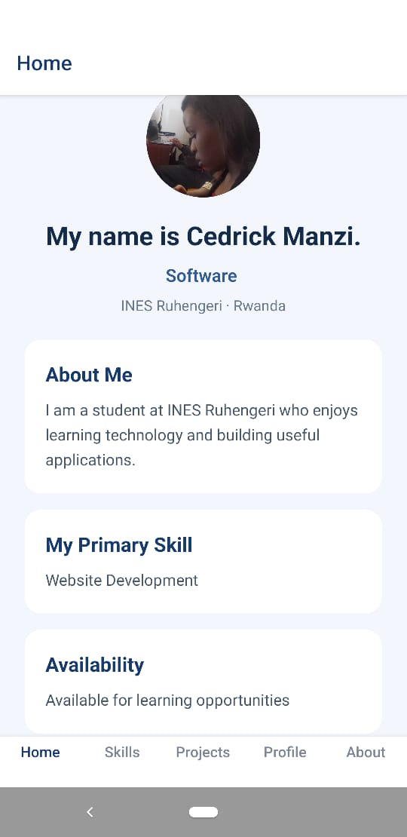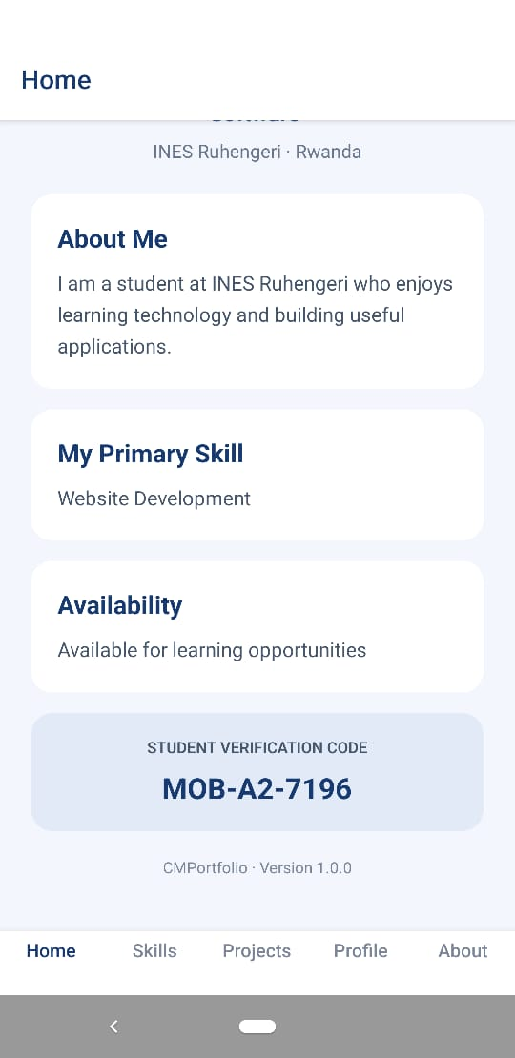

4.2 Skills
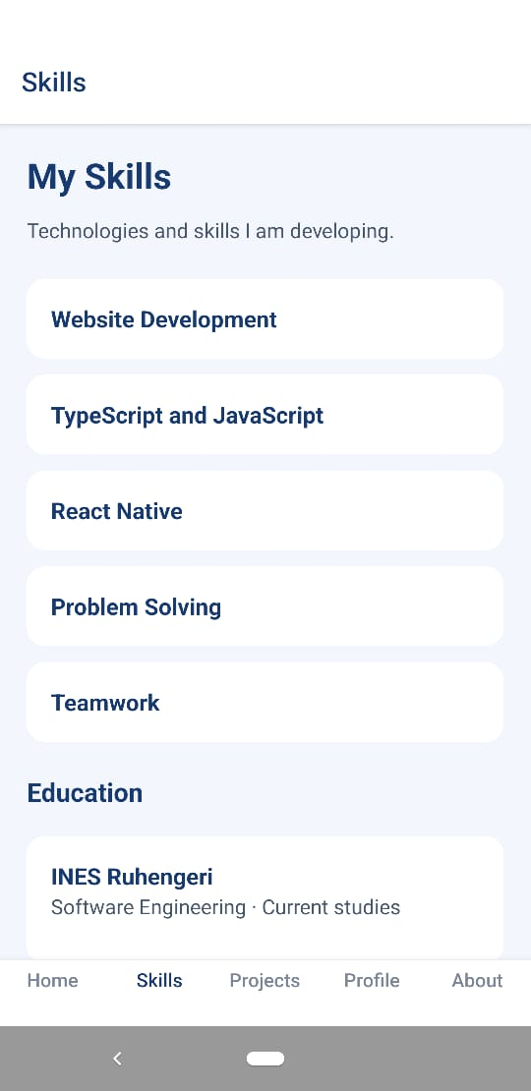

4.3 Projects
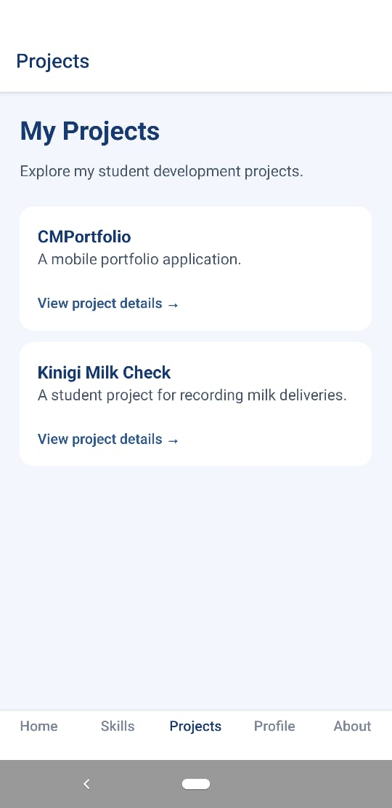

4.4 Project Details
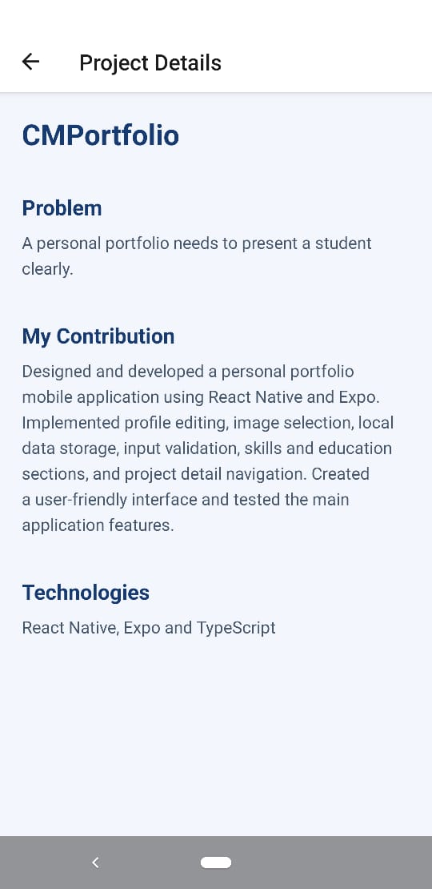
Each of the two projects supplies its own title, problem, contribution and technology descriptions. The second item, Kinigi Milk Check, is described as a student milk-delivery recording project with mobile and Python technologies.

4.5 Profile / editor
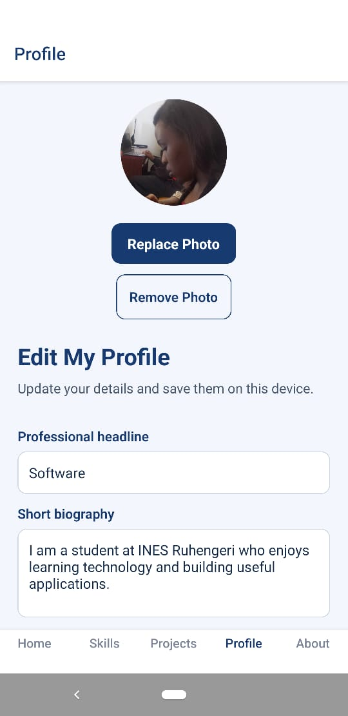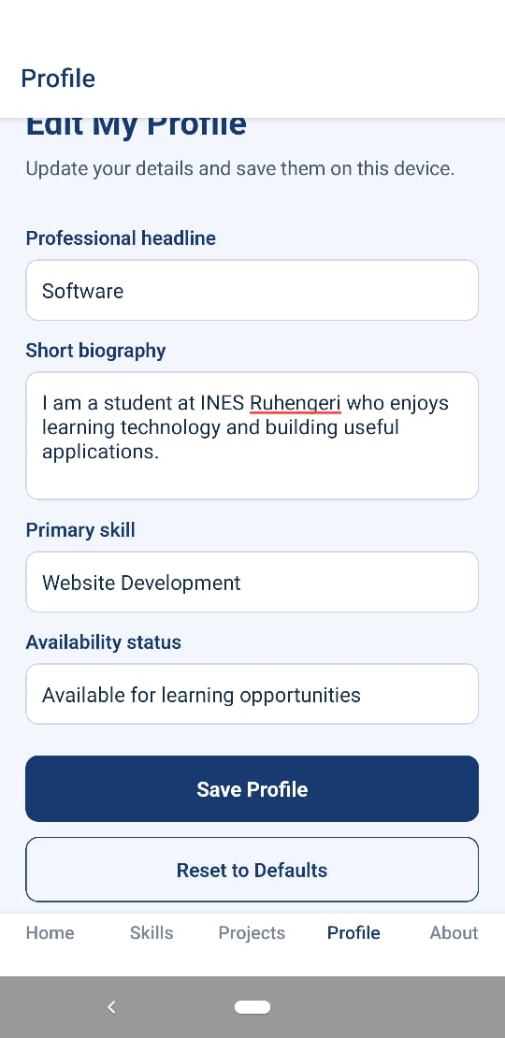
After invalid Save, the source places readable red error text under affected fields and shows a correction alert. Camera/gallery actions use a choice dialog and permission prompts; photo replacement and removal save the modified profile to local storage.

5. Visual design and accessibility
Design token | Value from source | Use
Primary navy | #173B70 | Headings, active tab, primary buttons, avatar
Page background | #F3F6FC | Screen surface
Cards / inputs | #FFFFFF | Content grouping and form fields
Primary text | #142B4A | Dark text
Secondary text | #46566B | Body copy
Muted text | #68778C / #7B8798 | Metadata and inactive tab
Verification card | #E2EAF7 | Home verification block
Error text | #B42318 | Profile validation
Input border | #CBD5E1 | Form field outline

6. Implementation comparison and testing checklist
Design requirement | Implementation evidence | Evidence status
Five bottom navigation destinations | Tab.Navigator defines Home, Skills, Projects, Profile and About | Verified in repository code
Separate project pages | Projects routes to ProjectDetails with distinct data for two projects | Verified in repository code
Editable profile fields | Headline, bio, primary skill and availability TextInput controls | Verified in repository code
Input validation | Minimum-length and nonblank checks with inline errors | Verified in repository code
Camera/gallery profile image | Expo ImagePicker permission, picker and capture calls | Verified in repository code
Photo replacement/removal | Conditional Replace / Remove actions and save calls | Verified in repository code
Local persistence | AsyncStorage key and load/save functions; Home focus reload | Verified in repository code
Real device visual match | Pixel 3a Android 12 stated by student | Screenshot evidence needed
Installed standalone APK | README states APK was tested | Build/install proof needed
Offline reopening and persistence | README reports testing | Reproducible test evidence needed

6.1 Manual validation checklist
[ ] Open standalone APK on Pixel 3a (Android 12); capture Home screen.
[ ] Switch through all five tabs; capture Skills and Projects.
[ ] Open both project detail pages and test Back navigation; capture one.
[ ] Submit empty / short headline and biography; capture validation.
[ ] Save valid profile, close app completely and reopen; confirm values remain.
[ ] Choose gallery image, take camera photo, replace photo and remove photo.
[ ] Deny photo/camera permission once and record error handling.
[ ] Disconnect internet, relaunch app and verify local content remains visible.
[ ] Run a larger system font and TalkBack review; record any issues.
[ ] Attach EAS build reference or installation evidence for standalone APK.

6.2 Screenshot and evidence register
Required evidence | Status in this report
Home, Skills, Projects, Project Details, Profile screenshots | NOT PROVIDED — insert actual captures from running app
Validation and photo selection screens | NOT PROVIDED — insert actual captures from device
Persistence / offline test result | STUDENT-REPORTED; no independent test log attached
APK installation / EAS build reference | NOT PROVIDED — add build URL or Android installation proof

7. Conclusion
CMPortfolio presents a focused personal portfolio with straightforward bottom navigation, a simple projects-to-details journey, and a locally editable profile. The source code supports the documented information architecture, validation and storage design. Its restrained navy, white and light-blue palette provides consistent visual grouping across the principal screens.
For the final academic submission, Cedrick should replace evidence placeholders with actual device captures and record the results of the checklist. Until those items are added, screenshots, UI fidelity on the named handset and successful standalone/offline test execution remain unverified in this report.

References and inspection record
Source repository: https://github.com/cedrickmanzi3/MOB_A2_2527196 (master branch; inspected 12 October 2026).
Examined files: README.md, App.tsx, src/screens/HomeScreen.tsx, src/screens/ProfileScreen.tsx, src/storage/profileStorage.ts, package.json, repository file tree. No application screenshot file was found in the reviewed tree.
Reported project identification and test handset: supplied by the student in the assignment request. No fresh runtime instrumentation was performed in preparing this document.

