# Brief Report

This report explains the assumption and approaches being used in the source code.

## 1. Metaheuristic Algorithm Selection

At after some studies and research from the internet, this delivery optimization task a.k.a vehicle routing problem (VRP) is a variant of travelling salesman problem (TSP). And some experiments have been carried to compare the best approach to solving this TSP is to use ant colony optimization algorithm (ACO).

<https://dl.acm.org/doi/fullHtml/10.1145/3545922.3545926#:~:text=The%20ACO%20metaheuristics%20optimized%20for,than%20using%20pre%2Ddefined%20parameters>

So, I’ve used ACO for completing this task. To begin, I start with some simple approach obtained from Medium.

<https://induraj2020.medium.com/implementation-of-ant-colony-optimization-using-python-solve-traveling-salesman-problem-9c14d3114475>

and modified this to adapt to this VRP task.

## 2. Implementation

Before beginning, Numpy library is used, and I’ve implemented all the reusable function and classes in **utils.py** and **models.py**.

To mimic the nature behavior of ACO, the pheromone matrix is first initialized to the size of customers (n_customer x n_customer), to indication the pheromone of movement from customer A to customer B.

$$\begin{matrix}P_{AA} & P_{AB} & P_{AC} & … \\ P_{BA} & P_{BB} & P_{BC} & … \\ … & … & … & …\end{matrix}$$

And other initialization parameters is being set (best traveled distance is infinity, best traveled path is none, etc).

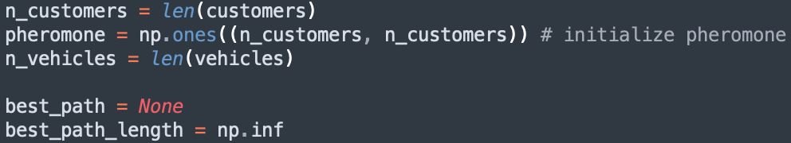

Next, at the start of iteration, all ants are assigned to depot and randomly selected an vehicle to use. Then a customer is randomly picked to delivery (as to mimic the behavior of ants). All the calculation are being calculated in **visit()** function (distance and capacity).

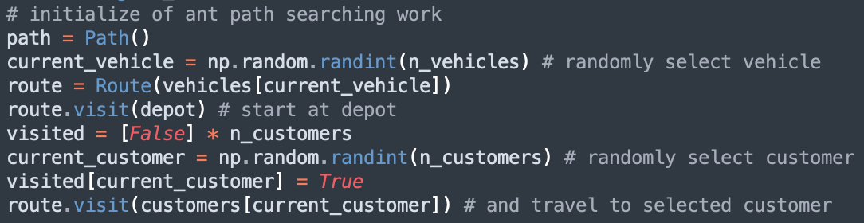

And next the possibility of next customer to deliver is calculated with the edge selection equation.

$$P_{τ}=\frac{{τ(i,j)}^{α}×{η(i,j)}^{β}}{\sum_{unvisted}{{τ(i,j)}^{α}×{η(i,j)}^{β}}}$$

Whereby $τ$ is the pheromone level or trail strength, $η$ is the heuristic information, and $α$ and $β$ are the weight of each parameter and it is 1 for this case as both are equality important, and the $η$ heuristic information is calculated by the inverse distance of the next customer.

$$η\left(i,j\right)=\frac{1}{Distance(i, j)}$$

other than this ant colony behaviour probability calculation, the capacity of the vehicle constraint is also taken into consideration. If it reached it maximum capacity it can carried for next customer, the probability will be 0. And if all the probabilities are 0, the vehicle will have to return to depot.

These process is being carried until all the customer is visited(delivered).

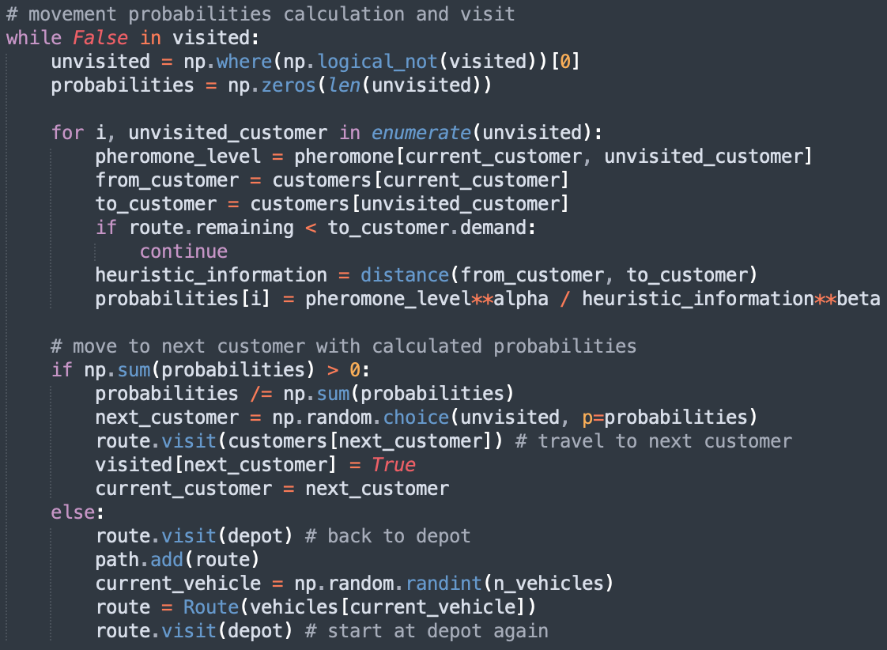

Once all the customers has been delivered the vehicle will go back to depot, and the total distance travelled will be calculated.

With all the possible shortest paths has been found for that iteration, the best shortest path is being evaluated and saved. Then, the pheromone will go through a nature evaporation process (mimic the nature behaviour and make the whole trails weaker), and trails is updated into the pheromone. And all the updated variables are share to next iteration.

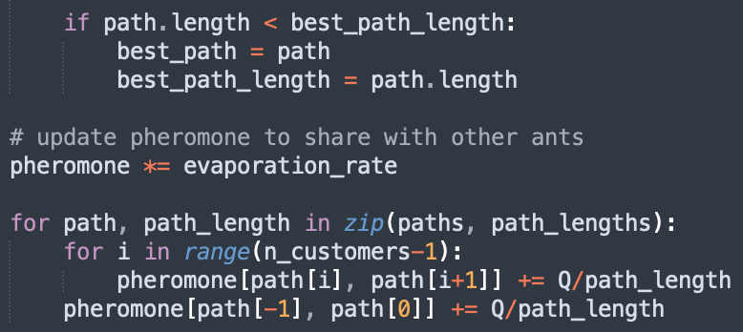

The ant colony optimization algorithm is then completed. The delivery optimization process is then configured to use 50 ants and 100 iterations and the best optimal route and vehicle has converged.

