**ONLINE FOOD ORDERING SYSTEM**

# INTRODUCTION

The food ordering system is an application that will help people in ordering food according to their various preferences, wherever they are or at any time, for the waiter will help them with their work because they will no longer give the food orders these clients want, while in management it will help them control all business activities and get reports on client information and orders issued.

This application will help restaurants to do their all functionality more accurately and faster way. Online Food ordering systems reduce manual work and improve the efficiency of the restaurant.

# PROBLEM

Many restaurants store information manually way which causes some information to be lost or damaged, accepting a large number of clients is also a problem because it is difficult to provide them with service at the same time. Due to many clients and storing information of clients, this application will help us provide a faster and easier service.

For a manager it is difficult to know what is happening in the kitchen, orders received, stock, daily transactions, and to know if there is a profit.

# SOLUTION

The online food ordering system will help people order food from restaurants they want because they will be able to get a menu restaurant of what is available and deliver it to you where you are without taking the time to go for it,

The restaurant will be able to easily identify what it is doing because it will be using more technology and it will be easier to receive orders and store customer information in a modern way.

With this application, restaurants may attract more customers, which will increase their revenues. Since the application’s main feature is free for both the users and the managers, there is no potential loss for any of them.

These features may be beneficial to tourists who do not know the best restaurants in the area. The online ordering feature may help workers and students order their lunch online.

# GENERAL OBJECTIVE

This application will help restaurants to maintain function effectively and efficiently and also help us to store daily information systematically.

The online ordering system is to provide customers with a way to place an order at a restaurant over the internet, customers can view all the menus of the restaurants available in the application, customize dishes to their requirements and place an order.

# SPECIFIC OBJECTIVE

**Customer**: the online food ordering system will help the customer to order a variety of different food options as there will be more variety, which will be done easily and in a short time using the application.

**Restaurant:** this application will help them advertise what they do more easily so that they can attract more customers and get their orders which will increase their revenues.

# FUNCTION REQUIREMENT

**I. Customer**

* A customer shall be able to sign up using his/her email address or Telephone number.
* A customer shall be able to log in using his/her email address or Telephone number.
* A customer shall be able to search for restaurants by category, city, and name
* A customer shall be able to filter results by delivery type, category, and neighborhood
* A customer shall be able to get more information about a specific restaurant such as description, opening hours, and address.
* A customer shall be able to grade and post a review about a restaurant
* A customer shall be able to view the average grade of a restaurant and reviews from other customers
* A customer shall be able to view the restaurant’s menu
* A customer shall be able to select items from the restaurant’s menu
* A logged customer shall be able to make an order with the selected items from the restaurant’s menu - A customer shall be able to view his/her orders

**I. Manager**

* A manager shall be able to sign up using his/her email
* A manager shall be able to log in using his/her email
* A manager shall be able to add a restaurant
* A manager shall be able to add a menu to his/her restaurant
* A manager shall be able to process the received orders
* A manager shall be able to view his/her customers
* A manager shall be able to change his/her restaurant’s information.

# NON-FUNCTION REQUIREMENT

* Performance - Initial load time should not exceed one second
* Scalability - The increasing number of users should not affect the performance of the application
* Extensibility - New features shall be easy to implement with separation of concern
* Security

1. Confidentiality - Traffic confidentiality shall be protected, and all operations performed by users must be preserved
2. Integrity - The integrity of all operations performed by users must be preserved
3. Availability - No single point of failure shall be tolerated.
4. Password generation- An application may not grant access until the user creates a strong password.

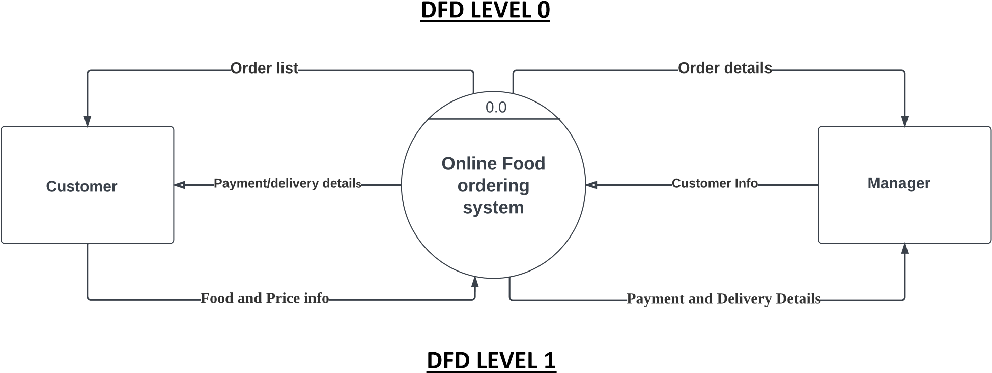

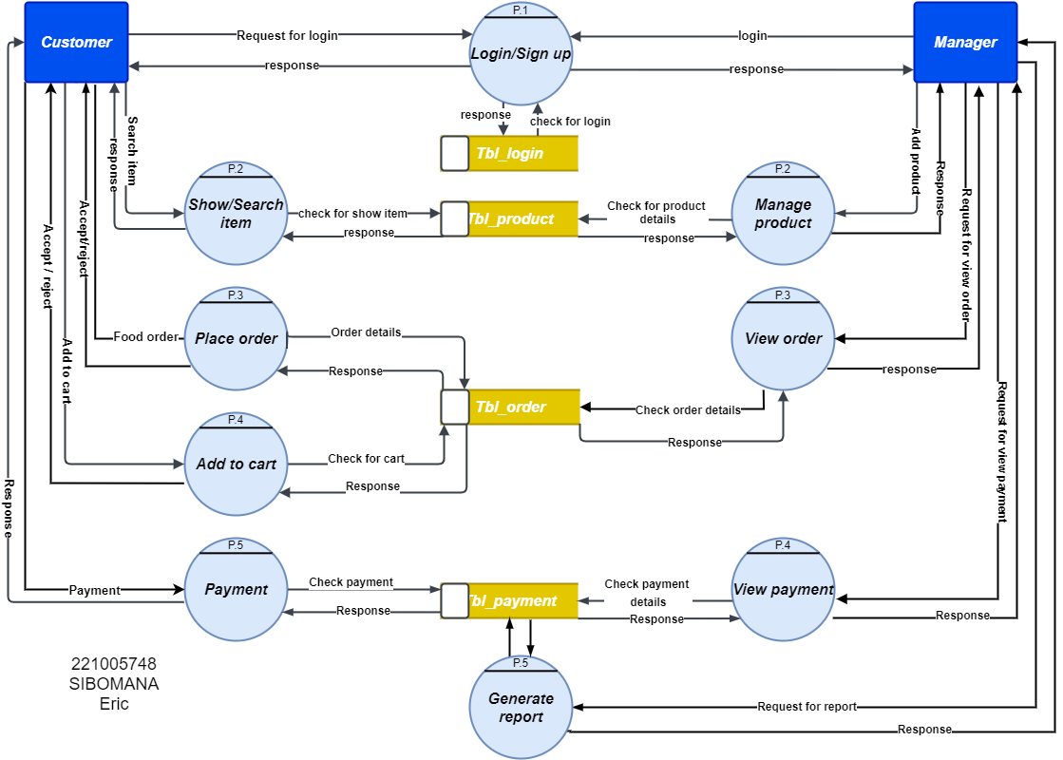

# DFD LEVEL 2 FOR CUSTOMER

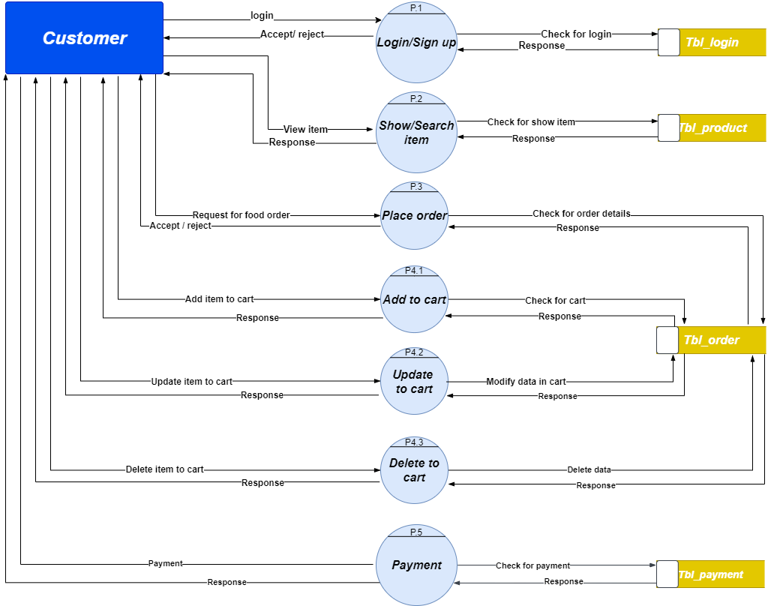

# DFD LEVEL 2 FOR MANAGER

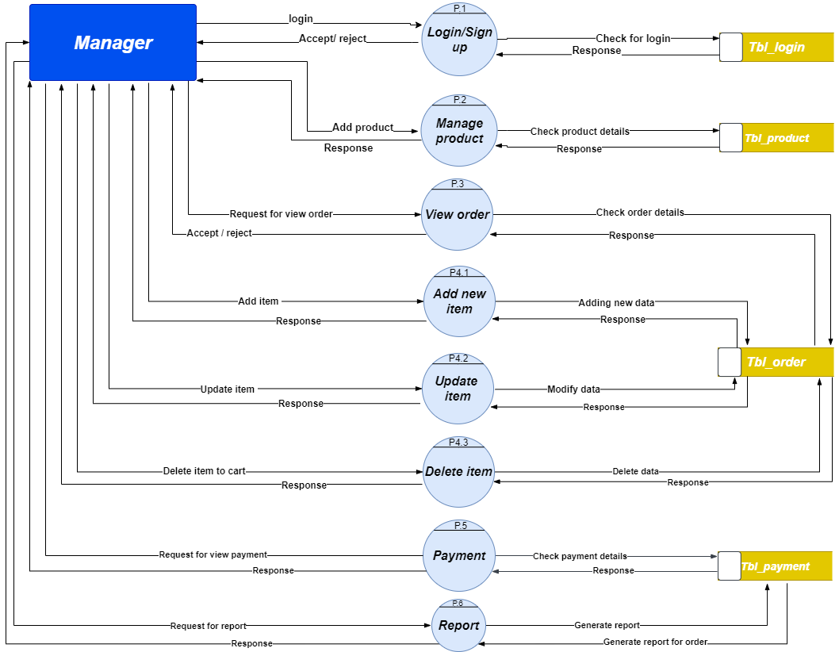

# USE CASE DIAGRAM

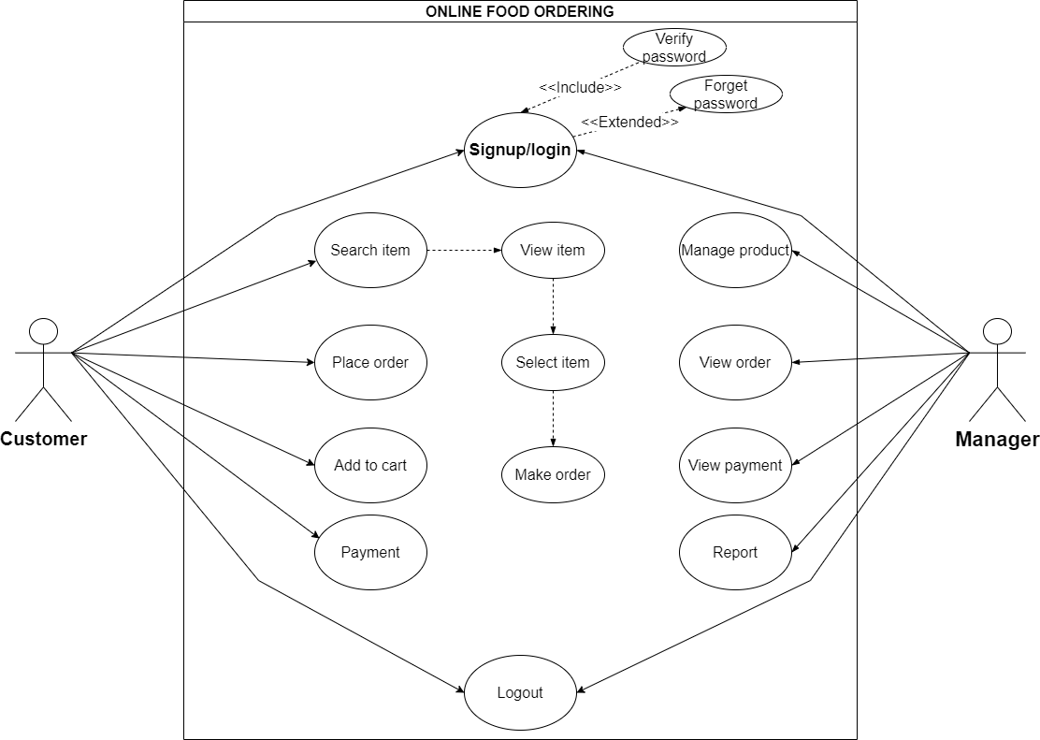

**CLAS S DIAGRAM**

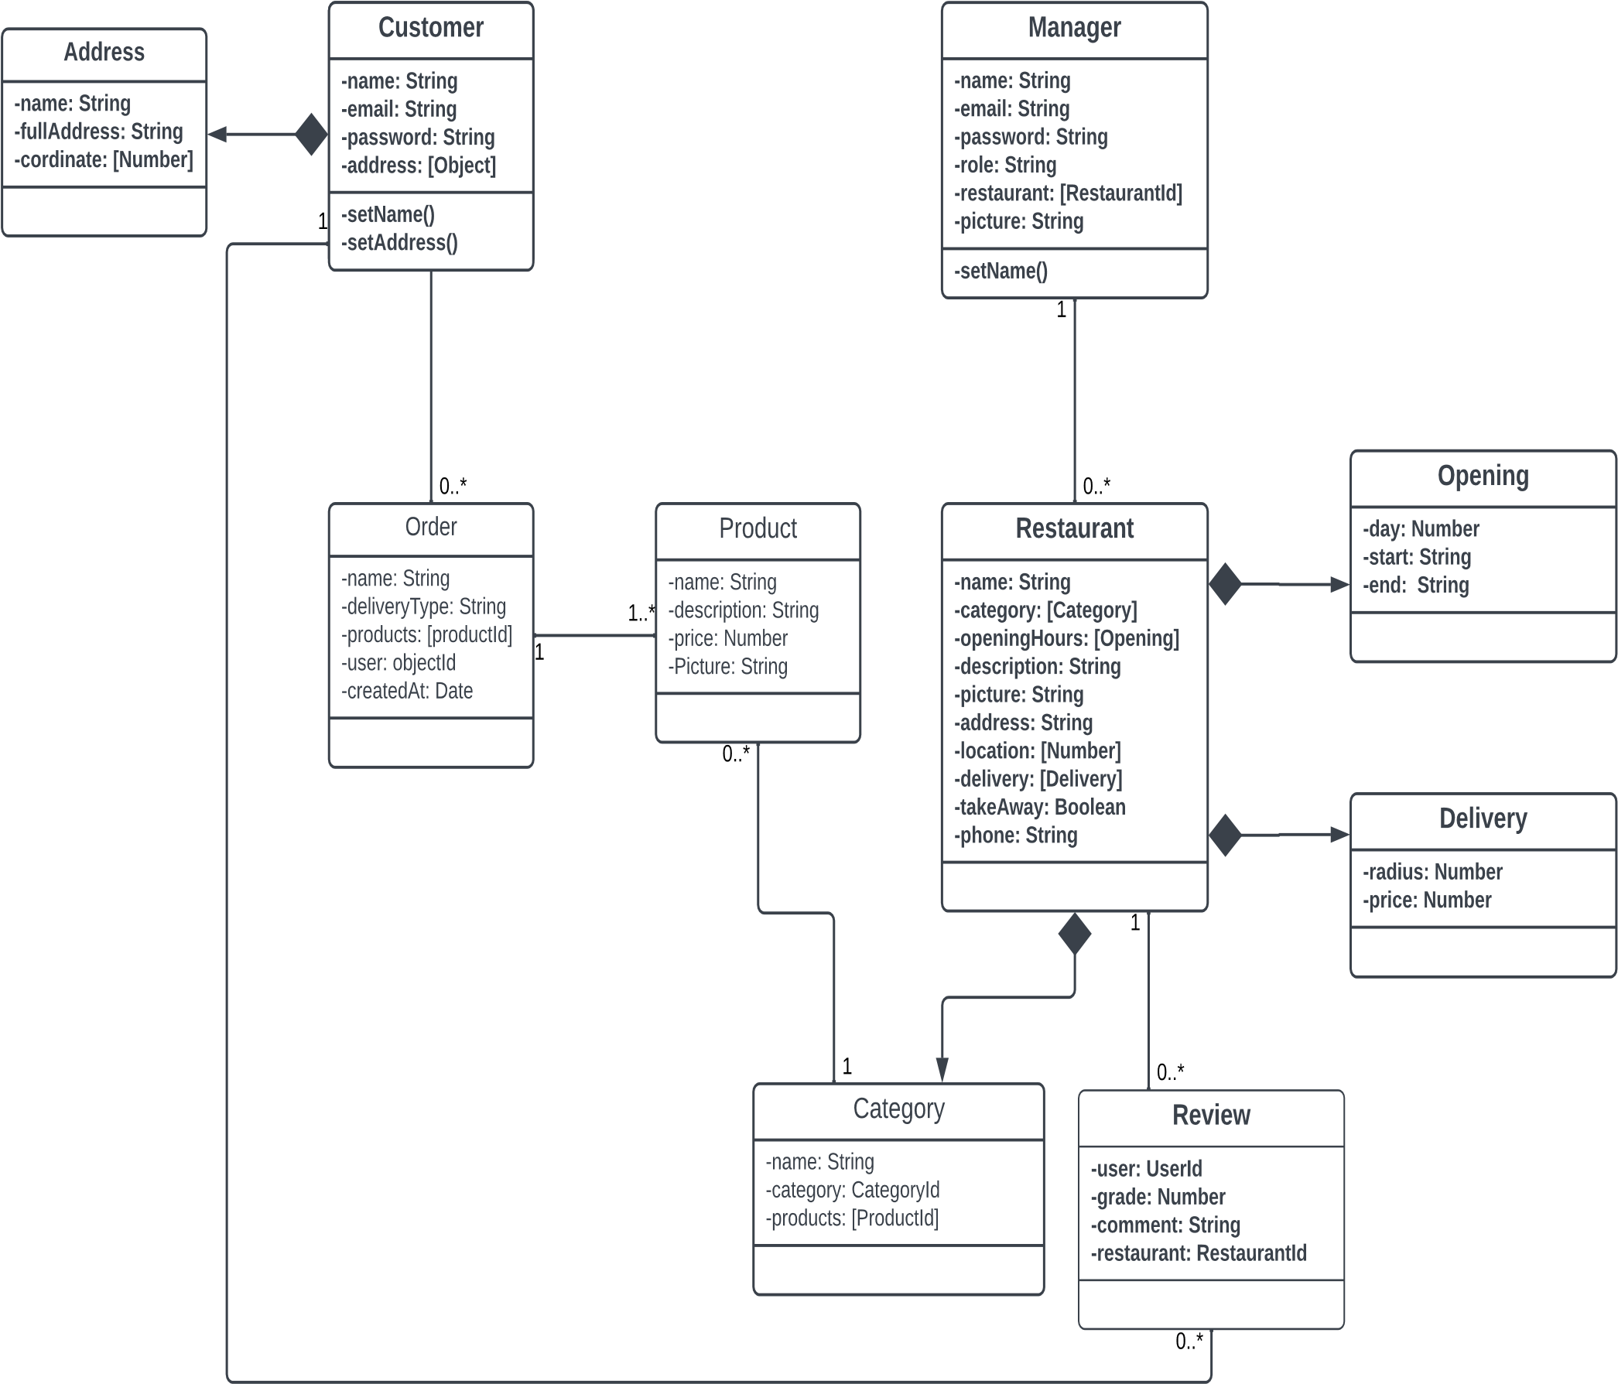

# SEQUENCE DIAGRAM

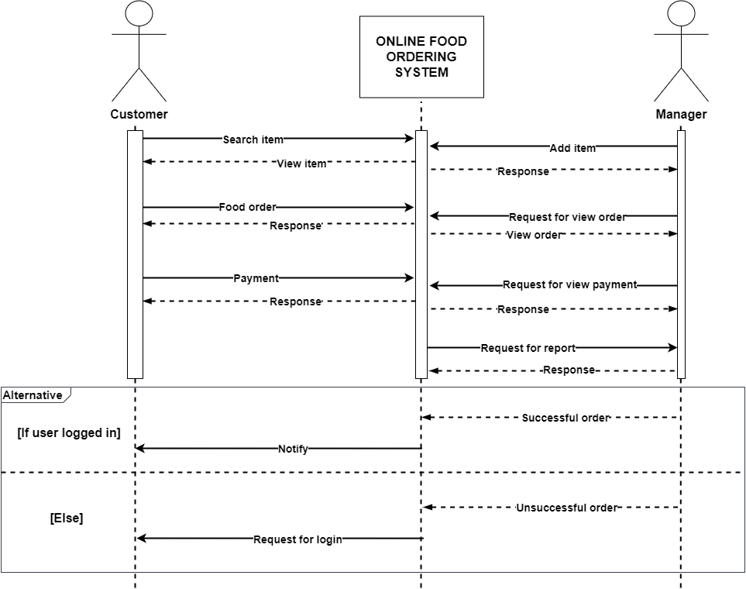

**CHAPTER 2: DATABASE**

**INTRODUCTION :**

Database of online food odering system which will used to hold tatha of this website this database composed 6 tables as showed bellow and it relationships.

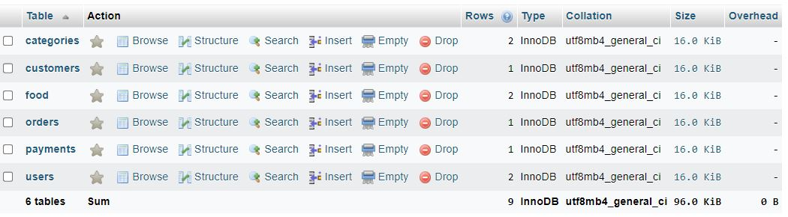

**Display of all tables used in this database**

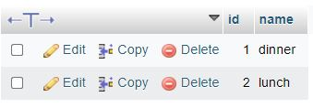

**Above table colled categories which will hold different food category**

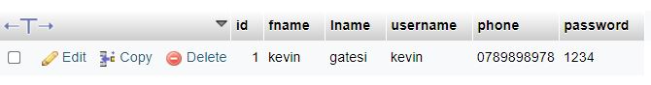

**Above table colled customers will hold customers information that create account in our system**

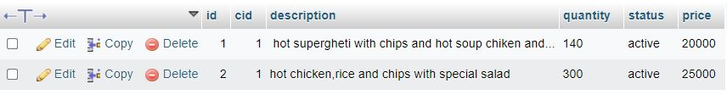

Table food will hold food intered by user in orer to be accesed by customers befoore ordering it



Order table will hord orders for clients.

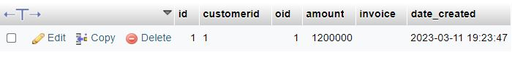

Table payment will hold payment information for customers

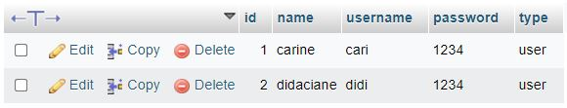

**Table users will hold users which will use this system note that user will be added by admin**

**­erd of our system**

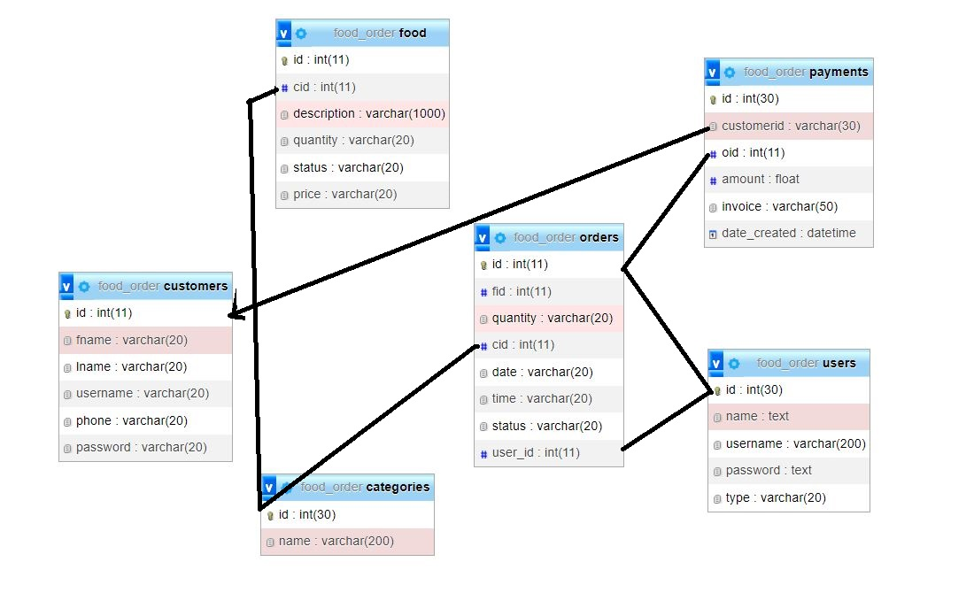

**CHAPTER 3. WEB DESIGN**

**Introduction**

This web will be used by three users first user will be admin where admin will have to add users, add food category, and view different reports second user will be normal users where this users will be able to add foos in system view, food oders and set as delivered and also con change his/her password last user will be crients where client has to sign up on our system after making login client(customer) has to view different food orders and order same food and also has to check his order history and can change his password

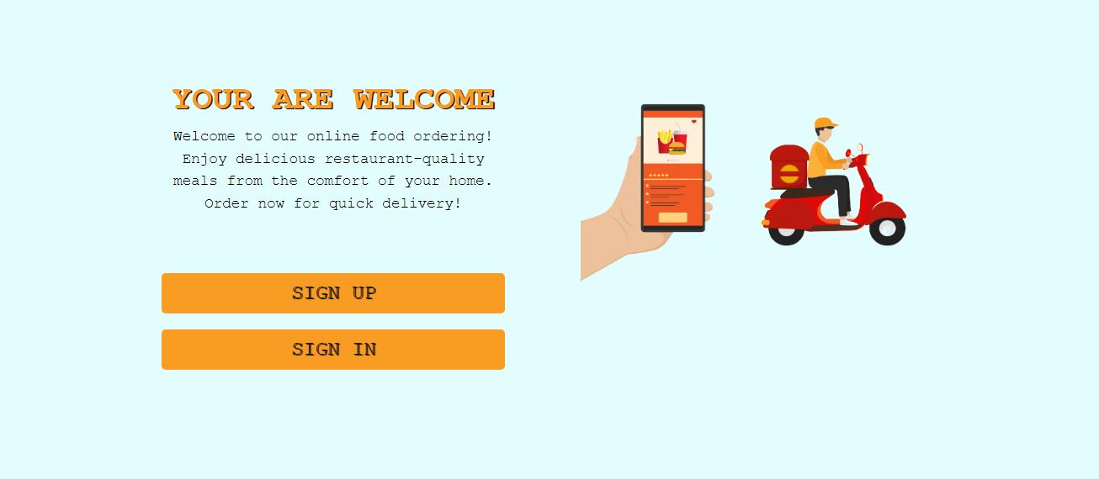

**Customers and users landing page can access the way to inter system by sign up or sign in for customers.**

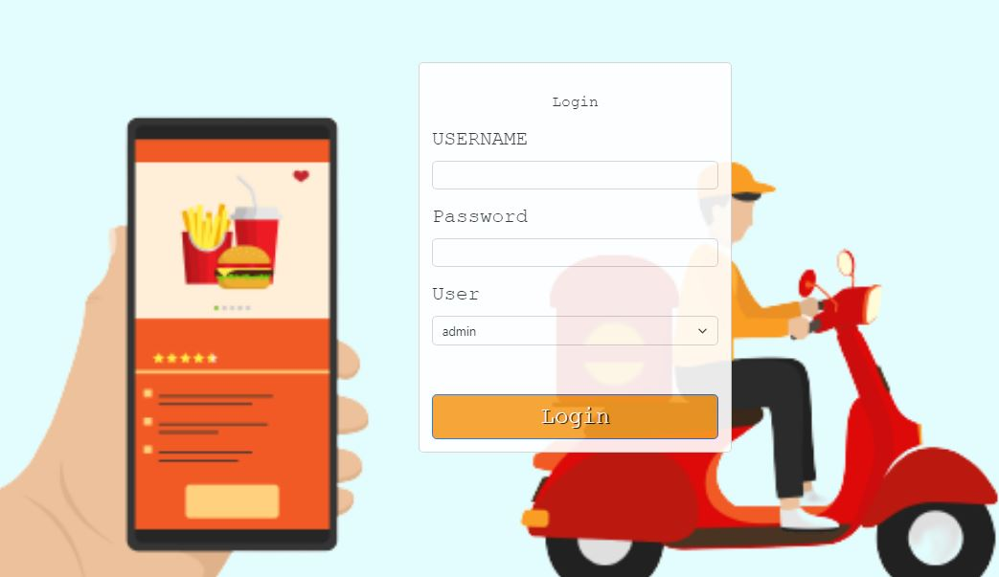

**Login page for all users**

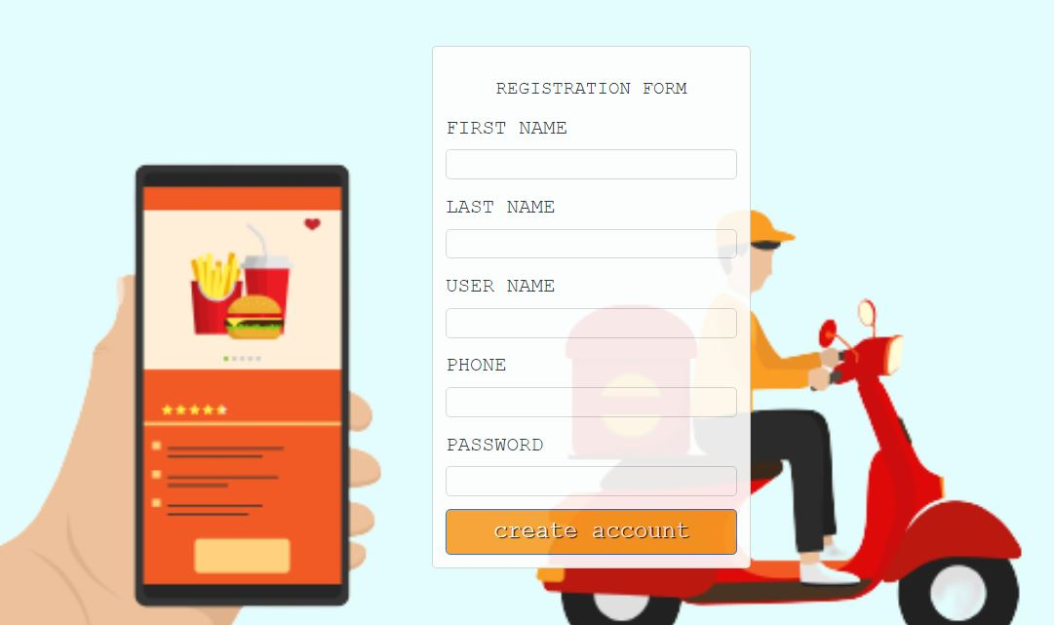

**Sign up page for customers**

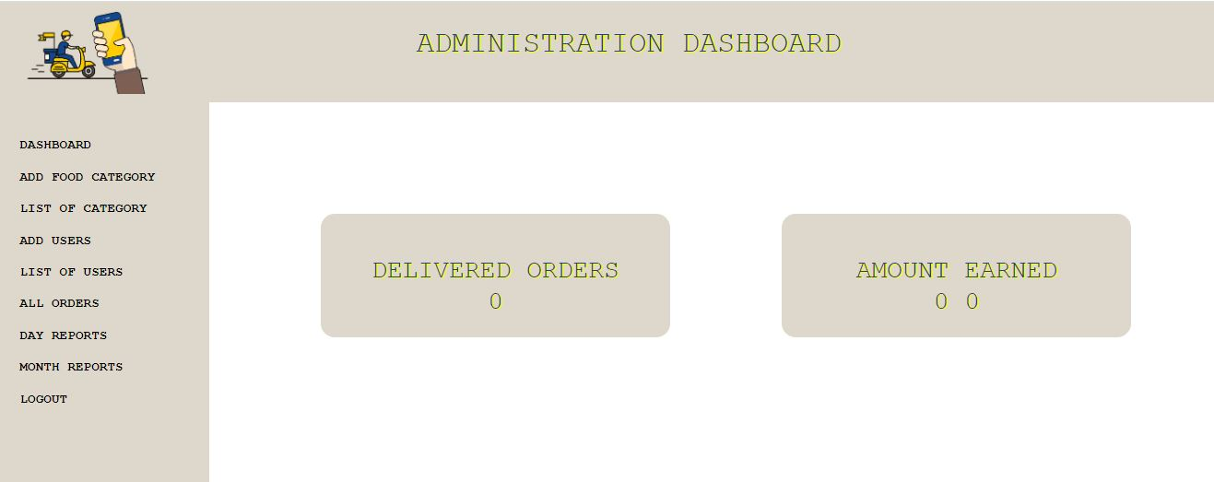

**Admin view different statistics number of orders….**

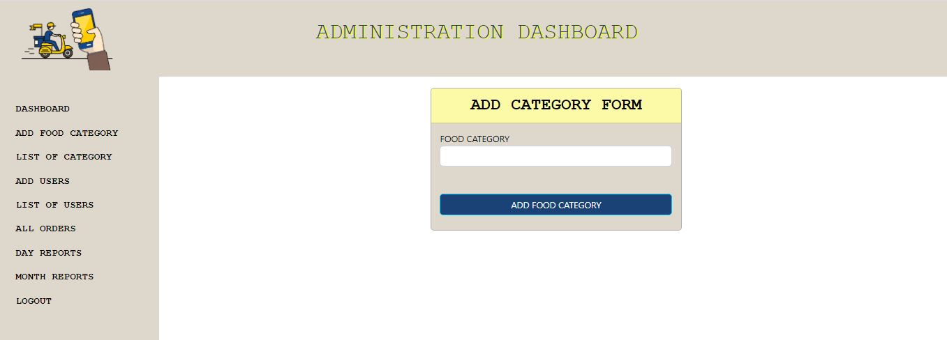

Admin can add category as I said before

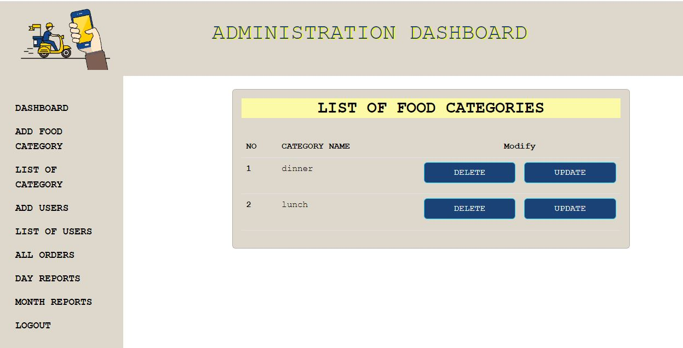

Admin can view categories and modify it.

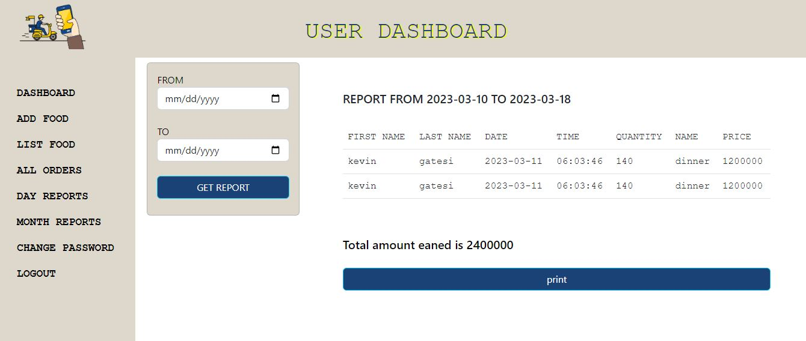

ADMIN VIEW DIFFERENT REPORTS

**USER PANEL**

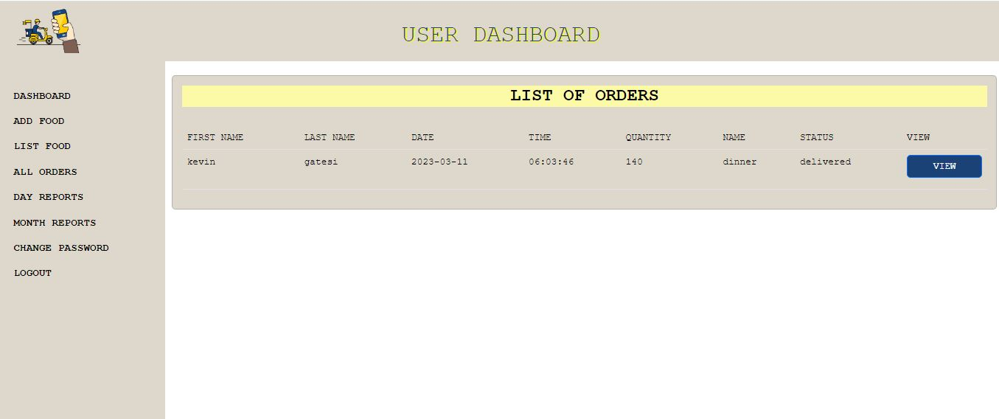

User can

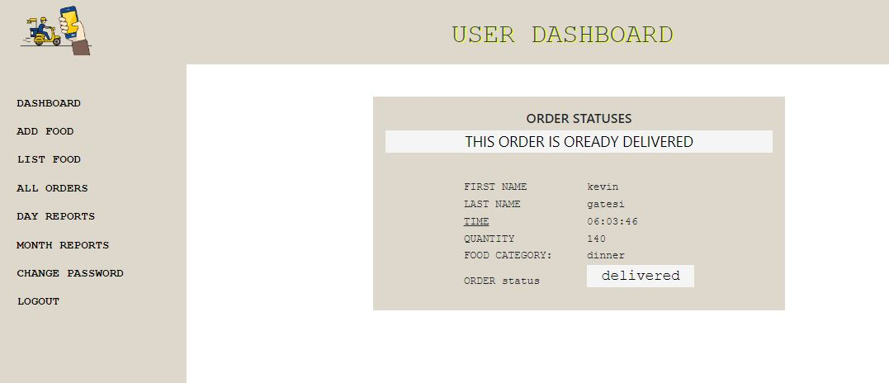

User can view oders and view one to set it delivered

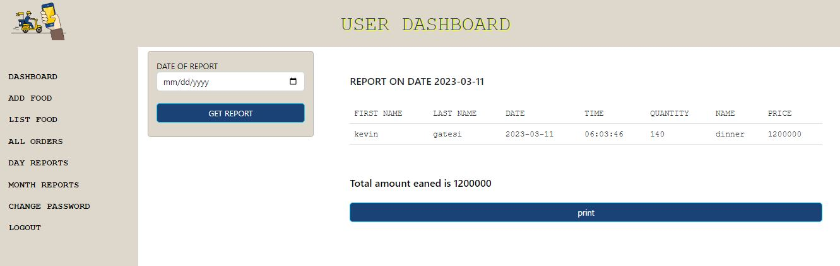

User can view different reports



**CUSTOMER PANEL**

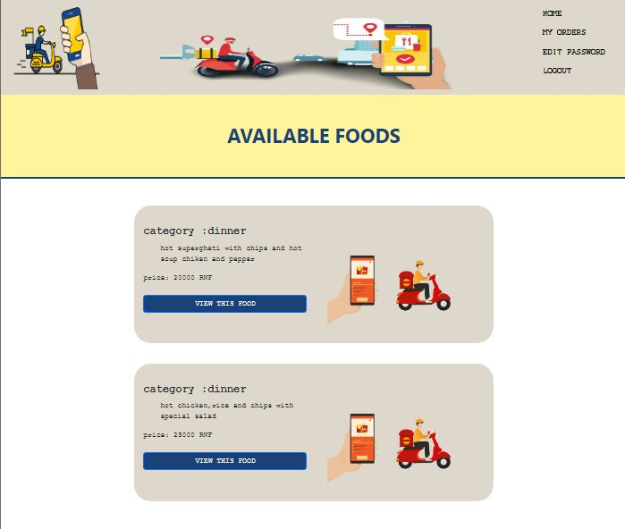

customer can view different foods uploaded by users and choose one to order.

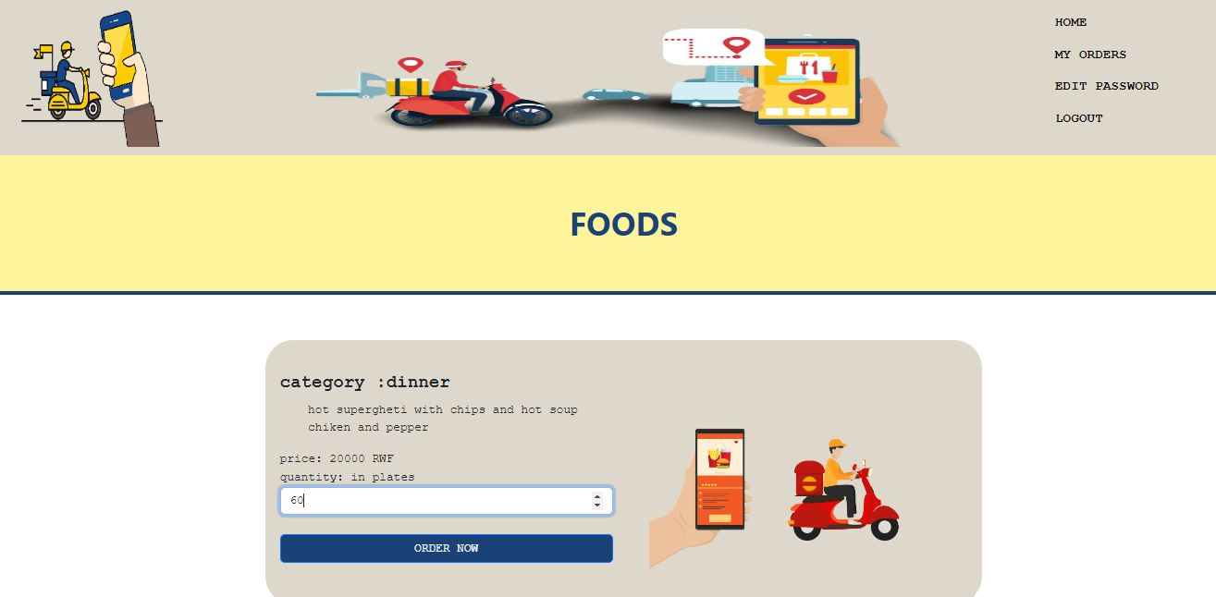

Customer can order food by choesing his our quantity he/she want

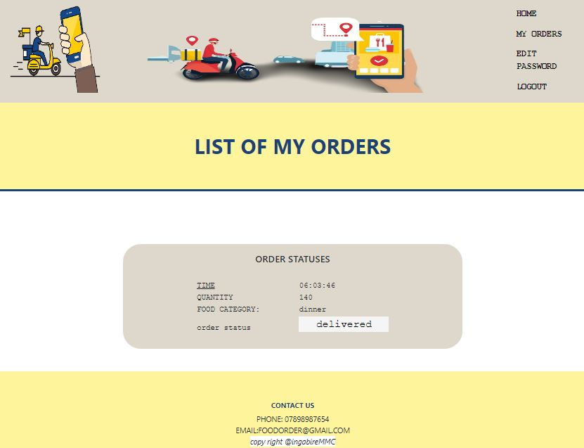

Customer can view hs historic orders

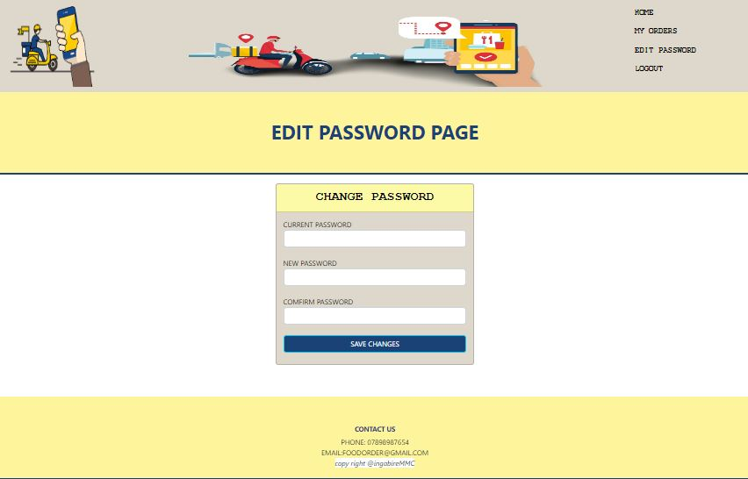

Customer can change password

**LITERATURE REVIEW**

**Introduction**

Online food ordering systems have become increasingly popular in recent years, particularly with the rise of food delivery services. These systems offer a convenient and efficient way for customers to order food from restaurants and other food providers. The purpose of this literature review is to examine the available research on the design and implementation of online food ordering systems.

Design of Online Food Ordering Systems:  
The design of an online food ordering system should be user-friendly, intuitive, and visually appealing. According to a study by Kuo and Wu (2019), the design of an online food ordering system should incorporate features such as clear and concise menus, easy navigation, and attractive food images. Additionally, the system should be responsive and compatible with a variety of devices, including mobile phones and tablets.  
  
  
**Conclusion**  
The literature suggests that online food ordering systems have the potential to be convenient, efficient, and accessible to all customers. The design of an online food ordering system should prioritize usability, security, and accessibility to ensure that the ordering process is easy and convenient for customers. As the use of online food ordering systems continues to increase, further research is needed to evaluate their effectiveness and identify areas for improvement.  
  
Similar Work refferenced  
  
"An Online Food Ordering and Delivery System" by Singh and Gupta (2021):

<https://www.researchgate.net/publication/350925346_An_Online_Food_Ordering_and_Delivery_System>

"Design of a User-Friendly Online Food Ordering System" by Alqahtani et al. (2020):

<https://www.mdpi.com/1424-8220/20/16/4479>

"Development and Implementation of an Online Food Ordering System for Campus Cafeteria" by Adebayo and Waboso (2020): <https://ieeexplore.ieee.org/abstract/document/9243084>