LAN Network Traffic Monitoring and Analysis Dashboard

1. What exactly is being monitored?
The system monitors traffic inside a Local Area Network (LAN), not the internet provider itself.
Specifically, it monitors:
- Devices connected to the LAN (PCs, phones)
- Bandwidth usage per device
- Network protocols and applications (e.g. streaming, downloads)
- Traffic patterns over time (peak hours, abnormal usage)
In simple words:
“We monitor who is using the network, how much data they use, and what type of traffic they generate.”

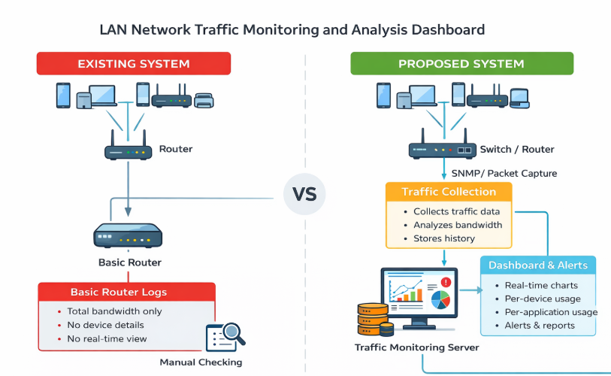

2. Existing System (Current Situation)
In most institutions today:
- A basic router (TP-Link, Cisco, etc.) connects devices to the network
- The router provides:
  - Total bandwidth usage
  - Simple logs
- No real-time, detailed visibility
Problems with the existing system:
- Cannot see which device is consuming most bandwidth
- No per-application visibility
- Difficult to detect misuse or abnormal traffic
- Limited or short-term logs
- Decisions are reactive, not proactive
This is what your left-side drawing represents:
Devices connected → router → very limited information

3. Proposed System (Your Solution)
Your proposed system adds a monitoring layer between the LAN and the administrator.
This matches your right-side drawing:
- Monitored Network
- Monitoring System
- Communication via SNMP / packet capture

4. Main Components of the Proposed System

A. Monitored Network
This is the existing LAN:
- Switches
- Routers
- Connected devices (users)
No major change here.

B. Traffic Collection Layer
This is new and very important.
It collects data using:
- SNMP → device statistics (bandwidth, interfaces)
- Packet capture / flow data → traffic behavior
- Router or switch mirroring (if available)
Purpose:
- Capture real-time traffic data
- Identify devices and usage patterns

C. Monitoring & Analysis Server
This is the core of your project.
It:
- Receives raw traffic data
- Processes and analyzes it
- Stores it in a database
- Calculates:
  - Bandwidth per device
  - Bandwidth per application
  - Usage over time

D. Dashboard & Visualization Layer
This is what the admin sees.
It provides:
- Real-time dashboards
- Charts and graphs
- Tables and reports
Examples:
- Line chart: bandwidth usage over 24 hours
- Pie chart: bandwidth usage per device
- Table: top 10 bandwidth-consuming devices

5. How the System Works (Simple Flow)
- Devices generate traffic on the LAN
- Traffic data is collected via SNMP / monitoring tools
- Data is sent to the monitoring server
- Server analyzes and stores the data
- Dashboard displays results in real time
- Alerts are triggered if abnormal usage is detected

6. Why This System Is Better
Feature | Existing System | Proposed System
Visibility | Total usage only | Per device & per app
Monitoring | Manual | Real-time
Alerts | None or basic | Automated
Reports | Short-term logs | Long-term analytics
Decision Making | Guesswork | Data-driven

Tools & Technology Stack (Summary)

Hardware & Network
- Computers / PCs – Generate LAN traffic
- Router / Switch – Connect network devices

Traffic Monitoring
- Wireshark – Captures and analyzes network traffic
- SNMP – Collects device bandwidth statistics

Backend & Server
- PHP – Data processing and analysis
- XAMPP – Local server (Apache, PHP, MySQL)
- MySQL – Stores traffic data and reports

Frontend & Dashboard
- HTML – Page structure
- CSS – User interface design

Users
- System Administrator – Monitors, analyzes, and manages the network

8. One-Sentence Summary
“This project introduces a real-time LAN traffic monitoring dashboard that gives administrators clear visibility into device-level and application-level bandwidth usage, enabling better control, performance optimization, and proactive network management.”

