RWVCA,
NYAGATARE DISTRICT
EASTERN PROVINCE
E-mail:josephnshimiye1989@ gmail.com
Tel: +250788834461/+250734150029
21, Mata, 2026.
Madam Umunyamabanga nshingwabikorwa wa Rwanda Wood value chain Association
RWVCA,KIGALI
Impamvu: Kubagezaho gahunda y’ibikenewe kugirango sites zasigaye zidasuwe mu rwego rw’ubukangurambaga zisurwe,
Nizeye ko muri Amahoro!
Nejejwe no kubandikira iyi baruwa ikubiyemo gahunda y’ibikenewe kugirango sites zitasuwe mu rwego rw’ubukangurambaga mu karere kose ahari udukiriro, kugirango barusheho kumva imisoro ndetse no gukorana na RWVCA muri rusange.
Imbonerahamwe igaragara ku mugereka w’iyi baruwa igaragaza aha zasurwa,ibizakenerwa mu ngendo zijyayo harimo kugenda no kugaruka ndetse n’ifunguro kubera ko ni sites ziri kure kandi nibura twagiye duhuza sites 3 umunsi umwe kugirango dushobore gusura henshi hashoboka.
Dukomeje kubashimira,intumwa mwatwoherereje zabyaye umusaruro,ubu mu gakiriro ka Nyagatare bamaze kumva neza ndetse batangiye imikorere mishya.
Mugire amahoro!
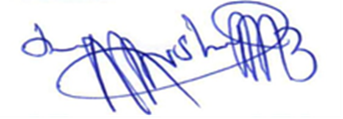
NSHIMIYIMANA JOSEPH
Umuyobozi wa RWVCA /Nyagatare

RWVCA,
NYAGATARE DISTRICT
EASTERN PROVINCE
E-mail:josephnshimiye1989@ gmail.com
Tel: +250788834461/+250734150029
21, Mata, 2026.
IMBONERAHAMWE YA SITES ZIZASURWA N’IBIZAKENERWA
NO | AMATALIKI | SITES | IBIKENEWE (rwfs) | CYONGERWAHO
1 | 24/04/2026 | -BUGARAGARA  -RWIMIYAGA  -MATIMBA | ITIKE:15,000*2=30,000  KURYA:10,000*2=20,000 | Kugenda no kugaruka umunsi wose
2 | 28/04/2026 | -RUKOMO  -CYABAYAGA  -MIMULI | ITIKE:18,000*2=36,000  KURYA:10,000*2=20,000 | Kugenda no kugaruka umunsi wose

Biteguwe :
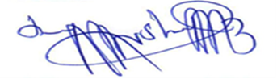
NSHIMIYIMANA JOSEPH
Umuyobozi wa RWVCA /Nyagatare

