LEAVE REQUEST FORM

Annual leave Compassionate leave others

Names : Mr. NIYITEGEKA Moses
Position : Membership Relations Officer
Year : 2026
From : 05th May 2026
Return date : 06th May, 2026
Number of days requested : 1 days
Number of days authorized : 18 days
Number of remaining days : 12 days
Reason (in case of compassionate leave or others): …others ………………
Annual leave

Done at Kigali, on 05/04/2026

Name and signature of the applicant : NIYITEGEKA Moses-------------------------
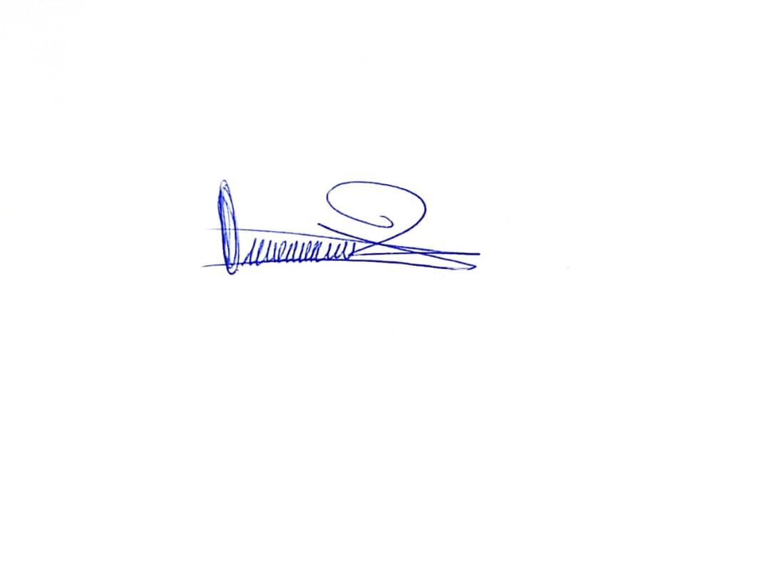
Verified by the HR on: ……...……………...……….…Signature ………………

Approved by Executive Secretary on: ……...……….……Signature ………………

