NTAKIRENDE John
04.05.2026
GIKONDO SECTOR
KICUKIRO DISTRICT
TEL: 0788640935

Subject: Request for annual Leave

Dear HR,

I am writing to request annual leave from 06th May 2026 to 07th May 2026. I will ensure that all tasks are completed and make arrangements for coverage during my absence .

Thank you for considering my request
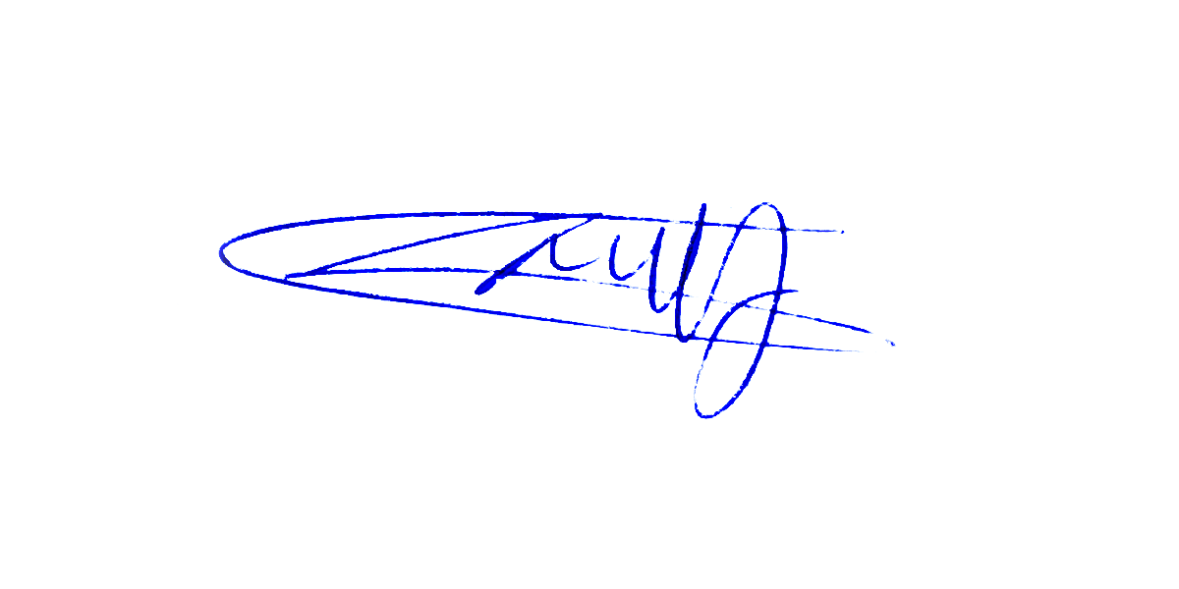
NTAKIRENDE John

