NTAKIRENDE John
08.07.2026
GIKONDO SECTOR
KICUKIRO DISTRICT
TEL: 0788640935

Subject: Request for annual Leave

Dear HR,
I’d like to request seven days of annual leave from July 10, 2026, to July 17, 2026, and will return on July 20. I’ll make sure all my tasks are completed and arrange coverage during my absence.

Thank you for considering my request
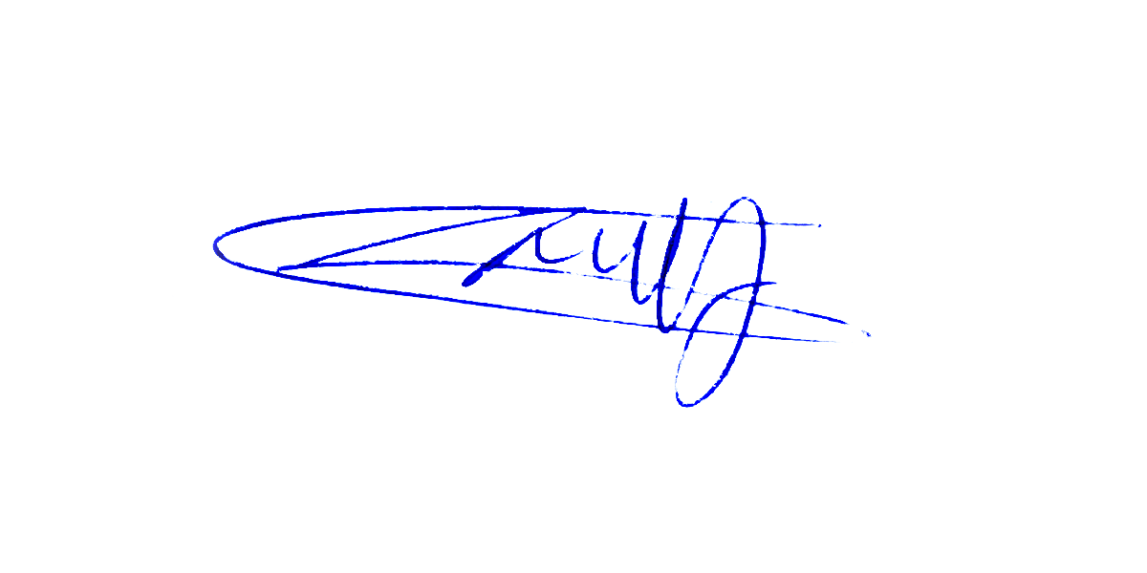
NTAKIRENDE John

