NTAKIRENDE John
26.08.2026
GIKONDO SECTOR
KICUKIRO DISTRICT
TEL: 0788640935

Subject: Request for annual Leave

Dear HR,
I’d like to request two days of annual leave from August 27, 2026, to August 28, 2026, and will return on August 31. I’ll make sure all my tasks are completed and arrange coverage during my absence.

Thank you for considering my request
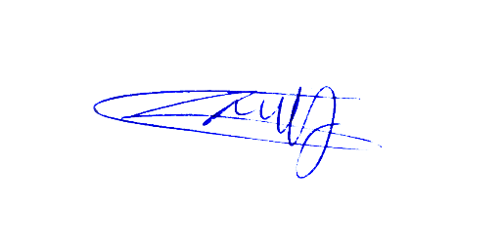
NTAKIRENDE John

