Subject: Application for Annual Leave
Dear Olga,
I am writing to formally request 17 days of my annual leave, starting from 17/08/2026 and returning to work on 05/08/2026.
During this period, I will have limited access to my work email, but you can reach me on my cell phone in case of urgent matters.
Thank you for considering my request. Please let me know if this dates configuration works or if you need any adjustments.
Sincerely,
Chantal NIYIGENA
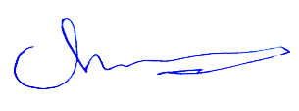
Membership Supervisor Officer

