RAPORO Y’URUZINDUKO RW’AKAZI MU KARERE KA NYAGATARE KUWA 17/04/2026
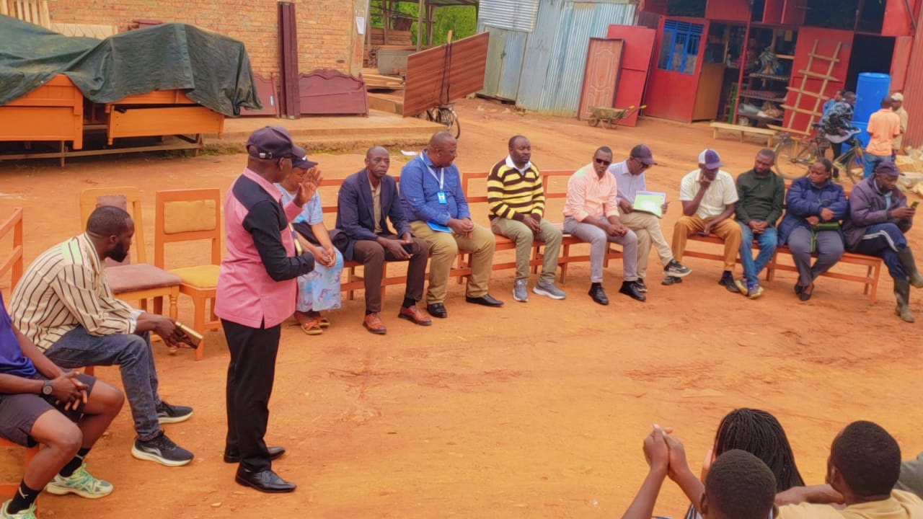

Nyuma y’uruzinduko twari twarakoreye muri Aka karere ka Nyagatare, Ku itariki ya 24 Werurwe 2026, Hatanzwe icyifuzo cy’uko twazagarukayo hamwe na RRA,kugirango abacuruzi b’imbaho barusheho gufasha uburyo hashyirwaho umurongo w’uko bajya barangura imbaho ziturutse Uganga kandi bagahabwa fagitire.

Ni muri urwo rwego, Association yateguye iki gikorwa ,kikaba cyaragezweho ku itariki ya 17 Mata 2026.
Abagiye muri iki gikorwa baturutse muri RWVCA:
- Bwana NDAYAMBAJE JANVIER umuyobozi wa RWVCA mu karere ka Rwamagana akaba n’umuyobozi uyoboye abandi mu Ntara y’iburasirazuba.
- Bwana Bizumuremyi Emmanuel, Umukozi wa RWVCA ushnzwe abanyamuryango,
- Bwana Muhirwa Felecien, umushoferi wa RWVCA.
Ibyingenzi byaganiriweho:

- Ikibazo cy’uko abacuruzi b’imbaho zituruka Uganda badatanga VAT,bikabaviramo kutagira stock muri EBM zabo, bityo bikaba imbogamizi mu mikorere yabo kuko basabwa gucuruza batanga fagitire kandi bo batarayihawe ubwo baranguraga.

Abitabiriye inama kuruhande rw’Agakiriro n’izindi nzego:

- Abacururuzi bose bakorera mu gakiriro,byumwihariko harimo n’abacuruzi b’imbaho 4 kuri batanu bakorera muri aka Gakiriro.
- Umuyobozi w’ungirije wa RRA mu karere ka Nyagatare
- Ubuyobozi bw’Agakiriro
- MRO mu karere ka Nyagatare.
Umuyobozi wa RWVCA mu karere ka Nyagatare bwana Nshimiyimana Joseph, yasobanuriye abakorera mu gakiriro ka Nyagatare impamvu y’inama ndetse anabereka abayitabiriye bose kumpande zombie.

Bwana Janvier, umuyobozi wa RWVCA mu Ntara y’iburasirazuba yahawe umwanya maze aganiriza abacuruzi, abasobanurira ikibazo cyatumye tuza kubasura, agaragaza ibihombo biterwa no kutagira fagitire fagitire baranguriraho. Aha iyo bagiye kwishyura umusoro kunyungu usanga basora amafaranga menshi kandi nabo batinjije. Yababwiye ko ibyo bibazo bitera ingaruka nyinshi harimo no gufungirwa konti za banki mugihe bigaragaye ko hari ibitarubahirijwe mugihe cyo kumenyekanisha imisoro. Yababwiyeko ibyo bibazo RWVCA yahanganye nabyo, mugihe hari abacuruzi babaga bafite fagitire za baringa bibaviramo guhanwa ariko association ikora uko ishoboye ibakorera ubuvugizi ari naho havuye imikoranire na RRA, maze yemererwa kujya itanga inyemezabwishyu mu rwego rwo kurangiza icyo kibazo cya fagitire zitarizo.

Nyuma yahoo umukozi wa RRA wungirije mu karere ka Nyagatare, yasobanuriye abari mu nama bose, ababwira amako y’imisoro itangwa mu gihugu imbere, by’umwihariko agaruka ku mbaho, yabajije abacuruzi b’imbaho niba bacuruza batanga fagitire? Bamubwiyeko bayitanga. Hanyuma ababaza uko basohora stock batinjije , Babura icyo bamusubiza.

Imyanzuro yafashwe:

- Hafashwe icyemezo cy’uko imbaho zose zije mu karere zigomba kubarwa n’umukozi wa RWVCA mbere yuko zipakururwa kandi zigahabwa fagitire ya EBM.Ibi bigomba kubahirizwa mu karere kose nkuko bikorwa hirya no hino mu Gihugu.
- Umuyobozi wa RRA wungirije mu karere ka Nyagatare yasabye ko umucuruzi wese wakwanga gusora yitwaje ko imbaho ziturutse Uganda, yabwiyeko umukozi wacu azajya abameneysha uwo muntu ahanwe.
- Hemejwe ko hagiye kubakwa inzego mu Gakiriro hagendewe ku mirimo abantu babarizwamo mu Gakiriro.
- Fagitire zatanzwe n’izindi company zibyemerewe, uzazizana azajya abanza kuzijyana kubiro bya RRA Nyagatare kugirango zibanze kwemezwa.
- Umuyobozi wa RWVCA Nyagatere , hamwe n’umukozi wa RWVCA mu karere bari kumwe n’umukozi wa RRA mu karere bazazenguruka site zose zicururizwaho imbaho, abahakorera nabo babwirwe ibi byemezo byafashwe.

Nyagatare, kuwa 17/04/2026

BIZUMUREMYI Emmanuel

Umukozi wa RWVCA ushinzwe abanyamuryango

