IDETECT
USER MANUAL

OCR-Based Discount ID Validation System
For Senior Citizen and PWD Discount ID Validation and Fraud Intelligence in Valenzuela City
Prepared for the Capstone Project
De Los Reyes, Carlo M. • Enoria, Jorich Maricar C. • Mercado, Vesti Sahm Angielo • Santiago, Ishmael Luis C.

Field | Value
Project | Design and Development of iDetect
Institution | Pamantasan ng Lungsod ng Valenzuela — College of Engineering and Information Technology
Source basis | Post-Capstone 1 Revision Manuscript, May 2026

Document Control & Quick Start
Field | Value
Manual status | Capstone User Manual — based on supplied Post-Capstone 1 manuscript
System version | [TO BE PROVIDED]
Official support contact | [TO BE PROVIDED]
Client/BPLO/OSCA/PDAO URLs | [TO BE PROVIDED]
Mobile app distribution links | [TO BE PROVIDED]

60-Second Quick Start — Establishment Staff
- Open the Client Portal
Sign in using the establishment account provisioned through BPLO.
Expected: Validation dashboard opens.

Scan the ID
Use the mobile camera and follow the position/distance/lighting guide.
Expected: Readable capture is accepted and preprocessed.

Review OCR
Check ID number, full name, beneficiary type, validity period, and issuing office.
Expected: Data is ready for validation or manual correction.

View the result
Submit for OSCA/PDAO validation.
Expected: VALID, SUSPICIOUS, or INVALID appears within the 30-second target under normal conditions.

Flag when appropriate
Use the flag action for a suspicious/invalid credential requiring LGU investigation.
Expected: Reference number is generated and the report is routed.
LEGAL / OPERATIONAL NOTE iDetect does not override existing DOJ requirements concerning unverifiable credentials. It is a fraud-intelligence and reporting mechanism.

Introduction
  - Brief Overview
iDetect is an integrated five-portal system designed to validate Senior Citizen and PWD identification cards used in food service establishments in Valenzuela City. It combines mobile camera capture, Tesseract OCR, field-level validation, real-time cross-checking against OSCA and PDAO records, bidirectional fraud reporting, and beneficiary accountability mechanisms.

Purpose
The system is intended to reduce manual verification effort, strengthen coordinated fraud intelligence, improve validation speed and consistency, and give registered beneficiaries visibility into validation activity and structured recourse for erroneous outcomes.

Intended Users
Establishment staff, BPLO administrators, OSCA administrators, PDAO administrators, and Senior Citizen/PWD beneficiaries use separate role-specific interfaces.

System at a Glance
Portal / Role | Access | Primary responsibilities
Client Portal / Establishment Staff | Mobile app | ID capture, OCR extraction, validation, flagging, transaction history, compliance reports
BPLO Administrator | Web portal | Establishment provisioning, permit validation, account status, permit-expiry monitoring, operational dashboard
OSCA Administrator | Web portal | Senior Citizen records,  flagged-ID investigation, fraud confirmation/dismissal, analytics
PDAO Administrator | Web portal | PWD records, flagged-ID investigation, fraud confirmation/dismissal, analytics
Beneficiary | Mobile app | Optional account, status monitoring, notifications, history, disputes, fraud/unauthorized-use reporting

Important Boundaries
    - Valenzuela City only; the implementation validates Valenzuela City OSCA/PDAO credentials and serves BPLO-registered establishments.
    - Food-service scope: restaurants, cafes, and fast-food chains.
    - Automated OCR is configured for the supported Valenzuela City OSCA/PDAO card layouts; other formats may require manual entry.
    - No biometrics. VALID confirms credential-data matching, not that the presenter is the registered cardholder.
    - iDetect does not determine eligibility, issue IDs, or independently change official government status.
    - Beneficiary registration is optional.
SCOPE WARNING Severely damaged/illegible cards, unsupported layouts, and extended connectivity loss fall outside reliable automated operation.

Software Specifications
Only technologies and platform requirements explicitly documented in the manuscript are listed below.

Component | Supported / documented requirement
Client Portal | Mobile application; Android 8.0+ and iOS 12.0+
Beneficiary Mobile App | Android 8.0+ and iOS 12.0+
OCR engine | Tesseract OCR
Image preprocessing | Deskewing, contrast enhancement, noise reduction; automated image-quality assessment
Integration | Secure RESTful APIs for real-time OSCA/PDAO validation and fraud-flag transmission
Authentication | RBAC; bcrypt hashing; JWT/session-token architecture documented
Notifications | SMS via Semaphore gateway; push via Firebase FCM / APNs

Authentication & Notifications
The design uses role-based access control, bcrypt hashing, and token/session-based authentication. Beneficiary authentication uses ID number + birthdate and a one-time PIN/OTP.

Push notifications are documented through Firebase FCM / APNs; SMS is documented as independent of mobile data and the implementation references the Semaphore gateway.

Developer / Deployment Environment
The manuscript requires a repository, version control, CI/CD pipelines, linters, migration scripts, API scaffolding, and API health checks. Exact language/framework versions, hosting platform, environment-variable names, browser versions, and deployment commands are [TO BE PROVIDED].

Hardware Specifications
The manuscript defines functional hardware needs but does not provide numerical RAM, CPU, storage, or server-sizing values.

Hardware | Minimum / required | Recommended / guidance
Mobile device | Android 8.0+ or iOS 12.0+ with working camera | Device that can capture a sharp, well-lit supported ID
Camera | Built-in mobile camera | Rear camera with stable focus and adequate lighting
Computer | Required for BPLO/OSCA/PDAO portals | Modern desktop/laptop with supported browser
Internet | Stable connection for live verification | Reliable Wi-Fi/mobile data at point of service
Dedicated scanner | Not required by documented workflow | Mobile camera is the documented capture method

ID Capture Guidance
    - Use the mobile camera workflow; no dedicated scanner is required by the documented process.
    - Keep the supported ID readable, flat, aligned, and adequately lit.
    - Avoid blur, glare, heavy skew, and obstructed text. Poor images may be rejected or sent to manual entry.

Connectivity
Real-time verification is online-first. Recently verified records may be cached for limited offline validation, and pending fraud flags are queued for synchronization after reconnection. Cached results are labeled with their last online timestamp.

Installation & Deployment Guide
AUDIENCE For authorized deployment/system administrators. End users should not change database, API, hosting, or security configuration.

  - Pre-Installation Checklist
    - Approved iDetect package/repository — [TO BE PROVIDED].
    - Backend/API environment — [TO BE PROVIDED].
    - Database engine/version and credentials — [TO BE PROVIDED].
    - OSCA/PDAO integration endpoints/credentials — [TO BE PROVIDED].
    - Semaphore SMS and FCM/APNs configuration.
    - Official mobile packages and production URLs — [TO BE PROVIDED].
    - TLS/SSL and hosting configuration — [TO BE PROVIDED].

Backend / API Setup
- Prepare repository
Obtain the approved deployment package and required tooling.
Expected: Repository/tooling is available.

Configure environment
Set database, API, OSCA/PDAO, SMS, and push-service settings. Exact variable names/values are [TO BE PROVIDED].

Expected: Services can be reached.

Initialize database
Create the target database and execute official migration scripts; use approved seed data where applicable.
Expected: Schemas are created without errors.

Configure API
Deploy API scaffolding and secure OSCA/PDAO connections without exposing underlying databases directly.
Expected: API health check succeeds.

Configure notifications
Connect Semaphore and Firebase FCM/APNs with approved credentials.
Expected: Controlled notification test succeeds.

Run health checks
Use the final deployment health-check procedure [TO BE PROVIDED].
Expected: Required services report healthy/ready.

Database Setup
The documented schema includes users, establishments, beneficiaries, beneficiary_accounts, verification_logs, fraud_flags, disputes, notifications, audit_logs, and staff_alerts. Exact database engine/version and connection settings are [TO BE PROVIDED].

DATABASE SAFETY Functional testing is described as using seeded test databases without real beneficiary data.

Web Portal Deployment
- Deploy portals
Publish BPLO, OSCA, and PDAO responsive web builds.
Expected: Each assigned URL loads.

Set API base URL
Configure the approved API endpoint: [TO BE PROVIDED].
Expected: Portal actions reach the correct backend.

Verify role routing
Test BPLO, OSCA, and PDAO accounts separately.
Expected: Cross-portal access is blocked.

Verify encryption
Confirm production traffic uses encrypted channels/certificates.
Expected: Sensitive traffic is protected.

Mobile Installation
- Obtain official package
Install the approved Client Portal or Beneficiary package/link: [TO BE PROVIDED].
Expected: Correct app is installed.

Grant permissions
Allow camera access for Client Portal and notification access where applicable.
Expected: Required permissions are active.

Sign in
Use establishment credentials or beneficiary ID/birthdate/OTP.
Expected: Correct dashboard opens.

Run controlled test
Use approved test credentials/IDs only.
Expected: Controlled validation/notification succeeds.

Common Installation Problems
Problem | Cause | Response
Migration failure | Connection/schema conflict | Check configuration, review error, roll back partial migration, retry.
API health-check failure | Dependency/configuration unavailable | Check environment settings and dependent services.
Portal cannot reach API | Endpoint/network/TLS issue | Verify API URL, route, and certificate.
OTP not received | SMS/contact configuration | Verify registered contact and Semaphore configuration.
Push absent | FCM/APNs/device-token issue | Check permissions and push-service configuration.
Camera unavailable | Permission/device issue | Enable permission and confirm supported OS.

User Functions & Capabilities
  - Establishment Staff — Client Portal
The point-of-sale workflow is intentionally limited to launch → scan → view result.

Log in
Enter registered username/password. Account must be approved and active.
Expected: Validation dashboard opens.

Capture ID
Use camera and follow position/distance/lighting guidance.
Expected: Quality-approved image is accepted.

Review OCR
Check ID number, full name, beneficiary type, validity period, and issuing office. Correct fields or use manual fallback.
Expected: Data is ready for validation.

Validate
Submit credential data for the dual-database check.

Expected: VALID, SUSPICIOUS, or INVALID is displayed within 30 seconds under normal conditions.

Validation Statuses
Result | Meaning | Recommended response
VALID | Credential data matches an active, non-revoked official record within system rules. | Review result and follow applicable  establishment/legal procedure.
SUSPICIOUS | Discrepancy/conflict/anomaly warrants LGU investigation. | Review and flag when appropriate; not a final fraud determination.
INVALID | No matching record or clear invalid/revoked/expired condition under system rules. | Review; flag for investigation when appropriate. If type is unknown, choose Senior Citizen or PWD.
MANUAL_REVIEW | OCR confidence is too low for automated processing. | Review/correct fields or use manual entry, then validate.
IMPORTANT SUSPICIOUS is an investigation trigger, not a final fraud determination.

Flagging a Credential
- Tap Flag
Use the flag action after a SUSPICIOUS or INVALID result.
Expected: Confirmation prompt appears.

Confirm
Confirm the report.
Expected: ID image, extracted data, establishment, timestamp, and outcome are routed to OSCA/PDAO.

Select type if unknown
For an INVALID no-record case with unconfirmed type, choose Senior Citizen or PWD.
Expected: Correct LGU route is selected.

Record reference
Note the generated reference number.
Expected: Flag is linked to history/audit records.

OFFLINE Flags can be queued locally and automatically synchronized after connectivity returns.

Transaction History & Compliance Reports
Open transaction history, choose a date range, and request a compliance summary. The documented report presents counts of VALID, SUSPICIOUS, and INVALID outcomes.

BPLO Administrator — BPLO Portal
- Sign in
Use institutionally issued BPLO credentials.
Expected: BPLO dashboard opens.

Provision establishment
Enter a valid Valenzuela City business permit number and designated staff credentials.
Expected: Permit is validated and an eligible account is created.

Deliver credentials
System generates/displays credentials and sends onboarding information by email/SMS.
Expected: Establishment receives access instructions.

Manage status
Activate, suspend, or revoke accounts when authorized.
Expected: Access changes and action is logged.

Monitor permit expiry
Review alerts for permits approaching expiry within 30 days or already expired.
Expected: BPLO can take manual action; alerting does not automatically suspend.

Monitor operations
Review active accounts, recent provisioning, pending actions, and technical performance metrics.
Expected: Operational oversight is available without beneficiary data.
BOUNDARY BPLO does not access flagged credential records, beneficiary personal information, or validation intelligence.

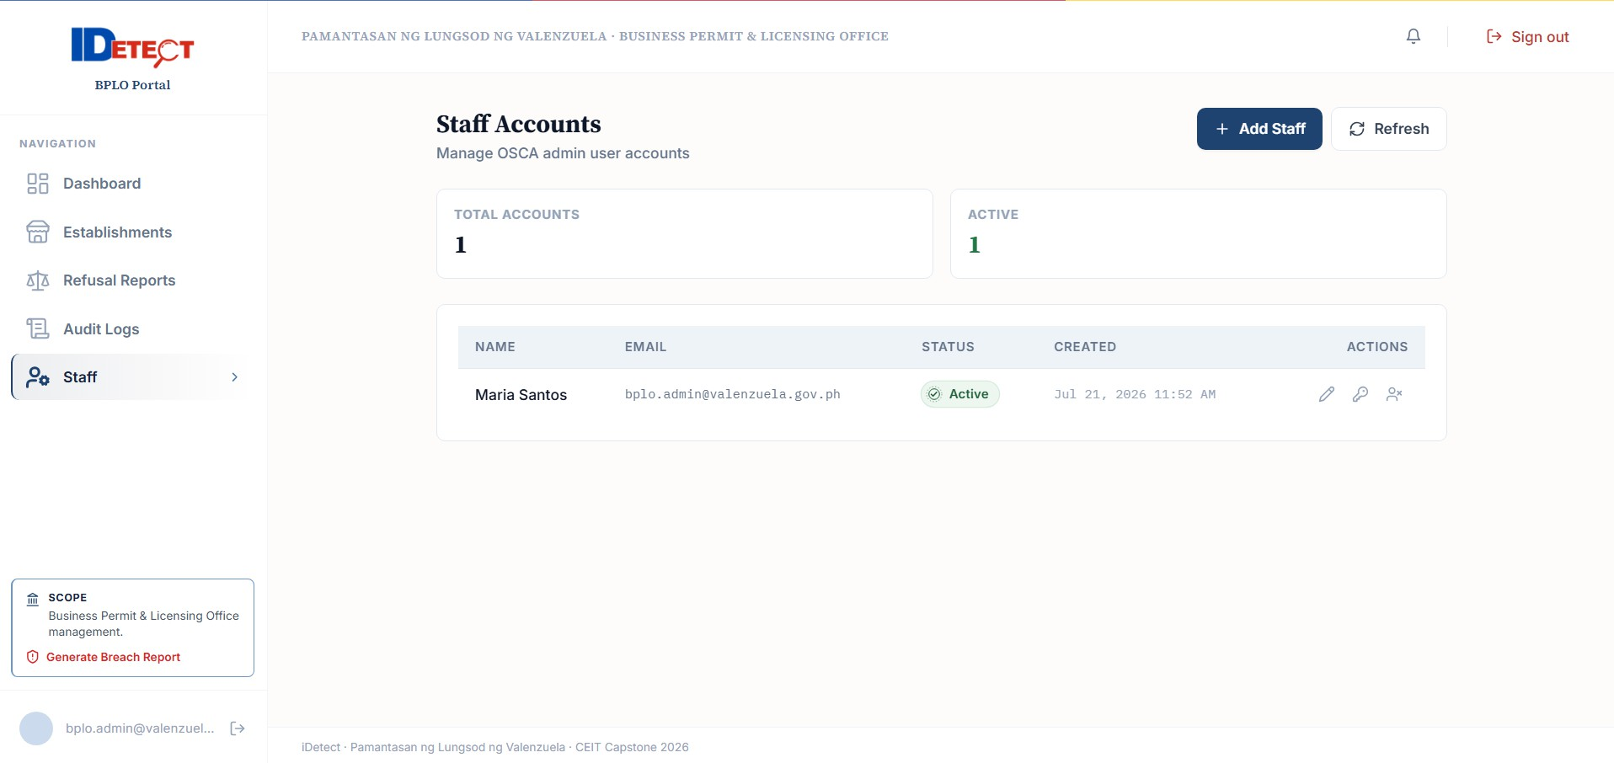
OSCA Account Management

OSCA Administrator — OSCA Portal
- Sign in
Use OSCA credentials.
Expected: Senior Citizen-only dashboard opens.

Review flags
Open incoming flagged credential notifications.
Expected: Captured image, extracted fields, establishment, and timestamp are shown.

Investigate
Review evidence and official Senior Citizen record.
Expected: Case is handled within OSCA scope.

Decide
Mark confirmed fraud or dismiss a legitimate flag.
Expected: Status/audit update occurs; confirmed fraud propagates to connected Client Portals.

Manage records
Add/update Senior Citizen records, renewals, and corrections.
Expected: Authorized official record changes are saved.

Use analytics
Review temporal, geographic, establishment-specific and conversion-rate trends.
Expected: Fraud intelligence supports investigation.
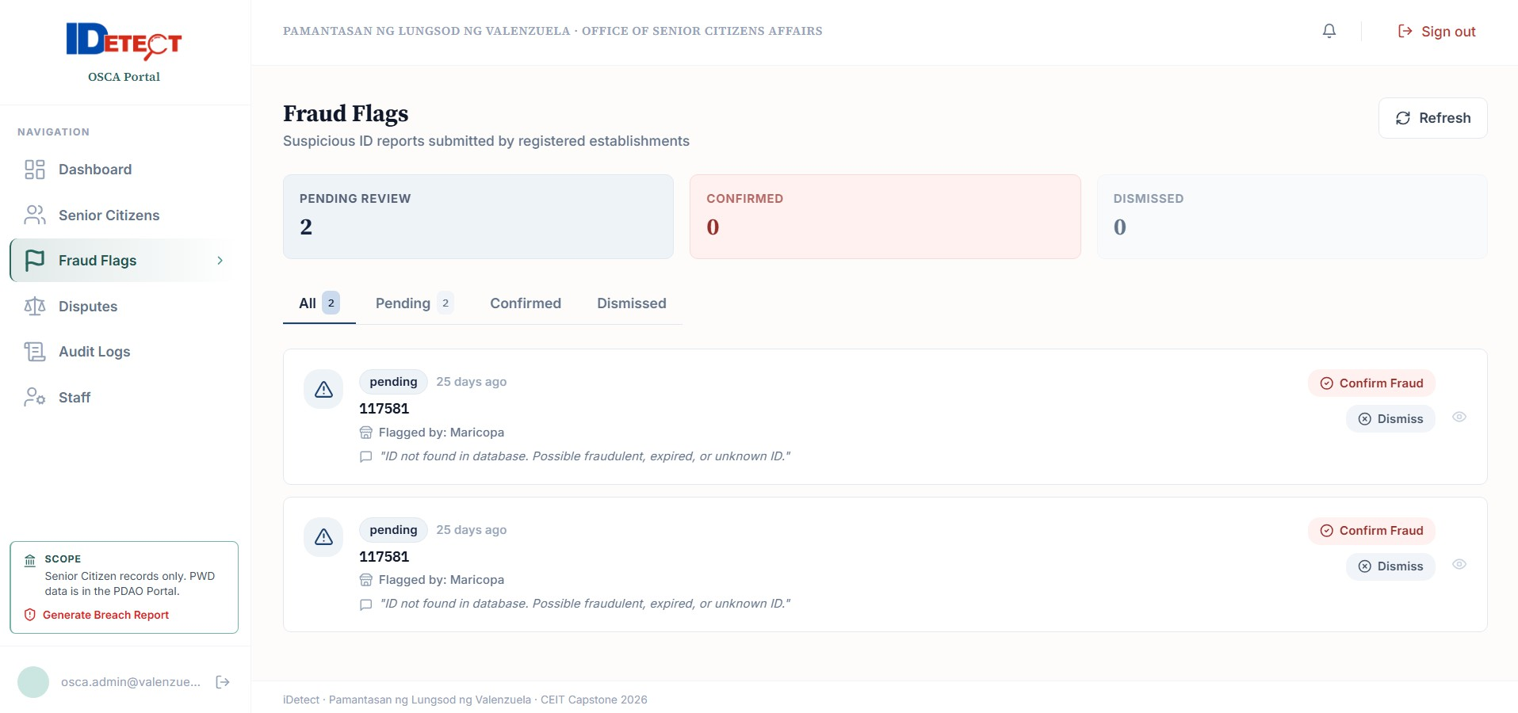
PDAO Fraud Flags

PDAO Administrator — PDAO Portal
- Sign in
Use PDAO credentials.
Expected: PWD-only dashboard opens.

Review flags
Open incoming PWD flag notifications.
Expected: Captured image, extracted fields, establishment, and timestamp are shown.

Investigate and decide
Confirm fraud or dismiss a legitimate flag.
Expected: PWD status/audit records update and confirmed fraud propagates.

Manage records
Add/update PWD records, renewals, and corrections.
Expected: Authorized changes are saved.

Use analytics
Review PWD fraud trends and establishment patterns.

Expected: Intelligence supports enforcement.
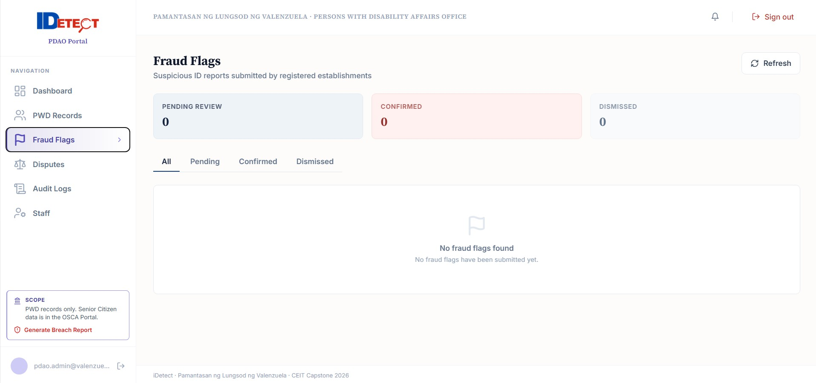

  - Beneficiary Mobile Application
OPTIONAL Registration is voluntary and does not affect statutory discount entitlement.

Registration & Authentication
- Enter ID number and birthdate
Submit credential details.
Expected: Corresponding OSCA/PDAO record is checked.

Receive OTP
A one-time PIN is sent to the mobile number registered with the credential.
Expected: Second authentication factor is available.

Submit OTP
Enter valid OTP within configured window.
Expected: Account is activated/authorized.

Status, Notifications & History
Authenticated beneficiaries can view Active, Under Review, Suspended, or Expired status, last successful validation details, expiration date, and issuing-office contact information. Validation attempts can generate SMS and push notifications containing establishment, timestamp, and Approved/Denied outcome; denied notices may include specific reasons.

Dispute Procedure
- Select denied transaction
Open the notification/history entry and choose Dispute.
Expected: Form is pre-populated with transaction reference, establishment, and denial reason.

Choose category
Wrong Denial, ID Used Without My Authorization, or Database Contains Incorrect Information.
Expected: Issue is categorized.

Write explanation
Provide the required written explanation; supporting documentation may be uploaded.
Expected: Form is ready for submission.

Submit
Send to OSCA/PDAO queue.
Expected: Reference number is generated; acknowledgment target is 24 hours.

Track
Monitor dispute status.
Expected: Updates/final explanation are delivered after human review.

Beneficiary Accountability Reports
Report type | Route | Expected handling
Unauthorized ID use | OSCA/PDAO | Investigation; confirmed unauthorized use can support network-wide protection.
Business refusal despite VALID | BPLO | Investigation of potential non-compliance.
Incorrect database information | OSCA/PDAO | Validation/correction by authorized LGU personnel.

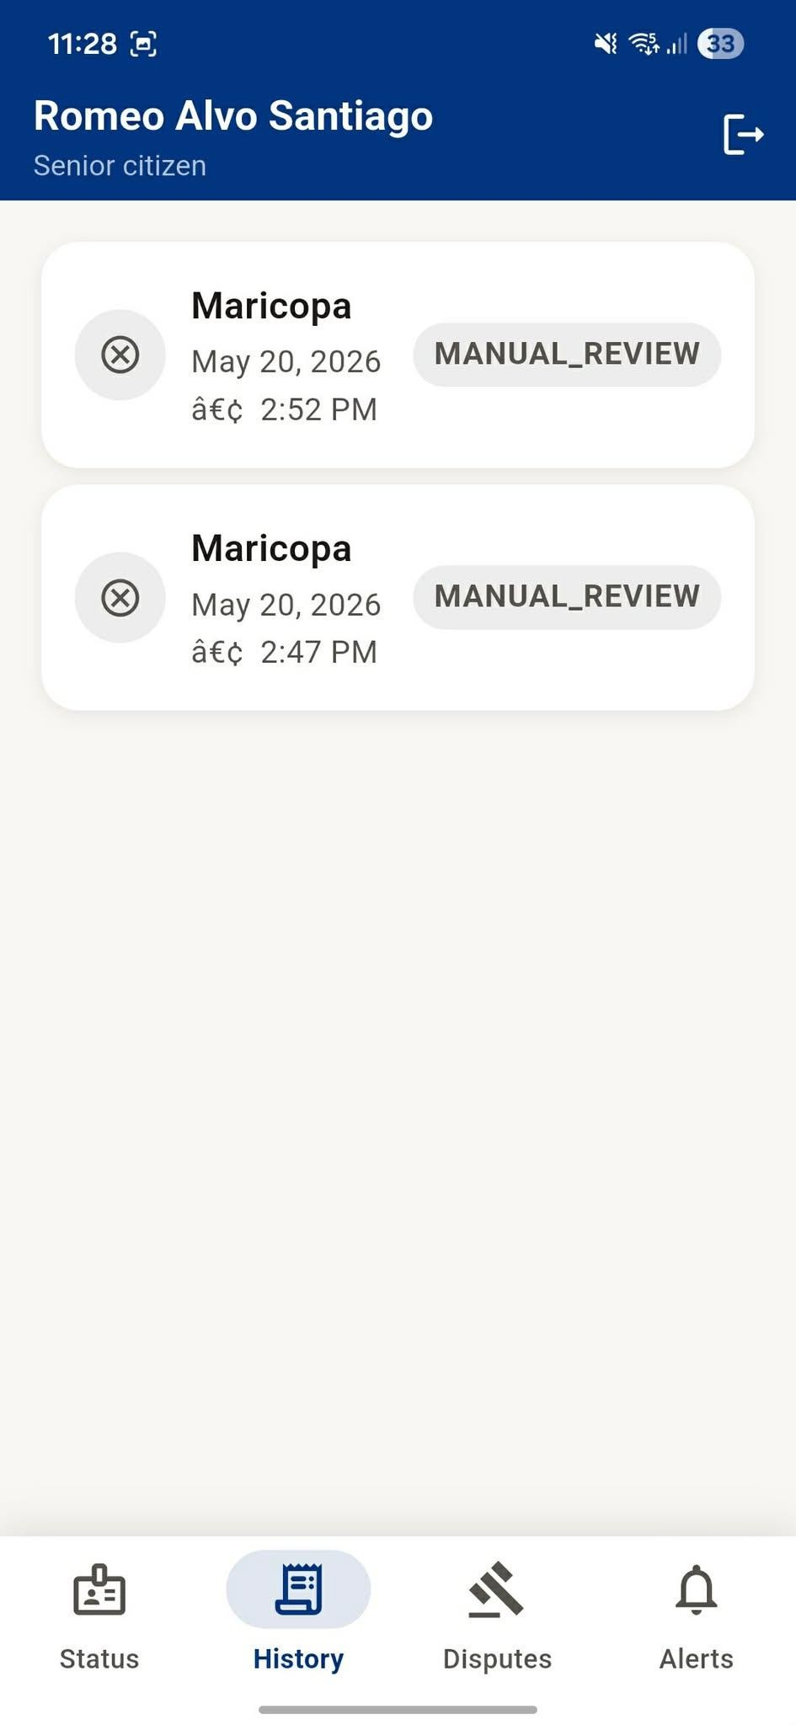
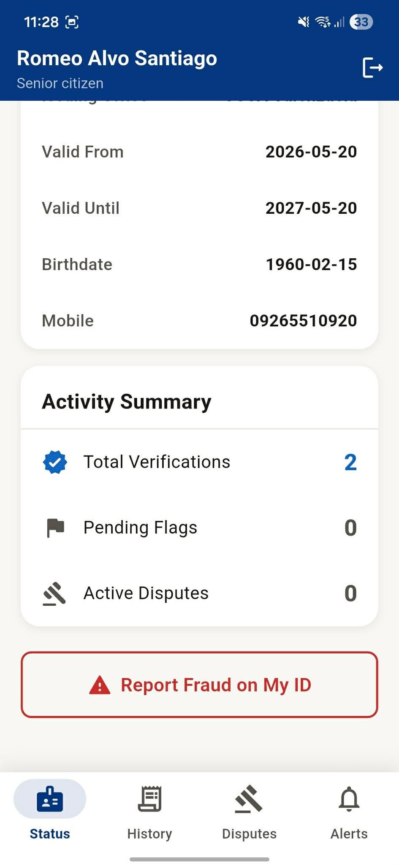
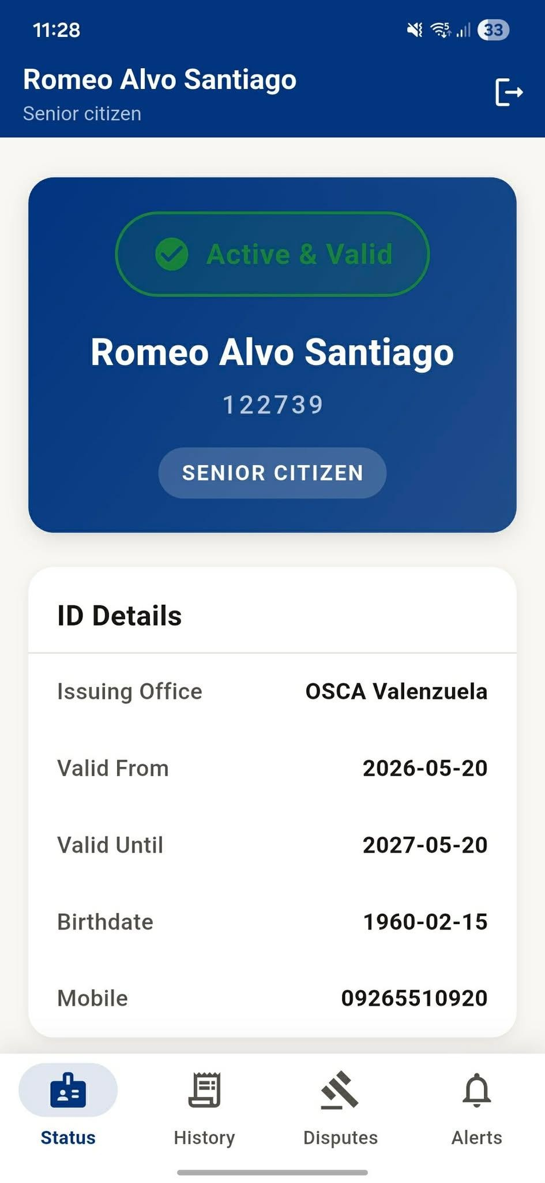
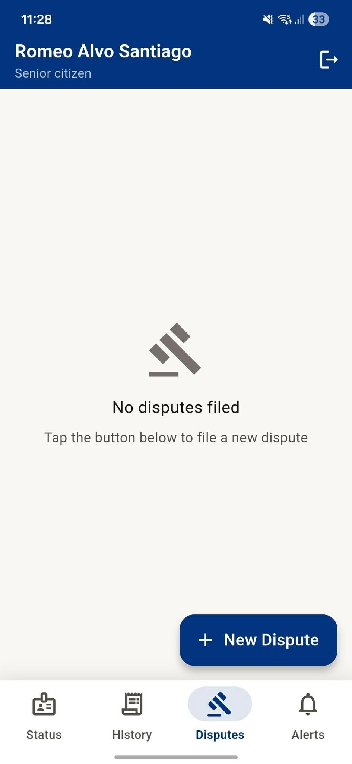
Beneficiary registration/status/dispute screens

System Workflow

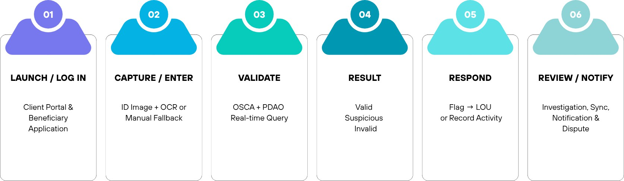

End-to-End Flow
- Authenticate the appropriate user.
- Capture the supported ID or use the manual-entry fallback.
- Assess image quality and preprocess accepted images.
- Extract ID number, full name, beneficiary type, validity period, and issuing office with Tesseract OCR and field-level confidence scoring.
- Cross-check against OSCA and PDAO through secure RESTful APIs.
- Return and log VALID, SUSPICIOUS, or INVALID.
- Flag suspicious/invalid credentials when appropriate and route to OSCA/PDAO.
- Investigate and synchronize confirmed status across connected Client Portals.
- Notify registered beneficiaries and support disputes/accountability reports.
SYNCHRONIZATION Confirmed fraud status is designed to propagate to connected Client Portals within 10 seconds of the database update under normal network conditions.

Offline / Reconnection Flow
The Client Portal shows a persistent offline indicator. Recently verified credentials may be checked from local cache with the last online timestamp. New live validation without a cached record is unavailable. Queued fraud flags synchronize automatically after reconnection.

Beneficiary Accountability Loop
Transaction notification → beneficiary review → dispute/unauthorized-use report → OSCA/PDAO or BPLO review → resolution notification. This is the documented bidirectional accountability model.

Troubleshooting & FAQs
Problem | Possible cause | Simple solution
Camera rejects image | Blur, glare, poor light, skew, damaged ID | Reposition, improve lighting, steady camera, recapture; use manual entry if needed.
OCR is wrong | Poor image or unsupported/aged card layout | Review and correct extracted fields; use manual fallback.
Validation is slow | Network/service latency | Wait for result; if offline, follow offline guidance and use cached results only when labeled.
No live result offline | Credential not in local cache | Reconnect before relying on a live database result.
Flag is pending | Queued while offline or temporary sync failure | Keep device connected; automatic retry/synchronization is expected.
Account locked | Three consecutive failed login attempts | Wait for cooldown or contact the proper administrator.
OTP fails/expires | Incorrect/expired OTP | Request a new OTP within the allowed resend limit.
Old beneficiary status | Offline/last synchronized state | Check timestamp and reconnect.
BPLO cannot create establishment | Permit invalid/expired/ineligible | Verify permit in BPLO registry.
Authorization error | Role is attempting an unauthorized portal/data access | Use assigned portal or contact administrator.

Frequently Asked Questions
Q. Does a beneficiary need the app to receive the discount?
A. No. Registration is optional and does not affect entitlement or Client Portal validation.

Q. Does VALID prove the presenter owns the ID?
A. No. iDetect does not use biometrics; physical identity confirmation remains with establishment staff.

Q. Is SUSPICIOUS the same as fraud?

A. No. It triggers investigation; OSCA/PDAO make the final determination.

Q. Can BPLO see beneficiary or fraud records?
A. No. BPLO is limited to establishment management/operational oversight.

Q. Can OSCA see PWD records?
A. No. OSCA is restricted to Senior Citizen records; PDAO is restricted to PWD records.

Q. Can beneficiaries directly edit government records?
A. No. They submit disputes; authorized OSCA/PDAO personnel adjudicate and correct records.

Q. What happens if the same ID is flagged again?
A. A new report can be linked as a supplementary report to an existing open investigation.

Q. How long are audit logs retained?
A. The manuscript specifies at least five years before archival may occur under policy.

Security & Data Privacy
iDetect uses role separation, encrypted transmission, authentication controls,
minimum-disclosure validation responses, session expiry, and audit logging to protect credential and beneficiary information.

Security Controls
    - RBAC restricts functions/data by role.
    - Data is transmitted over encrypted channels.
    - Beneficiary accounts use ID number + birthdate and OTP; the implementation also documents a PIN-based return-login path.
    - Passwords/secrets are bcrypt-hashed in the documented schema.
    - Validation, fraud flags, disputes, database changes, and administrative actions are logged in tamper-evident audit records.
    - Audit records cannot be modified/deleted through normal user functions.
    - Client and Beneficiary sessions auto-expire after inactivity.
    - Unauthorized API requests are rejected and logged.
    - Client Portal receives validation status rather than comprehensive beneficiary personal data.

Data Minimization & Compartmentalization
Validation uses only the fields needed to determine credential validity: ID number, full name, beneficiary type, validity period, and issuing office. Establishments receive the validation outcome without comprehensive beneficiary data. OSCA, PDAO, BPLO, and beneficiary boundaries are enforced by RBAC.

Responsible Handling
    - Treat ID images, names, ID numbers, birthdates, mobile numbers, disputes, and transaction records as sensitive.
    - Use only authorized iDetect workflows/storage.
    - Do not share screenshots or reports through personal messaging/social media.
    - Never share passwords, OTPs, PINs, or session credentials.
    - Report suspected unauthorized access/data exposure through the approved privacy/security channel: [TO BE PROVIDED].
PRIVACY REMINDER The design is framed around RA 10173, including access/correction mechanisms, minimum disclosure, and breach-reporting support. Follow the organization’s approved privacy policy and incident-response procedure.

Breach Incident Reporting
The functional requirements include a system-administrator capability to generate a breach incident report describing the breach, affected data categories, and estimated affected data subjects. The actual escalation contacts/procedure are [TO BE PROVIDED].

Tips & Best Practices
Tip | Practice
Capture clearly | Use adequate light, avoid glare, keep the ID steady, and fit the card inside the guide.
Tip | Practice
Always review OCR | OCR is an extraction aid; confirm fields before validation.
Tip | Practice
Do not equate SUSPICIOUS with fraud | Only OSCA/PDAO investigation makes the final determination.
Tip | Practice
Keep reference numbers | Save flag/dispute references when follow-up is needed.
Tip | Practice
Prefer live validation | Cached results are limited and may be stale.
Tip | Practice
Respect role boundaries | Never access another portal or stakeholder data.
Tip | Practice
Protect sensitive information | Avoid unnecessary exposure of IDs and personal data.
Tip | Practice
Use test data | Functional testing should use approved seeded databases without real beneficiary data.
Tip | Practice
Escalate persistent errors | Record the error/time and contact [TO BE PROVIDED].

Actual Interface Reference
The manuscript appendix includes actual system screenshots. These are reproduced here as visual references; insert final production captures if the deployed interface differs.

Beneficiary Mobile Application

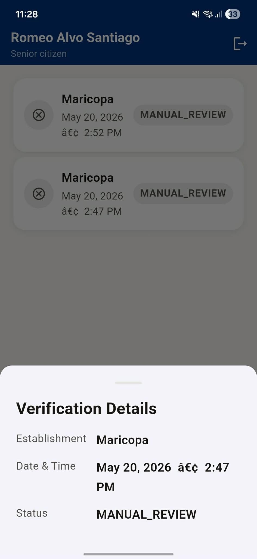
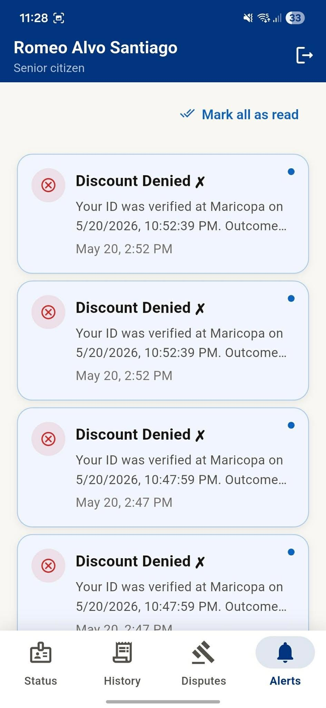

Actual Beneficiary Mobile Application screenshot sheet

BPLO Portal

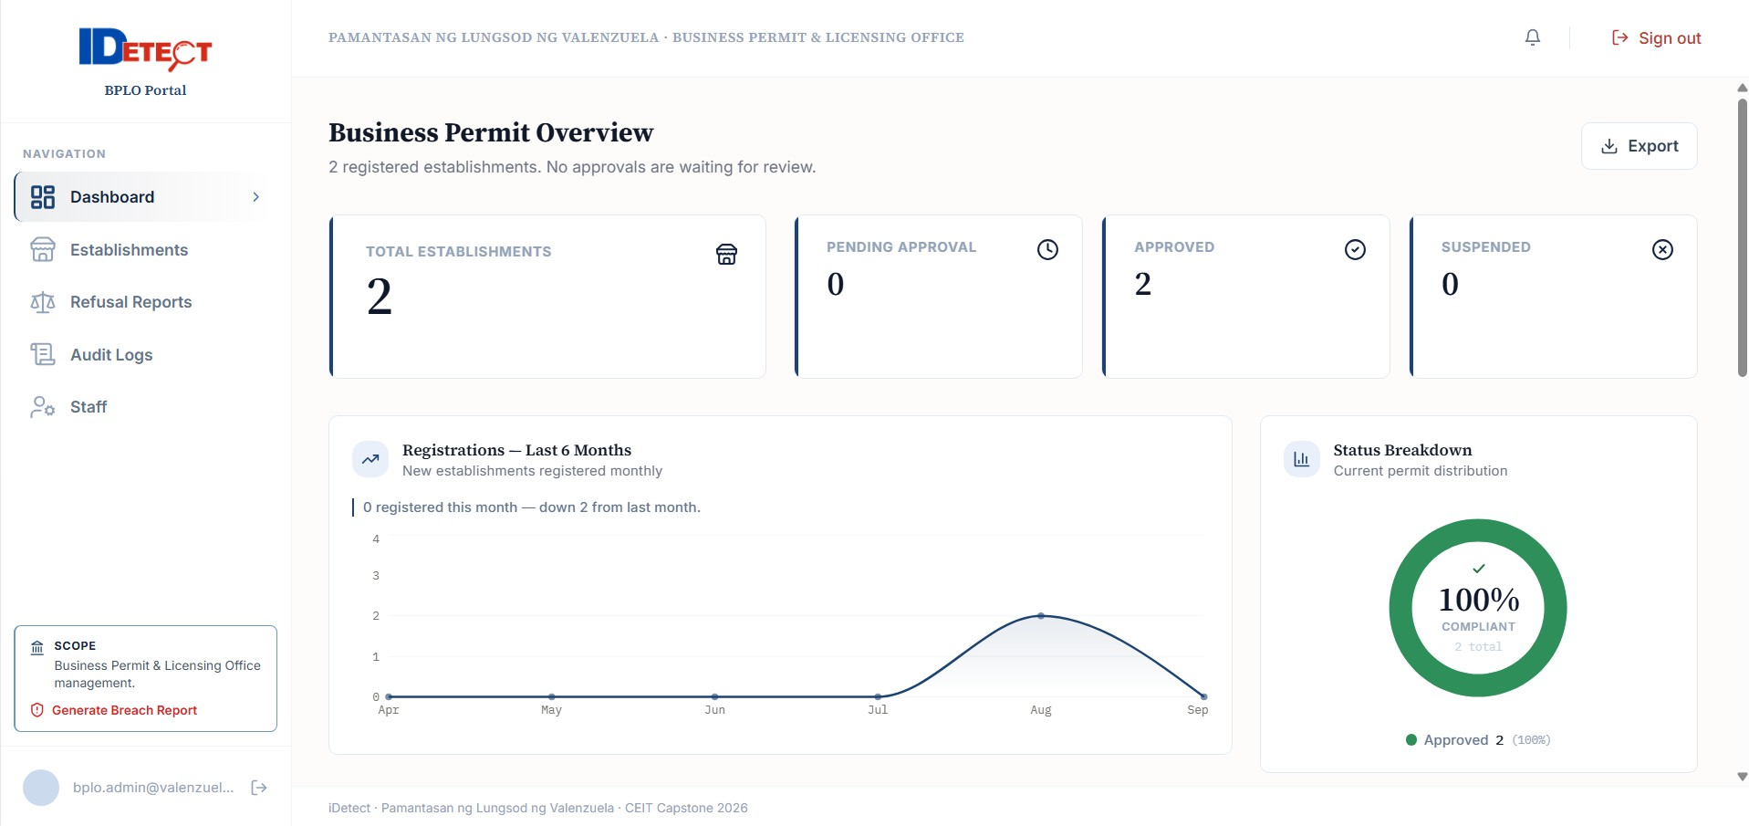
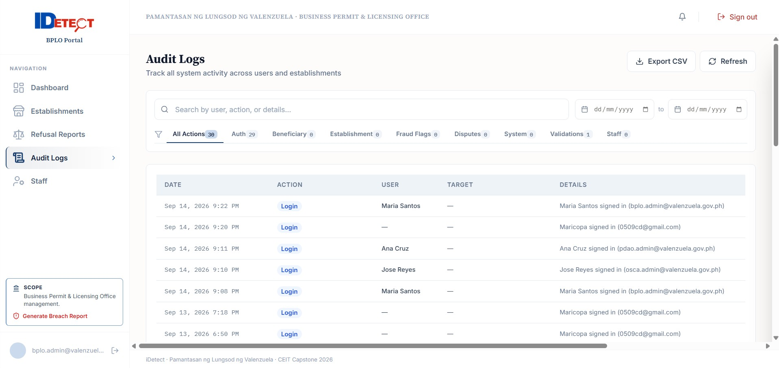
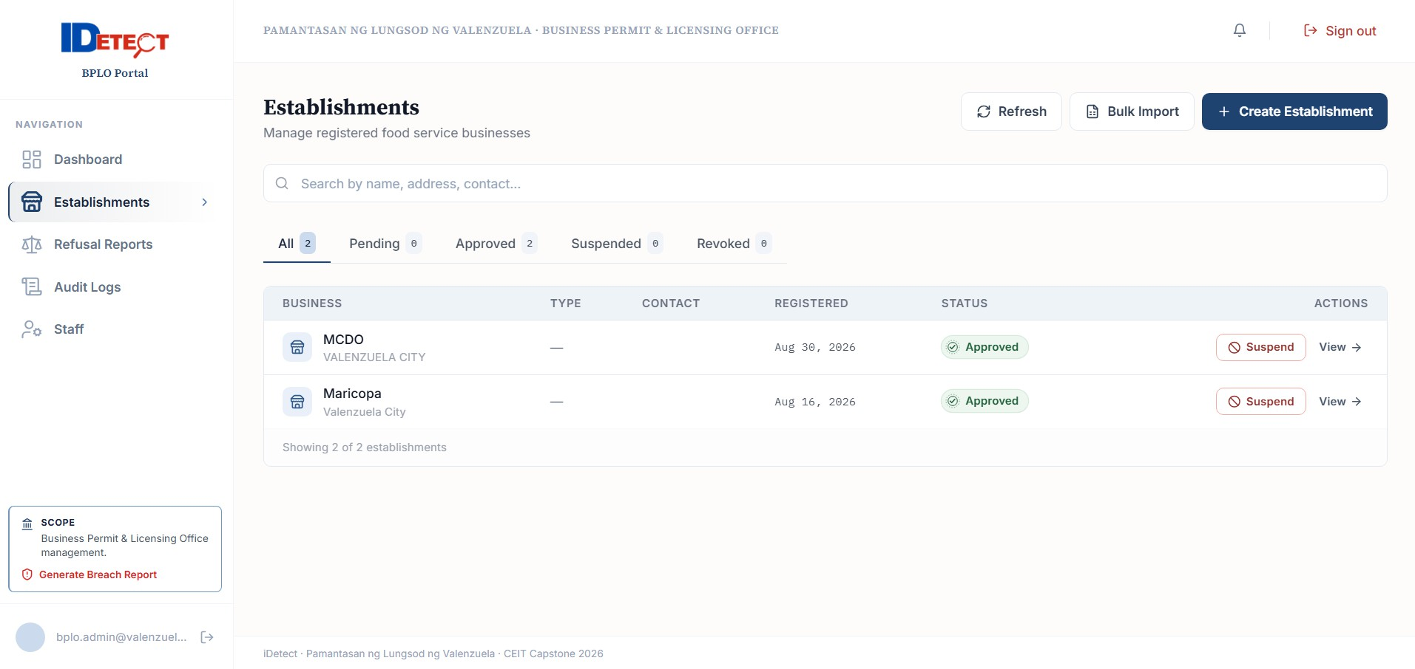
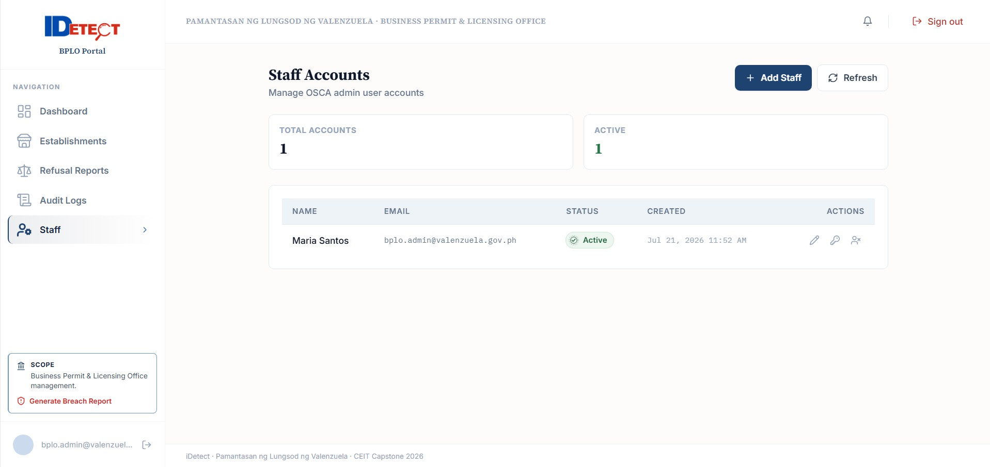
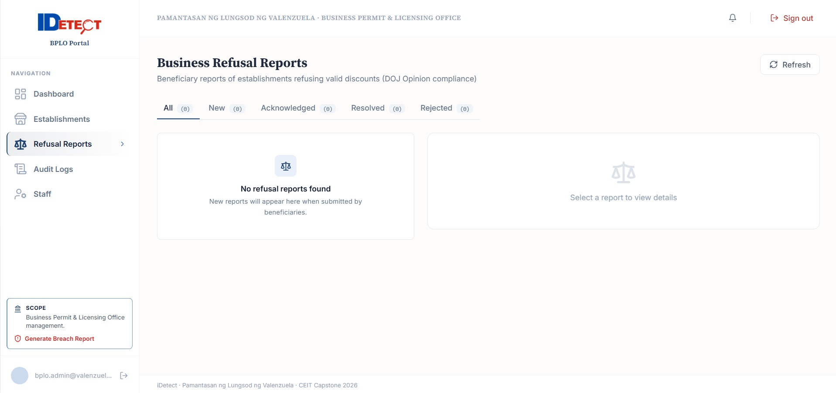

Actual BPLO Portal screenshot sheet

  - Screens Requiring Final Production Capture
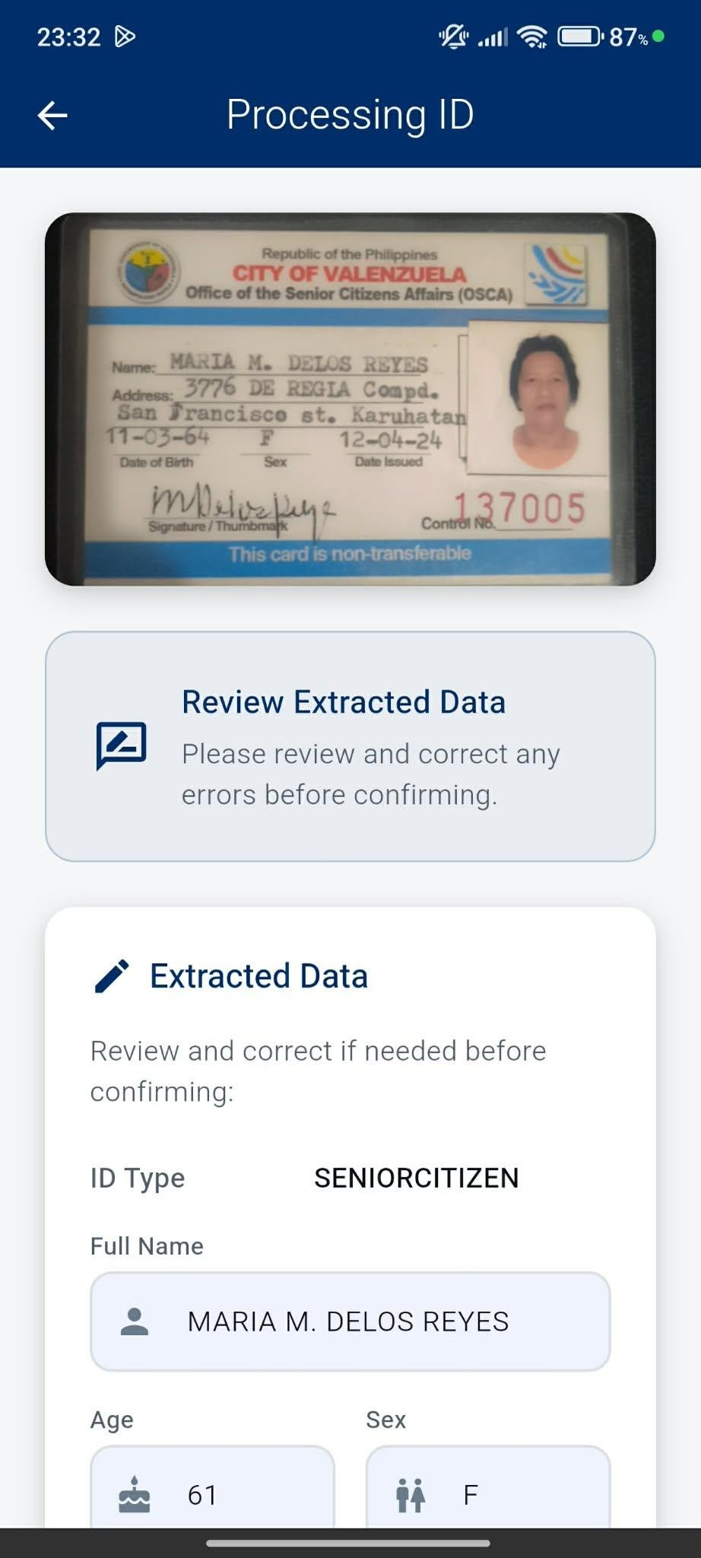
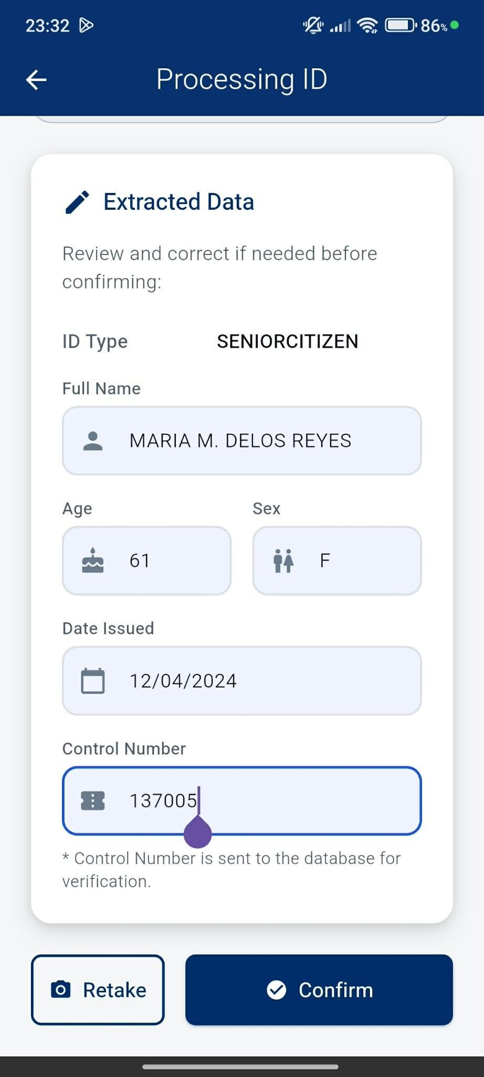
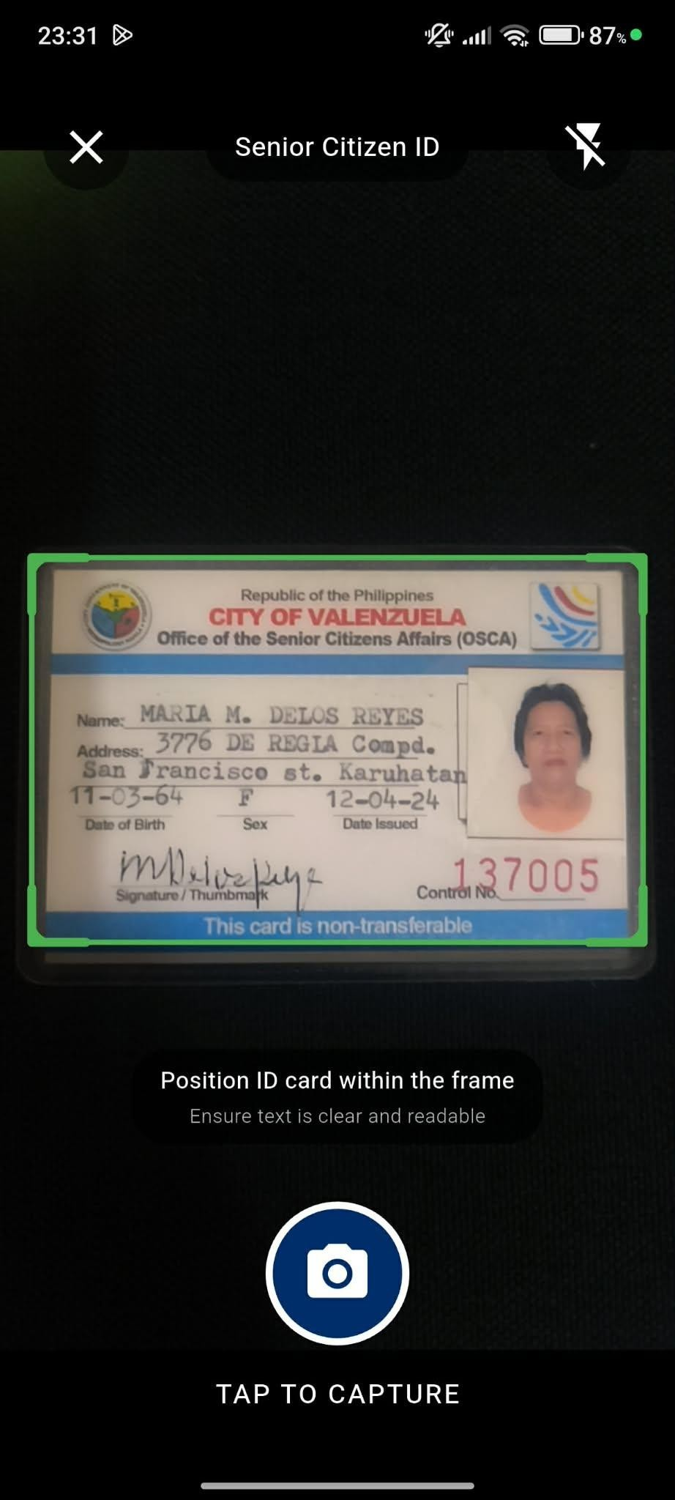
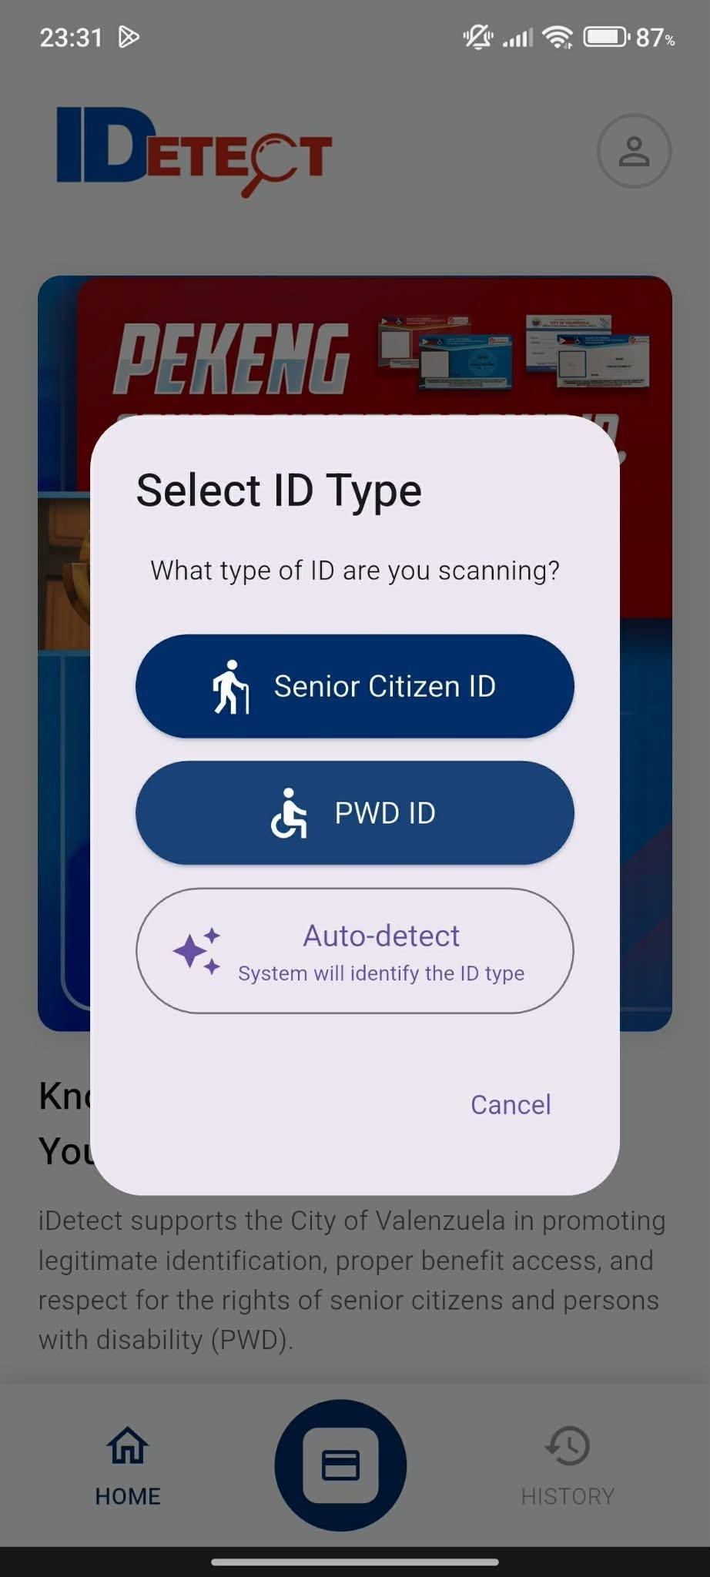

Client Portal OCR/capture screen

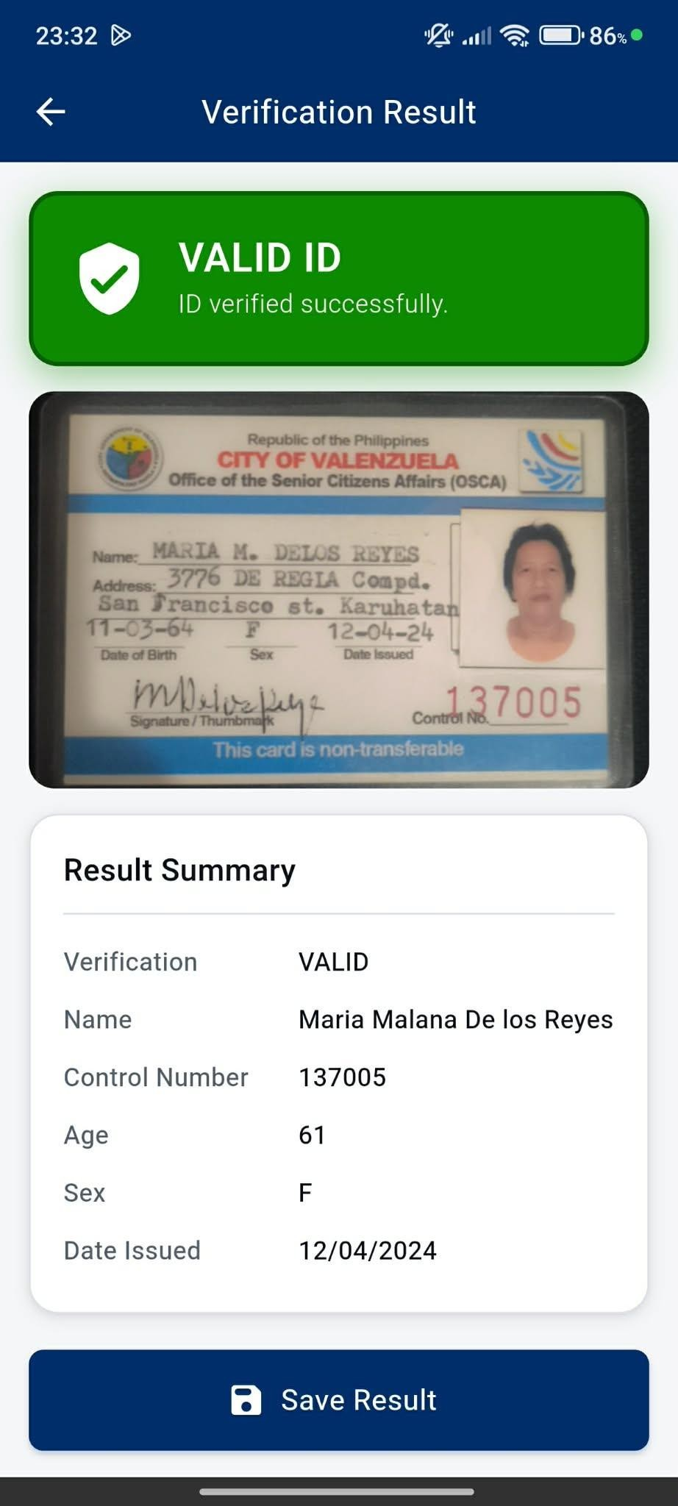

Client Portal validation result

OSCA investigation and analytics
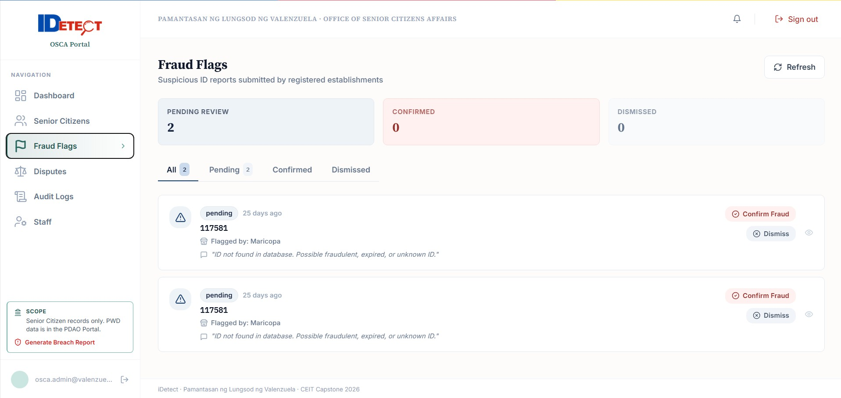
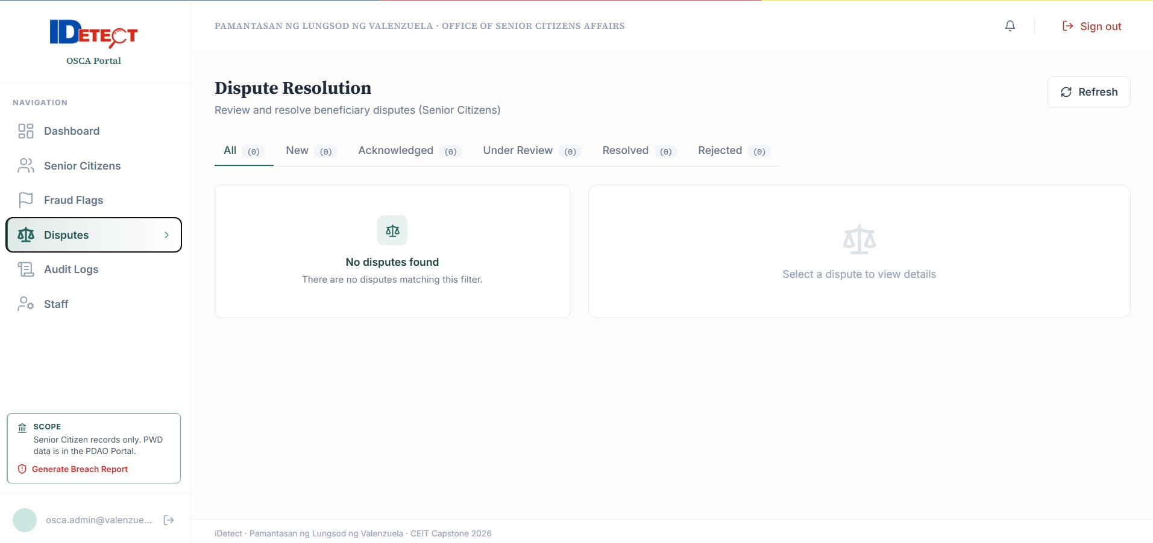

PDAO investigation and analytics
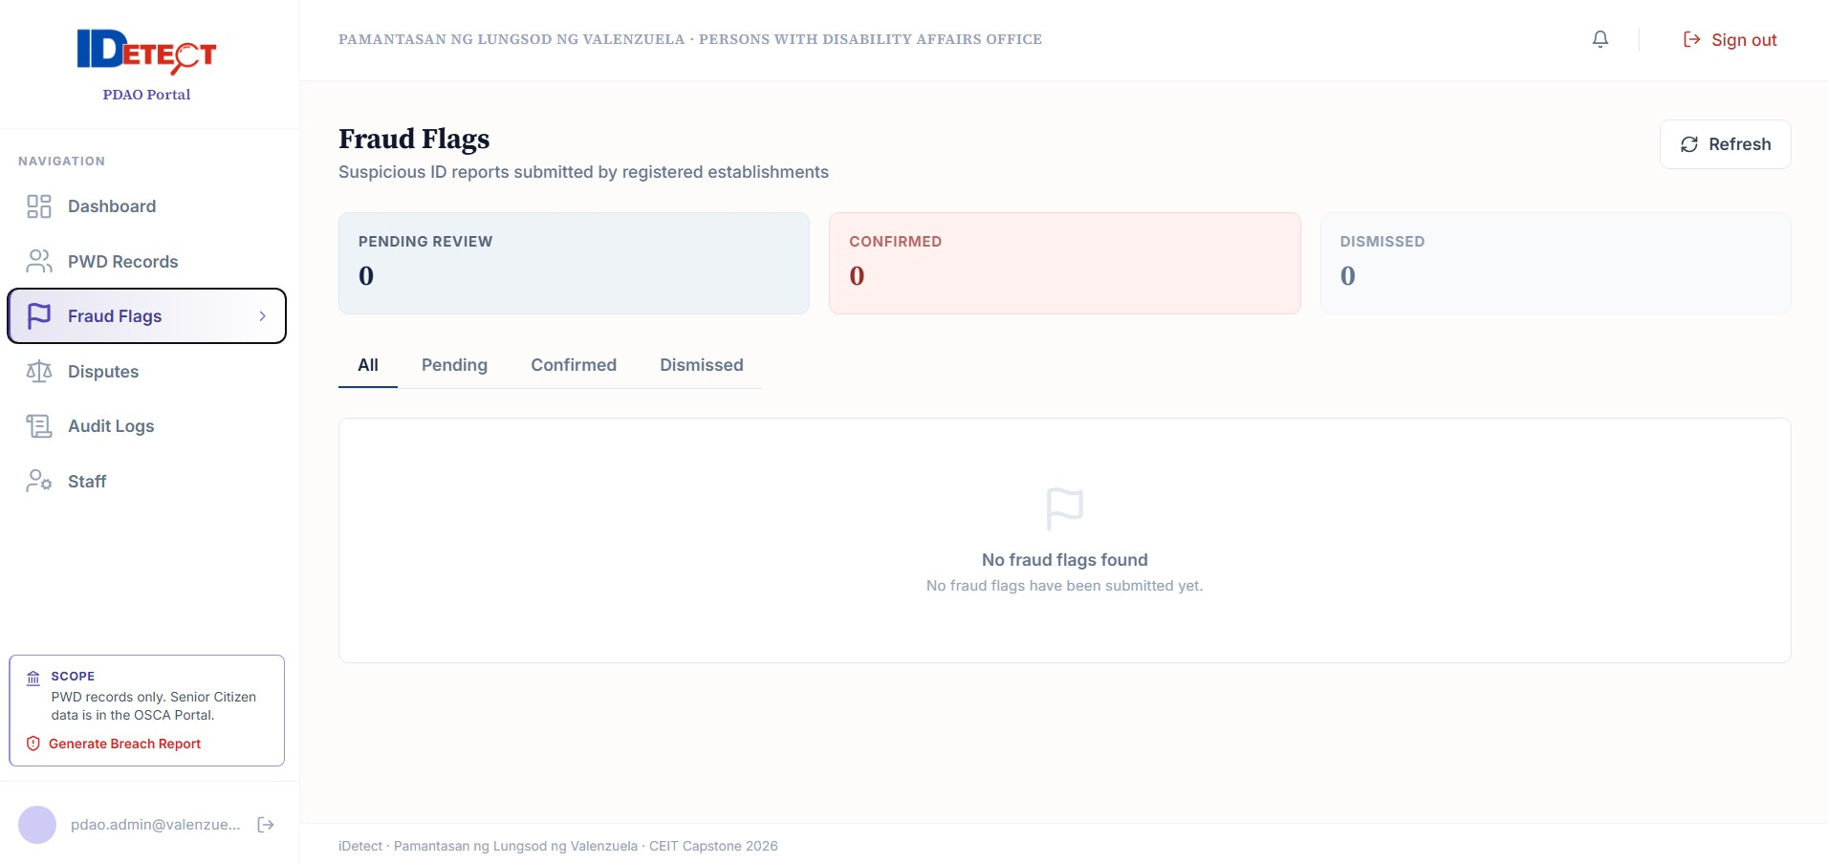
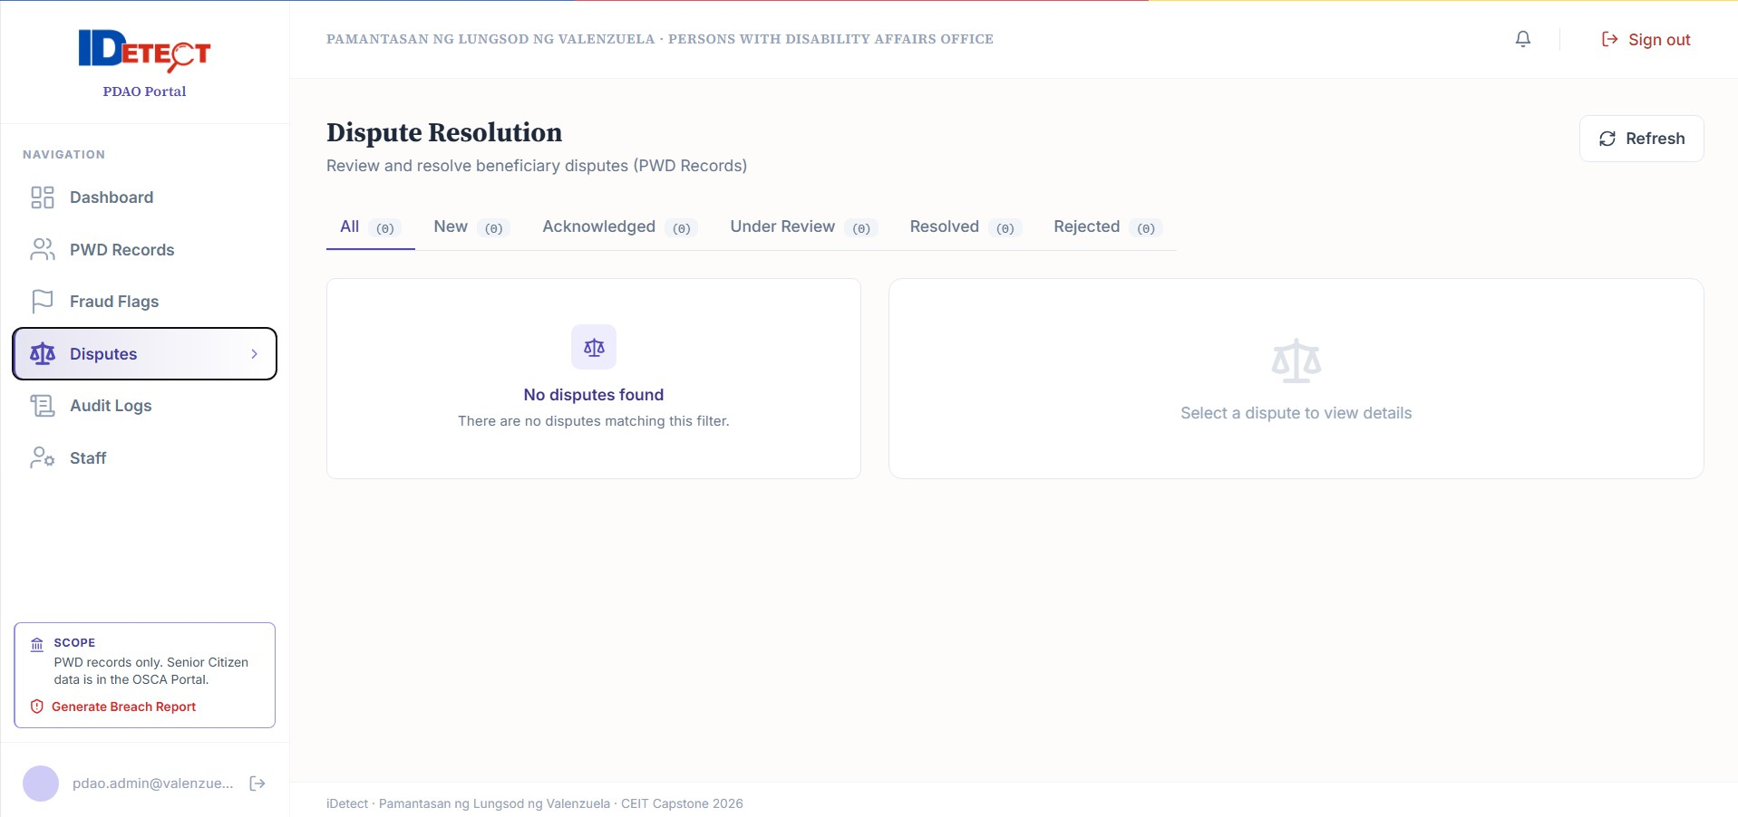

Beneficiary registration/login/dispute screens

End of iDetect User Manual

