IDETECT
USER MANUAL

OCR-Based Discount ID Validation System
For Senior Citizen and PWD Discount ID Validation and Fraud Intelligence in Valenzuela City
Prepared for the Capstone Project
De Los Reyes, Carlo M. • Enoria, Jorich Maricar C. • Mercado, Vesti Sahm Angielo • Santiago, Ishmael Luis C.

Field | Value
Project | Design and Development of iDetect
Institution | Pamantasan ng Lungsod ng Valenzuela — College of Engineering and Information Technology
Source basis | Post-Capstone 1 Revision Manuscript and current implementation/deployment documentation; reviewed 15 October 2026.

Document Control & Quick Start
Field | Value
Manual status | Updated Capstone User Manual — checked against the current implementation and deployment documentation.
System version | No release number is supplied with the project files. Ask the iDetect administrator which build is currently deployed.
Official support contact | Contact your office’s designated iDetect administrator: BPLO for establishment access; OSCA or PDAO for beneficiary-record matters. No public support phone number or email is listed in the project materials.
Client/BPLO/OSCA/PDAO URLs | Staff sign in at https://idetect.it.com (one role-routed portal in the documented production setup). Client and beneficiary users use their mobile apps; app links are provided by the administrator.
Mobile app distribution links | Obtain the approved installation package from your iDetect administrator. No public app-store or download link is listed in the project materials.

60-Second Quick Start — Establishment Staff
- Open the Client Portal
Sign in using the establishment account provisioned through BPLO.
Expected: Validation dashboard opens.

Scan the ID
Use the mobile camera and follow the position/distance/lighting guide.
Expected: Readable capture is accepted and preprocessed.

Review OCR
Check ID number, full name, beneficiary type, validity period, and issuing office.
Expected: Data is ready for validation or manual correction.

View the result
Submit for OSCA/PDAO validation.
Expected: VALID, SUSPICIOUS, or INVALID appears within the 30-second target under normal conditions.

Flag when appropriate
Use the flag action for a suspicious/invalid credential requiring LGU investigation.
Expected: Reference number is generated and the report is routed.
LEGAL / OPERATIONAL NOTE iDetect does not override existing DOJ requirements concerning unverifiable credentials. It is a fraud-intelligence and reporting mechanism.

Introduction
  - Brief Overview
iDetect connects an establishment mobile app, one role-based staff website, and an optional beneficiary mobile app. Staff capture an ID image, review the text the app reads, and request a check from the central iDetect service. Authorized OSCA and PDAO staff manage their own types of beneficiary records and investigate reports; BPLO staff manage establishment-related workflows. Beneficiaries who register can check their status and activity and submit reports or disputes.

Purpose
iDetect is designed to make ID checks more consistent, help staff report concerns, and give registered beneficiaries a way to see activity and ask an office to review a problem. The evaluation and operational measurements should be consulted before claiming that it reduces fraud or processing time.

Intended Users
BPLO, OSCA, and PDAO staff use the same staff website with individual accounts; the account role determines which work areas and records are available. Establishment staff use the Client Portal mobile app. Senior Citizen and PWD beneficiaries may use the separate Beneficiary mobile app.

System at a Glance
Portal / Role | Access | Primary responsibilities
Client Portal / Establishment Staff | Mobile app | ID capture, OCR extraction, validation, flagging, transaction history, compliance reports
BPLO Administrator | Web portal | Establishment provisioning, permit validation, account status, permit-expiry monitoring, operational dashboard
OSCA Administrator | Web portal | Senior Citizen records,  flagged-ID investigation, fraud confirmation/dismissal, analytics
PDAO Administrator | Web portal | PWD records, flagged-ID investigation, fraud confirmation/dismissal, analytics
Beneficiary | Mobile app | Optional account, status monitoring, notifications, history, disputes, fraud/unauthorized-use reporting

Important Boundaries
    - Valenzuela City only; the implementation validates Valenzuela City OSCA/PDAO credentials and serves BPLO-registered establishments.
    - Food-service scope: restaurants, cafes, and fast-food chains.
    - Automated OCR is configured for the supported Valenzuela City OSCA/PDAO card layouts; other formats may require manual entry.
    - The ID check does not use face matching or biometrics to prove who is holding the card. A VALID result means the scanned credential data passed the system checks; staff must still follow their office’s identity-checking procedure. The Beneficiary app may offer device biometrics for signing in or unlocking that app, if enabled on the phone.
    - iDetect checks records and supports reporting; it does not issue an ID, decide legal eligibility, or let an establishment change a beneficiary’s official record. Only authorized government staff can make record or status changes.
    - Beneficiary registration is optional.
SCOPE WARNING Severely damaged/illegible cards, unsupported layouts, and extended connectivity loss fall outside reliable automated operation.

Software Specifications
Only technologies and platform requirements explicitly documented in the manuscript are listed below.

Component | Supported / documented requirement
Client Portal | Mobile app for establishment staff; use an administrator-approved Android/iOS package. Check the package listing for its minimum OS version.
Beneficiary Mobile App | Optional mobile app for Senior Citizens and PWD beneficiaries; use the approved package and OS requirements supplied by the administrator.
Text recognition | Tesseract OCR with Google ML Kit available as a fallback; the text is an aid and must be checked against the physical card.
Image processing | The app improves captured images and attempts to read supported card layouts. Glare, blur, damaged cards, or another layout may require manual review.
Record check | The mobile apps send requests to the central iDetect API. OSCA/PDAO records are stored in a shared iDetect database and separated by office permissions; the apps do not connect directly to separate office databases.
Sign-in and access | Separate staff roles and beneficiary/establishment sign-in. Do not share accounts, passwords, PINs, or one-time codes.
Notifications | SMS and push notifications are available when the service, contact details, and device permissions are configured. Delivery can be delayed or unavailable.

Authentication & Notifications
Beneficiary first-time sign-in uses the ID number and birthdate on the official record, followed by a one-time code sent to the registered mobile number. If no mobile number is registered, the app may ask the beneficiary to add one and verify it. Returning users may sign in with a PIN or device biometrics if those options were set up and are available.

The system can send SMS and push notifications, but they depend on the phone number, notification permission, network, and service configuration. If a message does not arrive, check the in-app Notifications/History and contact the relevant office; do not assume a message was delivered.

Developer / Deployment Environment
The documented production setup serves the staff website and Node.js/Express API from https://idetect.it.com and uses PostgreSQL and file storage through Supabase. The two mobile apps connect to the same API. Release numbers, supported browser versions, and installation links are not published in the project files; ask the system administrator for the current approved build. Keep production credentials in the organization’s secret manager, never in this manual or in source code.

Hardware Specifications
No numeric RAM, processor, storage, or server-sizing minimum is specified in the project files. Use a supported smartphone with a working rear camera for the mobile apps and a current, supported browser on a computer for the staff website. A stable internet connection is needed for live verification and synchronization.

Hardware | Minimum / required | Recommended / guidance
Mobile device | Android 8.0+ or iOS 12.0+ with working camera | Device that can capture a sharp, well-lit supported ID
Camera | Built-in mobile camera | Rear camera with stable focus and adequate lighting
Computer | Required for BPLO/OSCA/PDAO portals | Modern desktop/laptop with supported browser
Internet | Stable connection for live verification | Reliable Wi-Fi/mobile data at point of service
Dedicated scanner | Not required by documented workflow | Mobile camera is the documented capture method

ID Capture Guidance
    - Use the mobile camera workflow; no dedicated scanner is required by the documented process.
    - Keep the supported ID readable, flat, aligned, and adequately lit.
    - Avoid blur, glare, heavy skew, and obstructed text. Poor images may be rejected or sent to manual entry.

Connectivity
Live verification needs an internet connection. The Client Portal can queue scans or flags during some connection interruptions and retry synchronization after reconnection. A queued item is not the same as a completed server check or successfully delivered report. Cached status can be old, and a queued scan can be dropped after repeated failures. Do not rely on an offline or cached result as a current official confirmation; reconnect, check the sync/history status, and ask a supervisor if the result is still pending.

Installation & Deployment Guide
AUDIENCE For authorized deployment/system administrators. End users should not change database, API, hosting, or security configuration.

  - Pre-Installation Checklist
    - Approved source: the organization’s authorized iDetect repository or deployment package. Do not use an unofficial copy.
    - API: https://idetect.it.com/api in the documented production setup. A system administrator must approve any alternate environment.
    - Database: PostgreSQL managed through Supabase in the documented setup. Obtain access only through the authorized technical administrator; do not put database credentials in a mobile app or share them with end users.
    - The apps do not connect directly to OSCA or PDAO database servers. Office records are managed in the central iDetect service with OSCA/PDAO role separation.
    - Semaphore SMS and FCM/APNs configuration.
    - Staff website: https://idetect.it.com. Client and Beneficiary app packages must be obtained from the iDetect administrator; public download links are not supplied.
    - The documented public website uses HTTPS. Hosting and TLS certificates are managed by the deployment administrator; users should not bypass a browser certificate warning.

Backend / API Setup
- Prepare repository
For the documented production deployment, the API and staff website are hosted together on Northflank. The API uses Supabase PostgreSQL and storage. Only an authorized deployment administrator should publish or change these services.
Expected: Repository/tooling is available.

Configure environment
Use the approved deployment guide and set required service credentials in the hosting provider’s protected Secrets settings. Never paste passwords, API keys, database URLs, OTP secrets, or service-account files into chat, screenshots, source code, or this manual.

Expected: Services can be reached.

Initialize database
Create or select the approved PostgreSQL database, confirm a verified backup/restore plan, then have an authorized administrator apply the repository’s database migrations. Do not run migrations against production from a personal computer unless you have explicit deployment authorization.
Expected: Schemas are created without errors.

Configure API
Deploy the Node.js/Express API with its approved environment settings. The Client and Beneficiary apps communicate with the API; they must not be configured with direct database credentials or direct OSCA/PDAO database access.
Expected: API health check succeeds.

Configure notifications
Connect Semaphore and Firebase FCM/APNs with approved credentials.
Expected: Controlled notification test succeeds.

Run health checks
After deployment, open https://idetect.it.com/api/health from an authorized browser or monitoring tool. The administrator should confirm that the API and database are ready, then perform a controlled test using approved test data.
Expected: Required services report healthy/ready.

Database Setup
The system uses a PostgreSQL database. It contains beneficiary records with a beneficiary type (Senior Citizen or PWD), staff and establishment accounts, verification history, fraud reports, disputes, notifications, audit records, and staff alerts. OSCA and PDAO access is separated by role in the central service; users do not need direct database access to use the portals.

DATABASE SAFETY Functional testing is described as using seeded test databases without real beneficiary data.

Web Portal Deployment
- Deploy portals
The documented production setup has one staff website at https://idetect.it.com. Sign-in routes each staff member to the work areas allowed by their BPLO, OSCA, or PDAO role. The Client and Beneficiary mobile apps are separate installations and use the same API service.
Expected: Each assigned URL loads.

Set API base URL
For the documented production deployment, configure the mobile/web clients to use https://idetect.it.com/api. Use a different API address only when the deployment administrator provides and approves it.
Expected: Portal actions reach the correct backend.

Verify role routing
Test BPLO, OSCA, and PDAO accounts separately.
Sign in with a test account for each authorized role. Confirm that OSCA can access Senior Citizen work, PDAO can access PWD work, and BPLO can access its establishment workflows. If an account is routed to the wrong area or can see records outside its role, stop testing and report it to the administrator.

Verify encryption
Confirm production traffic uses encrypted channels/certificates.
Expected: Sensitive traffic is protected.

Mobile Installation
- Obtain official package
Install only the Client Portal or Beneficiary app package supplied by your iDetect administrator. The project materials do not list public store links. Check the app name and publisher/source with the administrator before installation.
Expected: Correct app is installed.

Grant permissions
Allow camera access for Client Portal and notification access where applicable.
Expected: Required permissions are active.

Sign in
Establishment staff: sign in with the individual account provided for your establishment. Beneficiary: enter the ID number and birthdate from the official record, then follow the SMS verification steps. Returning beneficiaries can use a previously configured PIN or device biometric when available.
Expected: Correct dashboard opens.

Run controlled test
Use approved test credentials/IDs only.
Expected: Controlled validation/notification succeeds.

Common Installation Problems
Problem | Cause | Response
Migration failure | Database connection or schema error | Stop and contact the authorized deployment administrator. Do not retry production migrations blindly; have them check the backup and migration logs.
API health-check failure | Service or database may be unavailable | Check https://idetect.it.com/api/health and report the time and message to the administrator.
Portal cannot reach API | Network, endpoint, or certificate issue | Check the internet connection and approved URL. Do not bypass a certificate warning; contact the administrator.
OTP not received | Wrong/old registered phone, poor signal, or SMS service unavailable | Check mobile reception and number. Never share a code; contact OSCA/PDAO to correct the record or your administrator for delivery issues.
Push absent | Notifications disabled, device token, or network/service issue | Check phone notification permission and in-app Alerts. Push delivery is not guaranteed.
Camera unavailable | Permission or device issue | Allow camera permission in phone settings, close/reopen the app, and ask the administrator if it still fails.

User Functions & Capabilities
  - Establishment Staff — Client Portal
For establishment staff, the normal workflow is: sign in, capture the card, check the text read by the app, submit an online validation, review the result, and report a concern when appropriate. Use History to check earlier scans and follow-up references.

Log in
Enter the email/username and password for your approved establishment account as prompted. Use your own account; do not share sign-in details. If access is pending, suspended, locked, or the password is not accepted, contact your establishment administrator or BPLO instead of repeatedly guessing.
Expected: Validation dashboard opens.

Capture ID
Use camera and follow position/distance/lighting guidance.
Expected: Quality-approved image is accepted.

Review OCR
Check ID number, full name, beneficiary type, validity period, and issuing office. Correct fields or use manual fallback.
Expected: Data is ready for validation.

Validate
Submit the ID number and the selected beneficiary type to the central iDetect service. The service checks the relevant record and the extracted identity details; it is not a connection from the phone to two separate government databases.

The app displays one of four outcomes: VALID, SUSPICIOUS, INVALID, or MANUAL_REVIEW. Thirty seconds is a design/evaluation target, not a guaranteed service time; actual response depends on connectivity and service availability. If the app shows Offline or Pending, wait for synchronization and do not describe it as a live result.

Validation Statuses
Result | Meaning | Recommended response
VALID | The relevant record is active and the submitted credential details passed the system checks. This does not prove that the person holding the card is its owner. | Compare the physical card and follow your establishment’s identity-check procedure. If anything does not match, ask a supervisor; do not ignore contrary evidence.
SUSPICIOUS | A mismatch, type conflict, or record under investigation needs a person to review it. This is not a final finding of fraud. | Do not treat the alert as proof. Follow the on-screen instructions and report it to the relevant OSCA/PDAO office when appropriate.
INVALID | No matching record was found, or the record is expired, revoked, or otherwise not valid under the system rules. | Check the card details and selected type. If the type is uncertain, use the available Senior Citizen/PWD selection. Follow office policy and report a suspected problem; do not accuse the cardholder.
MANUAL_REVIEW | The system cannot safely decide automatically—for example, some important text could not be read, the OCR quality is low, or a visual check is needed. | Compare the physical card carefully with the displayed fields. Correct a reading error or use the manual-entry option if available. Do not treat MANUAL_REVIEW as an automatic approval or rejection; ask a supervisor if uncertain.
IMPORTANT SUSPICIOUS is an investigation trigger, not a final fraud determination.

Flagging a Credential
- Tap Flag
Use the Flag/Report option when the result or physical card needs review and the screen offers that action. Submit only information you observed. A report asks the relevant office to investigate; it does not itself prove fraud.
Expected: Confirmation prompt appears.

Confirm
Confirm the report.
Review the details shown before confirming. If online, the report is submitted to the office responsible for the selected ID type and a reference is returned. If the report is queued while offline, it is not yet confirmed as received; reconnect and check History/sync status. Contact a supervisor if it remains pending.

Select type if unknown
For an INVALID no-record case with unconfirmed type, choose Senior Citizen or PWD.
Expected: Correct LGU route is selected.

Record reference
Save the reference shown after the server confirms submission. Use it when asking an administrator or office about the case. A temporary offline queue reference may not be the final server reference.
Expected: Flag is linked to history/audit records.

OFFLINE Flags can be queued locally and automatically synchronized after connectivity returns.

Transaction History & Compliance Reports
Open History to review recent verification activity and its result. If your account includes a report or export option, select the requested date range and follow the on-screen instructions. Check whether the report has finished loading before saving or sharing it; only share it with authorized staff.

BPLO Administrator — BPLO Portal
- Sign in
Use institutionally issued BPLO credentials.
Expected: BPLO dashboard opens.

Provision establishment
Open Establishments and choose the add/create action available to your BPLO role. Enter the business and permit details requested by the form, check them against the authorized permit source, and submit for review. Create access only after the required approval; follow the invitation or password-setup steps shown by the system.
Expected: Permit is validated and an eligible account is created.

Deliver credentials
Use the invitation or password-setup flow provided by the portal. Tell the establishment contact where to sign in, but never send a password, one-time code, or private account link in an unsecured group message.
Expected: Establishment receives access instructions.

Manage status
Open the establishment record, review its permit/account details, and use only the status action allowed by your role and office policy. Read the confirmation carefully and enter the required reason or dates. The change is recorded; alerting about an expiry does not automatically renew a permit or decide a sanction.
Expected: Access changes and action is logged.

Monitor permit expiry
Review alerts for permits approaching expiry within 30 days or already expired.
Expected: BPLO can take manual action; alerting does not automatically suspend.

Monitor operations
Use the Dashboard and Establishments pages to review account and permit information. Open Refusal Reports to review business-refusal cases routed to BPLO, and use Audit Logs only when your role authorizes the review. BPLO does not manage the OSCA/PDAO beneficiary master records.
Expected: Operational oversight is available without beneficiary data.
BOUNDARY BPLO does not access flagged credential records, beneficiary personal information, or validation intelligence.

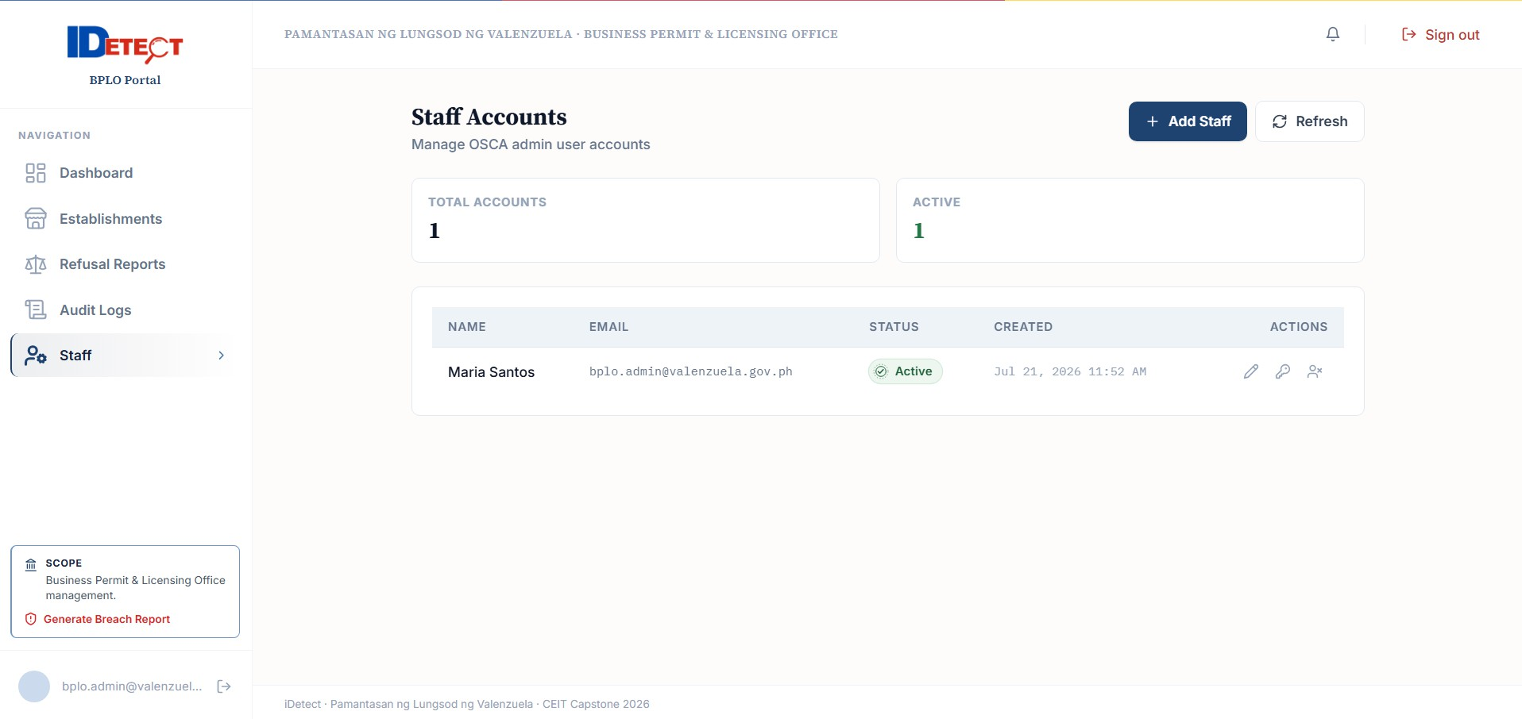
OSCA Account Management

OSCA Administrator — OSCA Portal
- Sign in
Use OSCA credentials.
Expected: Senior Citizen-only dashboard opens.

Review flags
Open Fraud Flags to review reports routed to your office. Open Disputes for beneficiary cases, including relevant business-refusal reports. The list may mask personal details; access only the information needed for the case.
Select a case to review its reference, status, submission time, and permitted evidence. Some sensitive details are hidden in ordinary lists and require authorized access to a beneficiary record. Do not assume the complete card image or unmasked OCR text is visible to every staff member.

Investigate
Compare the report with the official record and available evidence. Confirm that the case is within your office’s scope, protect the beneficiary’s personal information, and record a clear reason for the action you take.
Expected: Case is handled within OSCA scope.

Decide
Choose the available decision (for example, confirm or dismiss) only after review, then enter the required notes and confirm. Dismissing a flag means the report was not substantiated as fraud by that review; it does not mean the reporter acted improperly.
Expected: Status/audit update occurs; confirmed fraud propagates to connected Client Portals.

Manage records
Use Beneficiaries to search or open a record within your office’s scope. Add, import, or correct information only from an authorized source and follow the screen’s validation/confirmation steps. Sensitive values may be masked; opening protected details can require you to re-enter your password and is recorded in the audit trail.
Expected: Authorized official record changes are saved.

Use analytics
Use Dashboard and available reports to review trends as an aid to case review. A chart or count is not, by itself, proof that a person or establishment committed fraud.
Expected: Fraud intelligence supports investigation.
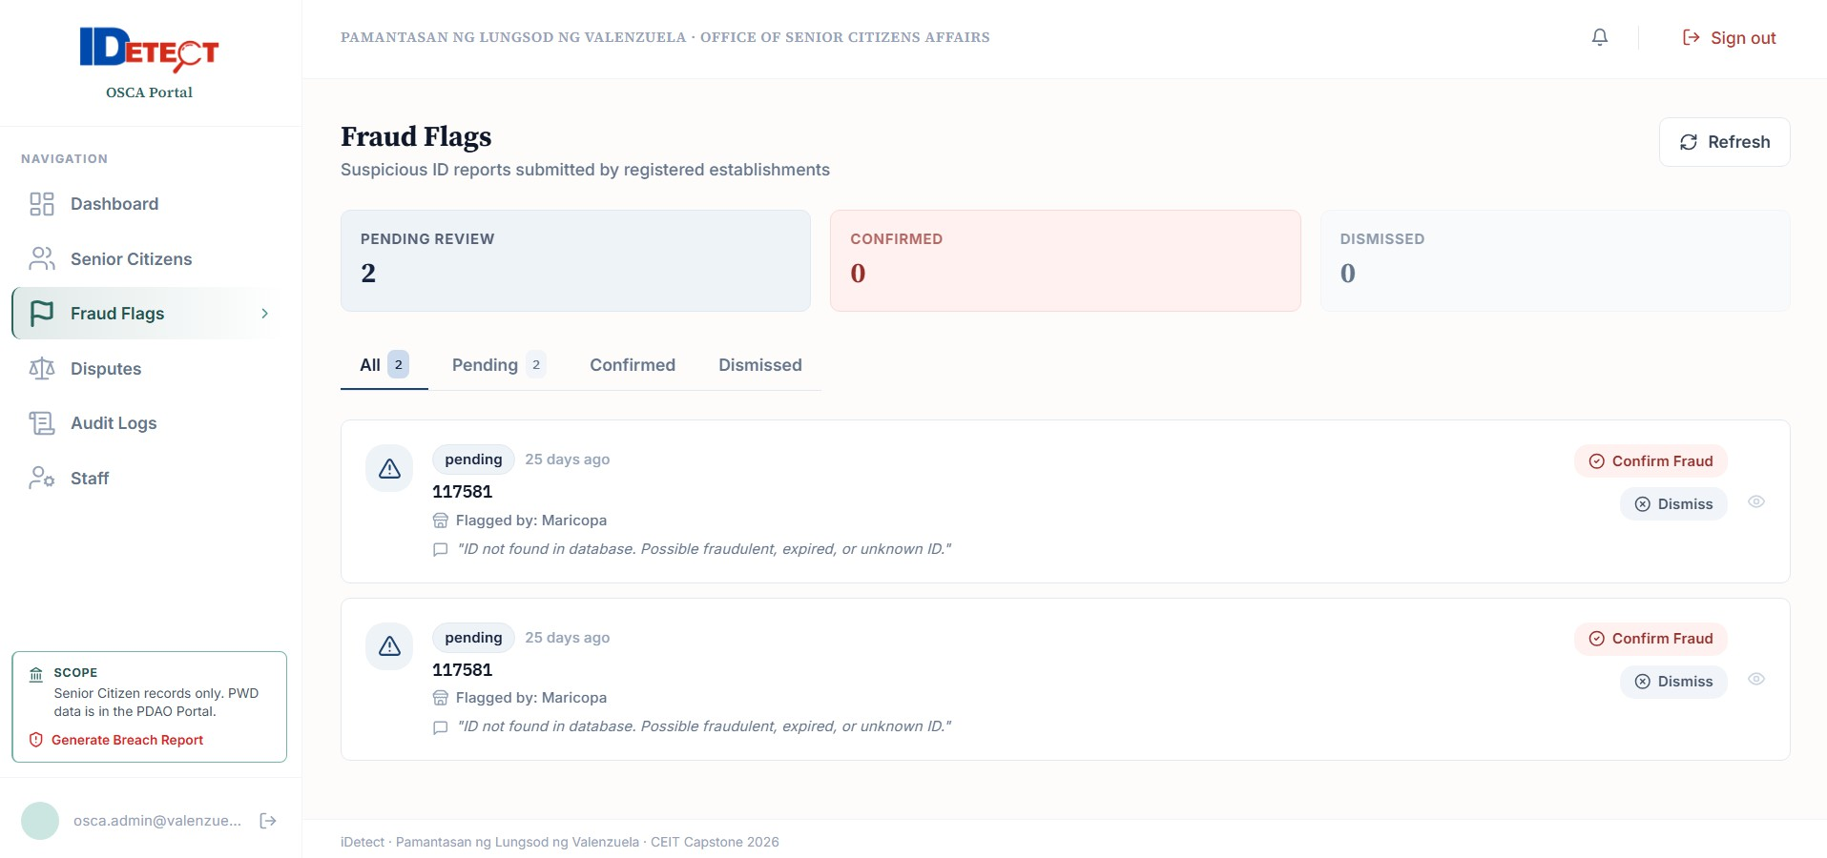
PDAO Fraud Flags

PDAO Administrator — PDAO Portal
- Sign in
Use PDAO credentials.
Expected: PWD-only dashboard opens.

Review flags
Open Fraud Flags to review reports routed to PDAO. Open Disputes for PWD-related cases within your authority. Personal data and supporting evidence may be masked unless your role and case justify access.
Open a case to review its reference, status, submission time, and evidence your role is allowed to view. Do not assume that every report list displays the full ID number, full OCR text, or image.

Investigate and decide
Compare the report with the official PWD record and available evidence. Confirm that the case is within PDAO’s scope, protect personal information, and document the reason for your action.
Select the decision offered by the portal (for example, confirm or dismiss), enter any required notes, and confirm only after review. Confirmed status changes follow the workflow and permissions in the portal; a flagged report alone is not a final decision.

Manage records
Use PWD Records to search or open a record within PDAO’s scope. Add or correct data only from an authorized source, and check the form’s validation/confirmation before saving. Opening protected details may require password re-entry and creates an audit record.
Expected: Authorized changes are saved.

Use analytics
Use Dashboard and available reports to review PWD-related trends as an aid to investigation. Review the underlying cases before taking action; summary counts are not a fraud determination.

Expected: Intelligence supports enforcement.
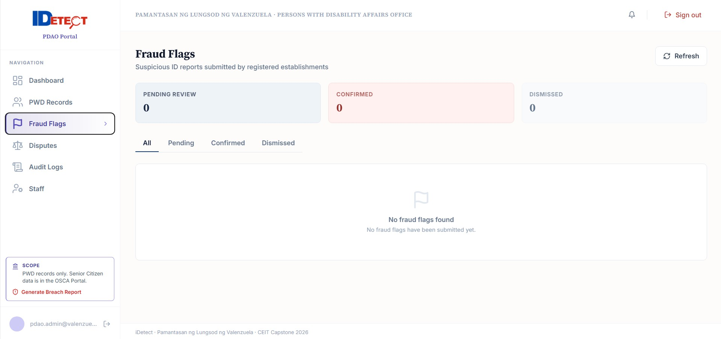

  - Beneficiary Mobile Application
OPTIONAL Registration is voluntary and does not affect statutory discount entitlement.

Registration & Authentication
- On first use, enter the ID number and birthdate exactly as recorded on the official card/record, then submit. Keep this information private and do not enter another person’s details unless you are authorized to assist them.
The app checks that the beneficiary record can be found. If the details do not match, stop and contact the issuing office; repeated guesses will not correct an official record.
Expected: Corresponding OSCA/PDAO record is checked.

Receive OTP
A one-time code is sent to the mobile number on the beneficiary record. If no number is registered, the app may offer a form to add and verify a mobile number. If the number is old or belongs to someone else, contact OSCA or PDAO to correct the record instead of asking another person to share a code.
Expected: Second authentication factor is available.

Submit OTP
Enter the six-digit code before it expires. Never share it with staff, callers, or anyone claiming to provide support. After successful verification, the app may offer to set a four-digit PIN and enable the phone’s biometric sign-in; choose a PIN you do not use elsewhere.
Expected: your own beneficiary account opens. If the account is suspended, expired, or otherwise restricted, read the status message and contact the issuing office. The app cannot reinstate or edit your official record.

Status, Notifications & History
First-time sign-in uses an SMS code. Returning users may use their PIN or phone biometrics if enabled. If the app locks while you are away, unlock it with the configured method; choose Sign in again if you cannot unlock.
Use the bottom tabs: Status shows your record status and validity details (your ID number is masked by default); History shows verification and dispute/report activity; Disputes lets you submit or track a case; Alerts shows in-app notifications. Tap the ID visibility control only when needed, then hide the number again. Choose EN or FIL in the app header to change language. SMS/push delivery depends on your phone number, permissions, network, and service availability.

Dispute Procedure
- Select denied transaction
Open Disputes and tap the button to start a new dispute. If it concerns a particular scan or refusal, include its date, establishment, and reference number if available; the form may not pre-fill all of these details.
Expected: a new dispute form opens. Include enough detail for the office to locate and review the event, but do not attach unrelated personal documents.

Choose category
Select the closest category shown: wrong denial, unauthorized use, business refusal, incorrect record information, or Other. The case is routed to BPLO or the beneficiary’s OSCA/PDAO office according to its type.
Expected: Issue is categorized.

Write explanation
Explain what happened in plain language, including when and where it happened. Attach only relevant supporting documents if you have them and the app offers an upload option. Do not include passwords, PINs, or one-time codes.
Expected: Form is ready for submission.

Submit
Review your explanation and any attachment, then submit. Wait for the app’s confirmation and save the dispute reference. A draft or network error is not proof that the office received it.
The app displays a reference after successful submission. Acknowledgment and resolution time depend on the responsible office; the project materials do not establish a guaranteed 24-hour response.

Track
Open Disputes to check the case status and reference. Open History to see the dispute alongside verification activity. If a load error appears, use Retry when connected; contact the responsible office with the reference if the case still does not appear.
The responsible office reviews the case and may request more information. Watch Alerts for updates. iDetect submits your request; it does not automatically change the official record or decide the dispute.

Beneficiary Accountability Reports
Use this table to choose the right report type. The category determines which office receives the case. Keep the generated reference and check the case in Disputes/History; if the app says it is queued, verify it synchronizes before assuming it was received.
Report type | Route | Expected handling
Unauthorized ID use | Beneficiary’s OSCA/PDAO office | The office reviews the report. A report alone does not establish fraud.
Business refusal despite an otherwise valid check | BPLO | The office reviews the reported business interaction; include the date, establishment, and reference if available.
Incorrect beneficiary record | OSCA/PDAO office responsible for the record | The authorized office checks the source record and decides whether a correction is needed.

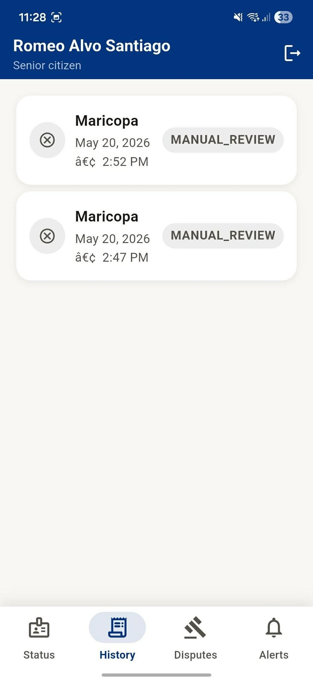
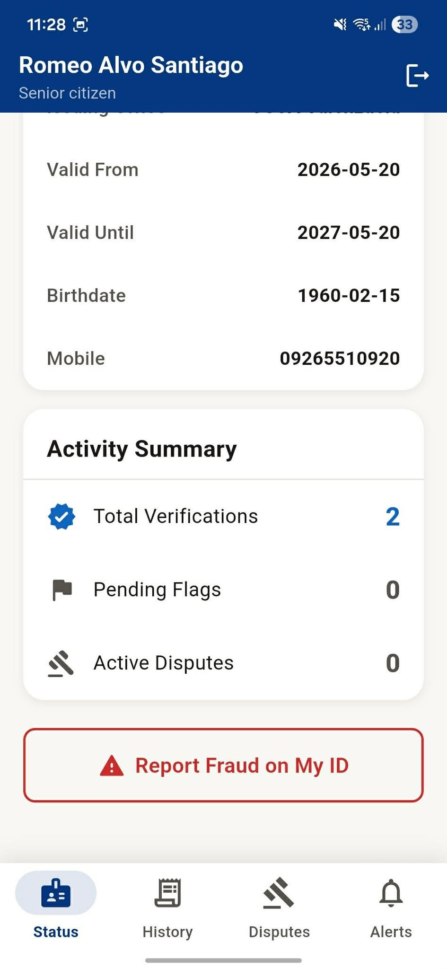
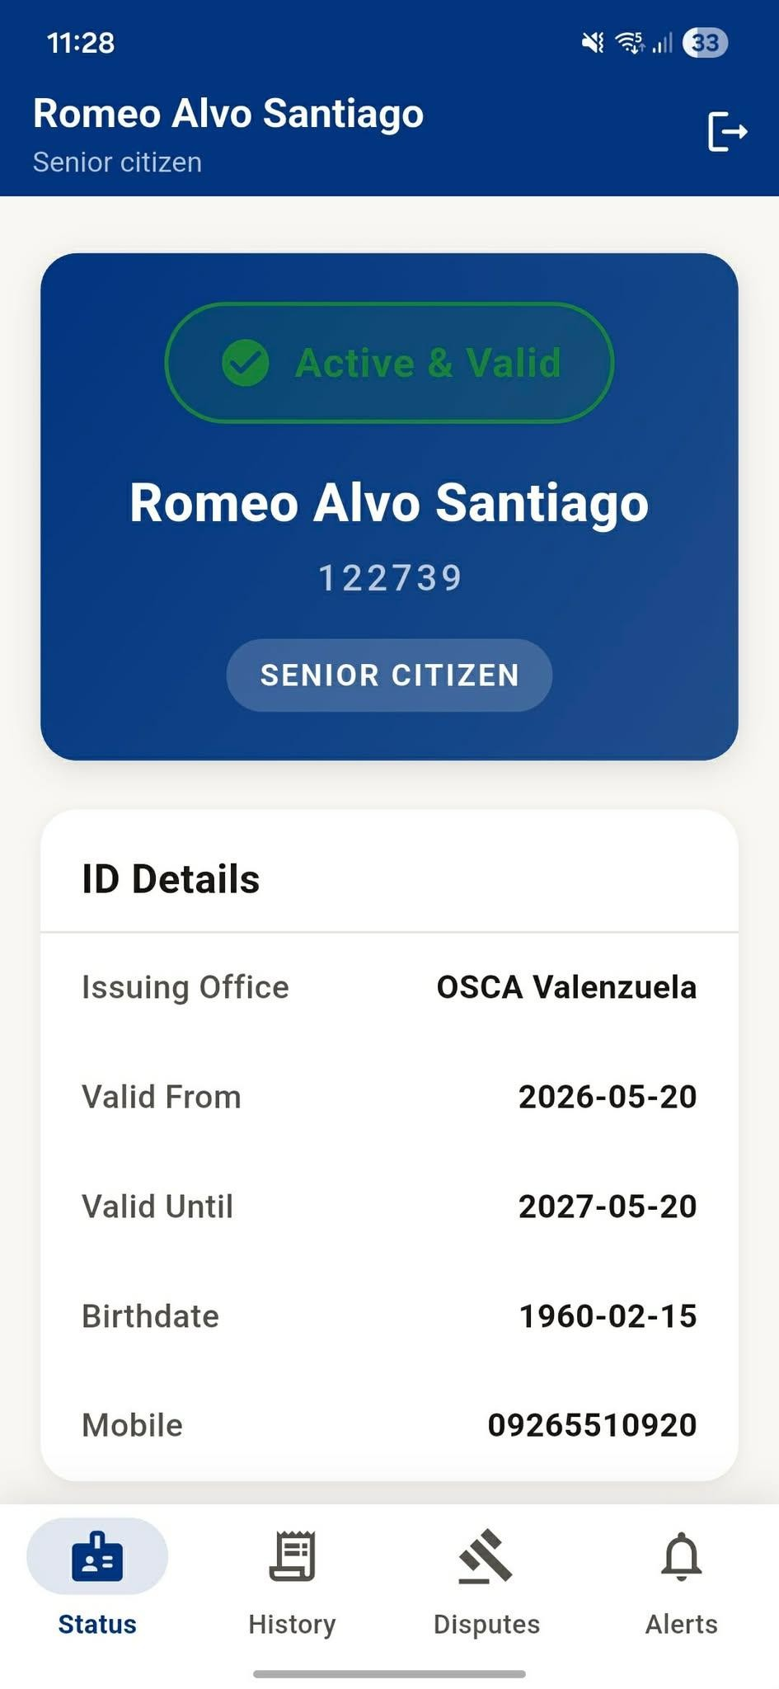
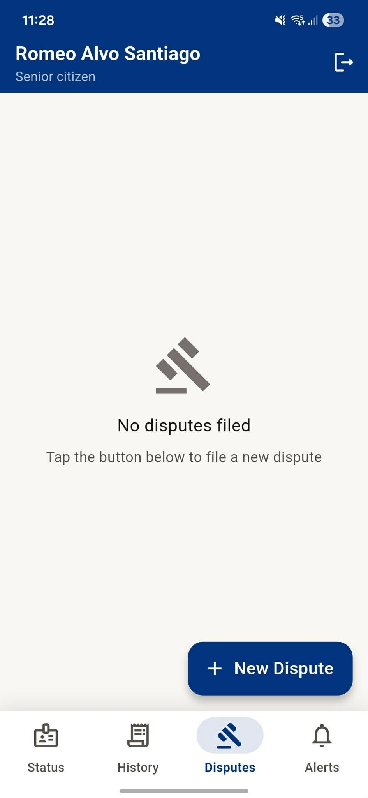
Beneficiary registration/status/dispute screens

System Workflow
In everyday use, the phone reads the card, the central service checks the relevant record, and a person reviews any uncertain result. Staff reports and beneficiary disputes are sent to the responsible office; only authorized staff can change government records.

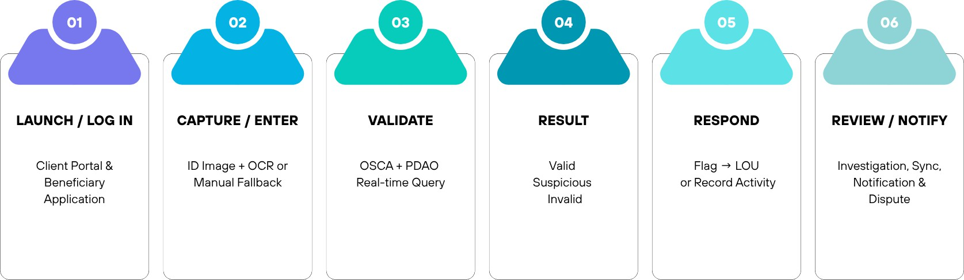

End-to-End Flow
- Authenticate the appropriate user.
- Capture the supported ID or use the manual-entry fallback.
- Assess image quality and preprocess accepted images.
- The scanner uses OCR to read fields from supported card layouts. OCR can make mistakes; the displayed quality score is a guide, not proof that an ID is genuine. Check the physical card and all important fields before sending the request.
- The central iDetect API checks the submitted details against the relevant Senior Citizen or PWD record and applies the system’s matching/status rules. It is not a direct connection from the phone to two separate government databases.
- The result is one of VALID, SUSPICIOUS, INVALID, or MANUAL_REVIEW. The system records the verification attempt; use the status table earlier in this manual to decide what to do next.
- Flag suspicious/invalid credentials when appropriate and route to OSCA/PDAO.
- Investigate and synchronize confirmed status across connected Client Portals.
- Notify registered beneficiaries and support disputes/accountability reports.
SYNCHRONIZATION Confirmed fraud status is designed to propagate to connected Client Portals within 10 seconds of the database update under normal network conditions.

Offline / Reconnection Flow
When the Client Portal is offline, it cannot perform a new live database check. Some previously synchronized blocked-status information may be available but can be out of date. Scans and flags can be queued for automatic retry after the connection returns; a queued item is not yet a completed check or confirmed report. Scans may be dropped after five unsuccessful synchronization attempts. Reconnect, check History/sync status, and contact a supervisor if an item remains pending. Never rely only on cached or offline results to approve a transaction.

Beneficiary Accountability Loop
Verification alert → beneficiary checks History → beneficiary submits a dispute or unauthorized-use report → the responsible OSCA/PDAO office reviews beneficiary-record matters or BPLO reviews a business-refusal matter → the beneficiary checks Alerts/Disputes for updates. A report starts a review; it does not automatically change a record or determine fault.

Troubleshooting & FAQs
Problem | Possible cause | Simple solution
Camera rejects image | Blur, glare, poor light, skew, damaged ID | Reposition, improve lighting, steady camera, recapture; use manual entry if needed.
OCR is wrong | Poor image or unsupported/aged card layout | Review and correct extracted fields; use manual fallback.
Validation is slow | Network/service latency | Wait for result; if offline, follow offline guidance and use cached results only when labeled.
No live result offline | Credential not in local cache | Reconnect before relying on a live database result.
Flag is pending | Queued while offline or temporary sync failure | Keep device connected; automatic retry/synchronization is expected.
Account locked | Three consecutive failed login attempts | Wait for cooldown or contact the proper administrator.
OTP fails/expires | Incorrect/expired OTP | Request a new OTP within the allowed resend limit.
Old beneficiary status | Offline/last synchronized state | Check timestamp and reconnect.
BPLO cannot create establishment | Permit invalid/expired/ineligible | Verify permit in BPLO registry.
Authorization error | Role is attempting an unauthorized portal/data access | Use assigned portal or contact administrator.

Frequently Asked Questions
Q. Does a beneficiary need the app to receive the discount?
A. No. Registration is optional and does not affect entitlement or Client Portal validation.

Q. Does VALID prove the presenter owns the ID?
A. No. iDetect does not use biometrics; physical identity confirmation remains with establishment staff.

Q. Is SUSPICIOUS the same as fraud?
A. No. MANUAL_REVIEW means the app could not safely finish the automatic check. Compare the physical card with the displayed fields and ask a supervisor if the details still do not match.

A. No. SUSPICIOUS means the system found something that needs a human review. The responsible OSCA or PDAO office determines the outcome.

Q. Can BPLO see beneficiary or fraud records?
A. BPLO handles establishment and business-refusal workflows and may see the limited information needed for those cases. It does not manage the OSCA/PDAO beneficiary master records. OSCA handles Senior Citizen records; PDAO handles PWD records.

Q. Can OSCA see PWD records?
A. No. OSCA is restricted to Senior Citizen records; PDAO is restricted to PWD records.

Q. Can beneficiaries directly edit government records?
A. No. They submit disputes; authorized OSCA/PDAO personnel adjudicate and correct records.

Q. What happens if the same ID is flagged again?
A. A new report can be linked as a supplementary report to an existing open investigation.

Q. How long are audit logs retained?
A. The source documents do not provide an approved retention period. The responsible LGU must set and publish the retention and archival policy; ask your administrator how long a particular record is retained.

Security & Data Privacy
Use the app and website only through links/packages provided by the administrator. In production, the documented staff website uses HTTPS. If a browser displays a certificate/security warning, stop and contact the administrator rather than continuing.
Access is separated by account role, and actions may be recorded for review. These controls help protect information but do not replace your responsibility to verify the person, check a card carefully, and handle information lawfully.

Security Controls
    - RBAC restricts functions/data by role.
    - Data is transmitted over encrypted channels.
    - Beneficiaries sign in with their ID number and birthdate, then verify a one-time code. A PIN or device biometric can be set up for later sign-in or to unlock the app, if supported and enabled. The Client Portal and staff website use their own account credentials.
    - Passwords are stored using a one-way password-hashing method. This does not make it safe to share passwords, PINs, OTPs, or account links; keep them private.
    - The system records verification, report, dispute, and administrative activity for authorized review. Some records are protected from ordinary editing through the application; do not describe this as a substitute for approved security, retention, or backup policies.
    - Ordinary user screens do not provide a way to edit or delete protected audit/verification history. If an entry appears wrong, report it through your approved office process; do not try to alter the record.
    - Staff accounts are signed out after inactivity; the website warns before the timeout. Beneficiary accounts lock the app after about five minutes of inactivity and may sign out after a longer idle period. Unlock with your PIN or enabled device biometric, or choose Sign in again. Always sign out on a shared device.
    - Unauthorized API requests are rejected and logged.
    - The Client Portal receives a result and only the fields needed for its checking workflow, not unrestricted access to the beneficiary database. Treat any displayed card details, image, name, or reference as sensitive.

Data Minimization & Compartmentalization
Only the minimum details needed for checking and case handling should be viewed or shared. OSCA and PDAO staff are limited to their office’s beneficiary type; BPLO works with establishments and its authorized cases; beneficiaries can see only their own account information.

Responsible Handling
    - Treat ID images, names, ID numbers, birthdates, mobile numbers, disputes, and transaction records as sensitive.
    - Use only authorized iDetect workflows/storage.
    - Do not share screenshots or reports through personal messaging/social media.
    - Never share passwords, OTPs, PINs, or session credentials.
    - If you suspect a lost device, compromised account, unauthorized access, or exposure of personal information, stop sharing or using the affected account if safe to do so and notify your office’s designated iDetect administrator/privacy officer immediately using the organization’s approved contact channel. The project files do not list a public contact number or email. Do not send screenshots containing personal data through personal messaging or social media.
PRIVACY REMINDER The design is framed around RA 10173, including access/correction mechanisms, minimum disclosure, and breach-reporting support. Follow the organization’s approved privacy policy and incident-response procedure.

Breach Incident Reporting
If you are not an authorized staff user, do not attempt to generate the staff report yourself. Report the incident immediately through your organization’s approved privacy/security channel.
Staff: in the role-based staff website, select Generate Breach Report in the lower part of the navigation panel. Describe what happened, select affected data categories, enter an estimated number of affected people and discovery date/time, then generate and download the report. The report is logged and downloaded as a file; this button does not submit it to the National Privacy Commission or notify affected people. Immediately follow your LGU privacy officer’s incident-response process and applicable reporting deadlines. Do not wait for the report generator before escalating an incident.

Tips & Best Practices
Tip | Practice
Capture clearly | Use adequate light, avoid glare, keep the ID steady, and fit the card inside the guide.
Check the result carefully | Read the status and reason; when it says MANUAL_REVIEW, compare the card yourself and ask a supervisor if unsure.
Always review OCR | OCR is an extraction aid; confirm fields before validation.
Protect your sign-in | Use your own account. Keep passwords, PINs, one-time codes, and reset links private.
Do not equate SUSPICIOUS with fraud | Only OSCA/PDAO investigation makes the final determination.
Check that reports were received | Save the server-confirmed reference. A queued offline item is still pending until it synchronizes.
Keep reference numbers | Save flag/dispute references when follow-up is needed.
Use reports carefully | Share reports only with authorized staff and only for the work purpose that requires them.
Prefer live validation | Cached results are limited and may be stale.
Keep your device secure | Lock shared phones and computers when you step away; sign out when your work is finished.
Respect role boundaries | Never access another portal or stakeholder data.
Support beneficiaries respectfully | Explain that SUSPICIOUS or MANUAL_REVIEW needs review; do not accuse someone based only on an app result.
Protect sensitive information | Avoid unnecessary exposure of IDs and personal data.
Do not promise a response time | Case response depends on the responsible office. Give the reference and follow the official office process.
Use test data | Functional testing should use approved seeded databases without real beneficiary data.
Escalate persistent errors | Record the time, screen, and non-sensitive error message; contact your office administrator through its approved channel.
Escalate persistent errors | Record the time, screen, and non-sensitive error message; contact your office administrator through its approved channel.

Actual Interface Reference
The images in this section show example iDetect screens from the capstone build. Button names and layouts may differ in a later deployment. Follow the labels in your installed version, and contact the administrator if a screen does not match these instructions.

Beneficiary Mobile Application

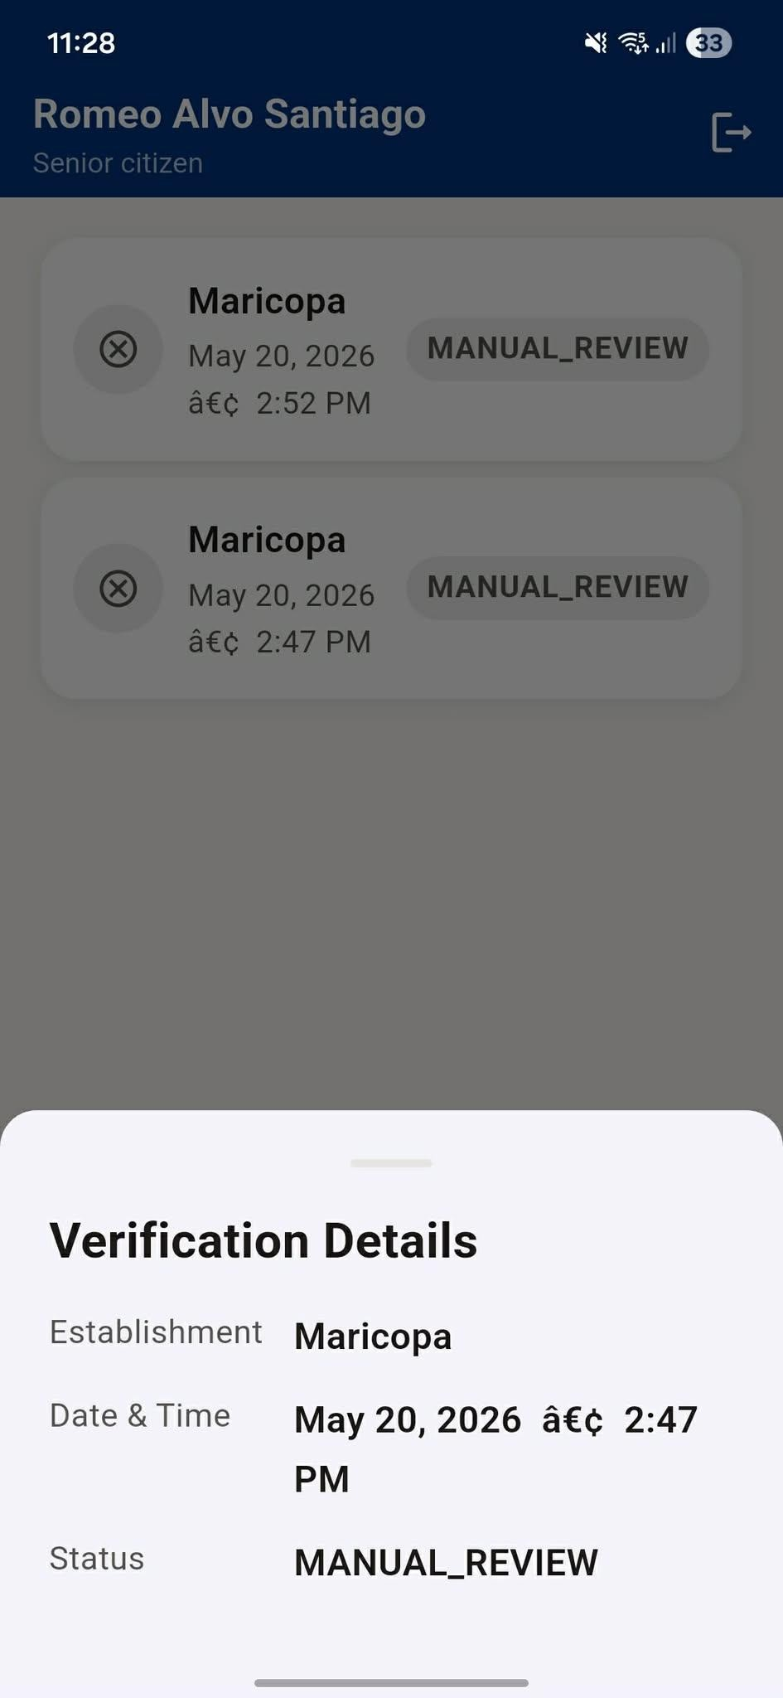
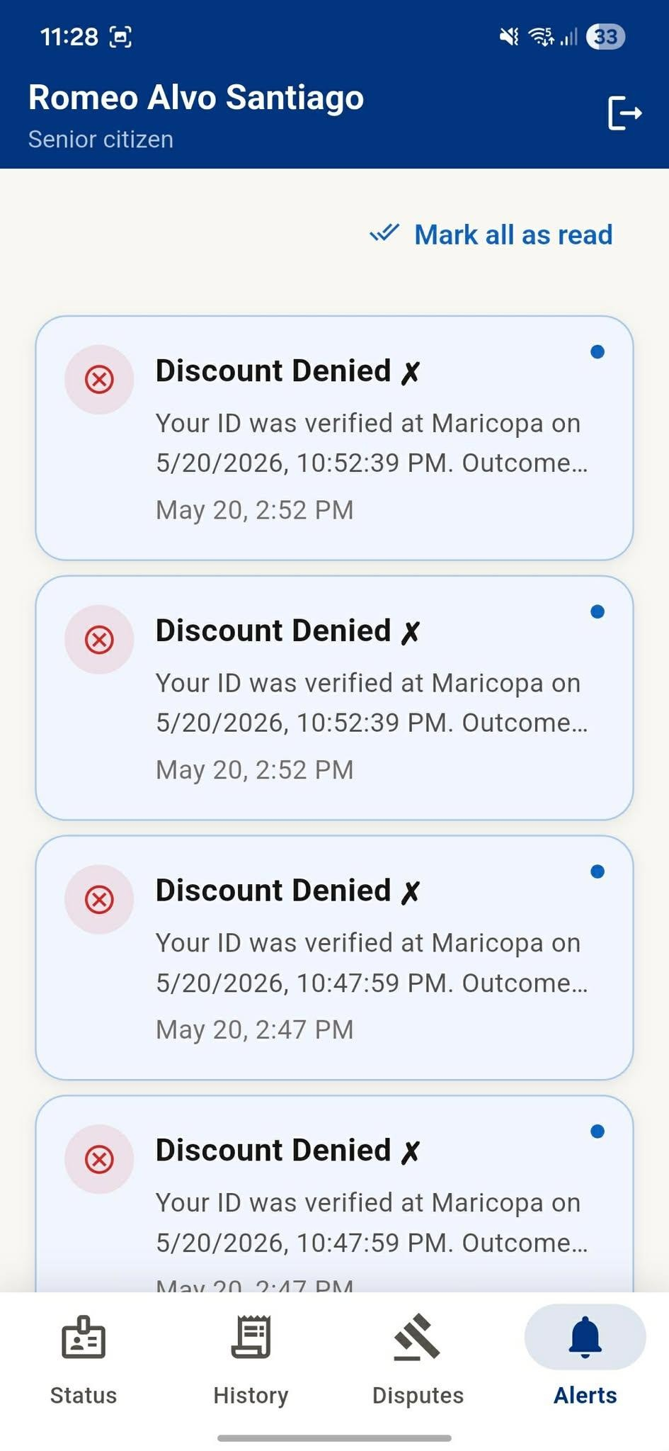

Actual Beneficiary Mobile Application screenshot sheet

BPLO Portal

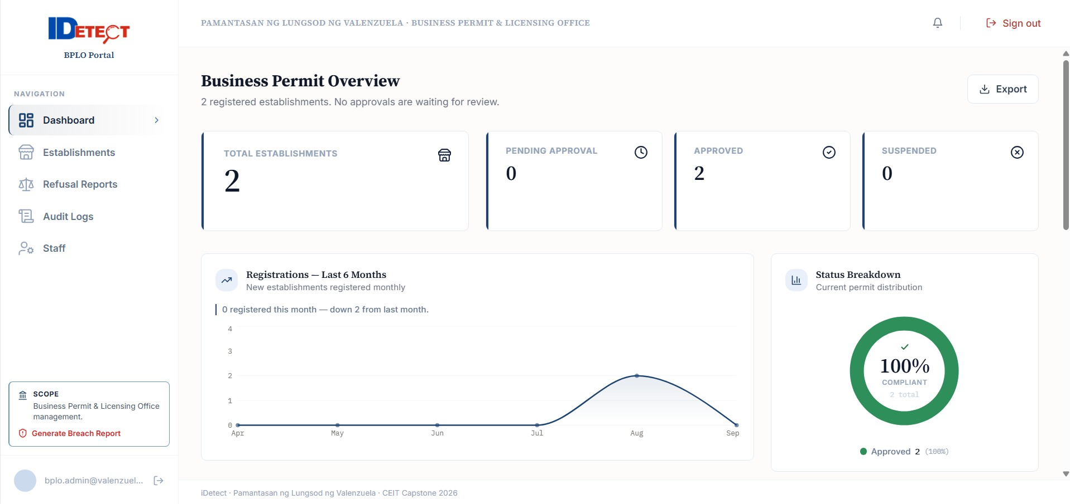
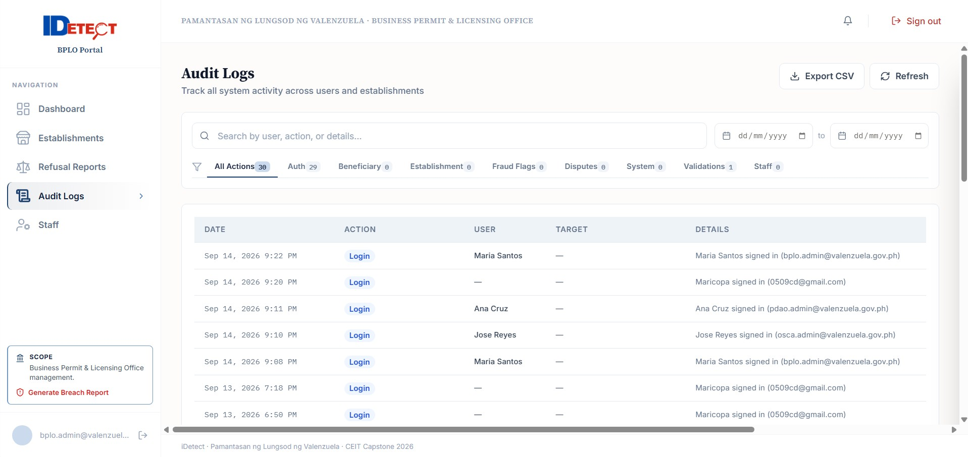
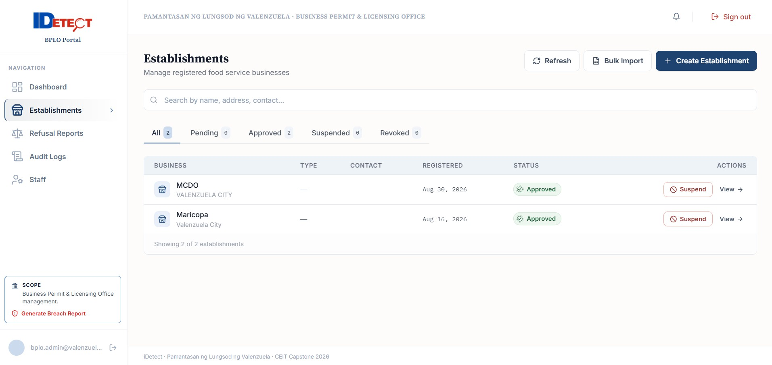
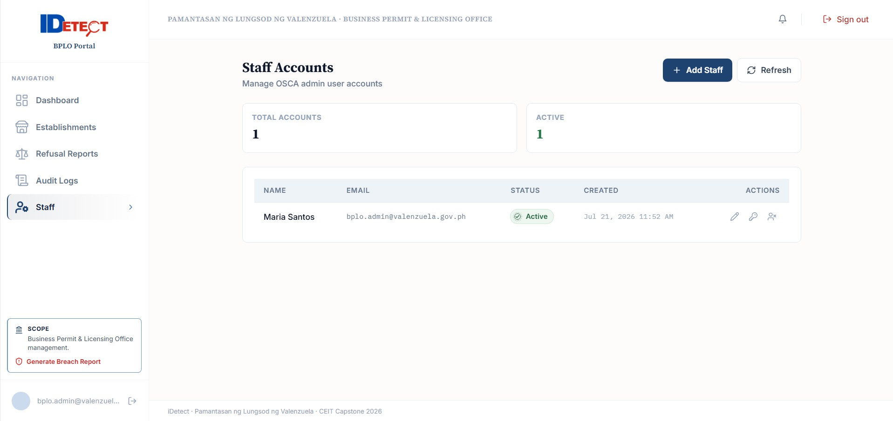
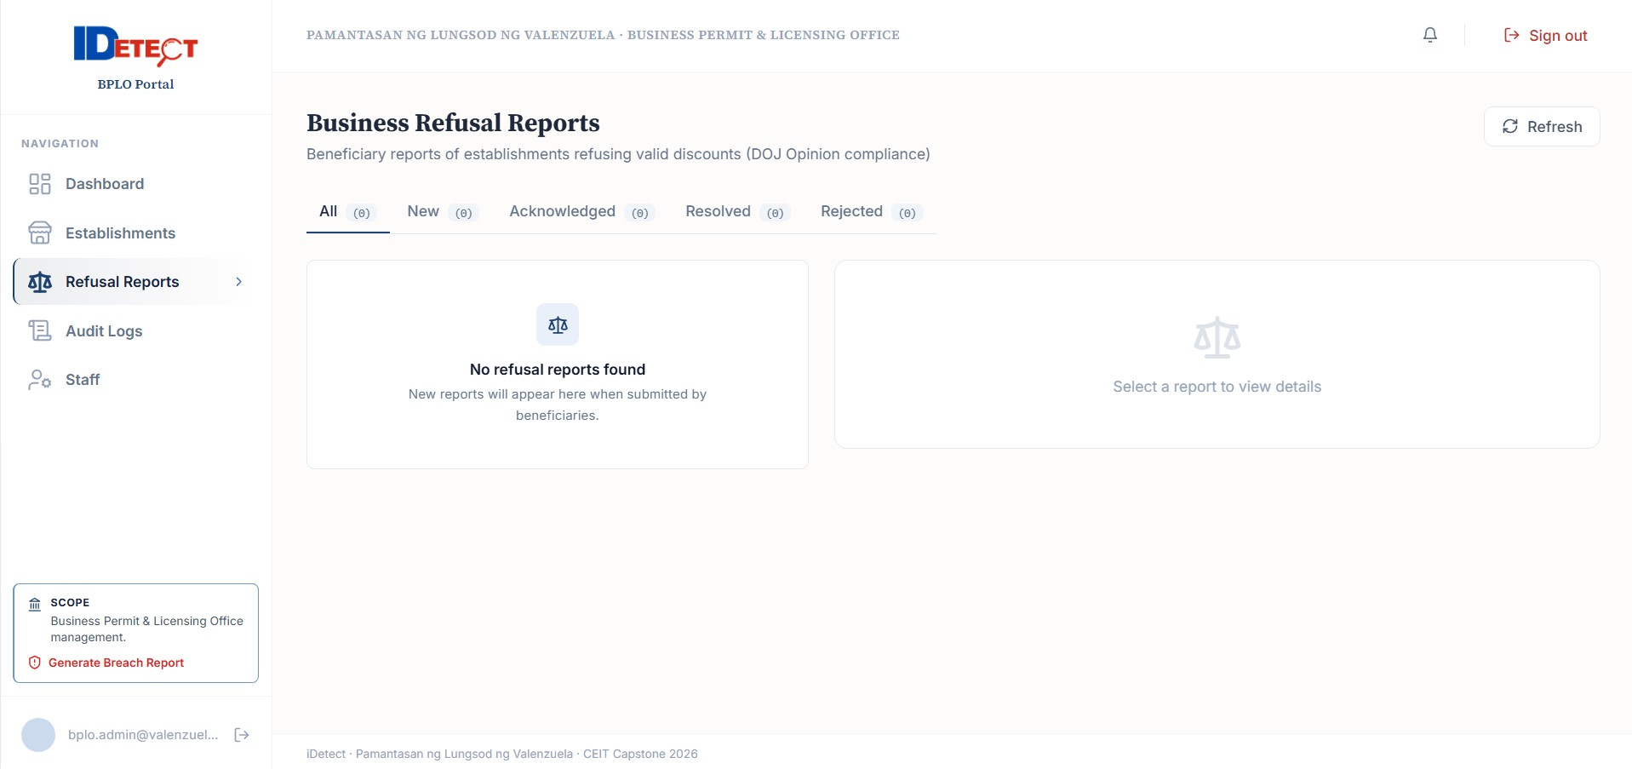

Actual BPLO Portal screenshot sheet

  - Additional Portal Screen Examples
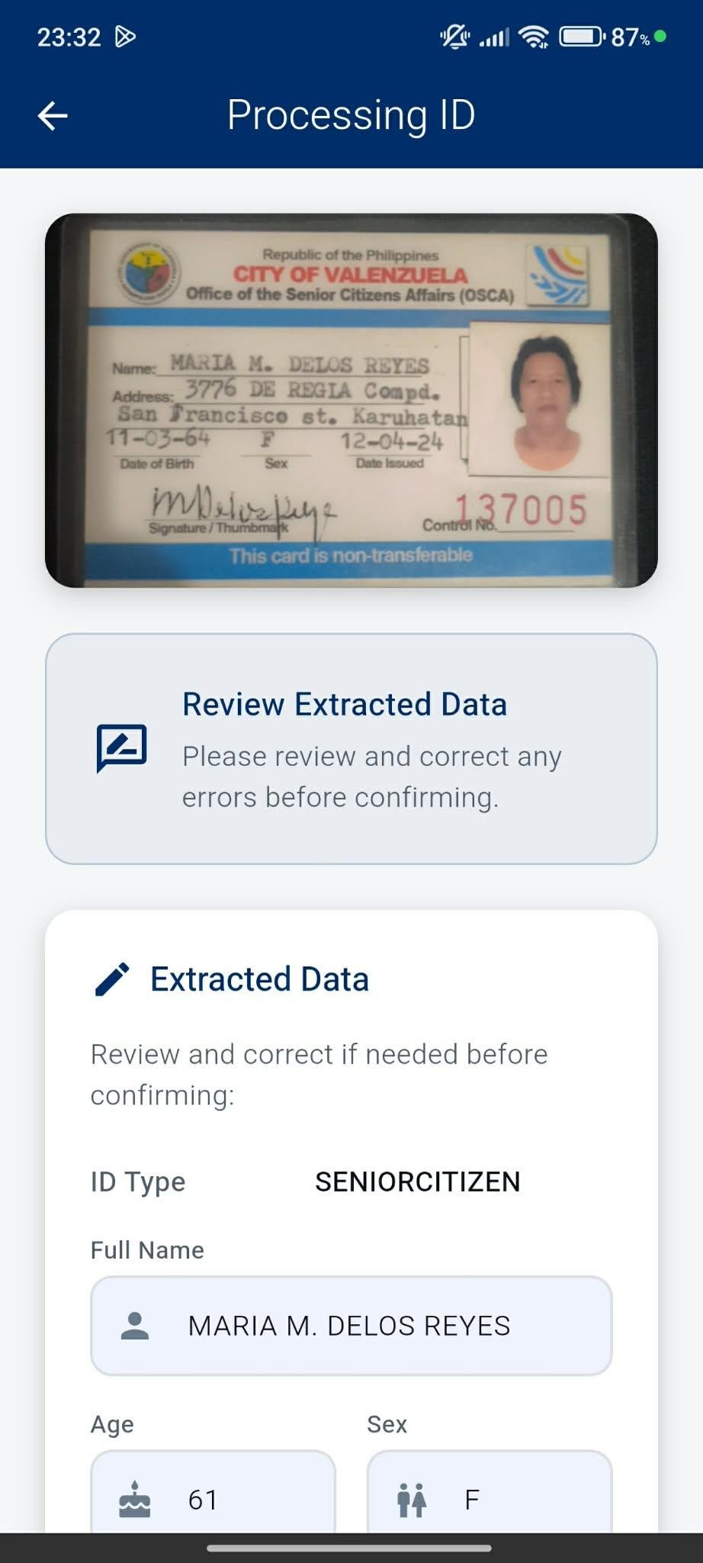
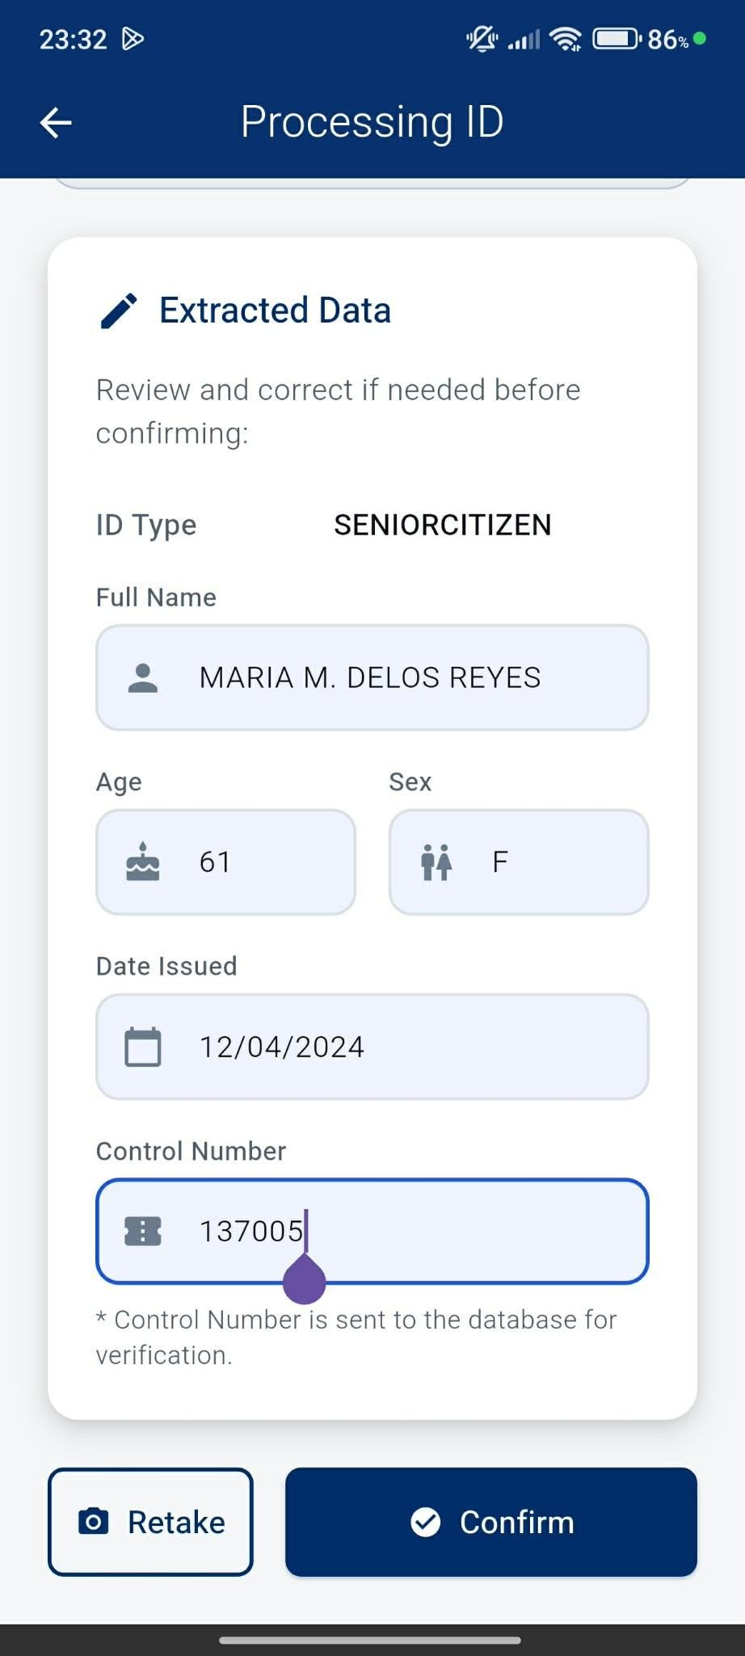
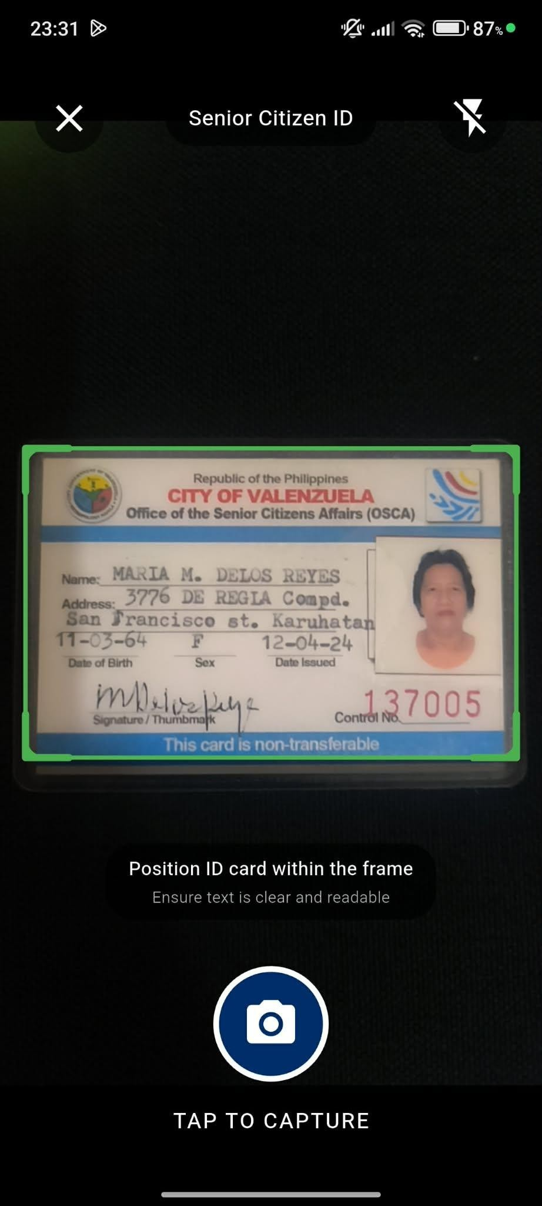
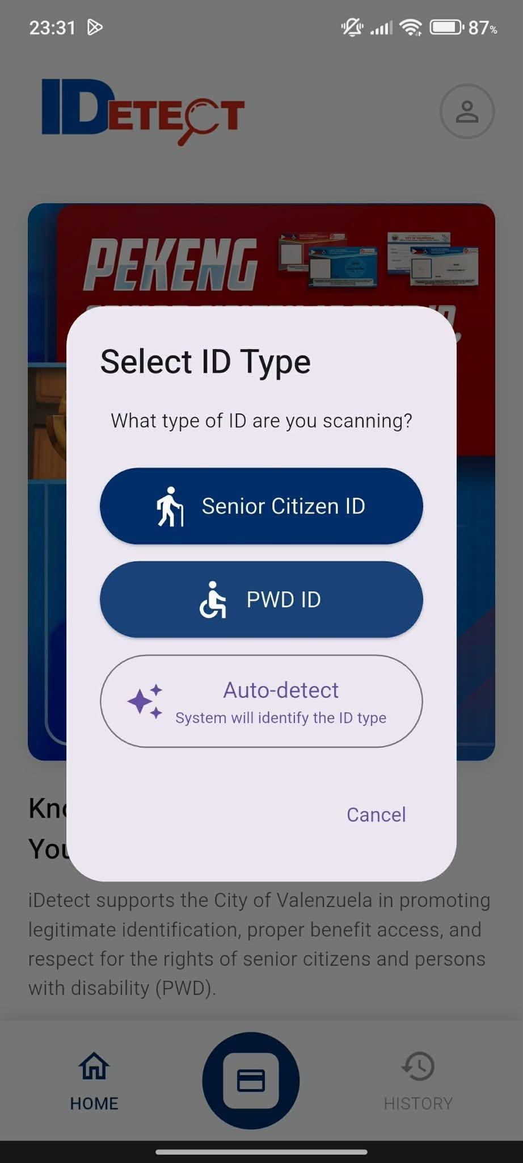

Client Portal OCR/capture screen

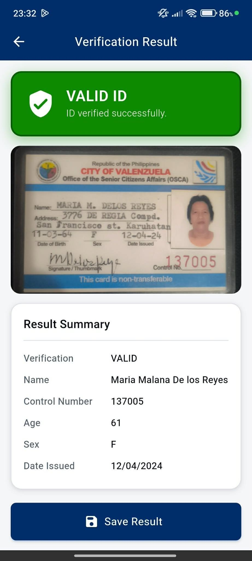

Client Portal validation result

OSCA investigation and analytics
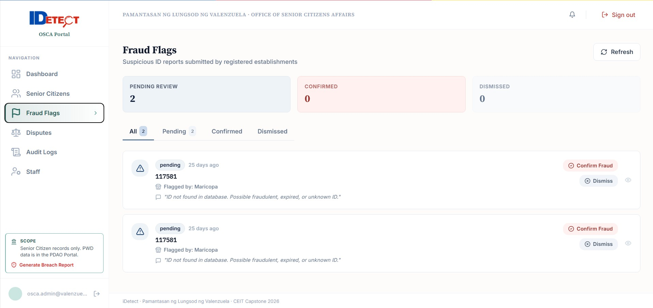
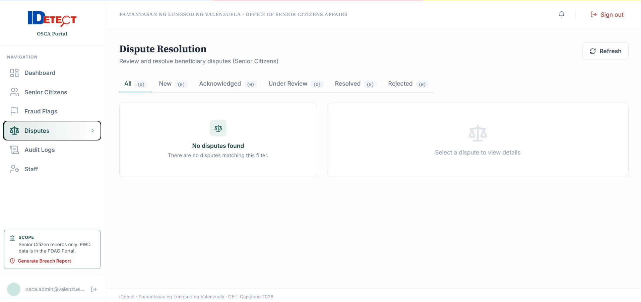

PDAO investigation and analytics
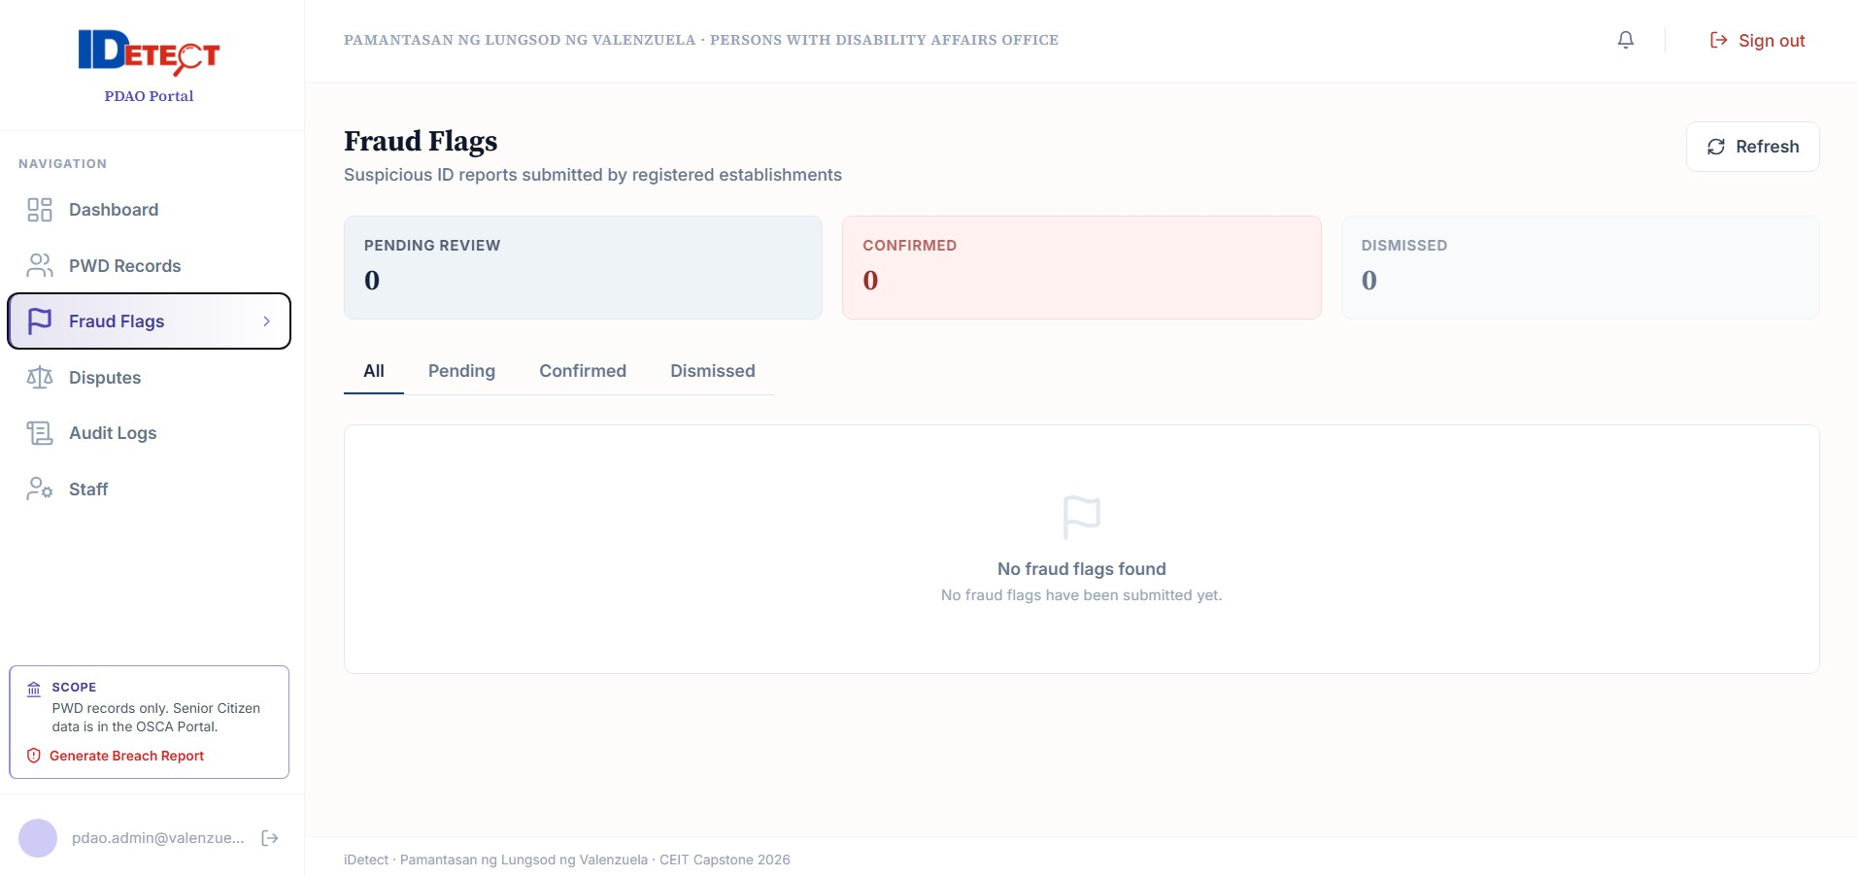
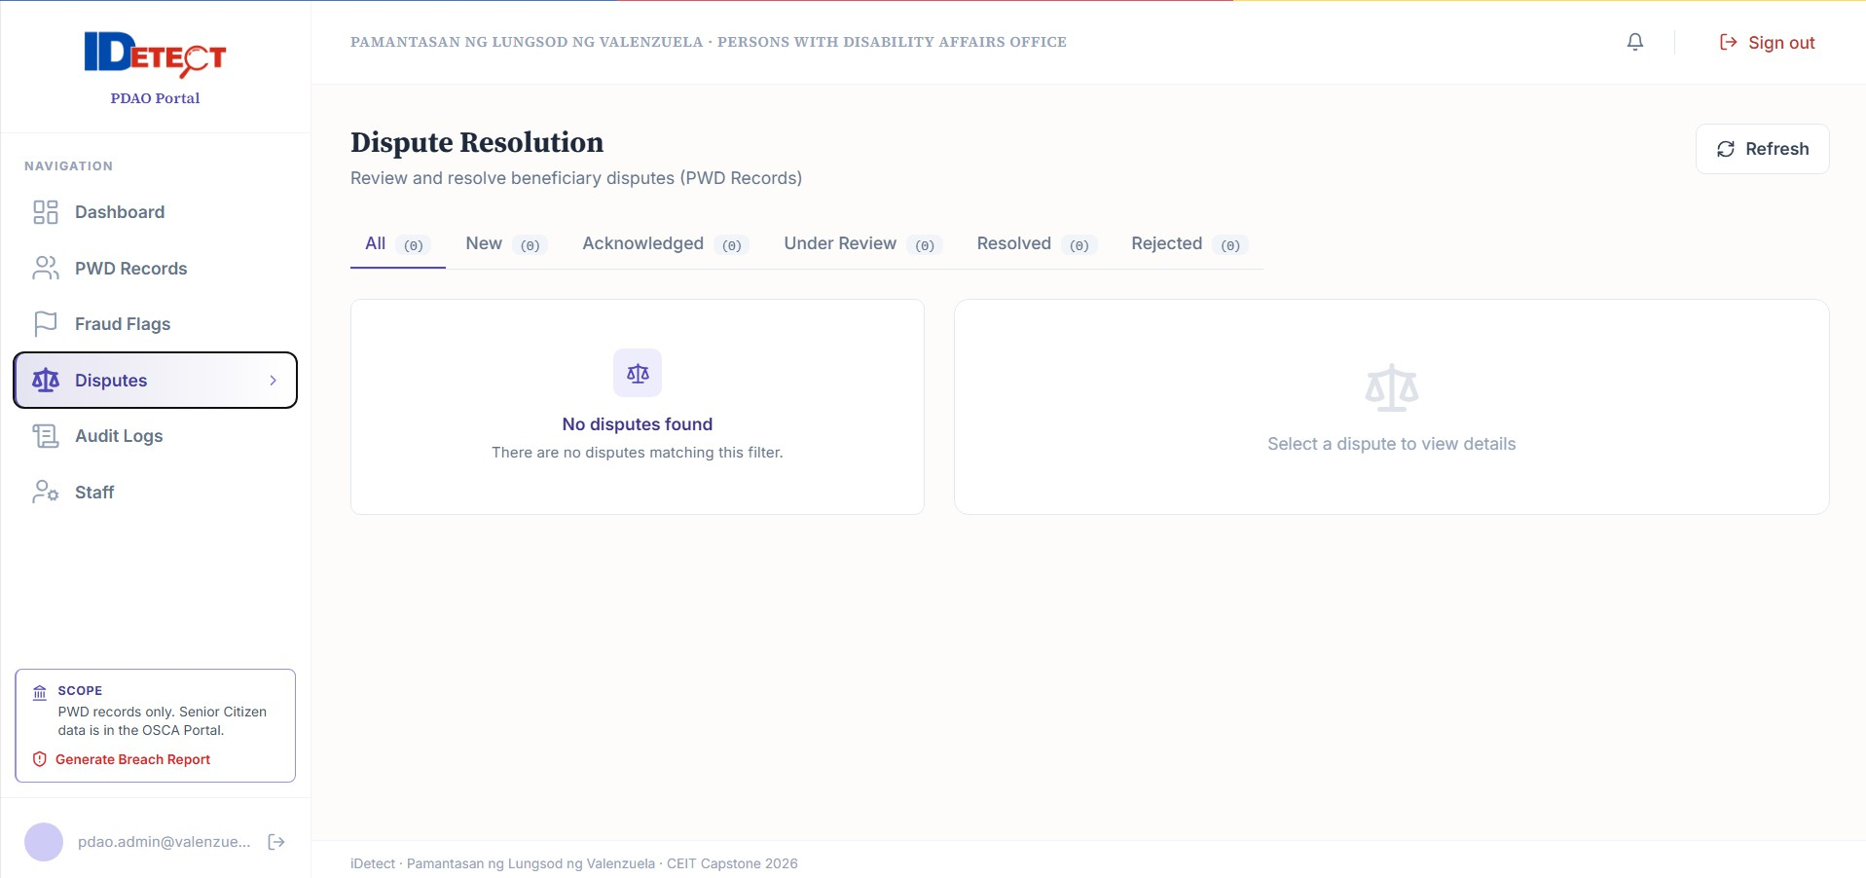

Beneficiary registration/login/dispute screens

End of iDetect User Manual

