3. No, Dijkstra’s algorithm should not be used to find the shortest paths in a graph with some negative weights. This is the example below:

1

-7

4

1

C

B

A

s

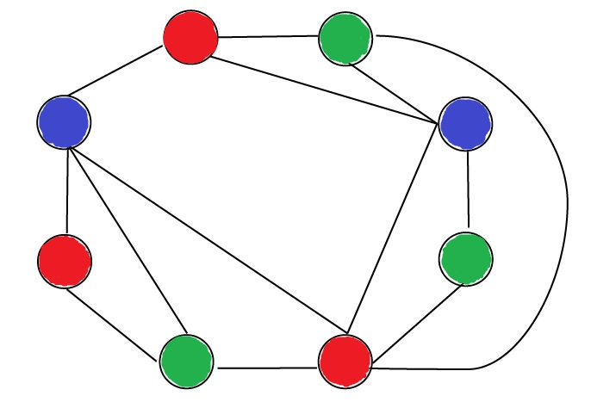

4.