0945070133 – 10

# Source Identification, Counterparts and Properties

## STONKS alert

* Type of Alert: High Flux State,
* Long-term Variability ,
* No short-term Variability.

The long-term variability is the difference between the upper limit of the flux lowest value and the lower limit of the flux highest value.

The short-term variability is the result of a test of the flux against a constant value.

## Simbad

<https://simbad.cds.unistra.fr/simbad/sim-id?Ident=%4013058032&Name=2MASS%20J03332989-2714334&submit=submit>

The source is identified on *Simbad* as a Star: 2MASS J03332989-2714334.

## ESASky

<https://sky.esa.int/esasky/?target=53.37579166666667%20-27.242833333333333&hips=XMM-Newton+EPIC+color&fov=1&projection=SIN&cooframe=J2000&sci=true&lang=fr>

The source has multiple counterparts on *ESASky*:

* EPIC Stack (Soft X-ray),
* XMM-SUSS 6.2 (UV to Optical)? Slightly off,
* Gaia DR3 (Optical),
* Euclid MER Q1 (Optical to Near-IR),
* 2MASS (Near-IR),
* AllWISE (Near-IR to Mid-IR).

Gaia DR3 gives the following useful data:

* Parallax: ,
* Magnitude: ,
* ,
* Effective temperature: .

The source is quite faint and most likely Galactic. The effective temperature corresponds to an M-star.

Gaia DR3 also gives a probability of classification:

* Classprob Dsc Combmod Galaxy ,
* Classprob Dsc Combmod Quasar ,
* Classprob Dsc Combmod Star .

There is a strong likelihood of the source being classified as a star.

There are 1 publication**:** Kado-Fong, E.et al., *M Dwarf Activity in the Pan-STARRS1 Medium-Deep Survey: First Catalog and Rotation Periods*, December 2016 (<https://ui.adsabs.harvard.edu/abs/2016ApJ...833..281K/abstract>).

## 3DNH-tool

<http://astro.uni-tuebingen.de/nh3d/nhtool>

*3DNH-tool* suggests a column density of , which is relatively low, typical of a Galactic source. However, this value might not be reliable as it does not account for the distance of the source.

# X-ray Variability and Periodicity

Only the data from the PN instrument observation show a periodicity. As the results differ between instruments, we chose to consider only those from the instrument with the highest maximum likelihood. According to the STONKS alert document, the maximum likelihood for PN is , while for M2 it is , supporting our decision to rely solely on the PN data.

The source exhibits an extremely short period of , characteristic of a rotating compact object, like:

* A pulsar (e.g., rotation-powered neutron star),
* A magnetic white dwarf (e.g., DQ Her-type),
* Or possibly a flaring low-mass star, although this is unusually fast.

But since the source is identified as stellar, this heavily favours a compact object binary (e.g., X-ray emitting white dwarf or neutron star).

# X-ray Spectral Properties

## Xspec models

The main models that we are using are: Black body, Bremsstrahlung, Apec and Powerlaw, or a combination of two components: Black body and Powerlaw, Bremsstrahlung and Powerlaw and, Apec and Apec.

### Black body

When an X-ray spectrum is well fitted by a black body model, it suggests that the X-ray emission is coming from a hot, dense surface or region that radiates like an ideal thermal emitter (i.e. a black body). A black body emits radiation with a spectrum that depends only on its temperature, and this emission is:

* Smooth and has a characteristic peak at a certain energy,
* Thermal, meaning it reflects a state of thermal equilibrium,
* Strongly dependent on temperature (the hotter the black body, the more it emits and the higher the peak energy).

A black body model fit generally implies that the X-rays are emitted by a compact and hot surface (not by diffuse gas). Likely sources include:

* The surface of a neutron star,
* The boundary layer in a white dwarf system (e.g., in cataclysmic variables),
* The accretion disk’s inner region (if dense and hot enough),
* Or even a hot stellar photosphere.

### Bremsstrahlung

When a bremsstrahlung model (also known as thermal bremsstrahlung or free-free emission) fits an X-ray spectrum well, it suggests that the X-ray emission is primarily produced by hot, ionized gas (i.e. plasma) through a specific process: Bremsstrahlung (German for “braking radiation”) occurs when electrons are decelerated as they pass near atomic nuclei. This deceleration causes them to lose energy in the form of X-ray photons. This type of emission is thermal, meaning the spectrum depends on the temperature of the plasma. A good fit with this model indicates that:

* The X-ray source likely contains hot plasma (temperatures typically in the range of millions of Kelvins, so to ).
* The X-ray spectrum is smooth and continuous, without strong emission lines (although lines may still be present if other processes are involved).

It is common in environments like:

* Accretion shocks (e.g., in cataclysmic variables, where infalling material heats up).
* Stellar coronae (like in active M-dwarfs).
* Supernova remnants or galaxy clusters.

Source of the plasma temperature: <https://www.sciencedirect.com/topics/earth-and-planetary-sciences/plasma-temperature>.

### Astrophysical Plasma Emission Code (APEC)

When an X-ray spectrum is well fitted by an Apec model, it indicates that the emission is coming from a hot, diffuse, optically thin plasma in collisional ionization equilibrium. It models emission from a plasma that contains a mix of elements (H, He, Fe, etc.) at a certain temperature, where:

* Electrons collide with ions, exciting them,
* The ions then de-excite by emitting photons, often in the X-ray range,
* Both continuum emission (mainly bremsstrahlung) and emission lines are included in the model.

Thus, when Apec fits the spectrum, it suggests that:

* We are observing a thermal plasma (like bremsstrahlung, but with line emissions),
* The plasma is optically thin (photons escape without being absorbed),
* The plasma is in collisional ionization equilibrium, meaning the ionization state is stable and set by the temperature.

It is common in environments like:

* Stellar coronae (like in active M-dwarfs),
* Supernova remnants,
* Hot gas in galaxy clusters,
* Accretion disks or shocks in systems like cataclysmic variables (CVs),
* Flares, where gas is suddenly heated and emits thermal X-rays.

### Powerlaw

When an X-ray spectrum is well fit by a powerlaw model, it means that the emission is of non-thermal origin, meaning that it doesn't come from a hot gas or a thermal surface like in blackbody or bremsstrahlung models. Instead, it points to processes involving high-energy particles, such as acceleration or scattering. Mathematically, a powerlaw has the form:

With the flux of photon at energy and the photon index (PhoIndex in *Xspec*) typically between 1 and 3. A steeper index (higher ) means the spectrum drops off faster with energy.

A good powerlaw fit implies non-thermal emission mechanisms, such as:

* Synchrotron radiation (relativistic electrons spiralling in magnetic fields),
* Inverse Compton scattering (high-energy electrons boosting low-energy photons),
* Emission from accretion flows, like in black holes or neutron stars,
* Emission from magnetically active stars (e.g. in the tail of a flare event).

We might see a powerlaw spectrum from:

* Active Galactic Nuclei (AGN) because of the non-thermal emission from jets or corona,
* X-ray binaries because of the accretion-powered emission with comptonization,
* Pulsars or magnetars because of the synchrotron and curvature radiation,
* Some flare stars or M-dwarfs because of high-energy particles in flare tails,
* Cataclysmic variables (CVs) if there is a strong magnetic activity or shock jets.

## Fit statistic

### Chi-squared

The chi-squared fit statistic assumes that each bin contains enough events to approximate the Poisson distribution with a normal distribution. If some bins have under 20 counts, this test becomes unreliable. In order to be more secure, we will consider that if the bins have less than 100 counts, C-statistic should be used instead. Here, we have about 95 counts which under 100 but still close, so we will do both Chi-squared and C-statistic.

The Chi-squared is the sum of the squared residuals, weighted by the errors in the data. The reduce Chi-squared (reduced by the number of degrees of freedom) is:

* : Good fit.
* : Bad fit.
* : Overfitting?

Here, the number of bins is: . The number of parameters depends on the model:

|  |  |  |
| --- | --- | --- |
| **Model** |  | **Main parameters** |
| tbabs*bbody | 3 | nH, kT, norm |
| tbabs*bremss | 3 | nH, kT, norm |
| tbabs*apec | 4 | nH, kT, abondance, norm |
| tbabs*powerlaw | 3 | nH, PhoIndex, norm |
| tbabs*(bbody+powerlaw) | 5 | nH, kT, norm (bbody), PhoIndex, norm (powerlaw) |
| tbabs*(bremss+powerlaw) | 5 | nH, kT, norm (bremss), PhoIndex, norm (powerlaw) |
| tbabs*(apec+apec) | 6 | nH, temp1, abondance, norm1, temp2, norm2 |

Let's compare the most promising models (i.e. with the chi-squared closest to 1):

|  |  |  |  |  |
| --- | --- | --- | --- | --- |
| **Criteria** | **Bremsstrahlung** | **Powerlaw** | **Black body + Powerlaw** | **Bremsstrahlung + Powerlaw** |
| Chi-squared | 1.1526 | 1.1882 | 1.1923 | 0.2076 |
| Reduce Chi-squared (5 bins) | 0.5763 | 0.5941 | nan | nan |
| Column density | 7.584e-02 ± 0.103 | 0.225 ± 0.185 | 0.215 ± 0.403 | 0.366 ± 8.051 |
|  | 1.096 ± 0.75 | X | 199.355 ± 2.381e+14 | 0.568 ± 3.353 |
| PhoIndex | X | 3.20 ± 1.15 | 3.137 ± 3.943 | 9.5 ± 246.635 |
| Norm | 2.428e-05 ± 2.082e-05 | 1.931e-05 ± 1.211e-05 | 3.106e-11 ± 665.837 (bbody), 1.873e-05 ± 1.491e-05 (powerlaw) | 1.051e-04 ± 2.246e-03 (bremss), 6.118e-07 ± 1.656e-04 (powerlaw) |
| Null hypothesis probability | 5.6196e-01 | 5.5205e-01 | nan | nan |
| Degrees of freedom | 2 | 2 | nan | nan |

In the case of **Black body + Powerlaw** and **Bremss + Powerlaw** models, . Therefore, we cannot calculate the reduced chi-squared, because that would amount to dividing by zero. This means that:

* The model has too many parameters compared to the data,
* The models are fitting the data exactly (overfitting),
* The may be close to zero, but no longer has any statistical significance, because there is no room for error to assess the quality of the fit.

We generally prefer that . Ideally, we want at least a few dozen degrees of freedom for the to be reliable.

Moreover, for the **Bremsstrahlung + Powerlaw** model:

* The spectral index is very poorly constrained . This shows that either the model is too flexible, the powerlaw component is not necessary or the data are insufficient to constrain this part of the spectrum.
* The value of is quite low , which is still in soft emission.

For the **Black body + Powerlaw** model is extremely poorly constrained. The very large errors on both of these models show that degeneracy remains a problem.

Thus, we will only retain **Bremsstrahlung** and **Powerlaw** models as promising:

* Both have a very close to 1, indicating that they fit the data well (over 5 bins).
* The column density value given by the **Bremsstrahlung** model isthe closest one to what 3DNH-tool suggest with . The value of the column density of the **Powerlaw** model is: , indicating a farer source but still coherent. Both imply a Galactic source.
* The **Bremsstrahlung** model has a temperature , which is consistent with hot plasmas, indicating possible coronal activity or accretion.
* The **Powerlaw** model yields a high photon index , which is rather soft, and therefore more typical of certain non-thermal sources or a spectrum dominated by the diffuse background (synchrotron, inverse Compton).
* The uncertainties are significant in both cases, but slightly smaller for **Powerlaw**.
* The probabilities of the null hypothesis are equivalent , so neither is statistically better.

Based solely on the statistical quality of the fit, the **Bremsstrahlung** model is slightly better. However, the final choice depends on the astrophysical context of your source:

* If the source is thermal, then the **Bremsstrahlung** model is more relevant.
* If the source is non-thermal (e.g., AGN, pulsar, synchrotron), then the **Powerlaw** model is more appropriate.

### C-statistic

In general, we can compare the value of C-statistic to as an order of magnitude. Here, the expected C-statistic value of a “perfect” fit is: C-statistic (with ). So, a C-statistic value between 113 and 145 approximately.

Let's compare the most promising models (i.e. with C-statistic between 113 and 145):

|  |  |  |  |  |
| --- | --- | --- | --- | --- |
| **Criteria** | **Bremsstrahlung** | **Apec** | **Powerlaw** | **Apec + Apec** |
| C-statistic | 135.7132 | 132.8102 | 134.7690 | 130.2412 |
| Column density | 4.62e-04 ± 2.63e-02 | 1.918e-09 ± 2.62e-02 | 4.503e-02 ± 5.008e-02 | 4.105e-16 ± 0.359 |
|  | 2.70 ± 1.5 | 1.87 ± 0.345 | X | 1.733 ± 0.514 (1), 57.464 ± 1323.80 (2) |
| PhoIndex | X | X | 2.135 ± 0.425 | X |
| Norm | 1.32e-05 ± 3.086e-06 | 1.999e-05 ± 5.289e-06 | 1.089e-05 ± 2.606e-06 | 1.707e-05 ± 1.257e-05 (1), 1.222e-05 ± 7.439e-05 (2) |
| Null hypothesis probability | 2.607e-01 | 7.998e-01 | 2.698e-01 | 2.753e-01 |
| Degrees of freedom | 126 | 126 | 126 | 124 |

* The C-statistic values of all models fall within the expected range (113 to 145) to be considered a good fit.
* Only the column density values of **Bremsstrahlung** and **Powerlaw** could be coherent and would imply a Galactic source, although the **Bremsstrahlung** one is quite low.
* The **Bremsstrahlung** and **Apec** models have a temperature , which is consistent with hot plasmas, indicating possible coronal activity or accretion.
* The **Powerlaw** model yields a quite high photon index , which is rather soft, and therefore more typical of certain non-thermal sources or a spectrum dominated by the diffuse background (synchrotron, inverse Compton).
* The uncertainties are significant in all cases, but slightly smaller for **Powerlaw**.
* The probabilities of the null hypothesis are equivalent for all models except **Apec** . Apec’s p-value show a stronger support for the null hypothesis. Thus, the other models are more statistically significant.

Supported by the Chi-squared results, **Bremsstrahlung** and **Powerlaw** appear to be the best-fitting models. Although the C-statistic suggests that the **Apec** model may also be viable, the unreliability of its value and its higher p-value make it less promising.

# X-ray Flux and X-ray-to-Optical Flux Ratio

## Optical flux

The source is detected by Gaia DR3 with a magnitude , a faint object which is consistent with a low-mass star at .

The G-band corresponds to the wavelength interval of: 330 nm to 1050 nm (<https://gaia.obspm.fr/la-mission/les-resultats/article/les-observations-spectro-photometriques>).

The optical flux is calculated as follow:

With Gaia zero-point magnitude.

Here, we have an optical flux of .

## X-ray flux to optical flux ratio

### Chi-squared

From *Xspec* AllModels.calcFlux(".2 12.0") we obtain the X-ray flux:

* Bremsstrahlung model: .
* Powerlaw model: .

So, an X-ray flux of regardless of the model.

Then, we calculate the X-ray to optical flux ratio:

* Bremsstrahlung model: .
* Powerlaw model: .

So, an X-ray to optical flux ratio of regardless of the model.

### C-statistic

From *Xspec* AllModels.calcFlux(".2 12.0") we obtain the X-ray flux:

* Apec + Apec model: .
* Apec model: .
* Bremsstrahlung model: .
* Powerlaw model: .

So, an X-ray flux between andregardless of the model; which is coherent with the value found with chi-squared.

Then, we calculate the X-ray to optical flux ratio:

* Apec + Apec model: .
* Apec model: .
* Bremsstrahlung model: .
* Powerlaw model: .

So, an X-ray to optical flux ratio between andregardless of the model; which is coherent with the value found with chi-squared. This range of values is typical for active late-type stars, cataclysmic variables (CVs), or magnetic white dwarfs.

# Luminosity and Distance

In order to calculate the luminosity in , the source is assumed to be spherical:

With the X-ray flux calculated previously in and the distance to the source in . This distance is calculated from value of the parallax given by Gaia: .

We get a distance of .

### Chi-squared

Finally, the luminosity of the source is:

* Bremsstrahlung model: .
* Powerlaw model: .

So, a luminosity of regardless of the model.

### C-statistic

Finally, the luminosity of the source is:

* Apec + Apec model: .
* Apec model: .
* Bremsstrahlung model: .
* Powerlaw model: .

So, a luminosity of regardless of the model; which is coherent with the value found with chi-squared.

This luminosity could correspond to:

* An active M stars, flaring,
* A cataclysmic variable in quiescence,
* Polars / Intermediate Polars (magnetic CVs),
* Young pulsars if in a binary (though this would normally be brighter in X-rays).

# Documentations and Catalogues

## Antonio C. Rodriguez paper

<https://doi.org/10.1088/1538-3873/ad357c>

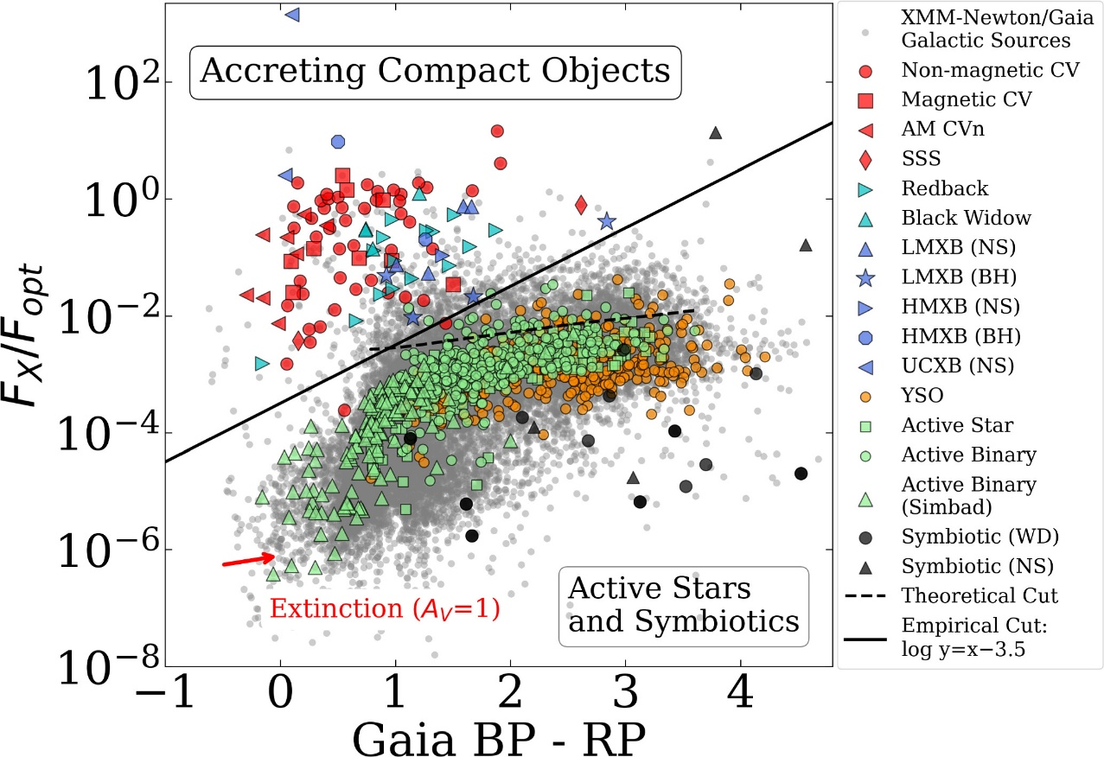

Figure 1. X-ray Main Sequence. Galactic sources from the XMM-Newton/Gaia crossmatch are shown in grey. Accreting compact object binaries in the upper left are separated from symbiotic and active stars on the bottom right by the “empirical cut” (solid line) or “theoretical cut” (dotted line). All classifications on the right-side panel are from the literature, and described in Section 2.3. No extinction correction is applied here, but the extinction vector is shown (de-reddening slides sources toward the lower left).

Gaia gives: and we previously calculated the ratio: **.** Reporting these values on the figure (pink lines) we cannot conclude on a clear classification. Our source points to a grey area where it could correspond to a YSO, an active star or an active binary, which does not exclude M-dwarf as a possibility.

## Tommaso Maccacaro et al. paper

<https://articles.adsabs.harvard.edu/pdf/1988ApJ...326..680M>

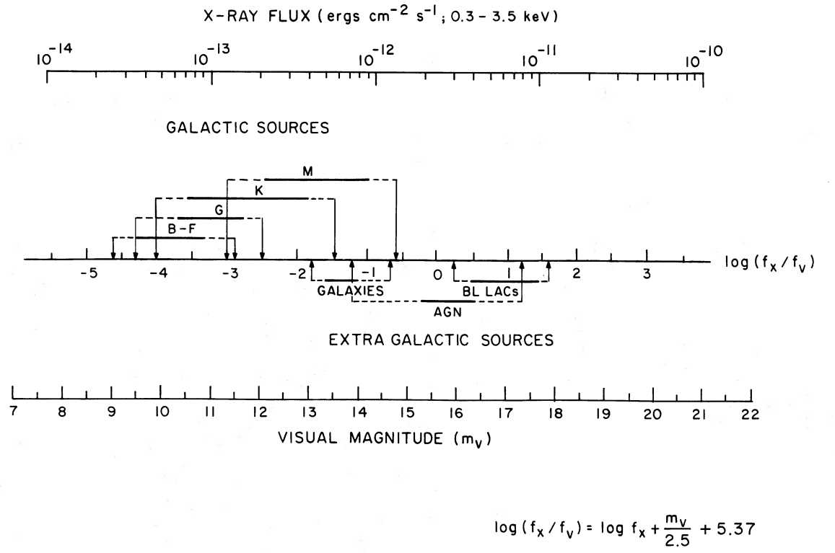

Figure 1. Nomograph to compute the log[fx/fv], given the X-ray flux and the visual magnitude of a source. The correspondance between the various classes of X-ray sources and their typical log[fx/fv] is also indicated.

The figure presents a nomograph to compute the given the X-ray flux in the band in ergs/cm^2/s and the visual magnitude of the source:

With the visual flux.

For we take the magnitude given by Gaia DR3, as previously.

### Chi-squared

From *Xspec* AllModels.calcFlux(".3 3.5") we obtain the X-ray flux:

* Bremsstrahlung model: .
* Powerlaw model: .

The logarithm is then:

* Bremsstrahlung model: .
* Powerlaw model: .

These values correspond to M-dwarf stars.

### C-statistic

The values found with C-statistic are between and which support the precedent results and conclusion.

## Dacheng Lin, Natalie Webb et al. paper

<https://dx.doi.org/10.1088/0004-637X/756/1/27>

The Dacheng Lin, Natalie Webb et al. paper discusses multi-wavelength data using X-ray hardness ratio.

## XMM-Athena Catalogue

<https://xmm-ssc.irap.omp.eu/xmm2athena/catalogues/>

Unclassified.

# Possible Classifications

## Active M-dwarf (flare Star)

M-dwarfs are active stars that exhibit variability in chromospheric emission and photometry at short and long timescales, including long cycles that are related to dynamo processes.

<https://arxiv.org/abs/2303.03998>

M-dwarf is the strongest candidate due to:

**Source Identification, Counterparts and Properties**

* *Simbad* identification as a star: 2MASS J03332989-2714334,
* Multiwavelength detection: EPIC Stack (Soft X-ray), XMM-SUSS 6.2 (UV to Optical), Gaia DR3 (Optical), Euclid MER Q1 (Optical to Near-IR), 2MASS (Near-IR) and AllWISE (Near-IR to Mid-IR),
* Quite faint: ,
* Most likely Galactic: ,
* Effective temperature of a M-star,
* Gaia DR3 classification as a star,
* Publication: Kado-Fong, E.et al., *M Dwarf Activity in the Pan-STARRS1 Medium-Deep Survey: First Catalog and Rotation Periods*, December 2016,

**X-ray Spectral Properties**

* Bremsstrahlung, Apec (only with C-statistic) and Powerlaw fit,
* Soft powerlaw index: and thermal emission: ,
* Low-to-moderate absorption: ,
* Low X-ray flux: ,
* X-ray to optical flux ratio: and luminosity match flaring M-dwarfs,
* Antonio C. Rodriguez paper figure 1: does not exclude M-dwarf as a possibility,
* Tommaso Maccacaro et al. paper figure 1: indicates a M-dwarf star.

However, if the short periodicity we found is actually right, therefore it would not be typical for flares or rotation of M-dwarfs (which is hours to days).

About M-dwarfs: <https://iopscience.iop.org/article/10.3847/1538-3881/acd6a2/pdf>.

# References

## Astronomical databases

Simbad (<https://simbad.cds.unistra.fr/simbad/sim-id?Ident=%4013058032&Name=2MASS%20J03332989-2714334&submit=submit>).

ESASky (<https://sky.esa.int/esasky/?target=53.37579166666667%20-27.242833333333333&hips=XMM-Newton+EPIC+color&fov=1&projection=SIN&cooframe=J2000&sci=true&lang=fr>).

3DNHTOOL (<http://astro.uni-tuebingen.de/nh3d/nhtool>).

XMM-Athena catalogue (<https://xmm-ssc.irap.omp.eu/xmm2athena/catalogues/>).

## Journal

ScienceDirect (<https://www.sciencedirect.com/topics/earth-and-planetary-sciences/plasma-temperature>).

## Scientific papers

Kado-Fong, E.et al. (2016), *M Dwarf Activity in the Pan-STARRS1 Medium-Deep Survey: First Catalog and Rotation Periods*, The Astrophysical Journal, Volume 833, Issue 2, article id. 281, 19 pp. (<https://ui.adsabs.harvard.edu/abs/2016ApJ...833..281K/abstract>).

Antonio C. Rodriguez (2024), *From Active Stars to Black Holes: A Discovery Tool for Galactic X-Ray Sources*, PASP **136** 054201 (<https://doi.org/10.1088/1538-3873/ad357c>).

Tommaso Maccacaro et al. (1988), *The X-ray spectra of the extragalactic sources in the einstein extended medium sensitivity survey*, The Astrophysical Journal, 326:680-690 (<https://articles.adsabs.harvard.edu/pdf/1988ApJ...326..680M>).

Dacheng Lin et al. (2012), *Classification of x-ray sources in the XMM-Newton serendipitous source catalog*, ApJ **756** 27 (<https://dx.doi.org/10.1088/0004-637X/756/1/27>

L. Mignon et al. (2023), *Characterisation of stellar activity of M dwarfs. I. Long-timescale variability in a large sample and detection of new cycles*, A&A 675, A168 (<https://doi.org/10.1051/0004-6361/202244249>).

Emily K. Pass et al. (2023), *Active Stars in the Spectroscopic Survey of Mid-to-late M Dwarfs within 15 pc*, The Astronomical Journal, 166:16 (14pp) (<https://iopscience.iop.org/article/10.3847/1538-3881/acd6a2>).

## Website

<https://gaia.obspm.fr/la-mission/les-resultats/article/les-observations-spectro-photometriques>