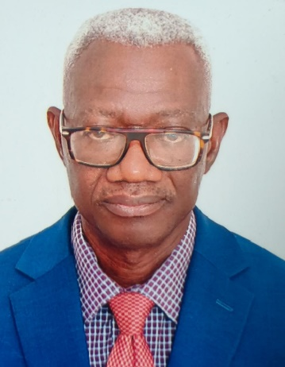




Education
Msc – Industrial Mathematics –Kwame Nkrumah University of Science and Technology, 2015

Bsc – Civil Engineering – Kwame Nkrumah University of Science and Technology, 1990

EMPLOYMENT
- 2024 To Date: Associated Consultants Ltd., Resident Engineer (Roads) on Tema Motorway project.

- 2018 – 2024: Joshob Construction Limited, Construction of Tema Steel Works Road and Valco Roundabout - Kpone Roads, Pavement/Materials Engineer.

- 2016– 2017: St. Annes Limited, Construction of Teshie Link Road, Resident Engineer.

Professional Overview
I am a purpose-driven Engineer fired with the passion for making positive impact in the construction landscape with emphasis on quality. As a self-starter and creative problem solver, I am able to adapt to diverse work environments and contribute meaningfully to people-centered institutional development. My ambition is to hone in on my over thirty years of construction experience in tandem with several years of computer programming, to leverage Machine Learning and Computer Vision in the Construction Industry, particularly, in the areas of material quality testing, construction supervision and management.

Work Experience
Tamale – Paga Road Rehabilitation (1995 - 1998)
This project involved the construction of 185km of Asphaltic Concrete Road from Tamale through Walewale, Bolgatanga to Paga. It involved the construction of major bridges near Tamale and Pwalugu.
My role as a Pavement/Materials Engineer involved monitoring of the quality of earthwork materials, asphalt and concrete – to ensure compliance to relevant specifications.

Rehabilitation/Construction of Anwiankwanta -Kumasi Road (1998 - 2000)
Undertaking my assignment as Soils and Materials Engineer, I liaised with field inspectors on materials related issues that cropped up on site for efficient delivery of quality control and quality assurance. Checking of Asphalt Mix Designs and Concrete Mix Designs presented by the Contractor for approval was also part of my duties in line with monitoring and evaluation of the works.

Construction of Kwame Nkrumah Circle - Achimota Road (2004 – 2006)
A 6.4km asphaltic concrete road with two footbridges, two railway underpass bridges and an interchange constituted the project’s main scope. In my capacity as Materials Engineer, I supervised construction of sub soil drains, undertook analysis and approval of concrete and asphalt mix designs and prepared monthly progress reports.
0503399073
elotetteh77@outlook.com
GE-347-3420

Contact

emmanuel lartey okine tetteh
RESIDENT ENGINEER (ROADS)

Skills
- Pavement Design
- Asphalt Mix Design
- Concrete Mix Design
- Computer Programming:
-JavaScript
-Python
-Visual Basic For
Application(For Excel,
Access, Word & PowerPoint)
-C++
-OpenCV
- Arduino Programming of sensors for air, noise, water quality, temperature and humidity monitoring.

Community Infrastructure Upgrading and Aboabo Storm Drain Improvement Works, Kumasi (2009 – 2012)
The project had as its scope, the upgrading of selected roads in Kumasi, the construction of public toilets and construction of the Aboabo Storm Drain from Anloga junction towards Atonsu. My duties as the Construction Engineer included positioning and establishing culvert levels, design of confluences to the storm drain, re-alignment of vertical and horizontal alignment designs of the roads, supervision of sampling and testing of materials, supervision of culvert construction and writing of monthly progress reports.

Reconstruction of Teshie Link Road (2017 – 2018)
As the Resident Engineer on the project, my duties included general oversight of the construction works, design of drainage structures, monitoring progress of works against the Contractor’s work program, organizing site meetings and writing monthly reports.

Reconstruction Of Tema Steel Works Road (2018 – 2022)
This project of 4.1km length, links the main Aflao road and the Tema Oil Refinery Road. Heavily trafficked, it courses through the Tema Industrial Area. The Construction of the road involved replacement of the existing sub grade material and the underlying clay material with rock fill and placing concrete pavement as the finished surface course.

As Materials Engineer on the project, I was involved in testing and certifying the materials that were to be incorporated in the permanent works and monitoring the works to ensure compliance to requisite project specifications.

Reconstruction of Valco Roundabout – Kpone Road, (2022 – 2024)
The Valco Roundabout to Kpone Road is approximately 7.1 km. Working as a Materials Engineer on the project, I undertook routine test monitoring of aggregates for concrete, supervision of borrow pit material sampling and testing and conduction of field density tests – as part of the quality control and quality assurance regime.

Accra-Tema Motorway and Extensions Project (2024 To Date)
The Accra–Tema Motorway Reconstruction and Expansion Project is a ten- lane road corridor comprising of four concrete-paved lanes and six asphaltic concrete-paved lanes. It has three interchanges and three main river bridges. My role as a Resident Engineer for Roads involves liaising with the client, contractor and stakeholders in general to facilitate work progress, monitor the progress of work as against the planned and ensure general site compliance with the relevant specifications.

