One Transaction, End to End
A worked example from LedgerBooks through MRA_TaxInvoice_System, using a real transaction posted during testing — every value below is what actually happened, not a mock-up.

1. The Transaction
Field | Value
LedgerBooks company | Second Test Co Ltd (Company #2)
Customer | Co2 Customer
Invoice | INV-0001 — 2026-08-14, due 2026-09-13
Line item | Test Service — Qty 1 @ 1,000.00, taxable
VAT rate | 15% (standard Mauritius rate)
Subtotal / VAT / Total | 1,000.00 / 150.00 / 1,150.00

2. Schematic Flow
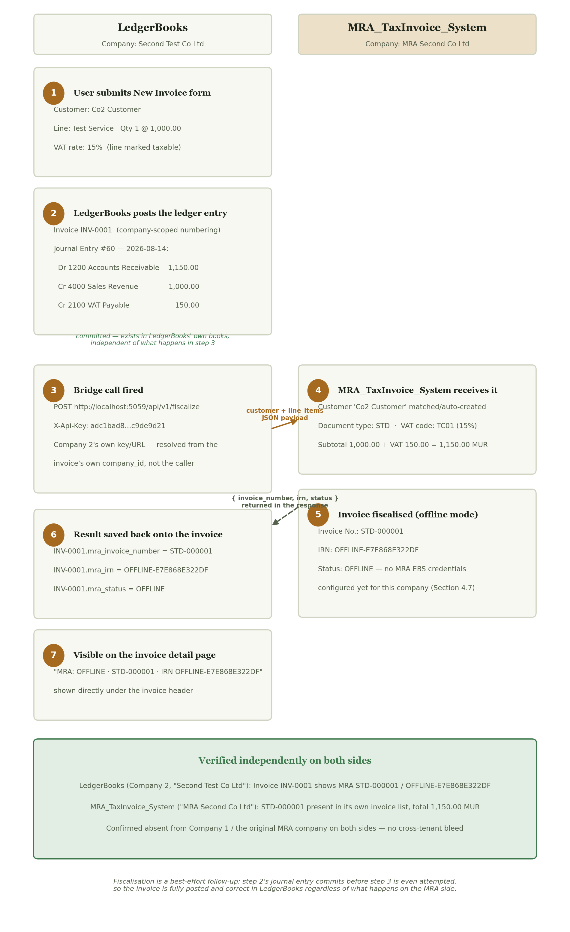
INV-0001, step by step — from the New Invoice form in LedgerBooks (Second Test Co Ltd) to a fiscalised record in MRA_TaxInvoice_System (MRA Second Co Ltd).

3. Step-by-Step Narrative

Step 1 — The form
A user, logged into LedgerBooks with Second Test Co Ltd as the active company, opens New Invoice, selects customer Co2 Customer, and adds one line: "Test Service", quantity 1, unit price 1,000.00, marked taxable, posting to income account 4000 – Sales Revenue.

Step 2 — Posted to the ledger
On submit, LedgerBooks assigns the next invoice number scoped to this company alone — INV-0001, because this is Second Test Co Ltd's first invoice, regardless of what number any other company is up to — and immediately builds and commits a balanced double-entry Journal Entry (#60):
Account | Debit | Credit
1200 — Accounts Receivable | 1,150.00
4000 — Sales Revenue |  | 1,000.00
2100 — VAT Payable |  | 150.00
This step is final and independent of everything that follows — the invoice is correctly posted in LedgerBooks' own books whether or not MRA_TaxInvoice_System is even reachable.

Step 3 — The bridge call
Immediately after committing, LedgerBooks fires POST http://localhost:5059/api/v1/fiscalize, authenticated with the X-Api-Key belonging specifically to Second Test Co Ltd's own MRA connection (configured on its own Settings page) — not a key shared across every LedgerBooks company. The payload is the customer's details and the one line item, in MRA_TaxInvoice_System's generic format.

Steps 4–5 — Received and fiscalised
MRA_TaxInvoice_System, running as company MRA Second Co Ltd, matches or auto-creates a customer record for "Co2 Customer", classifies the line under VAT code TC01 (the standard 15% rate), and computes the same total independently: 1,000.00 + 150.00 = 1,150.00 MUR. Because this MRA company has no live MRA EBS certification configured, the invoice is fiscalised in offline mode: invoice number STD-000001, IRN OFFLINE-E7E868E322DF.

Steps 6–7 — Result written back
The response is saved directly onto the LedgerBooks invoice — mra_invoice_number, mra_irn, and mra_status — and shown on the invoice's own detail page as "MRA: OFFLINE · STD-000001 · IRN OFFLINE-E7E868E322DF", with no further action needed from the user.

4. Independent Verification
Both ends of this transaction were checked directly against their own systems, not inferred:
- LedgerBooks, Company 2 (Second Test Co Ltd): invoice detail page for INV-0001 shows MRA STD-000001 / OFFLINE-E7E868E322DF.
- MRA_TaxInvoice_System, company MRA Second Co Ltd: STD-000001 appears in its own invoice list, customer Co2 Customer, total 1,150.00 MUR — matching exactly.
- Confirmed absent from Company 1 on the LedgerBooks side and from the original MRA company on the MRA side — this transaction belongs to exactly one pair of companies, with no cross-tenant bleed in either direction.

5. Why This Example Matters
This single transaction exercises every layer added in the multi-company build: company-scoped invoice numbering (INV-0001, not a number inherited from another company's sequence), a per-company MRA connection resolved from the invoice's own company_id rather than from whoever is logged in, and a ledger entry that posts and stays correct in LedgerBooks regardless of what MRA_TaxInvoice_System does with it afterward.

