* <https://www.un.org/en/climatechange/climate-fast-facts>
* <https://sdgs.un.org/topics/climate-action-synergies>
* <https://sdgs.un.org/goals/goal13#progress_and_info>
* <https://www.w3schools.com/howto/howto_css_fixed_footer.asp>
* <https://www.biologicaldiversity.org/programs/population_and_sustainability/sustainability/live_more_sustainably.html>
* <https://blog.tbhcreative.com/dark-mode-design-14-examples-of-black/>
* <https://www.color-hex.com/color-palette/98179>
* <https://www.w3schools.com/html/tryit.asp?filename=tryhtml_elem_textarea>
* <https://www.w3schools.com/js/tryit.asp?filename=tryjs_validation_js>
* <https://www.pexels.com/> - stock images

Wireframes

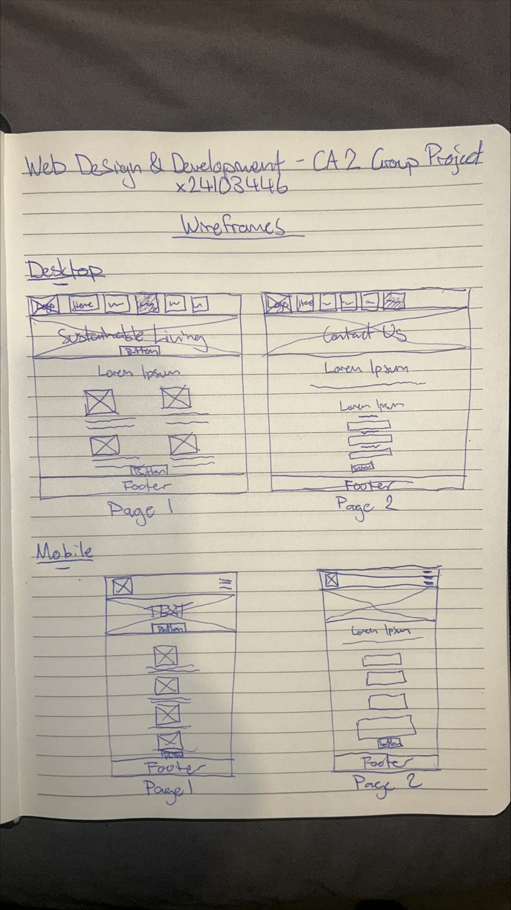

Time of Day



Git Commits





HTML Checker

Sustainable_living.html before & after

 

Contact.html before & after

