Project Report

**Goal of the App**

Finding the step count using mobile applications has always been an interest for most researchers in the past. There have been a lot of research findings on that and many researchers have moved their focus from the traditional ways of counting the step count using wearable devices to the sensor enabling smart phones. The latest android devices feature many sensors that can detect the movement of the user and thereby help the developers in developing an efficient application without the use of the complex algorithms to remove the noise, the gravity and fluctuations.

The goal of the app is to get the step count of the user using the Pedometer mobile application in the most efficient way as possible using sensors.

**High-level Architecture**

The high level architecture of the app is as shown below. The app uses the parse.com as the cloud to store the user login details. The home screen of the user shows him the app and his steps can be thereby recorded in the database.

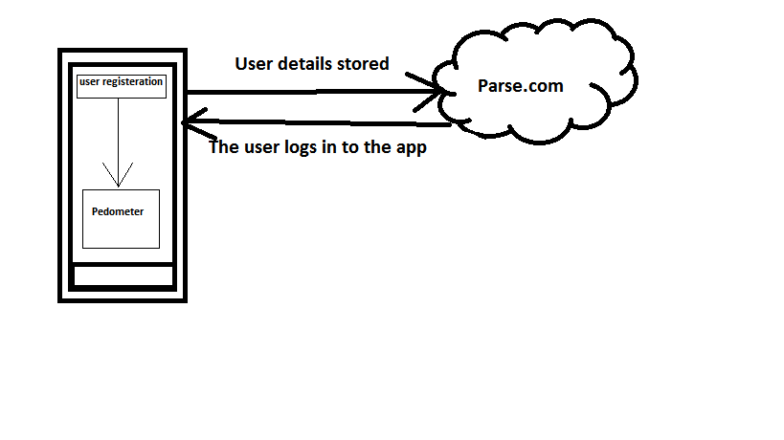

Figure1: High Level architecture of the app

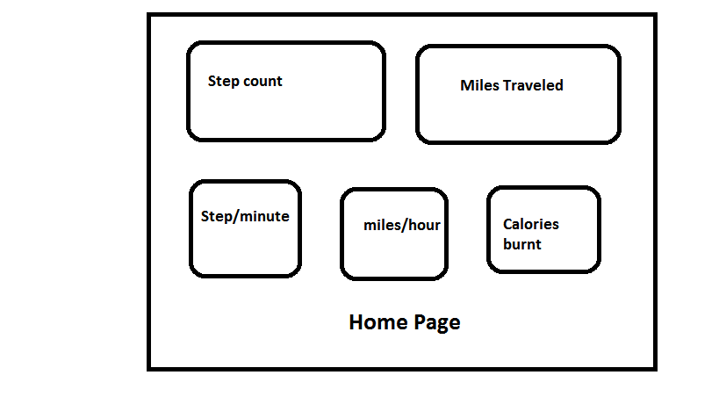

Figure 2: Home Page

**Android Techniques**

The calories are calculated according to the Step Length, Body weight and the metric(miles or kilometers) entered by the user. The user can enter the pace or speed he wants to go and the pedometer tells the user if he is fast or slow than the required pace. The foot length of the user can be entered along with the body weight which can be used to calculate the pace or speed in which the user is running and how much more is required to reach his desired speed or pace. The pedometer can be used to tell the users these numbers in speech using the ‘TextToSpeech’ Util interface to convert the text to speech. Settings can be changed to the operational level in which the app can be used like if the user wants the app to run in the background, keep the screen on while not in use or wake up when the screen is turned off. The steps are detected by implementing the sensor event listener and is calculated taking into account the standard gravity of the earth that is equivalent to 1G and the maximum magnetic field on the earth’s surface. Here the steps are counted according to the step sensitivity set in the settings. The whole functionality is written in the onSensorChanged() method where the type of sensor is the **accelerometer**.

**Testing**

The testing is done manually and using automation test tool called Seetest which is a simple record and run tool.

When the user enters the app, he is asked to enter the details and sign in. He will not be able to enter if the username and password don’t match and he hasn’t registered himself/herself.

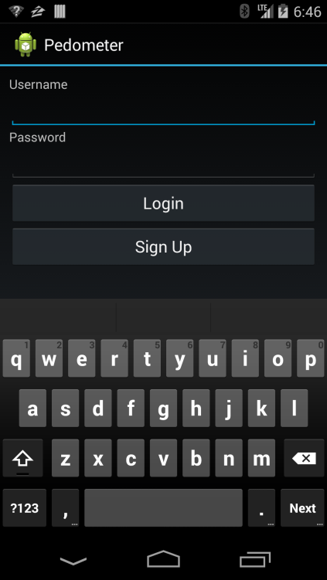

The user’s details are entered in the database as follows.

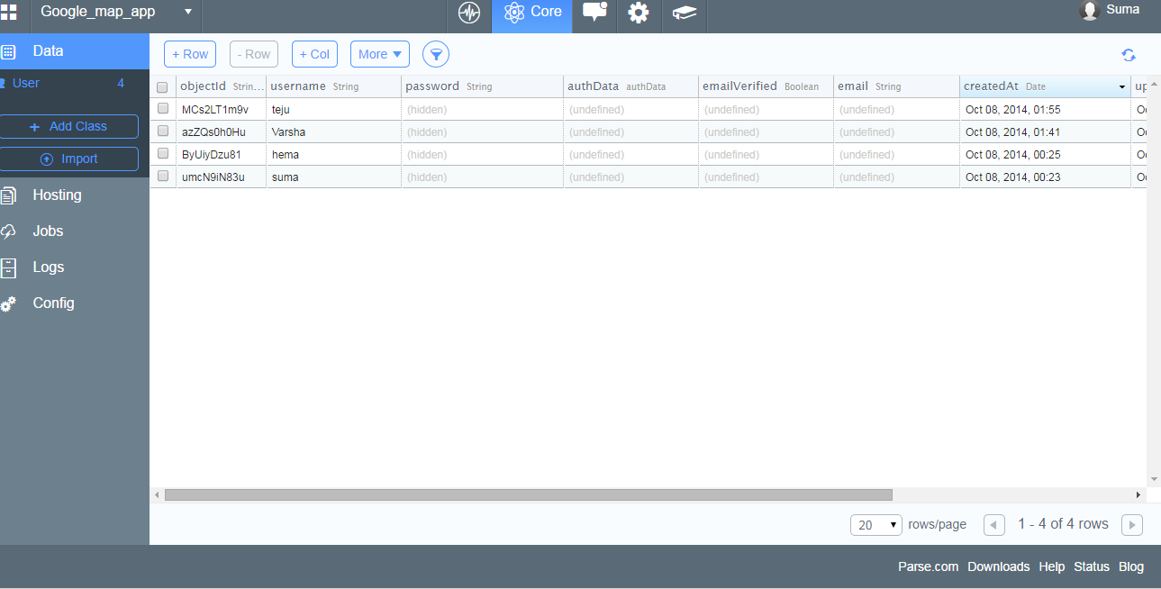

When he logs in with the correct username and password, he enters the app and the welcome screen shows up where he can either go to the pedometer app or exit the app.

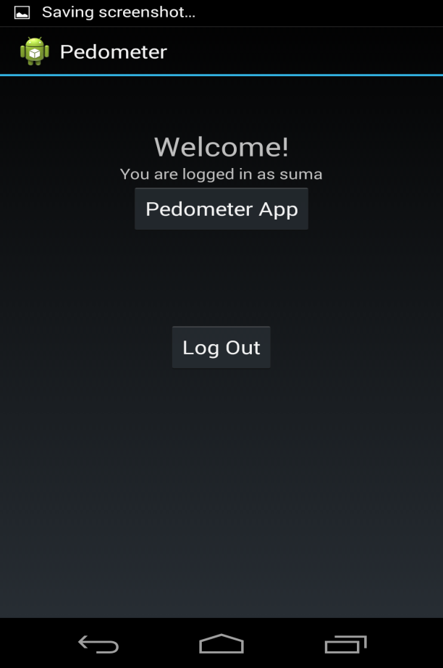

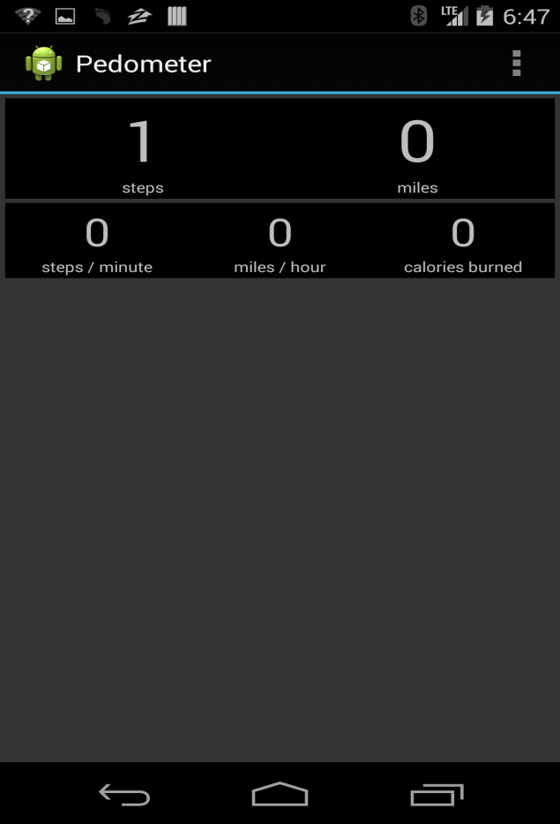

The pedometer can be paused or resumed. It can be restarted as well and it works fine.

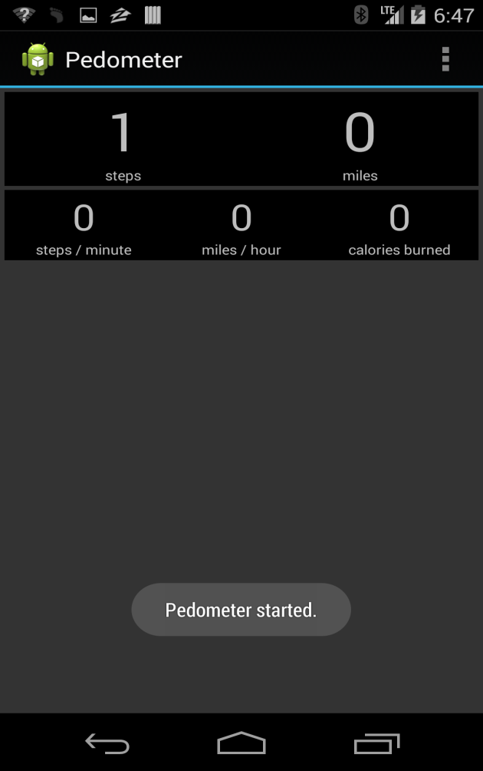

The app settings can be changed accordingly and below are the screenshots for the successful working of the app.

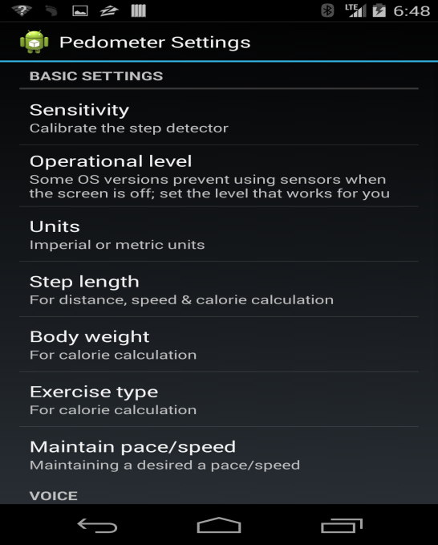

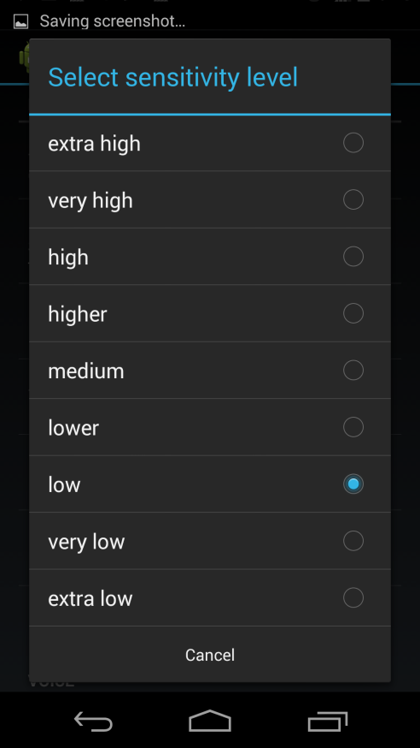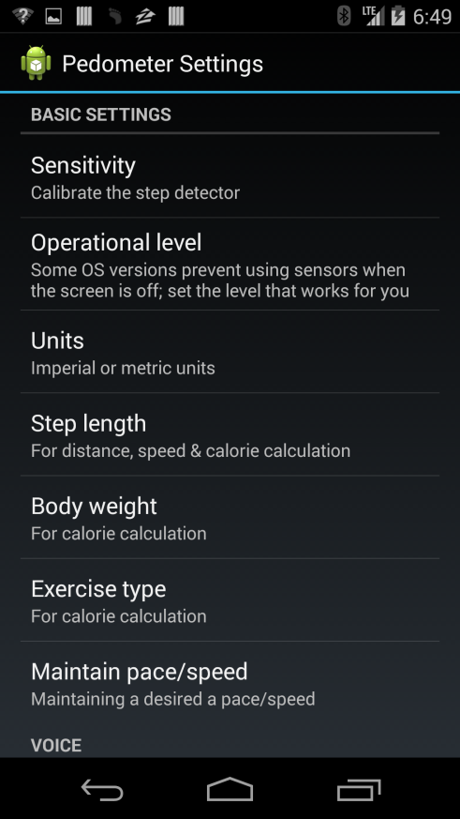

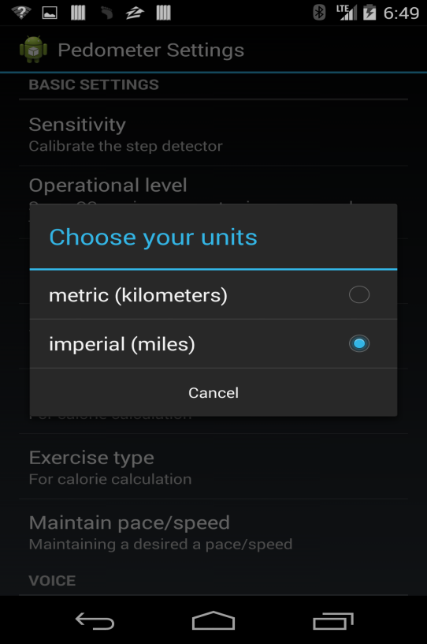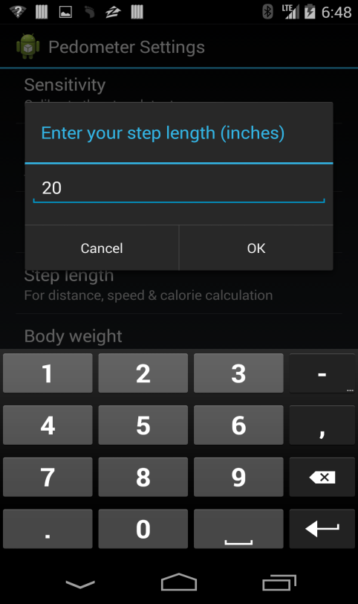

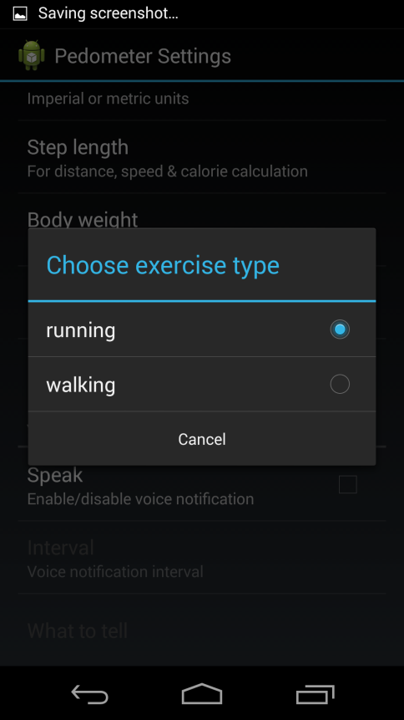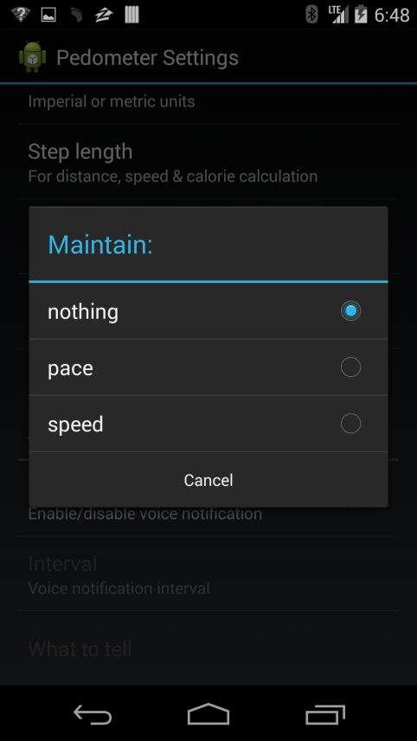

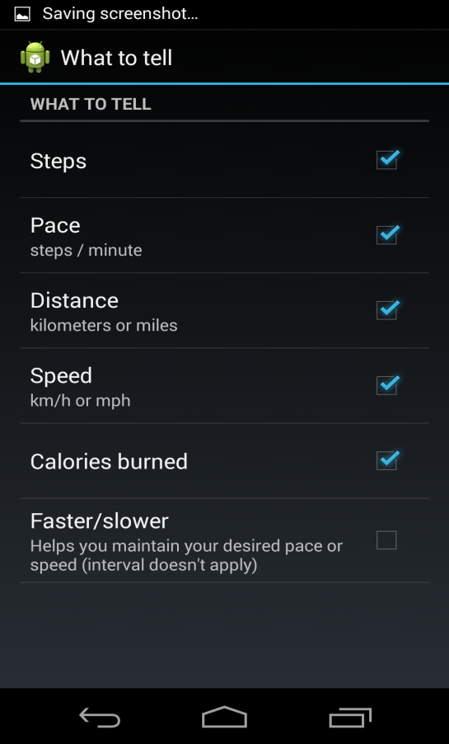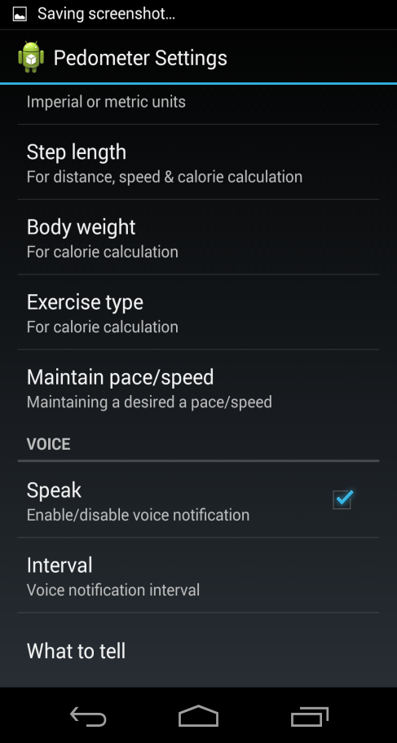

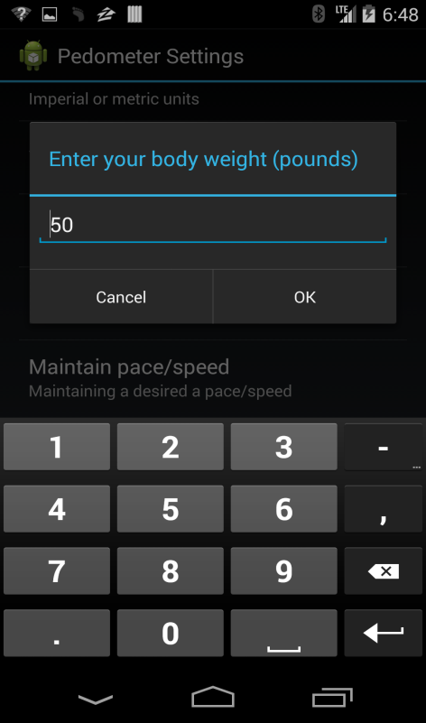

**Future Enhancements**

* Since accelerometer is very sensitive to even the small jitters, I would even try to use gyroscope to count the steps of the users.
* The steps should be recorded for individual users and analysis can be done on that to find the users who have reached the maximum steps.
* The users would be notified using push notifications about the user who has done the maximum number of steps in the speculated amount of time or before time.
* The users can log in using Facebook or Google account along with the normal registration.