**HIGH LEVEL DESIGN**

**FOR**

**INDUSTRY ANALYSIS**

|  |  |  |  |  |
| --- | --- | --- | --- | --- |
| Prepared by/ Modified by | | Role | | Start Date – End Date |
| Vanshaj Bhatia | | Team Lead | | 10 Sep 2018 –  20 Sep 2018 |
| Sunny Arora | | SME | | 10 Sep 2018 –  20 Sep 2018 |
| Santosh Kumar Neela | | Point of Contact | | 10 Sep 2018 –  20 Sep 2018 |
| Vibhor Gupta | | Designer | | 10 Sep 2018 –  20 Sep 2018 |
| Nellaippan ,Krubhakar | | ETL Developer | | 10 Sep 2018 –  20 Sep 2018 |
| Manoj Kumar Rathore | | Data Modeller | | 10 Sep 2018 –  20 Sep 2018 |
| Reviewed by | | Role | | Date of Review |
| Bhagyashri Gadkari | |  | | 17th Sep,2018 |
| Approved by | | Role | | Date of Approval |
| Shraddha Jadhav | |  | | 20th Sep,2018 |
| Circulation List | To all the ELTP mentors and the applicable trainee teams | | Version number of the template | **1.0** |
| **Version number of the work product** | V1.0 | | | |

**TABLE OF CONTENTS**

* 1. Introduction..............................................................................................................................1
  2. High Level Architecture.............................................................................................................2
  3. Schema Design..........................................................................................................................3
  4. Reporting...................................................................................................................................4
  5. Risk & Assumptions...................................................................................................................5

References

**1. INTRODUCTION:**

This Document outlines the High Level Design for the PLP “Industry Analysis” for the BI LOT. The project is to design the dataware house, reports and queries related to Industry Analysis. This document contains Design of Dimensional model, Schema structure and Report and related high level details.

Heterogeneous Sources i.e. operational data (Flat files)

EXTRACT

TRANSFORM

LOAD

Data warehouse (Tera Data)

Reports Based On Universe

UNIVERSE

( Ab Initio)

(QlikView)

(QlikView)

**2. SCHEMA STRUCTURE:**



**3. UNIVERSE STRUCTURE:**

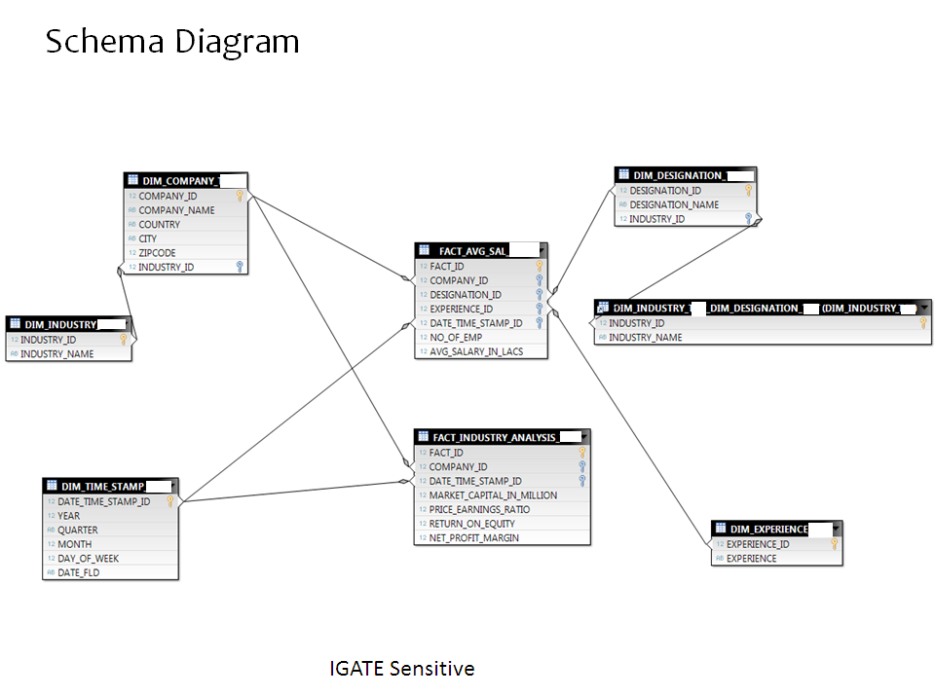

**4. REPORTING:**

1. Comparison of different companies.
2. Top designations present in a particular company
3. Top companies providing maximum salary for a particular designation
4. Country growth on the basis of industries growth in that country in 3 years
5. Ranking of companies on the basis of different growth factors(Price Earnings Ratio, Return On Equity, Number of Employees)
6. Growth in a particular industry on the basis of its companies growth
7. Designation Hierarchy in a Company on salary basis
8. Company’s growth in last 3 years

**5. RISK & ASSUMPTION:**

**Assumption:**

* It is assumed that the data present in the database has been verified

**Risk:**

* There can be NULL VALUES
* There may be few repeated records
* Values Can be of different data type

# Revision History

|  |  |  |  |  |
| --- | --- | --- | --- | --- |
| **#** | **Date** | **Version #** | **Section/Page # changed** | **Details of changes made** |
| 1. | 20th SEP 2018 | V1.0 |  |  |
|  |  |  |  |  |