3W Dataset — Oil Wells
Overview
The 3W dataset contains the first realistic and public collection of rare, undesirable real events in oil well drilling. This notebook demonstrates change point detection (CPD) on a univariate sensor extracted from a multivariate well series.
Dataset notes - Multivariate series with labeled change points (CPs) - Recommended use: multivariate or univariate CPD detection - Source: https://archive.ics.uci.edu/ml/datasets/3W+dataset

Load packages and dataset
Load the required packages for data access, modeling, visualization, and evaluation.
library(united)
library(daltoolbox)
library(harbinger)
Select a well as example and extract a series.
## Load series ----------------------
data(oil_3w_Type_1)
# Select first well from the Type 1 group
data <- oil_3w_Type_1[[1]]

Univariate series selection
Select the desired variable directly from preprocessed data.
# Choose a sensor (e.g., P_TPT) and plot
series <- data$p_tpt
plot(as.ts(series))
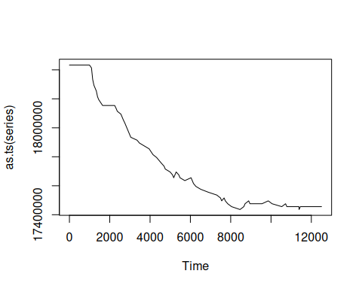

Event detection experiment
Define a CPD method and generate detections.
# Establish binary segmentation CPD model
model <- hcp_binseg()
# Fit the CPD model
model <- fit(model, series)
# Produce change-point detections
detection <- detect(model, series)
## Warning in BINSEG(sumstat, pen = pen.value, cost_func = costfunc, minseglen = minseglen, : The number of changepoints
## identified is Q, it is advised to increase Q to make sure changepoints have not been missed.

Results analysis
Inspect detected CPs, visualize overlays, and compute metrics.
# Show detected change points
print(detection |> dplyr::filter(event == TRUE))
## idx event type
## 1 994 TRUE changepoint
## 2 11453 TRUE changepoint
Visual analysis
# Plot detections (blue) vs. labels (red bands)
grf <- har_plot(model, series, detection, data$event)
plot(grf)
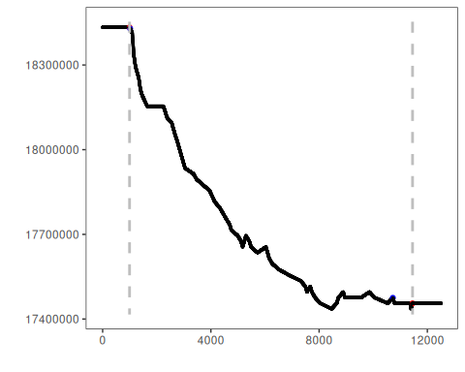
Evaluate metrics
# Point-wise evaluation (no tolerance)
ev <- evaluate(model, detection$event, data$event)
print(ev$confMatrix)
## event
## detection TRUE FALSE
## TRUE 0 2
## FALSE 2 12501
ev$accuracy
## [1] 0.9996801
ev$F1
## [1] NaN

SoftEd Evaluation
To analyze the results considering temporal tolerance, softED smoothed metrics can be used, as performed below.
ev_soft <- evaluate(har_eval_soft(sw = 90), detection$event, data$event)
print(ev_soft$confMatrix)
## event
## detection TRUE FALSE
## TRUE 0.74 1.26
## FALSE 1.26 12501.74
ev_soft$accuracy
## [1] 0.9997992
ev_soft$F1
## [1] 0.3722222

References
- Truong, C., Oudre, L., & Vayatis, N. (2020). Selective review of change point detection methods. Signal Processing, 167, 107299.

