GECCO Challenge — Water Quality
Overview
This notebook uses the GECCO water quality challenge data to illustrate anomaly detection in multivariate environmental time series. We will:
- Load the dataset and visualize the multivariate stream
- Select a univariate sensor for a focused experiment
- Train a baseline detector and evaluate results
Dataset notes - Multivariate series with labeled anomalies - Recommended use: multivariate or univariate event detection - Source: https://www.spotseven.de/gecco/gecco-challenge

Load packages and dataset
Load the required packages for data access, modeling, visualization, and evaluation.
library(united)
library(daltoolbox)
library(harbinger)
## Load series ----------------------
data(gecco)
# Plot selected multivariate columns
plot(as.ts(gecco$multi[, 2:10]))
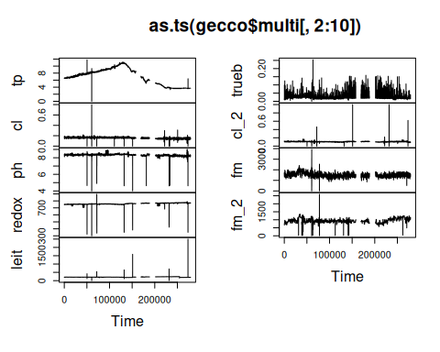
GECCO recommended sample: one day with anomalies
## Univariate series selection ----------------------
series <- gecco$ph
# Subset to a recommended one-day window with anomalies
series <- series[16500:18000, ]
plot(as.ts(series$value))
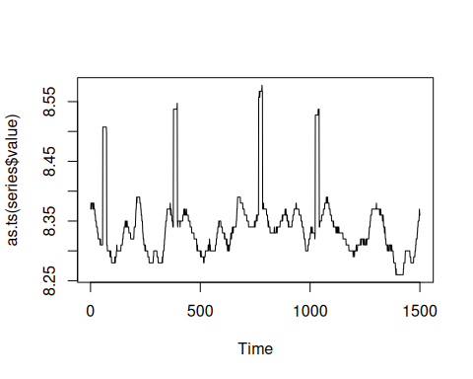

Event detection experiment
Define a baseline detector and generate anomaly predictions.
# Establish ARIMA-based detector
model <- hanr_arima()
# Fit the model on the value series
model <- fit(model, series$value)
# Produce anomaly detections
detection <- detect(model, series$value)

Results analysis
Inspect positives, plot overlays, and compute metrics.
# Show detected positives
print(detection |> dplyr::filter(event == TRUE))
## idx event type
## 1 56 TRUE anomaly
## 2 74 TRUE anomaly
## 3 378 TRUE anomaly
## 4 396 TRUE anomaly
## 5 766 TRUE anomaly
## 6 784 TRUE anomaly
## 7 1024 TRUE anomaly
## 8 1042 TRUE anomaly
Visual analysis
# Plot predictions (blue) versus true labels (red bands)
grf <- har_plot(model, series$value, detection, series$event)
plot(grf)
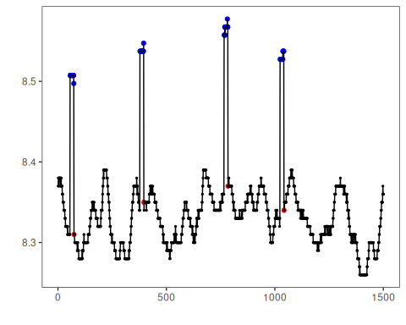
Evaluate metrics
# Point-wise evaluation (no temporal tolerance)
ev <- evaluate(model, detection$event, series$event)
print(ev$confMatrix)
## event
## detection TRUE FALSE
## TRUE 4 4
## FALSE 68 1425

References
- Chandola, V., Banerjee, A., & Kumar, V. (2009). Anomaly detection: A survey. ACM Computing Surveys, 41(3), 1–58.

