Numenta Anomaly Benchmark (NAB) — Cloud Services and Synthetic Data
Overview
This notebook demonstrates univariate anomaly detection using series from the Numenta Anomaly Benchmark (NAB). We will load a synthetic series, train a simple detector, visualize predictions, and compute metrics.
Dataset notes - Univariate series with labeled anomalies - Recommended use: univariate event detection - Source: https://www.numenta.com/

Load packages and dataset
Load the required packages for data access, modeling, visualization, and evaluation.
library(united)
library(daltoolbox)
library(harbinger)
Univariate use — Example 1
## Load series ----------------------
data(nab_artificialWithAnomaly)
# Select the first series from the collection
data <- nab_artificialWithAnomaly[[1]]
# Visualize value and label columns
plot(as.ts(data[, 2:3]),
main = names(nab_artificialWithAnomaly[1]))
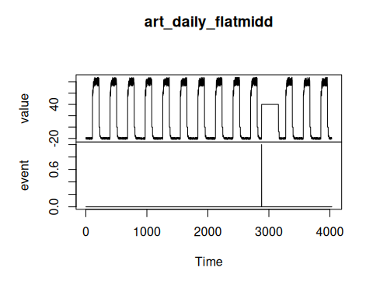

Event detection experiment
Define a baseline detector and generate anomaly predictions.
# Establish ARIMA-based detector
model <- hanr_arima()
# Fit the model on the value series
model <- fit(model, data$value)
# Produce anomaly detections
detection <- detect(model, data$value)

Results analysis
Inspect detected positives, plot overlays, and compute metrics.
# Show detected positives only
print(detection |> dplyr::filter(event == TRUE))
## idx event type
## 1 109 TRUE anomaly
## 2 217 TRUE anomaly
## 3 397 TRUE anomaly
## 4 505 TRUE anomaly
## 5 685 TRUE anomaly
## 6 793 TRUE anomaly
## 7 973 TRUE anomaly
## 8 1081 TRUE anomaly
## 9 1261 TRUE anomaly
## 10 1369 TRUE anomaly
## 11 1549 TRUE anomaly
## 12 1657 TRUE anomaly
## 13 1837 TRUE anomaly
## 14 1945 TRUE anomaly
## 15 2125 TRUE anomaly
## 16 2233 TRUE anomaly
## 17 2413 TRUE anomaly
## 18 2521 TRUE anomaly
## 19 2701 TRUE anomaly
## 20 2809 TRUE anomaly
## 21 2881 TRUE anomaly
## 22 3157 TRUE anomaly
## 23 3277 TRUE anomaly
## 24 3385 TRUE anomaly
## 25 3565 TRUE anomaly
## 26 3673 TRUE anomaly
## 27 3853 TRUE anomaly
## 28 3961 TRUE anomaly
Visual analysis
# Plot predictions (blue) over true labels (red bands)
grf <- har_plot(model, data$value, detection, data$event)
plot(grf)
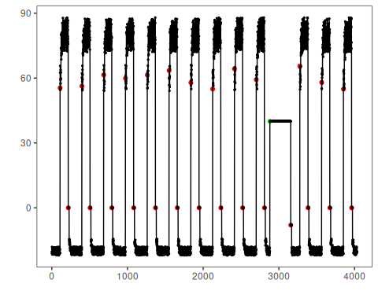
Evaluate metrics
# Point-wise evaluation (no temporal tolerance)
ev <- evaluate(model, detection$event, data$event)
print(ev$confMatrix)
## event
## detection TRUE FALSE
## TRUE 1 27
## FALSE 0 4004

References
- Lavin, A., & Ahmad, S. (2015). Evaluating real-time anomaly detection algorithms — the Numenta Anomaly Benchmark. 2015 IEEE 14th International Conference on Machine Learning and Applications (ICMLA).

