UCR Anomaly Archive — ECG Series
Overview
This notebook demonstrates a simple anomaly detection workflow using ECG series from the UCR Time Series Anomaly Archive. We will:
- Load the ECG dataset provided by the united package
- Visualize a selected series and its labels
- Train a baseline detector and generate anomaly predictions
- Evaluate performance using standard and soft (tolerant) metrics
Dataset notes - Univariate time series with labeled anomalous intervals - Recommended use: univariate anomaly detection - Source: https://paperswithcode.com/dataset/ucr-anomaly-archive

Load packages and dataset
Load the required packages for data access, modeling, visualization, and evaluation.
library(united)
library(daltoolbox)
library(daltoolboxdp)
library(harbinger)
library(tspredit)
Load the ECG dataset into memory using the package data helper.
## Load series ----------------------
data(ucr_ecg)
# Select a representative series for the experiment
series <- ucr_ecg[[3]]
# Quick visualization of values over time
plot(as.ts(series$value))
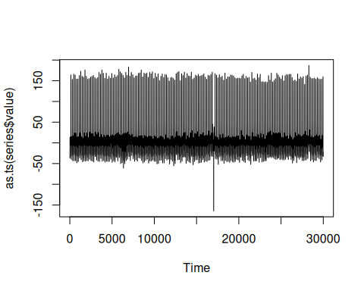

Event detection experiment
Define a detection method and train it with a subset of the series.
# Establish an autoencoder-based detector
# Alternative: uncomment to try ARIMA
# model <- hanr_arima()
model <- han_autoencoder(3, 2, autoenc_ed, num_epochs = 100)
# Fit the model on a training window (subset for speed)
train <- series[1:5000,]
model <- fit(model, train$value)
# Produce anomaly detections for the whole series
detection <- detect(model, series$value)

Results analysis
Inspect detections, visualize overlays, and compute metrics.
# Filter detected positives for quick inspection
print(detection |> dplyr::filter(event == TRUE))
## idx event type
## 1 17025 TRUE anomaly
Visual analysis
# Plot predictions (blue) versus true labels (red bands)
grf <- har_plot(model, series$value, detection, series$event)
plot(grf)
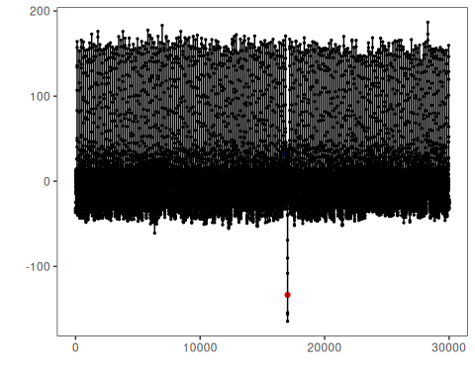
Evaluate metrics
# Point-wise evaluation (no temporal tolerance)
ev <- evaluate(model, detection$event, series$event)
print(ev$confMatrix)
## event
## detection TRUE FALSE
## TRUE 0 1
## FALSE 1 29998
# Soft evaluation with temporal tolerance window (sw = 200)
ev_soft <- evaluate(har_eval_soft(sw = 200), detection$event, series$event)
print(ev_soft$confMatrix)
## event
## detection TRUE FALSE
## TRUE 0.38 0.62
## FALSE 0.62 29998.38
print(ev_soft$accuracy)
## [1] 0.9999583
print(ev_soft$F1)
## [1] 0.375

References
- Chandola, V., Banerjee, A., & Kumar, V. (2009). Anomaly detection: A survey. ACM Computing Surveys, 41(3), 1–58.

