About the chart - Bar: compares aggregated values by categories. Useful for means, counts, and totals by group.
Graphics environment setup and color palette.
# installation
#install.packages("daltoolbox")
# loading DAL
library(daltoolbox)
library(RColorBrewer)
library(ggplot2)
colors <- brewer.pal(4, 'Set1')
# setting the font size for all charts
font <- theme(text = element_text(size=16))
Sample data aggregated by Species.
# iris dataset for the example
head(iris)
## Sepal.Length Sepal.Width Petal.Length Petal.Width Species
## 1 5.1 3.5 1.4 0.2 setosa
## 2 4.9 3.0 1.4 0.2 setosa
## 3 4.7 3.2 1.3 0.2 setosa
## 4 4.6 3.1 1.5 0.2 setosa
## 5 5.0 3.6 1.4 0.2 setosa
## 6 5.4 3.9 1.7 0.4 setosa
library(dplyr)
data <- iris |> group_by(Species) |> summarize(Sepal.Length=mean(Sepal.Length))
head(data)
## # A tibble: 3 × 2
## Species Sepal.Length
## <fct> <dbl>
## 1 setosa 5.01
## 2 versicolor 5.94
## 3 virginica 6.59
Basic bar chart and a vertical variant.
# Bar chart
# Displays categorical data with bars proportional to the aggregated value (count, mean, etc.).
# More info: https://en.wikipedia.org/wiki/Bar_chart
grf <- plot_bar(data, colors=colors[1]) + font
plot(grf)
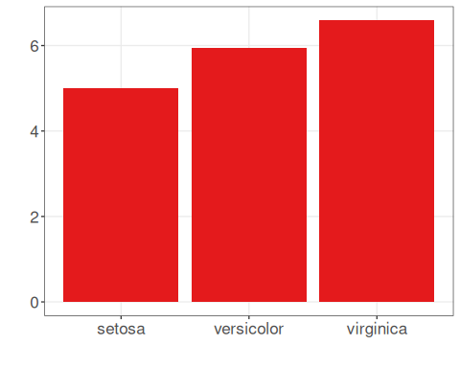
# Bars can be flipped (horizontal/vertical) with coord_flip().
grf <- grf + coord_flip()
plot(grf)
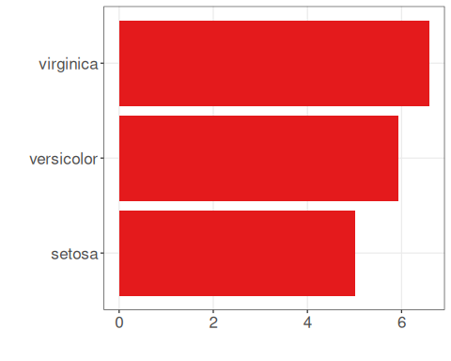
Color each bar by species.
# Bar graph with one color for each species
grf <- plot_bar(data, colors=colors[1:3]) + font
plot(grf)
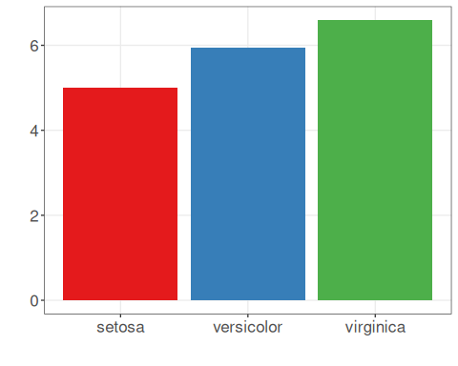
References - Wickham, H. (2016). ggplot2: Elegant Graphics for Data Analysis. Springer. - Cleveland, W. S. (1994). The Elements of Graphing Data (2nd ed.). Hobart Press.

