About the method - cluster_louvain_graph: graph community detection by modularity optimization.
Didactic goal: show the most important exception inside the clustering family. The workflow still follows the same DAL rhythm, but the input is now a graph instead of a feature matrix, and the interpretation is about communities rather than geometric groups.
Environment setup.
source(url("https://raw.githubusercontent.com/cefet-rj-dal/daltoolbox/main/examples/seed.R"))
# install.packages(c("daltoolbox", "igraph"))
library(daltoolbox)
Create a graph for the example.
if (requireNamespace("igraph", quietly = TRUE)) {
set_example_seed()
g <- igraph::sample_gnp(n = 20, p = 0.15)
g
}
## IGRAPH eca7e7b U--- 20 28 -- Erdos-Renyi (gnp) graph
## + attr: name (g/c), type (g/c), loops (g/l), p (g/n)
## + edges from eca7e7b:
## [1] 2-- 3 2-- 4 1-- 5 4-- 5 1-- 7 6-- 7 4-- 8 5-- 8 1-- 9 5-- 9 6-- 9 7-- 9 7--11 4--12 6--14 13--14 2--15
## [18] 8--15 9--15 13--15 8--16 9--16 11--16 3--17 5--17 3--18 17--18 8--19
Model configuration.
if (requireNamespace("igraph", quietly = TRUE)) {
model <- cluster_louvain_graph()
}
Fit the model and obtain community labels.
if (requireNamespace("igraph", quietly = TRUE)) {
model <- fit(model, g)
clu <- cluster(model, g)
table(clu)
}
## clu
## 1 2 3 4 5 6
## 7 6 3 1 2 1
Inspect the modularity attached to the result.
if (requireNamespace("igraph", quietly = TRUE)) {
attr(clu, "modularity")
}
## NULL
Optional graph view for interpretation.
if (requireNamespace("igraph", quietly = TRUE)) {
plot(
g,
vertex.color = as.factor(clu),
vertex.label = NA,
main = "Louvain communities"
)
}
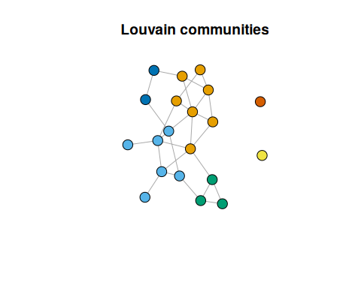
What to observe - The DAL workflow is still configure, fit, and cluster, but there is no feature matrix such as iris[, 1:4]. - The returned groups are communities in a network, not partitions of points in Euclidean space. - The attached modularity summarizes how strongly the discovered communities separate dense internal connections from sparse external ones.
Common mistakes - Comparing this example too literally with centroid-based clustering, as if both were solving the same geometric problem. - Expecting a reference label like Species; many graph problems are fully unsupervised and do not have an external class variable for evaluation. - Reading modularity as an absolute guarantee of community truth rather than as a structural quality indicator for this partition on this graph.
References - Blondel, V. D., Guillaume, J.-L., Lambiotte, R., and Lefebvre, E. (2008). Fast Unfolding of Communities in Large Networks.

