About the technique - fit_curvature_max: computes curvature via the second derivative of a smoothed spline and returns the maximum curvature position for decreasing curves; useful to choose a trade-off point where further reductions add little benefit.
source(url("https://raw.githubusercontent.com/cefet-rj-dal/daltoolbox/main/examples/seed.R"))
# installation
#install.packages("daltoolbox")
# loading DAL
library(daltoolbox)
# for ploting
library(ggplot2)
library(dplyr)
Synthetic example of a decreasing curve (-log) to illustrate the maximum curvature point.
# Maximum curvature
# If the curve is decreasing, use maximum curvature analysis.
# It brings a trade-off between having lower x values (with not so low y values) and having higher x values (not having to much decrease in y values).
x <- seq(from=1,to=10,by=0.5)
dat <- data.frame(x = x, value = -log(x), variable = as.factor("log"))
myfit <- fit_curvature_max()
res <- transform(myfit, dat$value)
head(res)
## x y yfit
## 1 9 -1.609438 9.224359e-08
grf <- plot_scatter(dat, label_x = "dimensions", label_y = "cumulative variance", colors="black") +
theme(text = element_text(size=16))
plot(grf + geom_vline(xintercept = dat$x[res$x], linetype="dashed", color = "red", size=0.5))
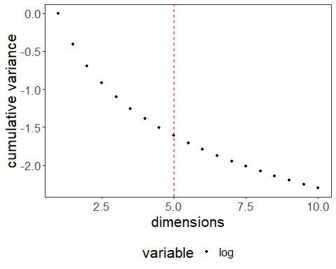
About the technique - fit_curvature_max: computes curvature via the second derivative of a smoothed spline over the sequence and returns the maximum curvature position (elbow) for decreasing or concave curves; useful to identify a knee where diminishing returns begin.
Didactic goal: focus on what changes in the dataset after each operation. In preprocessing examples, understanding the effect of the transformation is as important as learning the function name.
Environment setup.
# installation
#install.packages("daltoolbox")
# loading DAL
library(daltoolbox)
# for plotting
library(ggplot2)
library(dplyr)
Example curve and elbow detection.
x <- seq(from=1,to=10,by=0.5)
dat <- data.frame(x = x, value = -log(x), variable = "log")
dat$variable <- as.factor(dat$variable)
grf <- plot_scatter(dat, label_x = "x", label_y = "y", colors="black") +
theme(text = element_text(size=16))
plot(grf)
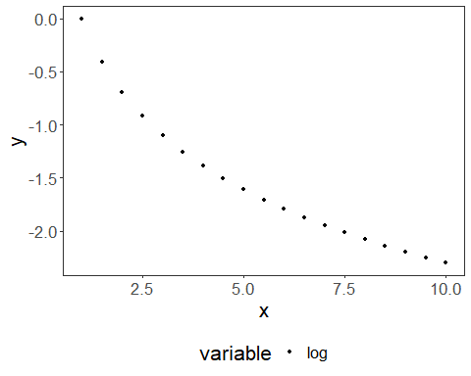
myfit <- fit_curvature_max()
res <- transform(myfit, dat$value)
res
## x y yfit
## 1 9 -1.609438 9.224359e-08
plot(grf + geom_vline(xintercept = res$x, linetype="dashed", color = "red", size=0.5))
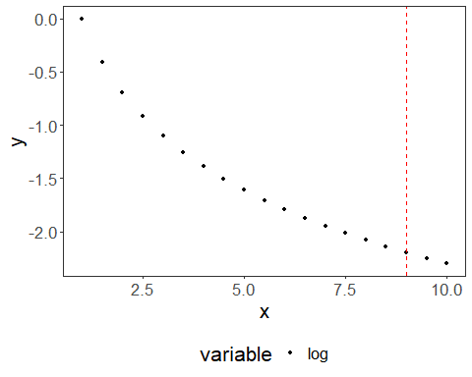
References - Satopaa, V., Albrecht, J., Irwin, D., Raghavan, B. (2011). Finding a “Kneedle” in a Haystack: Detecting Knee Points in System Behavior.

