About the chart - Stacked bars: shows each category’s composition by summing groups; useful for cumulative proportions.
Graphics environment setup.
# installation
#install.packages("daltoolbox")
# loading DAL
library(daltoolbox)
library(ggplot2)
library(RColorBrewer)
# color palette
colors <- brewer.pal(4, 'Set1')
# setting the font size for all charts
font <- theme(text = element_text(size=16))
Data aggregated by species for two metrics.
# iris dataset for the example
head(iris)
## Sepal.Length Sepal.Width Petal.Length Petal.Width Species
## 1 5.1 3.5 1.4 0.2 setosa
## 2 4.9 3.0 1.4 0.2 setosa
## 3 4.7 3.2 1.3 0.2 setosa
## 4 4.6 3.1 1.5 0.2 setosa
## 5 5.0 3.6 1.4 0.2 setosa
## 6 5.4 3.9 1.7 0.4 setosa
library(dplyr)
data <- iris |> group_by(Species) |> summarize(Sepal.Length=mean(Sepal.Length), Sepal.Width=mean(Sepal.Width))
head(data)
## # A tibble: 3 × 3
## Species Sepal.Length Sepal.Width
## <fct> <dbl> <dbl>
## 1 setosa 5.01 3.43
## 2 versicolor 5.94 2.77
## 3 virginica 6.59 2.97
Build a stacked bar chart and adjust X-axis labels.
# Stacked bars
# Organizes data by category, stacking bars for different groups; the final height shows the combined total.
# More info: https://en.wikipedia.org/wiki/Bar_chart#Grouped_or_stacked
grf <- plot_stackedbar(data, colors=colors[1:2]) + font
grf <- grf + theme(axis.text.x = element_text(angle=90, hjust=1))
plot(grf)
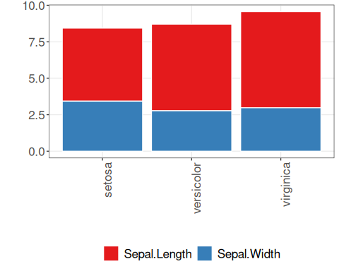
References - Wickham, H. (2016). ggplot2: Elegant Graphics for Data Analysis. Springer. - Cleveland, W. S. (1994). The Elements of Graphing Data (2nd ed.). Hobart Press.

