About the chart - Histogram: distributes observations into bins along the x-axis; useful to visualize frequency and skewness.
Graphics environment setup.
source(url("https://raw.githubusercontent.com/cefet-rj-dal/daltoolbox/main/examples/seed.R"))
# installation
#install.packages("daltoolbox")
# loading DAL
library(daltoolbox)
library(ggplot2)
library(RColorBrewer)
# color palette
colors <- brewer.pal(4, 'Set1')
# setting the font size for all charts
font <- theme(text = element_text(size=16))
Generate variables with distinct distributions (exponential, uniform, normal).
# Examples with data distributions
# We use random variables to facilitate visualization of different distributions.
# example: dataset to be plotted
example <- data.frame(exponential = rexp(100000, rate = 1),
uniform = runif(100000, min = 2.5, max = 3.5),
normal = rnorm(100000, mean=5))
head(example)
## exponential uniform normal
## 1 0.1983368 3.259554 4.896481
## 2 0.6608953 3.171106 5.187828
## 3 0.2834910 3.423250 4.389551
## 4 0.0381919 2.531736 3.741199
## 5 0.4731766 2.619622 4.529254
## 6 1.4636271 2.730006 4.735878
Histogram
Visualize the distribution of a continuous variable by binning the x-axis and counting observations per bin. geom_histogram() displays counts as bars. More info: ?geom_histogram (R documentation)
Build histograms and arrange multiple charts side by side.
library(dplyr)
grf <- plot_hist(example |> dplyr::select(exponential),
label_x = "exponential", color=colors[1]) + font
## Using as id variables
options(repr.plot.width=5, repr.plot.height=4)
plot(grf)
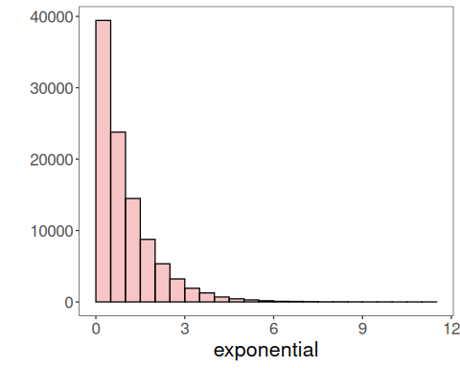
Chart arrangement
Use grid.arrange to place the generated charts side by side.
grfe <- plot_hist(example |> dplyr::select(exponential),
label_x = "exponential", color=colors[1]) + font
## Using as id variables
grfu <- plot_hist(example |> dplyr::select(uniform),
label_x = "uniform", color=colors[1]) + font
## Using as id variables
grfn <- plot_hist(example |> dplyr::select(normal),
label_x = "normal", color=colors[1]) + font
## Using as id variables
library(gridExtra)
options(repr.plot.width=18, repr.plot.height=3.2)
grid.arrange(grfe, grfu, grfn, ncol=3)
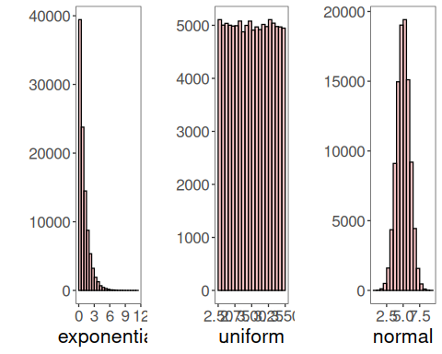
References - Freedman, D., and Diaconis, P. (1981). On the histogram as a density estimator: L2 theory. Zeitschrift für Wahrscheinlichkeitstheorie und verwandte Gebiete. - Wickham, H. (2016). ggplot2: Elegant Graphics for Data Analysis. Springer.

