About the method - cluster_hclust: agglomerative hierarchical clustering.
Didactic goal: keep the same clustering line of experiment and add a hierarchy that can be inspected before or after cutting the tree into clusters.
Environment setup.
source(url("https://raw.githubusercontent.com/cefet-rj-dal/daltoolbox/main/examples/seed.R"))
# install.packages("daltoolbox")
library(daltoolbox)
Load data and separate predictors from the reference labels used only for interpretation.
iris <- datasets::iris
x <- iris[, 1:4]
ref <- iris$Species
head(x)
## Sepal.Length Sepal.Width Petal.Length Petal.Width
## 1 5.1 3.5 1.4 0.2
## 2 4.9 3.0 1.4 0.2
## 3 4.7 3.2 1.3 0.2
## 4 4.6 3.1 1.5 0.2
## 5 5.0 3.6 1.4 0.2
## 6 5.4 3.9 1.7 0.4
Model configuration.
model <- cluster_hclust(k = 3, method = "ward.D2")
Fit the model and obtain cluster labels.
model <- daltoolbox::fit(model, x)
clu <- daltoolbox::cluster(model, x)
table(clu)
## clu
## 1 2 3
## 49 30 71
Evaluate the partition.
eval <- daltoolbox::evaluate(model, clu, ref)
eval
## $clusters_entropy
## # A tibble: 3 × 4
## x ce qtd ceg
## <fct> <dbl> <int> <dbl>
## 1 1 0 49 0
## 2 2 0.561 30 0.112
## 3 3 0.909 71 0.430
##
## $clustering_entropy
## [1] 0.5422445
##
## $data_entropy
## [1] 1.584963
##
## $metrics
## metric value goal type
## 1 silhouette 0.5030502 maximize internal
## 2 davies_bouldin 0.6826395 minimize internal
## 3 calinski_harabasz 11.0271758 maximize internal
## 4 entropy 0.5422445 minimize external
## 5 purity 0.8266667 maximize external
## 6 adjusted_rand_index 0.6153230 maximize external
Inspect the hierarchy graphically.
grf <- daltoolbox::plot_dendrogram(model$hc, title = "Hierarchical clustering of iris")
plot(grf)
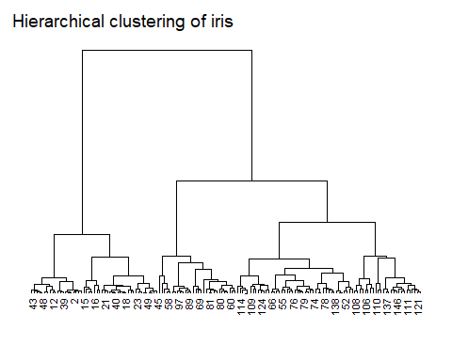
References - Johnson, S. C. (1967). Hierarchical Clustering Schemes.

