About the chart - Time series with fit and forecast: shows observed values, model fit, and forecast horizon for visual comparison.
Graphics environment setup.
source(url("https://raw.githubusercontent.com/cefet-rj-dal/daltoolbox/main/examples/seed.R"))
# installation
#install.packages("daltoolbox")
# loading DAL
library(daltoolbox)
library(ggplot2)
library(RColorBrewer)
# color palette
colors <- brewer.pal(4, 'Set1')
# setting the font size for all charts
font <- theme(text = element_text(size=16))
Synthetic series with noise; split windows for fit and forecast.
# Synthetic time series
x <- base::seq(0, 10, 0.25)
yvalues <- sin(x) + rnorm(41,0,0.1)
# prediction
adjust <- sin(x[1:35])
prediction <- sin(x[36:41])
Plot time series with fit and forecast.
# Time series with forecast
# Chart with observed values, model fit, and predicted values.
plot_ts_pred(y=yvalues, yadj=adjust, ypre=prediction)
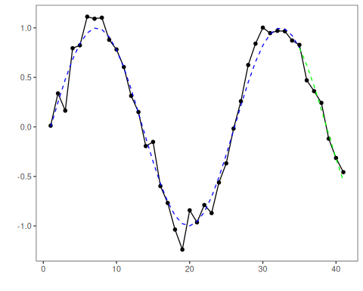
References - Hyndman, R. J., and Athanasopoulos, G. (2021). Forecasting: Principles and Practice (3rd ed.). OTexts.

