Tutorial 12 - Visual Analysis and Reporting
A mining workflow should not end with a metric table. Visual inspection helps the analyst understand the data, spot separation or overlap among groups, and communicate the result in a clearer way.
This tutorial uses one exploratory plot and one compact reporting table as a bridge between analysis and communication.
# install.packages(c("daltoolbox", "ggplot2", "RColorBrewer", "dplyr"))
library(daltoolbox)
library(ggplot2)
library(RColorBrewer)
library(dplyr)
Prepare a color palette and a shared theme so the plot is easier to read.
colors <- brewer.pal(4, "Set1")
font <- theme(text = element_text(size = 16))
iris <- datasets::iris
Create a scatter plot to inspect how two numeric attributes relate to the class structure. This kind of chart is often useful before choosing a classifier.
gr <- plot_scatter(
iris |>
dplyr::select(x = Sepal.Length, value = Sepal.Width, variable = Species),
label_x = "Sepal.Length",
label_y = "Sepal.Width",
colors = colors[1:3]
) + font
plot(gr)
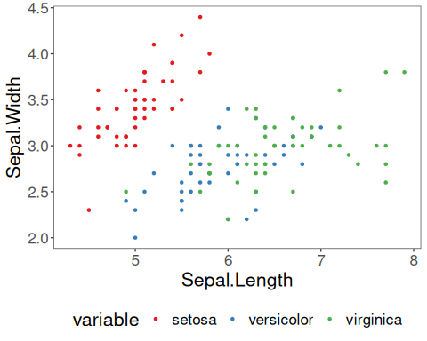
Now create a small comparison table that could appear in a report. The exact numbers are less important than the idea of communicating results in a compact and reproducible way.
set.seed(1)
sr <- train_test(sample_stratified("Species"), iris)
slevels <- levels(iris$Species)
models <- list(
majority = cla_majority("Species", slevels),
tree = cla_dtree("Species", slevels)
)
report <- lapply(names(models), function(name) {
fitted <- fit(models[[name]], sr$train)
pred <- predict(fitted, sr$test)
metrics <- evaluate(fitted, adjust_class_label(sr$test$Species), pred)$metrics
data.frame(model = name, t(metrics), check.names = FALSE)
})
do.call(rbind, report)
## model t(metrics)
## accuracy majority 0.3333333
## TP majority 10.0000000
## TN majority 0.0000000
## FP majority 20.0000000
## FN majority 0.0000000
## precision majority 0.3333333
## recall majority 1.0000000
## sensitivity majority 1.0000000
## specificity majority 0.0000000
## f1 majority 0.5000000
## accuracy1 tree 0.9666667
## TP1 tree 10.0000000
## TN1 tree 20.0000000
## FP1 tree 0.0000000
## FN1 tree 0.0000000
## precision1 tree 1.0000000
## recall1 tree 1.0000000
## sensitivity1 tree 1.0000000
## specificity1 tree 1.0000000
## f11 tree 1.0000000
For teaching purposes, this tutorial shows that analysis and communication should be treated as part of the same workflow.

