About the chart - Radar: displays multiple numeric variables on radial axes from a common origin; useful for comparative profiles.
Graphics environment setup.
source(url("https://raw.githubusercontent.com/cefet-rj-dal/daltoolbox/main/examples/seed.R"))
# installation
#install.packages("daltoolbox")
# loading DAL
library(daltoolbox)
library(ggplot2)
library(RColorBrewer)
# color palette
colors <- brewer.pal(4, 'Set1')
# setting the font size for all charts
font <- theme(text = element_text(size=16))
Mean per numeric variable and shaping the required format for radar.
# iris dataset for the example
head(iris)
## Sepal.Length Sepal.Width Petal.Length Petal.Width Species
## 1 5.1 3.5 1.4 0.2 setosa
## 2 4.9 3.0 1.4 0.2 setosa
## 3 4.7 3.2 1.3 0.2 setosa
## 4 4.6 3.1 1.5 0.2 setosa
## 5 5.0 3.6 1.4 0.2 setosa
## 6 5.4 3.9 1.7 0.4 setosa
library(dplyr)
data <- iris |> dplyr::select(-Species)
data <- sapply(data, mean)
data <- data.frame(name = names(data), value = data) |> dplyr::arrange(name)
head(data)
## name value
## Petal.Length Petal.Length 3.758000
## Petal.Width Petal.Width 1.199333
## Sepal.Length Sepal.Length 5.843333
## Sepal.Width Sepal.Width 3.057333
# Radar chart
# Graphical method to display multivariate data with 3+ quantitative variables on axes starting from the same point.
# More info: https://en.wikipedia.org/wiki/Radar_chart
grf <- plot_radar(data, colors=colors[1]) + font
plot(grf)
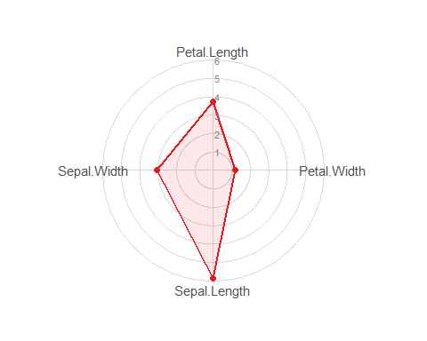
What to observe - With four variables, the profile is a quadrilateral. In general, the radar profile is an n-sided polygon, where n is the number of variables. - plot_radar() already sets the full drawing area, so adding ylim() can incorrectly cut the lower half of the figure.
References - Wickham, H. (2016). ggplot2: Elegant Graphics for Data Analysis. Springer. - Wilkinson, L. (2005). The Grammar of Graphics (2nd ed.). Springer.

