About the chart - Density (kernel density): smoothed version of the histogram for continuous variables; highlights distribution shapes.
Graphics environment setup.
source(url("https://raw.githubusercontent.com/cefet-rj-dal/daltoolbox/main/examples/seed.R"))
# installation
#install.packages("daltoolbox")
# loading DAL
library(daltoolbox)
library(RColorBrewer)
# color palette
colors <- brewer.pal(4, 'Set1')
library(ggplot2)
# setting the font size for all charts
font <- theme(text = element_text(size=16))
Examples with distinct distributions The following use random variables to visualize different distributions.
Generate example variables with different distributions.
# example4: dataset to be plotted
example <- data.frame(exponential = rexp(100000, rate = 1),
uniform = runif(100000, min = 2.5, max = 3.5),
normal = rnorm(100000, mean=5))
head(example)
## exponential uniform normal
## 1 0.7739627 3.205294 5.892116
## 2 0.2994734 2.868113 5.155478
## 3 0.4810232 2.678372 4.332598
## 4 1.8302383 2.800657 6.772819
## 5 0.7525840 2.550007 4.374387
## 6 0.4990995 2.545011 5.755205
Density plot
Draws a kernel density estimate, a smoothed alternative to the histogram for continuous data.
More info: ?geom_density (R documentation)
Build densities and arrange individual charts in a grid.
options(repr.plot.width=8, repr.plot.height=5)
grf <- plot_density(example, colors=colors[1:3]) + font
## Using as id variables
plot(grf)
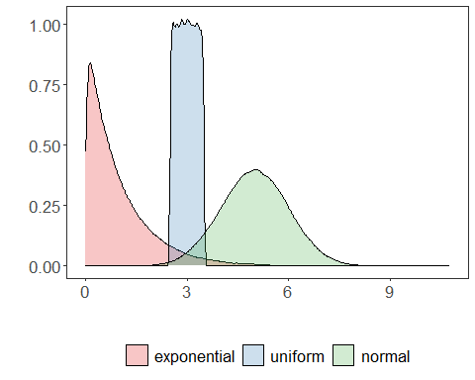
Chart arrangement
The grid.arrange function can arrange multiple previously created charts.
library(dplyr)
grfe <- plot_density(example |> dplyr::select(exponential),
label_x = "exponential", color=colors[1]) + font
## Using as id variables
grfu <- plot_density(example |> dplyr::select(uniform),
label_x = "uniform", color=colors[2]) + font
## Using as id variables
grfn <- plot_density(example |> dplyr::select(normal),
label_x = "normal", color=colors[3]) + font
## Using as id variables
library(gridExtra)
options(repr.plot.width=18, repr.plot.height=3.2)
grid.arrange(grfe, grfu, grfn, ncol=3)
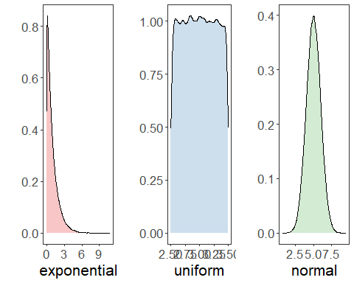
References - Silverman, B. W. (1986). Density Estimation for Statistics and Data Analysis. Chapman and Hall. - Wickham, H. (2016). ggplot2: Elegant Graphics for Data Analysis. Springer.

