About the chart - Boxplot: summarizes distribution via quartiles and highlights outliers; comparable across groups.
Graphics environment setup and palette.
source(url("https://raw.githubusercontent.com/cefet-rj-dal/daltoolbox/main/examples/seed.R"))
# installation
#install.packages("daltoolbox")
# loading DAL
library(daltoolbox)
library(ggplot2)
library(RColorBrewer)
# color palette
colors <- brewer.pal(4, 'Set1')
# setting the font size for all charts
font <- theme(text = element_text(size=16))
Data and construction of a simple boxplot and a colored variant.
# iris dataset for the example
head(iris)
## Sepal.Length Sepal.Width Petal.Length Petal.Width Species
## 1 5.1 3.5 1.4 0.2 setosa
## 2 4.9 3.0 1.4 0.2 setosa
## 3 4.7 3.2 1.3 0.2 setosa
## 4 4.6 3.1 1.5 0.2 setosa
## 5 5.0 3.6 1.4 0.2 setosa
## 6 5.4 3.9 1.7 0.4 setosa
# Boxplot
# Represents distribution by quartiles; “whiskers” indicate variability outside the quartiles (and help identify outliers).
# More info: https://en.wikipedia.org/wiki/Box_plot
grf <- plot_boxplot(iris, colors="white") + font
## Using Species as id variables
plot(grf)
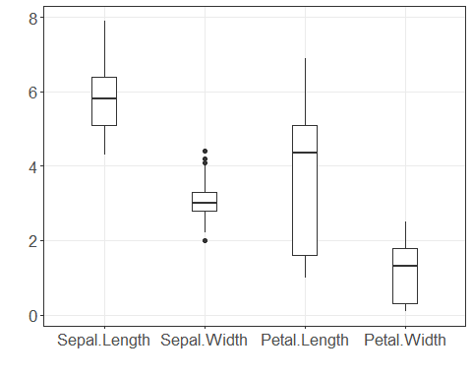
grf <- plot_boxplot(iris, colors=colors[1:4]) + font
## Using Species as id variables
plot(grf)
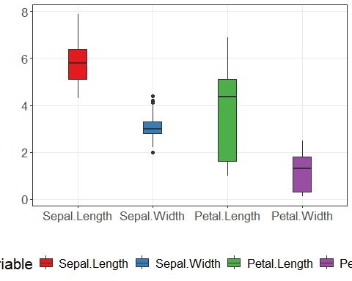
References - Tukey, J. W. (1977). Exploratory Data Analysis. Addison-Wesley. - Wickham, H. (2016). ggplot2: Elegant Graphics for Data Analysis. Springer.

