About the chart - Bar: compares aggregated values by categories. Useful for means, counts, and totals by group.
Didactic goal: treat the plot as an analytical tool, not as decoration. Pay attention to what question the chart answers and how the input data must be organized before plotting.
Graphics environment setup and color palette.
source(url("https://raw.githubusercontent.com/cefet-rj-dal/daltoolbox/main/examples/seed.R"))
# installation
#install.packages("daltoolbox")
# loading DAL
library(daltoolbox)
library(RColorBrewer)
library(ggplot2)
colors <- brewer.pal(4, 'Set1')
# setting the font size for all charts
font <- theme(text = element_text(size=16))
Sample data aggregated by Species.
# iris dataset for the example
head(iris)
## Sepal.Length Sepal.Width Petal.Length Petal.Width Species
## 1 5.1 3.5 1.4 0.2 setosa
## 2 4.9 3.0 1.4 0.2 setosa
## 3 4.7 3.2 1.3 0.2 setosa
## 4 4.6 3.1 1.5 0.2 setosa
## 5 5.0 3.6 1.4 0.2 setosa
## 6 5.4 3.9 1.7 0.4 setosa
library(dplyr)
data <- iris |> group_by(Species) |> summarize(Sepal.Length=mean(Sepal.Length))
head(data)
## # A tibble: 3 × 2
## Species Sepal.Length
## <fct> <dbl>
## 1 setosa 5.01
## 2 versicolor 5.94
## 3 virginica 6.59
Basic bar chart and a vertical variant.
# Bar chart
# Displays categorical data with bars proportional to the aggregated value (count, mean, etc.).
# More info: https://en.wikipedia.org/wiki/Bar_chart
grf <- plot_bar(data, colors=colors[1]) + font
plot(grf)
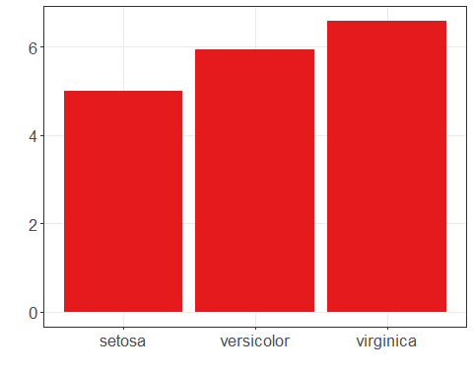
# Bars can be flipped (horizontal/vertical) with coord_flip().
grf <- grf + coord_flip()
plot(grf)
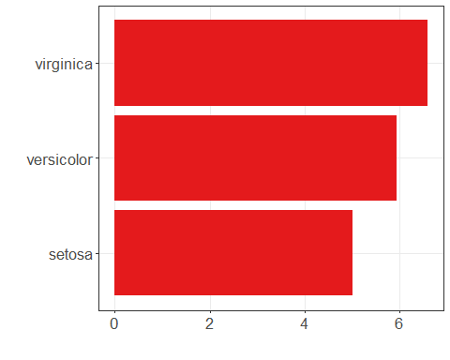
Color each bar by species.
# Bar graph with one color for each species
grf <- plot_bar(data, colors=colors[1:3]) + font
plot(grf)
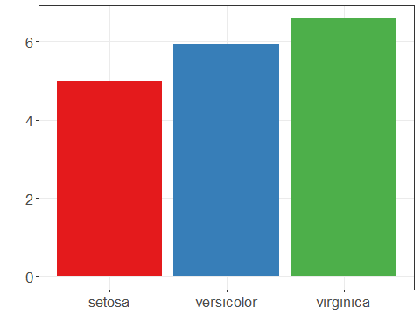
References - Wickham, H. (2016). ggplot2: Elegant Graphics for Data Analysis. Springer. - Cleveland, W. S. (1994). The Elements of Graphing Data (2nd ed.). Hobart Press.

