About the chart - Lollipop: alternative to bars, emphasizes values with a marker and a stem; lighter visual for comparisons.
Graphics environment setup.
source(url("https://raw.githubusercontent.com/cefet-rj-dal/daltoolbox/main/examples/seed.R"))
# installation
#install.packages("daltoolbox")
# loading DAL
library(daltoolbox)
library(ggplot2)
library(RColorBrewer)
# color palette
colors <- brewer.pal(4, 'Set1')
# setting the font size for all charts
font <- theme(text = element_text(size=16))
Data aggregated by species and chart construction.
# iris dataset for the example
head(iris)
## Sepal.Length Sepal.Width Petal.Length Petal.Width Species
## 1 5.1 3.5 1.4 0.2 setosa
## 2 4.9 3.0 1.4 0.2 setosa
## 3 4.7 3.2 1.3 0.2 setosa
## 4 4.6 3.1 1.5 0.2 setosa
## 5 5.0 3.6 1.4 0.2 setosa
## 6 5.4 3.9 1.7 0.4 setosa
library(dplyr)
data <- iris |> group_by(Species) |> summarize(Sepal.Length=mean(Sepal.Length))
head(data)
## # A tibble: 3 × 2
## Species Sepal.Length
## <fct> <dbl>
## 1 setosa 5.01
## 2 versicolor 5.94
## 3 virginica 6.59
# Lollipop chart
# Same purpose as the bar chart, highlighting the value with a marker and a stem.
grf <- plot_lollipop(data, colors=colors[1], max_value_gap=0.2) + font
plot(grf)
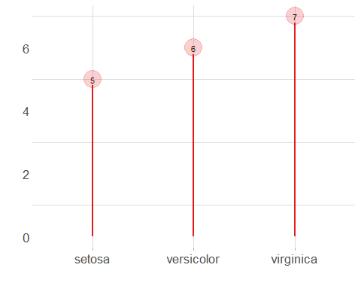
References - Wickham, H. (2016). ggplot2: Elegant Graphics for Data Analysis. Springer. - Cleveland, W. S. (1994). The Elements of Graphing Data (2nd ed.). Hobart Press.
grf <- plot_lollipop(data, colors=colors[1], max_value_gap=0.1) + font + coord_flip()
plot(grf)
