About the chart - Bars with error bars: add uncertainty/variability (e.g., standard deviation) to bars using geom_errorbar().
# installation
#install.packages("daltoolbox")
# loading DAL
library(daltoolbox)
Graphics environment setup.
library(ggplot2)
library(RColorBrewer)
# color palette
colors <- brewer.pal(4, 'Set1')
# setting the font size for all charts
font <- theme(text = element_text(size=16))
Aggregated data: mean and standard deviation by species.
# iris dataset for the example
head(iris)
## Sepal.Length Sepal.Width Petal.Length Petal.Width Species
## 1 5.1 3.5 1.4 0.2 setosa
## 2 4.9 3.0 1.4 0.2 setosa
## 3 4.7 3.2 1.3 0.2 setosa
## 4 4.6 3.1 1.5 0.2 setosa
## 5 5.0 3.6 1.4 0.2 setosa
## 6 5.4 3.9 1.7 0.4 setosa
library(dplyr)
data <- iris |> group_by(Species) |> summarize(mean=mean(Sepal.Length), sd=sd(Sepal.Length))
head(data)
## # A tibble: 3 × 3
## Species mean sd
## <fct> <dbl> <dbl>
## 1 setosa 5.01 0.352
## 2 versicolor 5.94 0.516
## 3 virginica 6.59 0.636
Build bars and add geom_errorbar.
# Bar graph with error bars
# When bar graphs present an average behavior, it is possible to plot a dispersion around it using an error bar.
# The error bar is added using $geom\_errorbar()$ function to a previously defined bar graph.
grf <- plot_bar(data, colors=colors[1], alpha=1) + font
grf <- grf + geom_errorbar(aes(x=x, ymin=y-sd, ymax=y+sd),
width=0.2, colour="darkred", alpha=0.8, size=1.1)
plot(grf)
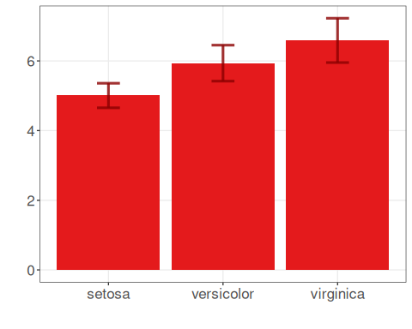
References - Wickham, H. (2016). ggplot2: Elegant Graphics for Data Analysis. Springer. (geom_errorbar)

