About the chart - Scatter: assesses the relationship between two numeric variables, with optional coloring by group/category.
This example is worth reading slowly because it teaches two things at once: what analytical question a scatter plot answers and how the data must be shaped before plotting.
Didactic goal: learn to use the chart for reasoning about the data, not only for producing a figure.
Graphics environment setup and color palette.
# installation
#install.packages("daltoolbox")
# loading DAL
library(daltoolbox)
library(ggplot2)
library(RColorBrewer)
# color palette
colors <- brewer.pal(4, 'Set1')
# setting the font size for all charts
font <- theme(text = element_text(size=16))
Sample data (iris) for the chart.
# iris dataset for the example
head(iris)
## Sepal.Length Sepal.Width Petal.Length Petal.Width Species
## 1 5.1 3.5 1.4 0.2 setosa
## 2 4.9 3.0 1.4 0.2 setosa
## 3 4.7 3.2 1.3 0.2 setosa
## 4 4.6 3.1 1.5 0.2 setosa
## 5 5.0 3.6 1.4 0.2 setosa
## 6 5.4 3.9 1.7 0.4 setosa
Build a scatter plot: select and rename columns to x, value (y), and variable (color).
# Scatter plot
# Used to visualize the relationship between two numeric variables.
# The first selected column is treated as X (independent) and the second as Y (dependent);
# a third categorical variable can color the points.
# The color vector must match the number of levels/groups.
# More info: https://en.wikipedia.org/wiki/Scatter_plot
library(dplyr)
grf <- plot_scatter(
iris |> dplyr::select(x = Sepal.Length, value = Sepal.Width, variable = Species),
label_x = "Sepal.Length", # X-axis label
label_y = "Sepal.Width", # Y-axis label
colors=colors[1:3] # one color per Species level
) + font
plot(grf)
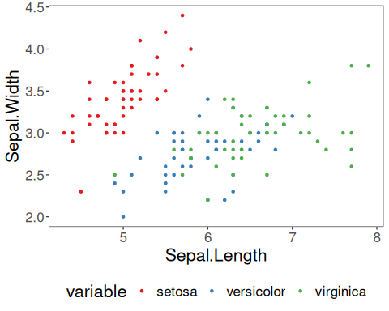
What to observe - The column names are adapted to the plotting helper, which is a useful reminder that visualization often starts with data organization. - The species colors make it easier to see overlap and separation between groups.
Common mistakes - Choosing two numeric variables without asking what relationship is being investigated. - Using too many groups or colors, which makes the visual comparison harder. - Treating the chart as final evidence instead of as part of exploratory analysis.
References - Cleveland, W. S. (1994). The Elements of Graphing Data (2nd ed.). Hobart Press. - Wickham, H. (2016). ggplot2: Elegant Graphics for Data Analysis. Springer.

