About the chart - Simple time series: exploratory visualization of a temporal vector with ordered x-axis and y values.
Graphics environment setup.
# installation
#install.packages("daltoolbox")
# loading DAL
library(daltoolbox)
library(ggplot2)
library(RColorBrewer)
# color palette
colors <- brewer.pal(4, 'Set1')
# setting the font size for all charts
font <- theme(text = element_text(size=16))
Synthetic series (sine) for the example and plot with plot_ts.
# Synthetic time series
x <- seq(0, 10, 0.25)
y <- sin(x)
# Time series chart
# Basic exploratory visualization of a time series
grf <- plot_ts(x = x, y = y, color=c("red"))
plot(grf)
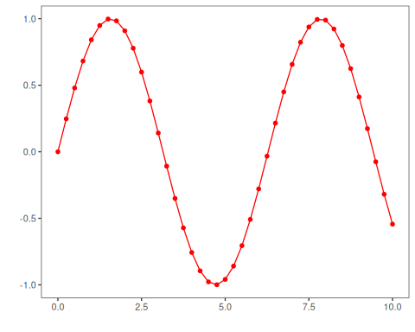
References - Wickham, H. (2016). ggplot2: Elegant Graphics for Data Analysis. Springer. - Hyndman, R. J., and Athanasopoulos, G. (2021). Forecasting: Principles and Practice (3rd ed.). OTexts.

