About the feature - Chart saving: example of exporting with ggsave() to PDF, controlling dimensions and units.
Graphics environment setup.
# installation
#install.packages("daltoolbox")
# loading DAL
library(daltoolbox)
library(ggplot2)
library(RColorBrewer)
# color palette
colors <- brewer.pal(4, 'Set1')
# setting the font size for all charts
font <- theme(text = element_text(size=16))
Synthetic series and chart to export.
# Synthetic time series
x <- seq(0, 10, 0.25)
serie <- data.frame(x, sin=sin(x), cosine=cos(x)+5)
head(serie)
## x sin cosine
## 1 0.00 0.0000000 6.000000
## 2 0.25 0.2474040 5.968912
## 3 0.50 0.4794255 5.877583
## 4 0.75 0.6816388 5.731689
## 5 1.00 0.8414710 5.540302
## 6 1.25 0.9489846 5.315322
# Series chart
# Shows points connected by lines, with x-axis ordered by time/index.
# More info: https://en.wikipedia.org/wiki/Line_chart
grf <- plot_series(serie, colors=colors[1:2]) + font
plot(grf)
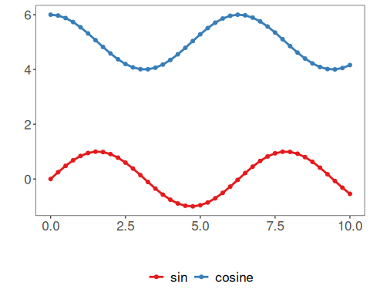
Export to PDF with ggsave.
ggsave("series.pdf", width = 5, height = 4, units = "cm")
References - Wickham, H. (2016). ggplot2: Elegant Graphics for Data Analysis. Springer. (ggsave)

