About the technique - fit_curvature_min: computes curvature via the second derivative of a smoothed spline over the sequence and returns the minimum curvature position for increasing curves; useful to find a trade-off point where additional gains become marginal.
# installation
#install.packages("daltoolbox")
# loading DAL
library(daltoolbox)
# for ploting
library(ggplot2)
library(dplyr)
Load example data (PCA on wine dataset) and build cumulative variance curve.
wine <- get(load(url("https://raw.githubusercontent.com/cefet-rj-dal/daltoolbox/main/examples/wine.RData")))
head(wine)
## X1 X14.23 X1.71 X2.43 X15.6 X127 X2.8 X3.06 X.28 X2.29 X5.64 X1.04 X3.92 X1065
## 1 1 13.20 1.78 2.14 11.2 100 2.65 2.76 0.26 1.28 4.38 1.05 3.40 1050
## 2 1 13.16 2.36 2.67 18.6 101 2.80 3.24 0.30 2.81 5.68 1.03 3.17 1185
## 3 1 14.37 1.95 2.50 16.8 113 3.85 3.49 0.24 2.18 7.80 0.86 3.45 1480
## 4 1 13.24 2.59 2.87 21.0 118 2.80 2.69 0.39 1.82 4.32 1.04 2.93 735
## 5 1 14.20 1.76 2.45 15.2 112 3.27 3.39 0.34 1.97 6.75 1.05 2.85 1450
## 6 1 14.39 1.87 2.45 14.6 96 2.50 2.52 0.30 1.98 5.25 1.02 3.58 1290

Example: PCA components
PCA cumulative variance: early dimensions concentrate high variance; adding too many dimensions brings marginal gains. The goal is to establish a trade-off point.
pca_res = prcomp(wine[,2:ncol(wine)], center=TRUE, scale.=TRUE)
y <- cumsum(pca_res$sdev^2/sum(pca_res$sdev^2)) # cumulative variance
x <- 1:length(y)
dat <- data.frame(x, value = y, variable = "PCA")
dat$variable <- as.factor(dat$variable)
head(dat)
## x value variable
## 1 1 0.3598307 PCA
## 2 2 0.5522435 PCA
## 3 3 0.6640381 PCA
## 4 4 0.7351492 PCA
## 5 5 0.8014366 PCA
## 6 6 0.8510403 PCA
grf <- plot_scatter(dat, label_x = "dimensions", label_y = "cumulative variance", colors="black") +
theme(text = element_text(size=16))
plot(grf)
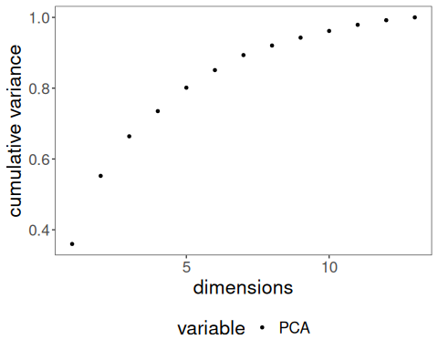

Minimum curvature
If the curve is increasing, use minimum curvature analysis. It brings a trade-off between having lower x values (with not-so-high y values) and higher x values (without too much increase in y values).
myfit <- fit_curvature_min()
res <- transform(myfit, y) # returns optimal index (knee)
head(res)
## x y yfit
## 1 6 0.8510403 -1.819591e-08
plot(grf + geom_vline(xintercept = res$x, linetype="dashed", color = "red", size=0.5))
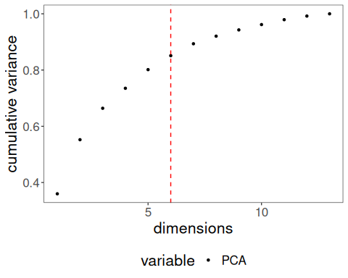
References - Satopaa, V., Albrecht, J., Irwin, D., Raghavan, B. (2011). Finding a “Kneedle” in a Haystack: Detecting Knee Points in System Behavior.

