About the chart - Boxplot: summarizes distribution via quartiles and highlights outliers; comparable across groups.

Graphics environment setup and palette.

# installation   
#install.packages("daltoolbox")  
  
# loading DAL  
library(daltoolbox)

library(ggplot2)  
library(RColorBrewer)  
  
# color palette  
colors <- brewer.pal(4, 'Set1')  
  
# setting the font size for all charts  
font <- theme(text = element_text(size=16))

Data and construction of a simple boxplot and a colored variant.

# conjunto de dados iris para o exemplo  
head(iris)

## Sepal.Length Sepal.Width Petal.Length Petal.Width Species  
## 1 5.1 3.5 1.4 0.2 setosa  
## 2 4.9 3.0 1.4 0.2 setosa  
## 3 4.7 3.2 1.3 0.2 setosa  
## 4 4.6 3.1 1.5 0.2 setosa  
## 5 5.0 3.6 1.4 0.2 setosa  
## 6 5.4 3.9 1.7 0.4 setosa

# Boxplot  
# Represents distribution by quartiles; “whiskers” indicate variability outside the quartiles (and help identify outliers).  
  
# More info: https://en.wikipedia.org/wiki/Box_plot  
  
grf <- plot_boxplot(iris, colors="white") + font

## Using Species as id variables

plot(grf)

## Ignoring unknown labels:  
## • colour : "c(\"Sepal.Length\", \"Sepal.Width\", \"Petal.Length\", \"Petal.Width\", \"Species\")"

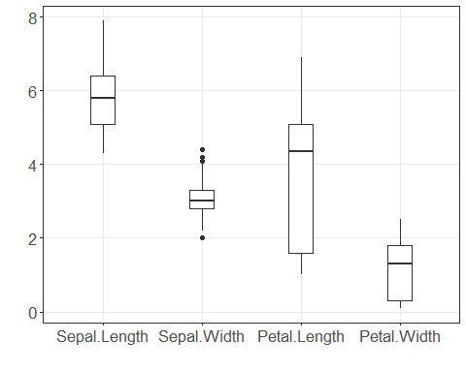

grf <- plot_boxplot(iris, colors=colors[1:4]) + font

## Using Species as id variables

plot(grf)

## Ignoring unknown labels:  
## • colour : "c(\"Sepal.Length\", \"Sepal.Width\", \"Petal.Length\", \"Petal.Width\", \"Species\")"

