About the chart - Density (kernel density): smoothed version of the histogram for continuous variables; highlights distribution shapes.

Graphics environment setup.

# installation   
#install.packages("daltoolbox")  
  
# loading DAL  
library(daltoolbox)

library(RColorBrewer)  
# color palette  
colors <- brewer.pal(4, 'Set1')  
  
library(ggplot2)  
# setting the font size for all charts  
font <- theme(text = element_text(size=16))

Examples with distinct distributions The following use random variables to visualize different distributions.

Generate example variables with different distributions.

# example4: dataset to be plotted   
example <- data.frame(exponential = rexp(100000, rate = 1),   
 uniform = runif(100000, min = 2.5, max = 3.5),   
 normal = rnorm(100000, mean=5))  
head(example)

## exponential uniform normal  
## 1 1.6445617 3.470041 3.414173  
## 2 0.5231597 2.935227 3.409228  
## 3 0.6436326 2.535932 5.927512  
## 4 1.9587219 2.693222 3.927637  
## 5 0.3029165 3.315365 3.836696  
## 6 2.3120488 3.181628 5.671860

# Density plot

Draws a kernel density estimate, a smoothed alternative to the histogram for continuous data.

More info: ?geom_density (R documentation)

Build densities and arrange individual charts in a grid.

options(repr.plot.width=8, repr.plot.height=5)  
grf <- plot_density(example, colors=colors[1:3]) + font

## Using as id variables

plot(grf)

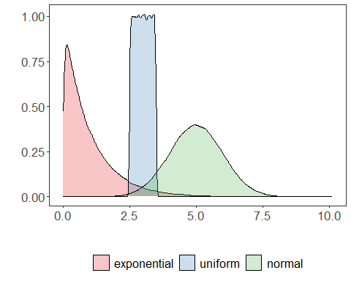

# Chart arrangement

The grid.arrange function can arrange multiple previously created charts.

library(dplyr)  
grfe <- plot_density(example |> dplyr::select(exponential),   
 label_x = "exponential", color=colors[1]) + font

## Using as id variables

grfu <- plot_density(example |> dplyr::select(uniform),   
 label_x = "uniform", color=colors[2]) + font

## Using as id variables

grfn <- plot_density(example |> dplyr::select(normal),   
 label_x = "normal", color=colors[3]) + font

## Using as id variables

library(gridExtra)   
options(repr.plot.width=15, repr.plot.height=4)  
grid.arrange(grfe, grfu, grfn, ncol=3)

